Supplemental material PSM-D-20-00745

Evidence, and replication thereof, that molecular genetic and environmental risks for psychosis impact through an affective pathway

Jim van Os, Lotta-Katrin Pries, Margreet ten Have, Ron de Graaf, Saskia van Dorsselaer, Philippe Delespaul, Maarten Bak, Gunter Kenis, Bochao D. Lin, Jurjen J. Luykx, Alexander L. Richards, Berna Akdede, Tolga Binbay, Vesile Altınyazar, Berna Yalınçetin, Güvem Gümüş-Akay, Burçin Cihan, Haldun Soygür, Halis Ulaş, Eylem Şahin Cankurtaran, Semra Ulusoy Kaymak, Marina M. Mihaljevic, Sanja Andric Petrovic, Tijana Mirjanic, Miguel Bernardo, Gisela Mezquida, Silvia Amoretti, Julio Bobes, Pilar A. Saiz, María Paz García-Portilla, Julio Sanjuan, Eduardo J. Aguilar, José Luis Santos, Estela Jiménez-López, Manuel Arrojo, Angel Carracedo, Gonzalo López, Javier González-Peñas, Mara Parellada, Nadja P. Maric, Cem Atbaşoğlu, Alp Ucok, Köksal Alptekin, Meram Can Saka, Celso Arango, Michael O'Donovan, Bart P.F. Rutten, Sinan Guloksuz

Table of contents

Fig. 6. NEMESIS- sensitivity analysis of RERI affective dysregulation x PRS for different percentile cut-offs of binary PRS risk variable 3
Fig. 7. EUGEI sensitivity analysis of RERI affective dysregulation x PRS for different percentile cut-offs of binary PRS risk variable 4

Fig. 6. NEMESIS- sensitivity analysis of RERI affective dysregulation x PRS for different percentile cut-offs of binary PRS risk variable

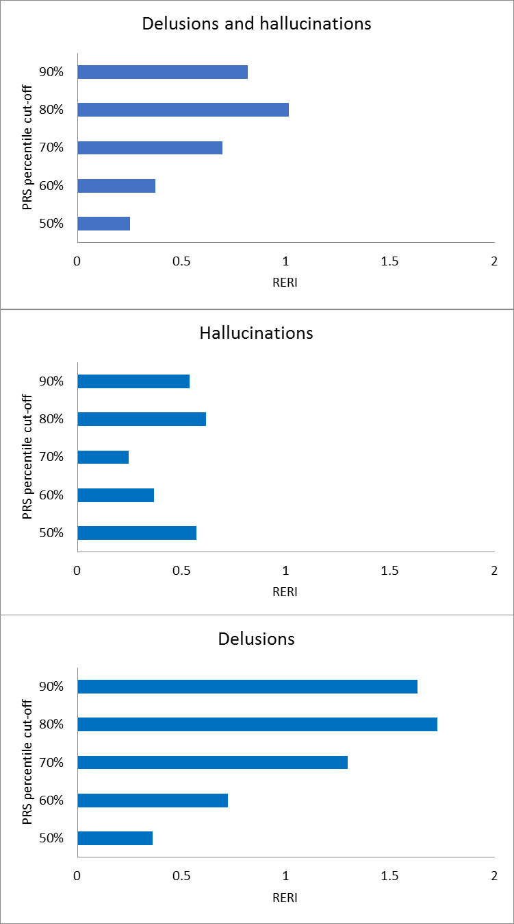

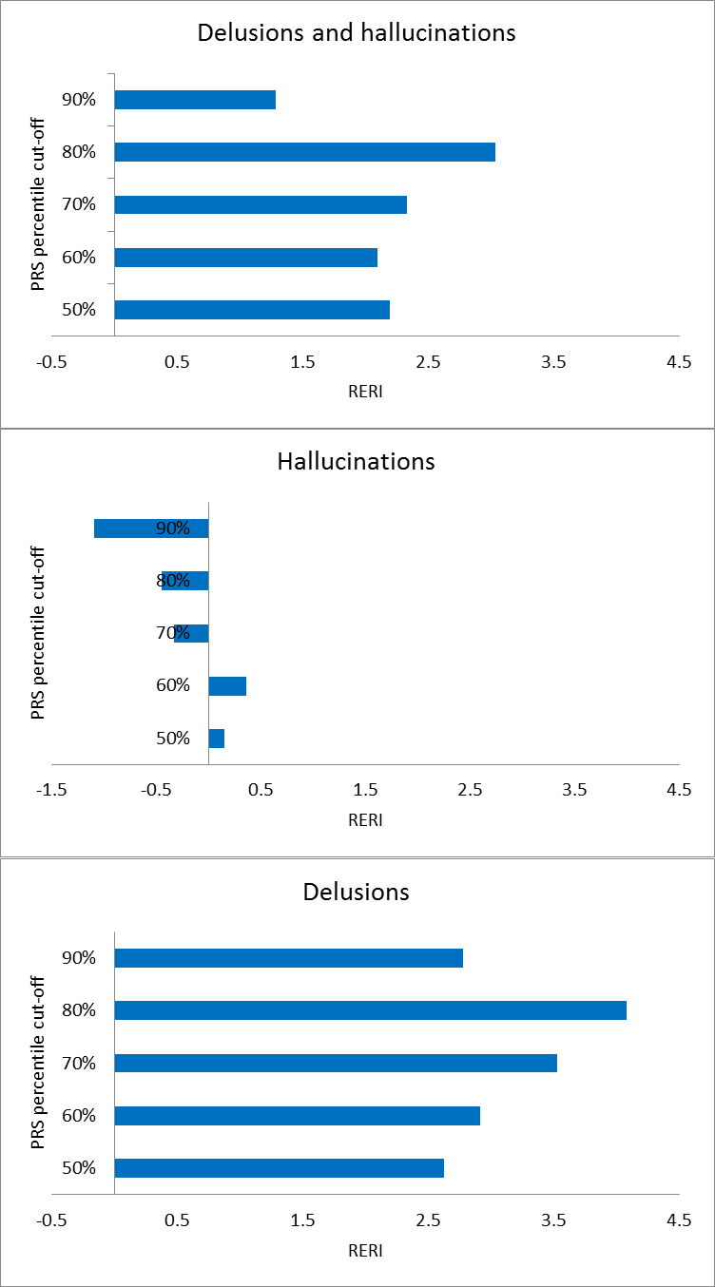
Fig. 7. EUGEI sensitivity analysis of RERI affective dysregulation x PRS for different percentile cut-offs of binary PRS risk variable

