Supplement
Personality disorders and cause-specific mortality:
a nationwide study of 2 million adolescents
Table of contents
S1 Methods | Screening for personality disorders and cognitive performance | Page 2
S1 Table | Risk estimate for external-specific causes of death | Page 5
S2 Table | Assessing the longitudinal risk trend of the main outcomes in the analysis | Page 6
S3 Table | Assessing a potential period effect on the association between personality disorder and mortality | Page 7
S4 Table | Assessing potential effect of DSM-4 acceptance on the stability of association of personality disorders with all-cause mortality | Page 8
S5 Table | The association between personality disorders and mortality: analyzing the association with follow-up commencing at the age of the baseline examination for all participants | Page 9
S6 Table | Multivariable-adjusted all-cause mortality among persons with personality disorders and their sex-matched siblings. | Page 10
S7 Table | Survival analysis using Cox regression while taking gender as a covariate | Page 11
S8 Table | Assessing mortality risk among examinees who were misclassified as non-personality disorder during the pre-recruitment evaluation | Page 12
S1 Figure | Cumulative incidence functions describing probability of cardiovascular and external-related mortality and mortality from other causes | Page 13
S2 Figure | Mortality by conscription year | Page 14
S3 Figure | The association between adolescents with personality disorders and cardiovascular-specific mortality - Sensitivity analyses | Page 15
S4 Figure | Poisson regression curves describing mortality rates and rate ratio, by gender since evaluation, divided to 2 study cohorts | Page 16
S5 Figure | Kaplan-Meier cumulative survival curves of a subset of persons with personality disorders and their sex-matched siblings. | Page 17
S6 Figure | Validation and misclassification of personality disorder diagnosis in the study cohort | Page 18
S1 Appendix | Using siblings of examinees with personality disorder as the control group to minimize residual confounding – A sub-analysis | Page 19

S1 Methods: Screening for personality disorders and cognitive performance.

Screening for personality disorders and cognitive performance
As part of the psychiatric screening, male examinees undergo a structured evaluation that has three levels:
- A structured interview that aimed to assess personality and behavioral disturbances. The screening process has been described in detail in previous reports ^{1–3}. The interview is delivered by college-age individuals who underwent a 4-month training course for this specific interview that include the following items: social functioning (to assess social potency), individual autonomy (to assess personal autonomy, maturity, and self-directed behavior), organizational ability (to assess compliance to time tables, self-mastery, and self-care) and physical activity, (to assess the involvement in extracurricular activities concentrating on health-related physical activities such as interest in sports and hiking). Each behavioral item is rated on a scale that ranges from 1 (worst) to 5 (best). Notably, the reliability of the scoring system is fairly high as inductees who were interviewed after several days by different interviewers exhibited test–retest reliability higher than 0.8 ^{4,5}.
- In-depth psychological assessment - After this interview, examinees at the lower quintile are referred for an in-depth psychosocial assessment performed by a clinical social worker. The specific criteria for referral for the in-depth psychosocial assessment includes one or more of the following: (a) obtaining the lowest score on rating of social functioning, documentation or self-report of present or past psychiatric symptoms (such as enuresis, sleep disturbances, drug or alcohol abuse), or prediction by the interviewer that the adolescent will not do well in the military.
- Psychiatric evaluation- If the social worker suspects that the adolescent has psychopathology, a provisional diagnosis is suggested, and the adolescent is then referred to an evaluation by a board-certified psychiatrist experienced with adolescents. The diagnoses following this evaluation covers the entire psychiatric spectrum. Adolescents who had previously been treated by mental health professionals, or who had been hospitalized, are required to present treatment summaries and/or discharge letters and then to undergo an evaluation by board-certified psychiatrist. We assigned as having personality disorder only examinees that were approved by a military board-certified psychiatrist at this level.

Diagnoses during the time covered by this study were based on the International Classification of Disease (ICD) 9 (up to 1997) and ICD 10 (from 1997 onwards). Examinees with diagnosis of personality disorders and poor functioning were discharged from the army, but were not excluded from the study. Women did not undergo the this 3-level screening process. Diagnosis of personality disorder among them was based on a pre-existing diagnosis as referred by the primary care physician and were then approved by board-certified psychiatrist.

Cognitive performance was routinely assessed by intelligence score, has been used extensively as an investigative tool, ^{6–9} and has a correlation of over 85% with intelligent quotient (IQ) score ⁵. It includes evaluation of language ability and intellectual performance, and comprises four sub-tests (Otis-R, Similarities-R Arithmetic-R and Raven's Progressive Matrices-R) ¹⁰ whose sum forms a validated measure of general intelligence (IQ) scored on a 9-point scale ⁵. This assessment was conducted routinely among participants of both sexes in this study.

References
1. Reichenberg A, Weiser M, Rabinowitz J, Caspi A, Schmeidler J, Mark M, Kaplan Z, Davidson M. A population-based cohort study of premorbid intellectual, language, and behavioral functioning in patients with schizophrenia, schizoaffective disorder, and nonpsychotic bipolar disorder. Am J Psychiatry. 2002;159:2027–2035.
2. Weiser M, Reichenberg A, Rabinowitz J, Kaplan Z, Caspi A, Yasvizky R, Mark M, Knobler HY, Nahon D, Davidson M. Self-reported drug abuse in male adolescents with behavioral disturbances, and follow-up for future schizophrenia. Biol Psychiatry. 2003;54:655–660.
3. Weiser M, Reichenberg A, Rabinowitz J, Kaplan Z, Mark M, Bodner E, Nahon D, Davidson M. Association between nonpsychotic psychiatric diagnoses in adolescent males and subsequent onset of schizophrenia. Arch Gen Psychiatry. 2001;58:959–964.
4. Reeb M. Construction of questionnaire to replace a valid structured interview in the Israeli Defense Forces. Megamot Behav Sci Q. 1968;16:69–74.
5. Gal R. The selection, classification and placement process. In: A portrait of the Israeli soldier. New York: Greenwood Pr; 1986.
6. Cukierman-Yaffe T, Kasher-Meron M, Fruchter E, Gerstein HC, Afek A, Derazne E, Tzur D, Karasik A, Twig G. Cognitive Performance at Late Adolescence and the Risk for Impaired Fasting Glucose Among Young Adults. J Clin Endocrinol Metab. 2015;100:4409–4416.
7. Davidson M, Reichenberg A, Rabinowitz J, Weiser M, Kaplan Z, Mark M. Behavioral and intellectual markers for schizophrenia in apparently healthy male adolescents. Am J Psychiatry. 1999;156:1328–1335.
8. Reichenberg A, Weiser M, Rapp MA, Rabinowitz J, Caspi A, Schmeidler J, Knobler HY, Lubin G, Nahon D, Harvey PD, Davidson M. Premorbid intra-individual variability in intellectual performance and risk for schizophrenia: a population-based study. Schizophr Res. 2006;85:49–57.
9. Twig G, Gluzman I, Tirosh A, Gerstein HC, Yaniv G, Afek A, Derazne E, Tzur D, Karasik A, Gordon B, Fruchter E, Lubin G, Rudich A, Cukierman-Yaffe T. Cognitive function and the risk for diabetes among young men. Diabetes Care. 2014;37:2982–2988.
10. Lezak MD, Howieson DB, Loring DW, Fischer JS. Neuropsychological assessment. Oxford University Press, USA; 2004.

S1 Table: Risk estimate for external-specific causes of death.
This table compares the crude rate, as well as the unadjusted and adjusted risk of external-specific causes of death between persons with personality disorder and others. ICD codes for specific-cause death were as follows: Intentional self-harm: ICD-9 codes 950-958; ICD-10 codes X60-X84, Assault: ICD-9 codes 960-968; ICD-10 codes X91-Y09, Accidents: ICD-9 codes 805-910; ICD-10 codes V05-X49, Other external causes: ICD-9 codes 849-999; ICD-10 codes W20-Y88.
 | Men |  | Women
 | Personality disorder | Other | Personality disorder | Other
N of participants | 55,508 | 1,173,744 | 8,237 | 814,117
Follow-up years, Mean ±SD | 20.86±8.33 | 20.78±8.82 | 13.99±6.65 | 19.55±8.59
Follow-up years, Median [25th-75th] | 20.22 [13.73-30.81] | 21.10 [12.89;31.00] | 12.62 [9.00;17.20] | 19.15 [12.00;28.52]
Cumulative follow-up (person-yr) | 1,158,132 | 24,391,168 | 115,251 | 15,913,537
Mean age at end of follow-up (yr) | 39.7 ±9.89 | 40.13 ±11.49 | 31.79 ±7.28 | 38.13 ±10.64
Intentional self-harm
Number of deaths (Crude rate) † | 205 (17.7) | 2,326 (9.54) | 10 (8.68) | 435 (2.73)
Minimally adjusted | 1.89 (1.64-2.19) | 1 (Reference) | 3.85 (2.05-7.25) | 1 (Reference)
Fully adjusted ‡ | 1.68 (1.44-1.95) | 1 (Reference) | 3.75 (1.98-7.09) | 1 (Reference)
Assault
Number of deaths (Crude rate) † | 90 (7.77) | 444 (1.82) | 3 (2.6) | 84 (0.53)
Minimally adjusted | 4.32 (3.44-5.42) | 1 (Reference) | 6.18 (1.93-19.8) | 1 (Reference)
Fully adjusted ‡ | 2.07 (1.62-2.64) | 1 (Reference) | 5.62 (1.73-18.21) | 1 (Reference)
Accidents
Number of deaths (Crude rate) † | 238 (20.55) | 3,298 (13.52) | 10 (8.68) | 616 (3.87)
Minimally adjusted | 1.49 (1.31-1.7) | 1 (Reference) | 2.19 (1.17-4.11) | 1 (Reference)
Fully adjusted ‡ | 1.26 (1.1-1.45) | 1 (Reference) | 2.15 (1.15-4.05) | 1 (Reference)
Other external causes
Number of deaths (Crude rate) † | 161 (13.9) | 1,875 (7.69) | 5 (4.34) | 211 (1.33)
Minimally adjusted | 1.75 (1.49-2.06) | 1 (Reference) | 4.21 (1.72-10.3) | 1 (Reference)
Fully adjusted ‡ | 1.28 (1.08-1.53) | 1 (Reference) | 3.86 (1.57-9.5) | 1 (Reference)

† Per 100,000 person-years
‡ Adjusted for birth year, age on study entry, education, residential socioeconomic status, intelligence score, country of origin, height and BMI at age 17.
SD: Standard Deviation
S2 Table: Assessing the longitudinal risk trend of the main outcomes in the analysis.
Outcomes, models and number of events reflecting different follow-up time intervals since enrollment. The time period (10, 20, 30 years) represents the maximal follow-up interval since enrollment. Cox models are adjusted for birth year, age on study entry, education, residential socioeconomic status, intelligence score, country of origin, height and BMI at age 17.
 | Men
 | 0-10 years |  | 10-20 years |  | 20-30 years
 | Deaths* | HR | Deaths* | HR | Deaths* | HR
Cardiovascular mortality | 259 (17) | 1.42 (0.83-2.43) | 866 (55) | 1.53 (1.11-2.10) | 1,828 (119) | 1.44 (1.16-1.79)
External cause mortality | 5,063 (357) | 1.32 (1.18-1.48) | 2,405 (231) | 1.60 (1.38-1.85) | 1,513 (115) | 1.45 (1.18-1.78)
All-cause mortality | 8,026 (535) | 1.33 (1.21-1.45) | 6,640 (557) | 1.64 (1.49-1.80) | 9,374 (611) | 1.42 (1.29-1.55)

 | Women
 | 0-10 years |  | 10-20 years |  | 20-30 years
 | Deaths* | HR | Deaths* | HR | Deaths* | HR
Cardiovascular mortality | 83 (0) | - | 134 (1) | 1.77 (0.25-12.79) | 205 (2) | 2.93 (0.72-11.85)
External cause mortality | 832 (20) | 2.73 (1.74-4.29) | 396 (5) | 2.35 (0.97-5.73) | 211 (3) | 5.02 (1.59-15.81)
All-cause mortality | 1,696 (32) | 2.31 (1.63-3.3) | 1,902 (19) | 2.11 (1.32-3.37) | 2,709 (10) | 1.45 (0.78-2.70)

* Numbers in parentheses represents number of deaths of persons with personality disorders.

S3 Table: Assessing a potential period effect on the association between personality disorder and mortality.
We studied the stability of the association between occurrence of personality disorders and mortality by dividing the cohort into 3 periods; period#1, 1967-1981; period#2, 1982-1996; period#3, 1997-2011. We classified participants enrolling the study in period#1 and period#2 as subcohort#1 and subcohort#2, respectively, and recorded deaths for them during period#2 and period#3, respectively. Thus, the period of enrollment and the period when death were recorded was similar between the two sub-cohorts. Risk estimates were adjusted for birth year, age on study entry, education, residential socioeconomic status, intelligence score, country of origin, height and BMI at age 17.

Enrollment period | Period of recording death | Sex | Group | Participants  (n) | Mean Follow-up (yr) | Cardiovascular Deaths |  | All-cause mortality
 |  |  |  |  |  | Deaths (n) | HR (95%CI) | Deaths (n) | HR (95%CI)
1967-1981 | 1982-1996 | Men | Personality disorder | 15937 | 14.85±1.1 | 28 | 1.33  (0.94-2.29) p=0.09 | 329 | 1.36  (1.20-1.54)
 |  |  | Control | 354747 | 14.90±1.0 | 488 | 1 (ref) | 4693 | 1 (ref)
 |  | Women | Personality disorder | 448 | 14.86±1.2 | -- | -- | 8 | 3.54  (1.76-7.12)
 |  |  | Control | 180513 | 14.96±0.6 | -- | -- | 1094 | 1 (ref)
1982-1996 | 1997-2011 | Men | Personality disorder | 23882 | 14.88±1.1 | 26 | 1.46  (0.96-2.22, p=0.08 | 377 | 1.38  (1.24-1.54)
 |  |  | Control | 462400 | 14.93±0.84 | 242 | 1 (ref) | 4157 | 1 (ref)
 |  | Women | Personality disorder | 2595 | 14.92±0.72 | -- | -- | 22 | 1.93  (1.25-2.99)
 |  |  | Control | 345475 | 14.97±0.52 | -- | -- | 1463 | 1 (ref)

S4 Table: Assessing potential effect of DSM-4 acceptance on the stability of association of personality disorders with all-cause mortality.
We studied the association between personality disorders and all-cause mortality for subjects enrolled in 1997 and later years, well within the DSM-4 classification (released in 1994). Risk estimates were adjusted for birth year, age on study entry, education, residential socioeconomic status, intelligence score, country of origin, height and BMI at age 17.

 | Men |  | Women
 | Personality disorder | Other | Personality disorder | Other
N | 15,508 | 354,263 | 5,186 | 287,573
Deaths | 138 | 1,717 | 15 | 443
HR, All-cause mortality | 1.40 (1.17-1.68) | 1 (ref) | 1.86 (1.01-3.13) | 1 (ref)

S5 Table: The association between personality disorders and mortality: analyzing the association with follow-up commencing at the age of the baseline examination for all participants.
Since cause-specific mortality was available to us from 1981 but enrolment started from 1967, follow-up commenced in the main analysis from 1981. Since cardiovascular mortality in this cohort was expected to be extremely low between 1967 and 1980, we also conducted a sensitivity analysis to show that mortality risk estimates remained unchanged when the Cox models for deaths attributed to the study outcomes were computed with follow-up beginning at age at examination (16-19 years). To facilitate comparison with the main analysis presented in Figure 3 in which the follow-up for those examined before 1981 began at their attained ages in 1981, the results of the main analysis are also shown. Models were defined as described in Figure 3.

 | Men, All-cause mortality |  | Women, All-cause mortality |  | Men, Cardiovascular mortality
 | Personality disorder | Other | Personality disorder | Other | Personality disorder | Other
Person-years | 1,224,507 | 26,732,676 | 116,845 | 16,920,711 | 1,224,507 | 354,263
Deaths | 1,768 | 23,560 | 63 | 6,600 | 201 | 3,005
Unadjusted mortality rate † | 144.38 | 88.13 | 53.92 | 39.01 | 16.41 | 11.24
Adjusted HR, ‡ | 1.44 (1.36-1.51) | 1 (ref) | 2.00 (1.56-2.58) | 1 (ref) | 1.43 (1.19-1.65) | 1 (ref)
Adjusted HR, (main analysis) ‡ | 1.44 (1.36-1.51) | 1 (ref) | 2.01 (1.56-2.58) | 1 (ref) | 1.45 (1.23-1.71) | 1 (ref)

† Per 100,000 person-years
‡ Adjusted for birth year, age on study entry, education, residential socioeconomic status, intelligence score, country of origin, height and BMI at age 17.

S6 Table: Multivariable-adjusted all-cause mortality among persons with personality disorders and their sex-matched siblings.
 | Men |  | Women
 | Sibling control group | Personality disorder | Sibling control group | Personality disorder
Number of participants | 37,329 | 24,870 | 4,460 | 3,365
Up to 10 years of follow-up
Number of deaths | 238 | 203 | 7 | 12
Mean follow-up (years) | 9.71±0.99 | 9.76±0.90 | 9.53±1.17 | 9.43±1.23
HR(GEE) | 1 (ref) | 1.17 (0.97-1.42) | -- | --
HR (Cox, siblings only) | 1 (ref) | 1.19 (0.98-1.44) | -- | --
HR (Cox, all subjects) | 1 (ref) | 1.33 (1.21-1.45) | 1 (ref) | 2.31 (1.63-3.3)
Up to 20 years of follow-up
Number of deaths | 413 | 374 | 21 | 17
Mean follow-up (years) | 16.80±4.43 | 16.41±4.26 | 14.16±4.78 | 13.50±4.45
HR(GEE) | 1 (ref) | 1.25 (1.09-1.45) | -- | --
HR (Cox, siblings only) | 1 (ref) | 1.27 (1.10-1.47) | 1 (ref) | 1.54 (0.77-3.09)
HR (Cox, all subjects) | 1 (ref) | 1.45 (1.36-1.55) | 1 (ref) | 2.21 (1.67-2.93)
Up to 30 years of follow-up
Number of deaths | 526 | 494 | 24 | 21
Mean follow-up (years) | 19.77±7.27 | 18.88±7.04 | 16.28±6.61 | 14.19±5.77
HR(GEE) | 1 (ref) | 1.30 (1.15-1.48) | -- | --
HR (Cox, siblings only) | 1 (ref) | 1.33 (1.17-1.51) | 1 (ref) | 1.83 (0.97-3.46)
HR (Cox, all subjects) † | 1 (ref) | 1.43 (1.35-1.51) | 1 (ref) | 2.03 (1.57-2.62)
Entire study period
Number of deaths | 534 | 499 | 24 | 22
Mean follow-up (years) | 19.86±7.41 | 18.97±7.18 | 16.31±6.67 | 14.20±5.82
HR(GEE) | 1 (ref) | 1.27 (1.12-1.45) | 1 (ref) | -
HR (Cox, siblings only) | 1 (ref) | 1.33 (1.17-1.50) | 1 (ref) | 1.93 (1.03-3.60)
HR (Cox, all subjects) † | 1 (ref) | 1.44 (1.36-1.51) | 1 (ref) | 2.01 (1.56-2.58)

HR, hazard ratio; GEE, generalized estimating equation model
† From Figure 3
To facilitate comparison, we present the point estimates of the cox regression for the different follow-up intervals.

S7 Table: Survival analysis using Cox regression while taking sex as a covariate. The table presents adjusted Hazard Ratio (HR) and P value for each cause-specific mortality, for personality disorder and men (with women as reference category). Note that External-cause mortality was broken down to specific external causes.

 | HR (95%CI) | P
All-Cause mortality
Personality disorder | 1.48 (1.41-1.56) | <0.001
Men | 1.84 (1.79-1.89) | <0.001
Coronary Heart Disease Mortality
Personality disorder | 1.33 (1.02-1.72) | 0.03
Men | 5.33 (4.32-6.58) | <0.001
Stroke
Personality disorder | 1.86 (1.26-2.74) | <0.001
Men | 1.37 (1.09-1.71) | 0.01
Cardiovascular Mortality
Personality disorder | 1.42 (1.21-1.67) | <0.001
Men | 2.65 (2.39-2.93) | <0.001
External - Intentional self-harm
Personality disorder | 1.76 (1.52-2.04) | <0.001
Men | 3.2 (2.88-3.55) | <0.001
External - Assault
Personality disorder | 2.17 (1.71-2.76) | <0.001
Men | 2.41 (1.9-3.05) | <0.001
External - Accidents
Personality disorder | 1.29 (1.13-1.48) | <0.001
Men | 3.3 (3.03-3.6) | <0.001
Other external causes
Personality disorder | 1.32 (1.11-1.57) | <0.001
Men | 4.94 (4.28-5.7) | <0.001
Models are adjusted for sex, birth year, age on study entry, education, residential socioeconomic status, intelligence score, country of origin, height and BMI at age 17.

S8 Table: Assessing mortality risk among examinees who were misclassified as non-personality disorder during the pre-recruitment evaluation.
 | No history of personality disorder  (True negatives) | Diagnosis of personality disorder added during service (False negatives) | Persons who were originally diagnosed with personality disorder and retained it till discharge from army service (True positives)
Men
N of participants | 1,147,780 | 25,964 | 53,242
Follow-up (person-yr) | 23,984,682 | 406,485 | 1,101,217
All-cause mortality
N | 23,011 | 549 | 1,678
Crude rate* | 95.94 | 135.06 | 152.38
HR | 1 (Ref) | 1.59 (1.46-1.74) | 1.45 (1.38-1.53)
Women
N of participants | 808,559 | 5,558 | 7,989
Follow-up (person-yr) | 15,839,684 | 73,852 | 110,191
All-cause mortality
N | 6,566 | 34 | 59
Crude rate* | 41.45 | 46.04 | 53.54
HR | 1 (Ref.) | 1.92 (1.37-2.69) | 2.07 (1.59-2.68)

* Per 100,000 person-years

We identified 31,522 examinees (25,964 men; 5,558 women) that have not been diagnosed as having personality disorder following the screening process at age 17 years, but were given this diagnosis later during their service. We compared their crude mortality rate and adjusted risk for all-cause mortality using Cox regression. Multivariable model accounted birth year, age at enrollment, education, residential socioeconomic status, intelligence score, country of origin, height and BMI at age 17. Note that adjusted mortality risk estimates among both men and women diagnosed as having personality disorder (either during pre-recruitment or during service) were higher than controls. Additionally, all-cause mortality risk estimates were comparable between those diagnosed as having personality disorder at age 17 or later during service.

S1 Figure: Cumulative incidence functions describing probability of cardiovascular and external-related mortality and mortality from other causes.
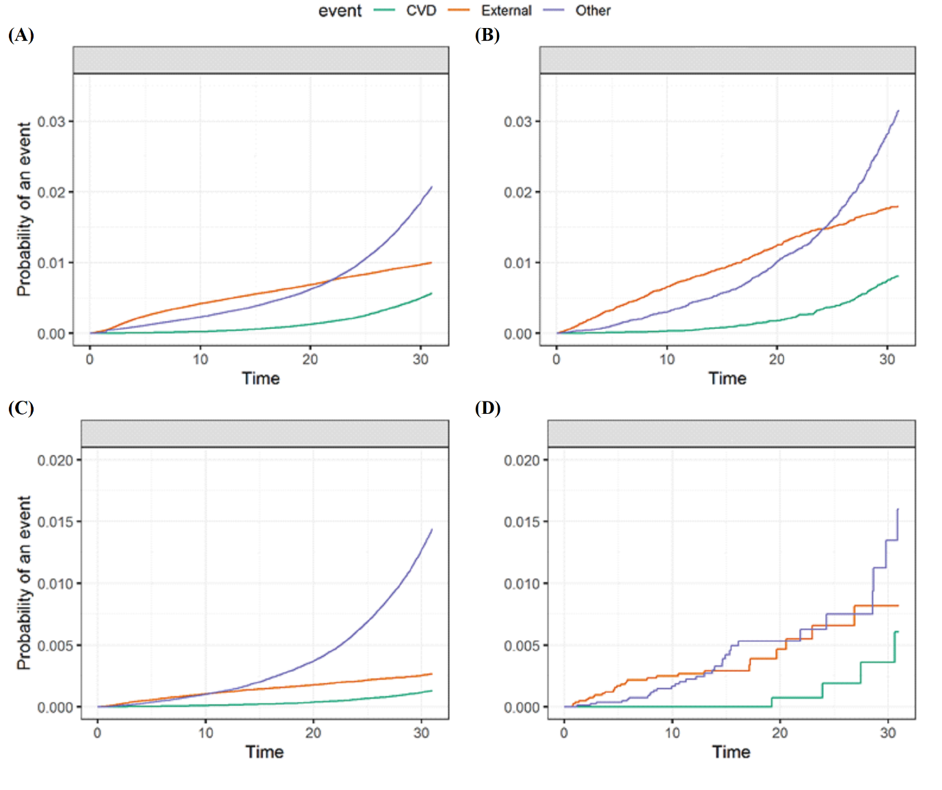 CVD: Cardiovascular death
Cumulative incidence functions of (A) Men without personality disorders, (B) Men with personality disorders, (C) Women without personality disorders and (D) Women with personality disorders.

S2 Figure: Mortality by conscription year.
This histogram describes the overall mortality by year of conscription (1967-2006), stratified by gender.

S3 Figure: The association between adolescents with personality disorders and cardiovascular-specific mortality - Sensitivity analyses.
The sensitivity analyses include the followings: (i) participants with at least 35 years of follow-up who have enrolled the study between 1967 and 1977 ('1967-1977'), (ii) participants who had unimpaired health at enrolment (ie. participants with no chronic comorbidity or chronic consumption of a medicine; 'unimpaired health'). For clarity of comparison the results of the main analysis presented in Figure 3 are shown.
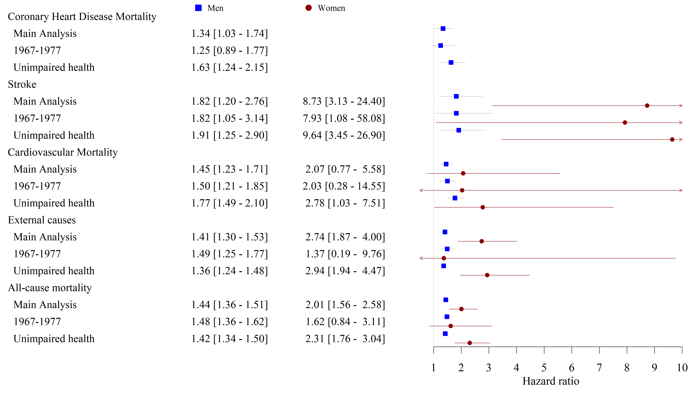

S4 Figure: Poisson regression curves describing mortality rates and rate ratio, by gender since evaluation, divided to 2 study cohorts.
–– Personality disorders –– No personality disorders –– Rate ratio
(A) | (B)
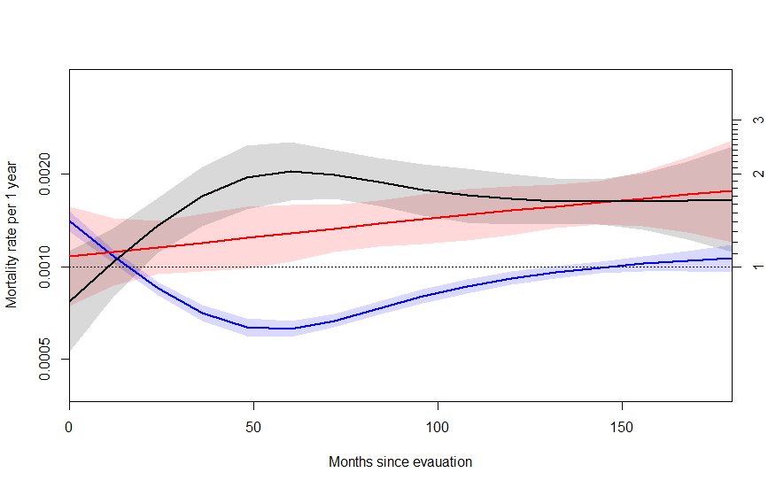 | 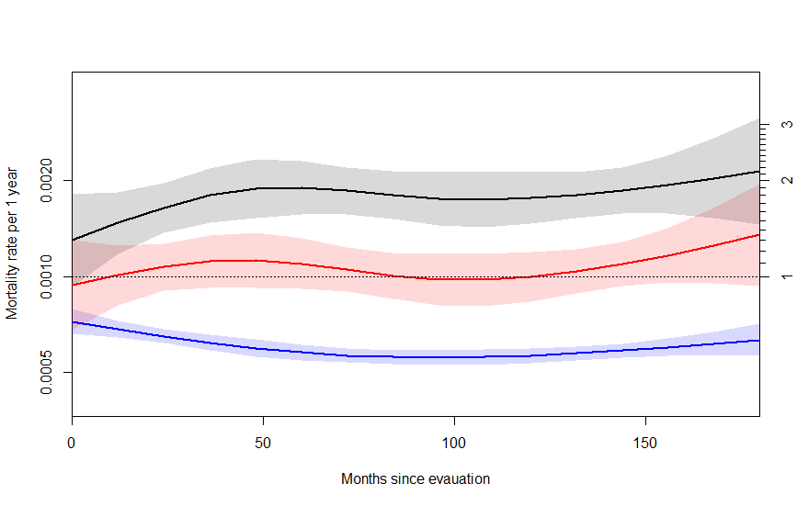
(C) | (D)
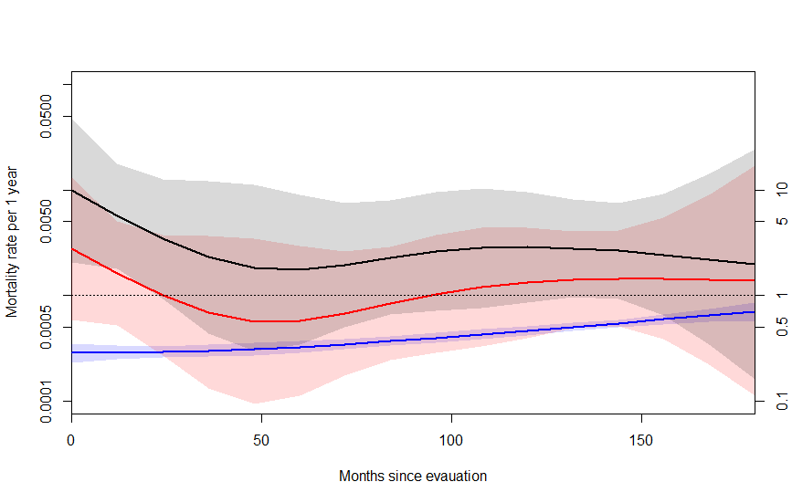 | 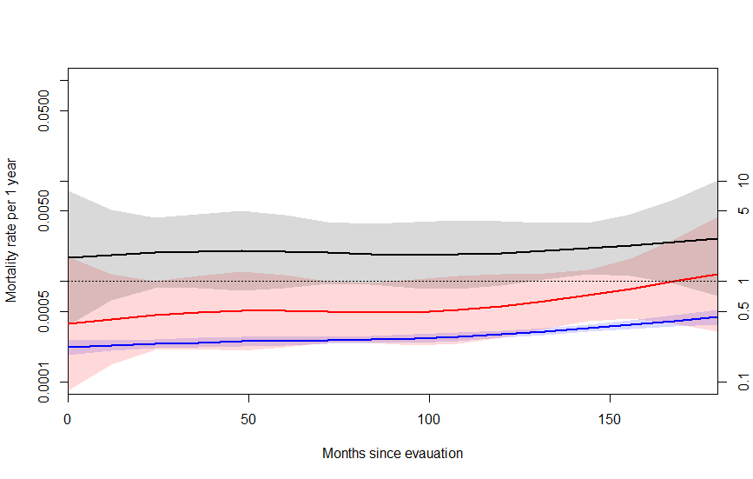
Poisson regression curves of (A) Men, 1st cohort, (B) Men, 2nd cohort, (C) Women, 1st cohort (D) Women, 2nd cohort. Please note that the time interval of study entry, and recording mortality were identical so follow-up will be comparable between the two cohorts (for details see Additional File 1: S3 Table)
S5 Figure: Kaplan-Meier cumulative survival curves of a subset of persons with personality disorders and their sex-matched siblings.
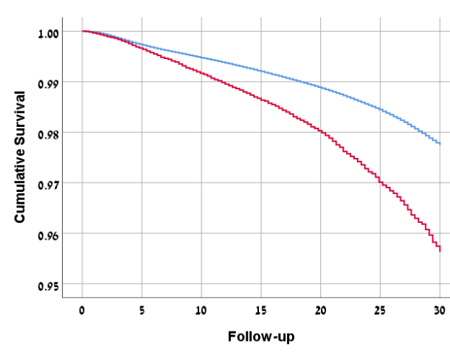

Control (siblings)
Personality disorder

Survival among men with personality disorders (n=24,870; red line) and their brothers without personality disorders (n=37,329; blue line). Note that only participants with personality disorder who have at least one brother without this diagnosis were included in this analysis this analysis (Log rank<0.001).

S6 Figure: Validation and misclassification of personality disorder diagnosis in the study cohort.
The following flow chart presents schematically this process for men and women in our cohort. Out of 55,508 men who were diagnosed as having personality disorder, 42,272 were recruited to service. Of the latter,16,687 underwent a re-evaluation by a psychiatrist after recruitment and during the 3-year term of mandatory service. Personality disorder diagnosis was removed in 2,266 of them (13.6%). Among women, of the 8,237 with diagnosis of personality disorder in our study sample, 3,362 were recruited to service and 1,077 of them underwent a re-evaluation by a psychiatrist during the mandatory 2-year of service. In 248 of them (23.0%), diagnosis was removed. We next assessed the mortality risk of 2,266 "false-positive" men vs. those (n=14,421) who retained diagnosis (served as the reference group). The adjusted risk was 0.82 (95%CI, 0.65-1.03, p=0.079). A small number of deaths among the 1,077 women limited the performance of such analysis.
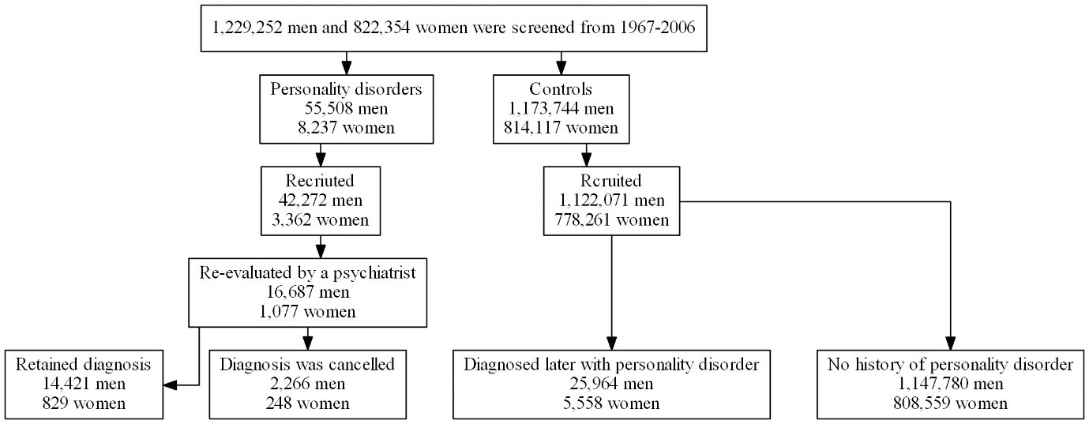

S1 Appendix: Using siblings of examinees with personality disorder as the control group to minimize residual confounding – A sensitivity analysis.
Since our cohort includes nationwide data, we defined siblings of cases with personality disorder as the control group in order to better match on sociodemographic background and to decrease potential residual confounding. Among men in our cohort, we have identified 23,454 families in which there was one male member with personality disorder and at least one male sibling in the control group (24,870 in the personality disorder group and 37,329 examinees in the control). Similarly, there were 3,319 families among women in which there was at least one female member with diagnosis of personality disorder and a female sibling without this disorder (3,365 in the personality disorder group and 4,460 examinees in the control).
To account for family effect, we used general estimating equations (GEE, Hanley JA. Statistical Analysis of Correlated Data Using Generalized Estimating Equations: An Orientation. American Journal of Epidemiology. 2003 Feb 15;157(4):364–75) with family as the subject variable and the siblings of those with personality disorders as the within-subject variable. We used Poisson loglinear model using Ln(follow-up) as the offset variable. The proportions of deaths among men were 0.71%, 1.26%, 1.64% and 1.66% after 10, 20, 30 years of follow-up and all study period, respectively, and were even lower among women (please see Table 3). Therefore, we used pre-defined follow-up intervals of 0-10, 0-20, 0-30 years, to better control for the length of follow-up between the two groups. This analysis was limited to men due to a small number of deaths among women. We also used Cox models to the same data, taking follow-up into consideration, but without accounting for the effects of members within the same family. For both approaches (GEE and Cox), adjustment was done using a multivariable model. Note that, for men, the risk estimates were significantly higher in those with personality disorder than in their siblings, regardless of the model, and for follow-up lengths of up to 20 and 30 years and throughout the all study period (Table 3). The survival curves of this sensitivity analysis are shown in Figure 4. To facilitate a comparison, we also present the survival curves of the study groups in the main analysis (55,508 and 1,173,744 men with personality disorder and controls, respectively). Although there were few deaths among women, their adjusted HR was 1.93 (1.03-3.60) at the end of the follow-up (Table 3).

