Supplementary Figure 2
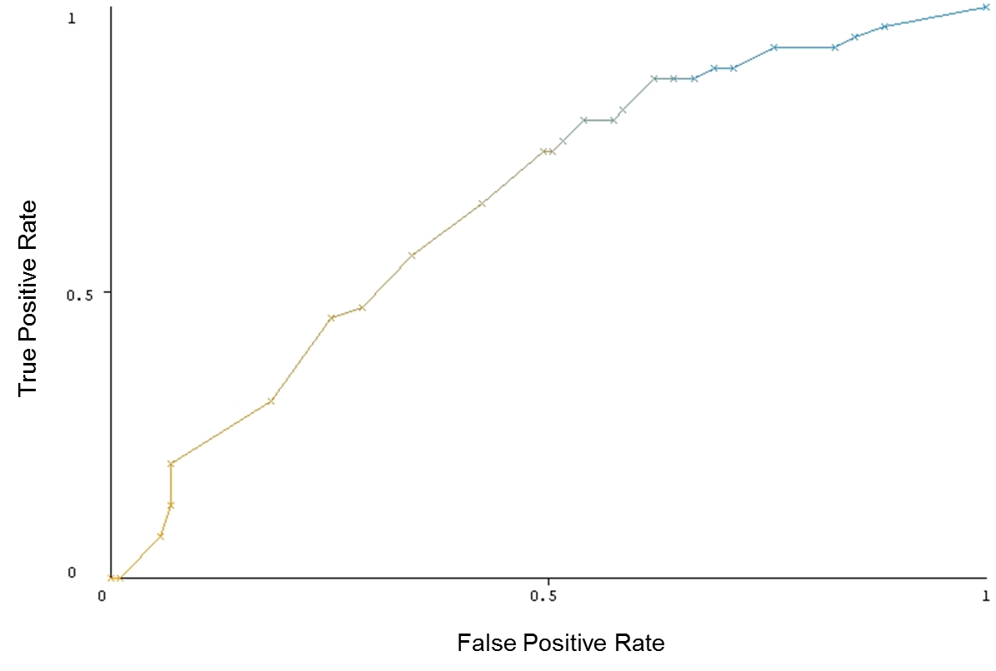
Receiver Operating Characteristic curve of the CART model.

