Supplementary Figure 1
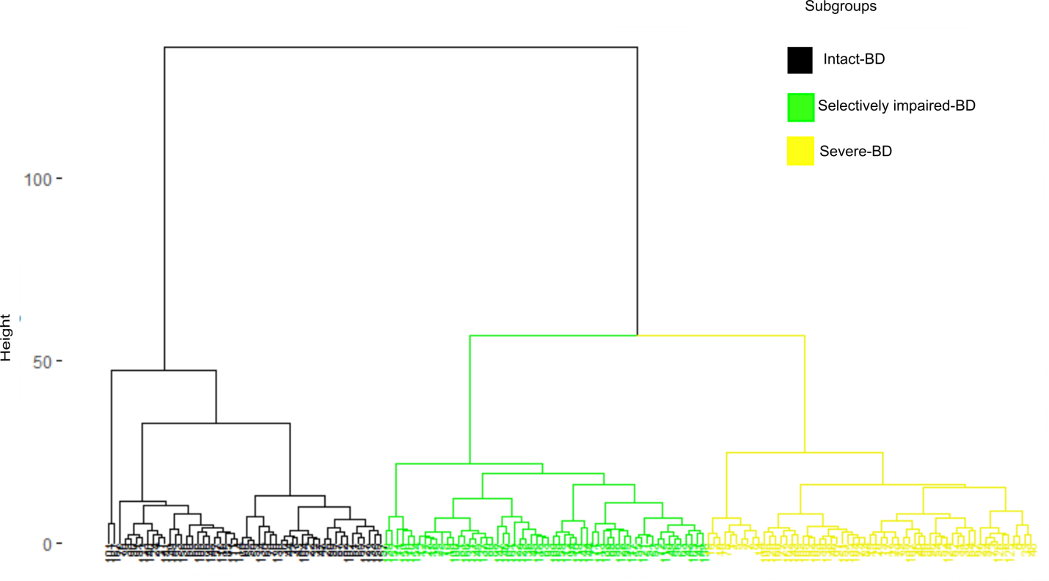
Dendrogram of individuals with bipolar disorder produced by Hierarchical Cluster Analysis, illustrating the arrangement of the cognitive clusters. Abbreviations: intact-BD (cognitively intact cluster of subjects with Bipolar Disorder), selectively impaired-BD (selectively impaired cluster of subjects with Bipolar Disorder), severe-BD (severely impaired cluster of subjects with Bipolar Disorder).

