Supplemental Material
Supplemental Methods
Primary care registry data. Data availability for the Primary Care Register differs across region due to different timing in the digitization of records. Dates of availability across regions were as follows: Blekinge (2009-2016), Dalarna (2005-2013), Värmland (2005-2015), Kalmar Län (2007-2016), Sörmland (1992-2017), Uppsala Län (2005-2015), Västernorrland (2008-2015), Norrbotten Län (2001-2014), Gävleborg (2010-2017), Gotland (2011-2018), Halland (2007-2014), Jönköpings Län (2008-2014), Kronoberg (2006-2016), Skåne (1989-2018), Västerbotten (1992- 2018), Östergötland (1990-2014), Stockholms Län (2003-2016), and Västra Götaland (2000-2013).
Identification of oral contraceptive use. ATC codes used to identify progestogen only pills were as follows: G03AC01, G03AC02, G03AC03, and G03AC09. ATC codes used to identify combination pills were as follows: norethisterone (G03AA01, G03AA03, G03AA05, G03AB04), levonorgestrel (G03AA07, G03AB03), norgestimate (G03AA11), desogestrel (G03AA09, G03AB05), gestodene: G03AA10, G03AB06, drospirenone (G03AA12), and cyproterone and estrogen (G03HB01). We defined natural estrogen (G03AB, G03AA14), and non-oral contraceptives (G03AA13, G02BB01, G03AC08, G02BA03, G03DA02) and censored at the time these were first used.
Censored medical conditions. For a small number of medical conditions, we censored women upon the date of diagnosis. These included polycystic ovarian syndrome (ICD-10 code E282); endometriosis (N80); venous thromboembolism (VTE) (I260, I269, I676, I801, I802, I803, I808, I819, I822, I823, I828, I829, O087, O223, O225, O228, O229, O871, O873, O878, O879, O880, O881, O882); and cancer using ICD codes ; 14, 15, 16, 17, 18, 19, and 20, except skin tumor; 191.

Supplemental Results
The Kaplain-Meier plot for women who did not use oral contraceptives (OC), women who used combination pills, and women who used progestin-only pills, is presented in Supplemental Figure 1.
Previous research has suggested that OC use increases the risk of internalizing symptoms (de Wit et al., 2019; Skovlund, Morch, Kessing, & Lidegaard, 2016). Because internalizing symptoms are associated with increased risk of suicidal behavior (Baldessarini, Tondo, Pinna, Nunez, & Vazquez, 2019; Franklin et al., 2017; Nock, Hwang, Sampson, & Kessler, 2010), it is possible that, for some women, the association between OC and suicidal behavior operates through internalizing problems. We therefore elected to pursue a series of secondary analyses aimed at clarifying these associations. As no parallel pathway wherein OC increases risk of BPN has been proposed, the following analyses are limited to depression and anxiety disorders (DAD): We included lifetime BPN as a covariate in Adjusted Models 3 and 4, but did not test an interaction with OC.
Descriptive statistics
Among N=216,702 women in the study, N=40,500 were registered for DAD at some point. Rates of suicidal behavior, across women who did not use OC, used combination pills, or used progestin-only pills are provided in Supplemental Table 1.
Evaluating the relationship between internalizing disorders, OC, and suicidal behavior
We first tested whether a history of DAD was associated with increased likelihood of later being prescribed OC, relative to women with no prior DAD registration. In a model adjusted for lifetime BPN, parental education, and parental suicidal behavior, we observed a positive association between DAD and OC (HR=1.07 [1.04, 1.10]).
We next tested whether the association between OC and suicidal behavior differed as a function of DAD history by adding to Adjusted Model 3 (Table 2, primary text) an interaction term between contraception and DAD (Supplemental Table 2; AIC=31,039.90). Consistent with the primary models, DAD was included as a time-varying predictor. Effect sizes of OC were modestly higher than those in Adjusted Model 3, with overlapping confidence intervals. The interaction terms for both combination and progestin-only pills were less than 1, but the upper confidence intervals approached (for combination pills) or included (for progestin-only pills) 1.
Supplemental Table 3 provides HR point estimates as a function of DAD status, derived from the model including the interaction term; Supplemental Figure 2 illustrates the shift in risk across duration of OC use as a function of DAD status. As in models described in the primary text, HRs decline with increased duration of OC use regardless of DAD status. However, for women with DAD who used combination pills, the risk of suicidal behavior attributable to OC use was not different than 1. Similarly, by the 6th month of progestin-only pill use among women with DAD, OC use was not associated with increased risk of suicidal behavior. Among women without DAD, risks attributable to OC were significantly higher than 1 throughout the observation period.
Interpretation of findings
We reiterate that the DAD*OC interaction term was only narrowly statistically significant for combination pills (upper 95% CI=0.999) and was not statistically significant for progestin-only pills. We therefore offer a cautious interpretation of the observed hazard ratios, which were below 1 and therefore suggest that, among women with a DAD registration before or during OC use, OC use is not supported as a risk factor for suicidal behavior. While this specific research question has not, to our knowledge, been addressed previously, a review by Pagano and colleagues (2016) found that women with depressive or bipolar disorders overall did not experience exacerbation of symptoms when using hormonal contraception. This is likely due to the fact that DAD itself is strongly associated with increased risk of suicidal behavior — relative to the “baseline” of high risk among this group, the addition of OC does not meaningfully increase risk. However, given low “baseline” risk for suicidal behavior among women with no such psychiatric history, OC is associated with increased risk. Analyses reported here and in the primary text cannot elucidate whether this is due to a causal pathway or confounding factors.
This model is on a multiplicative scale, which needs to be considered when interpreting the estimated parameters, including interaction terms. In a Cox model, the absolute risk level, represented by the underlying hazard function, is estimated non-parametrically and therefore changes during follow-up time. Contraceptive use is modeled using both a time-invariant and a time-variant variable. In both approaches, the relative risk increases attributable to DAD, or to risk of BPN, is constant during follow-up time. In other words, the relative increase in risk is independent of the absolute level from which you start, for example slightly more than two-fold for young women taking progestin-only pills. Consequently, the interaction between DAD and OC is also on a multiplicative scale. We (Kendler & Gardner, 2010) and others (Hasin et al., 2020) have previously argued that the additive scale is of more interest from a public health perspective, as it can be more readily translated into an estimate of the increased/decreased number of cases (and corresponding health care resources). However, considering that we aim to investigate how the association between OC and suicide behavior is modified during the first years of OC use, and that we see advantages with providing estimates comparable with Skovlund and colleagues (2018), we believe the Cox proportional hazard model was the most suitable model.

Supplemental Table 1. Rates of suicidal behavior among individuals with and without a registration for depressive or anxiety disorders (DAD), across users and non-users of oral contraception (OC).
Contraceptive use status | Rate of suicidal behavior, per 10,000 person years
No use | 13.69
DAD¹ registration prior to age 15 | 11.89
DAD registration after age 15 | 18.51
Combination pills | 10.58
DAD registration prior to OC² use | 12.13
DAD registration after OC use | 9.62
Progestin-only pills | 13.03
DAD registration prior to OC use | 10.52
DAD registration after OC use | 14.51
¹Registration for depressive or anxiety disorders.
²Registration for bipolar disorder or non-affective psychosis.

Supplemental Table 2. Time-specific estimates of risk (hazard ratios and 95% confidence intervals) of suicidal behavior from an expansion of Adjusted Model 3 in the main text, including an interaction term between oral hormonal contraceptive use and a registration for depressive or anxiety disorders. Both terms in the interaction were time-varying.
 | Hazard Ratio
Combination pills vs. no contraception (1 month) | 1.70 (1.39, 2.07)
Combination pills vs. no contraception (3 months) | 1.60 (1.34, 1.91)
Combination pills vs. no contraception (6 months) | 1.48 (1.26, 1.74)
Combination pills vs. no contraception (12 months) | 1.30 (1.08, 1.56)
Progestin-only pills vs. no contraception (1 month) | 2.41 (1.81, 3.21)
Progestin-only pills vs. no contraception (3 months) | 2.22 (1.76, 2.85)
Progestin-only pills vs. no contraception (6 months) | 1.69 (1.29, 2.22)
Progestin-only pills vs. no contraception (12 months) | 1.73 (1.17, 2.56)
Parental education, mid vs low | 0.79 (0.60, 1.04)
Parental education, high vs low | 0.75 (0.57, 0.99)
Parental suicidal attempt | 2.21 (1.80, 2.71)
DAD¹ | 25.58 (19.36, 26.33)
BPN² | 31.18 (27.06, 35.94)
Interaction: combination pills and DAD | 0.76 (0.58, 0.999)
Interaction: progestin-only pills and DAD | 0.69 (0.44, 1.005)
¹Time-varying registration for depressive or anxiety disorders.
²Lifetime registration for bipolar disorder or non-affective psychosis.

Supplemental Table 3. Time-specific hazard ratios (95% confidence intervals) for suicidal behavior as a function of oral hormonal contraceptive use, for women without versus with a registration for depressive or anxiety disorders. Collapsed estimates are presented in Supplemental Table 2.
 | Hazard Ratio
 | No DAD¹ | DAD
Combination pills vs. no contraception (1 month) | 1.70 (1.39, 2.07) | 1.29 (0.99, 1.67)
Combination pills vs. no contraception (3 months) | 1.60 (1.34, 1.91) | 1.22 (0.96, 1.56)
Combination pills vs. no contraception (6 months) | 1.48 (1.26, 1.74) | 1.13 (0.90, 1.42)
Combination pills vs. no contraception (12 months) | 1.30 (1.08, 1.56) | 1.00 (0.78, 1.27)
Progestin-only pills vs. no contraception (1 month) | 2.41 (1.81, 3.21) | 1.66 (1.14, 2.40)
Progestin-only pills vs. no contraception (3 months) | 2.22 (1.76, 2.85) | 1.53 (1.09, 1.14)
Progestin-only pills vs. no contraception (6 months) | 1.69 (1.29, 2.22) | 1.37 (1.00, 1.88)
Progestin-only pills vs. no contraception (12 months) | 1.73 (1.17, 2.56) | 1.16 (0.83, 1.63)
¹Time-varying registration for depressive or anxiety disorders.

Supplemental Table 4. Time-specific hazard ratios for suicidal behavior among women who became former users of oral hormonal contraceptive during the observation period, relative to women who had not used oral hormonal contraception.
 | Hazard Ratio
Combination pills vs. no contraception (1 month) | 3.44 (2.65, 4.47)
Combination pills vs. no contraception (3 months) | 3.29 (2.63, 4.11)
Combination pills vs. no contraception (6 months) | 3.09 (2.55, 3.73)
Combination pills vs. no contraception (12 months) | 2.80 (2.29, 3.42)
Progestin-only pills vs. no contraception (1 month) | 3.75 (2.58, 5.43)
Progestin-only pills vs. no contraception (3 months) | 3.55 (2.60, 4.86)
Progestin-only pills vs. no contraception (6 months) | 3.31 (2.56, 4.29)
Progestin-only pills vs. no contraception (12 months) | 2.96 (2.27, 3.86)
Parental education, mid vs low | 0.80 (0.62, 1.03)
Parental education, high vs low | 0.76 (0.59, 0.98)
Parental suicidal attempt | 2.03 (1.69, 2.45)
DAD¹ | 17.56 (15.65, 19.70)
BPN² | 28.91 (23.36, 32.96)
¹Time-varying registration for depressive or anxiety disorders.
²Lifetime registration for bipolar disorder or non-affective psychosis.

Supplemental Table 5. Time-specific hazard ratios for suicidal behavior for a sensitivity analysis in which women who have initiated use of oral hormonal contraceptives are censored upon a subsequent registration for a depressive or anxiety disorder.
 | Hazard Ratio
Combination pills vs. no contraception (1 month) | 1.44 (1.18, 1.76)
Combination pills vs. no contraception (3 months) | 1.36 (1.15, 1.60)
Combination pills vs. no contraception (6 months) | 1.25 (1.08, 1.45)
Combination pills vs. no contraception (12 months) | 1.10 (0.92, 1.33)
Progestin-only pills vs. no contraception (1 month) | 1.77 (1.32, 2.38)
Progestin-only pills vs. no contraception (3 months) | 1.72 (1.35, 2.19)
Progestin-only pills vs. no contraception (6 months) | 1.66 (1.34, 2.05)
Progestin-only pills vs. no contraception (12 months) | 1.57 (1.20, 2.05)
Parental education, mid vs low | 0.79 (0.60, 1.05)
Parental education, high vs low | 0.75 (0.57, 0.999)
Parental suicidal attempt | 2.15 (1.74, 2.66)
DAD¹ | 20.68 (18.11, 23.62)
BPN² | 32.44 (28.13, 37.42)
¹Time-varying registration for depressive or anxiety disorders, prior to initiation of OC use.
²Lifetime registration for bipolar disorder or non-affective psychosis.

Supplemental Table 6. Time-specific hazard ratios for suicidal behavior for a sensitivity analysis in which women with a lifetime registration for bipolar disorder or non-affective psychosis were excluded.
 | Hazard Ratio
Combination pills vs. no contraception (1 month) | 1.67 (1.36, 2.04)
Combination pills vs. no contraception (3 months) | 1.54 (1.30, 1.83)
Combination pills vs. no contraception (6 months) | 1.38 (1.19, 1.61)
Combination pills vs. no contraception (12 months) | 1.16 (0.97, 1.39)
Progestin-only pills vs. no contraception (1 month) | 2.16 (1.61, 2.91)
Progestin-only pills vs. no contraception (3 months) | 1.96 (1.52, 2.51)
Progestin-only pills vs. no contraception (6 months) | 1.71 (1.37, 2.13)
Progestin-only pills vs. no contraception (12 months) | 1.40 (1.07, 1.83)
Parental education, mid vs low | 0.72 (0.54, 0.97)
Parental education, high vs low | 0.68 (0.51, 0.91)
Parental suicidal attempt | 2.66 (2.13, 3.33)
DAD¹ | 20.71 (18.25, 23.51)
¹Time-varying registration for depressive or anxiety disorders.
Supplemental Figure 1. Kaplain-Meier plot across groups, where suicidal behavior is the outcome of interest. Observation began at age 15. Curves are provided for individuals not using oral hormonal contraception (black lines), those using combination pills (blue lines), and those using progestin-only pills (red lines). Dashed lines represent 95% confidence intervals.
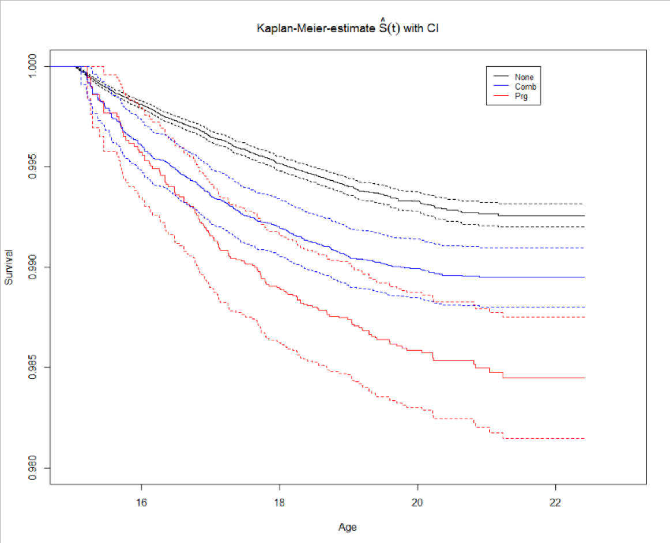

Supplemental Figure 2. Hazard ratios (solid lines) and 95% confidence intervals (dashed lines) for the association between oral hormonal contraceptive use and suicidal behavior, as a function of follow-up time. The top panel provides results for combination pills and the bottom panel provides results for progestin-only pills. The y-axis is on the linear scale. The grey horizontal line at HR=1 represents the reference.

References

Baldessarini, R. J., Tondo, L., Pinna, M., Nunez, N., & Vazquez, G. H. (2019). Suicidal risk factors in major affective disorders. British Journal of Psychiatry, 215(4), 621-626. doi:10.1192/bjp.2019.167
de Wit, A. E., Booij, S. H., Giltay, E. J., Joffe, H., Schoevers, R. A., & Oldehinkel, A. J. (2020). Association of Use of Oral Contraceptives With Depressive Symptoms Among Adolescents and Young Women. JAMA Psychiatry, 77(1), 52-59. doi:doi:10.1001/jamapsychiatry.2019.2838
Franklin, J. C., Ribeiro, J. D., Fox, K. R., Bentley, K. H., Kleiman, E. M., Huang, X., . . . Nock, M. K. (2017). Risk factors for suicidal thoughts and behaviors: A meta-analysis of 50 years of research. Psychological Bulletin, 143(2), 187-232. doi:10.1037/bul0000084
Hasin, D. S., Shmulewitz, D., Cerda, M., Keyes, K. M., Olfson, M., Sarvet, A. L., & Wall, M. M. (2020). U.S. Adults With Pain, a Group Increasingly Vulnerable to Nonmedical Cannabis Use and Cannabis Use Disorder: 2001-2002 and 2012-2013. American Journal of Psychiatry, Advanced online publication. appiajp201919030284. doi:10.1176/appi.ajp.2019.19030284
Kendler, K. S., & Gardner, C. O. (2010). Interpretation of interactions: guide for the perplexed. British Journal of Psychiatry, 197(3), 170-171. doi:197/3/170 [pii] 10.1192/bjp.bp.110.081331
Nock, M. K., Hwang, I., Sampson, N. A., & Kessler, R. C. (2010). Mental disorders, comorbidity and suicidal behavior: results from the National Comorbidity Survey Replication. Molecular Psychiatry, 15(8), 868-876. doi:10.1038/mp.2009.29
Pagano, H. P., Zapata, L. B., Berry-Bibee, E. N., Nanda, K., & Curtis, K. M. (2016). Safety of hormonal contraception and intrauterine devices among women with depressive and bipolar disorders: a systematic review. Contraception, 94(6), 641-649. doi:10.1016/j.contraception.2016.06.012
Skovlund, C. W., Morch, L. S., Kessing, L. V., Lange, T., & Lidegaard, O. (2018). Association of Hormonal Contraception With Suicide Attempts and Suicides. American Journal of Psychiatry, 175(4), 336-342. doi:10.1176/appi.ajp.2017.17060616
Skovlund, C. W., Morch, L. S., Kessing, L. V., & Lidegaard, O. (2016). Association of Hormonal Contraception With Depression. JAMA Psychiatry, 73(11), 1154-1162. doi:10.1001/jamapsychiatry.2016.2387

