Supplementary Online Materials for

EEG power spectra and subcortical pathology in chronic disorders of consciousness
Evan S. Lutkenhoff, Ph.D, Anna Nigri, Ph.D, Davide Rossi Sebastiano, MD, Ph.D, Davide Sattin, PsyD, Elisa Visani, M.Sc., Cristina Rosazza, Ph.D., Ludovico D’Incerti, MD, Maria Grazia Bruzzone, MD, Silvana Franceschetti, MD, Matilde Leonardi, MD, Stefania Ferraro, Ph.D, Martin M. Monti Ph.D.

Contents:
Table S1………………………………………………………………………………………..2
Table S2.……………………………………………………………………………………….3
Figure S1……………………………………………………………………………………….4
Figure S2……………………………………………………………………………………….5

 | Included (n=61) | Excluded (n=55)
Age (years) | 51.04 (15.38) | 50.24 (13.25)
MPI (months)† | 32.45 (32.81) | 51.45 (50.79)
Sex | 25F, 36M | 22F, 33M
Etiology | 20T, 19H, 3I, 1HI, 18A, 0TA | 15T, 18H, 0I, 0HI, 21A, 1TA
Diagnosis | 37 VS, 17 MCS-, 7 MCS+, 0 E-MCS | 36 VS, 11 MCS-, 7 MCS+, 1 E-MCS
Coma Recovery Scale Revised (CRS-R)
Total score | 7.56 (2.05) | 8.13 (2.46)
Auditory | 1.25 (0.67) | 1.45 (0.83)
Visual | 1.46 (1.10) | 1.62 (1.34)
Motor | 2.00 (0.41) | 2.00 (0.38)
Oromotor/Verbal | 1.11 (0.52) | 1.07 (0.38)
Communication | 0.10 (0.30) | 0.09 (0.29)
Arousal† | 1.69 (0.53) | 1.89 (0.42)
Table S1. Comparison of demographic and clinical variables of patients included in the final analyzed sample (n-61) and patients excluded during the MRI processing/QC step (n=55). (Abbreviations: VS, Vegetative State; MCS- Minimally conscious State “minus”; MCS+, Minimally Conscious State “plus”; MPI, months post-injury; T, traumatic; H, hemorrhagic injury, I, ischemic injury, A, anoxic. ‘†’ indicates significant difference across groups prior to correction for multiple comparisons. No significant differences were observed after correction for multiplicity.)
Table S2. Spearman correlation between the three ratio components (β/δ, α/δ, and θ/δ) and the raw ratio of each pair of frequencies (calculated by taking the ratio of the average relative power across all channels), as well as the numerator frequency (β, α, and θ, respectively) and the denominator frequency (δ for all components).

 | raw ratio | numerator | denominator
β/δ comp | 0.95 | 0.94 | -0.61
α/δ comp | 0.87 | 0.94 | -0.78
θ/δ comp | 0.85 | 0.79 | -0.80

Figure S1. Examples of excluded dataset (for each category) during the MRI quality control process.

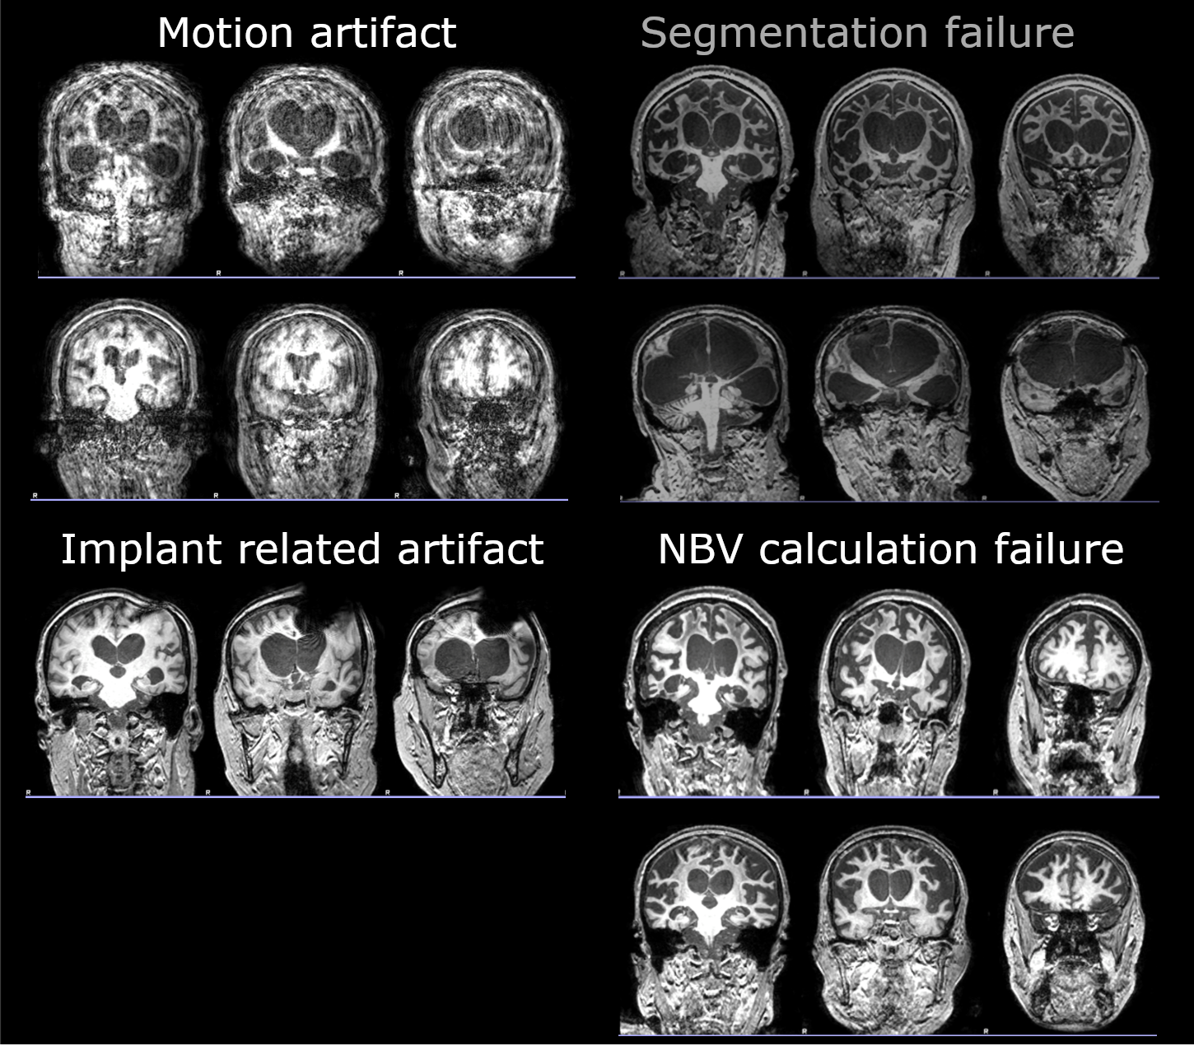

Figure S2. Mean intensity of each EEG component across the three DOC clinical categories. (Error bars show standard error.).
