Supplementary material
Table S1. Articles excluded after full-text revision.
Reason for exclusion | Explication | Studies excluded
No original data | The studies provide only data referring to neuroanatomy, the sample has been manipulated or it is a summary of a conference, for example | Clark, L. (2001). A neuropsychological investigation of prefrontal cortex involvement in acute mania  Gollier-Briant, F. (2008). The neural correlates of decision-making in bipolar disorder: An fMRI study  Martino, D. (2014). A comparison of decision making in patients with bipolar I disorder and schizophrenia  Roiser, J. (2009). The effect of positive mood induction on emotional processing in euthymic individuals with bipolar disorder and controls  Trost, S. (2014). Disturbed anterior prefrontal control of the mesolimbic reward system and increased impulsivity in bipolar disorder
No behavioural measures | Studies don’t use a behavioural paradigm to assess the cognitive domains | Molz, A. (2013). Aggression and impulsivity as predictors of stress generation in bipolar spectrum disorders  Muhtadie, L. (2014). A profile approach to impulsivity in bipolar disorder: the key role of strong emotions  Perroud, N. (2011). Impulsivity, aggression and suicidal behavior in unipolar and bipolar disorders
Non-standardized test | Studies employ unusual behavioral paradigms | Henry, B. (2013). Inhibitory deficits in euthymic bipolar disorder patients assessed in the human behavioral pattern monitor  Mason, L. (2014). Decision-making and trait impulsivity in bipolar disorder are associated with reduced prefrontal regulation of striatal reward valuation  Mason, L. (2016). Attentional bias predicts increased reward salience and risk taking in bipolar disorder  Welander-Vatn, A.S. (2009). No altered dorsal anterior cingulated activation in bipolar II disorder patients during a Go/No-go task: an fMRI study
No BD diagnostic | The study sample isn’t diagnosed with Bipolar Disorder | Mason, L. (2012). I want it now! Neural correlates of hypersensitivity to immediate reward in hypomania
Duplicated sample | After careful review of the studies the authors considered that the samples came from the same centre, had an N, a very similar sex and age distribution. As a precaution, we decided to exclude them to avoid possible duplicated data | Adida, M. (2008). Lack of insight may predict impaired decision making in manic patients  Adida, M. (2015). Lithium might be associated with better decision-making performance in euthymic bipolar patients  Bauer, I. (2018). Increased reward-oriented impulsivity in older bipolar patients: A preliminary study
Strakowski, S. (2008). MRI brain activation in first-episode bipolar mania during a response inhibition task
Strakowski, S. (2009). Characterizing impulsivity in mania
Swann, A. (2003). Impulsivity and phase of illness in bipolar disorder
Swann, A. (2011). Interacting mechanisms of impulsivity in bipolar disorder and antisocial personality disorder
Swann, A. (2013). Pre-attentive information processing and impulsivity in bipolar disorder
No data for Meta-Analysis | The studies don’t provide the necessary data to perform the meta-analysis | Cotrena, C. (2016). Executive function impairments in depression and bipolar disorder: association with functional impairment and quality of life  Ono, Y. (2015). Reduced prefrontal activation during performance of the Iowa Gambling Task in patients with bipolar disorder  Minassian, A. (2004). Increased sensitivity to error during decision-making in bipolar disorder patients with acute mania  Powers, R. (2013). Impulsivity in bipolar disorder: relationships with neurocognitive dysfunction and substance use history  Saunders, K. (2015). Insensitivity to the magnitude of potential gains or losses when making risky choices: women with borderline personality disorder compared with bipolar disorder and controls  Strasser, E. (2016). Behavioral measures and self-report of impulsivity in bipolar disorder: no association between Stroop test and Barratt Impulsiveness Scale  Swann, A. (2001). Measurement of inter-episode impulsivity in bipolar disorder  Yechiam, E. (2008). Decision making in bipolar disorder: A cognitive modeling approach
Outcome measure not valid | Outcome measure is not valid to assess the cognitive domain. | Chandler, R. (2009). Altered risk-aversion and risk-seeking behavior in bipolar disorder

Table S2. Description of the information collected from the studies.
Variable | Description | Categories
FIRST AUTHOR | First Author of the publication.
YEAR-PUBLICATION | Year which the article was published.
MEAN AGE | Mean age of the study population.
SAMPLE | Number of individuals included in the study | - BD-I  - BD-II
PHASE OF ILLNES | Phase of bipolar disorder at the time of the study. | - Mania  - Depression  - Euthymia  - Hypomania  - Mixed epidose
NEUROCOGNITIVE TEST | Instrument used to assess the cognitive domain.
NEUROCOGNITIVE OUTCOME | Cognitive domain measured in the study. | - Impulsivity: Response inhibition, Delay aversion or Inattention.  - Decision-making  - Risk taking
RESULTS | Summary of the results of the study.
AGE RANGE | Age Range of the population in the study.
GENDER | Gender of the study population expressed as a percentage. | - Male  - Female
STUDY DESIGN | Whether the study is cross-sectional or longitudinal. | - Cross-sectional  - Longitudinal
NEUROIMAGING TEST | Use of a neuroimaging test during the study. | - Yes  - No
MATCHING | Way in which the population was matched with healthy controls. | - Depending of study variables  - Not matched
QUALITY OF STUDY | Indicates the quality range of the study through the Newcastle-Ottawa Scale (NOS). | 0-9
FUNDING | Sources of funding for the study or other support. | - Yes  - No

BD-I, Bipolar disorder type I; BD-II, Bipolar disorder type II.

Table S3. Quality Reporting Scale (The Newcastle-Ottawa Scale).*†
Items for case controls studies | Quality Score
SELECTION
1. Is the case definition adequate?  - Yes, with independent validation  - Yes, eg record linkage or based on self-reports  - No description | 1  0  0
2. Representativeness of the cases  - Consecutive or obviously representative series of cases  - Potential for selection biases or not stated | 1  0
3. Selection of Controls  - Community controls  - Hospital controls  - No description | 1  0  0
4. Definition of Controls  - No history of disease (endpoint)  - No description of source | 1  0
COMPARABILITY
1. Comparability of cases and controls on the basis of the design or analysis  - Study controls for___________ (Select the most important factor)  - Study controls for any additional factor (This criteria could be modified to indicate specific control for a second important factor) | 1  1
EXPOSURE
1. Ascertainment of exposure  - Secure record (eg surgical records)  - Structured interview where blind to case/control status  - Interview not blinded to case/control status  - Written self-report or medical record only  - No description | 1  1  0  0  0
2. Same method of ascertainment for cases and controls  - Yes  - b) No | 1  0
3. Non-Response rate  - Same rate for both groups  - Non respondents described  - Rate different and no designation | 1  0  0
* Range = 0-9; Maximum score in each section: 4, 2 and 3, respectively; Quality: Low (< 5 score); Medium (5-6 score); High (≥ 7 score).
†Wells, G.A., Shea, B., O'Connell, D., Peterson, J., Welch, V., Losos, M. & Tugwell, P. (2014). The Newcastle-Ottawa Scale (NOS) for assessing the quality of nonrandomised studies in meta-analyses. Ottawa (ON): Ottawa Health Research Institute. http://www.ohri.ca/programs/clinical_epidemiology/oxford.asp

Table S4. Characteristics and quality assessment of the studies selected.
First author,  year-pub | Age range | Gender | Study design | Neuroimaging test | Matching | Quality of study | Funding | Neurocognitive test
Adida et al. (2011) | 18 – 65  19 – 64 | BD patients  41.3% M, 58.7% F  Controls  50% M, 50% F | Cross-sectional study | No | Age, level of education, NART (Z score) and sex ratio | 8 | Yes | Iowa Gambling Task (IGT)
Ahn et al. (2011) | Not specified | BD patients  45.5% M, 54.5% F  Controls  40% M, 60% F | Cross-sectional study | No | Not matched | 6 | Yes | Delay Discounting Task
Bauer et al. (2017) | Not specified | BD patients  28.8% M, 71.2% F  Controls  34.4% M, 65.6% F | Cross-sectional study | No | Not matched | 6 | Yes | Affective Go/No-Go task (AGN)  Cambridge Gambling Task (CGT)
Bersani et al. (2016) | Not specified | BD patients  60% M, 40% F  Controls  46.7% M, 53.3% F | Cross-sectional study | No | Age, gender, educational level and intelligence | 8 | Not specified | Stop Signal Task (SST)
Brambilla et al. (2013) | 18 – 65 | BD patients  52.9% M, 47.1% F  Controls  50.7% M, 49.3% F | Cross-sectional study | No | Age, sex and IQ | 8 | Yes | Iowa Gambling Task (IGT)
Cheema et al. (2015) | 18 – 60 | BD patients  61.9% M, 38.1% F  Controls  52.2% M, 47.8% F | Cross-sectional study | No | Age and gender ratio | 8 | Yes | Emotional Go/No-Go Task
Duek et al. (2014) | 18 – 65 | BD patients  55% M, 45% F  Controls  56.1% M, 43.9% F | Cross-sectional study | No | Age and education | 8 | Not specified | Single Key Impulsivity Paradigm (SKIP)
Edge et al. (2013) | 18 – 65 | BD patients  35% M, 65% F  Controls  41% M, 59% F | Cross-sectional study | No | Not matched | 6 | Yes | Iowa Gambling Task (IGT)
Fleck et al. (2011) | Not specified | BD patients  38.9% M, 61.1% F  Controls  20% M, 80% F | Cross-sectional study | Yes | Age, sex, race, education years | 8 | Yes | Go/No-Go Task
Hidiroğlu et al. (2013) | 21 – 59  20 – 69  22 – 59 | BD patients  36.7% M, 63.3% F  BD-Relatives  32% M, 68% F  Controls  36.7% M, 63.3% F | Cross-sectional study | No | Sex, age and educationally | 8 | Yes | Balloon Analogue Risk Task (BART)
Holmes et al. (2009) | 21 – 63  21 – 60 | BD patients  38.2% M, 61.8% F  Controls  44% M, 56% F | Cross-sectional study | No | Age, years of education, race, full scale IQ | 6 | Yes | Balloon Analogue Risk Task (BART)
Hummer et al. (2013) | 18 – 60 | BD patients  36.5% M, 63.5% F  Controls  36.6% M, 63.3% F | Cross-sectional study | Yes | Age and gender | 8 | Yes | Picture of Facial Affect (Go/No-Go Task)
Ibañez et al. (2012) | 18 – 64 | BD patients  61.5% M, 38.5% F  Controls  64% M, 36% F | Cross-sectional study | Yes | Sex, age, handedness and years of education | 8 | Not specified | Iowa Gambling Task (IGT)
Jogia et al. (2012) | 18-63 | BD patients  47.2% M, 52.8% F  Controls  56.7% M, 43.3% F | Cross-sectional study | Yes | Age, IQ and BPRS | 7 | Yes | Iowa Gambling Task (IGT)
Kaladjian et al. (2009) | Not specified | BD patients  50% M, 50% F  Controls  50% M, 50% F | Cross-sectional study | Yes | Sex, age, handedness, estimated premorbid IQ and level of education | 7 | Not specified | Go/No-Go Task
Kopf et al. (2018) | Not specified | BD patients  52.8% M, 47.2% F  Remitted patients  66.7% M, 33.3% F  Controls  33.3% M, 66.7% F | Cross-sectional and longitudinal study | Yes | Age, sex and performance on the multiple-choice word test  (MWT-B) | 8 | Yes | Combined Stop-Signal-Go/No-Go Task
Linke et al. (2013) | 18 – 65 | BD I patients  42.1% M, 57.9% F  BD-Relatives  50% M, 50% F  Controls  42.1% M, 57.9% F | Cross-sectional study | Yes | Age and gender | 9 | Yes | Cambridge Gambling Task (CGT)
Malloy-Diniz et al. (2011) | Not specified | BD patients  30.5% M, 69.5% F  Controls  43.6% M, 56.4% F | Cross-sectional study | Yes | Not matched | 6 | Yes | Continuous Performance Test (CPT-II)  Iowa Gambling Task (IGT)
Martino et al. (2011) | 18-60 | BD- I  39.4% M, 60.6%F  BD-II  21.5% M, 78.5% F  Controls  35.3 M, 64.7% F | Cross-sectional study | No | Age and years of education | 7 | Yes | Iowa Gambling Task (IGT)
Mazzola-Pomietto et al. (2009) | Not specified | BD patients  37.5% M, 62.5% F  Controls  37.5 % M, 62.5%F | Cross-sectional study | Yes | Sex, age and handedness | 7 | Yes | Go/No-Go Task
Moraes et al. (2013) | Not specified | BD patients  31.6% M, 68.4% F  Controls  36.5% M, 63.5% F | Cross-sectional study | No | Not matched | 6 | Not specified | Continuous Performance Test II (CPT-II)  Iowa Gambling Task (IGT)
Murphy et al. (2001) | Not specified | BD patients  44.5% M, 55.5% F  Controls  46.2% M, 53.8% F | Cross-sectional study | No | Age, sex and NART-IQ | 8 | Yes | Decision-making task
Okasha et al. (2014) | 18-50 | BD patients  50% M, 50% F  Controls  50% M, 50% F | Cross-sectional study | No | Age, gender and educational level | 7 | No | Continuous Performance Test (CPT)
Reddy et al. (2014) | Not specified | BD patients  54.4% M, 45.6% F  Controls  55.6% M, 44.4% F | Cross-sectional study | No | Not matched | 6 | Yes | Balloon Analogue Risk Task (BART)
Rubinsztein et al. (2006) | 18-60 | Not specified | Cross-sectional study | No | Gender, IQ and age | 7 | Yes | Decision-making task
Scholz et al. (2016) | Not specified | BD patients  58.3% M, 41.7% F  Controls  58.3% M, 41.7% F | Cross-sectional study | Yes | Age, gender and years of education | 8 | Yes | Cambridge Gambling Task (CGT)
Strakowski et al. (2010) | 18-50 | BD patients  46% M, 54% F  Controls  40% M, 60% F | Longitudinal study | No | Demographic variables | 7 | Yes | Logan Stop-Signal Task (SST)  Delayed Reward Task (DRT)  Degraded Stimulus version of the CPT (DSCPT)
Swann et al. (2009) | Not specified | BD patients  43.7% M, 56.3% F  Controls  42.9% M, 57.1% F | Cross-sectional study | No | Not matched | 5 | Yes | Immediate Memory Task (IMT)  Single Key Impulsivity Paradigm (SKIP)
Tavares et al. (2007) | 18-59 | BD patients  29.4% M, 70.6% F  Controls  28% M, 72% F | Cross-sectional study | No | Age and IQ | 7 | Yes | Cambridge Gamble Task (CGT)
van Enkhuizen et al. (2014) | 18-55 | BD patients  56.3% M, 43.7% F  Controls  29.4% M, 70.6% F | Cross-sectional study | No | Age, gender, education, and ethnicity | 8 | Yes | Iowa Gambling Task (IGT)

BD, Bipolar disorder; M, Males; F, Females; NART, National Adult Reading Test; IQ, Intelligence Quotient; BPRS, Brief Psychiatric Rating Scale.

Table S5. Paradigms used to assess impulsivity, decision-making and risk behavior.
Cognitive Domain | Paradigms | Score
Impulsivity
Response Inhibition | Affective Go/No-Go task (AGN)  Emotional Go/No-Go task  Go/No-Go task  Picture of Facial Affect  Combined Stop-Signal-Go/No-Go Task  Stop Signal Task (SST)  Immediate Memory Task (IMT)  Continuous Performance Test (CPT)  Continuous Performance Test II (CPT-II) | Commission negative  Commission errors total  Proportion commission errors  Letter No-Go: No-Go trials  SSRT (ms)  SSRT (ms)  Commission errors  Commission errors  Commission errors
Delay of Gratification | Delay Discounting Task  Cambridge Gambling Task (CGT)  Delayed Reward Task (DRT)  Single Key Impulsivity Paradigm (SKIP) | Delay discounting choice behavior  Delay aversion  % IMP  Total responses (Number of presses)
Inattention | Continuous Performance Test (CPT)  Continuous Performance Test II (CPT-II)  Degraded Stimulus version of the CPT (DSCPT) | Omission errors  Omission errors  B”
Decision-making | Iowa Gambling Task (IGT)  Decision-making task  Cambridge Gambling Task (CGT) | Net score  Quality of decision making  Quality of decision making
Risk behavior | Cambridge Gambling Task (CGT)  Balloon Analogue Risk Task (BART) | Risk taking  Adjustment scores (Bart pumps)

Table S6. Summary of the meta-analysis results.
Variable | Studies | Patients | Controls | ES* | 95% CI | Z† | p
Response inhibition complete | 13 | 869 | 595 | 0.49 | 0.38/0.60 | 8.92 | <0.0001
Response inhibition euthymic | 7 | 335 | 327 | 0.59 | 0.43/0.75 | 7.23 | <0.0001
Response inhibition depressed | 3 | 84 | 70 | 0.48 | 0.16/0.81 | 2.92 | 0.0035
Response inhibition manic | 3 | 154 | 94 | 0.47 | 0.21/0.74 | 3.49 | 0.0005
Response inhibition BD I - euthymic | 3 | 71 | 58 | 0.29 | -0.07/0.65 | 1.59 | 0.1121
Response inhibition without CPT | 10 | 619 | 356 | 0.40 | 0.26/0.53 | 5.84 | <0.0001
Delay of gratification | 5 | 466 | 283 | 0.54 | 0.39/0.70 | 6.97 | <0.0001
Delay of gratification without CGT | 4 | 282 | 190 | 0.65 | 0.46/0.84 | 6.60 | <0.0001
Inattention | 4 | 358 | 287 | 0.49 | 0.33/0.65 | 5.92 | <0.0001
Decision making complete | 13 | 875 | 821 | 0.61 | -0.93/-0.28 | -3.68 | 0.0002
Decision making euthymic | 8 | 502 | 634 | -0.39 | -0.51/-0.27 | -6.39 | <0.0001
Decision making depressed | 3 | 73 | 201 | -0.92 | -2.99/1.15 | -0.87 | 0.3828
Decision making manic | 3 | 79 | 193 | -1.35 | -2.43/-0.27 | -2.45 | 0.0143
Decision making BD I – euthymic | 5 | 299 | 400 | -0.25 | -0.41/-0.10 | -3.22 | 0.0013
Decision making Iowa Gambling Task | 9 | 632 | 651 | -0.43 | -0.55/-0.32 | -7.49 | <0.0001
Risk taking complete | 6 | 380 | 227 | 0.41 | -0.02/0.84 | -1.88 | 0.0598
Risk taking BD I – euthymic | 3 | 73 | 73 | 0.92 | 0.57/1.26 | 5.24 | <0.0001
Risk taking Cambridge Gambling Task | 3 | 227 | 136 | 0.41 | -0.22/1.04 | 1.28 | 0.1992
Risk taking Balloon Analogue Risk Task | 3 | 153 | 91 | 0.43 | -0.35/1.20 | 1.08 | 0.2799
*Effect Size
†Test of significance of effect size

- Response inhibition
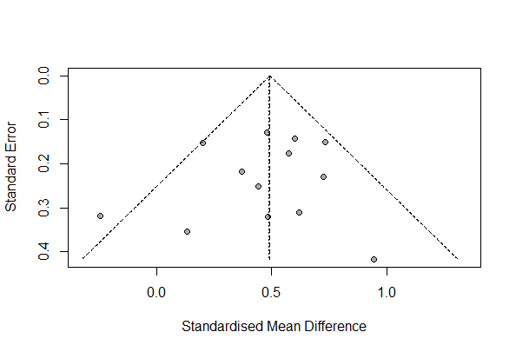

- Decision-making
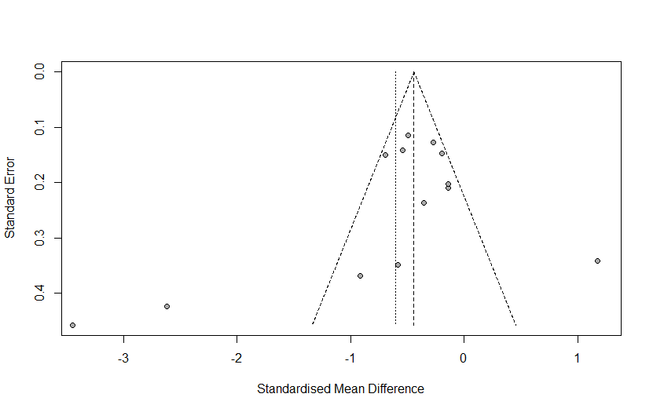

Figure S1. Funnel plots. (a) Response inhibition. Rank correlation test of funnel plot asymmetry (p=0.6255). Egger test of funnel plot asymmetry (p= 0.6058). (b) Decision-making. Rank correlation test of funnel plot asymmetry (p=0.1431). Egger test of funnel plot asymmetry (p= 0.2454).

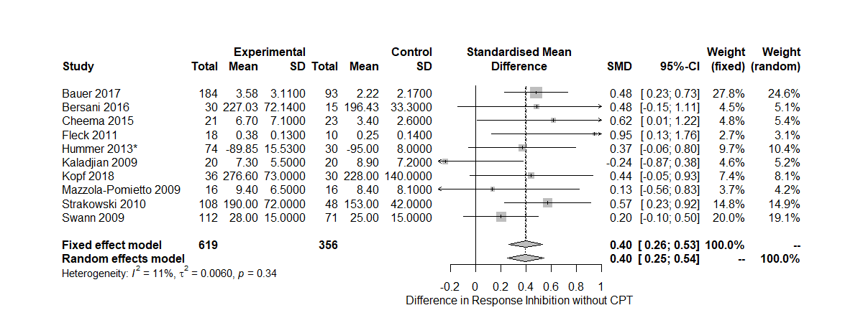

Figure S2. Forest plots of response inhibition without Continuous Performance Test.

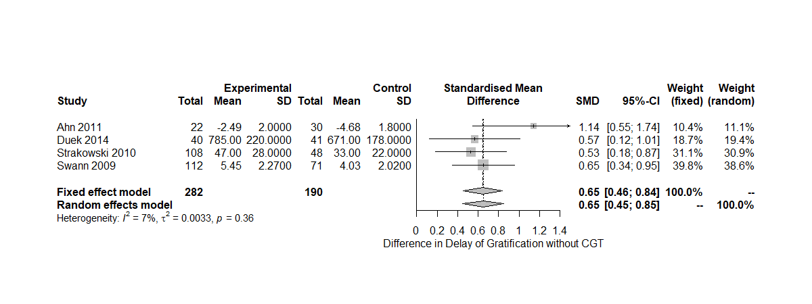
Figure S3. Forest plots of delay of gratification without Cambridge Gambling Task.

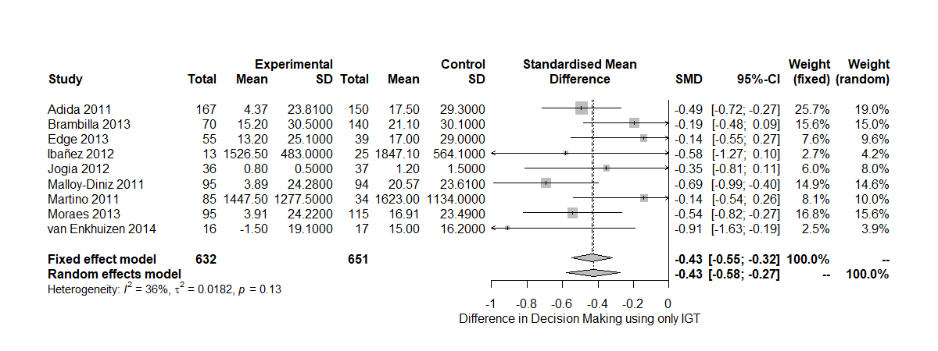
Figure S4. Forest plots of decision-making behavior using only Iowa Gambling Task.

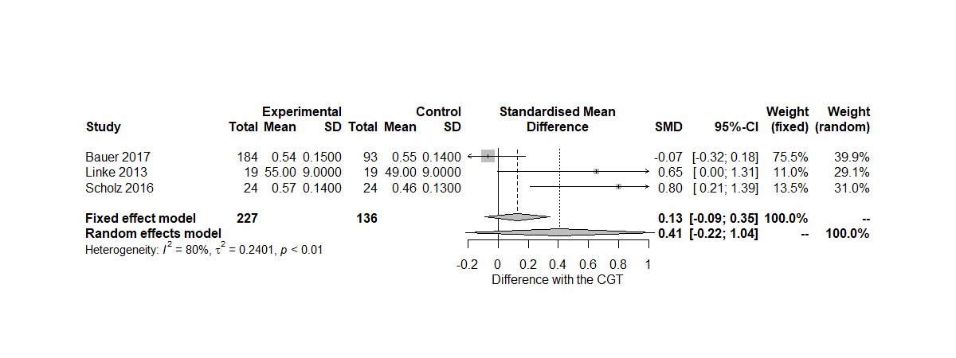
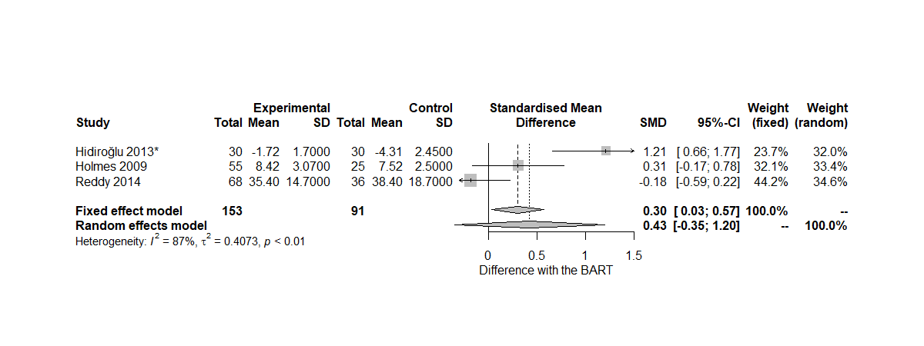

Figure S5. Forest plots of risk-taking behavior using the Balloon Analogue Risk Task and the Cambridge Gambling Task.

