**Methods Supplement**

*Genotyping and polygenic risk score (PRS) calculation*

In all subjects of the MACS test sample DNA extraction from peripheral blood samples and genotyping using the Infinium PsychArray BeadChip were performed according to previously published methods (Opel et al., 2018). Quality control was conducted in PLINK v1.90b5 (Chang et al., 2015) and R v3.3.3 as described elsewhere (Meller et al., 2019). Briefly, individuals were removed if they met any of the following criteria: genotyping call rate <98%, gender mismatches or other X-chromosome-related issues, genetic duplicates, cryptic relatives with pi-hat ≥0.125, genetic outlier with a distance from the mean of >4 *SD* in the first eight ancestry components (Supplementary Figure SF1), or a deviation of the autosomal or X-chromosomal heterozygosity from the mean >4 *SD.* Samples mapped reasonably within CEU PCA space(Supplementary Figure SF2). The genotype data were imputed using the 1000 Genomes Phase 3 reference panel and the programs SHAPEIT and IMPUTE2 (Delaneau, Marchini, & Zagury, 2011; B. Howie, Fuchsberger, Stephens, Marchini, & Abecasis, 2012; B. N. Howie, Donnelly, & Marchini, 2009).

PRS for schizophrenia (SZ), bipolar disorder (BD), and major depression (MDD) were calculated in R v3.33 by summing the minor allele dosages of linkage disequilibrium (LD)-independent SNPs (discarding markers: distance < 500 kilobases (kb) and LD r2 ⩾ 0.1; minor allele frequency <0.01) in our test sample, weighted by GWAS effect sizes (SZ: Ripke et al., 2014; BD: Stahl et al., 2019; MDD: Wray, 2018). The weighted PRS thus represent an estimation of cumulative, additive risk. PRS were calculated at *p*-value thresholds that showed the best discrimination of case-control status in the original GWAS (SZ: *p*=0.05, BD: *p*=0.01, MDD: *p*=0.05).

To adjust for genetic heterogeneity within our sample, we computed multi-dimensional scaling (MDS) components based on the pairwise identity-by-state distance matrix calculated on the genotype data in PLINK v1.90b5. Based on screeplot inspection, the first three components (C1–C3) were included as covariates in the analyses.

The Mannheim sample served as part of the control cohort in the framework of a case-control GWAS of Borderline Personality Disorder (BPD) for which details have been published previously (Witt et al., 2017). Analyses in the present manuscript are based on an updated quality control and imputation carried out using the RICOPILI GWAS pipeline (Lam et al., 2019), which was also used to generate PRS (see below). DNA extraction was carried out using the chemagic Magnetic Separation Module I (Chemagen Biopolymer-Technologie, Baesweiler, Germany) and samples were genotyped using the Infinium PsychArray-24 Bead Chip (Illumina, San Diego, CA, USA).

Individuals and SNPs were removed if they met any of the following exclusion criteria in the first round of quality control: genotyping call rate for given SNPs or individuals <98%, difference in SNP genotyping call rate between cases and controls >2%, deviation for the autosomal heterozygosity from the mean (|Fhet|>0.2), or a deviation from Hardy-Weinberg equilibrium (*p*<1x10−10 in cases; *p*<1x10−6 in controls). Genotype data were imputed using a publicly available reference panel consisting of 54,330 phased haplotypes with 36,678,882 variants from the haplotype reference consortium (EGAD00001002729) with the pre-phasing/imputation stepwise approach in EAGLE/MINIMAC3 (default parameters and a variable chunk size of 132 genomic chunks) (Das et al., 2016; Loh, Palamara, & Price, 2016). In the second round of quality control, relatedness testing and population structure analysis were performed using a SNP subset that fulﬁlled strict quality criteria after imputation (INFO >0.8, missingness <1%, minor allele frequency >0.05), and which had been subjected to LD pruning (*r*2>0.02). This subset comprised 66,240 SNPs. For cryptic relatives with pi-hat >0.2, one member of each pair was removed at random following the preferential retention of cases over controls. The thresholds for exclusion of genetic outliers on the first four principle components were determined via visual inspection. After excluding outliers and adjusting for the first four PCAs the population stratification lambda was 1.044 and samples mapped reasonably within CEU PCA space (Supplementary Figure SF3&SF4). To obtain a highly informative SNP set with minimal statistical noise for PRS calculation, the following were excluded: Low frequency SNPs (minor allele frequency <0.1), low-quality variants (INFO <0.9), and indels in each of three GWAS (SZ: Ripke et al., 2014; BD: Stahl et al., 2019; MDD: Wray, 2018). Subsequently, the remaining SNPs were LD-clumped (discarding markers: distance < 500 kilobases (kb) and LD r2 ⩾ 0.1). Because of extended LD structure within the extended major histocompatibility complex region (ch6 25–35Mb), only one variant with the strongest significance in the respective discovery GWAS was retained (see Supplementary Table ST5). PRS were then calculated as implemented in the RICOPILI pipeline (Lam et al., 2019) by summing the minor allele dosages of those SNPs weighted by GWAS effect sizes (SZ: Ripke et al., 2014; BD: Stahl et al., 2019; MDD: Wray, 2018) for each individual in the cohort. PRS using the same thresholds as in the MACS sample were analysed (SZ: *p*=0.05, BD: *p*=0.01, MDD: *p*=0.05). Five principle components (C1–C4 and C7; selected as those PCs were associated with case-control status in the original BPD GWAS) were used to adjust for genetic heterogeneity within the Mannheim cohort along with sex and age in subsequent analyses.

**Supplementary Tables**

Analyses have been repeated for the Mannheim sample with all scales recalculated as the respective subject mean if at least 80% of the items per subscale had been answered.

**Table ST1.** Model statistics of regression models with **SZ-PRS** as predictor.

|  |  |  |  |  |  |  |  |  |
| --- | --- | --- | --- | --- | --- | --- | --- | --- |
| dependent variable | MACS sample | | | Mannheim sample | | | | **comb. *p\**** |
| **ß**  **SZ-PRS** | *f2*  SZ-PRS | *p*(ß) | **ß**  **SZ-PRS** | *f2*  SZ-PRS | *p*(ß) | n sub-sample |
| SPQ-B total score | 0.003 | 9.2×10-6 | 0.955 | 0.010 | 1.0×10-4 | 0.708 | 1423 | 0.943 |
| *Cognitive-Perceptual* | 0.006 | 3.8×10-5 | 0.873 | 0.023 | 5.4×10-4 | 0.376 | 1448 | 0.720 |
| *Interpersonal* | 0.007 | 5.0×10-5 | 0.882 | -0.005 | 2.5×10-5 | 0.855 | 1430 | 0.944 |
| *Disorganized* | -0.007 | 5.1×10-5 | 0.860 | 0.008 | 6.8×10-5 | 0.764 | 1422 | 0.898 |
| Adj. *Positive* | 0.010 | 1.0×10-4 | 0.617 | 0.020 | 4.1×10-4 | 0.464 | 1431 | 0.558 |
| Adj. *Negative* | -0.013 | 1.7×10-4 | 0.743 | -0.004 | 1.6×10-5 | 0.860 | 1351 | 0.890 |
| Adj. *Cognitive* | -0.012 | 1.5×10-4 | 0.807 | -0.019 | 3.7×10-4 | 0.467 | 1426 | 0.710 |
| Adj. *Eccentricity* | 0.009 | 8.3×10-5 | 0.833 | 0.013 | 1.8×10-4 | 0.637 | 1409 | 0.773 |

*Note.* Age, sex, and MDS components C1–C3 (MACS)/C1–C4, C7 (Mannheim) were included as covariates in all models. All *p-* and ß- values after z-transformation of PRS values and schizotypy scores (within each subsample for the Mannheim sample) and bootstrapping with *N*=1000. \**p*-values were combined with the Stouffer meta-analysis method. All *p-*values are above the threshold for statistical significance (*pT*=.00625–.05).

**Table ST2.** Model statistics of regression models with **BD-PRS** as predictor.

|  |  |  |  |  |  |  |  |  |
| --- | --- | --- | --- | --- | --- | --- | --- | --- |
| dependent variable | MACS sample | | | Mannheim sample | | | | **comb. *p\**** |
| **ß**  **BD-PRS** | *f2*  BD- PRS | *p*(ß) | **ß**  **BD- PRS** | *f2*  BD- PRS | *p*(ß) | n sub-sample |
| SPQ-B total score | -0.010 | 1.0×10-4 | 0.824 | 0.026 | 7.0×10-4 | 0.286 | 1423 | 0.602 |
| *Cognitive-Perceptual* | -0.044 | 0.002 | 0.247 | 0.022 | 5.0×10-4 | 0.380 | 1448 | 0.242 |
| *Interpersonal* | 0.007 | 5.0×10-5 | 0.871 | 0.018 | 3.3×10-4 | 0.480 | 1430 | 0.778 |
| *Disorganized* | 0.009 | 8.4×10-5 | 0.801 | 0.023 | 5.7×10-4 | 0.334 | 1422 | 0.616 |
| Adj. *Positive* | -0.034 | 0.001 | 0.384 | 0.031 | 9.9×10-4 | 0.216 | 1431 | 0.222 |
| Adj. *Negative* | -0.014 | 2.0×10-4 | 0.734 | 0.006 | 3.7×10-5 | 0.797 | 1351 | 0.848 |
| Adj. *Cognitive* | 0.014 | 2.0×10-4 | 0.715 | 0.026 | 6.9×10-4 | 0.326 | 1426 | 0.533 |
| Adj. *Eccentricity* | 0.003 | 9.2×10-6 | 0.940 | 0.008 | 6.7×10-5 | 0.740 | 1409 | 0.940 |

*Note.* Age, sex, and MDS components C1–C3 (MACS)/C1–C4, C7 (Mannheim) were included as covariates in all models. All *p-* and ß- values after z-transformation of PRS values and schizotypy scores (within each subsample for the Mannheim sample) and bootstrapping with *N*=1000. \**p*-values were combined with the Stouffer meta-analysis method. All *p-*values are above the threshold for statistical significance (*pT*=.00625–.05).

**Table ST3.** Model statistics of regression models with **MDD-PRS** as predictor.

|  |  |  |  |  |  |  |  |  |
| --- | --- | --- | --- | --- | --- | --- | --- | --- |
| dependent variable | MACS sample | | | Mannheim sample | | | | **comb. *p\**** |
| **ß**  **MDD- PRS** | *f2*  MDD- PRS | *p*(ß) | **ß**  **MDD- PRS** | *f2*  MDD- PRS | *p*(ß) | n sub-sample |
| SPQ-B total score | -0.026 | 6.9×10-4 | 0.543 | 0.111 | 0.013 | 0.001 | 1423 | 0.017 |
| *Cognitive-Perceptual* | -0.039 | 0.002 | 0.348 | 0.083 | 0.007 | 0.005 | 1448 | 0.018 |
| *Interpersonal* | -0.012 | 1.4×10-4 | 0.762 | 0.099 | 0.010 | 0.001 | 1430 | 0.046 |
| *Disorganized* | -0.008 | 6.6×10-5 | 0.848 | 0.094 | 0.010 | 0.001 | 1422 | 0.072 |
| Adj. *Positive* | -0.042 | 0.002 | 0.325 | 0.039 | 0.002 | 0.141 | 1431 | 0.140 |
| Adj. *Negative* | -0.020 | 4.1×10-4 | 0.632 | 0.097 | 0.010 | 0.001 | 1351 | 0.026 |
| Adj. *Cognitive* | 0.013 | 1.7×10-4 | 0.743 | 0.070 | 0.005 | 0.009 | 1426 | 0.112 |
| Adj. *Eccentricity* | -0.021 | 4.5×10-4 | 0.607 | 0.110 | 0.013 | 0.001 | 1409 | 0.023 |

*Note.* Age, sex, and MDS components C1–C3 (MACS)/C1–C4, C7 (Mannheim) were included as covariates in all models. All *p-* and ß- values after z-transformation of PRS values and schizotypy scores (within each subsample for the Mannheim sample) and bootstrapping with *N*=1000. \**p*-values were combined with the Stouffer meta-analysis method. All *p-*values are above the threshold for statistical significance (*pT*=.00625–.05).

**Table ST4.** Results of separate exploratory factor analysis in the MACS and Mannheim samples, with fixed extraction of three factors and Oblimin rotation.

|  |  |  |  |  |
| --- | --- | --- | --- | --- |
| **Mannheim** pattern matrix | | | | |
|  | factor | | | |
|  | 1 | 2 | 3 | |
| SPQB21 IP | .667 |  |  | |
| SPQB15 IP | .618 |  |  | |
| SPQB11 IP | .611 |  |  | |
| SPQB22 IP | .528 |  |  | |
| SPQB18 IP | .523 |  |  | |
| SPQB14 IP | .495 | .150 |  | |
| SPQB1 IP | .392 |  | -.103 | |
| **SPQB9 CP** | **.178** | .133 | -.178 | |
| **SPQB17 CP** | **.167** |  | -.166 | |
| SPQB2 CP |  | .642 |  | |
| SPQB5 CP |  | .544 | -.121 | |
| SPQB12 CP |  | .405 |  | |
| SPQB4 CP |  | .399 |  | |
| SPQB10 CP |  | .235 |  | |
| SPQB6 DO |  |  | -.572 | |
| SPQB3 DO |  |  | -.559 | |
| SPQB19 DO |  |  | -.527 | |
| SPQB8 DO | .108 |  | -.514 | |
| SPQB20 DO | .273 |  | -.384 | |
| SPQB13 DO |  | .159 | -.344 | |
| **SPQB16 CP** |  | .177 | **-.325** | |
| **SPQB7 CP** | .134 | .129 | **-.210** | |
| Extraction Method: Principal Axis Factoring.  Rotation Method: Oblimin with Kaiser Normalization. | | | |
| Rotation converged in 11 iterations. | | | |

|  |  |  |  |
| --- | --- | --- | --- |
| **MACS** pattern matrix | | | |
|  | factor | | |
|  | 1 | 2 | 3 |
| SPQB11 IP | 0.519 |  |  |
| SPQB18 IP | 0.484 |  |  |
| SPQB21 IP | 0.475 |  |  |
| SPQB15 IP | 0.450 | -0.114 |  |
| SPQB14 IP | 0.444 | 0.124 |  |
| SPQB22 IP | 0.420 | -0.119 |  |
| **SPQB20 DO** | **0.400** |  | -0.204 |
| **SPQB7 CP** | **0.350** | 0.108 |  |
| SPQB1 IP | 0.343 | -0.130 |  |
| **SPQB9 CP** | **0.329** | 0.120 |  |
| **SPQB16 CP** | **0.261** | 0.104 | 0.102 |
| SPQB2 CP |  | 0.545 |  |
| SPQB5 CP |  | 0.516 |  |
| SPQB12 CP |  | 0.511 |  |
| SPQB4 CP |  | 0.387 |  |
| SPQB10 CP |  | 0.220 |  |
| SPQB17 CP | 0.155 | 0.188 |  |
| SPQB6 DO | -0.125 |  | -0.837 |
| SPQB3 DO |  |  | -0.549 |
| SPQB19 DO |  |  | -0.475 |
| SPQB8 DO | 0.255 |  | -0.408 |
| SPQB13 DO |  | 0.128 | -0.250 |
| Extraction Method: Principal Axis Factoring.  Rotation Method: Oblimin with Kaiser Normalization. | | | |
| Rotation converged in 6 iterations. | | | |

*Note.* CP, IP, DO refer to original scale of the respective item (CP = Cognitive Perceptual, IP = Interpersonal, DO = Disorganised). Bold print indicates items that load on a different scale than originally.

**Table ST5.** SNPs in the MHC region selected for each Disorder PRS for the Mannheim Cohort.

|  |  |  |  |  |  |
| --- | --- | --- | --- | --- | --- |
| Discovery GWAS | CHR | SNP | BP | A1 | P |
| SCZ | 6 | rs114541829 | 28705074 | T | 2.128e-26 |
| BD | 6 | rs36034627 | 27237363 | T | 4.307e-06 |
| MDD | 6 | rs6905391 | 28262686 | A | 3.468e-11 |

SNP = Rs-number, BP = base pair position, A1 = effect allele, P = P-value in the respective

**Supplementary Figures**

**Supplementary Figure SF1:**

Standardized MDS components of the FOR2107/MACS sample after QC.

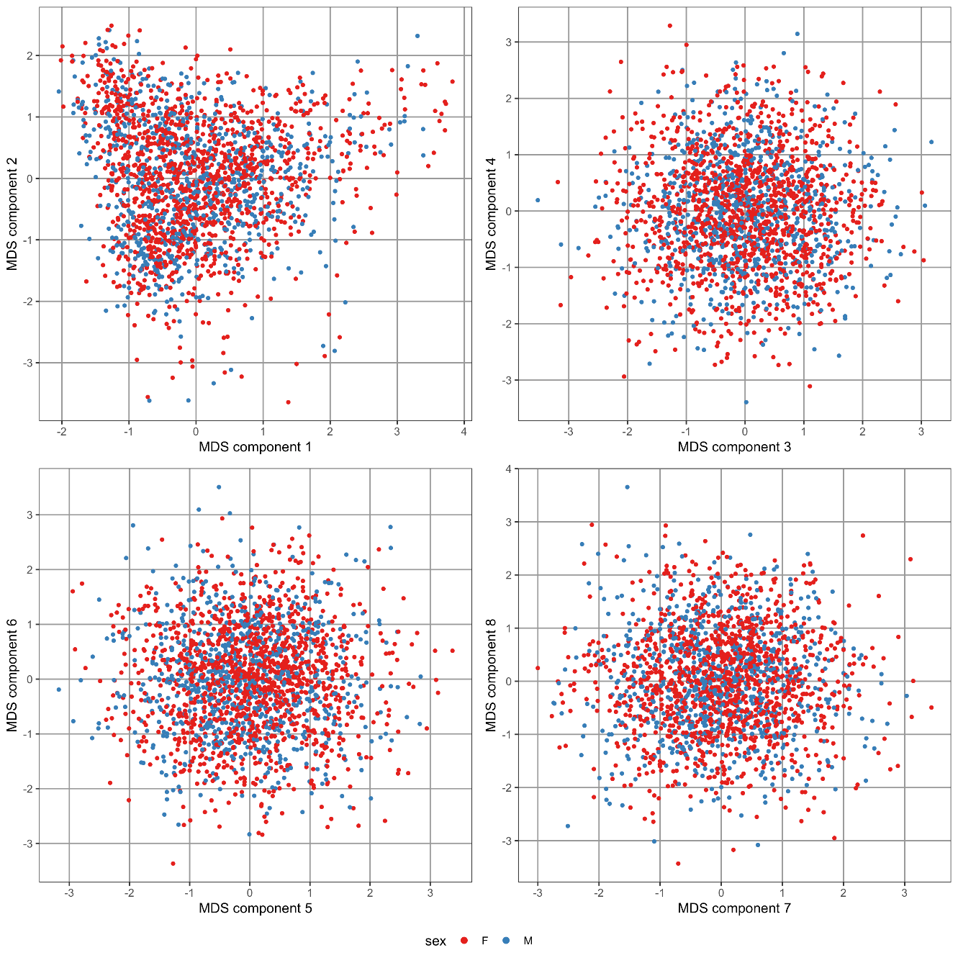

**Supplementary Figure SF2:**

Standardized MDS components of the FOR2107/MACS sample relative to the EUR populations (CEU, GBR, FIN, IBS, TSI) from the 1000 Genomes Phase 3 reference panel.

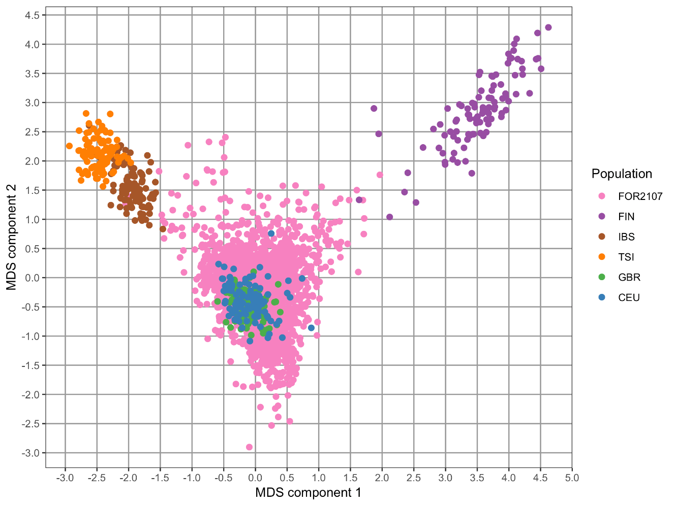

**Supplementary Figure SF3**:

Standardized PCA components of the Mannheim sample after QC.

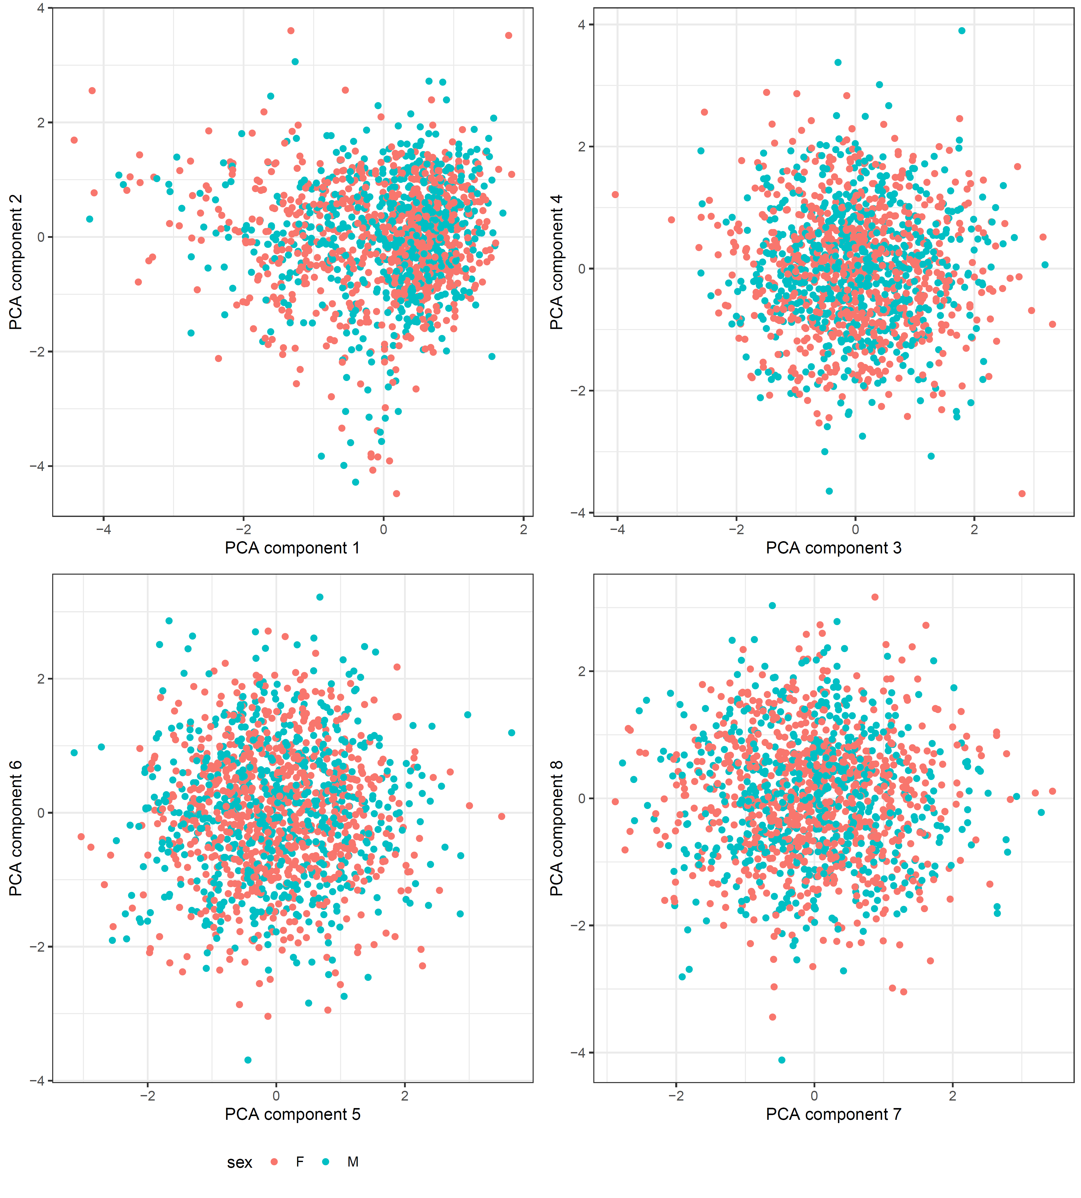

**Supplementary Figure SF4:**

PCA plot of the Mannheim sample relative to the EUR populations (CEU, GBR, FIN, IBS, TSI) from the 1000 Genomes Phase 3 reference panel.

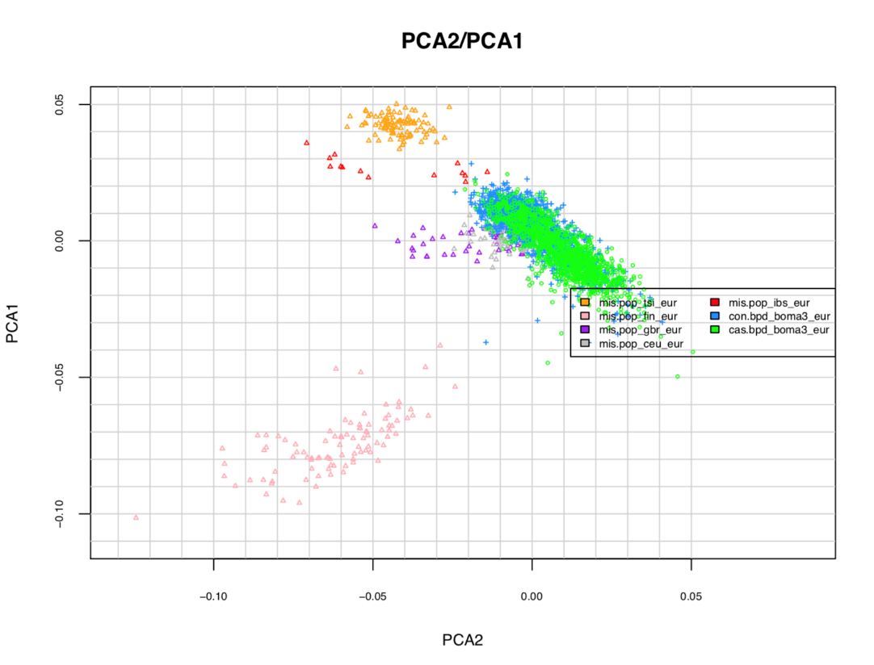

**Supplement References**

Chang, C. C., Chow, C. C., Tellier, L. C., Vattikuti, S., Purcell, S. M., & Lee, J. J. (2015). Second-generation PLINK: rising to the challenge of larger and richer datasets. *Gigascience, 4*(1), 7.

Das, S., Forer, L., Schönherr, S., Sidore, C., Locke, A. E., Kwong, A., . . . Fuchsberger, C. (2016). Next-generation genotype imputation service and methods. *Nature Genetics, 48*, 1284. doi:10.1038/ng.3656

https://www.nature.com/articles/ng.3656#supplementary-information

Delaneau, O., Marchini, J., & Zagury, J.-F. (2011). A linear complexity phasing method for thousands of genomes. *Nature Methods, 9*(2), 179-181. doi:10.1038/nmeth.1785

Howie, B., Fuchsberger, C., Stephens, M., Marchini, J., & Abecasis, G. R. (2012). Fast and accurate genotype imputation in genome-wide association studies through pre-phasing. *Nature Genetics, 44*(8), 955-959. doi:10.1038/ng.2354

Howie, B. N., Donnelly, P., & Marchini, J. (2009). A flexible and accurate genotype imputation method for the next generation of genome-wide association studies. *PLoS Genetics, 5*(6), e1000529. doi:10.1371/journal.pgen.1000529

Lam, M., Awasthi, S., Watson, H. J., Goldstein, J., Panagiotaropoulou, G., Trubetskoy, V., . . . Ripke, S. (2019). RICOPILI: Rapid Imputation for COnsortias PIpeLIne. *Bioinformatics*. doi:10.1093/bioinformatics/btz633

Loh, P. R., Palamara, P. F., & Price, A. L. (2016). Fast and accurate long-range phasing in a UK Biobank cohort. *Nature Genetics, 48*(7), 811-816. doi:10.1038/ng.3571

Meller, T., Schmitt, S., Stein, F., Brosch, K., Mosebach, J., Yuksel, D., . . . Nenadic, I. (2019). Associations of schizophrenia risk genes ZNF804A and CACNA1C with schizotypy and modulation of attention in healthy subjects. *Schizophrenia Research*. doi:10.1016/j.schres.2019.04.018

Opel, N., Amare, A. T., Redlich, R., Repple, J., Kaehler, C., Grotegerd, D., . . . Dannlowski, U. (2018). Cortical surface area alterations shaped by genetic load for neuroticism. *Molecular Psychiatry*. doi:10.1038/s41380-018-0236-9

Ripke, S., Neale, B. M., Corvin, A., Walters, J. T. R., Farh, K.-H., Holmans, P. A., . . . O’Donovan, M. C. (2014). Biological insights from 108 schizophrenia-associated genetic loci. *Nature, 511*, 421. doi:10.1038/nature13595 https://www.nature.com/articles/nature13595#supplementary-information

Stahl, E. A., Breen, G., Forstner, A. J., McQuillin, A., Ripke, S., Trubetskoy, V., . . . Sklar, P. (2019). Genome-wide association study identifies 30 loci associated with bipolar disorder. *Nature Genetics, 51*(5), 793-803. doi:10.1038/s41588-019-0397-8

Witt, S. H., Streit, F., Jungkunz, M., Frank, J., Awasthi, S., Reinbold, C. S., . . . Rietschel, M. (2017). Genome-wide association study of borderline personality disorder reveals genetic overlap with bipolar disorder, major depression and schizophrenia. *Translational Psychiatry, 7*(6), e1155. doi:10.1038/tp.2017.115

Wray, N. R. (2018). Genome-wide association analyses identify 44 risk variants and refine the genetic architecture of major depression. *bioRxiv*, 167577. doi:10.1101/167577