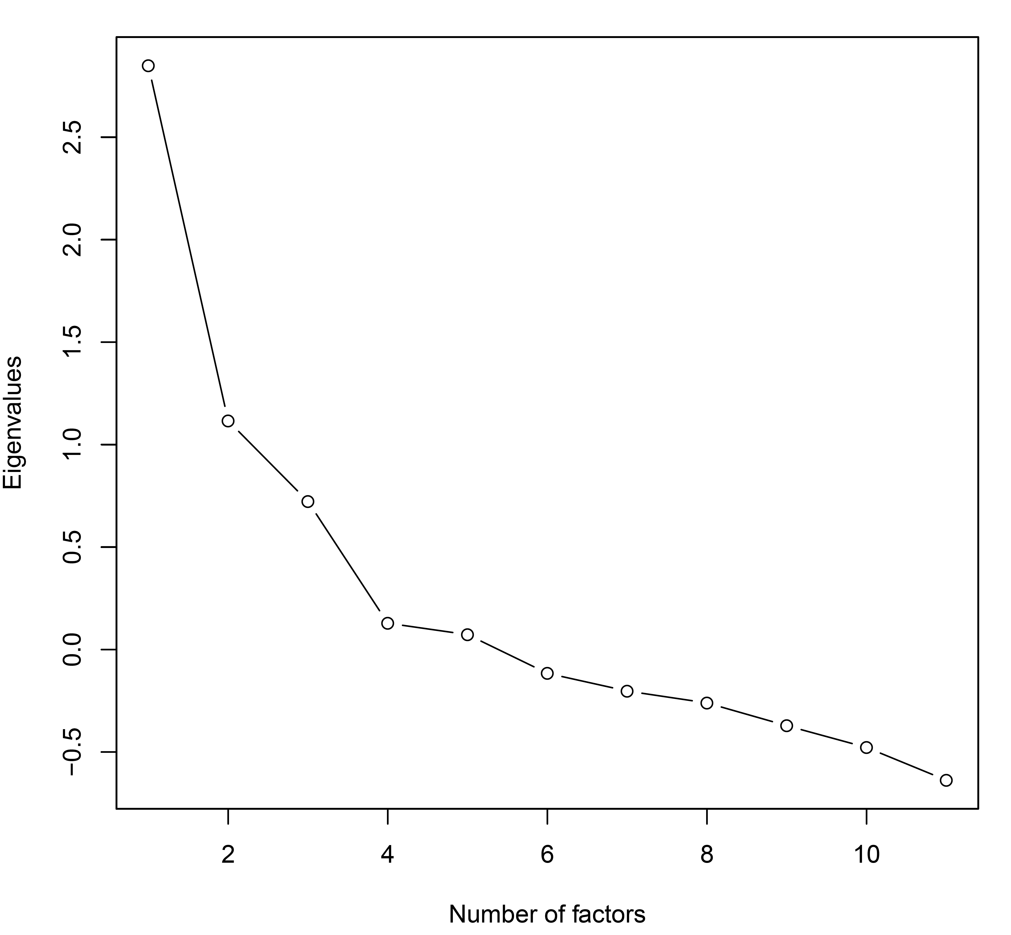
Supplementary Figure 1. The scree plot shows eigen values of the factors in the model. The eigen values were extracted using fa.parallel() in psych v.1.8.12.

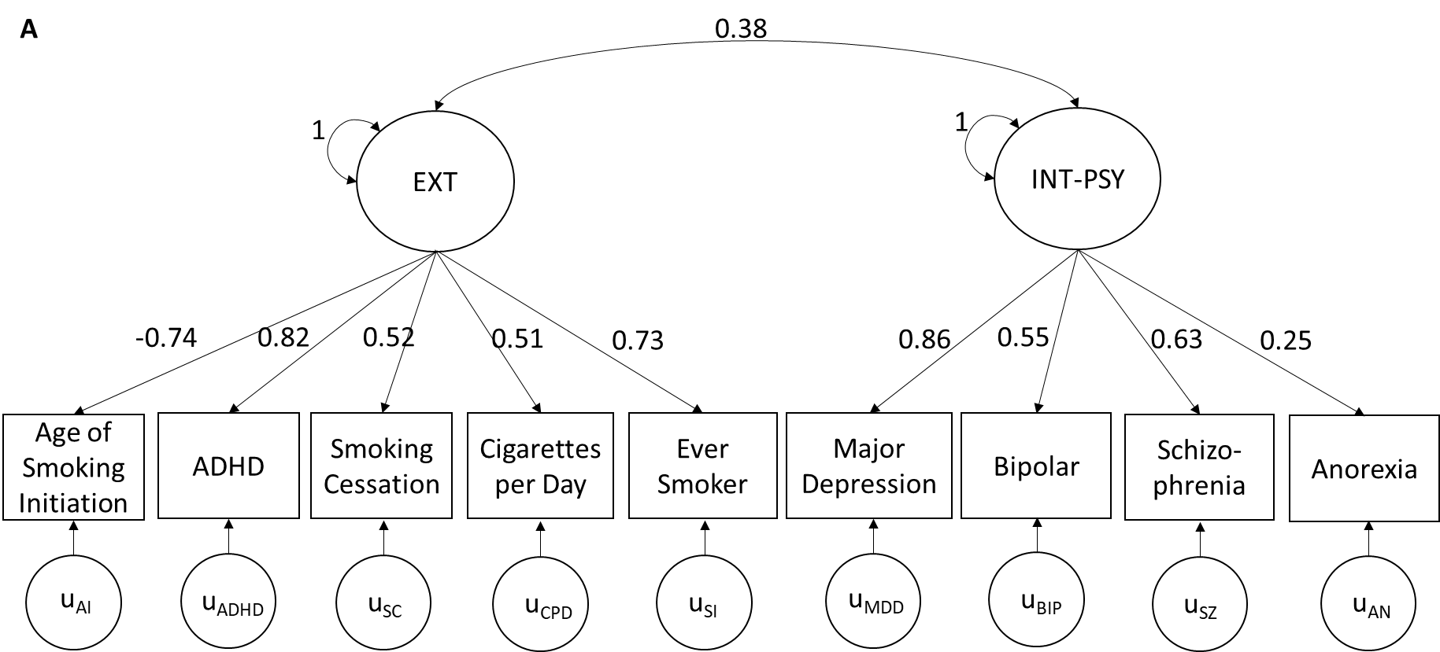
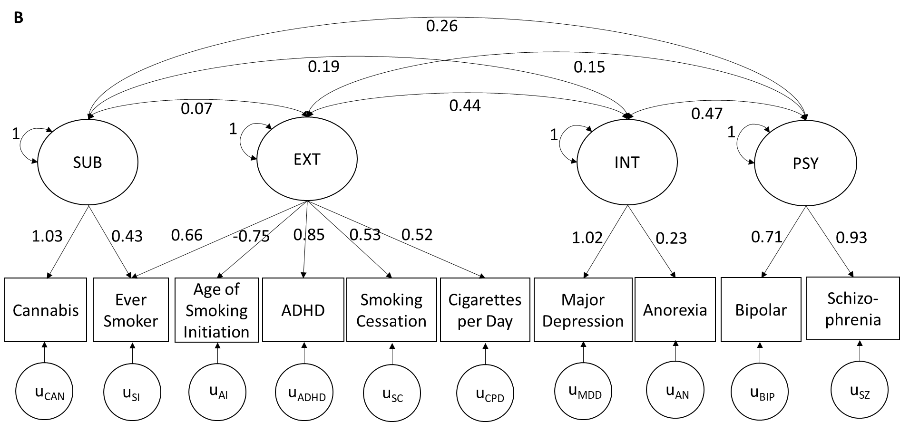
Supplementary Figure 2. Figure A and B show the two-factor and four-factor model, respectively. Large and small circles indicate latent factors and uniqueness, respectively, and square boxes indicate manifest variables.

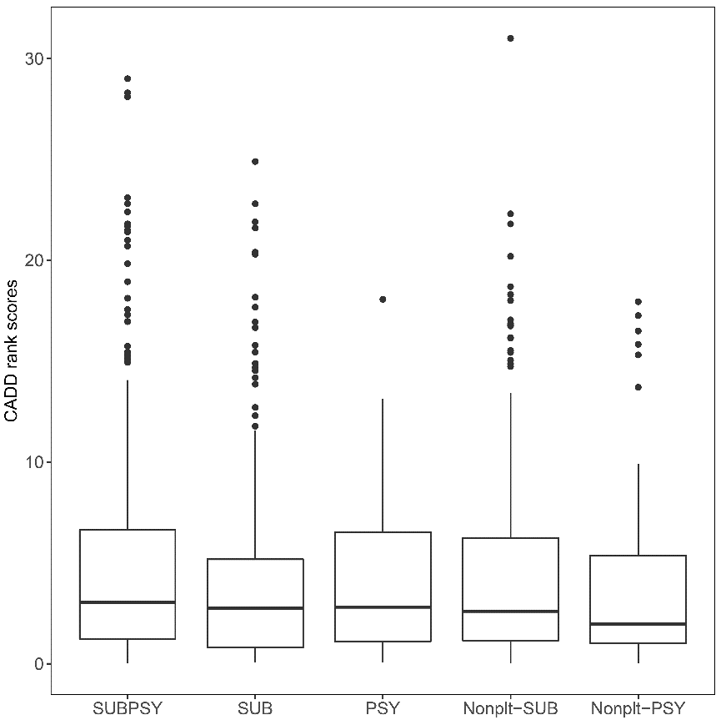

Supplementary Figure 3. The box plot shows the distribution of the CADD rank scores of the lead SNPs across different pleiotropic loci: SUBPSY indicates pleiotropic loci shared across substance use and psychiatric disorders, while SUB and PSY indicate substance use- or psychiatric disorders-specific pleiotropic loci. Nonplt-SUB and Nonplt-PSY indicate non-pleiotropic loci (genome-wide significant variants associated with either single substance use or psychiatric disorder phenotype and not falling in any of the pleiotropic loci identified in the current study). Phred scaled CADD rank scores are displayed here, which range from 0 to 30 where 10, 20, and 30 means top 10%, 1%, and 0.1% deleterious variants of all GRCh37 reference SNVs.
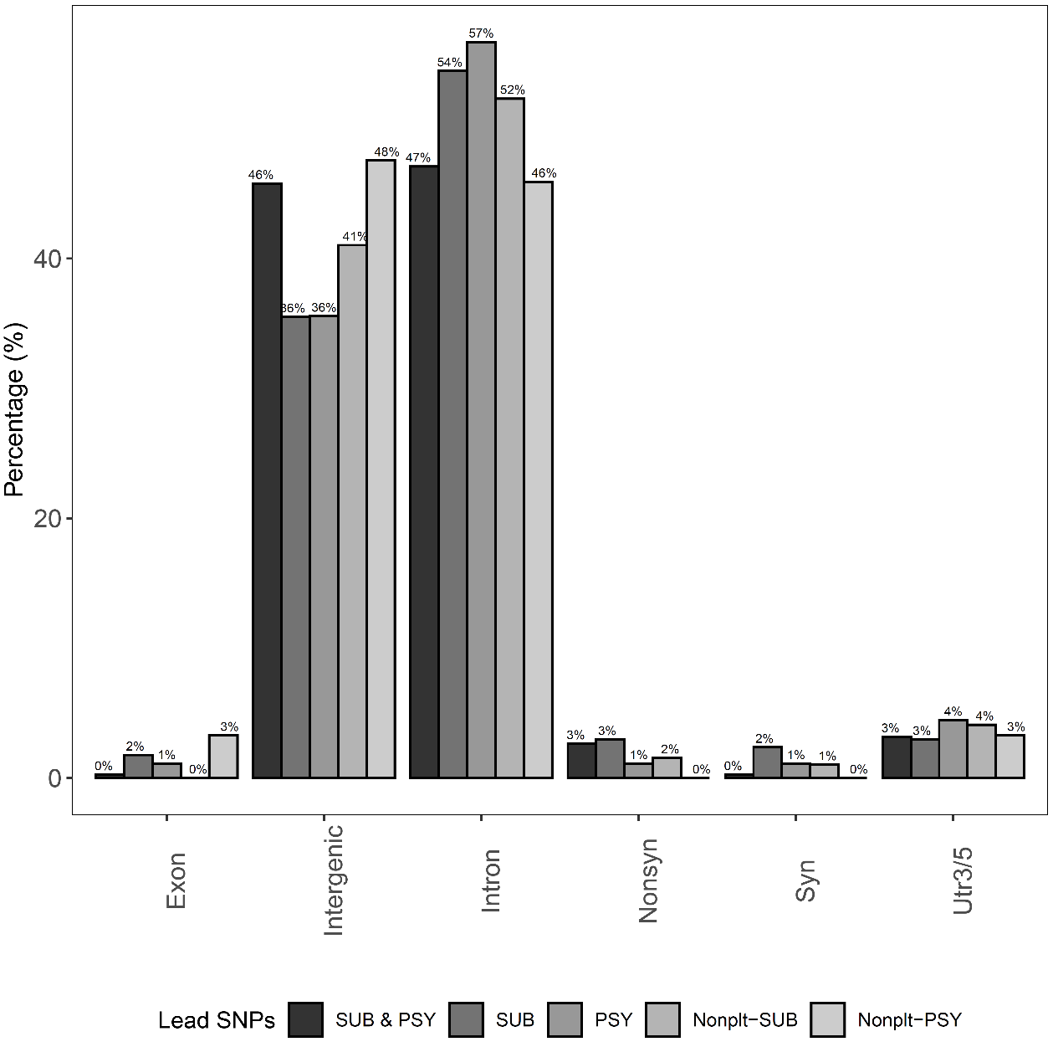
Supplementary Figure 4. The bar plot shows a proportion of the lead SNPs for each functional categories across different pleiotropic loci: SUBPSY indicates pleiotropic loci shared across substance use and psychiatric disorders, while SUB and PSY indicate substance use- or psychiatric disorders-specific pleiotropic loci. Nonplt-SUB and Nonplt-PSY indicate non-pleiotropic loci (GWAS variants associated with either single substance use or psychiatric disorder phenotype and not falling in any of the pleiotropic loci identified in the current study). “Nonsyn” and “Syn” indicate nonsynonymous and synonymous variants, respectively.

