Supplemental Materials
Supplemental Figure 1: Map of Chile by regional subdivisions
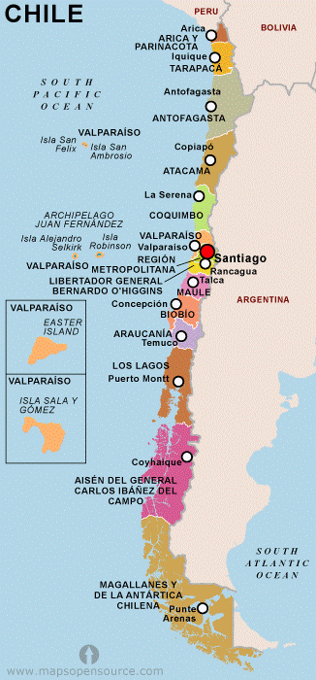
Supplemental Methods
Multidimensional poverty
Multidimensional poverty has been used by the Chilean government since 2009 as a measure of poverty and is estimated using The National Socioeconomic Characterization Survey (CASEN, Encuesta de Caracterización Socioeconómica Nacional). This survey uses household as analysis unit and assesses four broad dimensions - health, education, work/social security and housing. Each dimension is subdivided into three poverty indicators.
- Health is divided in i) malnutrition (if there is a child with obesity or undernutrition); ii) lack of health protection (if one of household´s member does not have health insurance); and iii) deficit in healthcare (if one of household´s member did not receive medical care in the last three months due to external reasons, such as severe delay on medical attention).
- Education is divided in i) school attendance (if there is household´s member between four and eighteen years is not attending to school); ii) low level of education (if one of household´s member have not completed at least twelve years of minimal formal education); and iii) school delay (if any of household´s member with twenty-one years old or less is attending to school and is delayed two or more years).
- The work and social security dimension is divided into i) lack of employment (if any of non-student household´s member, older than eighteen years old, is unemployed and is looking for a job); ii) lack of social security (if any of worker´s household member older than eighteen years does not have a social security income); and iii) problems with retirement (if any of retired household´s member does not: receive a pension).
- The housing dimension is divided in i) overcrowded (the number of people per each room is more than 2,5); ii) poor structural house quality, and iii) deficit in basics services, such as poor access to clean drinking water.
Every poverty indicator has the same weighting, and a household is considered to live in multidimensional poverty if criteria for three or more of these twelve indicators are met.
Fractional polynomial transformations.
For continuous covariates (year, deprivation, population density and latitude) we determined whether they exhibited non-linear associations with the incidence of non-affective psychoses by testing the fit of different fractional polynomial transformations in univariable models. We considered up to second degree fractional polynomial functions over a range of powers {-0.5,0,0.5,1,2,3} permitting a flexible range of curve shapes to be tested, as recommended by Royston and Sauerbrei.¹ Two-dimensional fractional polynomials take the form:
$$x^{(p_{1},p_{2})'}β= β_{0}+β_{1}x^{(p_{1})}+β_{2}x^{(p_{2})}\ln\left(x\right)$$
and in the special case where:
$$p= 0$$
then:
$$x^{(0)}= \ln\left(x\right)$$
The fractional polynomial transformation of each variable which provided best fit to the incidence data in a univariable regression, assessed via likelihood ratio test [LRT], was used during multivariable modelling.

Supplemental Results
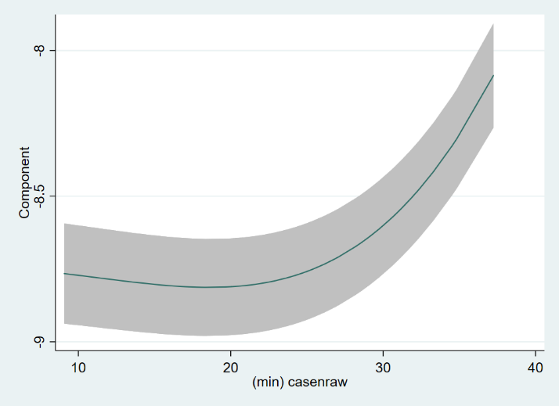
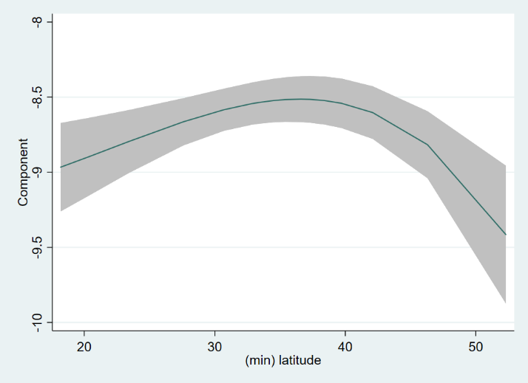
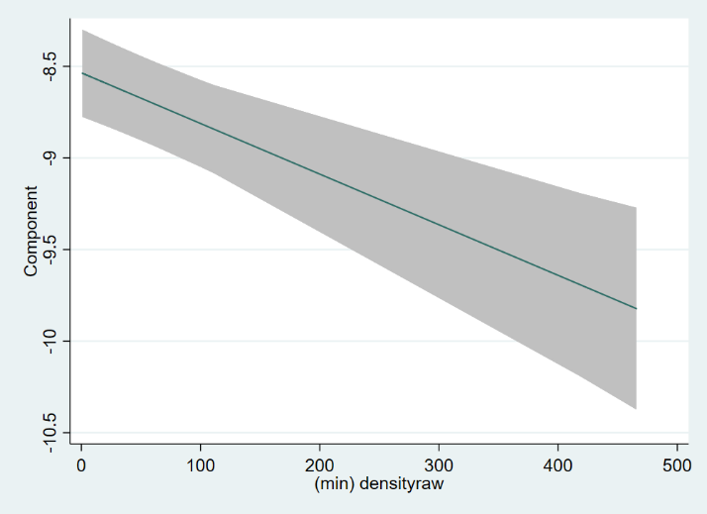
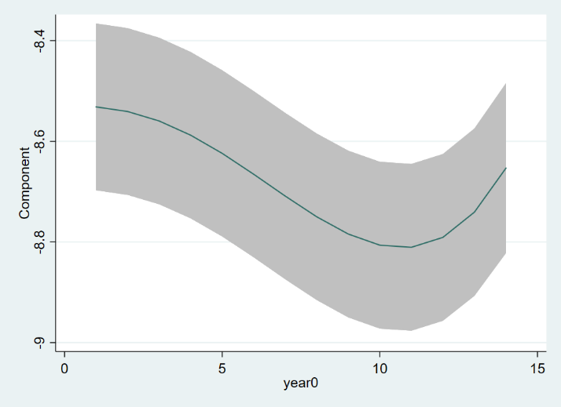
Supplemental Figure 2: Fractional polynomial parameterizations for regional covariates and time (in years) from univariable models¹
(a) Multidimensional poverty
(b) Latitude
(c) Time (years)
(d) Population density

¹Multidimensional poverty, latitude and time (years) were all best-parameterized with a second-degree cubic function (see Supplemental Table 2); population density was best modelled as a linear term.

Supplemental Figure 3: Re-estimated fractional polynomial parameterization for univariable association between latitude and incidence of non-affective psychoses in Chile, excluding Magallanes region in sensitivity analyses¹
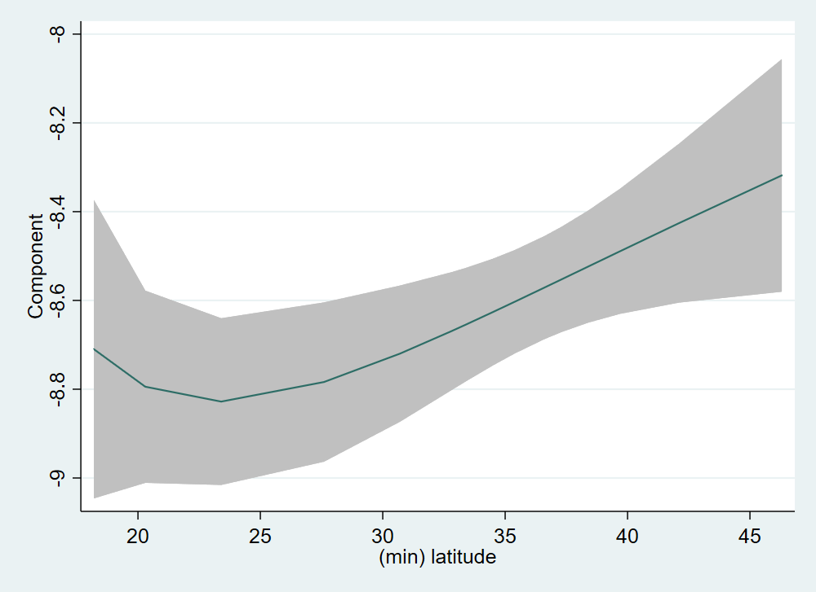

¹After excluding the Magallanes region, the univariable association between latitude and the incidence of non-affective psychoses in Chile, 2005-2018, was best-parameterized with a $x^{(-1,-1)'}β$ fractional polynomial term

Supplemental Table 1: Correlation between regional variables in 2018, Chile (N=17)
Covariate | Median (IQR) | Range | Correlation¹
 |  |  | Population density | Deprivation | Latitude
Population density (ppkm²) | 19.9 (6.4-46.5) | 1.0-465.6 | -
Multidimensional poverty² (%) | 19.9 (17.1-21.5) | 10.7-21.5 | -0.13 | -
Latitude (degrees south) | 35.0 (29.2-39.1) | 18.2-52.3 | -0.02 | -0.36 | -
IQR: Interquartile range; ppkm²: people per square kilometre
¹No correlation met statistical significance at p<0.10
²Proportion of households in each region living in multidimensional poverty

Supplemental Table 2: Best-fitting fractional polynomial functions for selected covariates in univariable models of the incidence of non-affective psychoses, Chile, 2005-2018
Covariate | Best-fitting term (x^{p1,p2}) | Improvement over linear (i.e. x¹)
Population density | Linear (x¹) | -
Multidimensional poverty | (x^{3,3}) | <0.001
Latitude | (x^{3,3}) | <0.001
Year | (x^{3,3}) | <0.001

Covariate | Men  IRR (95%CI) | Women  IRR (95%CI)
Age group
10-14 | 0.25 (0.23, 0.27) | 0.46 (0.43, 0.49)
15-19 | Ref | Ref
20-24 | 0.74 (0.71, 0.77) | 0.55 (0.52, 0.59)
25-29 | 0.40 (0.38, 0.42) | 0.42 (0.39, 0.45)
30-34 | 0.31 (0.29, 0.32) | 0.38 (0.35, 0.41)
35-39 | 0.26 (0.25, 0.28) | 0.42 (0.39, 0.45)
40-44 | 0.23 (0.21, 0.24) | 0.42 (0.39, 0.45)
45-49 | 0.22 (0.20, 0.24) | 0.46 (0.43, 0.50)
50-54 | 0.18 (0.17, 0.19) | 0.42 (0.39, 0.46)
55-59 | 0.15 (0.14, 0.16) | 0.34 (0.31, 0.37)
60-64 | 0.11 (0.10, 0.12) | 0.29 (0.26, 0.32)
Supplemental Table 3: Age-specific incidence rate ratios for men and women from fully-adjusted model, Chile, 2005-2018¹

¹Alternative parameterization of age-sex interaction term from fully-adjusted model reported in Table 3, additionally adjusted for regional multidimensional poverty, latitude and time x sex.

Supplemental Table 4: Sensitivity analyses excluding the Magallanes region from multivariable modelling
Covariate | Full sample¹  IRR (95%CI) | Exc. Magellanes²  IRR (95%CI) | LRT p-value (exc. Magallanes)³
Age group | Sex IRR (M vs. F) | Sex IRR (M vs. F) | Age x sex:
10-14 | 0.91 (0.82, 0.99) | 0.91 (0.83, 0.99) | 1084.4 (10); <0.001
15-19 | 1.53 (1.48, 1.59) | 1.70 (1.60, 1.80)
20-24 | 1.83 (1.76, 1.90) | 2.29 (2.13, 2.44)
25-29 | 1.49 (1.41, 1.57) | 1.63 (1.50, 1.76)
30-34 | 1.32 (1.24, 1.41) | 1.38 (1.26, 1.50)
35-39 | 1.07 (0.98, 1.16) | 1.07 (0.98, 1.17)
40-44 | 0.91 (0.82, 1.01) | 0.91 (0.83, 1.00)
45-49 | 0.79 (0.70, 0.89) | 0.81 (0.73, 0.89)
50-54 | 0.67 (0.57, 0.78) | 0.72 (0.64, 0.80)
55-59 | 0.72 (0.60, 0.85) | 0.76 (0.66, 0.85)
60-64 | 0.55 (0.40, 0.71) | 0.64 (0.54, 0.74)
Time |  |  | Time x year:
Men (per year) |  |  | 97.1 (2); <0.001
First-degree cubic | 0.9997 (0.9989, 1.0005) | 0.9998 (0.9990, 1.0006)
Second-degree cubic | 1.0001 (0.9998, 1.0004) | 1.0001 (0.9998, 1.0004)
Women (per year)
First-degree cubic | 0.9989 (0.9984, 0.9994) | 0.9989 (0.9984, 0.9993)
Second-degree cubic | 1.0004 (1.0002, 1.0006) | 1.0004 (1.0002, 1.0006)
Multidimensional poverty (z-standardised) |  |  | 283.3 (2); <0.001
First-degree cubic | 0.978 (0.973, 0.983) | 0.980 (0.976, 0.984)
Second-degree cubic | 1.011 (1.009, 1.014) | 1.010 (1.008, 1.012)
Population density (z-standardised) | -⁴ | -⁴ | 0.14 (1); 0.70
Latitude (per 10 degrees south) |  |  | 3.23 (2); 0.20
First-degree³ | 1.08 (1.03, 1.13) | -⁵
Second-degree³ | 0.95 (0.93, 0.98) | -⁵
Random intercepts (σ²) | 0.07 (0.03, 0.14) | 0.07 (0.03, 0.14)
¹As reported in Table 3. Included here for comparison only.
²Data re-analysed excluding Chile’s most southerly region, Magallanes, with low incidence rates of non-affective psychoses, to inspect role of non-linear latitude on results
³LRT χ² (degrees of freedom [df]); p-value
⁴Not retained in the final model for the full sample (IRR: 0.98; 95% CI: 0.88, 1.10) or the sample excluding Magallanes (IRR: 1.02; 95% CI: 0.92, 1.14)
⁵Cubic in the full sample model, better parameterized as a two-degree inverse power function of the form $x^{(-1,-1)'}β$ (see Supplemental Figure 2), but not statistically-significant in final model at p<0.05. IRR estimates for the first- and second-degree inverse power of latitude (per 10 degrees) were 1.02 (95% CI: 0.96, 1.09) and 0.99 (95% CI: 0.95, 1.03), respectively.

Supplemental Bibliography

¹ Royston P, Sauerbrei W. Multivariable Model-Building: A Pragmatic Approach to Regression Analysis Based on Fractional Polynomials for Modelling Continuous Variables. Chichester, West Sussex: Wiley; 2008.

