Supplementary material
Given that GSR may contain an important source of information (Li, et al., 2019), we repeated the same prediction analyses based on the corresponding FC features without GSR, which can serve as a control analysis for the FCs identified in our study and may provide complementary insights. Firstly, in sample 1, we found that the FCs also significantly predicted the NA-PCS. The correlation between the real value (Y) and the predicted Y was 0.63 (Figure S1A), and the permutation test (1,000 iterations) showed that the prediction function was significant (p < 0.001). In sample 2, these FCs also predicted the NA-PCS with the permutation test at p=0.002. And the correlation between Y and the predicted Y reached 0.25 (Figure S1B). 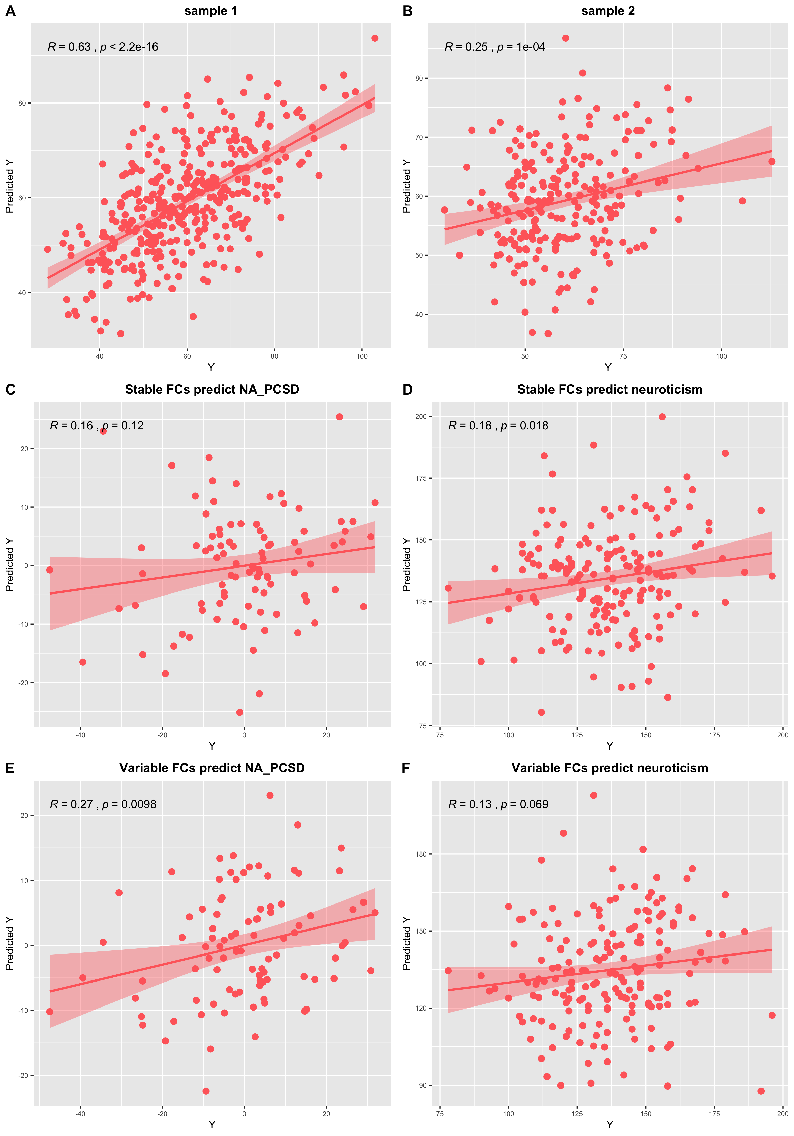

Moreover, based on the preprocessing data without GSR, the ΔSCC also did not show a predictive function with regard to the NA-PCSD. The correlation between the Y and the predicted Y was 0.16 (see Figure S1C). The permutation test (1,000 iterations) showed that the prediction function was not significant (p=0.251). In contrast, a significant predictive function regarding SCC and neuroticism was presented with r=0.18 (see Figure S1D) and p=0.020. The ΔVCC had a marginally significant effect in predicting the NA-PCSD, the correlation between the Y and the predicted Y was 0.27 (Figure S1E), and the permutation test (1,000 iterations) showed p=0.079. And the VCC had a marginally significant effect in predicting the neuroticism (r=0.13, p=0.051; Figure S1F).

Li, J., Bolt, T., Bzdok, D., Nomi, J. S., Yeo, B. T., Spreng, R. N., & Uddin, L. Q. (2019). Topography and behavioral relevance of the global signal in the human brain. Scientific Reports, 9, 1-10.

