Supplementary Materials
Shared and specific patterns of dynamic functional connectivity variability of striato- cortical circuitry in unmedicated bipolar and major depressive disorders

Functional Image Preprocessing
The preprocessing was carried out using Data Processing Assistant for Resting-State fMRI (DPABI_V2.3, http://restfmri.net/forum/DPABI) (Yan, Wang, Zuo, & Zang, 2016) which is based on Statistical Parametric Mapping (SPM12, http://www.fil.ion.ucl.ac.uk/spm/). For each subject, the first 10 images of the rs-fMRI dataset were discarded to ensure steady-state longitudinal magnetization. The remaining 200 images were first slice-time corrected and then were realigned to the first image for correcting for inter-TR head motion. This realignment correction provided a record of the head motion within the rs-fMRI scan. All subjects should have no more than 2 mm maximum displacement in any plane, 2° of angular motion as well as 0.2mm in mean frame-wise displacement (FD) (Jenkinson, Bannister, Brady, & Smith, 2002). The individual T1 structural images were segmented (white matter, gray matter, and cerebrospinal fluid) using a segmentation toolbox. Then, the DARTEL toolbox was used to create a study specific template for the accurate normalization. Then, resting-state functional images were coregistered to the structural images and transformed into standard Montreal Neurological Institute (MNI) space, resliced to a voxel size of 3×3×3mm³ resolution. The data were removed linear trend and passed through band-pass filtered of 0.01-0.1 Hz. Several spurious covariates and their temporal derivatives were then regressed out from the time course of each voxel, including the signals of the brain global mean, white matter, and cerebrospinal fluid as well as the Friston-24 parameters of head motion.

Fig. S1. The dFC variability patterns within BD II, MDD and HCs groups. Panel A displayed the six seeds of the striatum in each hemisphere. Panel B and Panel C showed the dFC variability patterns for each pair striatum seed in BD II, MDD and HCs groups. Shades of red represent increased dFC regions. dFC, dynamic functional connectivity; VSi, ventral striatum inferior; VSs, ventral striatum superior; DC, dorsal caudate; DCP, dorsal-caudal putamen; DRP, dorsal-rostral putamen; VRP, ventral-rostral putamen; BD, bipolar disorder; MDD, major depressive disorder; HCs, healthy controls; R, right hemisphere; L, left hemisphere.

F
Fig. S2. A: The validation results in 30 TRs sliding window length among three groups were identified using One-Way ANOVA analyses. B: The bar graph was obtained by using two-sample t-tests. Multiple comparisons were corrected using Gaussian random field (GRF) theory (minimum z > 2.3, cluster significant p < 0.05, corrected) for One-Way ANOVA analysis, and Bonferroni correction (p < 0.05) for two-sample t-tests. VSs, ventral striatum superior; DCP, dorsal-caudal putamen; VRP, ventral-rostral putamen; dFC, dynamic functional connectivity; MFG, middle frontal gyrus; MTG, middle temporal gyrus; *, denotes p < 0.05 Bonferroni correction; BD, bipolar disorder; MDD, major depressive disorder; HC, healthy control; L (R), left (right) hemisphere.

Fig. S3. A: The validation results in 70 TRs sliding window length among three groups were identified using One-Way ANOVA analyses. B: The bar graph was obtained by using two-sample t-tests. Multiple comparisons were corrected using Gaussian random field (GRF) theory (minimum z > 2.3, cluster significant p < 0.05, corrected) for One-Way ANOVA analysis, and Bonferroni correction (p < 0.05) for two-sample t-tests. DCP, dorsal-caudal putamen; DRP, dorsal-rostral putamen; VRP, ventral-rostral putamen; dFC, dynamic functional connectivity; SMA, supplementary motor area; *, denotes p < 0.05 Bonferroni correction; BD, bipolar disorder; MDD, major depressive disorder; HC, healthy control; L (R), left (right) hemisphere.

Pattern classification analysis by using PRoNTo
A binary classification analysis was performed to investigate whether each of the two groups could be distinguished based on the dFC variability of the significantly different brain regions. An SVM in Pattern Recognition for Neuroimaging Toolbox (PRoNTo) software (Schrouff et al., 2013) was used for classification analysis. For the SVM model, a permutation test (with 5000 permutations) was used to determine the significance of classification performance measures. The leave-one-out cross-validation (LOOCV) method was used to validate the performance of the SVM model. A single significantly altered dFC value (voxel level) of each participant was extracted as the feature. Leaving one single voxel as a testing set, the remaining voxels were designated as the training set to train the classifier in each cross-validation iteration. The receiver operating characteristic (ROC) curve was plotted to show the classification accuracy of the classifier.
Result of Pattern classification analysis by using PRoNTo
Based on the dFC variability showing significant group effects, the ROC curves were plotted to examine their ability to distinguish patients with MDD from HCs, patients with BD II from HCs, and patients with BD II from patients with MDD. The dFC variability between the left VSi and the left mPFC provided the highest classification power to distinguish patients with MDD from HCs (Area Under Curve (AUC) = 0.63; sensitivity = 0.64; specificity = 0.62; Fig. S4A). The dFC variability between the right DCP and the left precentral gyrus provided the highest classification power to distinguish patients with BD II from HCs (AUC = 0.61; sensitivity = 0.62; specificity = 0.52; Fig. S4B) and patients with BD II from patients with MDD (AUC = 0.62; sensitivity = 0.65; specificity = 0.52; Fig. S4B).

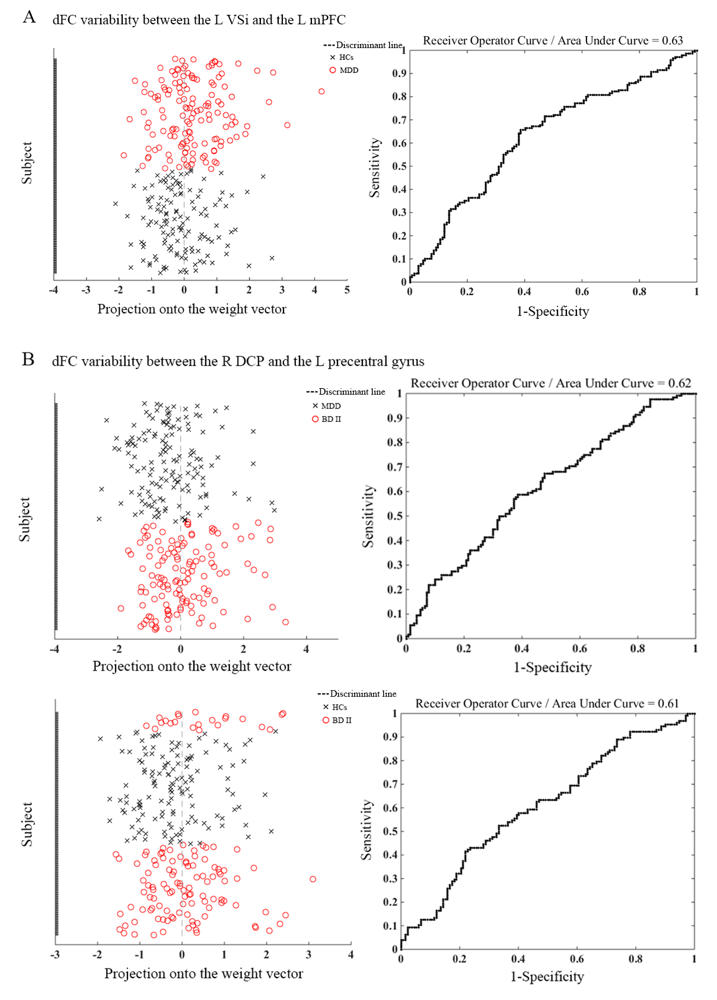Fig. S4. The results of the SVM classification and the ROC curve based on the significant different dFC variability maps among three groups. SVM, support vector machine; ROC, Receiver Operator Curve; dFC, dynamic functional connectivity; VSi, ventral striatum inferior; mPFC, medial prefrontal cortex; DCP, dorsal-caudal putamen; BD, bipolar disorder; MDD, major depressive disorder; HC, healthy control; L (R), left (right) hemisphere; The y-axis represents each subject.

Pattern classification analysis by using LIBSVM toolbox
Based on the dFC variability of the significantly different brain regions, the linear SVM was selected as the classifier to classify each of the two groups using LIBSVM toolbox (www.csie.ntu.edu.tw/~cjlin/libsvm/). To determine the classification features, a ten-fold cross-validation was used to evaluate classification performance (Liao et al., 2018; Varoquaux et al., 2017). The dataset was randomly divided into ten folds. Among them, one fold was selected as the testing set, and the remaining folds were used as training sets. In order to evaluate the statistical significance of accuracy in validation, the null distribution was obtained by performing nonparametric permutation tests (5,000 times). Statistical significance of the overall accuracy, sensitivity, and specificity was determined by permutation testing. The number of permutations to obtain a larger value than the true labels was used to obtain a P value. The receiver operating characteristic (ROC) curve was plotted to show the classification accuracy of the classifier.
Results of pattern classification analysis by using LIBSVM toolbox
Based on the dFC variability showing significant group effects, the ROC curves were plotted to examine their ability to distinguish patients with MDD from HCs, patients with BD II from patients with MDD, and patients with BD II from HCs. The dFC variability between the left VSi and the left mPFC provided the highest classification power to distinguish patients with MDD from HCs (Area Under Curve (AUC) = 0.61; sensitivity = 0.40; specificity = 0.80; Fig. S5A). The dFC variability between the right DCP and the left precentral gyrus provided the highest classification power to distinguish patients with BD II from patients with MDD (AUC = 0.61; sensitivity = 0.41; specificity = 0.80; Fig. S5B) and patients with BD II from HCs (AUC = 0.61; sensitivity = 0.70; specificity = 0.48; Fig. S5B).
Fig. S5. The results of the SVM classification and the ROC curve based on the significant different dFC variability maps among three groups. dFC, dynamic functional connectivity; VSi, ventral striatum inferior; mPFC, medial prefrontal cortex; DCP, dorsal-caudal putamen; SVM, support vector machine; ROC, Receiver Operator Curve; AUC, Area Under Curve; BD, bipolar disorder; MDD, major depressive disorder; HC, healthy control; L (R), left (right) hemisphere; The y-axis represents the subject number.

Participants
We combined BD II and MDD into one group as the patients with depressive symptoms. Finally, 268 patients were recruited in the patients group, and 132 HCs were recruited.
Statistical analysis between patients group and HCs group
Independent-sample t-test and X² test were used to compare the demographic data between the patients group and HCs group using SPSS17.0 software (SPSS, Chicago, IL, USA). All tests were two-tailed, and p < .05 was considered statistically significant. The one-sample t test was performed to demonstrate the within-group dFC variability distribution of each striatum seed in patients group and HCs group. The significant level was set at a P value less than 0.05 (uncorrected). Next, a two-sample t-test was performed on the standard deviation in the z value at each voxel within the union mask of one-sample t test results of two groups. Age, gender and years of education and the mean frame-wise displacement (FD) were included as nuisance covariates in the comparisons. The Gaussian random field (GRF) theory was used for the cluster-level multiple comparison correction (minimum z > 2.3; cluster significant: P < 0.05, corrected).
Results
Demographic information
Table S1 shows the demographic and clinical information for all the study participants.
Dynamic functional connectivity variability of the striatum seeds
According to the two-sample t-test, patients with depressive symptoms exhibited increased dFC variability between the right VRP and the right IPL compared with HCs (Fig.S6 and Table S2).
Table S1. Demographic and clinical data and (standard deviations) by group

 | Patients | HCs | P value
Number of subjects | 268 | 132
Age (years) | 27.01 (10.46) | 29.27 (8.99) | 0.026*
Gender (male/female) | 119/149 | 61/71 | 0.732†
Education (years) | 13.30 (3.03) | 15.39 (3.40) | 0.000*
Age at onset (years) | 24.62 (10.36) | n/a
Number of episodes | 2.43 (1.47) | n/a
HDRS-24 scores | 25.95 (6.12) | n/a
YMRS scores | 2.95 (3.21) | n/a
Duration of illness (months) | 38.04 (51.00) | n/a
Means (with standard deviations in parentheses) are reported unless otherwise noted.
HCs, Healthy controls; HDRS, Hamilton Depression Rating Scale; YMRS, Young Mania Rating Scale.
* The P values were obtained by Independent-sample t-test.
† The P value for gender distribution was obtained by chi-square test.
Table S2. The significant dynamic FC variability differences between patients groups and HCs group
Seed | Significant regions | BA | voxels | MNI |  |  | T | Comparisons | P
 |  |  |  | x | y | z
R VRP | R IPL/supramarginal | 40 | 77 | 63 | -30 | 21 | 4.098 | Patients> HCs | <0.05
FC, functional connectivity; BA, Brodmann Area; MNI, Montreal Neurological coordinate; VRP, ventral-rostral putamen; IPL, inferior parietal lobule; L (R), left (right) hemisphere.
Fig. S6. The significant dFC variability differences between two groups for striatum seed (minimum z > 2.3; cluster significance: P < 0.05, GRF corrected). The color bar indicates the t value from two-sample t-test. dFC, dynamic functional connectivity; GRF, Gaussian random field; VRP, ventral-rostral putamen; L (R), left (right) hemisphere.
References:
Jenkinson, M., Bannister, P., Brady, M., & Smith, S. (2002). Improved optimization for the robust and accurate linear registration and motion correction of brain images. Neuroimage, 17, 825-841. doi: 10.1016/s1053-8119(02)91132-8.
Liao, W., Li, J., Duan, X. J., Cui, Q., Chen, H., & Chen, H. F. (2018). Static and dynamic connectomics differentiate between depressed patients with and without suicidal ideation. Human Brain Mapping, 39, 4105-4118. doi:10.1002/hbm.24235.
Schrouff, J., Rosa, M. J., Rondina, J. M., Marquand, A. F., Chu, C., Ashburner, J., . . . Mourao-Miranda, J. (2013). PRoNTo: pattern recognition for neuroimaging toolbox. Neuroinformatics, 11, 319-337. doi:10.1007/s12021-013-9178-1.
Varoquaux, G., Raamana, P. R., Engemann, D. A., Hoyos-Idrobo, A., Schwartz, Y., & Thirion, B. (2017). Assessing and tuning brain decoders: Cross-validation, caveats, and guidelines. Neuroimage, 145, 166-179. doi:10.1016/j.neuroimage.2016.10.038.
Yan, C. G., Wang, X. D., Zuo, X. N., & Zang, Y. F. (2016). DPABI: Data Processing & Analysis for (Resting-State) Brain Imaging. Neuroinformatics, 14, 339-351. doi:10.1007/s12021-016-9299-4.

