Supplementary Information for

When expanding training from working memory to emotional working memory: not only improving explicit emotion regulation but also implicit negative control for anxious individuals

Dong-ni Pan^{1,2}, Delhii Hoid^{1,2}, Xiao-bo Wang^{1,2}, Zhuo Jia^{1,2}, Xuebing Li^{1,2, *}

1 Key laboratory of Mental Health, Institute of Psychology, Chinese Academy of Sciences, Beijing 100101, China
2 Department of Psychology, University of Chinese Academy of Sciences, Beijing 10049, China

*Correspondence: Xuebing Li, Key Laboratory of Mental Health, Institute of Psychology, Chinese Academy of Sciences; No 16 Lincui Rd Chaoyang District, Beijing 100101
Email: lixb@psych.ac.cn

This PDF file includes:

Detailed methods
Detailed results
Supplementary analysis
Table S1 to Table S2
Figures S1 to Figure S3
SI References

Detailed methods

Training tasks
We developed a new type of dual dimension n-back training application designed for smartphone use. The training task required participants to remember the color (red, green, yellow or blue) and position (3×3 matrix) of a colored block and then judge whether the color and position of the current block was the same as the forward nth character. At Level 1 (the number of levels was the number of n), the participant only needed to compare whether the current block color and position was the same as the previous color block. At level 2, the participant needed to compare whether the current block color and position was the same as the previous second character, and so on. Participants were required to press the screen button corresponding to Color (left button) or Position (right button) in response to the two separate attributes.
In each trial, the Color Block was presented for 500 ms and was followed by a blank screen presented for 2,500 ms. A completed training block contained 20 + n trials. The trials targeted at color and position were randomly assigned within 4–6 trials to reduce the propensity of participants to guess.
Animated feedback would flash at the edge of the button in three possible ways: ‘Correct’, ‘Wrong’ or ‘Miss’. After each training block was completed, feedback consisting of number of hits, false alarms, misses and total scores for the session of training was made available to participants. The total score was calculated as: (correct hit number/target number) × (correct rejection number/non-target number) × 100%, which ranged from 0 to 100. Training was progressive and adaptive. For each participant, task difficulty dynamically changed depending on their performance (based on scores from completed blocks).
Starting at Level 1, if scores from the two consecutive blocks were greater than or equal to 85 points, then training would move on to the next level; if scores from the two consecutive blocks were lower than 20 points, then task level would drop.
Participants in training groups were required to complete 30 training blocks every day for about 40 minutes. Between any two blocks, participants could take a rest. After daily training was completed, a training report would be presented, including whether the participant completed the 30 training blocks or not and their highest training level for the day. Historical results were cleared every day (12:00), which meant that all participants began their training from Level 1 every day. Participants were asked to train for 21 days within a month, with no more than a week's pause.
We used two training versions. Typical working memory training (WM-T) and emotional working memory training (EWM-T). The special feature of EWM-T was that the memory materials did not consist of pure color blocks, but instead included a face with a negative emotion transposed onto the color of the block. Twelve faces of fear, anger, disgust and sadness (half male and half female) were selected from the Chinese Facial Affective Picture System (CFAPS;(Gong, Huang, Wang, & Luo, 2011), which were then colored red, green, yellow and blue. In the EWM-T version, 192 (12×4×4) colored faces were used as memory materials, while the rules and operations were completely consistent with the WM-T. The training diagram is shown in Figure S1.

Self-reported questionnaires

Spielberg Trait Anxiety Inventory (STAI-T)
The STAI-T comprises 20 items, scored on a four-point Likert-type response scale, which assesses the tendency of individuals to experience stress, worry, and discomfort (Spielberger et al., 1970). The Chinese version of STAI-T used in our study has demonstrated good internal consistency (Cronbach alpha = 0.89), and can be used as a reliable assessment tool to screen individuals with trait anxiety in the Chinese culture (Shek, 1993).

Depression Anxiety Stress Scales (DASS-21)
DASS-21 is composed of three subscales of depression, anxiety and stress with each subscale containing seven questions (four-point Likert-type). It is a reliable and valid method of assessing features of depression, anxiety, and tension-stress in clinical and nonclinical groups (Antony, Bieling, Cox, Enns, & Swinson, 1998). The Chinese version of DASS-21 has high reliability and validity, which can be used as an effective tool to investigate the level of negative emotions among Chinese college students (Gong, Xie, Xu, & Luo, 2010). This was used as a tool to measure mood alteration before and after training.

Cognitive Emotion Regulation Questionnaire (CERQ)
CERQ is made of 36 items that are used to evaluate nine cognitive strategies of both adaptive (acceptance, positive refocusing, refocus on planning, positive reappraisal and putting into perspective) and maladaptive (self-blame, other-blame, focus on thought and catastrophizing) forms following the experience of a threatening or stressful life event (Garnefski, Kraaij, & Spinhoven, 2001). Each strategy is assessed using four items each with a 5-point scale, from 1 (never) to 5 (always). The Chinese version of the CERQ has satisfactory reliability and validity among college students (Wei, & Liu., 2008), and can be an effective tool for the subjective measurement of explicit emotion regulation.

Independent assessment Spatial 2-back task
Spatial 2-back task was used to measure the near transfer benefits of the training. In spatial 2-bakc task, target stimuli (“o”) were occurring 500 ms at 40 (8 for X axis, 5 for Y axis) randomly selected locations. After 1500ms of blank screen, next stimulus of random position appears. Participants were required to judge whether or not the spatial location of the current stimulus matched the location of that on forward second stimulus. Specifically, they were told to respond continuously from the third stimulus, to press the "F" key with their left index finger for the matching items and the "J" key with their right index finger for the non-matching items. The match and non-match trials are 50% respectively. Pseudo-random order prevents three consecutive pressures of F or J from occurring. The task contained 2 blocks and each block had 50+2 trials, resulting in 100 reacting trials and about 5 minutes.

Explicit Emotion regulation task
We modified the EEG emotional regulation task used in previous studies (Pan et al., 2019). In this task, 180 negative images (560 × 420 pixels) from the International Affective Picture System (Lang, Bradley, & Cuthbert, 1999) were divided into pre-test and post-test settings and each picture set was assigned to one of three conditions (viewing, reappraisal and distraction). There were no significant differences in normative valence and arousal between the pre- and post-test picture sets or among the three conditions.
We adopted a block design in which participants were required to view negative images. Crucially, the way that participants viewed the images altered depending on the block condition. In the Negative Watch block, participants were asked to view the negative images passively.
In the Reappraise block, participants should adopt a neutral attitude toward the image content and reconstruct the meaning of what they were viewing. Instructions for the cognitive reappraise block were as follows: “Next, you will see some emotional pictures. Please view each of them carefully as they are presented. At the same time, we would like to see how well you can control the way you view these images. So please try your best to adopt a neutral attitude as you view them. Try to reflect on them objectively and analytically rather than in any way that is personally or emotionally relevant to you. For instance, you could imagine that these pictures are taken from films or artificially created
by Photoshop.” There will be six trials exercises before the formal recording. In the Distract condition, participants were asked to focus on the non-emotional background instead of core image content. The specific instructions for the ‘Distraction’ blocks were as follows: “Next you will see some emotional pictures. When the image is presented, please put your attention on things that have nothing to do with the core content of the image, such as the background behind the character or event.”
Each block (condition) contained 30 images. In each viewing or regulation trial, a “+” fixation point was presented at the center of the screen for 500 ms, after which the instruction words corresponding to the appeared for 1,000 ms block (i.e., “watching”, “reappraisal”, or “distraction”). Following a blank screen lasting 500–800 ms, a picture was presented for 3,000 ms. Once the image left the screen, participants needed to complete the 9-point score rating of their current emotional state (valence) ranging from 1 (very negative) to 9 (very positive). They were also asked to provide a rating of emotional intensity (arousal degree) ranging from 1 (very weak) to 9 (very strong). Once completed, the next trial would begin.

Facial Stroop tasks
Emotional attention bias processing was assessed using a modified emotional face-color Stroop task (Lee et al., 2009) accompanied by EEG. Twelve face pictures for each emotional expression (disgust, fear and neutral) with equal gender (260*300 pixels) were selected from the CFAPS, but the faces used in the training APP (in the EWM-T) were excluded. Participants were asked to ignore the expression of the faces and instead identify the color that they were tinted with (red, yellow, green or blue) by pressing a key (“D”, “F”, “J” or “K” respectively) as quickly as possible on a keyboard. For each trial, faces were presented after a 1500ms fixation point and for a 300ms duration in a pseudo-random fashion to ensure that there were no appearances of the same color on three consecutive trials. Inter-stimulus-interval duration varied randomly at 1700±2000 ms. 144 facial combinations (12 persons × 3 expressions × 4 colors) were randomly repeated two times, and the total number of 288 trials were broken down into six blocks. Pre-test and post-test consisted of the same task requirements although the stimuli sequence differed.

EEG recoding and analyses
We recorded EEG data during performance of the emotional regulation task and facial Stroop task during both pre- and post-training assessment. Electroencephalography (EEG) was continuously recorded with a NeuroscanAynamp2 Amplifier using 64 Ag-AgCl electrodes cap (NeuroScanInc., Herndon, VA, USA) placed on the scalp according to the extended International 10/20 system. EEG activity was recorded using a right mastoid reference electrode and re-referenced offline to the mean of bilateral mastoid electrodes. All electrode impedances were maintained below 5 KΩ. EEG activity was amplified with an AC 0.05-100 Hz band-pass and was continuously sampled at a rate of 500 Hz. EEG data were processed using EEGLAB (Delorme & Makeig, 2004), an open source toolbox running in the MATLAB environment. Continuous EEG data were subjected to low-pass digital filtering of 45Hz (slope of 24 dB/oct).
EEG epochs were extracted in the emotion regulation tasks with a temporal window from -500 ms to 3,000 ms relative to the picture onset (-500ms for baseline correction); and in facial Stroop task with a temporal window from -200 ms to 800 ms relative to the onset of face stimuli (-200ms for baseline correction). Trials contaminated by eyeblinks and movements were corrected using an Independent Component Analysis (ICA) algorithm (Jung, Makeig, Bell, & Sejnowski, 1998; Makeig, Bell, Jung, & Sejnowski, 1996). Artificial EEG (±80 uV) was automatically removed from further analysis. Signals were averaged across trials and time-locked to the onset of the compound stimuli for each condition of the emotion regulation task (negative-watching, reappraisal and distraction); and to the conditions of the facial Stroop task (disgust, fear and neutral).
According to the grand averaging waveform and distribution of topographic map of all subjects participated in pre-test of emotion regulation task, a time window of 350-800ms was selected for LPP analyses. Electrode points of ‘P5’ ‘P3’ ‘P1’ ‘PZ’ ‘P2’ ‘P4’ ‘P6’ ‘P8’ ‘PO5’ ‘PO3’ ‘POZ’ ‘PO4’ ‘PO6’ which can reflect the prominent LPP were averaged for further analysis. Similarly, a time window of 250-450ms was selected for P3 analyses in the emotional facial Stroop task, electrodes of ‘CP3’ ‘CPZ’ ‘CP4’ ‘P3’ ‘PZ’ ‘P4’, which can reflect the prominent P3, were averaged for further analysis.

Detailed results

Questionnaire

Depression Anxiety Stress Scales
For the DASS-depression subscale, the main effect of time was significant (F (1,95) = 10.47, p = 0.002, η_{p}² = 0.099). Depression scores among all three groups were significantly lower at post-test (M = 5.21, SE = 0.40) than at the pre-test (M = 6.80, SE = 0.46). The interaction between group and time was not significant (F (2,95) = 0.275, p =0.760, η_{p}² = 0.006).
For the DASS-anxiety subscale, there was a significant main effect of time (F (1,95) = 20.43, p < 0.001, η_{p}² = 0.177), but a significant interaction between group and time (F (2,95) = 4.08, p = 0.020, η_{p}² = 0.079). Paired sample t tests (pre-test vs. post-test) for each group showed that individuals in the WM-T and EWM-T groups demonstrated a significant reduction in anxiety (WM-T: t (32) = 4.49, p < 0.001; EWM-T: t (34) = 3.89, p < 0.001), while no anxiety reduction was observed in the Control group (t (29) = 0.227, p = 0.882).
For the DASS-tension stress subscale, there was a significant main effect of time (F (1,95) = 20.24, p < 0.001, η_{p}² = 0.176), but a significant interaction between group and time (F (2,95) = 3.59, p = 0.032, η_{p}² = 0.070). Paired sample t tests (pre-test vs. post-test) for each group showed that individuals in the WM-T and EWM-T groups demonstrated a significant reduction in stress (WM-T: t (32) =2.55, p = 0.015; EWM-T: t (34) = 4.09, p < 0.001), while no stress reduction was observed in the Control group (t(29) =1.071, p = 0.293).

Cognitive Emotion Regulation Questionnaire
We found a main effect of time for self-blame (F (1,95) = 6.57, p = 0.012, η_{p}² = 0.065), focusing on thought (F (1,95) =19.40, p < 0.001, η_{p}² = 0.170), catastrophizing (F (1,95) =14.12, p < 0.001, η_{p}² = 0.129), and refocusing on planning (F (1,63) = 8.90, p = 0.004, η_{p}² = 0.086). Scores were favorably affected for each group with scores being significantly reduced for self-blame (pre-test: M = 14.32, SE =0.28; post-test: M =13.53, SE = 0.31), focus on thought (pre-test: M =15.07, SE = 0.30; post-test: M =13.81, SE = 0.33), catastrophizing (pre-test: M = 11.61, SE = 0.35; post-test: M =10.46, SE = 0.33), and significantly increased for refocusing on planning (pre-test M =15.04, SE = 0.22; post-test: M =15.72, SE = 0.19).
In addition, a significant main effect of time (F (1,63) =12.02, p = 0.001, η_{p}² = 0.112) and but significant interaction between time and group for positive refocusing was revealed (F (1,95) = 4.92, p = 0.009, η_{p}² = 0.094). Paired sample t tests (pre-test vs. post-test) for each group showed that positive refocusing was significantly increased in the WM-T group (t (32) = -3.92, p < 0.001) and EWM-T group (t(34) =-3.12, p = 0.004), but no changes in the Control group (t(29) = 0.51, p = 0.661).

Emotional regulation task

Behavior ratings
Three-way ANOVA (Time: pre-test/post-test × Condition: view/reappraisal/distraction × Group: Control/WM-T/EWM-T) were performed for valence rating and arousal rating respectively.
For valence rating, we found that the main effect of time is significant, (F (1,190) = 13.56, p < 0.001, η_{p}² = 0.125). The valence rating at post-test (M = 4.16, SE = 0.053) was higher than pre-test (M=3.99, SE =0.056). The main effect of condition was significant (F (2,190) = 325.96, p < 0.001, η_{p}² = 0.774). The valence rating for passively viewing (M = 3.22, SE = 0.076) was significantly lower than reappraisal (M = 4.33, SE = 0.055), and the rating for reappraisal was significantly lower than distraction (M = 4.68, SE = 0.068), p_{s}<0.001; For ratings of arousal, we found that the main effect of condition was significant (F (2,190) = 169.89, p<0.001, η_{p}² = 0.641). The arousal rating of Viewing (M = 5.28, SE = 0.15) was significantly higher than reappraisal (M = 3.97, SE = 0.14), and the arousal rating for reappraisal was significantly higher than distraction (M = 3.41, SE = 0.14), p_{s}<0.001.

LPP
Three-way ANOVA (Time: pre-test/post-test × Condition: view/reappraisal/distraction × Group: Control/WM-T/EWM-T) were performed for the averaged LPP amplitudes of selected electrodes.
We found that the main effect of condition is significant [ F (2,190) = 7.11, p = 0.01, η_{p}² = 0.101]. Post hoc test showed LPP amplitude of simply viewing was significantly higher than reappraisal (p = 0.050) and distraction(p<0.001); the amplitude of reappraisal was larger than distraction (p = 0.054).The main effect of time was significant, F(1, 190) = 9.30, p = 0.03, η_{p}² = 0.129, but we found a significant triple interaction of conditions, time and group (F (4,190) = 3.17, p = 0.015, η_{p}²= 0.063), only the LPP reduction (pre-test minus post-test) in the reappraisal condition was modulated by group. Specifically, the LPP amplitude for reappraisal at the post-test was significantly lower than at pre-test for WM-T group (t (32) = 2.25, p = 0.015) and EWM-T group (t (34) = 2.76, p = 0.009), which was not observed in the Control group (t (29) = -0.94, p = 0.345).

Facial Stroop task

Behavior results
Three-way ANOVA (Time: pre-test/post-test × Condition: neutral/disgust/fear × Group: Control/WM-T/EWM-T) were performed for levels of accuracy during performance of the facial Stroop task. We found a significant main effect of time (F (1,95) = 6.61, p = 0.012, η_{p}² = 0.065), whereby accuracy at post-test (M = 0.96, SE = 0.006) was higher than at pre-test (M = 0.94, SE = 0.009).
Three-way ANOVA (Time: pre-test/post-test × Condition: neutral/disgust/fear × Group: Control/WM-T/EWM-T) were also performed for reaction times (RT) during performance of the facial Stroop task. We found a significant main effect of condition (F (2,190) = 6.15, p = 0.003, η_{p}² =0.061), RT of the fear faces (M = 348.14, SE =10.14) and the disgust faces (M = 345.77, SE =10.23) was significantly longer than the neutral faces (M = 339.71, SE =10.05), p_{s}<0.01, indicating the existence of a negative attention bias. In addition, the triple interaction of time × condition × is marginally significant F (4,190) = 2.16, p = 0.080, η_{p}² = 0.06.
To better decompose and visualize the marginal triple interactions, we calculated a behavior indicator of attention bias, i.e., the difference between RTs for responses to negative faces (including disgust and fear) and RTs for responses to neutral faces. Two-way ANOVA (Time: pre-test/post-test × Group: Control/WM-T/EWM-T) was performed, which indicated a significant time by group interaction (F (2,95) = 3.00, p = 0.050, η_{p}² = 0.054). Paired sample t test (pre-test and post-test) by group and observed that only individuals in the EWM-T group showed a significant reduction in attention bias, t (34) = 2.38, p = 0.023, but not in the Control t (29) = -0.18, p=0.856 or the WM-T group t (32) = -0.55, p = 0.584.

P3
Three-way ANOVA (Time: pre-test/post-test × Condition: neutral/disgust/fear × Group: Control/WM-T/EWM-T) were performed for averaged P3 amplitudes of selected electrodes. We found that a significant interaction of time by group F (2,95) = 3.38, p = 0.038, η_{p}² = 0.067. A paired sample t test by grouping showed that P3 at post-test was only significantly smaller than that at pre-test in the EWM-T group. This difference was particularly apparent for responses to negative faces (disgust: t (34) = 4.03, p < 0.001; fear: t (34) = 4.20, p < 0.001), but was also present for responses to neutral faces (t (34) = 2.75, p = 0.010). P3 changes for facial stimuli in the other groups were not significant.

Correlation analysis
We performed a correlation analysis of the variables that had been revealed to be modulated by training (i.e., the increased two-back grades, decreased DASS-tension stress and DASS-anxiety; the increased positive refocusing of CERQ; the decreed LPP during reappraisal; the reduced behavior negative bias; and the reduced P3 for negative faces). We found that the for participants in the training groups, the decreases in LPP amplitude during the reappraisal were positively correlated with self-reported positive refocusing promotion (WM-T: r(33) = 0.440, p = 0.010, EWM-T: r(35) = 5.91, p = 0.001, Both: r(68) = 0.523, p < 0.001). This indicates an association between regulation ability in the laboratory and habitual using. In addition, increases in positive refocusing were significantly associated with decreases in anxiety (WM-T: r (33) = 0.406, p = 0.019; EWM-T: r(35) = 0.448, p = 0.07; Both: r(68) = 0.422, p<0.001), suggesting a close relationship between adaptive emotion regulation and anxiety alleviation. In addition, only in the EWM-T group, P3 decreases in response to negative faces were positively correlated with decrease in negative bias scores (r (35) = 0.52, p = 0.001), and the negative bias reduction was further correlated with tension stress reduction (r (35) = 0.41, p = 0.014), indicating negative bias decreases can serve as a potential pathway to the alleviation of tension.

Supplementary analysis
For two training groups, a) Maximum Training Level (MTL, the highest level of training attained in 21-day training) and b) Average Training Level (ATL, the average of the optimal levels of 21 training days) were calculated as the indicator of the training improvements.
In order to examine the relationship between individual training progress level and the ultimate training benefit in more detail. We performed a correlation analysis between training improvement indicators (MTL, ATL) and the variables that had been revealed to be modulated by training (i.e., the increased two-back grades, decreased DASS-tension stress and DASS-anxiety; the increased positive refocusing of CERQ; the decreed LPP during reappraisal; the reduced behavior negative bias; and the reduced P3 for negative faces). However, no significant positive correlation was found, see table S1.
In addition, based on the whether ATL is larger than 4, individuals (working memory trainers) were divided into two groups (HPG, high performance group and LPG, low performance group). Although from the descriptive data, the HPG showed bigger near-transfer, more mood improvements and decreased LPP during reappraisal. The independent sample t test revealed no significant difference between HPG and LPG on these indicators, see table S2.

Table S1. Correlation matrix between individual training improvements and final benefit
 | 1 | 2 | 3 | 4 | 5 | 6 | 7 | 8 | 9
1 ATL | 1
2 MTL | .930** | 1
3 increased two-back grades | 0.111 | 0.106 | 1
4 reduced behavior negative bias | -0.103 | -0.169 | 0.028 | 1
5 reduced P3 for negative faces | -0.123 | -0.124 | -0.032 | .380** | 1
6 decreed LPP during reappraisal | 0.139 | 0.141 | -0.125 | -0.043 | 0.042 | 1
7 decreased DASS-anxiety | 0.086 | 0.071 | 0.043 | 0.065 | -0.066 | 0.142 | 1
8 decreased DASS-tension stress | 0.133 | 0.086 | .242* | .278* | 0.073 | -0.061 | .473** | 1
9 increased positive refocusing of CERQ | 0.1 | 0.056 | -0.13 | -0.028 | -0.056 | .523** | .422** | -0.036 | 1

Table S2. Comparison of transfer effect between high and low training improvements individuals.
 | LPG(N=32) |  |  | HPG(N=36)
 |  |  |  |  |  | t |  | p
 | M | SD |  | M | SD
increased two-back grades | 0.07 | (0.11) |  | 0.10 | (1.12) | -1.30 |  | 0.197
reduced behavior negative bias | 10.82 | (41.07) |  | 3.80 | (35.18) | 0.76 |  | 0.450
reduced P3 for negative faces | 3.45 | (4.92) |  | 2.25 | (5.69) | 0.92 |  | 0.359
decreed LPP during reappraisal | 0.59 | (1.90) |  | 1.20 | (1.61) | -1.43 |  | 0.158
decreased DASS-anxiety | 1.63 | (2.25) |  | 2.22 | (3.15) | -0.89 |  | 0.378
decreased DASS-tension stress | 1.66 | (4.04) |  | 3.00 | (4.16) | -1.35 |  | 0.182
increased positive refocusing of CERQ | 1.47 | (2.68) |  | 1.53 | (2.34) | -0.10 |  | 0.923

Supplementaty Figures

Figure 1
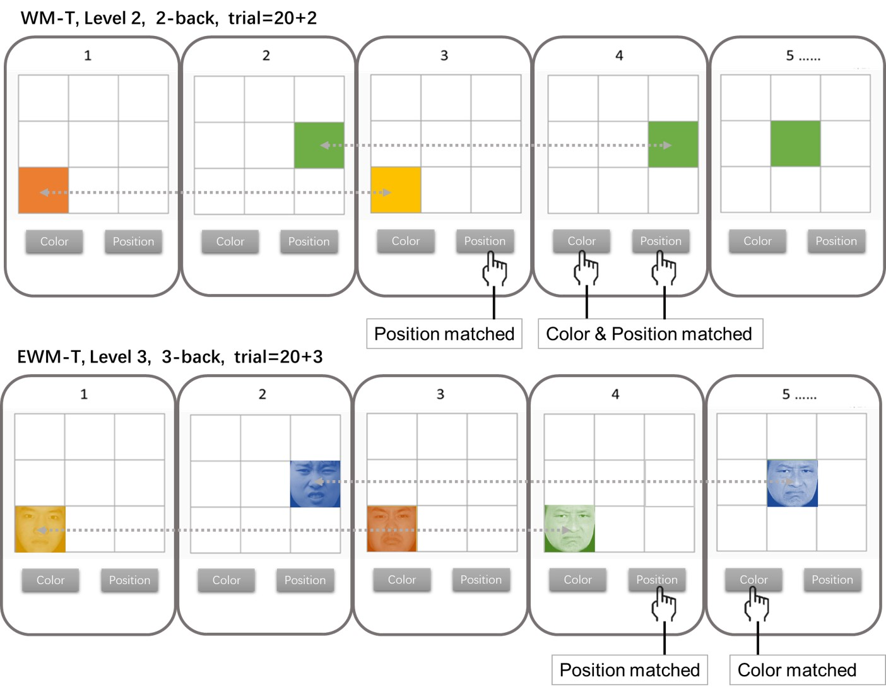
Figure 1. Training task diagram. The upper part represents WMT in level 2, and the lower part represents EWM-T in level 3.

Figure 2

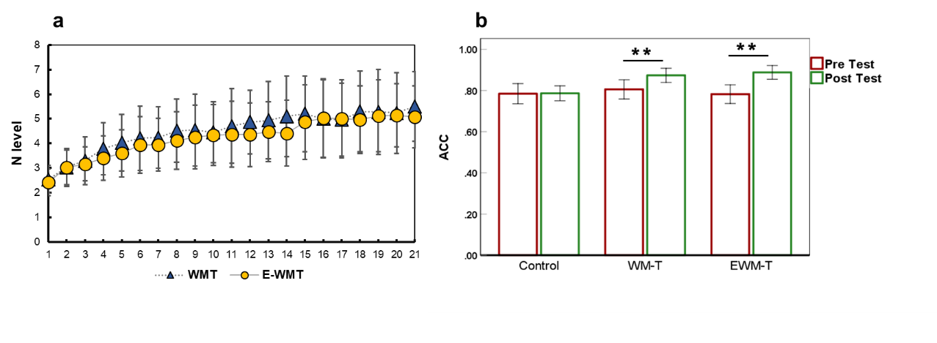
Figure 2. Training progress of working memory training. a) the training progress curves for 21 days of WM and EWM training. The recording index is the highest N-back level reached each day. Error bars represent the standard deviation of the highest training level for each group on that day; b) the improvements of the grades in the intendent space two-back task were observed in two training groups. **p < 0.01, Error bars represent the 95% confidence interval.

Figure 3

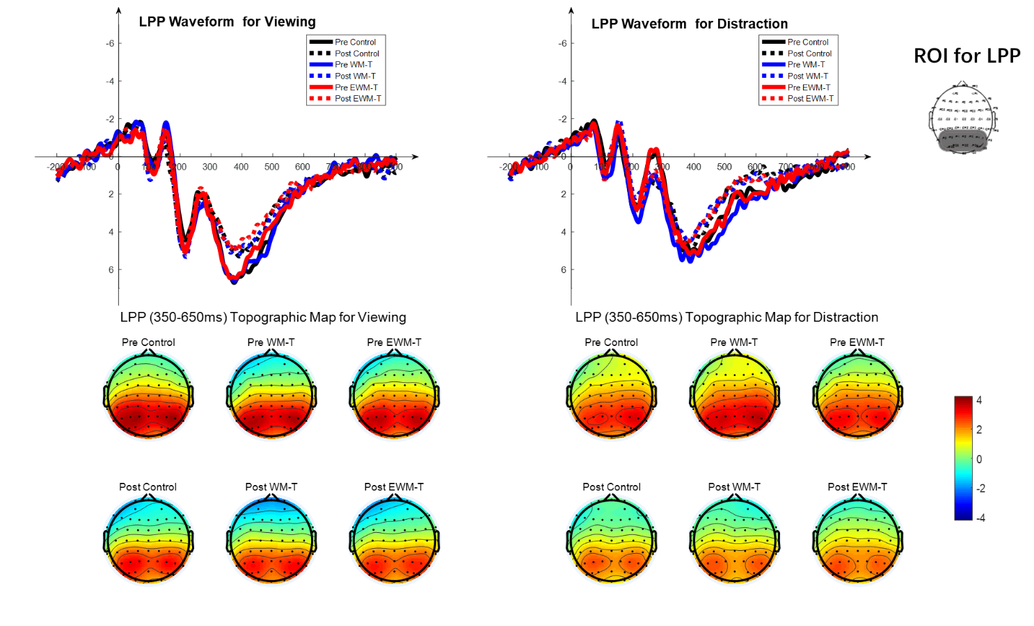
Figure S3. waveforms and topographic maps of the viewing and distraction

SI References
Delorme, A., & Makeig, S. (2004). EEGLAB: an open source toolbox for analysis of single-trial EEG dynamics including independent component analysis. Journal of Neuroscience Methods, 134(1), 9-21. doi:10.1016/j.jneumeth.2003.10.009
Garnefski, N., Kraaij, V., & Spinhoven, P. (2001). Negative life events, cognitive emotion regulation and emotional problems. Personality and Individual Differences, 30(8), 1311-1327. doi: 10.1016/S0191-8869(00)00113-6
Gong, X., Huang, Y. X., Wang, Y., & Luo, Y. J. (2011). Revision of the Chinese Facial Affective Picture System. Chinese Mental Health Journal.
Gong, X., Xie, X.-y., Xu, R., & Luo, Y.-j. (2010). Psychometric properties of the Chinese versions of DASS-21 in Chinese college students. Chinese Journal of Clinical Psychology, 18(4), 443-446.
Jung, T. P., Makeig, S., Bell, A. J., & Sejnowski, T. J. (1998). Independent component analysis of electroencephalographic and event-related potential data. Central Auditory Processing and Neural Modeling, 189-197.
Lang, P. J., Bradley, M. M., & Cuthbert, B. N. (1997). International affective picture system (IAPS): Instruction manual and affective ratings. The Center for Research in Psychophysiology, University of Florida, Gainesville, FL.
Makeig, S., Bell, A. J., Jung, T. P., & Sejnowski, T. J. (1996). Independent component analysis of electroencephalographic data. Advances in Neural Information Processing Systems 8, 8, 145-151.
Pan, D. N., Wang, Y., & Li, X. B. (2019). Strategy Bias in the Emotion Regulation of High Trait Anxiety Individuals: An Investigation of Underlying Neural Signatures Using ERPs. Neuropsychology, 33(1), 111-122. doi:10.1037/neu0000471
Wei, Y.-M., & Liu, Y.-X. (2008). Reliability and validity of the Cognitive Emotion Regulation Questionnaire (CERQ) in Chinese college students. Chinese Mental Health Journal, 22(4), 281–284. Retrieved from http://search.ebscohost.com/login.aspx?direct=true&db=psyh&AN=2008-05450-009&site=ehost-live
Shek, D. T. (1993). The Chinese version of the State-Trait Anxiety Inventory: Its relationship to different measures of psychological well-being. J Clin Psychol, 49(3), 349-358.

