# Supplementary material

The role of callous-unemotional traits and aggression subtypes on amygdala activity in response to negative faces

# Table 1. Site and scanner details

Functional magnetic resonance imaging (fMRI) was performed across nine sites in Europe (Radboud University Medical Center and the Donders Institute for Brain, Cognition and Behavior, Nijmegen. The Netherlands; Department of Neuroscience, University Medical Center Groningen, The Netherlands; Central Institute of Mental Health (CIMH). Mannheim. Germany; Department of Psychiatry III and Child and Adolescent Psychiatry/Psychotherapy, University of Ulm. Ulm. Germany; Centre for Neuroimaging Sciences, Institute of Psychiatry, Psychology and Neuroscience, King’s College London. London, United Kingdom; Department of Child Psychiatry, Institute of Psychiatry, Psychology and Neuroscience, King’s College London. London. United Kingdom; Department of Child and Adolescent Psychiatry and Psychology, Neurosciences Institute. Hospital Clinic de Barcelona. Barcelona. Spain; Hospital General Universitario Gregorio Marañón. Madrid. Spain; MR Center, Psychiatric University Hospital, Zurich. Switzerland; IRCCS Santa Lucia Foundation, Rome. Italy.

|  |  |  |  |  |  |  |
| --- | --- | --- | --- | --- | --- | --- |
| Functional MRI scan parameters across sites. | | | | | | |
| **Scanner** | **Site** | **TR/TE (ms)** | **Number of slices** | **Slice scan order** | **Voxel size (mm)** |
| Siemens | Nijmegen | 2100/35 | 36 | descending | 3x3x3 |
|  | Mannheim | 2100/35 | 36 | descending | 3x3x3 |
|  | Ulm | 2100/35 | 36 | descending | 3x3x3 |
|  | Barcelona | 2100/35 | 36 | descending | 3x3x3 |
|  | Madrid | 2100/35 | 36 | descending | 3x3x3 |
|  | Rome | 2100/35 | 36 | descending | 3x3x3 |
| Philips | Groningen | 2100/35 | 39 | descending | 3x3x3 |
|  | Zurich | 2100/35 | 36 | descending | 3x3x3 |
| GE* | London | 2100/35 | 36 | descending, interleaved | 3x3x3 |
| *All sites used a 32-channel head coil except for the General Electric 3-Tesla scanner (8-channel head coil). | | | | |  |  |

# Table 2 – Behavioural data – Accuracy (Correct response) and Reaction times

|  |  |  |  |  |  |  |  |
| --- | --- | --- | --- | --- | --- | --- | --- |
|  |  | Accuracy | |  | Reaction time | |  |
| Emotion | Group | Mean (%) | SD | p-value | Mean (s) | SD | p-value |
| Anger | TD | 83.82 | 17.61 | .147 | 2.22 | 0.49 | .173 |
|  | Cases | 76.25 | 24.10 | 2.38 | 0.58 |
| Fear | TD | 93.72 | 11.47 | **.018** | 1.94 | 0.45 | **.030** |
|  | Cases | 87.41 | 18.68 | 2.16 | 0.48 |
| Happy | TD | 86.72 | 17.29 | .228 | 1.97 | 0.48 | .314 |
|  | Cases | 80.52 | 21.09 | 2.09 | 0.50 |
| Neutral | TD | 94.93 | 11.89 | **<.001** | 1.95 | 0.44 | .582 |
|  | Cases | 83.32 | 23.13 | 2.01 | 0.50 |
| Shapes | TD | 90.94 | 13.39 | .404 | 1.43 | 0.49 | .975 |
|  | Cases | 84.13 | 20.37 | 1.50 | 0.53 |
| Note: TD: Typically developing peers. Cases = ODD/CD: Oppositional deviant disorder/Conduct disorder. Bonferroni corrected. | | | | | | | |

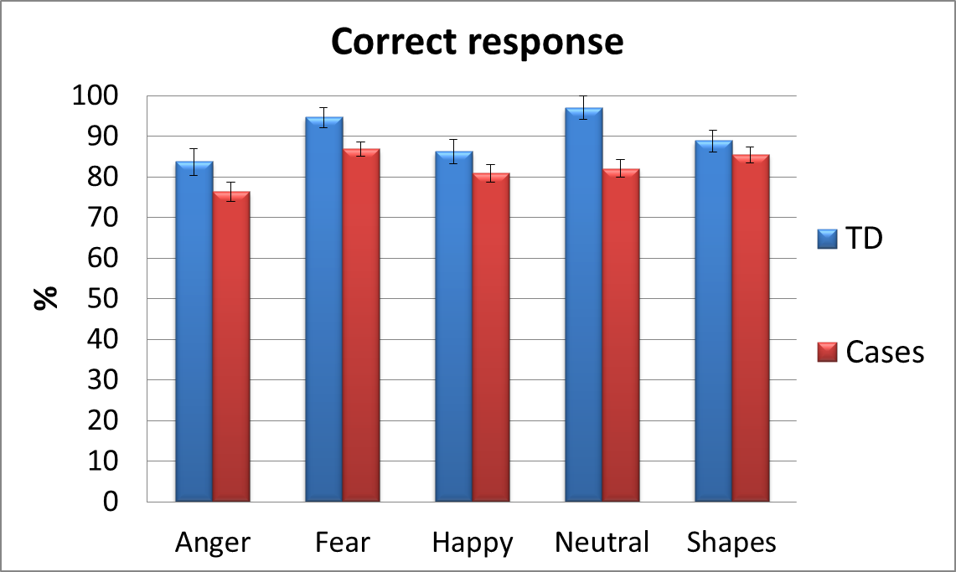

*

*

# Table 3 - Whole brain analysis for negative vs shapes between Cases and TD

|  |  |  |  |  |  |  |  |
| --- | --- | --- | --- | --- | --- | --- | --- |
| Region | Voxel size | Peak level | | | MNI coordinates (mm) | | |
|  |  | T | Z-score | p(unc) | x | y | z |
| Left superior occipital area | 31 | 3.73 | 3.65 | 0.000 | -24 | -91 | 23 |
| Frontal_Inf_Oper_L | 59 | 3.69 | 3.61 | 0.000 | -51 | 11 | 23 |
|  | 3.67 | 3.59 | 0.000 | -45 | 20 | 32 |
| Left amygdala | 10 | 3.61 | 3.54 | 0.000 | -27 | -4 | -13 |
| Left inferior parietal gyrus | 13 | 3.48 | 3.41 | 0.000 | -36 | -61 | 53 |

Brain regions were defined using the Automated anatomical labeling (AAL).

# Table 4 - Whole brain analysis for positive vs shapes between Cases and TD

|  |  |  |  |  |  |  |  |
| --- | --- | --- | --- | --- | --- | --- | --- |
| Region | Voxel size | Peak level | | | MNI coordinates(mm) | | |
|  |  | T | Z-score | p(unc) | x | y | z |
| Not labeled | 20 | 4.11 | 4.00 | 0.000 | 9 | 2 | -10 |
| Occipital_Sup_L | 28 | 4.09 | 3.98 | 0.000 | -18 | -94 | 29 |
| Olfactory_L | 22 | 3.97 | 3.88 | 0.000 | -3 | 11 | -10 |
|  | 3.63 | 3.55 | 0.000 | -6 | -1 | -13 |
| Frontal_Mid_R | 45 | 3.87 | 3.78 | 0.000 | 33 | 26 | 50 |
| Frontal_Sup_R |  | 3.45 | 3.39 | 0.000 | 24 | 38 | 44 |
|  | 3.29 | 3.23 | 0.001 | 24 | 23 | 62 |
| Frontal_Inf_Orb_R | 21 | 3.74 | 3.66 | 0.000 | 24 | 14 | -25 |
|  | 3.69 | 3.62 | 0.000 | 18 | 17 | -19 |
| Frontal_Med_Orb_L | 12 | 3.62 | 3.54 | 0.000 | -9 | 44 | -13 |
| Frontal_Med_Orb_R | 26 | 3.62 | 3.54 | 0.000 | 6 | 50 | -7 |
|  | 3.34 | 3.28 | 0.001 | 15 | 41 | -10 |
|  | 3.23 | 3.17 | 0.001 | 6 | 38 | -13 |
| Postcentral_R | 32 | 3.60 | 3.52 | 0.000 | 51 | -13 | -25 |
|  | 3.59 | 3.52 | 0.000 | 54 | 2 | -28 |

Brain regions were defined using the Automated anatomical labeling (AAL).

# Table 5 – Regression analysis parent ICU total scale. Whole brain analysis

|  |  |  |  |  |  |  |  |
| --- | --- | --- | --- | --- | --- | --- | --- |
| Region | Voxel size | Peak level | | | MNI coordinates (mm) | | |
|  |  | T | Z-score | p(unc) | x | y | z |
| Cingulum_Post_L | 81 | 4.44 | 4.30 | 0.000 | -6 | -43 | 11 |
| Temporal_Sup_R | 14 | 4.15 | 4.03 | 0.000 | 45 | -7 | -13 |
| Not labeled | 70 | 4.06 | 3.95 | 0.000 | -18 | 47 | -1 |
|  | 3.66 | 3.58 | 0.000 | -15 | 35 | -1 |
|  | 3.58 | 3.50 | 0.000 | -27 | 47 | -4 |
| Precuneus_L | 47 | 3.80 | 3.70 | 0.000 | 0 | -73 | 47 |
| Cuneus_R |  | 3.43 | 3.37 | 0.000 | 3 | -79 | 38 |
| Parietal_Inf_L | 13 | 3.65 | 3.57 | 0.000 | -36 | -73 | 47 |
| Cingulum_Mid_L | 17 | 3.61 | 3.53 | 0.000 | -9 | -43 | 38 |
| Insula_L | 13 | 3.50 | 3.43 | 0.000 | -36 | -1 | -1 |

Brain regions were defined using the Automated anatomical labeling (AAL).

Note: The influence of the CU traits was analyzed coding group as -1 ODD/CD HCU. 0 Typically developing children and 1 ODD/CD LCU.

# Table 6 - Non-medicated participants only ( Negative vs Shapes)

|  |  |  |  |  |  |  |  |
| --- | --- | --- | --- | --- | --- | --- | --- |
| Region | Voxel size | Peak level | | | MNI coordinates (mm) | | |
|  |  | T | Z-score | p(unc) | x | y | z |
| Frontal_Mid_L | 136 | 4.26 | 4.07 | 0.000 | -48 | 23 | 32 |
| Frontal_Inf_Oper_L |  | 3.95 | 3.80 | 0.000 | -51 | 11 | 23 |
| Precentral_L |  | 3.56 | 3.45 | 0.000 | -51 | 11 | 35 |
| Parietal_Inf_L | 38 | 3.80 | 3.66 | 0.000 | -36 | -67 | 47 |
| Not labeled | 10 | 3.66 | 3.53 | 0.000 | -36 | -49 | 35 |
| Frontal_Mid_L | 15 | 3.60 | 3.48 | 0.000 | -27 | 5 | 53 |
| Not labeled | 22 | 3.58 | 3.47 | 0.000 | -21 | -43 | 47 |

Brain regions were defined using the Automated anatomical labeling (AAL).

Note: This analysis was based on 44 ODD/CD children and 69 typically developing peers.

# Table 7 - ANCOVA with ROI left Amygdala activity

|  |  |  |  |  |  |
| --- | --- | --- | --- | --- | --- |
| *Tests of Between-Subjects Effects* | | | | | |
| Dependent Variable: Left Amygdala_ROI [Negative faces vs Shapes] | | | | | |
| Source | Type III Sum of Squares | df | Mean Square | F | Sig. |
| Corrected Model | 9.561 | 13 | .735 | 2.546 | .003 |
| Intercept | .001 | 1 | .001 | .004 | .952 |
| Group | 3.569 | 1 | 3.569 | 12.354 | .001 |
| Sites | 5.151 | 8 | .644 | 2.229 | .028 |
| Age | .001 | 1 | .001 | .005 | .946 |
| Medication | 2.120 | 1 | 2.120 | 7.338 | .007 |
| Gender | .039 | 1 | .039 | .134 | .715 |
| IQ | .117 | 1 | .117 | .406 | .525 |
| Error | 47.090 | 163 | .289 |  |  |
| Total | 62.384 | 177 |  |  |  |
| Corrected Total | 56.651 | 176 |  |  |  |
| a. R Squared = .169 (Adjusted R Squared = .102) | | | | | |

ROI = Region of interest. ANCOVA= Analysis of covariance. Fixed factors: Sites and Group. Covariates: Age, Sex, IQ and Medication. Significant impact of group and medication for the left amygdala activity was found. Amygdala activity showed to differ between Sites. sex and age.

# Table 8 - ANCOVA with ROI left Amygdala activity excluding sites with less than 5 participants for each group

|  |  |  |  |  |  |
| --- | --- | --- | --- | --- | --- |
| *Tests of Between-Subjects Effects* | | | | | |
| Dependent Variable: Left Amygdala_ROI [Negative faces vs Shapes] | | | | | |
| Source | Type III Sum of Squares | df | Mean Square | F | Sig. |
| Corrected Model | 6.993a | 9 | .777 | 2.569 | .009 |
| Intercept | .015 | 1 | .015 | .049 | .824 |
| Group | 3.559 | 1 | 3.559 | 11.770 | .001 |
| Sites | 1.924 | 4 | .481 | 1.591 | .181 |
| Age | .024 | 1 | .024 | .078 | .780 |
| Medication | 2.227 | 1 | 2.227 | 7.366 | .008 |
| Gender | .325 | 1 | .325 | 1.074 | .302 |
| IQ | .212 | 1 | .212 | .701 | .404 |
| Error | 39.613 | 131 | .302 |  |  |
| Total | 50.373 | 141 |  |  |  |
| Corrected Total | 46.606 | 140 |  |  |  |
| a. R Squared = .150 (Adjusted R Squared = .092) | | | | | |

ROI = Region of interest. ANCOVA= Analysis of covariance. Fixed factors: Sites and Group. Covariates: Age, Sex, IQ and Medication. Significant impact of group and medication for the left amygdala activity was found. Amygdala activity showed not to differ between Sites, sex and age