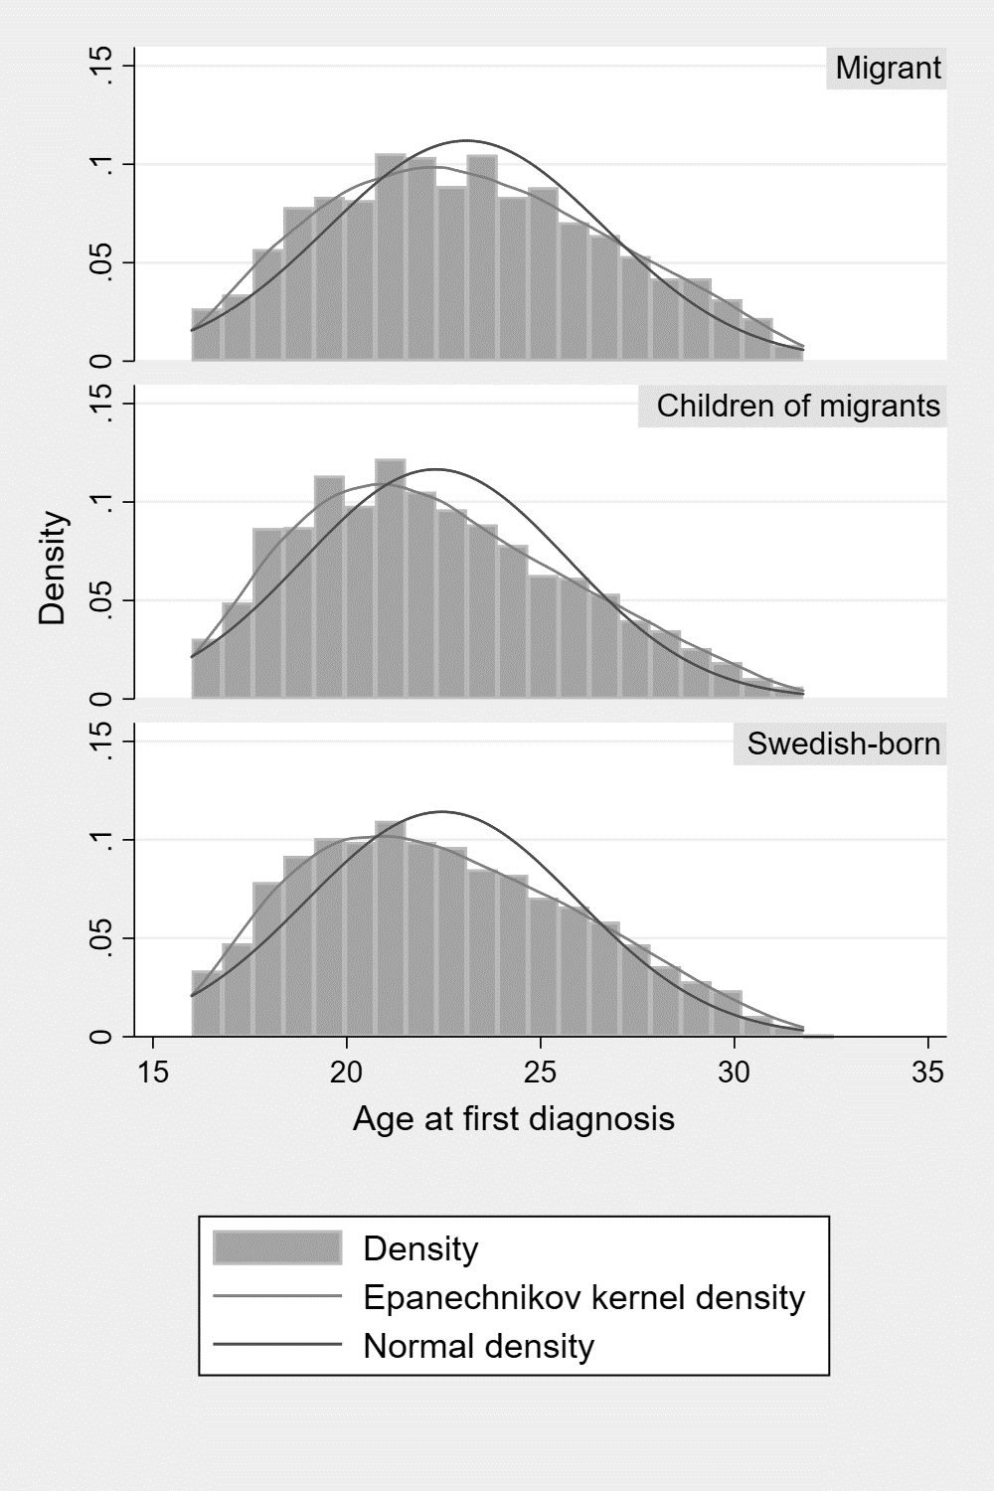
Supplemental Figure 1: Histogram of age at first diagnosis, by migrant status

Legend: The distribution of age-at-first diagnosis for psychotic disorder was positively skewed for all groups (see blue and green density functions), but differed by migrant status (Kruskal-Wallis Χ² test on 2 degrees of freedom: 66.7; p<0.001), with migrants having a later median age-at-first-diagnosis (22.9; IQR: 20.4-25.6) than children of migrants (21.9 years; IQR: 19.6-24.6) or Swedish-born participants (22.1; IQR: 19.7-25.0).

Supplement Table 1: List of countries by region of origin
Region of origin | SMA classification | Countries¹
Sweden² | Sweden | Sweden
Nordic | Nordic | Denmark, Norway, Finland, Iceland
Europe | UK & Ireland | UK, Ireland
 | Western Europe | Austria, Belgium, France, Germany, Liechtenstein, Luxembourg, Netherlands, Switzerland
 | Southern Europe | Andorra, Gibraltar, Greece, Italy, Malta, Monaco, Portugal, San Marino, Spain, Vatican City
 | Eastern Europe | Albania, Belarus, Bulgaria, Czech Republic, Hungary, Moldova, Poland, Romania, Slovakia, Ukraine
 | Former Yugoslavia | Bosnia Herzegovina, Croatia, Kosovo, Macedonia, Montenegro, Serbia, Slovenia
 | Russia & the Baltic States | Estonia, Latvia, Lithuania, Russia
Asia & Oceania | Oceania | Australia, New Zealand, Fiji, Kiribati, Marshall Islands, Micronesia Federated States, Nauru, Palau, Papua New Guinea, Samoa, Solomon Islands, Tuvalu, Tonga, Vanuatu
 | Central Asia | Afghanistan, Armenia, Azerbaijan, Bangladesh, Bhutan, Georgia, India, Kazakhstan, Kyrgyzstan, Maldives, Nepal, Pakistan, Sri Lanka, Tajikistan, Turkmenistan
 | Northeast Asia | China, Japan, Mongolia, People’s Republic of Korea, South Korea, Taiwan
 | Southeast Asia | Brunei, Cambodia, East Timor, Hong Kong, Indonesia, Laos, Malaysia, Myanmar, Philippines, Singapore, Thailand, Vietnam
Middle East & North African | Iran | Iran
 | Iraq | Iraq
 | Middle East, other | Bahrain, Cyprus, Israel, Jordan, Kuwait, Lebanon, Oman, Palestine, Qatar, Saudi Arabia, Syria, United Arab Emirates, Yemen, Turkey
 | North Africa | Algeria, Egypt, Libya, Morocco, Tunisia
Sub-Saharan Africa | West Africa | Benin, Burkina Faso, Cape Verde, Gambia, Ghana, Guinea, Guinea Bissau, Ivory Coast, Liberia, Mali, Mauritania, Niger, Nigeria, Senegal, Sierra Leone, Togo
 | East Africa | Djibouti, Eritrea, Ethiopia ,Somalia
 | Africa, other | Angola, Botswana, Burundi, Cameroon, Central African Republic, Chad, Comoros, Congo, Democratic Republic of Congo, Equatorial Guinea, Gabon, Kenya, Lesotho, Madagascar, Malawi, Mauritius, Mozambique, Namibia, Rwanda, Sao Tome and Principe, Seychelles, South Africa, Swaziland, Tanzania, Uganda, Zambia, Zanzibar
North & South America | USA & Canada | USA, Canada
 | North America, other | Antigua and Barbuda, Bahamas, Barbados, Belize, Costa Rica, Cuba, Dominica, Dominican Republic, El Salvador, Grenada, Guatemala, Haiti, Honduras, Jamaica, Mexico, Nicaragua, Panama, Saint Kitts and Nevis, Saint Lucia, Saint Vincent and the Grenadines, Trinidad and Tobago
 | South America, South | Argentina, Brasil, Chile, Uruguay
 | South America, other | Bolivia, Colombia, Ecuador, Guyana, Paraguay, Peru, Surinam, Venezuela
¹Countries of origin, as defined by the Swedish Migration Agency [SMA], in each SMA category. Country-level data is not made available by the SMA/Statistics Sweden for research purposes.
Supplement Table 2: Comparison of sample by missing data status
Variables | Non-missing |  | Missing |  | Χ²-test (df);
 | n | % | n | % | p-value
Compulsory admission |  |  |  |  | 5.1 (1); 0.02
Voluntary | 10,394 | 97.1 | 308 | 3.0
Involuntary | 1,246 | 96.0 | 52 | 4.0
Migrant status |  |  |  |  | 539.9 (2); <0.001
Swedish-born | 7,107 | 98.8 | 87 | 1.2
Migrants | 1,912 | 89.3 | 230 | 10.7
Children of migrants | 2,621 | 98.4 | 42 | 1.6
Sex |  |  |  |  | 8.3 (1); 0.004
Male | 6,913 | 96.6 | 241 | 3.4
Female | 4,727 | 97.5 | 119 | 2.5
Age at diagnosis |  |  |  |  | 31.0 (3); <0.001
16-19 | 3,246 | 98.3 | 56 | 1.7
20-23 | 4,559 | 96.5 | 165 | 3.5
24-27 | 2,924 | 96.8 | 96 | 3.2
28-31 | 911 | 95.5 | 43 | 4.5
Region |  |  |  |  | 398.7 (9); <0.001
Sweden | 7,107 | 98.8 | 87 | 1.2 | -
Nordic | 235 | 95.5 | 11 | 4.5
Europe | 747 | 94.3 | 45 | 5.7
Asia + Oceania | 355 | 91.3 | 34 | 8.7
Middle East + North Africa | 817 | 91.8 | 73 | 8.2
Sub-Saharan Africa | 506 | 88.2 | 68 | 11.9
North + South America | 232 | 95.9 | 10 | 4.1
Children of migrants:
Swedish-Nordic | 610 | 97.0 | 19 | 3.0
Swedish-migrant | 862 | 98.9 | 10 | 1.2
Mixed migrant | 169 | 99.4 | 10 | 0.6
Family income |  |  |  |  | 58.5 (4); <0.001
Quintile 1 (lowest) | 1,281 | 96.7 | 44 | 3.3
Quintile 2 | 2,098 | 98.5 | 32 | 1.5
Quintile 3 | 2,712 | 98.4 | 43 | 1.6
Quintile 4 | 2,983 | 99.1 | 27 | 0.9
Quintile 5 (highest) | 2,566 | 99.5 | 13 | 0.5
Population density |  |  |  |  | 7.3 (4); 0.12
Quintile 1 (lowest) | 1,594 | 99.1 | 14 | 0.9
Quintile 2 | 1,952 | 98.3 | 34 | 1.7
Quintile 3 | 2,197 | 98.2 | 40 | 1.8
Quintile 4 | 2,762 | 98.1 | 53 | 1.9
Quintile 5 (highest) | 3,135 | 98.3 | 54 | 1.7
Neighbourhood deprivation index |  |  |  |  | 44.2 (4); <0.001
Quintile 1 (lowest) | 1,424 | 99.1 | 13 | 0.9
Quintile 2 | 1,740 | 99.2 | 14 | 0.8
Quintile 3 | 2,037 | 99.0 | 21 | 1.0
Quintile 4 | 2,557 | 98.5 | 40 | 1.5
Quintile 5 (highest) | 3,882 | 97.3 | 107 | 2.7
Neighbourhood ethnic density¹ |  |  |  |  | 9.5 (4); 0.05
Quintile 1 (lowest) | 963 | 95.8 | 40 | 4.2
Quintile 2 | 995 | 96.0 | 38 | 4.0
Quintile 3 | 915 | 97.1 | 27 | 2.9
Quintile 4 | 917 | 97.1 | 27 | 2.9
Quintile 5 (highest) | 893 | 94.9 | 48 | 5.1
¹Comparison restricted to migrants and children of migrants

Supplement Table 3: Adjusted odds of compulsory admission by region of origin, with and without adjustment for family income (n=11,640)
 | Adjusted¹ |  |  | Adjusted²
 | OR | 95% CI |  | OR | 95% CI
Region
Sweden | 1.00 | - | - | 1.00 | - | -
Nordic | 0.68 | 0.40 | 1.14 | 0.68 | 0.40 | 1.14
Europe | 1.27 | 1.01 | 1.61 | 1.29 | 1.02 | 1.64
Asia + Oceania | 1.17 | 0.83 | 1.65 | 1.20 | 0.84 | 1.70
Middle East + North Africa | 1.46 | 1.17 | 1.81 | 1.49 | 1.19 | 1.87
Sub-Saharan Africa | 1.94 | 1.51 | 2.49 | 1.99 | 1.54 | 2.57
North + South America | 1.29 | 0.86 | 1.93 | 1.30 | 0.86 | 1.94
Children of migrants:
Swedish-Nordic | 1.33 | 1.03 | 1.72 | 1.33 | 1.03 | 1.73
Swedish-migrant | 1.13 | 0.89 | 1.42 | 1.13 | 0.90 | 1.43
Mixed migrant | 0.79 | 0.45 | 1.39 | 0.79 | 0.45 | 1.39
Family income
Quintile 1 (lowest) | - | - | - | 1.00 | - | -
Quintile 2 | - | - | - | 1.15 | 0.91 | 1.44
Quintile 3 | - | - | - | 1.00 | 0.80 | 1.25
Quintile 4 | - | - | - | 1.06 | 0.85 | 1.32
Quintile 5 (highest) | - | - | - | 1.09 | 0.87 | 1.37

¹Adjusted for sex, age group at diagnosis and population density. As per Table 2.
²Additional adjustment for family income

Supplement Table 4: Stratified analysis of compulsory admission and neighbourhood own-group migrant density by migrant status, mutually adjusted for other variables
Variables | Adjusted OR (95% CI) for migrants¹ | Adjusted OR (95% CI) for children of migrants¹ | LRT (df) p-value for interaction with migrant status²
Participant N (%): | 1,800 (40.9%) | 2,605 (59.1%) | -
Region of origin |  |  | 1.0 (5); p=0.97
Nordic | 1 | 1
Europe | 1.25 (0.47 – 3.31) | 2.19 (1.03 – 4.64)
Asia + Oceania | 1.24 (0.45 – 3.42) | 1.87 (0.64 – 5.43)
Middle East + North Africa | 1.45 (0.54 – 3.89) | 2.22 (1.08 – 4.58)
Sub-Saharan Africa | 1.99 (0.75 – 5.31) | 3.59 (1.63 – 7.88)
North + South America | 1.47 (0.52 – 4.22) | 2.31 (0.86 – 6.22)
Children of migrants:
Swedish-Nordic | - | 2.41 (1.22 – 4.76)
Swedish-migrant | - | 2.10 (1.08 – 4.12)
Mixed migrant | - | 1.54 (0.66 – 3.61)
Population density | 1.14 (0.99 – 1.31) | 1.05 (0.94 – 1.18) | 0.4 (1); p=0.55
Neighbourhood own-region migrant density (z-standardised) | 1.09 (0.96 – 1.24) | 1.16 (1.01 – 1.33) | 0.5 (1); p=0.47
¹Adjusted for age group, sex and other parameters in the table
²Likelihood ratio test [LRT] Χ² statistic, degrees of freedom [df], and p-value for interaction between migrant status and other variable on odds of compulsory admission

Supplement Table 5: Distribution of family disposable income by selected region of origin¹ (n=11,640)
 | Family disposable income quintile (N, %)
Region | Low | 2 | 3 | 4 | High
Sweden | 374 (5.3) | 1,219 (17.2) | 1,549 (21.8) | 2,049 (28.8) | 1,916 (27.0)
Nordic | 45 (19.2) | 52 (22.1) | 54 (23.0) | 41 (17.5) | 43 (18.3)
Europe | 180 (24.1) | 140 (18.7) | 171 (22.9) | 171 (22.9) | 85 (11.4)
Swedish-Nordic children of migrants | 39 (6.4) | 117 (19.2) | 159 (26.1) | 163 (26.7) | 132 (21.6)

¹Χ²-test on 12 degrees of freedom, p-value: 474.8, p<0.001

