SUPPLEMENTARY MATERIALS

Supplementary Table 1: Prisma checklist.
Supplementary Table 1. Table displaying the Prisma Checklist items and the page numbers the items are on in the manuscript.

Section/topic | # | Checklist item | Reported on page #
TITLE
Title | 1 | Identify the report as a systematic review, meta-analysis, or both. | 1
ABSTRACT
Structured summary | 2 | Provide a structured summary including, as applicable: background; objectives; data sources; study eligibility criteria, participants, and interventions; study appraisal and synthesis methods; results; limitations; conclusions and implications of key findings; systematic review registration number. | 2-3
INTRODUCTION
Rationale | 3 | Describe the rationale for the review in the context of what is already known. | 3-4
Objectives | 4 | Provide an explicit statement of questions being addressed with reference to participants, interventions, comparisons, outcomes, and study design (PICOS). | 4
METHODS
Protocol and registration | 5 | Indicate if a review protocol exists, if and where it can be accessed (e.g., Web address), and, if available, provide registration information including registration number. | 5
Eligibility criteria | 6 | Specify study characteristics (e.g., PICOS, length of follow-up) and report characteristics (e.g., years considered, language, publication status) used as criteria for eligibility, giving rationale. | 5-6
Information sources | 7 | Describe all information sources (e.g., databases with dates of coverage, contact with study authors to identify additional studies) in the search and date last searched. | 5
Search | 8 | Present full electronic search strategy for at least one database, including any limits used, such that it could be repeated. | Supplementary materials
Study selection | 9 | State the process for selecting studies (i.e., screening, eligibility, included in systematic review, and, if applicable, included in the meta-analysis). | 5-7
Data collection process | 10 | Describe method of data extraction from reports (e.g., piloted forms, independently, in duplicate) and any processes for obtaining and confirming data from investigators. | 6-7
Data items | 11 | List and define all variables for which data were sought (e.g., PICOS, funding sources) and any assumptions and simplifications made. | 5-6
Risk of bias in individual studies | 12 | Describe methods used for assessing risk of bias of individual studies (including specification of whether this was done at the study or outcome level), and how this information is to be used in any data synthesis. | 6-7
Summary measures | 13 | State the principal summary measures (e.g., risk ratio, difference in means). | 7
Synthesis of results | 14 | Describe the methods of handling data and combining results of studies, if done, including measures of consistency (e.g., I²) for each meta-analysis. | 7

From: Moher D, Liberati A, Tetzlaff J, Altman DG, The PRISMA Group (2009). Preferred Reporting Items for Systematic Reviews and Meta-Analyses: The PRISMA Statement. PLoS Med 6(7): e1000097. doi:10.1371/journal.pmed1000097

Item 2: Standardised Search strategy

The following search string was used within each database. For all searches the limits were English language, 2011-current and human

“Posttraumatic stress disorder” or ptsd or psychological adj2 trauma
And
Child* or adolescen* or teen* or youth or “young adult” or undergrad*
And
Counsel* or therap* or intervention or psychoeducation or training

For Embase the following MeSH terms were used:
Posttraumatic stress disorder
And
Adolescent or adolescent health or adolescent behaviour or adolescent development
And
Cognitive therapy or play therapy or aversion therapy or emotion-focused therapy or couple therapy or art therapy or early goal-directed therapy or cognitive behavioral therapy or therapy effect or "acceptance and commitment therapy" or sleep therapy or recreational therapy or dance therapy or family therapy or virtual reality exposure therapy or behavior therapy or reality therapy or device therapy or systemic therapy or short course therapy or combination drug therapy or exposure therapy or group therapy or narrative therapy or music therapy or therapy or cognitive remediation therapy or anger management therapy

For Medline the following MeSH terms were used:
Stress Disorders, Post-Traumatic
And
Adolescent Medicine or Adolescent Health or Adolescent Psychology or Adolescent Development or Adolescent Psychiatry or Adolescent Behaviour or Adolescent Health Services or Adolescent
And
Psychotherapy or Cognitive Behavioural Therapy

For Psycinfo the following MeSH terms were used:
War or Military Veterans or Posttraumatic Stress Disorder or Trauma or Natural Disasters or Stress
And
Adolescent Psychiatry or Adolescent Behaviour or Adolescent Psychotherapy or Adolescent Development or Adolescent Psychology or Adolescent Psychopathology or Adolesecnt Health
And
Treatment

Supplementary Table 2: Standardised data extraction form

Supplementary Table 2. Data extraction table for systematic review

Study | Country |  | Mean age (years) (range/sd) | Description of participants | Sample size | Number of females (%); number of males %) | Description of Intervention | Description of control | Primary outcome  measures | Post-treatment effect sizes (d) | Follow-up period (months) | Follow-up Treatment effect size (d) | Key Findings

Supplementary Table 3: Secondary outcomes table

Some interventions were more effective at reducing depressive symptoms compared to controls (i.e. De Roos et al., 2017; Jensen et al., 2014). In some interventions there was no difference in reduction of depressive symptoms between conditions (i.e. Cohen et al., 2011; Dorsey et al., 2014) and in some studies there was no reduction in depressive symptoms between pre and post-assessment (Ertl et al., 2011).

Supplementary Table 3. Secondary measures and outcomes of included studies

Study | Secondary outcomes | Outcome measure | Key Findings
Barron et al. (2013) | Depression | DSRS¹ | There were significant reductions in depression and mental health difficulties in TRT¹⁶ group compared with WL¹⁷ group.
 | Emotional and Behavioural Difficulties | SDQ²
Barron et al. (2016) | Depression | DSRS¹ | There was no difference in depression scores between TF-CBT²⁰ and WL¹⁷ at posttest.
Chen et al. (2014) | Depression | CESD-R³ | There were differences in reduction of depressive symptoms between CBT¹⁸ group and control, and CBT ¹⁸and general support at three-month follow up.
Church et al. (2012) | Not applicable | Not applicable | Not applicable
Cohen et al. (2011) | Anxiety | SCARED⁴ | Mean scores for the TF-CBT²⁰ group moved from the clinical range to the reference range on the SCARED⁴, but scores remained in the clinical range for CCT²¹ group
 | Depression | CDI⁵ | No difference in change in depressive symptoms between TF-CBT²⁰ group and CCT²¹ group. Both were effective at reducing behavioural problems
 | Cognitive Functioning | Kaufman Brief Intelligence Test | Evidence of a difference in TF-CBT²⁰ group and CCTgroup cognitive functioning. TF-CBT²⁰ reported better cognitive functioning compared with CCT ²¹
 | Total Behaviour Problems | CBCL⁶ | No difference in change in Behavioural problems across the interventions. Both are effective at reducing behavioural problems
Study | Secondary outcomes | Outcome measure | Key Findings
Dawson et al. (2018) | Depression | CDI⁵ | Depression didn’t decrease following intervention in either intervention arm.
 | Anger | Anger Expression Scale for Children | Anger decreased following the intervention in both conditions.
De Roos et al. (2011) | Depression | DSRS | CBT¹⁸ and EMDR²³ were equally effective in reducing symptoms of depression, anger or behavioural problems.
 | Anxiety | MASC⁷
 | Behaviour problems | CBCL⁶
De Roos et al. (2017) | Anxiety and Depression | RCADS-C⁸ | EMDR²³ and CBWT²⁴ groups had greater reductions in symptoms of anxiety and depression compared with WL group
 | Emotional and Behavioural Difficulties | SDQ²-Parent-reported | EMDR²³ and CBWT²⁴ groups had greater reductions in  parent reported emotional and behavioural symptoms compared with WL¹⁷ group
 | Quality of Life | Kidscreen-27 | EMDR²³ group had better quality of life compared with WL¹⁷
Deblinger et al. (2011) | Externalising problems | CBCL⁶ | Children who received TF-CBT²⁰ without the trauma narrative were rated by their parents as having fewer externalising problems than children assigned to trauma narrative conditions
 | Anxiety | MASC⁷ | Children assigned to the 8 session TF-CBT²⁰ condition with a trauma narrative component reported less anxiety at post-treatment compared with children assigned to the 8 session TF-CBT²⁰ without a trauma narrative component.
 | Fear | Fear Thermometer | Children who had received the trauma narrative component described less fear regarding the abuse compared with children in the no trauma narrative conditions.

Study | Secondary outcomes | Outcome measure | Key Findings
Diehle et al. (2014) | Depression | RCAS | There were improvements in the TF-CBT²⁰ and EMDR intervention groups on child-reported RCAS subscales.  In the EMDR condition there were improvements on parent-reported RCAS subscales except for the separation anxiety disorder and social phobia subscale.
Dorsey et al. (2014) | Depression | CDI⁵ | There were no differences on any of the clinical outcomes by study condition. Both TF-CBT²⁰ with engagement and TF-CBT²⁰ standard condition had improvements of 0.87 in CBCL⁶ internalising scores per month, improvements of 0.4 in CBCL⁶ externalising scores and improvements of 0.37 in CDI⁵ per month
 | Emotional and Behavioural difficulties | Internalising and Externalising Scales of CBCL⁶
Ertl et al. (2011) | Depression symptoms | Module A of the MINI⁹ | There was no difference in reduction of depression symptoms or suicidal ideation between the narrative exposure therapy group, the academic catch-up group or wait-list group. There was no difference in these outcomes at pre and post-treatment.
 | Suicidal ideation | Module C of the MINI⁹
Foa et al. (2013) | Depressive severity | CDI⁵ | Both those receiving PE²⁶ and Supportive Counselling had improvements in depressive symptoms.  Those in the PE²⁶ group had greater improvements than those in supportive counselling groups (Difference in improvement 4.9, 95% CI 1.6-8.2)  These improvements in depressive symptoms were maintained through the 12 month follow up
Study | Secondary outcomes | Outcome measure | Key Findings
Ford et al. (2012) | Anxiety | TSCC¹⁰ anxiety subscale | Both treatments had small to medium effect size changes in anxiety, depression and anger.  TARGET²⁷ had greater improvements on anxiety compared with ETAU²⁸ had greater improvements on anger compared with TARGET²⁷
 | Depression | TSCC¹⁰ depression subscale
 | Anger | TSCC¹⁰ anger subscale
Goldbeck et al. (2016) | Depression | CDI⁵ | TF-CBT²⁰ was superior to WL¹⁷ in terms of depressive symptoms
 | Anxiety | SCARED⁴ | TF-CBT²⁰ was superior to WL²⁰ in terms of anxiety symptoms
 | Behavioural difficulties | CBCL⁶ | TF-CBT²⁰ was superior to WL¹⁷ in terms of improvements in behavioural difficulties
 | Quality of Life | Quality of Life Inventory for Children | There was no superiority of TF-CBT²⁰ compared with WL¹⁷ in terms of Quality of Life after treatment
Jensen et al. (2014) | Depression | MFQ³⁵ | Those receiving TF-CBT²⁰ reported lower depression symptoms compared with those receiving TAU after treatment (14.40 vs 22.67)
 | Anxiety | SCARED⁴ | There was no effect of treatment condition on child anxiety symptoms
 | General mental health problems | SDQ² | Those in TAU group TF-CBT²⁰ group had lower scores in the SDQ² than those in the TAU group
Mannarino et al. (2012) | Depression | CDI⁵ | Nr
 | Anxiety | MASC⁷ | Children’s anxiety symptoms continued to decline post treatment.  Children’s anxiety was lower at 12 month follow-up compared with posttreatment
Murray et al. (2015) | Behavioural difficulties | CBCL⁶ | Nr

Study | Secondary outcomes | Outcome measure | Key Findings
Nixon et al. (2012) | Depression | CDI⁵ and BDI³⁶ | Nr
 | Anxiety | RCMAS¹¹ | Children who received CBT¹⁸ had less general anxiety after treatment and follow-up compared with before treatment  Children in CT group didn’t demonstrate any reduction in anxiety between pre and post-treatment. At 6 months they had less anxiety
 | Behavioural difficulties | CBCL⁶ | Nr
Nixon et al. (2017) | Depression | CDI⁶ | There were large effect sizes for reductions in depressive symptoms on CDI ⁵and RCMAS¹¹ in both groups  These effect sizes were all larger for the CBT¹⁸ group compared with CT group
 | Anxiety | RCMAS¹¹
 | Behavioural difficulties | CBCL⁶ | Children reported reductions in CBCL⁶ at 1 year follow-up
Pfeiffer et al. (2018) | Depression | Patient Health Questionnaire | Those in the MW³¹group had greater improvement in depression symptoms compared with Usual Care group. There was no improvement in the Usual Care group
Pityaratstian et al. (2015) | Not applicable | Not applicable | Not applicable
Rosner et al. (2019) | Depression | BDI³⁶ | Those in the D-CPT³³ participants showed greater and stable improvement in depression symptoms compared with those in WL¹⁷ condition
 | BPD Symptoms | BSL¹³-23 | Those in the D-CPT³³ participants showed greater and stable improvement in borderline personality disorder symptoms compared with those in WL ¹⁷condition
 | Behaviour and emotional Problems | YSR³⁷ | Those in the D-CPT ³³participants showed greater and stable improvement in behaviour problems compared with those in WL¹⁷ condition
Rossouw et al. (2016) | Depression | BDI³⁶ | Participants in ²⁶PE and SC had improvement on the BDI. Those in the PE group maintained improvements in depressive symptoms at 12 months, compared with those in SC group.

Study | Secondary outcomes | Outcome measure | Key Findings
Rossouw et al. (2018) | Depression | BDI³⁶ | Both groups had improvements in depressive symptoms after treatment, with the PE²⁶ group had a greater improvement compared with SC (Difference in mean scores:24.32 vs 16.4).
Scheeringa et al. (2011) | Depression | MDD module of PAPA¹⁴ | Effect sizes were large for depression, separation anxiety and oppositional defiant disorder at post-treatment  Effect sizes were not large for ADHD at post-treatment  Follow-up tests indicating effect of the treatment on depression, separation anxiety and Oppositional Defiant Disorder but not Attention Deficit Hyperactive Disorder.  The researchers didn’t report on differences between intervention groups
 | Separation anxiety | SAD module of PAPA¹⁴
 | Oppositional Defiant disorder | ODD module of PAPA¹⁴
 | ADHD | ADHD module of PAPA¹⁴
Schottelkorb et al. (2012) | Not applicable | Not applicable | Not applicable

Footnote: ¹DSRS: Depression Self-rating Scale for Children. ²SDQ: Strengths and Difficulties Questionnaire. ³CESD-R:Center for Epidemiologic Studies Depression Scale. ⁴SCARED: Screen for Child Anxiety Related Emotional Disorders. ⁵CDI: Children’s Depression Inventory. ⁶CBCL: Child Behavioural Checklist. ⁷MASC: Multidimensional Anxiety Scale For Children. ⁸RCADS: Revised Child Anxiety and Depression Scale. ⁹MINI: Mini International Neuropsychiatric Interview. ¹⁰TSCC: Trauma Symptom Checklist for Children. ¹¹RCMAS: Revised Children’s Manifest Anxiety Scale. ¹²BPD: Borderline Personality Disorder. ¹³BSL: Borderline symptom list. ¹⁴PAPA: Preschool Age Psychiatric Assessment. ¹⁵ADHD: Attention Deficit Hyperactive Disorder. ¹⁶TRT: Teaching Recovery Techniques. ¹⁷WL: Waiting List. ¹⁸CBT: Cognitive Behavioural Therapy. ¹⁹EFT: Emotional Freedom techniques. ²⁰TF-CBT: Trauma-focused Cognitive Behavioural Therapy. ²¹CCT: Child-centered therapy. ²²PS: Problem Solving. ²³EMDR: Eye Movement Desensitive Reprocessing. ²⁴CBWT: Cognitive Behaviour Writing Therapy. ²⁵NET: Narrative Exposure Therapy. ²⁶PE: Prolonged Exposure. ²⁷TARGET: Trauma Affect Regulation: Guide for Education and Therapy. ²⁸ETAU: Enhanced Treatment as Usual. ²⁹TLPT: Time Limited Dynamic Therapy for Adolescents. ³⁰CT: Trauma Focused therapy without exposure. ³¹MW: Mein Weg. ³²CATS-S: Child and Adolescent Trauma Screen- Self Report. ³³D-CPT: Developmentally Adapted Cognitive Processing Therapy. ³⁴CCPT: Child centred play therapy. ³⁵MFQ: Mood and Feelings Questionnaire. ³⁶BDI: Beck’s Depression Inventory. ³⁷YSR: Youth Self Report.

Supplementary Table 3: Individual effect sizes for meta-analysis

Supplementary Table 3. Table displaying the individual effect sizes for included studies in the meta-analysis
Study | Intervention | Control | Effect Size (Cohen’s d) | 95% CI
Barron et al. (2016) | TRT¹ | WL² | -0.66 |  | -1.00 to -0.33
Chen et al. (2014) | SC | No-treatment | -0.19 |  | -1.03 to 0.65
Chen et al. (2014) | CBT³ | No treatment | -0.48 |  | -1.33 to 0.37
Church et al. (2012) | EFT⁴ | WL² | -8.54 |  | -11.66 to -5.42
Cohen et al. (2011) | TF-CBT⁵ | CCT⁶ | -0.15 |  | -0.50 to 0.20
De Roos et al. (2011) | CBT³ | EMDR⁸ | 0.09 |  | -0.54 to 0.71
De Roos et al. (2017) | EMDR⁸ | WL² | -1.42 |  | -2.02 to -0.81
De Roos et al. (2017) | CWBT⁹ | WL² | -1.05 |  | -1.63 to -0.46
Diehle et al. (2014) | TF-CBT⁵ | EMDR⁸ | -0.06 |  | -0.62 to 0.51
Ertl et al. (2011) | SC | WL² | -0.34 |  | -0.89 to 0.21
Ertl et al. (2011) | NET¹⁰ | WL² | -0.31 |  | -0.85 to 0.23
Foa et al. (2013) | PE¹¹ | SC | -0.76 |  | -1.34 to -0.18
Ford et al. (2012) | TARGET¹² | ETAU¹³ | 0.24 |  | -0.34 to 0.83
Goldbeck et al. (2016) | TF-CBT⁵ | WL² | -0.43 |  | -0.75 to -0.12
Jensen et al. (2014) | TF-CBT⁵ | TAU | -0.44 |  | -0.81 to -0.07
Nixon et al. (2012) | TF-CBT⁵ | CT¹⁵ | -0.02 |  | -0.71 to 0.66
Study | Intervention | Control | Effect Size (Cohen’s d) |  | 95% CI
Pityaratstian et al. (2015) | Group CBT³ | WL² | -0.06 |  | -0.72 to 0.59
Scheeringa et al. (2011) | TF-CBT⁵ | WL² | -1.18 |  | -2.50 to 0.14
Schottelkorb et al. (2012) | CCPT¹⁹ | TF-CBT⁵ | -0.22 |  | -0.99 to 0.56

Footnote: ¹TRT: Teaching Recovery Techniques. ²WL: Waiting List. ³CBT: Cognitive Behavioural Therapy. ⁴EFT: Emotional Freedom techniques. ⁵TF-CBT: Trauma-focused Cognitive Behavioural Therapy. ⁶CCT: Child-Centered Therapy. ⁷PS: Problem Solving. ⁸EMDR: Eye Movement Desensitive Reprocessing. ⁹CBWT: Cognitive Behaviour Writing Therapy. ¹⁰NET: Narrative Exposure Therapy. ¹¹PE: Prolonged Exposure. ¹²TARGET: Trauma Affect Regulation: Guide for Education and Therapy. ¹³ETAU: Enhanced Treatment as Usual. ¹⁴TLPT: Time Limited Dynamic Therapy for Adolescents. ¹⁵CT: Trauma Focused therapy without exposure. ¹⁶MW: Mein Weg. ¹⁷CATS-S: Child and Adolescent Trauma Screen- Self Report. ¹⁸D-CPT: Developmentally Adapted Cognitive Processing Therapy. ¹⁹CCPT: Child Centred Play Therapy.

Supplementary Figure.1: Forest plot sensitivity analysis

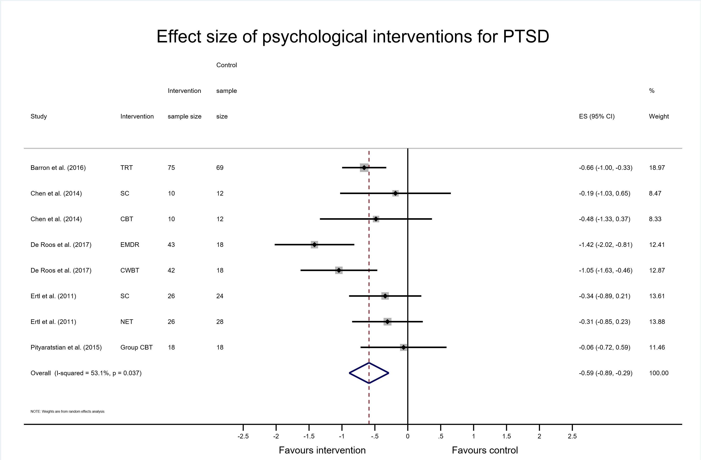
Supplementary figure 1. Forest plot showing individualised and the combined effect size for studies with normality of data
Supplementary Figure 2: Forest plot for the subgroup analysis
Supplementary Figure 2. Forest plot for interventions investigating the effectiveness of interventions in different age groups

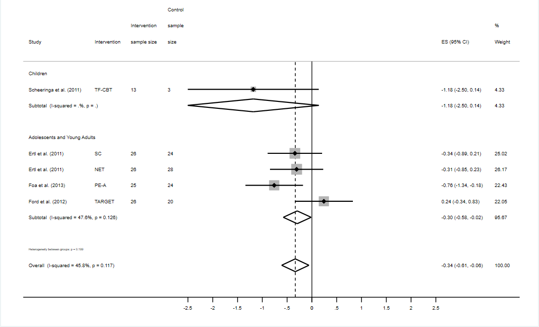
Supplementary Figure 3.: Funnel plot

We assessed small study effects (including publication bias) through visual inspection of a funnel plot and use of Egger’s test where possible (Harbord, Harris & Sterne, 2009). There was evidence of asymmetry and evidence of small study effects. The Egger’s test demonstrated some evidence of small study effects [bias= 0.539 95% CI= -0.134 to 1.21), p=0.109]. This was driven by one outlier: Church et al. (2012). This study had a large effect size (d=-8.54) and small sample size (n=16). Once this study was removed there was no longer any evidence of a small study effects [bias= 0.299 95% CI= -0.982 to 0.158), p=0.627].
0
5
10
15
s.e. of Effectsize
-30
-20
-10
0
10
20
Effect size
Funnel plot with pseudo 95% confidence limits

0
5
10
15
s.e. of Effectsize
-30
-20
-10
0
10
20
Effect size
Funnel plot with pseudo 95% confidence limits

