Online Supplementary

Sexual Symptoms In Post-Traumatic Stress Disorder Following Childhood Sexual Abuse: A Network Analysis

Leonhard Kratzer and Peter Heinz
Department of Psychotraumatology, Clinic St. Irmingard, Prien am Chiemsee, Germany
Rebecca Schennach
Schoen Clinic Roseneck, Prien am Chiemsee, Germany
Department of Psychiatry and Psychotherapy, Ludwig-Maximilians-University, Munich, Germany
Matthias Knefel
Faculty of Psychology, University of Vienna, Austria
Günter Schiepek
Institute for Synergetics and Psychotherapy Research, Paracelsus Medical University, Salzburg, Austria
Department of Psychiatry and Psychotherapy, Christian Doppler Medical Center, Paracelsus Medical University, Salzburg, Austria
Department of Psychology, Ludwig-Maximilians-University, Munich, Germany
Sarah V. Biedermann
Department of Psychiatry and Psychotherapy, Center of Psychosocial Medicine, University Medical Center Hamburg-Eppendorf, Hamburg, Germany
Melanie Büttner
Klinik und Poliklinik für Psychosomatische Medizin und Psychotherapie, Klinikum rechts der Isar, Technische Universität, München, Germany

Methods/Participants

Overall, 398 patients (89.4%) were German citizens. 202 patients (45.7%) lived with their partner and/or family, whereas 193 patients (43.7%) lived in their own household alone. At the time of admission, 248 patients (55.7%) had a partner and 155 patients (34.8%) did not have a partner for more than one year. 157 patients (35.3%) were unmarried, 28 patients (6.3%) were seperated, 97 patients (21.8%) were divorced, and 16 patients (3.6%) were widowed. 329 patients (73.9%) did not have children. 404 patients (90.8%) had some kind of secondary school qualification and 79 patients (17.8%) had gratuated from university. Only 92 patients (20.8%) had a full-time job and 302 patients (67.9%) received either sickness benefits, (early) pension and/or social care. 282 patients (63.4%) received analgesics. 391 patients (87.9%) had at least one prior psychiatric and/or psychotherapeutic hospitalization (min=0; max=49; median=3). 125 patients had at least one prior day clinic treatment (min=0, max=12, median=0). 423 patients (95.1%) had at least one outpatient psychotherapeutic treatment (min=0; max=7; median=3). 197 patients (44.2%) had attempted suicide at least once, 100 patients (22.5%) reported multiple suicide attempts.

Local Clustering

We used the Watts & Strogatz coefficient (Watts & Strogatz 1998), the Barrat coefficient (Barrat et al. 2004), the Onnela coefficient (Onnela et al. 2005), and the Zhang coefficient (Zhang & Horvath 2005). Also, we analyzed the associations of these measures with each other. Correlations of the local clustering coefficients were substantial (r_{min}=.57; r_{max}=.94; see table x1), reflecting an unambigous result regarding local clustering. As can be obtained from figure y1, all local clustering coefficients indicate that both paraphilia and sexual dysfunction do not cluster strongly and hence are not redundant.

Table x1

Means, standard deviations, and correlations with confidence intervals

Variable | M | SD | 1 | 2 | 3
1. WS | 0.38 | 0.12
2. ZHANG | 0.05 | 0.04 | .58**
 |  |  | [.31, .76]
3. ONNELA | 0.03 | 0.01 | .92** | .67**
 |  |  | [.85, .96] | [.43, .82]
4. BARRAT | 0.43 | 0.15 | .94** | .69** | .91**
 |  |  | [.89, .97] | [.47, .83] | [.83, .95]

Note. M and SD are used to represent mean and standard deviation, respectively. Values in square brackets indicate the 95% confidence interval for each correlation. The confidence interval is a plausible range of population correlations that could have caused the sample correlation (Cumming, 2014). * indicates p < .05. ** indicates p < .01.

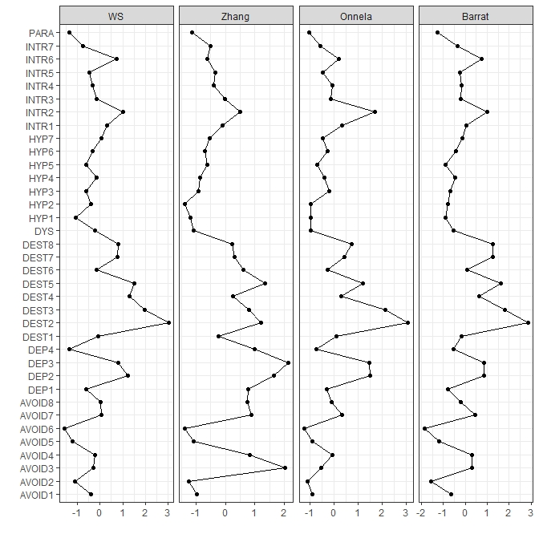
Figure y1: Local clustering plot

Psychological questionnaires are often constructed to measure unidimensional constructs with the goal to maximize internal consistency which is not in line with the network model of psychopathology (Fried 2020). To answer critical claims regarding our item selection, we decided to report the results of an analysis using the goldbricker function (Jones, 2019) in this supplement. The Goldbricker function allows to compare correlations in a psychometric network to identify nodes that likely measure the same construct. We used the Goldbricker function using the z procedure by Hittner, May, and Silver (Hittner et al. 2003), a 20% cut-off and an alpha level of p=.05. The suggested reductions were:

- DEST6 & DEST5
- DEST7 & DEST3
- DEST5 & DEST3
- DEST8 & DEST7
- AVOID7 & AVOID3
- DEP3 & DEP2

We carefully considered and discussed the implications of reducing the number of nodes using techniques like principal component analysis (PCA).

These items, while showing few significantly different associations, reflect very heterogeneous psychopathological phenomena (e.g. see (Holmes et al. 2005)(10.1016/j.cpr.2004.08.006) for dissociation):

While DEST6 reflects depersonalization, DEST5 measures derealization.
DEST7, also strongly associated with DEST3 and DEST5, relates to the experience of dissociated identities and DEST8 asks for voice hearing experiences.

Similarly, AVOID3 relates to overt avoidance while AVOID7 relates to thought suppression.

Finally, DEP2 and DEP3 reflect anhedonia and fatigue.

All of these items are clinically relevant and, importantly, do not reflect redundant concepts. We are aware of the problem that psychological questionnaires are often constructed to measure unidimensional constructs with the goal to maximize internal consistency which is not in line with the network model of psychopathology (Fried, 2020; https://osf.io/6cts9/). Given the clinical and conceptual uniqueness of the items identified by the goldbricker function, we do not believe that removing them would strengthen to our results.

We decided to keep all items in the analysis for two reasons:
- The stability of the presented analysis was adequate and reducing the number of items to boost stability seems not required.
- Dropping items would mean significant loss of clinical relevance.

Barrat A, Barthelemy M, Pastor-Satorras R, Vespignani A (2004). The architecture of complex weighted networks. Proceedings of the National Academy of Sciences 101, 3747–3752.
Fried EI (2020). Lack of theory building and testing impedesprogress in the factor and network literature
Hittner JB, May K, Silver NC (2003). A Monte Carlo Evaluation of Tests for Comparing Dependent Correlations. The Journal of General Psychology 130, 149–168.
Holmes EA, Brown RJ, Mansell W, Fearon RP, Hunter ECM, Frasquilho F, Oakley DA (2005). Are there two qualitatively distinct forms of dissociation? A review and some clinical implications. Clinical Psychology Review 25, 1–23.
Onnela J-P, Saramäki J, Kertész J, Kaski K (2005). Intensity and coherence of motifs in weighted complex networks. Physical Review E 71, 065103.
Watts DJ, Strogatz SH (1998). Collective dynamics of “small-world” networks. Nature 393, 440–442.
Zhang B, Horvath S (2005). A General Framework for Weighted Gene Co-Expression Network Analysis. Statistical Applications in Genetics and Molecular Biology 4

Chart Analysis

For 80 of the 102 patients who reported to suffer from their sexual preferences, the respective patient charts contained sufficient data on sexual anamnesis for further analyses. In six cases, there was no indication of a paraphilic disorder or a sexual orientation that could hint to the experience of minority stress, but the patients had most likely misunderstood the item and reported to suffer from conflicts with their partner because they did not want sexual intercourse at all. Furthermore, there were two homosexual patients and one trans patient who reported to suffer from their sexual preferences without any indication of a paraphilic symptomatology, hinting most likely to minority stress being the reason for their distress. Last but not least, two patients reported to suffer from having sexual impulses because it was in contradiction with their faith with no indication of paraphilia. Hence, chart analyses provided evidence of a genuine suffering from one’s sexual preferences in 70 of 80 cases (87.5%).
Chart analyses provided no evidence for cases of transvestism, exhibitionism, or pedophilia. Transvestic fetishism and voyeurism were rare with one case each. 43 patients (53.75%) reported to suffer from masochistic rape fantasies. High-risk sexual behavior was found in 41 cases (51.25%) and compulsive sexual behavior was found in 21 cases (26,25%). Sexual masochism was reported by 17 patients (21.25%). Reports of sexual masochism were associated to the presence of masochistic rape fantasies (one case), high-risk sexual behavior (one case), or both (13 cases). Sexual sadism was reported by four patients, all of whom also reported other problems like masochistic rape fantasies (100%). Hence, the alternative explanation for the endorsement of the paraphilia screening item of these patients of a safe, sane, and consensual sexual sadism and masochism but minority stress seems very unlikely. Four patients reported a history of sex work.

