eFigure1 Flowchart of the meta-analysis
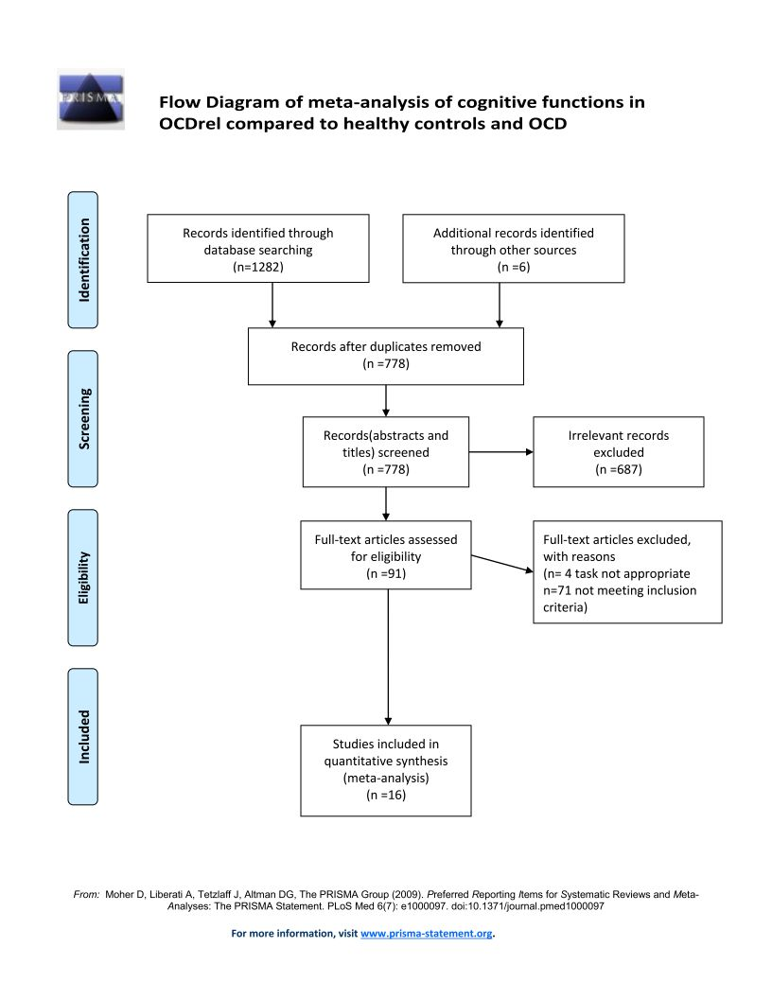

eFigure2 Forest plot of the meta-analysis of group differences in decision making between OCDrel and healthy controls
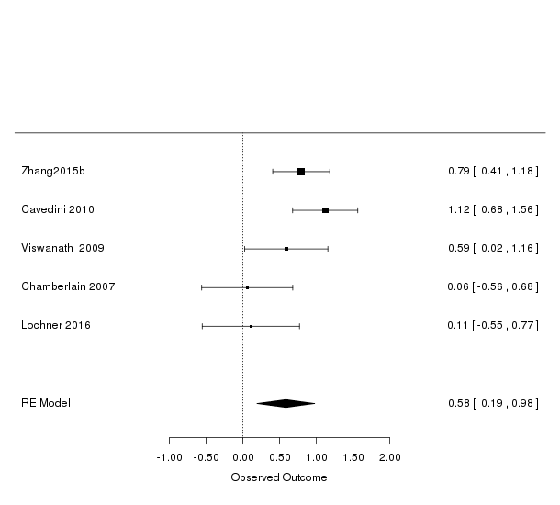

eFigure3 Forest plot of the meta-analysis of group differences in set-shifting between OCDrel and healthy controls
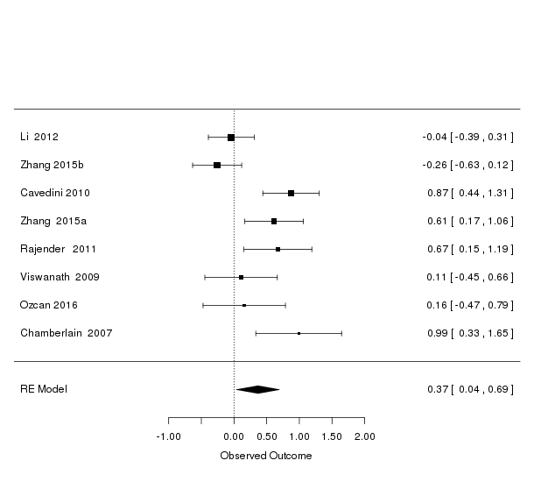

eFigure4 Forest plot of the meta-analysis of group differences in visual memory between OCDrel and healthy controls
