Supplementary Material S3

Cohen’s d calculation for between-group studies:
Cohen’s d and variance have been calculated using mes function from the compute.es package.

$$d=\frac{{\overline{X}}_{1} -{\overline{X}}_{2}}{{sd}_{pooled}}{ with sd}_{pooled}=\sqrt{\frac{\left(n_{1}-1\right){S_{1}}^{2}+\left(n_{2}-1\right){S_{2}}^{2}}{n_{1}+n_{2}-2} }$$

Cohen’s d calculation for correlation studies:
Correlation coefficients (Pearson’s r) and variance (Vr) were transformed into Cohen’s d and variance (Vd) using res function (compute.es package).

$$d=\frac{2r}{\sqrt{1- r^{2}}}$$

To transform Pearson’s r variances to Cohen’s d variances:
$$V_{d}=\frac{4V_{r}}{{(1-r^{2})}^{3}}$$

Cohen’s d conversion into Hedges’ g:
$$g=J.d{ and V}_{g}=J^{2}.V_{d} with J=1- \frac{3}{4.df-1}$$

Wald-Type test for subgroup analysis:
A random-effect omnibus test was conducted using the mareg function of the MAd package (an implementation of the metafor package’s rma function).
$$z=\frac{µ_{1}- µ_{2}}{\sqrt{SE{{[μ}_{1}]}^{2}+ SE{{[µ}_{2}]}^{2}}}$$

Plots:
Meta-analysis’s plots were constructed using metafor and ggplot2 packages.

Meta-regressions:
Meta-regressions were conducted using the mareg function of the metafor package.

Subgroup analysis:
Subgroup analyses were conducted using rma function of the metafor package.

Supplementary Material S4
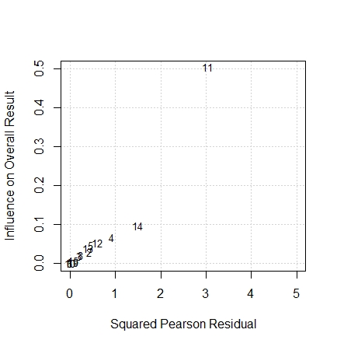
Baujat Plot: Studies influence on the summary effect size and their contribution to the heterogeneity.
¹Brunelin et al., 2007; ²Marjoram et al., 2006; ³Szoke et al., 2009; ⁴Garisson et al., 2017; ⁵Aldebot et al., 2012; ⁶Laroi et al., 2005; ⁷Laroi et al., 2004; ⁸Johns et al., 2010; ⁹Allen et al., 2006; ¹⁰Gaweda et al., 2018; ¹¹Versmissen et al., 2007; ¹²Versmissen et al., 2007; ¹³Alderson-Day et al., 2019; ¹⁴Peters et al., 2007; ¹⁵Humpston et al., 2017.

Supplementary Material S5

QQ Plot: Potential outliers visualisation.
¹Brunelin et al., 2007; ²Marjoram et al., 2006; ³Szoke et al., 2009; ⁴Garisson et al., 2017; ⁵Aldebot et al., 2012; ⁶Laroi et al., 2005; ⁷Laroi et al., 2004; ⁸Johns et al., 2010; ⁹Allen et al., 2006; ¹⁰Gaweda et al., 2018; ¹¹Versmissen et al., 2007; ¹²Versmissen et al., 2007; ¹³Alderson-Day et al., 2019; ¹⁴Peters et al., 2007; ¹⁵Humpston et al., 2017.

Supplementary Material S6

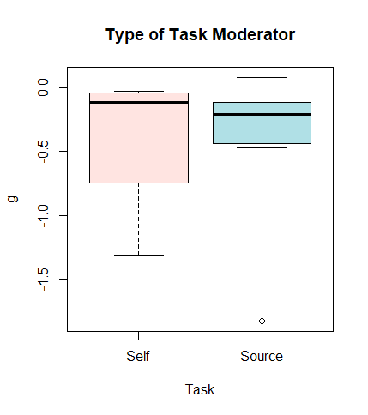

Boxplot: Type of Task Moderator visualisation.

Boxplot: Type of Analysis Moderator visualisation.

