Supplementary materials for research question 3: Description of the cluster modelling analysis.

The method chosen utilises all the data, and models clusters as a finite mixture of Gaussian distribution. The model selection was chosen according to BIC criterion. An expectation-maximization algorithm fits the parameters of the considered model and allows for ‘bottom up’ hierarchical clustering based on maximum likelihood. Only the information on cluster means was used for estimating the direction. This method reduces the dimensionality by identifying a set of linear combinations, ordered by importance as quantified by the associated eigenvalues, of the original features which capture most of the cluster structure contained in the data.

Supplementary Table 1. Comparison of sample demographics and symptom descriptives for the C-PAS and T-TIP trials.

 | C-PAS (UK) | T-TIP (Netherlands) | Cumulative count | Between group difference
Patients (N) | 61 | 155 | 216
Age M (SD) | 42.0 (10.2) | 41.2 (10.5) | 41.46 (10.4) | P = 0.6
Gender  Male  Female | 38  23 | 71  84 | 109  107
Psychosis diagnosis  Schizophrenia  Schizoaffective Disorder  Remaining psychotic disorders  Mood disorder with psychotic features | 45  16  0  0 | 95  45  5  10 | 140  61  5  10
AHRS M (SD)  DRS M (SD) | 16.67 (14.2)  12.18 (7.6) | 11.02 (14.3)  9.5 (8.0) | 12.62 (14.4)  10.23 (7.9) | p < 0.01  p < 0.03
CAPS, M (SD) | 63.44 (17.9) | 69.9 (16.2) | 68.18 (16.9) | p < 0.0001
PTCI | 161.4 (36.9)* | 148.63 (32.6) |  | p < 0.02
AHRS, Auditory Hallucination Rating Scale; DRS, Delusion Rating Scale; CAPS, Clinician-Administered PTSD Scale; PTCI, Post Traumatic Cognitions Inventory *n=53

Supplementary Figure 1. Accuracy of edge weights. Accuracy of edges estimated with bootstrapped 95% confidence intervals. The smaller confidence intervals indicate more accurate edge estimates.

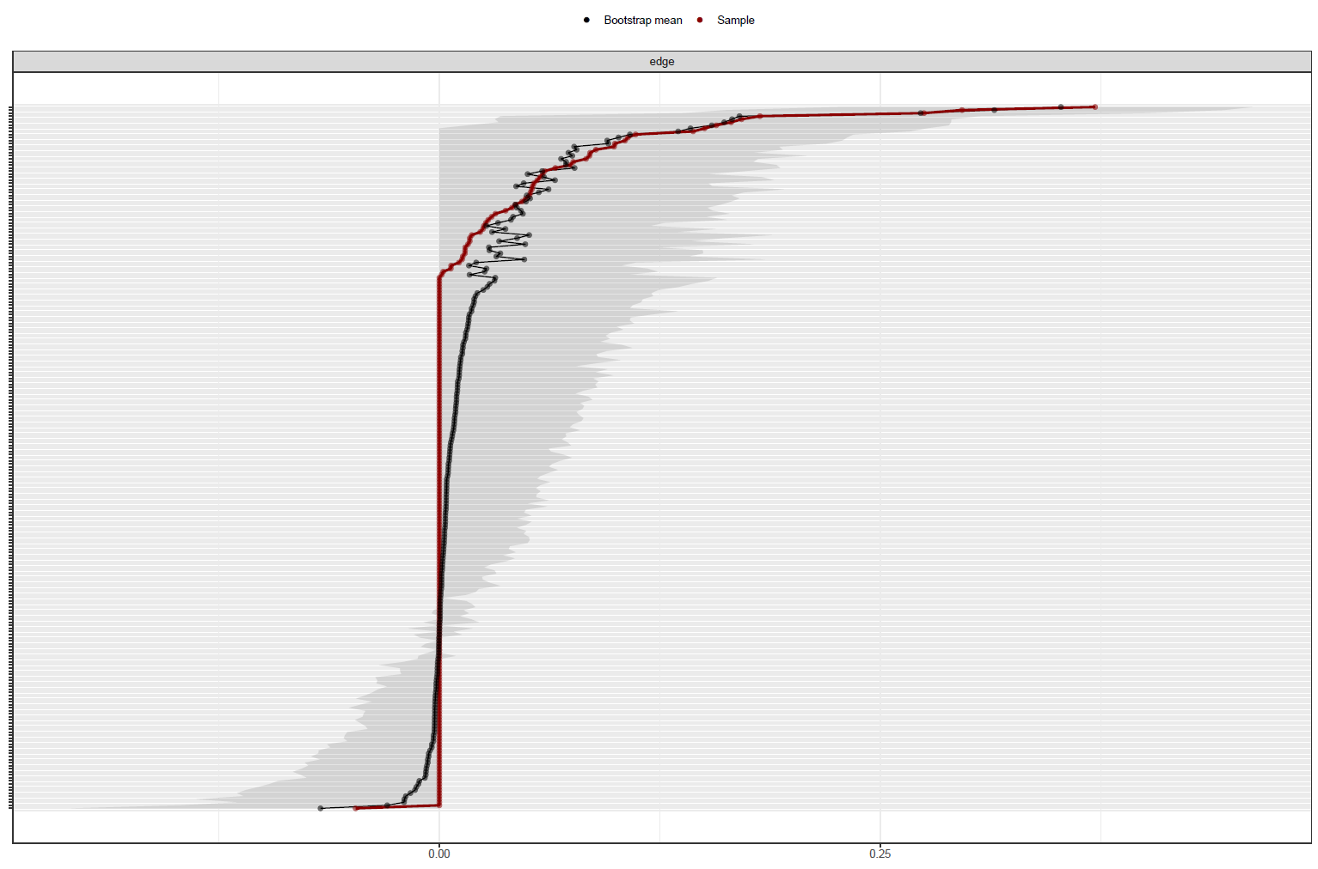

Supplementary Figure 2. Bootstrapped edge weights difference test. Black represents a significant difference between edge weight pairings, grey a non-significant difference.

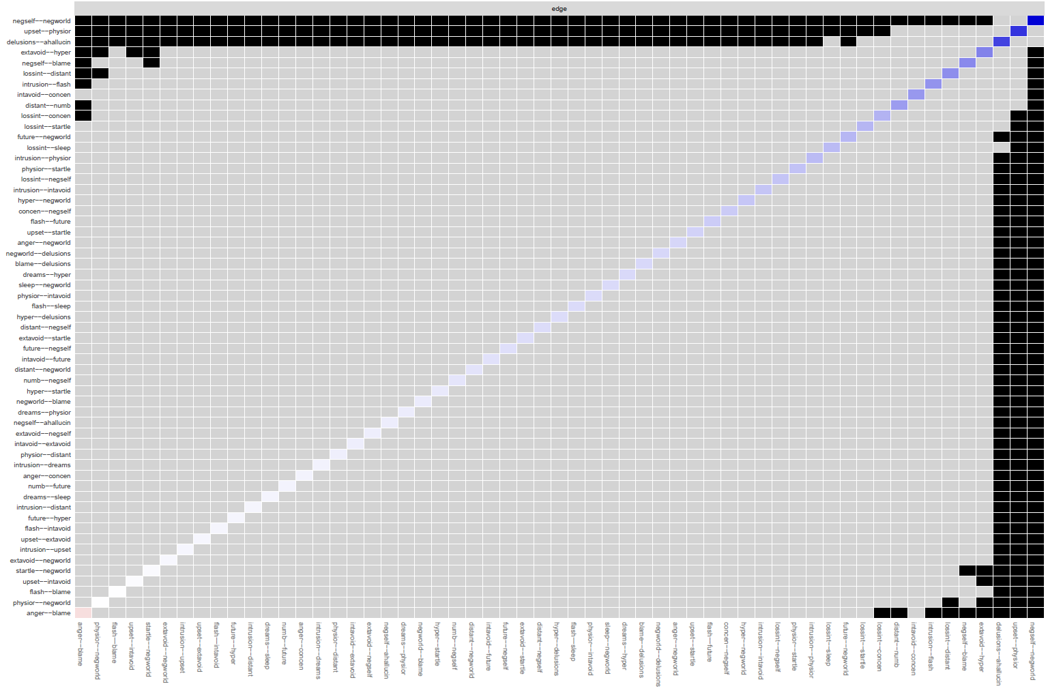

Supplementary Figure 3. Bootstrapped difference tests for node expected influence. Black represents a significant difference in node strength for each pairing, grey a non-significant difference, white the node strength value.

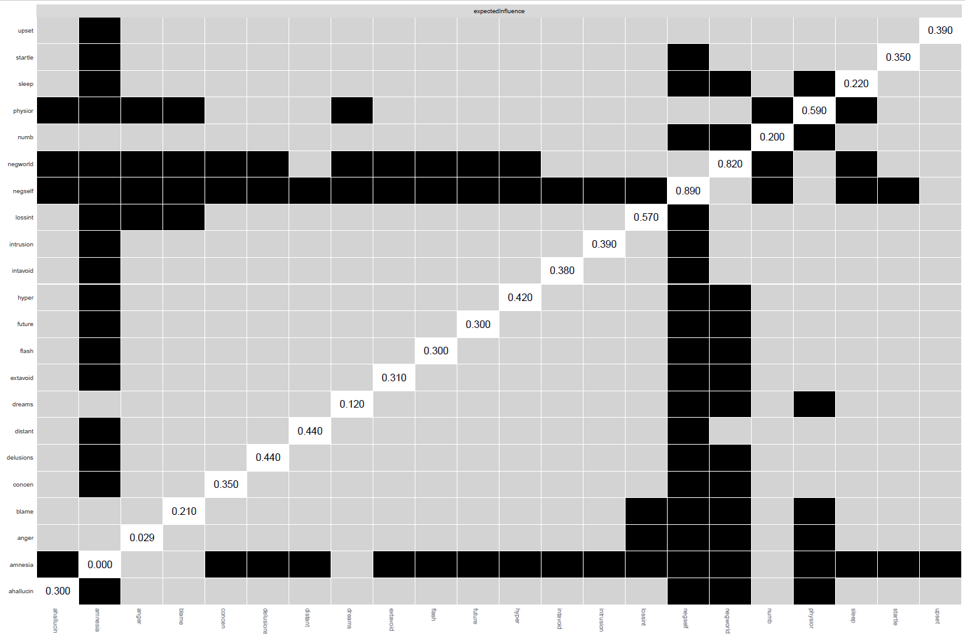

Supplementary Figure 4. Centrality metrics for the main network

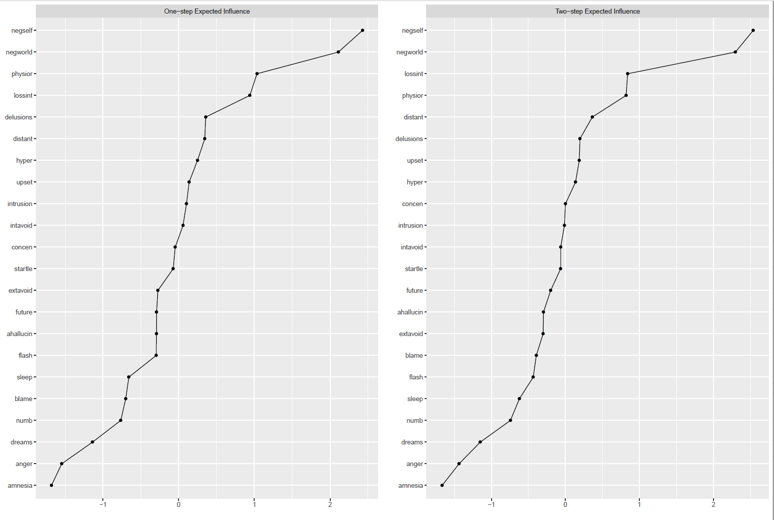

Supplementary Table 2. Predictability estimates.

 | Variable | RMSE | R2
1 | intrusion | 0.885 | 0.213
2 | dreams | 0.926 | 0.139
3 | flash | 0.899 | 0.187
4 | upset | 0.822 | 0.32
5 | physior | 0.799 | 0.358
6 | intavoid | 0.882 | 0.219
7 | extavoid | 0.914 | 0.16
8 | amnesia | 0.998 | 0
9 | lossint | 0.846 | 0.282
10 | distant | 0.879 | 0.224
11 | numb | 0.922 | 0.145
12 | future | 0.932 | 0.128
13 | sleep | 0.885 | 0.212
14 | anger | 0.913 | 0.162
15 | concen | 0.914 | 0.16
16 | hyper | 0.888 | 0.208
17 | startle | 0.912 | 0.165
18 | negself | 0.694 | 0.516
19 | negworld | 0.75 | 0.435
20 | blame | 0.837 | 0.296
21 | delusions | 0.881 | 0.22
22 | ahallucin | 0.902 | 0.183

Supplementary Figure 5. Bridging metrics.

Bridge strength is defined as the sum of the absolute value of all edges that exist between a node A and all nodes that are not in the same community as node A.

Bridge expected influence (1-step) is defined as the sum of the value (+ or -) of all edges that exist between a node A and all nodes that are not in the same community as node A.

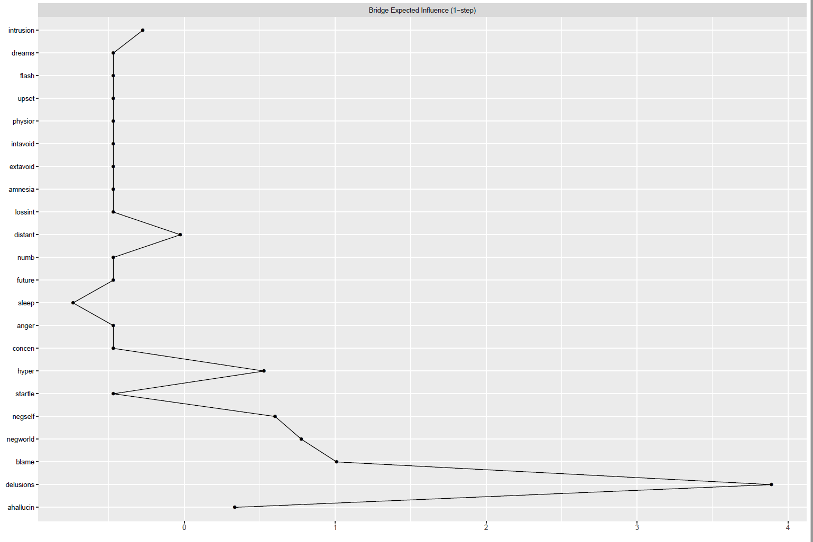

Supplementary Figure 6. The marginal mixture distribution presented reflects the two subpopulations based on the dimension reduction model (Dir1). The marginal density is composed of the component densities.
