Supplementary Table 1
Cross-lagged and autoregressive associations between model self-report variables.
Day 2 Outcome | Day 1 Predictor | B | β | p | SE
PD (T2)
 | PD (T1) | 0.75 | 0.73 | < .001 | .01
 | PB (T1) | 0.22 | 0.13 | < .001 | .01
 | TB (T1) | 0.13 | 0.06 | < .001 | .01
PB (T2)
 | PD (T1) | 0.05 | 0.09 | < .001 | .01
 | PB (T1) | 0.79 | 0.79 | < .001 | .01
 | TB (T1) | 0.07 | 0.06 | < .001 | .01
TB (T2)
 | PD (T1) | 0.01 | 0.02 | .300 | .01
 | PB (T1) | 0.09 | 0.11 | < .001 | .01
 | TB (T1) | 0.67 | 0.68 | < .001 | .01
WTL (T2)
 | PB (T1) | 0.05 | 0.19 | < .001 | .02
 | TB (T1) | 0.03 | 0.09 | < .001 | .01
 | WTL (T1) | 0.57 | 0.57 | < .001 | .01
PB (T2)
 | PB (T1) | 0.82 | 0.81 | < .001 | .01
 | TB (T1) | 0.07 | 0.06 | < .001 | .01
 | WTL (T1) | 0.26 | 0.06 | < .001 | .01
TB (T2)
 | PB (T1) | 0.07 | 0.09 | < .001 | .02
 | TB (T1) | 0.66 | 0.67 | < .001 | .01
 | WTL (T1) | 0.23 | 0.07 | < .001 | .01
WTD (T2)
 | PB (T1) | 0.04 | 0.15 | < .001 | .01
 | TB (T1) | 0.01 | 0.04 | < .001 | .01
 | WTD (T1) | 0.68 | 0.70 | < .001 | .01
PB (T2)
 | PB (T1) | 0.79 | 0.78 | < .001 | .01
 | TB (T1) | 0.07 | 0.06 | < .001 | .01
 | WTD (T1) | 0.34 | 0.10 | < .001 | .01
TB (T2)
 | PB (T1) | 0.10 | 0.12 | < .001 | .02
 | TB (T1) | 0.68 | 0.68 | < .001 | .01
 | WTD (T1) | -.01 | 0.00 | 0.815 | .02
PD (T2)
 | PD (T1) | 0.75 | 0.73 | < .001 | .01
 | WTL (T1) | 0.71 | 0.10 | < .001 | .01
 | WTD (T1) | 0.50 | 0.08 | < .001 | .01
WTL (T2)
 | PD (T1) | 0.02 | 0.11 | < .001 | .02
 | WTL (T1) | 0.55 | 0.55 | < .001 | .01
 | WTD (T1) | 0.15 | 0.17 | < .001 | .02
WTD (T2)
 | PD (T1) | 0.02 | 0.11 | < .001 | .01
 | WTL (T1) | 0.13 | 0.11 | < .001 | .01
 | WTD (T1) | 0.65 | 0.67 | < .001 | .01
Note. PD = Psychological Distress, PB = Perceived Burdensomeness, TB = Thwarted Belongingness, WTL = Wish to Live, WTD = Wish to Die. B = Unstandardized beta. β = Standardized beta. SE = standard error. T1 = self-report on the day prior to self-harm. For the comparison group this was the first day they answered questionnaires two days in a row. T2 = self-report on the day of self-harm. For the comparison group this was the second day they answered questionnaires two days in a row or more.
Supplementary Table 2
Network Weights
 |  | Network Weights
Variable |  | Belongingness |  | Burdensomeness |  | Distress |  | Self-Harm |  | Wish to Die |  | Wish to Live
Belongingness |  | 0.000 |  | 0.198 |  | 0.099 |  | 0.000 |  | 0.000 |  | 0.204
Burdensomeness |  | 0.198 |  | 0.000 |  | 0.354 |  | 0.000 |  | 0.244 |  | 0.150
Distress |  | 0.099 |  | 0.354 |  | 0.000 |  | 0.000 |  | 0.406 |  | 0.146
Self-Harm |  | 0.000 |  | 0.000 |  | 0.000 |  | 0.000 |  | 0.082 |  | 0.039
Wish to Die |  | 0.000 |  | 0.244 |  | 0.406 |  | 0.082 |  | 0.000 |  | 0.264
Wish to Live |  | 0.204 |  | 0.150 |  | 0.146 |  | 0.039 |  | 0.264 |  | 0.000

Edge Stability
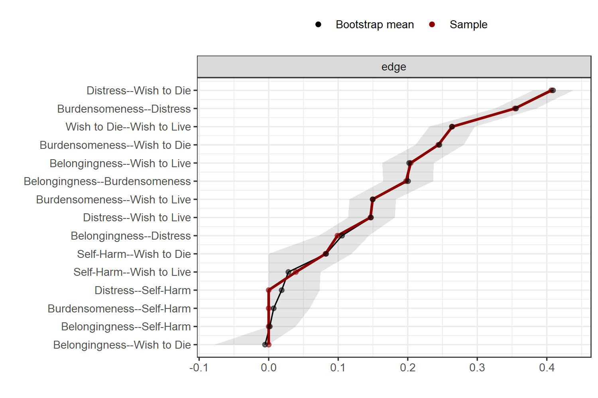

Centrality measures per variable
 |  | Network
Variable |  | Betweenness |  | Closeness |  | Strength
Belongingness |  | -0.678 |  | -0.533 |  | -0.646
Burdensomeness |  | -0.170 |  | 0.526 |  | 0.614
Distress |  | -0.678 |  | 0.562 |  | 0.785
Self-Harm |  | -0.678 |  | -1.751 |  | -1.723
Wish to Die |  | 1.865 |  | 1.010 |  | 0.758
Wish to Live |  | 0.339 |  | 0.186 |  | 0.212

Centrality Plot
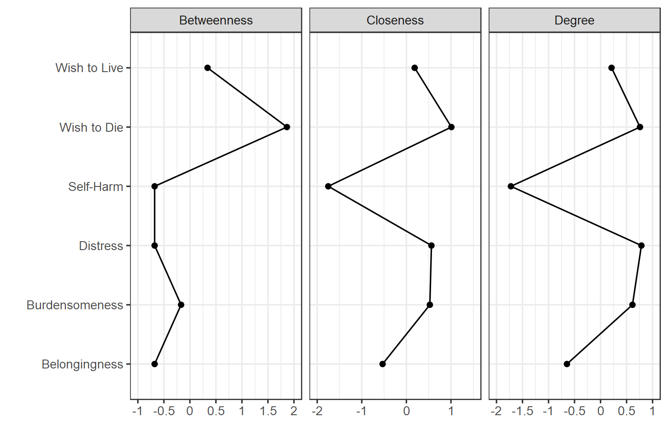

Supplementary Table 3

Weights matrix
 |  | Network
Variable |  | Belongingness |  | Burdensomeness |  | Distress |  | Self-Harm |  | Wish to Die |  | Wish to Live |  | Prior Self Harm
Belongingness |  | 0.000 |  | 0.198 |  | 0.097 |  | 0.000 |  | 0.000 |  | 0.191 |  | 0.000
Burdensomeness |  | 0.198 |  | 0.000 |  | 0.353 |  | 0.000 |  | 0.243 |  | 0.145 |  | 0.000
Distress |  | 0.097 |  | 0.353 |  | 0.000 |  | 0.000 |  | 0.404 |  | 0.141 |  | 0.000
Self-Harm |  | 0.000 |  | 0.000 |  | 0.000 |  | 0.000 |  | 0.070 |  | 0.000 |  | 0.195
Wish to Die |  | 0.000 |  | 0.243 |  | 0.404 |  | 0.070 |  | 0.000 |  | 0.256 |  | 0.044
Wish to Live |  | 0.191 |  | 0.145 |  | 0.141 |  | 0.000 |  | 0.256 |  | 0.000 |  | 0.000
Prior Self Harm |  | 0.000 |  | 0.000 |  | 0.000 |  | 0.195 |  | 0.044 |  | 0.000 |  | 0.000

Edge Stability
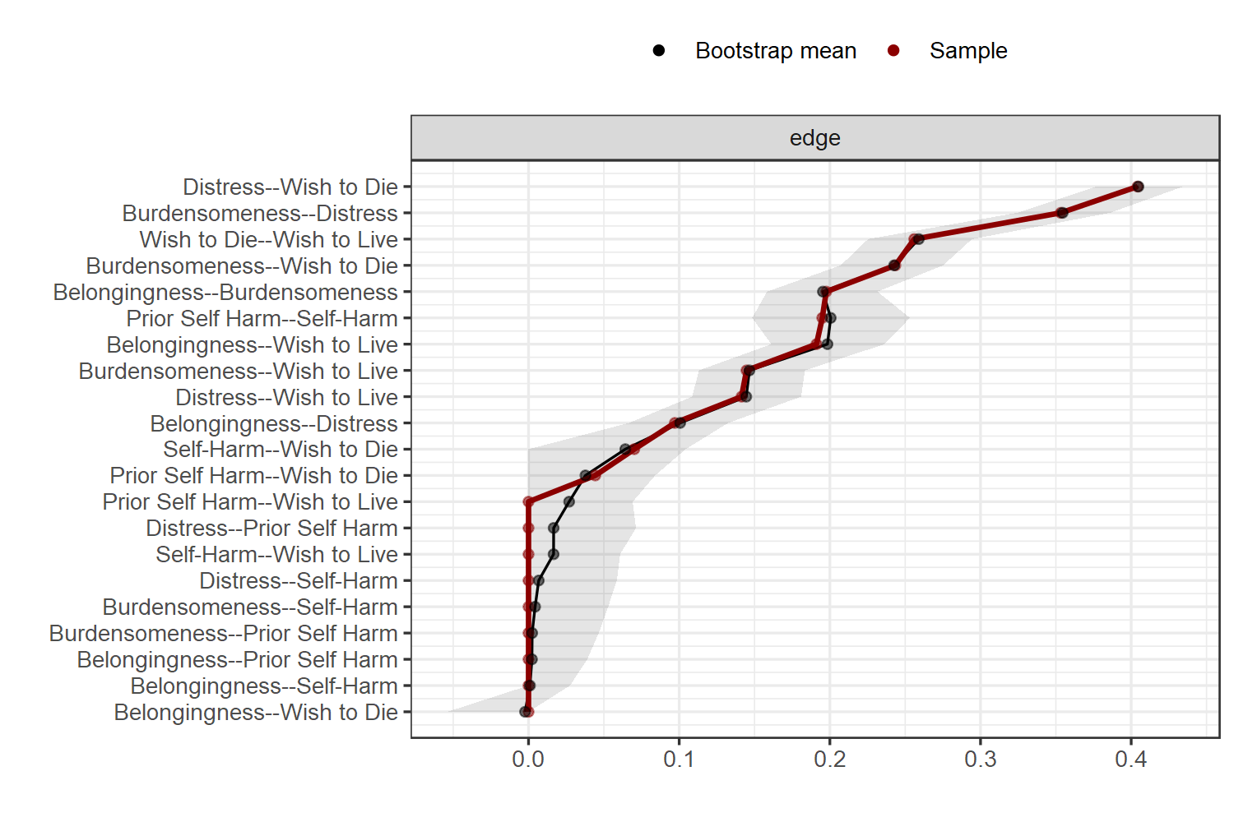

Centrality measures per variable
 |  | Network
Variable |  | Betweenness |  | Closeness |  | Strength
Belongingness |  | -0.754 |  | -0.400 |  | -0.539
Burdensomeness |  | -0.461 |  | 0.606 |  | 0.801
Distress |  | -0.754 |  | 0.745 |  | 0.969
Self-Harm |  | 0.712 |  | -0.971 |  | -1.191
Wish to Die |  | 1.886 |  | 1.211 |  | 1.035
Wish to Live |  | 0.126 |  | 0.352 |  | 0.192
Prior Self Harm |  | -0.754 |  | -1.544 |  | -1.267

Centrality Plot
