*Supplement*

**Method**

**Participants and Procedure**

Of the 160 children who completed the neuroimaging assessment, 9 were excluded from analysis due to excessive motion (n=2), lack of behavioral responding (n= 2), failure to complete the task (n=4), and exposure to violence that was not maltreatment-related (n=1).

**Materials and Measures**

**Maltreatment Exposure.** Children were classified as having experienced physical or sexual abuse if the child reported abuse on the Childhood Experiences of Care and Abuse (CECA) interview (Bifulco *et al.* 1994), UCLA PTSD Reaction Index (PTSD-RI) trauma screen (Steinberg *et al.* 2013), or above the validated threshold on the self-report Childhood Trauma Questionnaire (CTQ) (Walker *et al.* 1999) or reported by the parent on the Conflict Tactics Scale-Parent Child Version (CTS) (Straus *et al.* 1998), the Juvenile Victimization Questionnaire (JVQ) (Finkelhor *et al.* 2005), or PTSD-RI. Domestic violence was assessed by child-report only on the CECA interview and PTSD-RI. Inter-rater reliability was good for child and caregiver maltreatment reports (82.0% agreement; kappa=0.62).

**Transdiagnostic Psychopathology Factor (P Factor) Indicators.** The following measure of internalizing and externalizing psychopathology were included in the p-factor estimation.

**Internalizing symptoms.** Depression was assessed with the Children’s Depression Inventory-2 (CDI-2) (Kovacs 1992; Kovacs & Staff 2003), a widely used self-report measure of depressive symptoms in children and adolescents. The CDI has good reliability and validity among children and adolescents (Craighead *et al.* 1998) and had excellent internal consistency in our sample (α = .89). Anxiety symptoms were assessed with the Screen for Child Anxiety Related Emotional Disorders (SCARED) (Birmaher *et al.* 1997), which measures anxiety symptoms across five domains: panic/somatic, generalized anxiety, separation anxiety, social phobia, and school phobia. The SCARED has good psychometric properties (Birmaher *et al.* 1997) and had excellent internal consistency in our sample (α = .94). Finally, we administered the UCLA PTSD Reaction Scale (Steinberg *et al.* 2013), which is a widely used instrument to assess symptoms of PTSD. For this scale, as is commonly done (Steinberg *et al.* 2013), we took the highest sum score from either the parent or child report. Alpha in the current sample was high, (α = .98).   
 **Externalizing symptoms.**  Child and caregiver reports on the Youth Self-Report (YSR) and Child Behavior Checklist (CBCL) (Achenbach 1991a) were used to assess externalizing symptoms. The YSR/CBCL scales are among the most widely used measures of youth emotional and behavioral problems and use extensive normative data to generate age-standardized estimates of symptom severity. For each of the scales described below, we took the highest raw score across parent report on the Child Behavior Checklist (Achenbach 1991b) or the child report on the Youth Self Report (Achenback 1991) for the following scales: Attention Problems, Rule Breaking Behaviors, and Aggressive Behavior.

Given that half our sample was recruited for exposure to maltreatment, these psychopathology indicators were positively skewed and kurtotic (skewness values above 1 ranged from 1.1 to 2.27; kurtosis values above 1 ranged from 1.1 – 6.94). As such, we chose the robust maximum likelihood estimator in Mplus (estimator = MLR) to handle this non-normality. Finally, in order to ensure that our latent factors were not being driven by one or more indicators simply because of measurement differences across psychopathology instruments (i.e., different number of items, scoring, etc.), we binned scores on each indicator into deciles prior to CFA analyses.

**Emotion Regulation Task.** Developmentally appropriate images were purchased from a commercially available library of images ([www.shutterstock.com](http://www.shutterstock.com)). Images were selected to depict a wide range of emotional stimuli, including negative images depicting sadness, anger, fear, and social rejection and positive images depicting happiness and affiliation. Neutral images included objects with no obvious emotional content. These images were normed by a sample of 127 children and adolescents aged 6-16 years old using a procedure similar to that used in the development of the International Affective Picture System (IAPS; Lang *et al.* 1997). Each participant viewed 30 positive, 30 negative, and 20 neutral pictures in random order. Each picture was displayed for 4 seconds and was followed by three self-assessment mannequins (SAMs) assessing valence, arousal and dominance, each of which appeared underneath the image and was displayed for 3 seconds. SAMs are visual images that are easy to use with children and adolescents and were also used to norm the original IAPS stimulus set. Response options ranged from 1 to 5 for each SAM. We selected the 40 negative images with the highest valence ratings to include and the 20 neutral images with the lowest valence and arousal ratings in the current task. Valence, t(38)=.017, *p*=.99, and arousal, t(38)=.21, *p*=.83, ratings did not differ for Look Negative versus Regulation trials.

**Psychiatric Diagnoses.** All participants completed structured diagnostic interviews to assess for psychiatric diagnoses with the Kiddie Schedule for Affective Disorders and Schizophrenia (K-SADS-PL; hereafter referred to as K-SADS) (Kaufman et al., 1997) and the Clinician Administered PTSD Scale for Children and Adolescents (CAPS) (Nader et al., 1996). Interviewers were supervised and trained by licensed mental health clinicians in interview administration. Trained graduate students and lab staff administered the K-SADS to youth participants and to one caregiver reporting on youth symptoms. Interviews were administered to parents and youth separately. A psychiatric diagnosis was determined as “present” if endorsed by either the youth or parent and were separated into anxiety disorders (i.e., generalized anxiety disorder, specific phobia, separation anxiety disorder, and social phobia), major depressive disorder, posttraumatic stress disorder (PTSD), and externalizing disorders (i.e., attention deficit hyperactivity disorder, oppositional defiant disorder, and conduct disorder). Maltreated youth were more likely to endorse experiencing psychiatric diagnoses across all categories as compared to control youth (χ2(1, 169) > 5.00, *p*s < .04). The following rates of current psychiatric diagnoses were seen across maltreated participants: anxiety disorders: 38%; externalizing disorders: 38%; major depressive disorder: 9%; posttraumatic stress disorder: 38%. The following rates of psychopathology were seen across control participants: anxiety disorders: 21%; externalizing disorders: 9%; major depressive disorder: 1%

**Intelligence (IQ).** We utilized the full-scale IQ (FSIQ)-2 score derived from performance on the Vocabulary and Matrix Reasoning subtests on the Wechsler Abbreviated Scale of Intelligence, Second Edition (WASI-2) (Wechsler 2011) to estimate general cognitive ability.

# **Image Acquisition and Preprocessing**

All images were acquired using a Phillips Achieva 3T scanner using a 32 channel head coil at the University of Washington’s Integrated Brain Imaging Center. Anatomical scans (T1-weighted MPRAGE volumes; TR=2530ms, TE=3.5ms, flip angle=7°, FOV=256×256, 176 slices, in-plane voxel size=1mm3) were acquired for co-registration with functional magnetic resonance imaging (fMRI).

Blood oxygenation level dependent (BOLD signal during functional runs was acquired using a gradient-echo T2*-weighted echo planar imaging (EPI) sequence. 37 3mm thick axial slices were acquired sequentially and parallel to the AC-PC line (TR=2s, TE=25ms, flip angle=79°, Inter-slice gap=.6mm, FOV=224×224×132.6, matrix size=76x74). Prior to each scan, four images were acquired and discarded to allow longitudinal magnetization to reach equilibrium.

**Statistical Analysis**

**fMRI.**

***Whole-brain mediation analysis.*** MEPM performs voxel-wise mediation analysis using bootstrapping. Mediation models estimate the ‘a’ path (i.e., child maltreatment and neural activation), ‘b’ path (i.e., associations of neural activation with psychopathology, controlling for child maltreatment), and ‘c′’ path. The combined product of paths a*b represent the indirect effect of child maltreatment on psychopathology via brain activation (MacKinnon *et al.* 2002). We only conducted whole-brain mediation when we observed significant associations in the ‘a’ and ‘b’ paths in main effect analyses.

***ROI sensitivity analysis***. We examined whether our primary findings remained significant after controlling for IQ by conducting separate ROI analyses for several key regions identified in whole-brain analyses. Functional ROIs were created by intersecting a structural mask of frontal regions from the Harvard-Oxford subcortical atlas (50% threshold) with the map of activation in the entire sample during the contrast of interest (i.e., Look-Negative > Look-Neutral) including the following regions: superior frontal gyrus (SFG), middle frontal gyrus (MFG), inferior frontal gyrus (IFG), dorsal anterior cingulate cortex (dACC), paracingulate cortex (medial prefrontal cortex, mPFC), postcentral gyrus, and precentral gyrus. We conducted a univariate analysis of variance (ANOVA) with Group (maltreated, control) as a between-subjects factor, ROI activation as the outcome variable and controlling for SES, race/ethnicity, and IQ.

**Results**

**Emotion Regulation Task Performance**

Emotion intensity ratings did not vary by p-factor, *F*(2, 298)=.42, *p*=.66 or age, *F*(2, 306)=2.30, *p*=.10.

**Task-Related Neural Recruitment**

**Emotional Reactivity***.* The contrast of Look-Negative > Look-Neutral revealed activation in PFC and parietal cortex including left postcentral gyrus and bilateral middle frontal gyrus (MFG), IFG, precentral gyrus, SFG, lateral orbitofrontal cortex extending into the insula, and dorsal ACC (Supplemental Table 3, Supplemental Figure 4). This analysis also revealed bilateral activation in lateral occipital cortex, fusiform, lingual gyrus, precuneus, angular gyrus, and parahippocampal gyrus (PHG). Sub-cortically, this contrast revealed activation in bilateral amygdala, hippocampus, and left thalamus.

**Emotion Regulation**. The contrast of Regulation > Look-Negative demonstrated widespread activation in the PFC including right precentral gyrus, and bilateral SFG, MFG, and frontal pole extending into the left IFG and insula (Supplemental Table 3, Supplemental Figure 4). Additionally, it revealed activation within bilateral middle temporal gyrus, superior temporal gyrus, inferior temporal gyrus and fusiform.

**Sensitivity Analyses Controlling for Neglect**

We conducted sensitivity analyses that controlled for neglect as a marker of deprivation rather than poverty (i.e., SES). Maltreatment-related differences in the Look Negative > Look Neutral contrast were largely similar, with control participants exhibiting significantly greater activation than maltreatment-exposed children in one cluster (Supplemental Table 7A; Figure 1B) that continued to include bilateral SFG, MFG, dorsal ACC, and dmPFC. Maltreatment-exposed participants exhibited significantly greater activation than controls in one cluster that continued to include the left supplementary motor area (SMA), postcentral and precentral gyri. An additional cluster emerged including left insula, amygdala, putamen, and pallidum (Supplemental Table 7A; Figure 1B). Greater left amygdala activation among maltreated relative to control youth in the Look Negative > Look Neutral contrast persisted in the ROI analysis, *F*(1, 147)=3.74, *p*=.05, partial η2=.03.

In the Regulation > Look Negative contrast, maltreatment-exposed youth continued to show significantly increasing activation across development, whereas controls exhibited decreasing activation across age in one cluster that included left precentral and postcentral gyrus extending into the IFG and insula (Supplemental Table 7B, Figure 2B).

Whole-brain mediation continued to show a significant indirect effect of maltreatment exposure with p-factor scores via neural recruitment during the Look Negative > Look Neutral contrast in three clusters. Reduced activation in left dmPFC and greater activation in right cuneus and left postcentral gyrus mediated the association between maltreatment exposure and p factor score (indirect effect: .14, SE= .05, *p*=.005; Supplemental Table 6, Figure 4).

**Sensitivity Analyses Controlling for IQ**

We conducted sensitivity analyses for our primary maltreatment group findings that controlled for IQ in addition to SES and race/ethnicity. Maltreatment-related differences in the Look Negative > Look Neutral contrast were largely similar, with control participants continuing to exhibit significantly greater activation than maltreatment-exposed children in bilateral SFG, dorsal ACC, mPFC, left IFG, and right MFG (Supplemental Table 10). Maltreatment-exposed participants continued to show greater activation in the left postcentral gyrus and amygdala compared to controls, but no longer exhibited significantly greater activation than controls in the left precentral gyrus.

**Sensitivity Analyses Using FDR Correction**

We conducted further sensitivity testing of our findings to correct for multiple comparisons and found that the FDR corrected p-values for the clusters we obtained across 1) the age by maltreatment interaction during Regulation > Look-Negative; 2) maltreatment group main effects during Look-Negative > Look-Neutral; and 3) the main effect of general psychopathology factor (p-factor) for Look-Negative > Look-Neutral all remained significant at *p* ≤ .001.

**References**

**Achenbach TM** (1991a). *Integrative guide for the 1991 CBCL/4-18, YSR, and TRF profiles*. Department of Psychiatry, University of Vermont Burlington.

**Achenbach TM** (1991b). *Manual for the Child Behavior Checklist/4-18 and 1991 profile*. Department of Psychiatry, University of Vermont Burlington, VT.

**Achenback T** (1991). *Manual for the Youth Self-Report and 1991 Profile*. Department of Psychiatry, University of Vermont: Burlington, VT.

**Bifulco A, Brown GW, Harris TO** (1994). Childhood Experience of Care and Abuse (CECA): a retrospective interview measure. *Journal of Child Psychology and Psychiatry* **35**, 1419–1435.

**Birmaher B, Khetarpal S, Brent D, Cully M, Balach L, Kaufman J, Neer SM** (1997). The screen for child anxiety related emotional disorders (SCARED): Scale construction and psychometric characteristics. *Journal of the American Academy of Child & Adolescent Psychiatry* **36**, 545–553.

**Craighead W, Smucker MR, Craighead LW, Ilardi SS** (1998). Factor analysis of the Children’s Depression Inventory in a community sample. *Psychological Assessment* **10**, 156–165.

**Finkelhor D, Hamby SL, Ormrod R, Turner H** (2005). The Juvenile Victimization Questionnaire: reliability, validity, and national norms. *Child abuse & neglect* **29**, 383–412.

**Hayes AF** (2013). *Introduction to mediation, moderation, and conditional process analysis: A regression-based approach*. Methodology in the social sciences. Guilford Press: New York, NY, US.

**Kaufman J, Birmaher B, Brent D, Rao UMA, Flynn C, Moreci P, Williamson D, Ryan N** (1997). Schedule for affective disorders and schizophrenia for school-age children-present and lifetime version (K-SADS-PL): initial reliability and validity data. *Journal of the American Academy of Child & Adolescent Psychiatry* **36**, 980–988.

**Kovacs M** (1992). *Children’s depression inventory: Manual*. Multi-Health Systems: North Tonawanda.

**Kovacs M, Staff MHS** (2003). *Children’s Depression Inventory 2 (CDI2)*. Multi-Health Systems, Incorporated.

**Lang PJ, Bradley MM, Cuthbert BN** (1997). International affective picture system (IAPS): Technical manual and affective ratings. *NIMH Center for the Study of Emotion and Attention*, 39–58.

**MacKinnon DP, Lockwood CM, Hoffman JM, West SG, Sheets V** (2002). A comparison of methods to test mediation and other intervening variable effects. *Psychological methods* **7**, 83.

**Nader K, Kriegler JA, Blake DD, Pynoos RS, Newman E, Weather FW** (1996). Clinician administered PTSD scale, child and adolescent version. *White River Junction, VT: National Center for PTSD* **156**

**Steinberg AM, Brymer MJ, Kim S, Briggs EC, Ippen CG, Ostrowski SA, Gully KJ, Pynoos RS** (2013). Psychometric properties of the UCLA PTSD reaction index: part I. *Journal of traumatic stress* **26**, 1–9.

**Straus MA, Hamby SL, Finkelhor D, Moore DW, Runyan DK** (1998). The conflict tactics scales handbook (CTS2: Revised Conflict Tactics Scales & CTSPC: Parent–Child Version. *Los Angeles: Western Psychological Services*

**Walker EA, Unutzer J, Rutter C, Gelfand A, Saunders K, VonKorff M, Koss MP, Katon W** (1999). Costs of health care use by women HMO members with a history of childhood abuse and neglect. *Archives of General Psychiatry* **56**, 609–613.

**Wechsler D** (2011). *WASI-II: Wechsler abbreviated scale of intelligence*. PsychCorp.

|  |  |  |  |  |  |  |
| --- | --- | --- | --- | --- | --- | --- |
| **Supplemental Table 1**. Frequency of types of child maltreatment among maltreatment exposed group. | | | | | | |
|  | **Physical Abuse** | | **Sexual Abuse** | | **Witnessed Domestic Violence** | |
|  | **N** | **%** | **N** | **%** | **N** | **%** |
| Maltreatment Exposed | 57 | 37.7 | 36 | 23.8 | 60 | 39.7 |

**Supplemental Table 2**. Generalized Psychopathology Factor (P Factor) Correlated-Factors and Bi-Factor Model Fit Statistics

|  |  |  |  |  |
| --- | --- | --- | --- | --- |
|  | **Bi-Factor** | | **Correlated-Factors** | |
| N | 262 | | 262 | |
| AIC | 6018.23 | | 6056.31 | |
| BIC | 6228.77 | | 6249.00 | |
| Sample Adjusted BIC | 6041.71 | | 6077.79 | |
| **Factor Loadings** | **Beta** | **P** | **Beta** | **P** |
| **P Factor** |  |  |  |  |
| Depression Symptoms | .58 | <.001 | - | - |
| Anxiety Symptoms | .44 | <.001 | - | - |
| PTSD symptoms | .74 | <.001 | - | - |
| Attention Problems | .74 | <.001 | - | - |
| Aggressive Behavior | .80 | <.001 | - | - |
| Rule Breaking Behavior | .72 | <.001 | - | - |
| **Internalizing Factor** |  |  |  |  |
| Depression Symptoms | **-** | **-** | .73 | <.001 |
| Anxiety Symptoms | **-** | **-** | .73 | <.001 |
| PTSD symptoms | **-** | **-** | .65 | <.001 |
| **Externalizing Symptoms** | **-** | **-** |  |  |
| Attention Problems | **-** | **-** | .78 | <.001 |
| Aggressive Behavior | **-** | **-** | .87 | <.001 |
| Rule Breaking Behavior | **-** | **-** | .76 | <.001 |

**Supplemental Table 3.** Correlations between maltreatment exposure, p-factor, age and covariates

|  |  |  |  |  |  |  |
| --- | --- | --- | --- | --- | --- | --- |
|  | 1 | 2 | 3 | 4 | 5 | 6 |
| 1. Maltreatment Exposure | - |  |  |  |  |  |
| 1. P-Factor | .71*** | - |  |  |  |  |
| 1. Age | .07 | .10 | - |  |  |  |
| 1. Race/Ethnicity | .47*** | .39*** | .16* | - |  |  |
| 1. SES | -.62*** | -.45*** | .00 | -.41*** | - |  |
| 1. Neglect | .39*** | .38*** | .05 | .16 | -.11 | - |

*p<.05, ***p<.001; *Note.* P-Factor refers to the extracted p-factor latent construct constructed from several internalizing and externalizing psychopathology measures outlined in Supplement; Neglect was measured with the Childhood Trauma Questionnaire-Physical Neglect subscale; SES= Socioeconomic status.

|  |  |  |  |  |  |  |
| --- | --- | --- | --- | --- | --- | --- |
| **Supplemental Table 4**. Emotion Intensity Ratings Across Trial Type and by Maltreatment Exposure | | | | | | |
|  | **Neutral** | | **Reactivity** | | **Regulation** | |
|  | **M** | **(SD)** | **M** | **(SD)** | **M** | **(SD)** |
| Total Sample | 0.18 | 0.36 | 1.62 | 0.64 | 1.24 | 0.68 |
| Maltreatment Exposed | 0.27 | 0.46 | 1.74 | 0.68 | 1.50 | 0.72 |
| Controls | 0.08 | 0.17 | 1.49 | 0.58 | 0.97 | 0.52 |

|  |
| --- |
|  |

|  |  |  |  |  |  |  |  |
| --- | --- | --- | --- | --- | --- | --- | --- |
| **Supplemental Table 5**.Task-related neural activation in the whole sample | | | | | | | |
| **Emotion Reactivity Condition (Look Negative > Look Neutral)** | | | | | | | |
| **Anatomical Region** | **x** | **y** | **z** | **voxels** | **z-max** | **p-value** |
| Bilateral lateral occipital cortex  Bilateral temporal occipital FG  Bilateral lingual gyrus  Bilateral amygdala  Bilateral precuneus  Bilateral angular gyrus  Bilateral PHG  Bilateral middle temporal gyrus  Bilateral cerebellum  Bilateral thalamus  Bilateral hippocampus | 52 | -72 | -2 | 66369 | 15.04 | < 0.005 |
| Bilateral precentral gyrus  Bilateral MFG  Right SFG  Bilateral lateral orbitofrontal cortex  Bilateral insula  Bilateral dorsal ACC  Bilateral IFG |  |  |  |  |  |  |
| Bilateral superior parietal lobule  Left postcentral gyrus |  |  |  |  |  |  |
| **Emotional Regulation Condition (Decrease Negative > Look Negative)** | | | | | | | |
| **Anatomical Region** | **x** | **y** | **z** | **voxels** | **z-max** | **p-value** |
| Left temporal occipital FG  Left temporal FG  Left cerebellum  Left middle temporal gyrus  Left inferior temporal gyrus | -28 | -52 | -24 | 4168 | 5.97 | < 0.005 |
| Right postcentral gyrus  Right precentral gyrus | 42 | -26 | 50 | 2820 | 7.37 | < 0.005 |
| Right middle temporal gyrus  Right temporal FG  Right temporal occipital FG | 64 | -36 | -10 | 2738 | 4.93 | < 0.005 |
| Left frontal pole  Left orbitofrontal cortex  Left insula | -38 | 38 | -12 | 2476 | 4.75 | < 0.005 |
| Right frontal pole  Right SFG | 16 | 42 | 40 | 1138 | 4.80 | < 0.005 |
| Right frontal pole  Right orbitofrontal cortex | 46 | 36 | -12 | 851 | 4.17 | < 0.005 |
| Left angular gyrus | -52 | -56 | 32 | 707 | 4.14 | < 0.005 |
| Left occipital pole  Left occipital FG | -18 | -100 | -10 | 566 | 6.18 | < 0.005 |
| Right MFG | 38 | 14 | 48 | 391 | 4.28 | < 0.005 |
| Right occipital FG  Right occipital pole | 20 | -90 | -14 | 307 | 4.75 | < 0.005 |
| Right putamen  Right pallidum | 22 | 2 | 4 | 278 | 4.81 | < 0.005 |
| Right angular gyrus | 58 | -52 | 30 | 220 | 3.98 | < 0.005 |
| Left putamen | -26 | 4 | 4 | 216 | 4.21 | < 0.005 |
| Left inferior temporal gyrus  Left temporal FG | -42 | -8 | -44 | 211 | 3.80 | < 0.005 |

*Note*. ACC= anterior cingulate cortex; IFG= inferior frontal gyrus; MFG= middle frontal gyrus; SFG= superior frontal gyrus; FG= fusiform gyrus; PHG=parahippocampal gyrus.

|  |  |  |  |  |  |  |  |
| --- | --- | --- | --- | --- | --- | --- | --- |
| **Supplemental Table 6**. Maltreatment-related differences in whole-brain neural activation controlling for SES and race/ethnicity | | | | | | | |
| **A. Main Effects** | | | | | | | |
|  | | **Emotional Reactivity Condition** | | | | | |
| **Anatomical Region** | **x** | | **y** | **z** | **voxels** | **z-max** | **p-value** |
| **Control > Maltreatment Exposed** |  | |  |  |  |  |  |
| Bilateral dorsal ACC  Bilateral dorsomedial PFC | 6 | | 28 | 48 | 1561 | 4.32 | < 0.005 |
| Bilateral SFG |  | |  |  |  |  |  |
| Right MFG | 48 | | 10 | 44 | 764 | 3.92 | < 0.005 |
| Left IFG | -38 | | 16 | 32 | 718 | 4.61 | < 0.005 |
| Right thalamus | -6 | | -40 | -14 | 369 | 3.55 | < 0.005 |
| Left insula | -32 | | 18 | -10 | 281 | 3.64 | < 0.005 |
| **Maltreatment Exposed > Control** |  | |  |  |  |  |  |
| Left precentral gyrus  Left SMA | -24 | | -32 | 64 | 562 | 3.71 | < 0.005 |
| Left postcentral gyrus |  | |  |  |  |  |  |
| Left precentral gyrus  Left postcentral gyrus | -32 | | -28 | 34 | 238 | 3.43 | < 0.005 |
| Right lingual gyrus | 20 | | -94 | -4 | 271 | 3.47 | < 0.005 |
| **B. Age X Group Status** | | | | | | | |
|  | | **Emotion Regulation Condition** | | | | | |
| **Anatomical Region** | **x** | | **y** | **z** | **voxels** | **z-max** | **p-value** |
| **Maltreatment Slope > Control Slope** |  | |  |  |  |  |  |
| Left IFG | -42 | | 10 | 14 | 448 | 3.70 | < 0.005 |
| Left precentral gyrus  Left ACC | -8 | | -6 | 50 | 305 | 3.86 | < 0.005 |
| Left insula | -50 | | -14 | 14 | 282 | 3.55 | < 0.005 |

*Note*. SES= socioeconomic status; ACC= anterior cingulate cortex; IFG= inferior frontal gyrus; MFG= middle frontal gyrus; SFG= superior frontal gyrus; SMA= supplementary motor cortex.

|  |  |  |  |  |  |  |
| --- | --- | --- | --- | --- | --- | --- |
| **Supplemental Table 7**. Maltreatment-related differences in whole-brain neural activation controlling for neglect and race/ethnicity | | | | | | |
| **A. Main Effects** | | | | | | |
|  | **Emotional Reactivity Condition** | | | | | |
| **Anatomical Region** | **x** | **y** | **z** | **voxels** | **z-max** | **p-value** |
| **Control > Maltreatment Exposed** |  |  |  |  |  |  |
| Bilateral SFG  Bilateral dorsomedial PFC | -8 | 36 | 54 | 517 | 3.94 | < 0.005 |
| Right MFG  Right IFG | 50 | 10 | 42 | 459 | 4.01 | < 0.005 |
| Bilateral brainstem | 2 | -16 | -14 | 302 | 4.17 | < 0.005 |
| **Maltreatment Exposed > Control** |  |  |  |  |  |  |
| Left putamen | -34 | -30 | 8 | 683 | 4.37 | < 0.005 |
| Left postcentral gyrus | -34 | -24 | 32 | 475 | 4.08 | < 0.005 |
| Right lateral occipital cortex  Right occipital fusiform gyrus | 32 | -82 | -4 | 256 | 3.84 | < 0.005 |
| **B. Age X Group Status** | | | | | | |
|  | **Emotion Regulation Condition** | | | | | |
| **Anatomical Region** | **x** | **y** | **z** | **voxels** | **z-max** | **p-value** |
| **Maltreatment Slope > Control Slope** |  |  |  |  |  |  |
| Left precentral gyrus  Left IFG | -42 | -2 | 20 | 506 | 3.68 | < 0.005 |
| Left postcentral gyrus  Left insula | -42 | -16 | 10 | 345 | 3.70 | < 0.005 |
| Left precentral gyrus  Left SMA | -8 | -6 | 50 | 271 | 3.63 | < 0.005 |
|  |  |  |  |  |  |  |

*Note*. IFG= inferior frontal gyrus; MFG= middle frontal gyrus; SFG= superior frontal gyrus; SMA= supplementary motor cortex.

|  |  |  |  |  |
| --- | --- | --- | --- | --- |
| **Supplemental Table 8.** Transdiagnostic Psychopathology Factor (P Factor) Related Differences in Whole-brain Neural Activation | | | | |
|  | **Emotional Reactivity Condition** | | | | | |
| **Anatomical Regions** | **x** | **y** | **z** | **voxels** | **z-max** | **p-value** |
| **Activation as P Factor Decreases** |  |  |  |  |  |  |
| Bilateral SFG  Bilateral ACC  Bilateral dorsomedial PFC | 4 | 18 | 46 | 2347 | 4.58 | < 0.005 |
| Right insula  Right IFG  Right MFG  Right frontal pole | 42 | 20 | -4 | 2141 | 4.06 | < 0.005 |
| Left IFG  Left frontal pole | -38 | 16 | 32 | 1321 | 4.89 | < 0.005 |
| Bilateral precuneus | 8 | -78 | 38 | 770 | 4.81 | < 0.005 |
| Left insula | -38 | 16 | -2 | 408 | 3.78 | < 0.005 |
| Bilateral thalamus | 8 | -12 | 2 | 335 | 3.52 | < 0.005 |
| Bilateral thalamus | 4 | -28 | 26 | 262 | 3.83 | < 0.005 |
| **Activation as P Factor Increases** |  |  |  |  |  |  |
| Left postcentral gyrus | -32 | -34 | 62 | 1235 | 4.26 | < 0.005 |
| Left precentral gyrus  Right precuneus  Bilateral postcentral gyrus | 10 | -36 | 50 | 492 | 3.59 | < 0.005 |
| Left lateral occipital cortex | -28 | -76 | 16 | 375 | 3.77 | < .005 |
|  | | | | | | |

*Note*. ACC= anterior cingulate cortex; IFG= inferior frontal gyrus; MFG= middle frontal gyrus; SFG= superior frontal gyrus; SMA=supplementary motor area.

|  |  |  |  |  |  |
| --- | --- | --- | --- | --- | --- |
| **Supplemental Table 9.** Whole-brain Mediation Predicting P Factor Scores | | | | | |
|  | **Emotional Reactivity Condition** | | | | |
| **Anatomical Region** | **x** | **y** | **z** | **voxels** | **z-max** | **p-value** | |
| **Controlling for SES and Race/Ethnicity** |  |  |  |  |  |  | |
| Left MFG | -38 | 16 | 32 | 65 | 9.03 | <.0001 | |
| Right dorsomedial PFC | 2 | 22 | 44 | 72 | 6.69 | <.005 | |
| Left postcentral gyrus | -30 | -36 | 62 | 13 | 5.65 | <.005 | |
| Right precuneus | 12 | -76 | 38 | 13 | 6.60 | <.005 | |
| Left dorsal ACC, left dorsomedial PFC | -6 | 22 | 30 | 43 | 6.77 | <.005 | |
|  |  |  |  |  |  |  | |
| **Controlling for Neglect and Race/Ethnicity** |  |  |  |  |  |  | |
| Left postcentral gyrus | -30 | -34 | 62 | 29 | 7.55 | <.005 | |
| Right cuneus | 8 | -78 | 36 | 12 | 6.75 | <.005 | |
| Left dorsomedial PFC | -2 | 18 | 46 | 8 | 5.69 | <.005 | |
| *Note*. ACC= anterior cingulate cortex; PFC= prefrontal cortex; MFG= middle frontal gyrus; 005 | | | | | | |

|  |  |  |
| --- | --- | --- |
| **Supplemental Table 10**. Maltreatment-related differences in ROI activation controlling for SES, race/ethnicity, and IQ during emotional reactivity contrast (Look-Negative > Look-Neutral) | | |
| **Anatomical Region** | **F** | **p-value** |
|  |  |  |
| Left dorsal ACC | 11.23 | .001 |
| Right dorsal ACC | 7.84 | .006 |
| Left SFG | 10.43 | .002 |
| Right SFG | 14.31 | <.001 |
| Left mPFC | 9.98 | .002 |
| Right mPFC | 9.86 | .002 |
| Right MFG | 16.18 | <.001 |
| Left IFG | 5.93 | .02 |
| Left amygdala | 4.54 | .03 |
| Left precentral gyrus | 0.46 | .50 |
| Left postcentral gyrus | 4.15 | .04 |
| *Note*. ACC= anterior cingulate cortex; PFC= prefrontal cortex; MFG= middle frontal gyrus; IFG= inferior frontal gyrus; SFG= superior frontal gyrus.<. | | |

Supplemental Figure 1. Generalized psychopathology factor (p factor) bi-factor model (A) and correlated-factor model (B).

A.

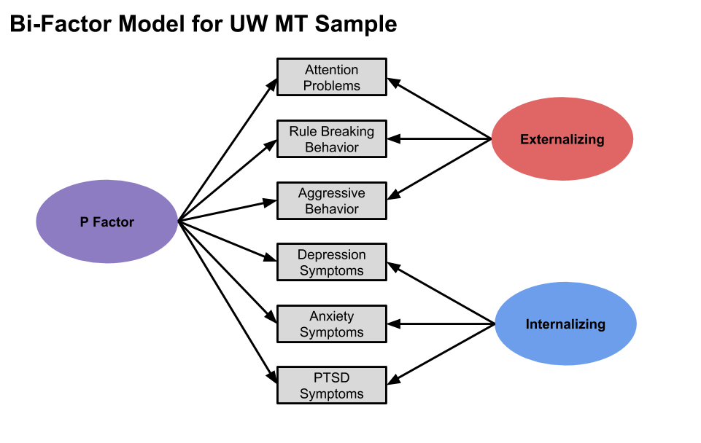

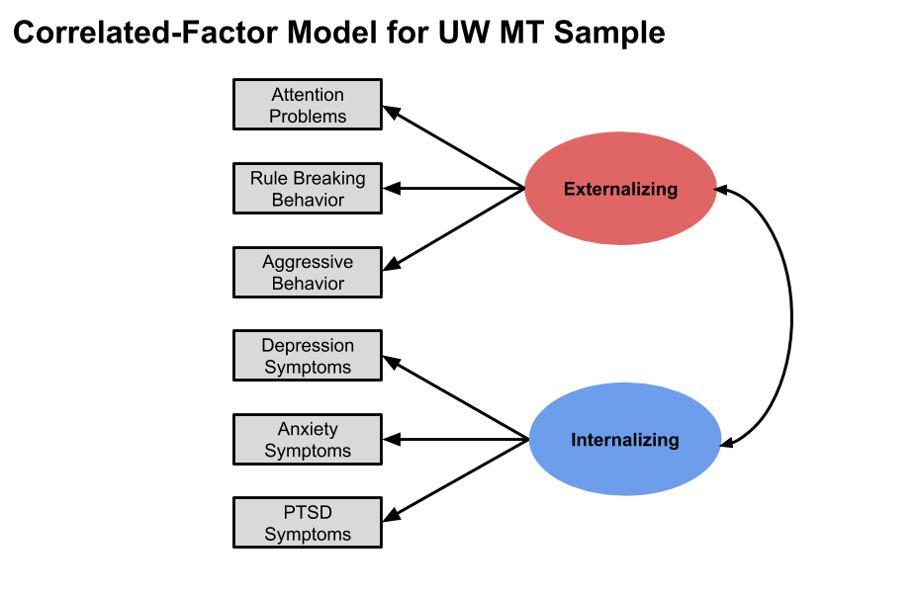

B.

Supplemental Figure 2. Emotion regulation task.



Supplemental Figure 3. Emotion regulation task performance. There were significant main effects of condition and maltreatment group status. Error bars represent standard error.

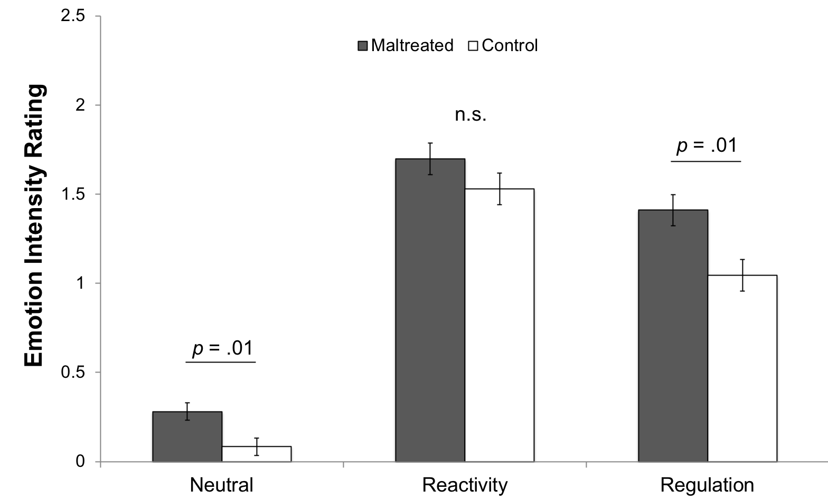

Supplemental Figure 4. Whole-brain activation in the entire sample during the emotional reactivity and regulation conditions. See Supplemental Table 5 for details.

