Supplemental material

EFFICACY OF PSYCHOLOGICAL INTERVENTIONS ON PSYCHOLOGICAL OUTCOMES IN CORONARY ARTERY DISEASE: SYSTEMATIC REVIEW AND META-ANALYSIS

Brief title: Meta-analysis of psychological interventions in CAD

Inés Magán, PhDª; Laura Casado, MSª; Rosa Jurado-Barba, PhD^{a, b}; Haley Barnum, PharmD^{c}; Marta M. Redondo, PhDª; Adrian V. Hernandez, MD, PhD^{c, d}; Héctor Bueno, MD, PhD^{b, e, f}

ªDepartment of Psychology, Facultad de Educación y Salud, Universidad Camilo José Cela, Madrid, Spain; ^{b}Instituto de Investigación Biomedica del Hospital 12 de Octubre (Imas12), Madrid, Spain, ^{c}Health Outcomes, Policy, and Evidence Synthesis (HOPES) Group, University of Connecticut School of Pharmacy, Storrs, CT, USA; ^{d}Vicerrectorado de Investigacion, Universidad San Ignacio de Loyola (USIL), Lima, Peru; ^{e}Department of Cardiology, Hospital Universitario 12 de Octubre, Madrid, Spain; ^{f}Multidisciplinary Translational Cardiovascular Research Group, Centro Nacional de Investigaciones Cardiovasculares (CNIC), Madrid, Spain.

February 24, 2020

Contents of supplementary files
- Search strategy for all data bases
- Online Figure 1: Risk of bias of included trials
- Online Figure 2: Effect of psychological interventions at the end of the intervention on secondary outcomes
  - Online Figure 2A: Negative affect at the end of the intervention
  - Online Figure 2B: Positive affect at the end of the intervention
  - Online Figure 2C: Hostility at the end of the intervention
  - Online Figure 2D: Quality of life at the end of the intervention
  - Online Figure 2E: Dispositional hope at the end of the intervention
- Online Figure 3: Effect of psychological interventions at the end of follow-up on secondary outcomes
  - Online Figure 3A: Daily activities at the end of follow-up
  - Online Figure 3B: Quality of life at the end of follow-up
  - Online Figure 3C: Dispositional hope at the end of follow-up
- Online Figure 4: Subgroups analysis of depression at the end of the intervention
  - Online Figure 4A: Depression at the end of the intervention subgroup by provider of intervention (psychologist and unknown)
  - Online Figure 4B: Depression at the end of the intervention subgroup by type of population (any CAD included both chronic and acute CAD patients)
  - Online Figure 4C: Depression at the end of the intervention subgroup by type of PI (CBT vs. PPT)
  - Online Figure 4D: Depression at the end of the intervention subgroup by post-treatment assessment time (> 12 weeks and < 12 weeks)
  - Online Figure 4E: Depression at the end of the intervention subgroup by session type (individual and group)
- Online Figure 5: Subgroups analysis of depression at the end of follow-up
  - Online Figure 5A: Depression at the end of follow-up subgroup by provider of intervention (psychologist and unknown)
  - Online Figure 5B: Depression at the end of follow-up subgroup by type of population (any CAD included both chronic and acute CAD patients)
  - Online Figure 5C: Depression at the end of follow-up subgroup by follow-up assessment time (< 6 months and > 6 months)
- Online Figure 6: Subgroup analysis of anxiety at the end of the intervention
  - Online Figure 6A: Anxiety at the end of the intervention subgroup by type of population (any CAD included both chronic and acute CAD patients)
  - Online Figure 6B: Anxiety at the end of the intervention subgroup by risk of bias (low and high or unclear)
  - Online Figure 6C: Anxiety at the end of the intervention subgroup by post-treatment assessment time (> 10 weeks and < 10 weeks)
  - Online Figure 6D: Anxiety at the end of the intervention subgroup by session type (group and individual)
- Online Figure 7: Subgroup analysis of anxiety at the end of follow-up
  - Online Figure 7A: Anxiety at the end of follow-up subgroup by type of population (any CAD included both chronic and acute CAD patients)
  - Online Figure 7B: Anxiety at the end of follow-up subgroup by assessment follow-up time (< 6 months and > 6 months)
- Online Figure 8: Subgroup analysis of stress at the end of treatment
  - Online figure 8A: Subgroup analysis of stress at the end treatment by type of population (any CAD included both chronic and acute CAD patients)
  - Online figure 8B: Subgroup analysis of stress at the end of treatment by post-treatment assessment time (<10 weeks and >10 weeks)
  - Online figure 8C: Subgroup analysis of stress at the end by session type (group and individual)
- Online Figure 9: Subgroup analysis of stress at the end of follow-up by session type (group and individual)

Search strategy for all data bases
We searched PubMed, PsycInfo, Scopus, The Web of Science, and Cochrane Library for randomized controlled trials (RCTs). Searches were undertaken from 1980 to May 2018. References were also checked to add studies. The search strategy for PubMed was:
((“coronary artery disease” [All Fields] OR “ischemic heart disease” [All Fields] OR “acute coronary syndrome” [All Fields] AND “psychological treatment” [All Fields]) OR “psychological intervention” [All Fields] OR “cognitive behavioral therapy” [All Fields] OR (“cognitive behavioral” [All Fields] AND “therapy”) OR “positive psychology intervention” [All Fields] OR (“positive psychology” [All Fields] AND “intervention” [All Fields])) AND (“randomized controlled trial” [Publication Type] OR “randomized controlled trials” [All Fields]).

Online Figure 1: Risk of bias of included trials
Online figure 1 shows risk of bias assessment of the included trials in this meta-analysis, following the Cochrane Collaboration’s risk of bias assessment tool. The risk of bias was evaluated with the following items: random sequence generation (selection bias), allocation concealment (selection bias), blinding of participants and personnel (performance bias), blinding of outcome assessment (detection bias), incomplete outcome data (attrition bias), selective reporting (reporting bias) and other bias.

Online Figure 2: Effect of psychological interventions at the end of the intervention on secondary outcomes
Online figure 2 includes forest-plot showing the effect of psychological intervention on negative affect (online figure 2A), positive affect (online figure 2B), hostility (online figure 2C), quality of life (online figure 2D), and dispositional hope (online figure 2E) immediately at the end of the intervention.
Online Figure 2A: Negative affect at the end of the intervention
Online Figure 2B: Positive affect at the end of the intervention
Online Figure 2C: Hostility at the end of the intervention
Online Figure 2D: Quality of life at the end of the intervention
Online Figure 2E: Dispositional hope at the end of the intervention

Online Figure 3: Effect of psychological interventions at the end of follow-up on secondary outcomes
Online figure 3 includes forest-plots showing the effect of psychological intervention on daily activities (online figure 3A), quality of life (online figure 3B), and dispositional hope (online figure 3C) at the end of follow-up.
Online Figure 3A: Daily activities at the end of follow-up
Online Figure 3B: Quality of life at the end of follow-up
Online Figure 3C: Dispositional hope at the end of follow-up

Online Figure 4: Subgroups analyses of depression at the end of the intervention
Online figure 4 includes forest-plots showing the effects of psychological interventions compared to control groups on depression immediately after treatment across the two pre-specified subgroups analyses: provider of intervention (online figure 4A), type of population (online figure 4B), type of PI (CBT and PPT (online figure 4C), post-treatment assessment time (online figure 4D), and session type (online figure 4E).
Online Figure 4A: Depression at the end of the intervention subgroup by provider of intervention (psychologist and unknown)
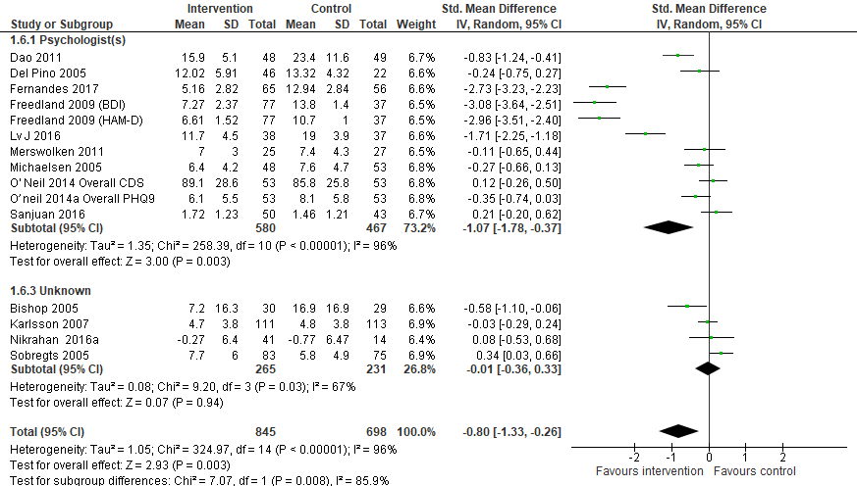

Online Figure 4B: Depression at the end of the intervention subgroup by type of population (any CAD included both chronic and acute CAD patients)
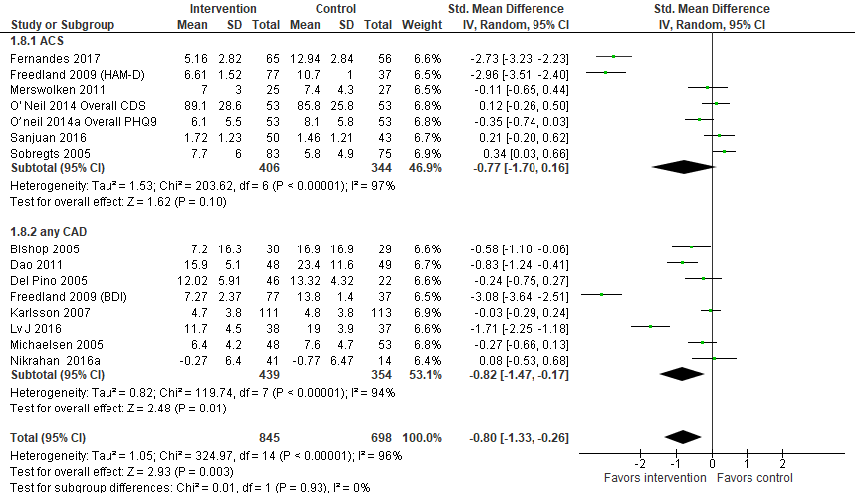
Online Figure 4C: Depression at the end of the intervention subgroup by type of PI (CBT vs. PPT)
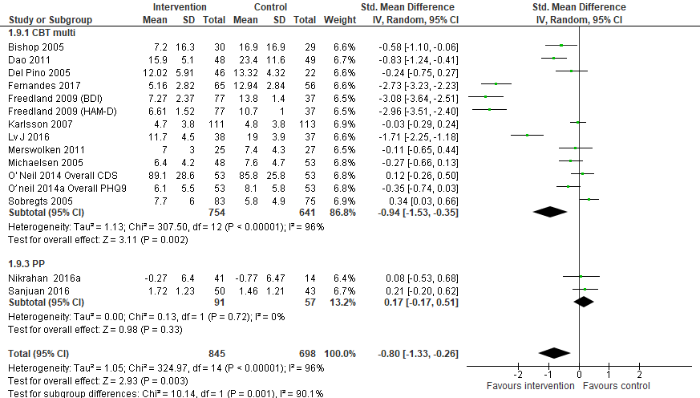
Online Figure 4D: Depression at the end of the intervention subgroup by post-treatment assessment time (>12 weeks and <12 weeks)
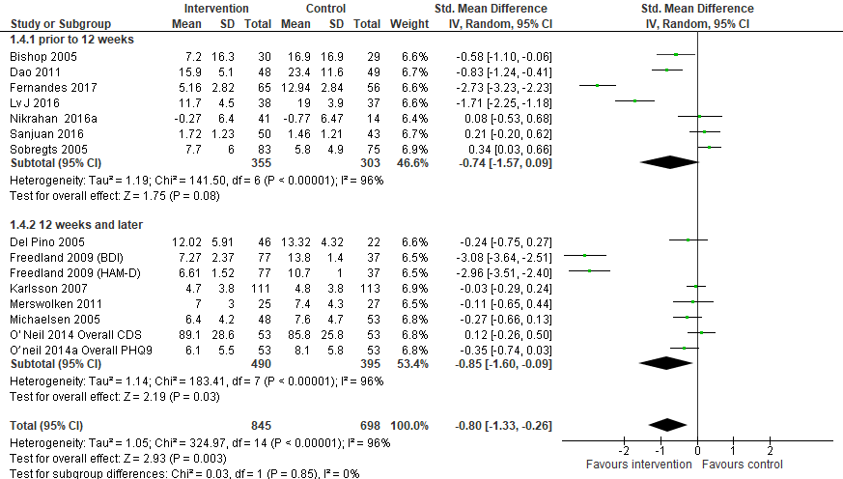Online Figure 4E: Depression at the end of the intervention subgroup by session type (individual and group)
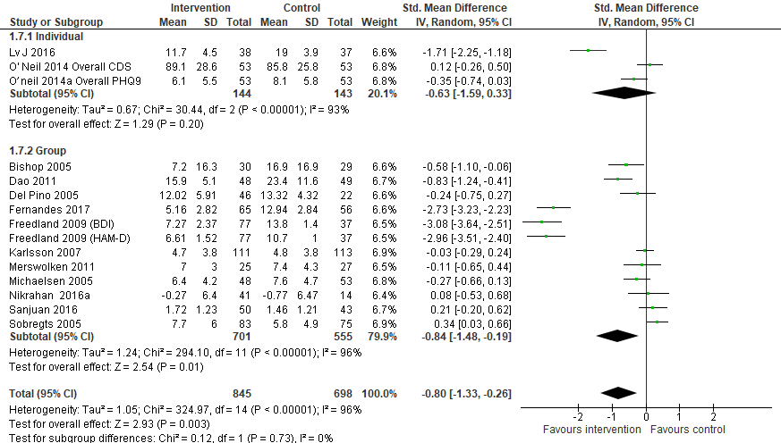
Online Figure 5: Subgroups analyses of depression at the end of follow-up
Online figure 5 includes forest-plots showing the effects of psychological interventions compared to control groups on depression at the end of follow-up across the two pre-specified subgroups analyses: provider of intervention (online figure 5A), type of population (online figure 5B), and follow-up assessment time (online figure 5C).
Online Figure 5A: Depression at the end follow-up subgroup by provider of intervention (psychologist and unknown)
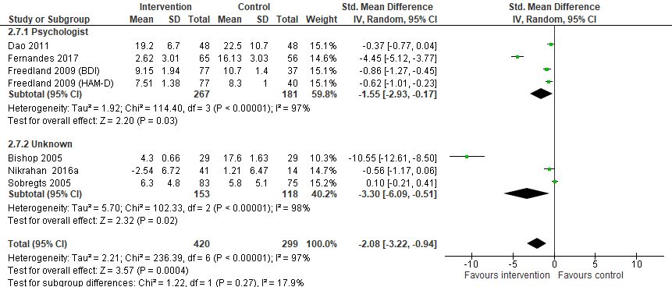
Online Figure 5B: Depression at the end of follow-up subgroup by type of population (any CAD included both chronic and acute CAD patients)
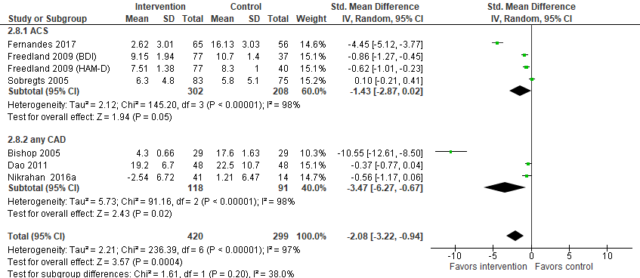
Online Figure 5C: Depression at the end of follow-up subgroup follow-up assessment time (<6 months and >6 months)
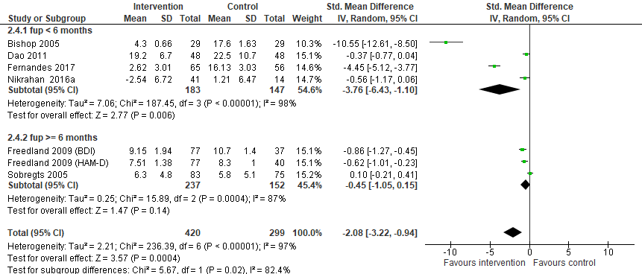

Online Figure 6: Subgroups analyses of anxiety at the end of the intervention
Online figure 6 includes forest-plots showing the effects of psychological interventions compared to control groups on anxiety immediately after treatment across the two pre-specified subgroups analyses: type of population (online figure 6A), risk of bias (online figure 6B), post-treatment assessment time (online figure 6C), and session type (online figure 6D).

Online Figure 6A: Anxiety at the end of the intervention subgroup by type of population (any CAD included both chronic and acute CAD patients)

Online Figure 6B: Anxiety at the end of the intervention subgroup by risk of bias (low and high or unclear risk of bias)
Online Figure 6C: Anxiety at the end of the intervention subgroup by post-treatment assessment time (>10 weeks and <10 weeks)
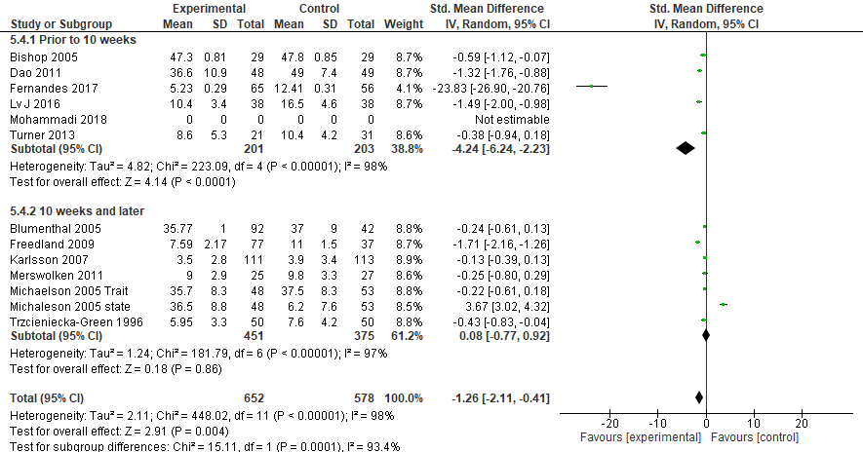
Online Figure 6D: Anxiety at the end of the intervention subgroup by session type (group and individual)
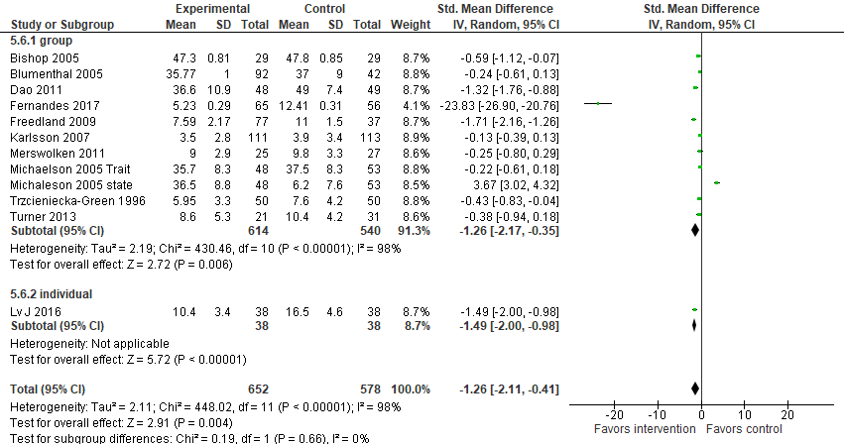

Online Figure 7: Subgroup analysis of anxiety at the end of follow-up
Online figure 7 includes forest-plot showing the effects of psychological interventions compared to control groups on anxiety at the end of follow-up across the pre-specified subgroup analysis by type of population (online figure 7A), and assessment follow-up time (online figure 7B).
Online Figure 7A: Anxiety at the end of follow-up subgroup by type of population (any CAD included both chronic and acute CAD patients)
Online Figure 7B: Anxiety at the end of follow-up subgroup by assessment follow-up time (<6 months and >6 months)
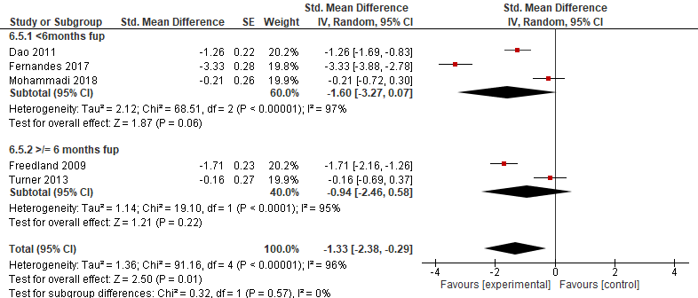
Online Figure 8: Subgroup analysis of stress at the end of post-treatment
Online figure 8 includes forest-plot showing the effects of psychological interventions compared to control groups on stress at the end of treatment across the pre-specified subgroup analysis by type of population (online figure 8A), post-treatment assessment time (online figure 8B), and session type (online figure 8C).
Online Figure 8A: Subgroup analysis of stress at the end treatment by type of population (any CAD included both chronic and acute CAD patients)

Online Figure 8B: Subgroup analysis of stress at the end of treatment by post-treatment assessment time (<10 weeks and >10 weeks)
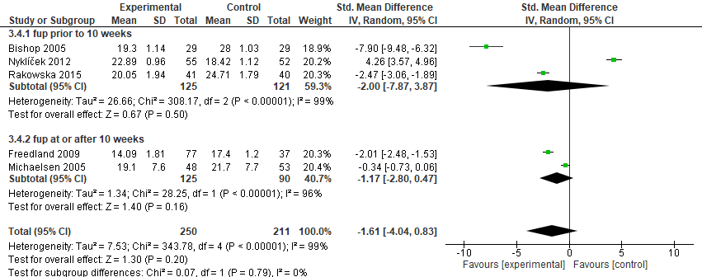
Online Figure 8C: Subgroup analysis of stress at the end by session type (group and individual)
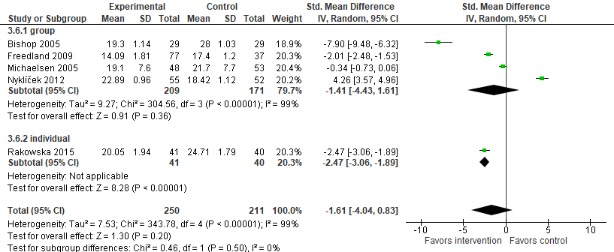

Online Figure 9: Subgroup analysis of stress at the end of follow-up by session type (group and individual)
Online figure 9 includes forest-plot showing the effects of psychological interventions compared to control groups on stress at the end of follow-up across the pre-specified subgroup analysis by session type.
