A Computational Network Perspective on Pediatric Anxiety

Supplemental material

Methods
Participants
Participants were drawn from seven international research sites. See Table 1 in the main text for demographic and clinical information. In some of the samples, participants were recruited for intervention studies; SCARED scores used in this report were collected prior to any intervention.

Anxiety diagnosis
Participants in the NIMH, UFRGS, FIU, and Yale sites were assessed for psychiatric disorders through semi-structured interviews conducted by trained clinicians. Interviews used either the Kiddie Schedule for Affective Disorders and Schizophrenia-Present and Lifetime version (K-SADS-PL; Kaufman et al., 1997) (NIMH, UFRGS) or Anxiety Disorders Interview Schedule for DSM-IV: Child and Parent versions (ADIS; Silverman and Albano, 1996) (FIU, Yale).

Sites
National Institute of Mental Health (NIMH). Participants from the NIMH (Bethesda, MD) site were 1,089 youths enrolled in research protocols examining pediatric anxiety. Of those, 455 youths (49.5% females) were seeking treatment for an anxiety disorder and received a diagnosis of at least one of these anxiety disorders: generalized anxiety disorder (GAD), separation anxiety disorder (SEP), or social anxiety disorder (SAD). 634 youth (51.3% females) were recruited as healthy volunteers with no current or past psychiatric diagnoses. Inclusion criteria were age 8-17 years and a diagnosis of GAD, SAD, and/or SEP for the patient sub-sample, as diagnosed using the K-SADS-PL. Exclusion criteria for all participants were IQ <70 or use of psychiatric medication. Furthermore, for the patient sub-sample, exclusion criteria were current major depressive disorder, obsessive-compulsive disorder, or posttraumatic stress disorder, or a lifetime history of psychosis, bipolar disorder, extreme trauma, organic mental disorders, pervasive developmental disorders, or mental retardation; for the healthy sub-sample: any psychiatric diagnosis.
Florida International University (FIU). Participants from FIU (Miami, FL) were 222 treatment-seeking youth. Inclusion criteria were age 6-17 years and diagnosis of GAD, SAD, and/or SEP (as diagnosed using the ADIS). Data included in this report were collected at a pretreatment intake evaluation. Exclusion criteria were similar to those applied in the NIMH site.
Yale University Child Study Center. Participants from Yale University Child Study Center (New Haven, CT) were 485 youths. Of those, 340 were treatment-seeking patients diagnosed with GAD, SAD, and/or SEP (as diagnosed using ADIS), and 149 were non-selected. Exclusion criteria were similar to those applied in the NIMH site.
The Pennsylvania State University (PSU). Participants from PSU (University Park, PA) were 209 youths ages 9 to 12 recruited for a larger study of temperament, attention bias to threat, and anxiety. Participants were screened for behavioral inhibition (BI) using parent-report on the Behavioral Inhibition Questionnaire (Bishop et al., 2003). Children meeting BI cutoffs were recruited, along with non-BI age- and sex-matched controls. Exclusion criteria were similar to those applied in the NIMH site.
High Risk Cohort Study for the Development of Childhood Psychiatric Disorders (HRC; Brazil). Participants were youth taking part in a Brazilian community cohort study that oversampled for child and family psychopathology (Salum et al., 2015). Of those, 1,664 provided data at two time-points (T1: M age=10.13 years, SD=1.90; T2: M age=13.45, SD=1.91).
Universidade Federal do Rio Grande do Sul (UFRGS). Participants from UFRGS (Porto Alegre, Brazil) were 72 treatment-seeking youth with anxiety disorders. Inclusion criteria were age 6-12 years and a diagnosis of GAD, SAD, and/or SEP (as diagnosed using the K-SADS-PL). Exclusion criteria were similar to those applied in the NIMH site.
University of Amsterdam (UvA). Participants from UvA (Amsterdam, the Netherlands) were 673 non-selected adolescent youths recruited in a school setting for studies on the efficacy of anxiety interventions. Inclusion criteria were students in the 6th to 12th grade of school (all levels except special education).

Sites differed significantly by age, F(6,4957)=402.72, p<.001, sex, χ²(6)=41.73, p<.001, and SCARED scores (total and all subscale scores), Fs(6,4957)>26.53, ps<.001. To diminish site-specific effects, network analyses were conducted on residual data controlling for sites (see main text).

Anxiety symptoms
The 41 items of the SCARED index responses that relate to various anxiety symptoms. As noted in the main text, multiple exploratory and confirmatory factor analyses support a domain structure that maps onto DSM pediatric anxiety disorder categories (in addition to a factor indexing school-related anxiety) (Hale et al., 2011). As noted, broadly, items grouped into the generalized anxiety disorder domain (GAD; nine items) assess worry-related cognitions (e.g., “I worry about being as good as other kids”; “I am a worrier”). The separation anxiety disorder domain (SEP; eight items) assesses fear responses relating to separation from significant others (e.g., “I follow my mother or father wherever they go”; “I have nightmares about something bad happening to my parents”). The social anxiety disorder domain (SOC; seven items) assesses fear responses in social settings (e.g., “I feel shy with people I don’t know well”; “I feel nervous when I am with other children or adults and I have to do something while they watch me (for example: read aloud, speak, play a game, play a sport)”). The panic disorder domain (PAN; 13 items) assesses physiological arousal (e.g., “When I get frightened, I sweat a lot”;” I get shaky”). Finally, the school anxiety domain (SCH; four items) assesses fear responses in the context of school (e.g., “I am scared to go to school”; “I get headaches when I am at school”). While some items may contain aspects that refer to more than one domain (e.g., “I get stomachaches at school”), most items do not explicitly cross domains. As such, these domains assess fear-related responses as a core broad feature of anxiety, but distinct aspects/contexts of these responses, as supported by factor analyses.
It should be noted that the item groupings utilized in the current report are well grounded theoretically and empirically as reflected in the DSM and as supported in factor analyses. These theory-driven groupings reflect the presence of DSM-related domains. Nevertheless, the domains related to nodes in the current study may not necessarily reflect unidimensional constructs but rather may include sub-domains of symptoms lying within them. We conducted an analysis to empirically explore the extent of unidimensionality, whereby we calculated the eigen values for factors derived by a factor analysis on the items of each of the five domains, using the scree function from the psych R package (Revelle, 2019). We then used scree plots and the ratio of the first eigen value to the second eigen value, as described by Greven, Buitelaar, & Salum (2018). For each of the five domains, the scree plots indicated one dominant factor, with the eigen values for the first and second factors (and ratio between them) being: GAD: 1st=3.20, 2nd=0.34 (ratio=9.54); SOC: 1st=2.56, 2nd=0.20 (ratio=12.56); SEP: 1st=2.66, 2nd=0.38 (ratio=7.04); PAN: 1st=3.84, 2nd=0.24 (ratio=16.16); and SCH: 1st=1.22, 2nd=0.22 (ratio=5.59). These results provide some support for essential unidimensionality of the domains (Greven et al., 2018, Cattell, 1966). Nevertheless, future research could also utilize individual symptom-related items, which are clustered as part of one domain-related node in the current study, to function as distinct nodes in a more complex network than modeled in the current study.

Network analysis
Network topology estimation. Network edges reflected partial correlations between pairs of symptom subscale scores (nodes) estimated using the esimateNetwork function with the EBICglasso option in the R package qgraph.(Epskamp et al., 2012). Partial correlations were used in order to quantify unique associations among node pairs. Networks were regularized using graphical LASSO (Least Absolute Shrinkage and Selection Operator; Friedman et al., 2008) to reduce the number of false positives, overcoming multiple-testing problems that would occur in traditional significance testing in the context of networks. Of note, given the large sample size, we also estimated networks without regularization using ggmModSelect models (Williams and Rast, preprint). As similar results were derived with and without regularization, and since regularized estimation generated models with better accuracy, the text reports on the regularized networks. It should also be noted that networks generated from raw and normalized subscale scores are identical (the latter is a linear transformation of the former). Network centrality was assessed using node strength: the sum of all absolute edge weights to which a node is directly connected (Barrat et al., 2004). Previous work demonstrates that node strength shows the highest accuracy among centrality indices, and thus was used here (Epskamp et al., 2018).
The bootnet package was used to calculate edge and node accuracy estimates (based on 1,000 bootstrapped networks) and to test for pairwise differences in node strength within a network (p-values are Bonferroni-corrected) (Epskamp et al., 2018). While these methods for assessing network replicability are considered the standard in network analysis research, it should be noted that there is an ongoing debate on the best ways to assess such metrics (Borsboom et al., 2017, Forbes et al., 2019, Forbes et al., 2017); future research should consider opposing views on this topic. Networks were visualized in a “circle” layout to facilitate comparison between networks (Jones et al., 2018).
The NetworkComparisonTest (NCT) R package (Van Borkulo, 2016) tests for differences between network in terms of two global invariance metrics: 1) The global structure test assumes, under the null hypothesis, that the overall structure of two networks is identical, i.e., H₀: A₁=A₂, whereby A₁ and A₂ are the connection strength matrices of networks G₁ and G₂, respectively. 2) The global strength test assumes, under the null hypothesis, that the overall level of connectivity of two networks is identical, whereby overall connectivity is defined as the weighted absolute sum of all edges in the network (Opsahl et al., 2010). A third test examines differences in edge strength between two networks. This test was used as a post-hoc analysis following significant effects in (1) or (2). P-values for edge differences are Holm-Bonferroni corrected.
As in previous work, for longitudinal data, we examined edge-weight stability over time (correlations between edge-weight matrices at Time 1 and Time 2) (von Stockert et al., 2018, Santos et al., 2018).
As noted in the main text, previous studies used individual questionnaire items and parent-report alone to estimate anxiety-related symptom networks. The use of subscale scores in the current study as opposed to individual items (e.g., Fonseca-Pedrero et al., 2018, Briganti et al., 2018) has several advantages in this context: it models validated symptom domains; it reduces estimation problems due to item overlap and multicollinearity; it improves the accuracy of estimated parameters; and it facilitates interpretation of findings (Fried and Cramer, 2017, Epskamp et al., 2018). The use of child-report data may provide more reliable indices of internalizing symptoms relative to parent-report data (Silverman and Eisen, 1992).
Differences in symptom domain scores were tested using linear mixed effects through the R package nlme (Pinheiro et al., 2019), using subject as a random effect and site as covariate to account for site differences.

Results
The anxiety symptom network in the full sample
Linear mixed effects analysis indicated that mean severity varied by symptom domain, F(4,20374)=1593.11, p<.001. SOC severity was significantly higher (p<.001) than that of GAD and SEP, which did not differ (p=.23). GAD and SEP severity was significantly higher than SCH severity (p<.001), which in turn was higher than PAN severity (p<.001). Network accuracy metrics for edge and node strength estimates are presented in Fig. S1. Pairwise tests for differences in node strength (p<.05, corrected) indicated the following pattern: GAD=PAN>SEP=SCH>SOC.

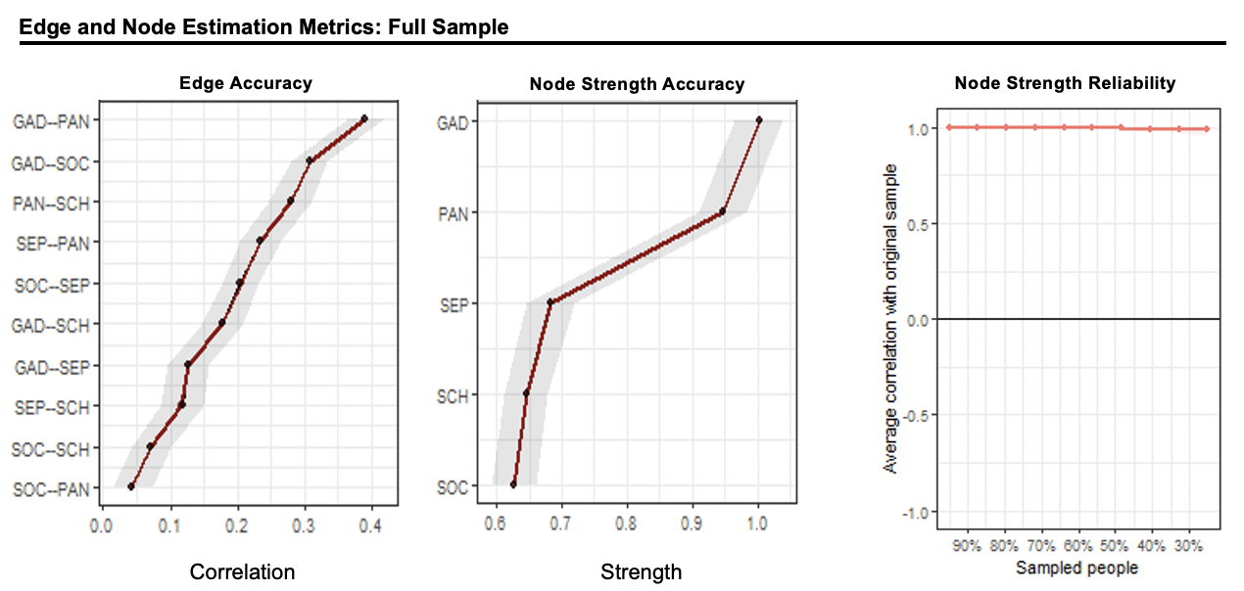
Figure S1. Edge and node estimates metrics in the full sample (n=4,964). In the accuracy plots, the black dots depict bootstrapped point estimates of the edge and node strength, and the red dots depict the sample statistics; the grey bar reflects 95% confidence intervals. The reliability plot depicts correlations of the sample node strength estimates as a function of proportion of the participants sampled.
Note: GAD = generalized anxiety disorder symptoms; SEP = separation anxiety disorder symptoms; SOC = social anxiety disorder symptoms; PAN = panic disorder/somatic symptoms; SCH = school phobia symptoms.

The findings depicted in Fig. S1 indicate high accuracy and reliability of estimated network parameters. Given that generalizability is an important concern in network analysis research (Forbes et al., 2017), we wanted to explore whether this network structure generalizes across sites. To this end, we estimated the network structure and centrality indices separately within each site (the FIU, UFRGS, and PSU sites were combined due to their relatively smaller sample sizes). See Fig. S2. Overall, the average correlation between edge-weight adjacency matrices among all pairs of sites was r=0.61, suggesting at least moderate cross-site consistency in network structure. As in the network estimated from the full sample, the GAD-PAN edge consistently emerged as a relatively strong edge while the SOC-PAN edge was consistently weak or estimated as 0. Likewise, the GAD and PAN were also consistently central in the individual sites. Some differences among sites also were observed, including differences in weights for the SOC-SCH edge and centrality of SEP and SCH, potentially reflecting site differences in size or population sampled. Additional studies could leverage site-related variability to identify additional moderators of network structures.
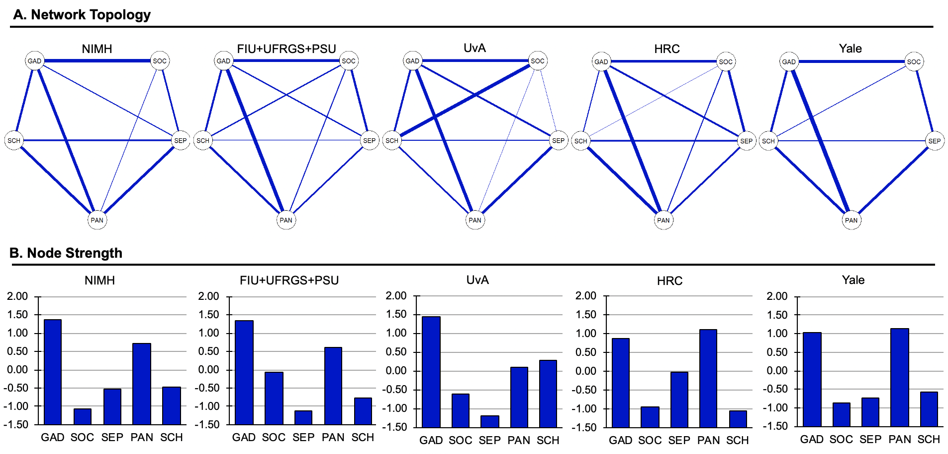
Figure S2. Anxiety symptom domains by site. A) Anxiety symptom network topology and B) node strength (Z-scored) in the different sites: NIMH (n=1,089); FIU, UFRGS, and PSU (combined n=503); UvA (n=673); HRC (n=2,214), and Yale (n=485). All edges shown are positive; thicker edges represent stronger associations.
Note: GAD = generalized anxiety disorder symptoms; SEP = separation anxiety disorder symptoms; SOC = social anxiety disorder symptoms; PAN = panic disorder/somatic symptoms; SCH = school phobia symptoms; NIMH = National Institute of Mental Health (USA; n=1,089); FIU = Florida International University (USA); UFRGS = Universidade Federal do Rio Grande do Sul (Brazil); PSU = The Pennsylvania State University (USA); UvA = University of Amsterdam (the Netherlands); HRC = High Risk Cohort Study for the Development of Childhood Psychiatric Disorders (Brazil); Yale = Yale University Child Study Center (USA).

In addition, we calculated zero-order correlations between all domain pairs. All domains were positively correlated, with correlation coefficients ranging from .37 to .64 (all ps<.001, see Table S3).
Finally, an additional supplemental analysis used subscale factor-scores rather than sum-scores to estimate the anxiety network. Factor-scores were generated by a confirmatory factor analysis on the individual SCARED items grouped by the five subscales, using the cfa() and lavPredict() functions from the lavaan R package (Rosseel, 2012). The factor analysis yielded the following fit statistics: χ²(769)=9262, p<0.001; CFI=0.86, TLI=0.86, RMSEA=0.047. Factor- and sum-scores were highly correlated for all subscales, 0.91<rs<0.99. The adjacency matrices for the estimated factor- and sum-score networks were correlated at r=0.90, indicating overall similarity. However, some differences were also noted, such as PAN-SCH being the strongest edge and SOC-PAN being negatively correlated in the factor-score network (see Fig. S3). Some minor differences in node strength were also observed between the networks, although GAD and PAN maintained their high centrality (Fig. S3).

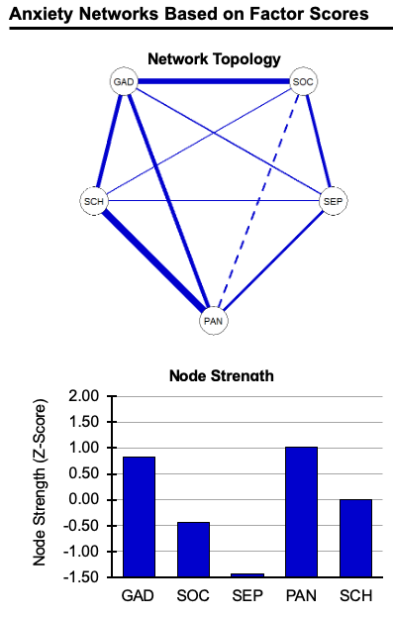
Figure S3. Anxiety symptom network based on factor scores. A) Anxiety symptom network topology and B) node strength (Z-scored) in the full sample, based on factor scores generated from a confirmatory factor analysis. Dashed edges are negative; thicker edges represent stronger associations.
Note: GAD = generalized anxiety disorder symptoms; SEP = separation anxiety disorder symptoms; SOC = social anxiety disorder symptoms; PAN = panic disorder/somatic symptoms; SCH = school phobia symptoms;

The anxiety symptom network in pathological anxiety
Mean symptom domain severity varied as a function of group (Scale x Group interaction), F(4,6973)=18.71, p<.0001. Follow-up analyses indicated that the patient group endorsed higher severity than the HV group on all domains, ps<.001. Accuracy and reliability metrics for edge and node strength estimates in the HV and patient networks are presented in Fig. S4. Pairwise tests for differences in node strength (p<.05, corrected) indicated the following pattern in the anxious sample: GAD=PAN>SCH>SOC=SEP. The following pattern was observed in the HV sample: GAD>PAN=SCH=SOC=SEP.

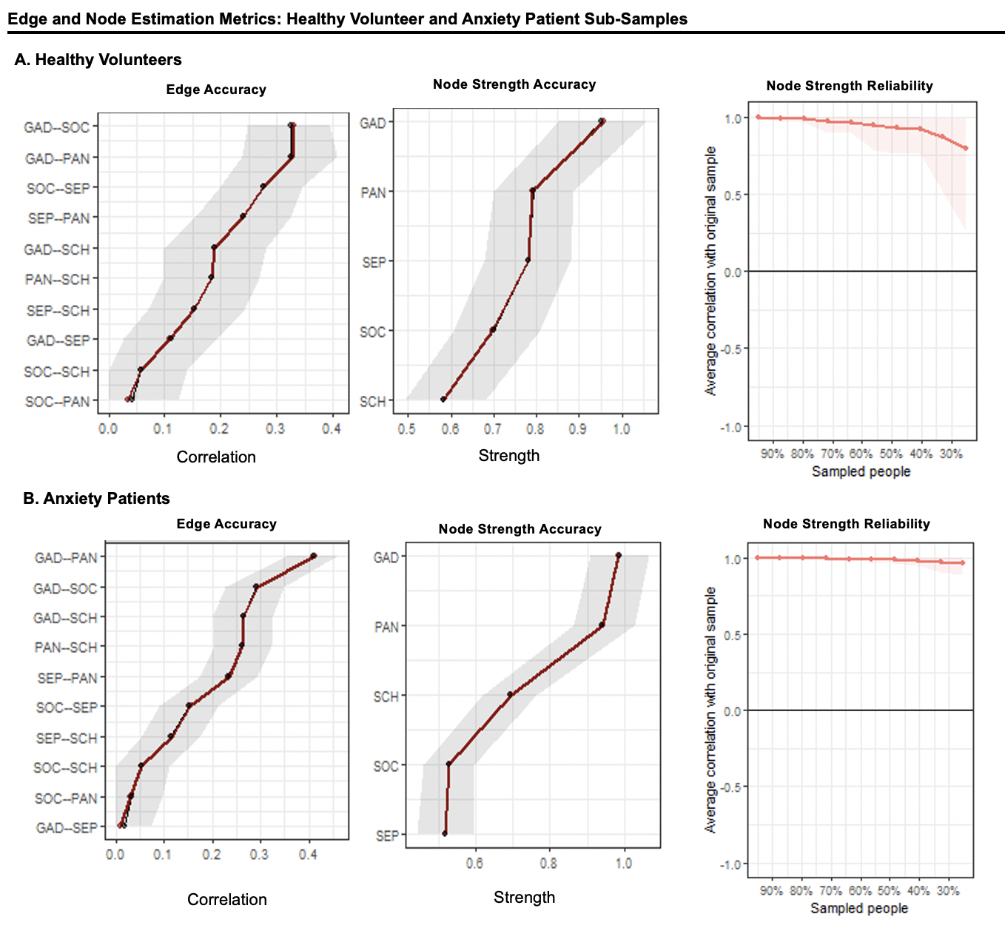
Figure S4. Edge and node strength estimation metrics in the A) healthy volunteer (n=634) and B) anxiety patient (n=1,089) samples. In the accuracy plots, the black dots depict bootstrapped point estimates of the edge and node strength, and the red dots depict the sample statistics; the grey bar reflects 95% confidence intervals. The reliability plot depicts correlations of the sample node strength estimates as a function of proportion of the participants sampled.
Note: GAD = generalized anxiety disorder symptoms; SEP = separation anxiety disorder symptoms; SOC = social anxiety disorder symptoms; PAN = panic disorder/somatic symptoms; SCH = school phobia symptoms.

The anxiety symptom network and sex
Patterns of symptom domain severity in the female and male sub-samples were relatively similar; females: SOC>GAD>SEP>SCH>PAN, males: SOC>SEP>GAD>SCH>PAN. Network accuracy and reliability metrics are presented in Fig. S5. Pairwise tests for differences in node strength (p<.05, corrected) indicated the following pattern in the male sample: GAD=PAN>SEP=SOC>SCH. The following pattern was observed in the female sample: GAD=PAN>SCH=SEP>SOC.

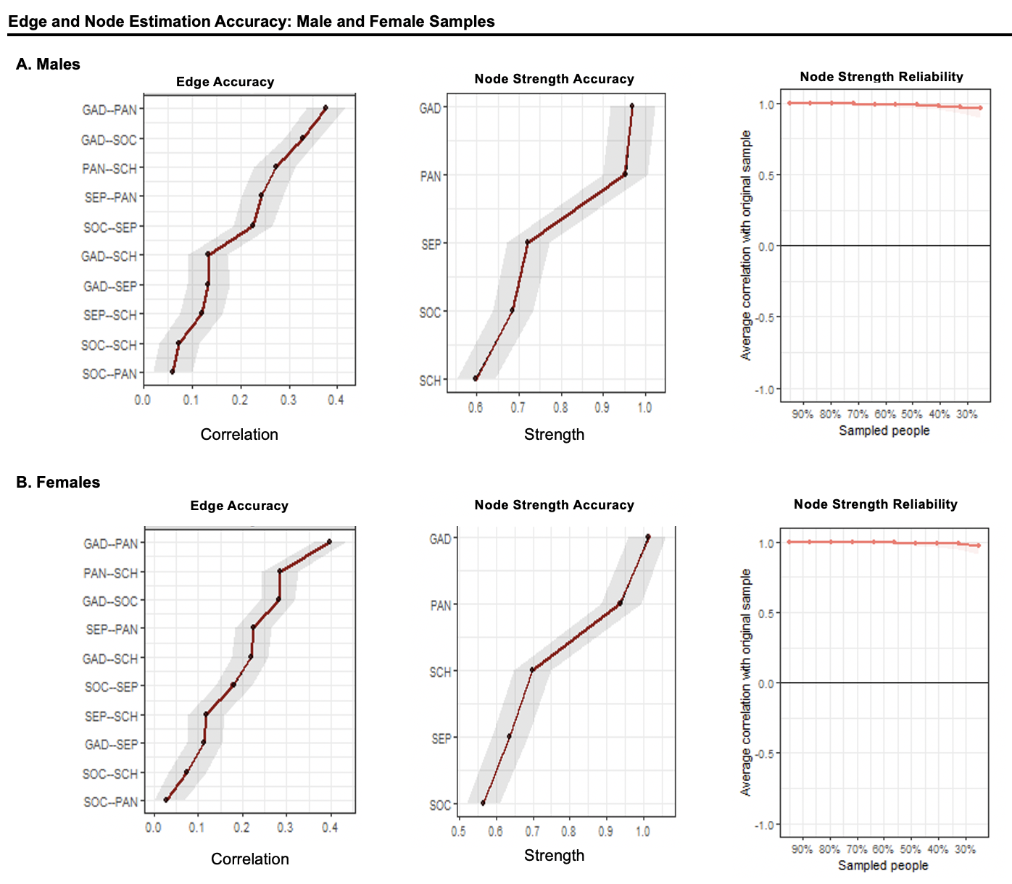
Figure S5. Edge and node strength estimation metrics in the A) male (n=2,522) and B) female (n=2,470) anxiety networks. In the accuracy plots, the black dots depict bootstrapped point estimates of the edge and node strength, and the red dots depict the sample statistics; the grey bar reflects 95% confidence intervals. The reliability plot depicts correlations of the sample node strength estimates as a function of proportion of the participants sampled.
Note: GAD = generalized anxiety disorder symptoms; SEP = separation anxiety disorder symptoms; SOC = social anxiety disorder symptoms; PAN = panic disorder/somatic symptoms; SCH = school phobia symptoms.

Changes in the anxiety symptom network with development
Accuracy and reliability metrics for edge and node strength estimates in the longitudinal child and adolescent networks are presented in Fig. S6 and S7. Pairwise tests for differences in node strength (p<.05, corrected) indicated the following pattern in the child time 1 network: GAD=PAN>SEP>SOC>SCH; child time 2 network: PAN>GAD=SEP>SOC=SCH. Pairwise tests for differences in node strength indicated the following pattern in the adolescent time 1 network: GAD=PAN>SEP>SCH=SOC; adolescent time 2 network: PAN>GAD=SEP>SOC=SCH.

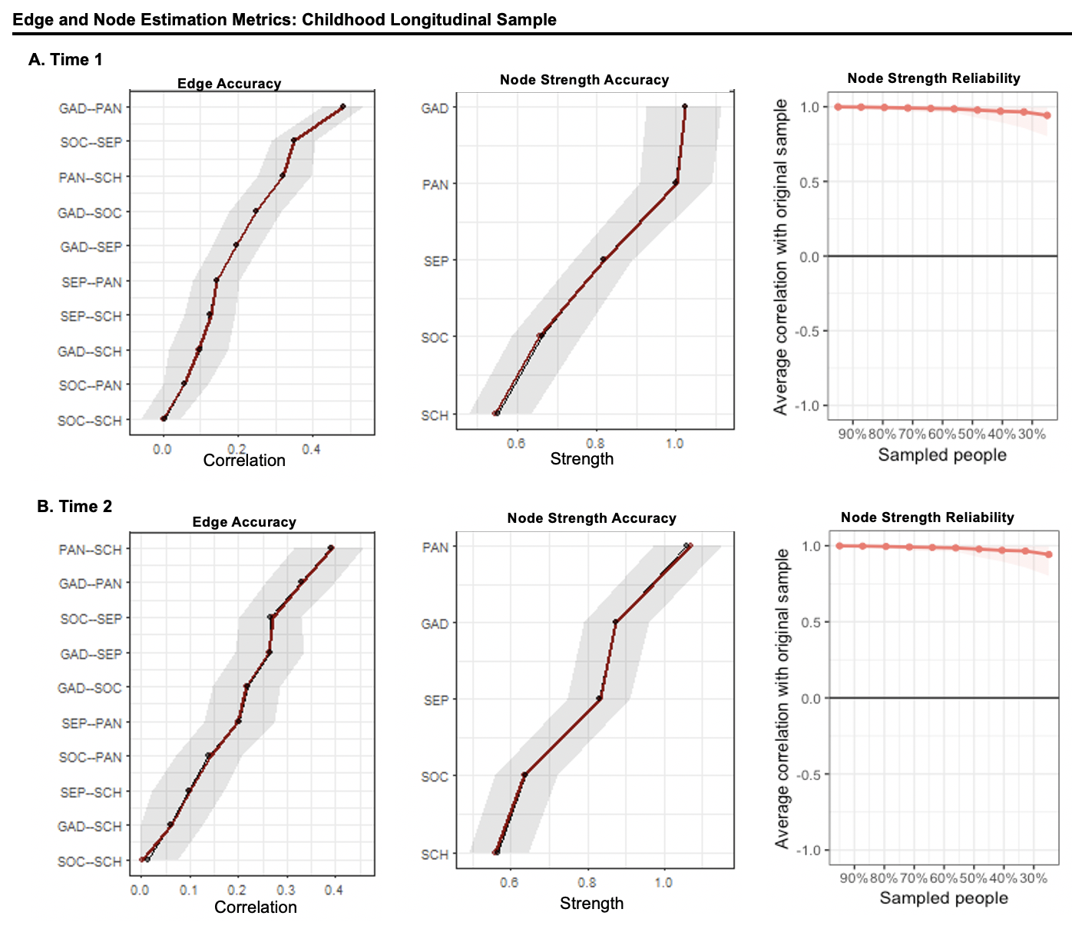
Figure S6. Edge and node strength estimation metrics in the child cohort network (n=793), for A) Time 1 and B) Time 2. In the accuracy plots, the black dots depict bootstrapped point estimates of the edge and node strength, and the red dots depict the sample statistics; the grey bar reflects 95% confidence intervals. The reliability plot depicts correlations of the sample node strength estimates as a function of proportion of the participants sampled.
Note: GAD = generalized anxiety disorder symptoms; SEP = separation anxiety disorder symptoms; SOC = social anxiety disorder symptoms; PAN = panic disorder/somatic symptoms; SCH = school phobia symptoms.

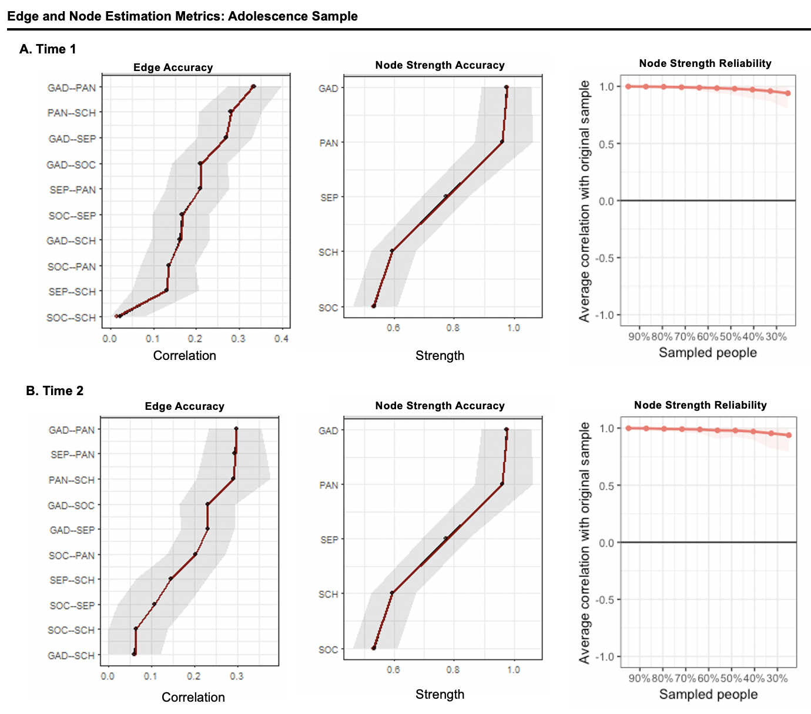
Figure S7. Edge and node strength estimation metrics in the adolescent cohort network (n=871), for A) Time 1 and B) Time 2. In the accuracy plots, the black dots depict bootstrapped point estimates of the edge and node strength, and the red dots depict the sample statistics; the grey bar reflects 95% confidence intervals. The reliability plot depicts correlations of the sample node strength estimates as a function of proportion of the participants sampled.
Note: GAD = generalized anxiety disorder symptoms; SEP = separation anxiety disorder symptoms; SOC = social anxiety disorder symptoms; PAN = panic disorder/somatic symptoms; SCH = school phobia symptoms.

Additional analyses
Additional analyses examined effects of informant (child vs. parent reports in dyads) differences on anxiety symptom domains.(Behrens et al., 2018) Children- and parent-reported severity scores were significantly correlated on all domains, r(1986)s≥.26, ps<.001. Children and parents reported a similar pattern of relative symptom severity (SOC>GAD>SEP>SCH>PAN; Fig. S8, top). A linear mixed effects model indicated that domain severity varied by informant (Domain x Informant interaction on severity scores), F(4,17974)=41.68, p<.0001. Follow-up analyses indicated that parents reported higher GAD severity for their children, whereas children reported higher SOC, SEP, SCH, and PAN severity than their parents, all ps<.001.
The estimated networks of both samples (Fig. S8, center; see Fig. S9 for accuracy metrics) featured positive associations between most symptom domains. GAD-PAN was the strongest edge in the child network (r=.38), whereas GAD-SOC was the strongest edge in the parent network (r=.37); the parent network did not include the SOC-PAN edge (see Table S8 for all values). NCT indicated a significant informant difference in global network structure, M=.20, p<.001. Follow-up analyses indicated that children reported a weaker GAD-SEP association, p<.001, but stronger GAD-PAN and SOC-SEP associations, ps<.001. Networks did not differ in global strength, S=.04, p=.18. Finally, the children network featured high relative strength of GAD and PAN symptoms and low strength for the other domains (GAD=PAN>SCH=SOC=SEP; Fig. S8, bottom); in the parent network, GAD symptoms featured higher centrality relative to PAN, which in turn showed higher centrality relative to the rest (GAD>PAN>SCH=SEP>SOC).

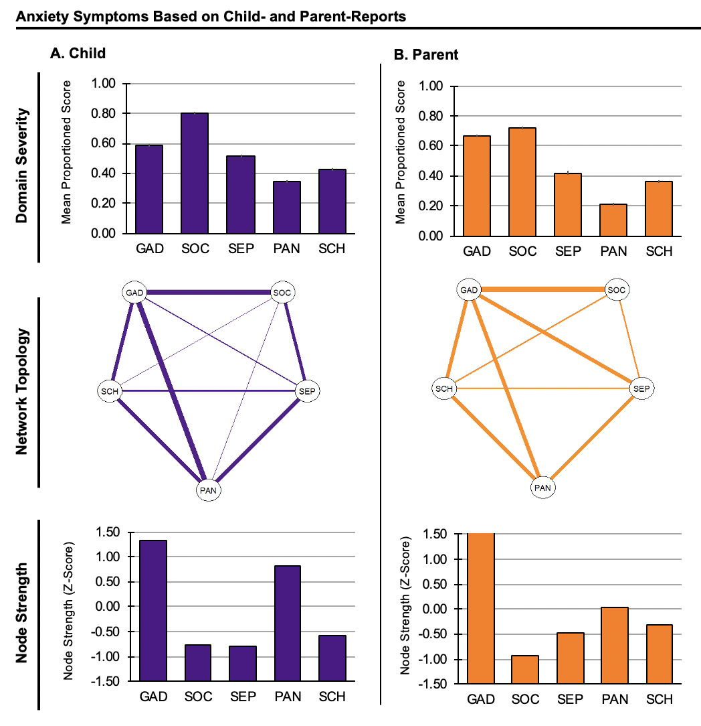
Figure S8. Informant differences in anxiety symptoms (n=1,988).
Data presented are for the subsample (n=1,988) of participants for which both parent and child ratings were available, divided into: A) child report and B) parent report. Top: mean domain scores for the five anxiety symptom domains. Center: anxiety symptom network topology. All edges are positive; thicker edges represent stronger regularized partial correlations. Bottom: strength of each node in the anxiety network (Z-scored).
Note: GAD = generalized anxiety disorder symptoms; SEP = separation anxiety disorder symptoms; SOC = social anxiety disorder symptoms; PAN = panic disorder/somatic symptoms; SCH = school phobia symptoms. Symptom domain score was calculated as subscale score divided by the number of subscale items. Error bars indicate one standard error of the mean.

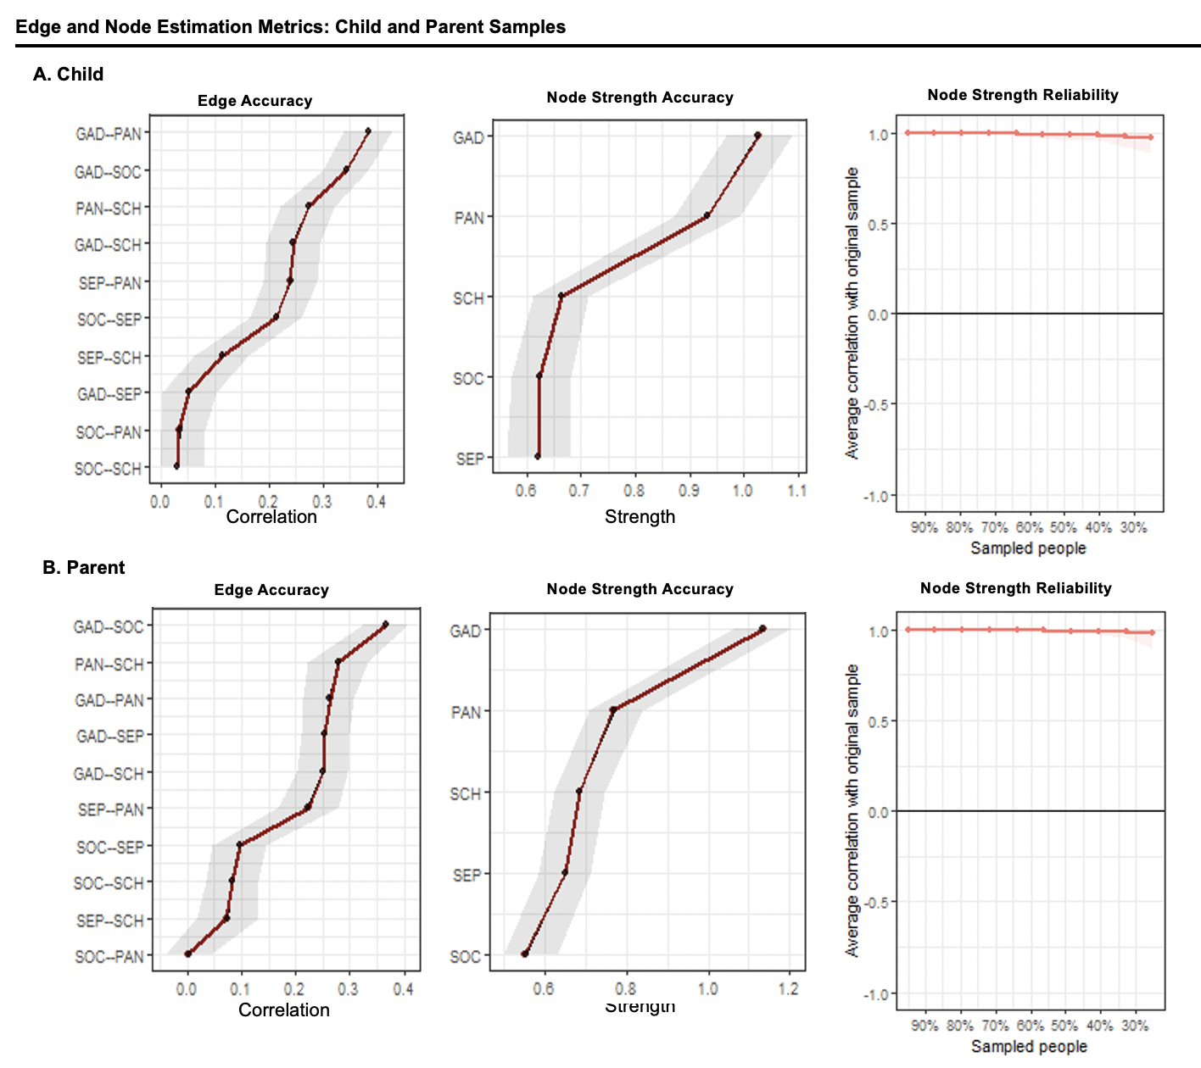
Figure S9. Edge and node strength estimation metrics in the subsample of participants with both child and parent reports (n=1,988), for A) Child Network and B) Parent Network. In the accuracy plots, the black dots depict bootstrapped point estimates of the edge and node strength, and the red dots depict the sample statistics; the grey bar reflects 95% confidence intervals. The reliability plot depicts correlations of the sample node strength estimates as a function of proportion of the participants sampled.
Note: GAD = generalized anxiety disorder symptoms; SEP = separation anxiety disorder symptoms; SOC = social anxiety disorder symptoms; PAN = panic disorder/somatic symptoms; SCH = school phobia symptoms.

Tables
Description | Children  (n=793) |  | Adolescents  (n=871)
 | Time 1 | Time 2 | Time 1 | Time 2
Age [M (SD)] | 8.47  (0.92) | 11.79  (0.95) | 11.64  (1.15) | 14.96  (1.17)
Female [N (%)] | 340  (42.88) |  | 388  (44.55)
SCARED Domain Subscale Score [M (SD)]
GAD | 5.73  (4.58) | 5.83  (3.55) | 6.67  (4.22) | 6.54  (3.53)
SOC | 5.54  (3.59) | 5.09  (2.89) | 6.04  (3.41) | 5.03  (3.16)
SEP | 7.22  (3.81) | 5.00  (3.00) | 5.92  (3.44) | 4.06  (2.75)
PAN | 4.85  (5.30) | 3.67  (4.08) | 4.23  (4.48) | 3.46  (3.94)
SCH | 1.71  (1.85) | 1.29  (1.33) | 1.30  (1.49) | 1.07  (1.21)
Total Score | 25.04  (15.57) | 20.89  (11.88) | 24.15  (13.31) | 20.16  (11.50)

Table S1. Longitudinal demographic characteristics and anxiety symptom scores for the children (n=793) and adolescent (n=871) samples (for Time 1 and Time 2).
Note: SCARED = The Screen for Child Anxiety Related Emotional Disorders; GAD = generalized anxiety disorder symptoms; SOC = social anxiety disorder symptoms; SEP = separation anxiety disorder symptoms; PAN = panic/somatic disorder symptoms; SCH = school avoidance symptoms.

 | GAD | SOC | SEP | PAN | SCH
GAD
SOC | .54
SEP | .49 | .44
PAN | .64 | .43 | .52
SCH | .51 | .37 | .42 | .55

Table S2. Zero-order correlations between all pairs of symptom domain scores for the full sample. All correlation coefficients are significant, ps<.001.
Note: GAD = generalized anxiety disorder symptoms; SEP = separation anxiety disorder symptoms; SOC = social anxiety disorder symptoms; PAN = panic disorder/somatic symptoms; SCH = school phobia symptoms.

 | GAD | SOC | SEP | PAN | SCH
GAD
SOC | .31
SEP | .13 | .20
PAN | .39 | .04 | .23
SCH | .18 | .07 | .12 | .28

Table S3. Partial correlations between all pairs of symptom domain scores for the full sample. Empty cells (-) denote correlations estimated to be not different than 0.
Note: GAD = generalized anxiety disorder symptoms; SEP = separation anxiety disorder symptoms; SOC = social anxiety disorder symptoms; PAN = panic disorder/somatic symptoms; SCH = school phobia symptoms.

NIMH |  |  |  |  |  |  | FIU+UFRGS+PSU
 | GAD | SOC | SEP | PAN | SCH |  |  | GAD | SOC | SEP | PAN | SCH
GAD |  |  |  |  |  |  | GAD
SOC | .37 |  |  |  |  |  | SOC | .30
SEP | .10 | .18 |  |  |  |  | SEP | .11 | .24
PAN | .32 | .04 | .26 |  |  |  | PAN | .40 | .07 | .16
SCH | .24 | - | .16 | .29 |  |  | SCH | .20 | .14 | .04 | .24
UvA |  |  |  |  |  |  | HRC
 | GAD | SOC | SEP | PAN | SCH |  |  | GAD | SOC | SEP | PAN | SCH
GAD |  |  |  |  |  |  | GAD
SOC | .29 |  |  |  |  |  | SOC | .27
SEP | .20 | - |  |  |  |  | SEP | .18 | .26
PAN | .36 | .01 | .27 |  |  |  | PAN | .41 | .08 | .19
SCH | .21 | .38 | .10 | .16 |  |  | SCH | .10 | - | .16 | .32
Yale
 | GAD | SOC | SEP | PAN | SCH
GAD
SOC | .30
SEP | - | .23
PAN | .43 | - | .29
SCH | .24 | .04 | .08 | .27

Table S4. Partial correlations between all pairs of symptom domain scores in each sample. Data from FIU, UFRGS, and PSU were combined. Empty cells (-) denote correlations estimated to be not different than 0.
Note: GAD = generalized anxiety disorder symptoms; SEP = separation anxiety disorder symptoms; SOC = social anxiety disorder symptoms; PAN = panic disorder/somatic symptoms; SCH = school phobia symptoms; NIMH = National Institute of Mental Health (USA); FIU = Florida International University (USA); UFRGS = Universidade Federal do Rio Grande do Sul (Brazil); PSU = The Pennsylvania State University (USA); UvA = University of Amsterdam (the Netherlands); HRC = High Risk Cohort Study for the Development of Childhood Psychiatric Disorders (Brazil); Yale = Yale Child Study Center (USA).

Healthy Volunteers |  |  |  |  |  |  | Anxiety Patients
 | GAD | SOC | SEP | PAN | SCH |  |  | GAD | SOC | SEP |  | PAN |  | SCH
GAD |  |  |  |  |  |  | GAD
SOC | .33 |  |  |  |  |  | SOC | .29
SEP | .11 | .28 |  |  |  |  | SEP | .01 | .15
PAN | .33 | .03 | .24 |  |  |  | PAN | .41 | .03 | .24
SCH | .19 | .06 | .15 | .18 |  |  | SCH | .26 | .05 | .12 |  | .26

Table S5. Partial correlations between all pairs of symptom domain scores for the healthy volunteer and anxiety patient sub-samples. Empty cells (-) denote correlations estimated to be not different than 0.
Note: GAD = generalized anxiety disorder symptoms; SEP = separation anxiety disorder symptoms; SOC = social anxiety disorder symptoms; PAN = panic disorder/somatic symptoms; SCH = school phobia symptoms.

Males |  |  |  |  |  |  | Females
 | GAD | SOC | SEP | PAN | SCH |  |  | GAD | SOC | SEP | PAN | SCH
GAD |  |  |  |  |  |  | GAD
SOC | .33 |  |  |  |  |  | SOC | .28
SEP | .13 | .23 |  |  |  |  | SEP | .11 | .18
PAN | .38 | .06 | .24 |  |  |  | PAN | .40 | .03 | .22
SCH | .13 | .07 | .12 | .27 |  |  | SCH | .22 | .08 | .12 | .29

Table S6. Partial correlations between all pairs of symptom domain scores for the male and female sub-samples. Empty cells (-) denote correlations estimated to be not different than 0.
Note: GAD = generalized anxiety disorder symptoms; SEP = separation anxiety disorder symptoms; SOC = social anxiety disorder symptoms; PAN = panic disorder/somatic symptoms; SCH = school phobia symptoms.

Child Longitudinal Cohort
Time 1 |  |  |  |  |  |  | Time 2
 | GAD | SOC | SEP | PAN | SCH |  |  | GAD | SOC | SEP | PAN | SCH
GAD |  |  |  |  |  |  | GAD
SOC | .25 |  |  |  |  |  | SOC | .22
SEP | .20 | .35 |  |  |  |  | SEP | .26 | .27
PAN | .48 | .06 | .14 |  |  |  | PAN | .33 | .14 | .20
SCH | .10 | - | .13 | .32 |  |  | SCH | .06 | <.01 | .10 | .39
Adolescent Longitudinal Cohort
Time 1 |  |  |  |  |  |  | Time 2
 | GAD | SOC | SEP | PAN | SCH |  |  | GAD | SOC | SEP | PAN | SCH
GAD |  |  |  |  |  |  | GAD
SOC | .21 |  |  |  |  |  | SOC | .23
SEP | .27 | .17 |  |  |  |  | SEP | .23 | .11
PAN | .33 | .14 | .21 |  |  |  | PAN | .30 | .20 | .29
SCH | .16 | - | .13 | .28 |  |  | SCH | .06 | .06 | .14 | .29

Table S7. Partial correlations between all pairs of symptom domain scores for the longitudinal child and adolescent samples. Empty cells (-) denote correlations estimated to be not different than 0.
Note: GAD = generalized anxiety disorder symptoms; SEP = separation anxiety disorder symptoms; SOC = social anxiety disorder symptoms; PAN = panic disorder/somatic symptoms; SCH = school phobia symptoms.
Child Ratings |  |  |  |  |  |  | Parent Ratings
 | GAD | SOC | SEP | PAN | SCH |  |  | GAD | SOC | SEP | PAN | SCH
GAD |  |  |  |  |  |  | GAD
SOC | .34 |  |  |  |  |  | SOC | .37
SEP | .05 | .21 |  |  |  |  | SEP | .25 | .10
PAN | .39 | .03 | .24 |  |  |  | PAN | .26 | - | .22
SCH | .25 | .03 | .11 | .27 |  |  | SCH | .25 | .08 | .07 | .28

Table S8. Partial correlations between all pairs of symptom domain scores for the sub-sample of participants that had data from both child and parents. Empty cells (-) denote correlations estimated to be not different than 0.
Note: GAD = generalized anxiety disorder symptoms; SEP = separation anxiety disorder symptoms; SOC = social anxiety disorder symptoms; PAN = panic disorder/somatic symptoms; SCH = school phobia symptoms.
Code (R)

library(qgraph)
library(bootnet)
library(NetworkComparisonTest)

net_names<-c("GAD", "SOC", "SEP", "PAN", "SCH")
sample_network <- estimateNetwork(sample, default = "EBICglasso") #estimates the network from a dataframe
sample_network$graph #shows edge correlation values

qgraph(sample_network$graph, layout="circle", edge.color = "red2",
labels = net_names, negDashed = TRUE, fade = FALSE, trans = FALSE, maximum=.42) #plot network
centralityTable(sample_network) #centrality table showing node strength values

## bootnet analyses to assess edge and node estimation metrics
sample_boot <- bootnet(sample_network, nBoots = 1000, nCores = 4) #bootnet p assess accuracy of parameters

plot(sample_boot, labels = TRUE, order = "sample") # edge accuracy
plot(sample_boot, "strength", plot="area", differenceShowValue=FALSE, order="sample") #node strength accuracy
plot(sample_boot, "strength", order="sample") #shows pairwise tests of strength between nodes

sample_boot2 <- bootnet(sample_network, type = "case", nCores = 8) #case dropping bootstrap
plot(sample_boot2, "strength", order="sample") # node strength reliability plot

#network comparison test to compare 2 networks (paired=TRUE for longitudinal analyses)
nct_sample <- NCT(sample, sample2, it=5000, test.edges = TRUE, paired=FALSE, weighted=TRUE, edges ='all', progressbar=TRUE)
summary(nct_sample)
nct_sample$einv.pvals #shows p values for edge-edge comparisons
nct_sample$glstrinv.pval #tests global strength difference
nct_sample$nwinv.pval #test for network invariance

References

BARRAT, A., BARTHELEMY, M., PASTOR-SATORRAS, R. & VESPIGNANI, A. 2004. The architecture of complex weighted networks. Proceedings of the National Academy of Sciences of the United States of America, 101, 3747-52.
BEHRENS, B., SWETLITZ, C., PINE, D. S. & PAGLIACCIO, D. 2018. The Screen for Child Anxiety Related Emotional Disorders (SCARED): Informant Discrepancy, Measurement Invariance, and Test-Retest Reliability. Child Psychiatry & Human Development.
BISHOP, G., SPENCE, S. H. & MCDONALD, C. 2003. Can parents and teachers provide a reliable and valid report of behavioral inhibition? Child Development, 74, 1899-1917.
BORSBOOM, D., FRIED, E. I., EPSKAMP, S., WALDORP, L. J., VAN BORKULO, C. D., VAN DER MAAS, H. L. J. & CRAMER, A. O. J. 2017. False Alarm? A Comprehensive Reanalysis of "Evidence That Psychopathology Symptom Networks Have Limited Replicability" by Forbes, Wright, Markon, and Krueger (2017). Journal of Abnormal Psychology, 126, 989-999.
BRIGANTI, G., FRIED, E. I. & LINKOWSKI, P. 2018. Network analysis of Contingencies of Self-Worth Scale in 680 university students. Psychiatry Research, 272, 252-257.
CATTELL, R. B. 1966. The Scree Test For The Number Of Factors. Multivariate Behavioral Research, 1, 245-276.
EPSKAMP, S., BORSBOOM, D. & FRIED, E. I. 2018. Estimating psychological networks and their accuracy: A tutorial paper. Behavior Research Methods, 50, 195-212.
EPSKAMP, S., CRAMER, A. O., WALDORP, L. J., SCHMITTMANN, V. D. & BORSBOOM, D. 2012. qgraph: Network Visualizations of Relationships in Psychometric Data. Journal of Statistical Software, 48, 1-18.
FONSECA-PEDRERO, E., ORTUNO, J., DEBBANE, M., CHAN, R. C. K., CICERO, D., ZHANG, L. C., BRENNER, C., BARKUS, E., LINSCOTT, R. J., KWAPIL, T., BARRANTES-VIDAL, N., COHEN, A., RAINE, A., COMPTON, M. T., TONE, E. B., SUHR, J., INCHAUSTI, F., BOBES, J., FUMERO, A., GIAKOUMAKI, S., TSAOUSIS, I., PRETI, A., CHMIELEWSKI, M., LALOYAUX, J., MECHRI, A., AYMEN LAHMAR, M., WUTHRICH, V., LAROI, F., BADCOCK, J. C., JABLENSKY, A., ISVORANU, A. M., EPSKAMP, S. & FRIED, E. I. 2018. The Network Structure of Schizotypal Personality Traits. Schizophrenia Bulletin, 44, S468-S479.
FORBES, M. K., WRIGHT, A. G. C., MARKO, K. E. & KRUEGER, R. F. 2019. Quantifying the Reliability and Replicability of Psychopathology Network Characteristics. Multivariate Behavioral Research.
FORBES, M. K., WRIGHT, A. G. C., MARKON, K. E. & KRUEGER, R. F. 2017. Evidence That Psychopathology Symptom Networks Have Limited Replicability. Journal of Abnormal Psychology, 126, 969-988.
FRIED, E. I. & CRAMER, A. O. J. 2017. Moving Forward: Challenges and Directions for Psychopathological Network Theory and Methodology. Perspectives on Psychological Science, 12, 999-1020.
FRIEDMAN, J., HASTIE, T. & TIBSHIRANI, R. 2008. Sparse inverse covariance estimation with the graphical lasso. Biostatistics, 9, 432-41.
GREVEN, C. U., BUITELAAR, J. K. & SALUM, G. A. 2018. From positive psychology to psychopathology: the continuum of attention-deficit hyperactivity disorder. Journal of Child Psychology and Psychiatry, 59, 203-212.
HALE, W. W., 3RD, CROCETTI, E., RAAIJMAKERS, Q. A. & MEEUS, W. H. 2011. A meta-analysis of the cross-cultural psychometric properties of the Screen for Child Anxiety Related Emotional Disorders (SCARED). Journal of Child Psychology and Psychiatry, 52, 80-90.
JONES, P. J., MAIR, P. & MCNALLY, R. J. 2018. Visualizing Psychological Networks: A Tutorial in R. Frontiers in Psychology, 9.
KAUFMAN, J., BIRMAHER, B., BRENT, D., RAO, U., FLYNN, C., MORECI, P., WILLIAMSON, D. & RYAN, N. 1997. Schedule for Affective Disorders and Schizophrenia for School-Age Children-Present and Lifetime Version (K-SADS-PL): initial reliability and validity data. Journal of the American Academy of Child and Adolescent Psychiatry, 36, 980-8.
OPSAHL, T., AGNEESSENS, F. & SKVORETZ, J. 2010. Node centrality in weighted networks: Generalizing degree and shortest paths. Social Networks, 32, 245–251.
PINHEIRO, J., BATES, D., DEBROY, S., SARKAR, D. & TEAM, R. C. 2019. nlme: Linear and Nonlinear Mixed Effects Models. R package version 3.1-140 ed. https://CRAN.R-project.org/package=nlme.
REVELLE, W. 2019. psych: Procedures for Psychological, Psychometric, and Personality Research. R package version 1.9.12 ed. Evanston, Illinois: Northwestern University.
ROSSEEL, Y. 2012. lavaan: An R Package for Structural Equation Modeling. Journal of Statistical Software, 48, 1-36.
SALUM, G. A., GADELHA, A., PAN, P. M., MORIYAMA, T. S., GRAEFF-MARTINS, A. S., TAMANAHA, A. C., ALVARENGA, P., VALLE KRIEGER, F., FLEITLICH-BILYK, B., JACKOWSKI, A., SATO, J. R., BRIETZKE, E., POLANCZYK, G. V., BRENTANI, H., DE JESUS MARI, J., DO ROSARIO, M. C., MANFRO, G. G., BRESSAN, R. A., MERCADANTE, M. T., MIGUEL, E. C. & ROHDE, L. A. 2015. High risk cohort study for psychiatric disorders in childhood: rationale, design, methods and preliminary results. International Journal of Methods in Psychiatric Research, 24, 58-73.
SANTOS, H. P., KOSSAKOWSKI, J. J., SCHWARTZ, T. A., BEEBER, L. & FRIED, E. I. 2018. Longitudinal network structure of depression symptoms and self-efficacy in low-income mothers. Plos One, 13.
SILVERMAN, W. K. & ALBANO, A. M. 1996. Anxiety Disorders Interview Schedule for Children-IV (Child and Parent Versions), San Antonio, TX, Psychological Corporation.
SILVERMAN, W. K. & EISEN, A. R. 1992. Age-Differences in the Reliability of Parent and Child Reports of Child Anxious Symptomatology Using a Structured Interview. Journal of the American Academy of Child and Adolescent Psychiatry, 31, 117-124.
VAN BORKULO, C. D. 2016. NetworkComparisonTest.
VON STOCKERT, S. H. H., FRIED, E. I., ARMOUR, C. & PIETRZAK, R. H. 2018. Evaluating the stability of DSM-5 PTSD symptom network structure in a national sample of US military veterans. Journal of Affective Disorders, 229, 63-68.
WILLIAMS, D. R. & RAST, P. preprint. Back to the Basics: Rethinking Partial Correlation Network Methodology.

