**Supplementary Material**

**Functional MRI Data Acquisition.**

In this task, thirteen 30 sec blocks of a baseline fixation cross (condition A) were interleaved with twelve 30 sec blocks of the emotional task – four blocks of sad (condition B), four blocks of happy (condition C), and four blocks of fear (condition D). During each emotional block participants viewed 10 emotional faces (5 female) all derived from a standard set of pictures of facial affect (Tottenham et al, 2009). Each face was presented for 150 ms and participants were asked to report the sex of the face via button press using an MRI-compatible keypad. The within block interstimulus intervals (ISI) was set at 2900 ms, and the experiment lasted 8.5 min. Participants completed the blocks in the following order: ADACABADACABADACABADACABA. In this task, thirteen 30 sec blocks of a baseline fixation cross (condition A) were interleaved with twelve 30 sec blocks of the emotional task – four blocks of sad (condition B), four blocks of happy (condition C), and four blocks of fear (condition D). During each emotional block participants viewed 10 emotional faces (5 female) all derived from a standard set of pictures of facial affect (Tottenham et al, 2009). Each face was presented for 150 ms and participants were asked to report the sex of the face via button press using an MRI-compatible keypad. The within block interstimulus intervals (ISI) was set at 2900 ms, and the experiment lasted 8.5 min.

Stimuli were presented on a personal computer using E-Prime (version 1.0; Psychology Software Tools Inc., Pittsburgh, PA, USA) and a cloned projection displayed to participants on an opaque screen located at the head of the scanner bore, which participants viewed using angled mirrors. Stimulus presentation and participant button presses were registered and time-locked to fMRI data using E-Prime. Both accuracy (correct sex discrimination) and reaction times were recorded.

Image data were acquired with a Siemens Skyra 3 tesla MR system with a 32-channel head coil. During functional imaging, echo planar T2*-weighted images (EPIs) were acquired in a transversal direction parallel to the AC-PC line (36 slices, repetition time (TR) = 2,520 ms, echo time (TE) = 30 ms, flip angle = 90°, field of view (FOV) = 192 mm2, imaging matrix = 64 × 64, slice thickness = 3 mm, slice gap = 0.8 mm, voxel size = 34 mm3). After the main experimental task, a three-dimensional T1-weighted Magnetization-Prepared Rapid Gradient Echo (MPRAGE) image volume was acquired as anatomical reference (192 slices, TR = 1,800 ms, TI = 800 ms, TE = 2.25 ms, imaging matrix = 256× 256, FOV = 240 mm2, flip angle = 9°, slice thickness = 0.9 mm, and voxel size = 0.8 mm3).

**Functional MRI Pre-Processing and Statistical Analysis.** fMRI data processing was carried out using FEAT (FMRI Expert Analysis Tool) Version 6.00, part of FSL (FMRIB's Software Library, [www.fmrib.ox.ac.uk/fsl](http://www.fmrib.ox.ac.uk/fsl)). Motion correction was applied using a rigid body registration to the central volume. Gaussian spatial smoothing was applied with a full width half maximum of 5 mm. High pass temporal filtering was applied using a Gaussian-weighted running lines filter, with a 3 dB cut-off of 120 sec. We fitted a general linear model with three explanatory variables: ‘sad faces’, ‘happy faces’ and ‘fearful faces’. All explanatory variables were convolved with a default haemodynamic response function (Gamma function, delay = 6 sec, standard deviation = 3 sec), and filtered by the same high pass filter as the data. The full model was simultaneously regressed to the data, giving the best-fitting amplitudes for each explanatory variable. This first-level analysis yielded beta difference images (contrast of parameter estimates; COPEs) for the blood oxygen level dependent (BOLD) response for happy>rest, sad>rest, and fearful>rest, as well as happy>sad, happy>fear, happy>sad+fear, and sad>fear.

Functional imaging data was transformed to standard space using each participant’s high resolution structural image (i.e., their MPRAGE scan). First, each participant’s functional images were registered to their structural scan using boundary-based registration (BBR, Greve & Fischl, 2009). Second, the structural brain volume was separated into brain and non-brain tissue using voxel-based morphometry (VBM8) in Statistical Parametric Mapping (SPM8, Wellcome Department of Cognitive Neurology, London, UK, [http://​www.​fil.​ion.​ucl.​ac.​uk/​spm](http://​www.​fil.​ion.​ucl.​ac.​uk/​spm))) software. Third, the resultant brain extracted structural images were registered to the Montreal Neurological Institute (MNI) template brain, using a combination of linear (FLIRT, Jenkinson, Bannister, Brady, & Smith, 2002) and non-linear (FNIRT) transformations. Finally, the different transformation matrices and non-linear warp fields were combined to allow transformation from functional to “standard” template space for the purpose of group analysis.

At the group level, individual participant’s first-level difference maps were compared using permutation testing in FSL (RANDOMISE: FSL’s tool for nonparametric permutation inference) within our regions of interest: the bilateral amygdala, bilateral dorsolateral prefrontal cortex (dlPFC), occipital cortex, and medial prefrontal cortex (mPFC). RANDOMISE allows spatial interrogation of effects within the ROI for pair-wise comparisons of lower-level contrasts. Furthermore, RANDOMISE is preferable to FLAME (FMRIB's Local Analysis of Mixed Effects, Beckmann, Jenkinson, & Smith, 2003; Woolrich, Behrens, Beckmann, Jenkinson, & Smith, 2004; Woolrich et al., 2009) for small volumes, such as ROIs. As RANDOMISE can use thresholded masks and makes voxel-wise comparisons, it has better spatial precision for measuring neural activation in a particular region. This is especially advantageous in regions where measuring activation has proven difficult, such as the amygdala, where measurements of activation have been found to be confounded by an adjacent large vein draining distant brain regions (Boubela et al., 2015). We applied a cluster-based correction for multiple comparisons across the voxels in the ROIs using a threshold of Z =2.3 and a corrected cluster level P < .05.

We derived masks for left and right amygdala from the Harvard-Oxford subcortical anatomical atlas, selecting voxels with a > 50% probability of lying within the amygdala. We used a derived mask for the occipital cortex from the Harvard-Oxford cortical anatomical atlas occipital lope, using a probability threshold of 50%. For the MPFC and DLPFC we downloaded the reverse-inference activation masks (searched terms MPFC and DLPFC respectively) from <http://neurosynth.org/>. For the DLPFC we then restricted the Neuro-synth mask to the medial frontal gyrus, manually removed voxels unattached to main cluster and then applied a dilation (fslmaths) to generate smooth masks for right (central coordinates 25, 79, 50) and left DLPFC (central coordinates 66, 78, 51). A similar procedure was used for the MPFC mask (central coordinates 45, 89, 41). Where group differences for emotion contrasts were identified, mean percent signal change values were extracted for each participant and compared across groups to characterise the specific effect.

Whole brain higher-level analysis was carried out using FLAME (FMRIB's Local Analysis of Mixed Effects (Beckman et al, 2003, Woolwich et al, 2004). Activations were identified using cluster-based thresholding of statistical images with a height threshold of Z > 2.3 and a (whole-brain corrected) spatial extent threshold of P < 0.05. We used the Harvard-Oxford Cortical and Sub-Cortical Structural Atlases and an automatic atlas query tool ‘autoaq’ to determine in which structures any activation resided.

**Functional MRI results (whole brain).** The higher-level whole brain analysis indicated evidence of main effects of training condition on the happy>sad+fear contrast, with participants in the intervention condition showing greater activation than participants in the control condition. The Harvard-Oxford Sub-Cortical Structural Atlas and an automatic atlas query tool ‘autoaq’ (http://brainder.org/2012/07/30/automatic-atlas-queries-in-fsl/) indicated a cluster of activation (402 voxels) encompassing the brainstem, peak Z-score 3.50 (2, -24, -20) and a second cluster encompassing the left amygdala (our a priori ROI), 448 voxels, peak Z-score 4.19 (-36, 0, -20) (see Figure S3, top). We also explored the other contrasts and found evidence of greater activation in the intervention condition for happy>fear and happy>rest (see Figure S3, bottom). No other group differences were observed. Full results are reported in Table S1.

**Study 2 Other measures.**

The Fishing Game assessed approach motivation and persistence. In this task, 12 brightly coloured plastic fish move round in a circle, opening and closing their mouths to reveal a magnet (Pictet et al, 2011) Participants are required to catch as many fish as they can in 2.5 minutes by ‘hooking’ them using a magnet on the end of a 900 mm plastic fishing rod. The fishing game task is a simple behavioural performance measure assumed to tap behaviour negatively associated with dysphoria, such as approach motivation and persistence.

The Scrambled Sentences Test assessed depressive interpretation bias. In this task, participants unscramble a list of 20 scrambled sentences (e.g., ‘winner born I am loser a’) under a cognitive load (remembering a six-digit number) (Rude et al 2002)). This task measures the tendency of participants to interpret ambiguous information either positively (‘I am a born winner’) or negatively (‘I am a born loser’). A negativity score is generated by calculating the proportion of sentences completed correctly with a negative emotional valence.

**Figure S1: Mean (+/- 1SE) balance points pre- and post-training (session 5) for training and control groups. Higher balance points indicate a bias towards happy responses.**

**Figure S2: Percent signal change of activation for each “emotion” > rest contrast in the left and right amygdala for the intervention and control conditions.**

Error bars represent the standard error of the mean.

**Figure S3: (Top) Increased activity observed in whole brain analysis for the happy>sad+fear contrast for the intervention condition relative to the control condition. Clusters of activation encompass the left amygdala and brainstem (cluster corrected P < 0.05).** **(Bottom) Increased activity observed in whole brain analysis for the happy>fear (red) and happy>rest (blue) contrasts for the intervention condition relative to the control condition. Clusters of activation for each contrast are reported in Table 2 (cluster corrected P < 0.05).** L indicates left hemisphere.

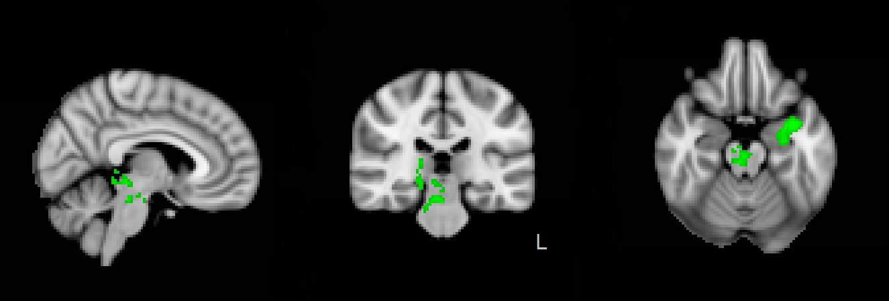

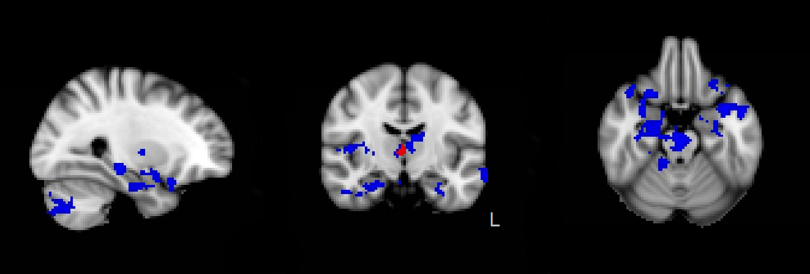

**Table S1: Summary of Results of Whole Brain Analysis.**

|  |  |  |  |  |  |  |  |  |  |  |
| --- | --- | --- | --- | --- | --- | --- | --- | --- | --- | --- |
| Cope | Cluster number | Structures to which cluster belongs | Voxels | MAX Z Score | MAX X (mm) | MAX Y (mm) | MAX Z (mm) | COG X (mm) | COG Y (mm) | COG Z (mm) |
| Happy>Sad | 2 | Left Amygdala | 448 | 4.19 | -36 | 0 | -20 | -30.8 | -4.4 | -18.4 |
|  | 1 | Brainstem | 402 | 3.50 | 2 | -24 | -20 | 9.5 | -30.0 | -8.8 |
| Happy>Fear | 1 | Right Thalamus | 428 | 3.43 | 16 | -34 | 4 | 10.5 | -30.5 | 1.6 |
| Happy >Rest | 8 | Right Hippocampus | 2264 | 4.29 | 40 | 24 | -18 | 18.3 | -14.3 | -12.0 |
|  | 7 | Temporal Pole | 903 | 4.33 | -36 | 2 | -20 | -33.0 | 6.8 | -19.4 |
|  | 6 | Frontal Pole | 847 | 4.33 | -24 | 52 | 30 | -11.7 | 54.1 | 30.7 |
|  | 5 | Middle Temporal Gyrus, posterior division | 457 | 3.99 | -50 | -28 | -4 | -58.6 | -26.1 | -6.5 |
|  | 4 | Frontal Operculum Cortex | 430 | 3.75 | -46 | 28 | 0 | -44.2 | 28.3 | -1.8 |
|  | 3 | Insular Cortex | 429 | 4.16 | 46 | -4 | 4 | 41.8 | -13.2 | 7.5 |
|  | 2 | Lateral Occipital Cortex | 399 | 3.62 | 28 | -70 | -44 | 31.8 | -75.1 | -40.7 |
|  | 1 | Superior Frontal Gyrus | 384 | 3.65 | 0 | 10 | 64 | -3.1 | 13.5 | 64.1 |

COG x, y, z, are the coordinates of the centres of gravity (COG) for each cluster and MAX x, y and z are local maxima. All coordinates are in MNI space.

**Figure C1: CONSORT flow chart for study 1**



**Figure C2: Consort flow chart for study 2**

