SUPPLEMENTARY INFORMATION

Effects of the dopamine transporter gene on striatal functional connectivity in youths with attention-deficit/hyperactivity disorder

Chi-Yung Shang, Hsiang-Yuan Lin, Susan Shur-Fen Gau

Details of resting-state fMRI preprocessing
The first five EPI volumes were discarded to allow for signal equilibration. Data preprocessing was performed using Data Processing Assistant for rs-fMRI (DPARSF) (Yan & Zhang 2010), which is based on Statistical Parametric Mapping (SPM12). fMRI image preprocessing started with slice timing correction with the 17th slice as a reference, then each volume was realigned to the first image volume using a least-squares minimization and a 6-parameter (rigid-body) spatial transformation. Participants were excluded from further analysis, if i) their translation and rotation realignment estimates were <1.5mm and <1.5° (half voxel size), or ii) their mean framewise displacement, based on Jenkinson and colleagues (Jenkinson et al. 2002), was larger than 1 standard deviation above the mean motion of all participants (threshold: 0.34mm). The mean realigned fMRI volume was co-registered to individual T1-weighted image, then segmented into gray matter (GM), white matter (WM) and cerebrospinal fluid (CSF) (based on the unified segmentation). The fMRI data were then spatially normalized to the Montreal Neurological Institute (MNI) space with isotropic 3mm voxel, via the gray matter segment (using the conventional normalization as implemented in SPM8). Spatially normalized fMRI volumes were smoothed with a full-width-at-half-maximum 6mm Gaussian kernel. Independent Component Analysis-based strategy for Automatic Removal of Motion Artifacts (ICA-AROMA) (Pruim et al. 2015) was used to address motion noises (volume censoring was intentionally eschewed to prevent losing large amounts of data, while still delivering robust denoising). After motion denoising, the EPI data were further denoised using the CONN toolbox v.15c (Whitfield-Gabrieli & Nieto-Castanon 2012) to remove other non-neuronal noises through a component-based (anatomical CompCor) approach (Behzadi et al. 2007). The first 3 principal components of the signals from the WM and CSF ROIs (anatomical masks derived from the prior segmentation steps), and linear detrending were included as regressors in the first-level denoising regression model. All of the regressors were filtered before performing the denoising regression (Hallquist et al., 2013). Temporally band-pass filtering (0.01-0.08 Hz) was performed simultaneously with regression.

Effects of IQ and age
We removed IQ from the covariates and repeat the main imaging analyses. The results demonstrated that youths with ADHD, relative to TD youths, showed no significant difference in the striatal functional connectivity. For all the participants (Supplementary Figure 2), youths with the CT haplotype showed significant hypoconnectivity of the right dcP with the bilateral lingual gyri and calcarine regions (coordinates -18, -45, 3; cluster size 49140mm³) and with bilateral sensorimotor clusters (coordinates -12, -12, 48; cluster size 13608mm³). A significant interaction was found in the connectivity between the left DC and the right sensorimotor cluster (Supplementary Figure 3; coordinates 33, -36, 66; cluster size 6129mm³).
To sum up, when removing IQ from the covariates of imaging analyses, the findings of the right dcP in the effects of the CT haplotype and the left DC in the effects of CT haplotype × ADHD interactions remained. The findings of the left DC and the left drP in the effects of ADHD, and the right DC in the effects of CT haplotype × ADHD interactions were no longer significant. An additional hypoconnectivity of the right dcP with bilateral sensorimotor clusters in the effects of the CT haplotype reached significance.
In the next step, we added the age-squared item into the covariates and repeated the main imaging analyses. For all the participants (Supplementary Figure 3), youths with the CT haplotype showed significant hypoconnectivity of the right dcP with the bilateral lingual gyri and calcarine regions (coordinates -21, -48, -9; cluster size 52272mm³) and with bilateral sensorimotor clusters (coordinates -12, -12, 48; cluster size 14337mm³). Significant interaction was found in the connectivity between the left DC and the right sensorimotor cluster (Supplementary Figure 4; coordinates 33, -36, 66; cluster size 5967mm³). All the significant clusters from the main analyses with IQ removed from the covariates still remained.

References
Behzadi Y, Restom K, Liau J and Liu TT (2007) A component based noise correction method (CompCor) for BOLD and perfusion based fMRI. NeuroImage 37, 90-101.
Hallquist MN, Hwang K and Luna B (2013) The nuisance of nuisance regression: spectral misspecification in a common approach to resting-state fMRI preprocessing reintroduces noise and obscures functional connectivity. NeuroImage 82, 208-225.
Jenkinson M, Bannister P, Brady M and Smith S (2002) Improved optimization for the robust and accurate linear registration and motion correction of brain images. NeuroImage 17, 825-841.
Pruim RH, Mennes M, van Rooij D, Llera A, Buitelaar JK and Beckmann CF (2015) ICA-AROMA: A robust ICA-based strategy for removing motion artifacts from fMRI data. NeuroImage 112, 267-277.
Yan CG and Zhang YF (2010) DPARSF: a MATLAB toolbox for "pipeline" data analysis of resting-state fMRI. Frontiers in Systems Neuroscience 4, 13.

Supplementary Figure
Figure S1. Surface Maps of the Functional Connectivity for the 10 Seeds in the Striatum. (A) left dorsal caudate; (B) right dorsal caudate; (C) left dorsal-caudal putamen; (D) right dorsal-caudal putamen; (E) left dorsal-rostral putamen; (F) right dorsal-rostral putamen; (G) left ventral-rostral putamen; (H) right ventral-rostral putamen; (I) left superior ventral striatum; and (J) right superior ventral striatum. DC, dorsal caudate; dcP, dorsal-caudal putamen; drP, dorsal-rostral putamen; vrP, ventral-rostral putamen; VSs, superior ventral striatum; L, left; R, right.

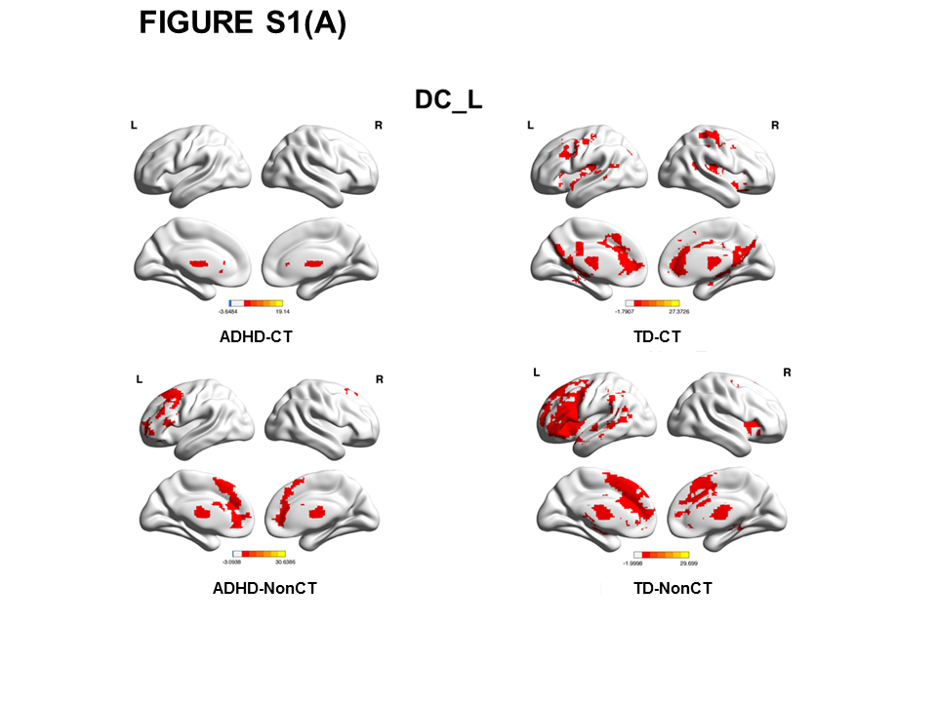

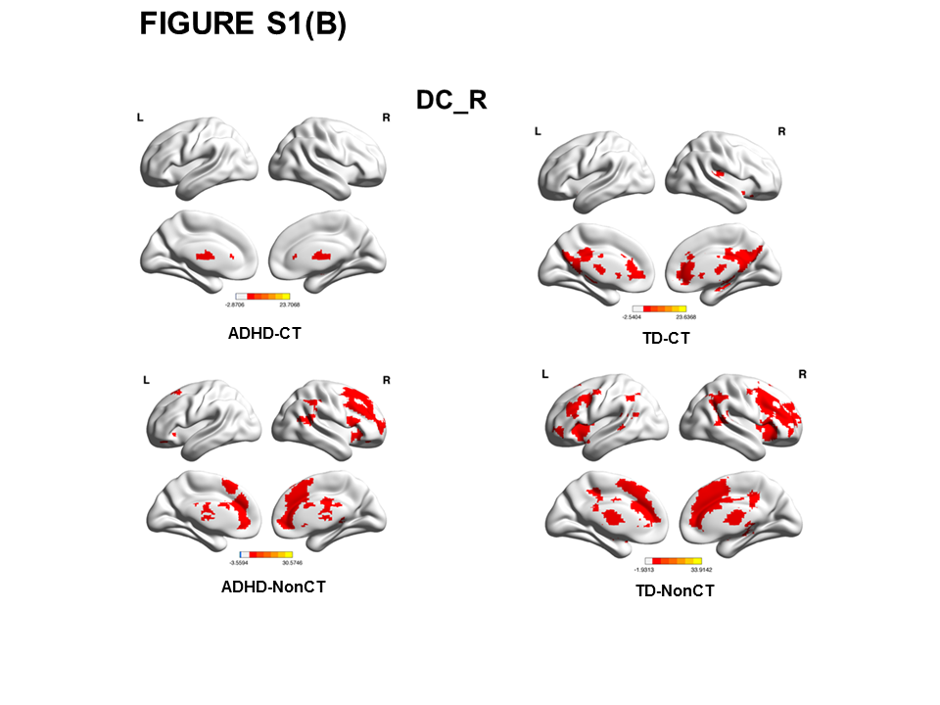

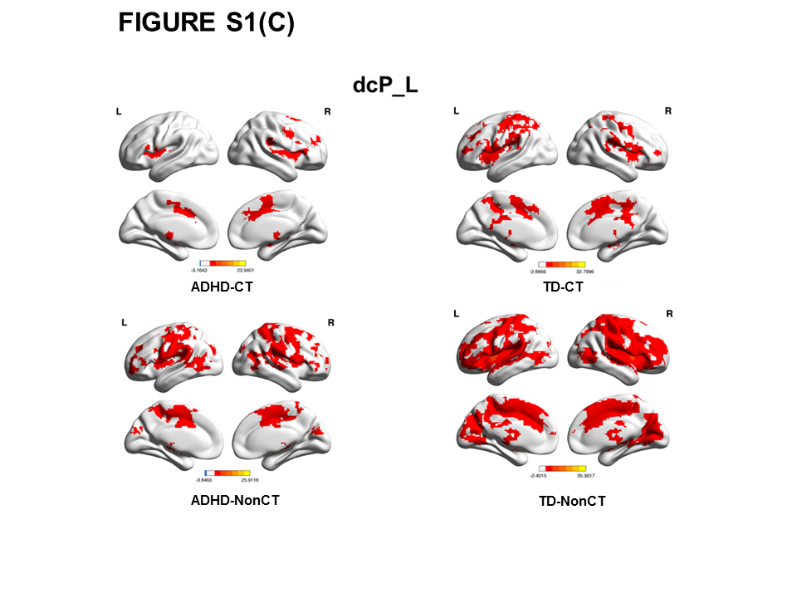

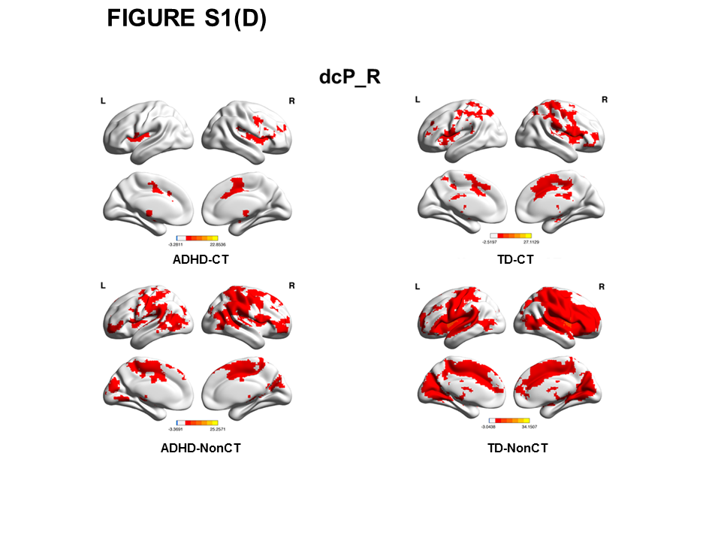

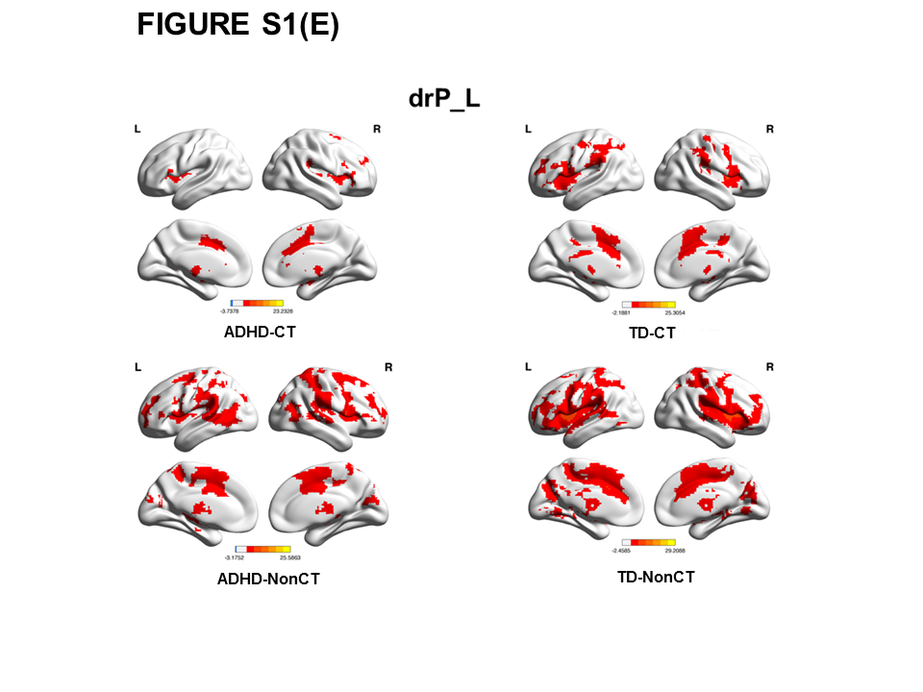

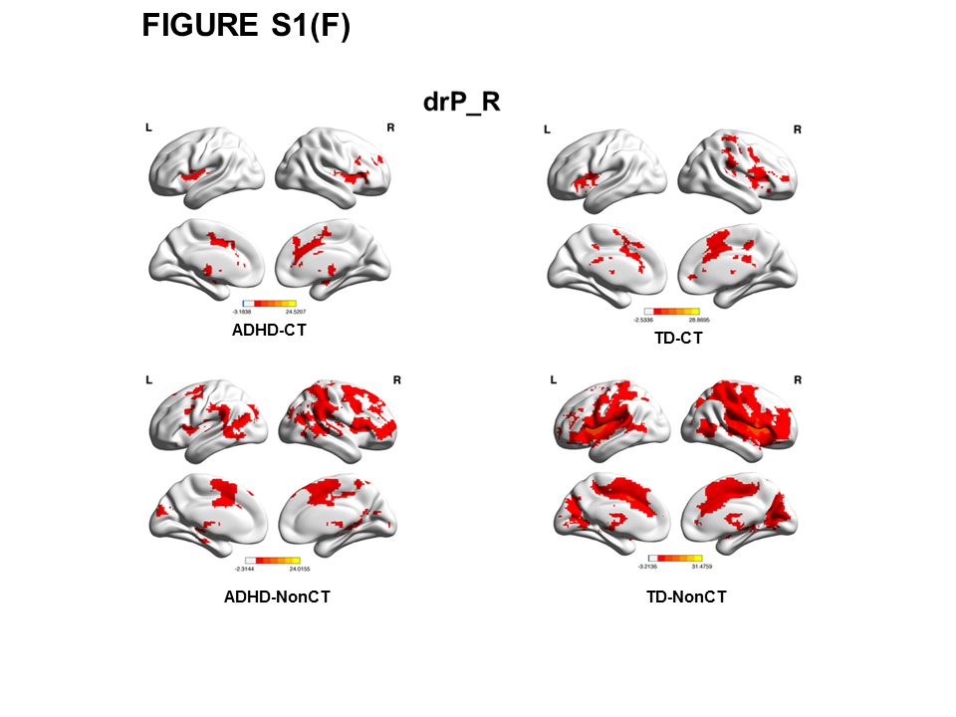

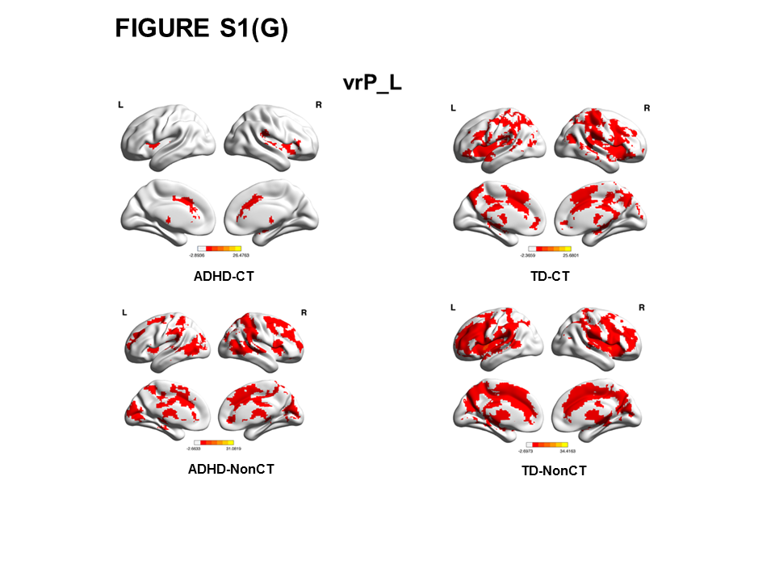

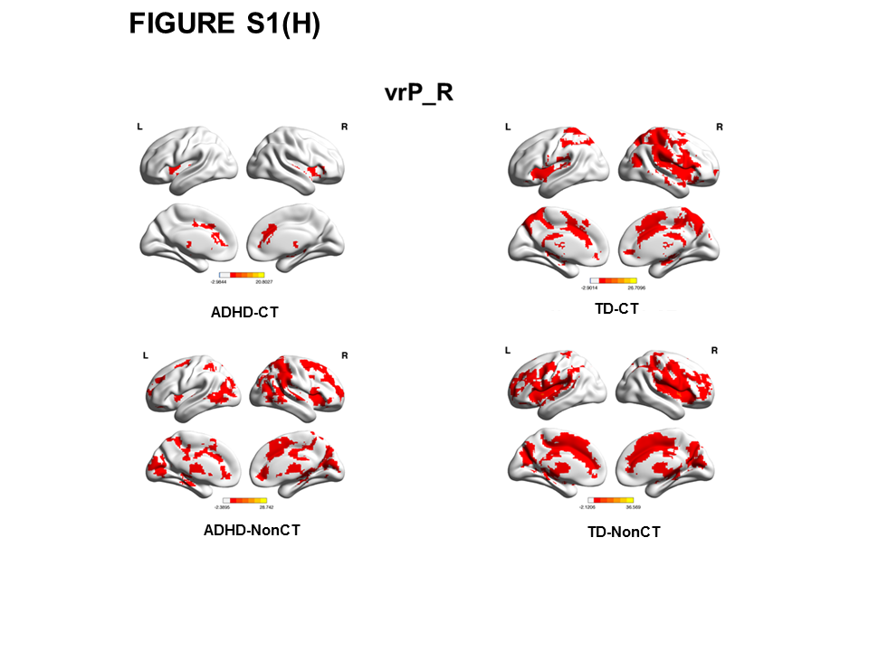

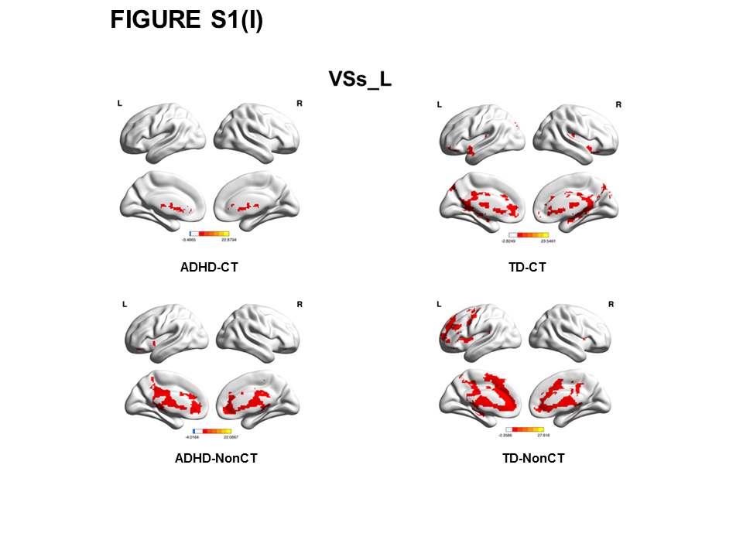

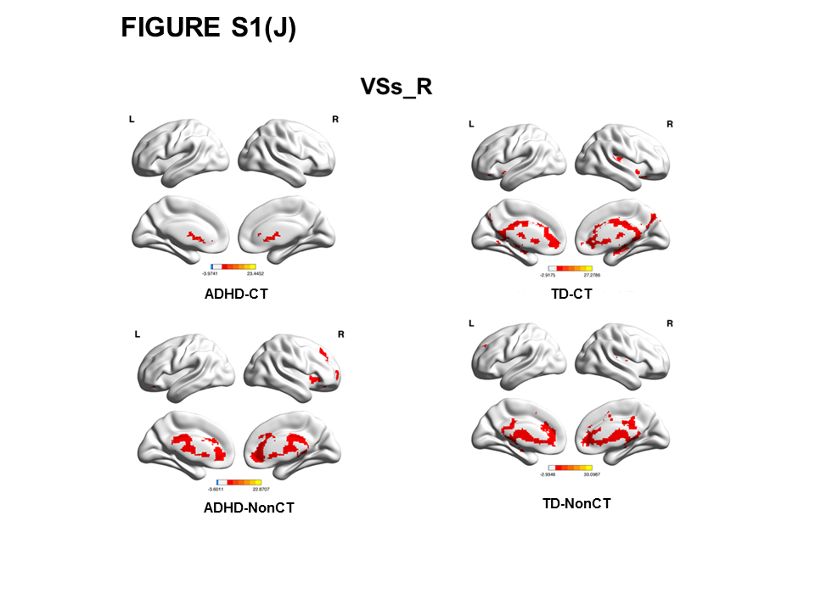

Figure S2. Main effects of the CT haplotype on striatal functional connectivity after IQ was removed from the covariates. All clusters survived cluster-level Gaussian Random Field corrected p<0.05, with cluster-height threshold p<0.005.
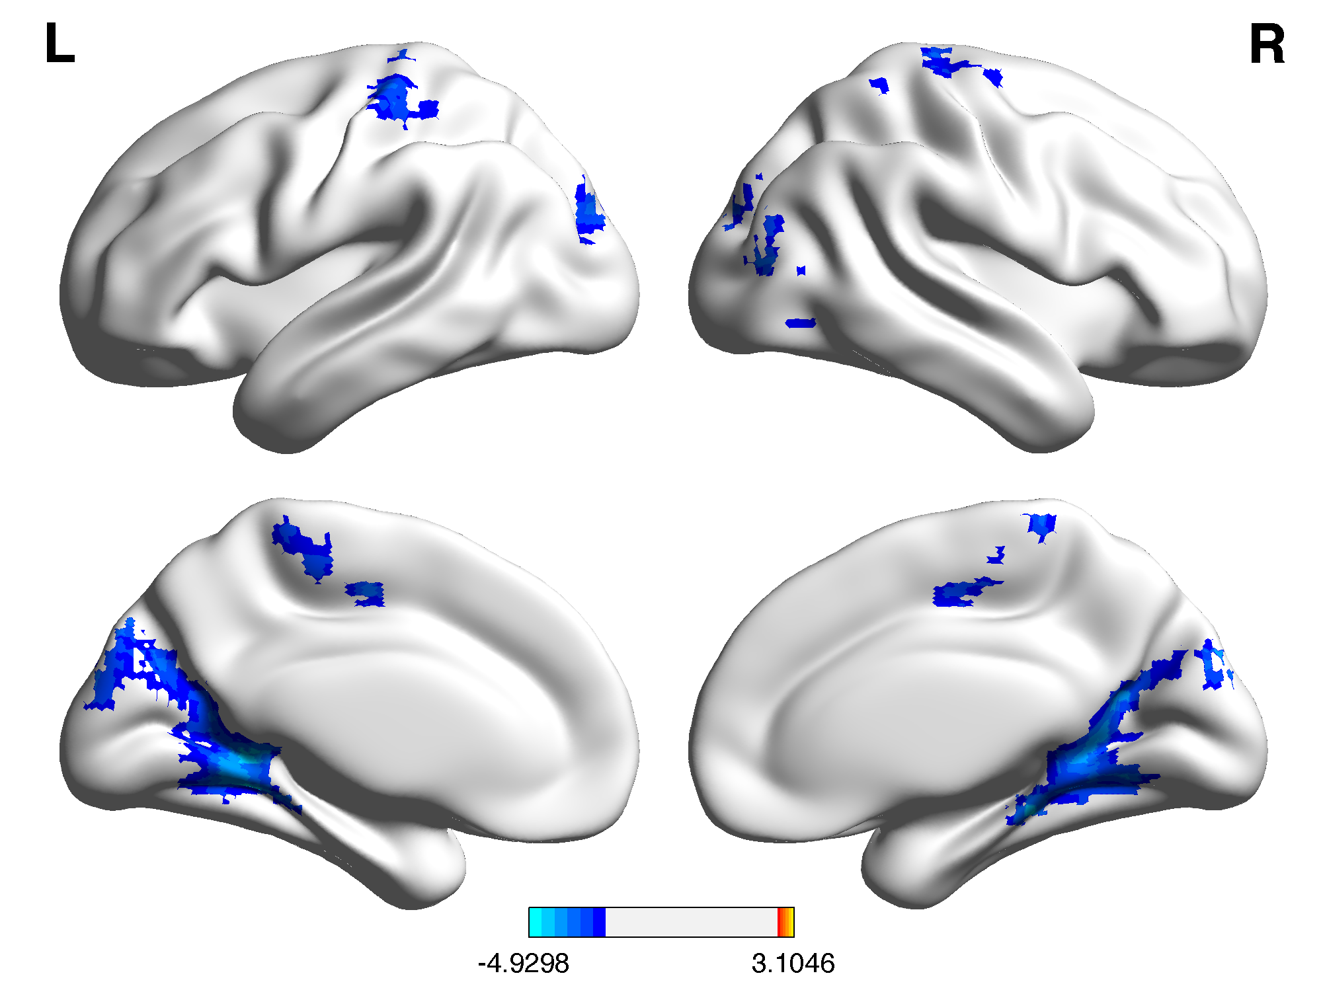
Figure S3. Effects of interaction of diagnosis × CT haplotype on striatal functional connectivity after IQ was removed from the covariates. All clusters survived cluster-level Gaussian Random Field corrected p<0.05, with cluster-height threshold p<0.005.
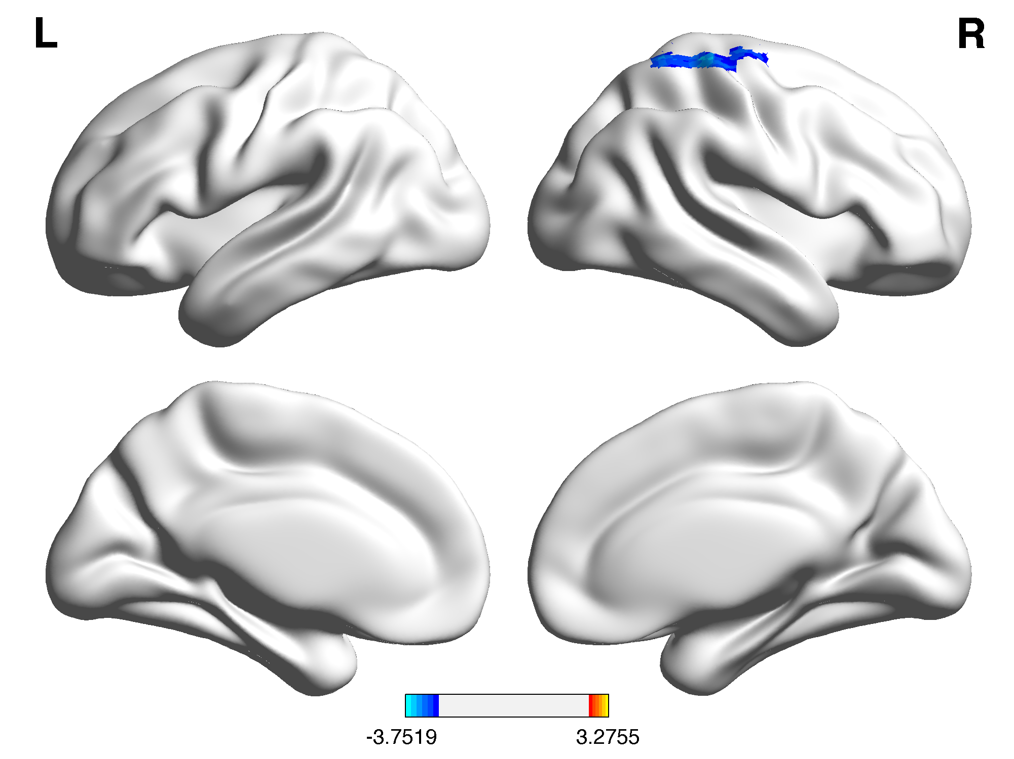
Figure S4. Main effects of the CT haplotype on striatal functional connectivity after IQ was removed from, and age² was added into the covariates. All clusters survived cluster-level Gaussian Random Field corrected p<0.05, with cluster-height threshold p<0.005.
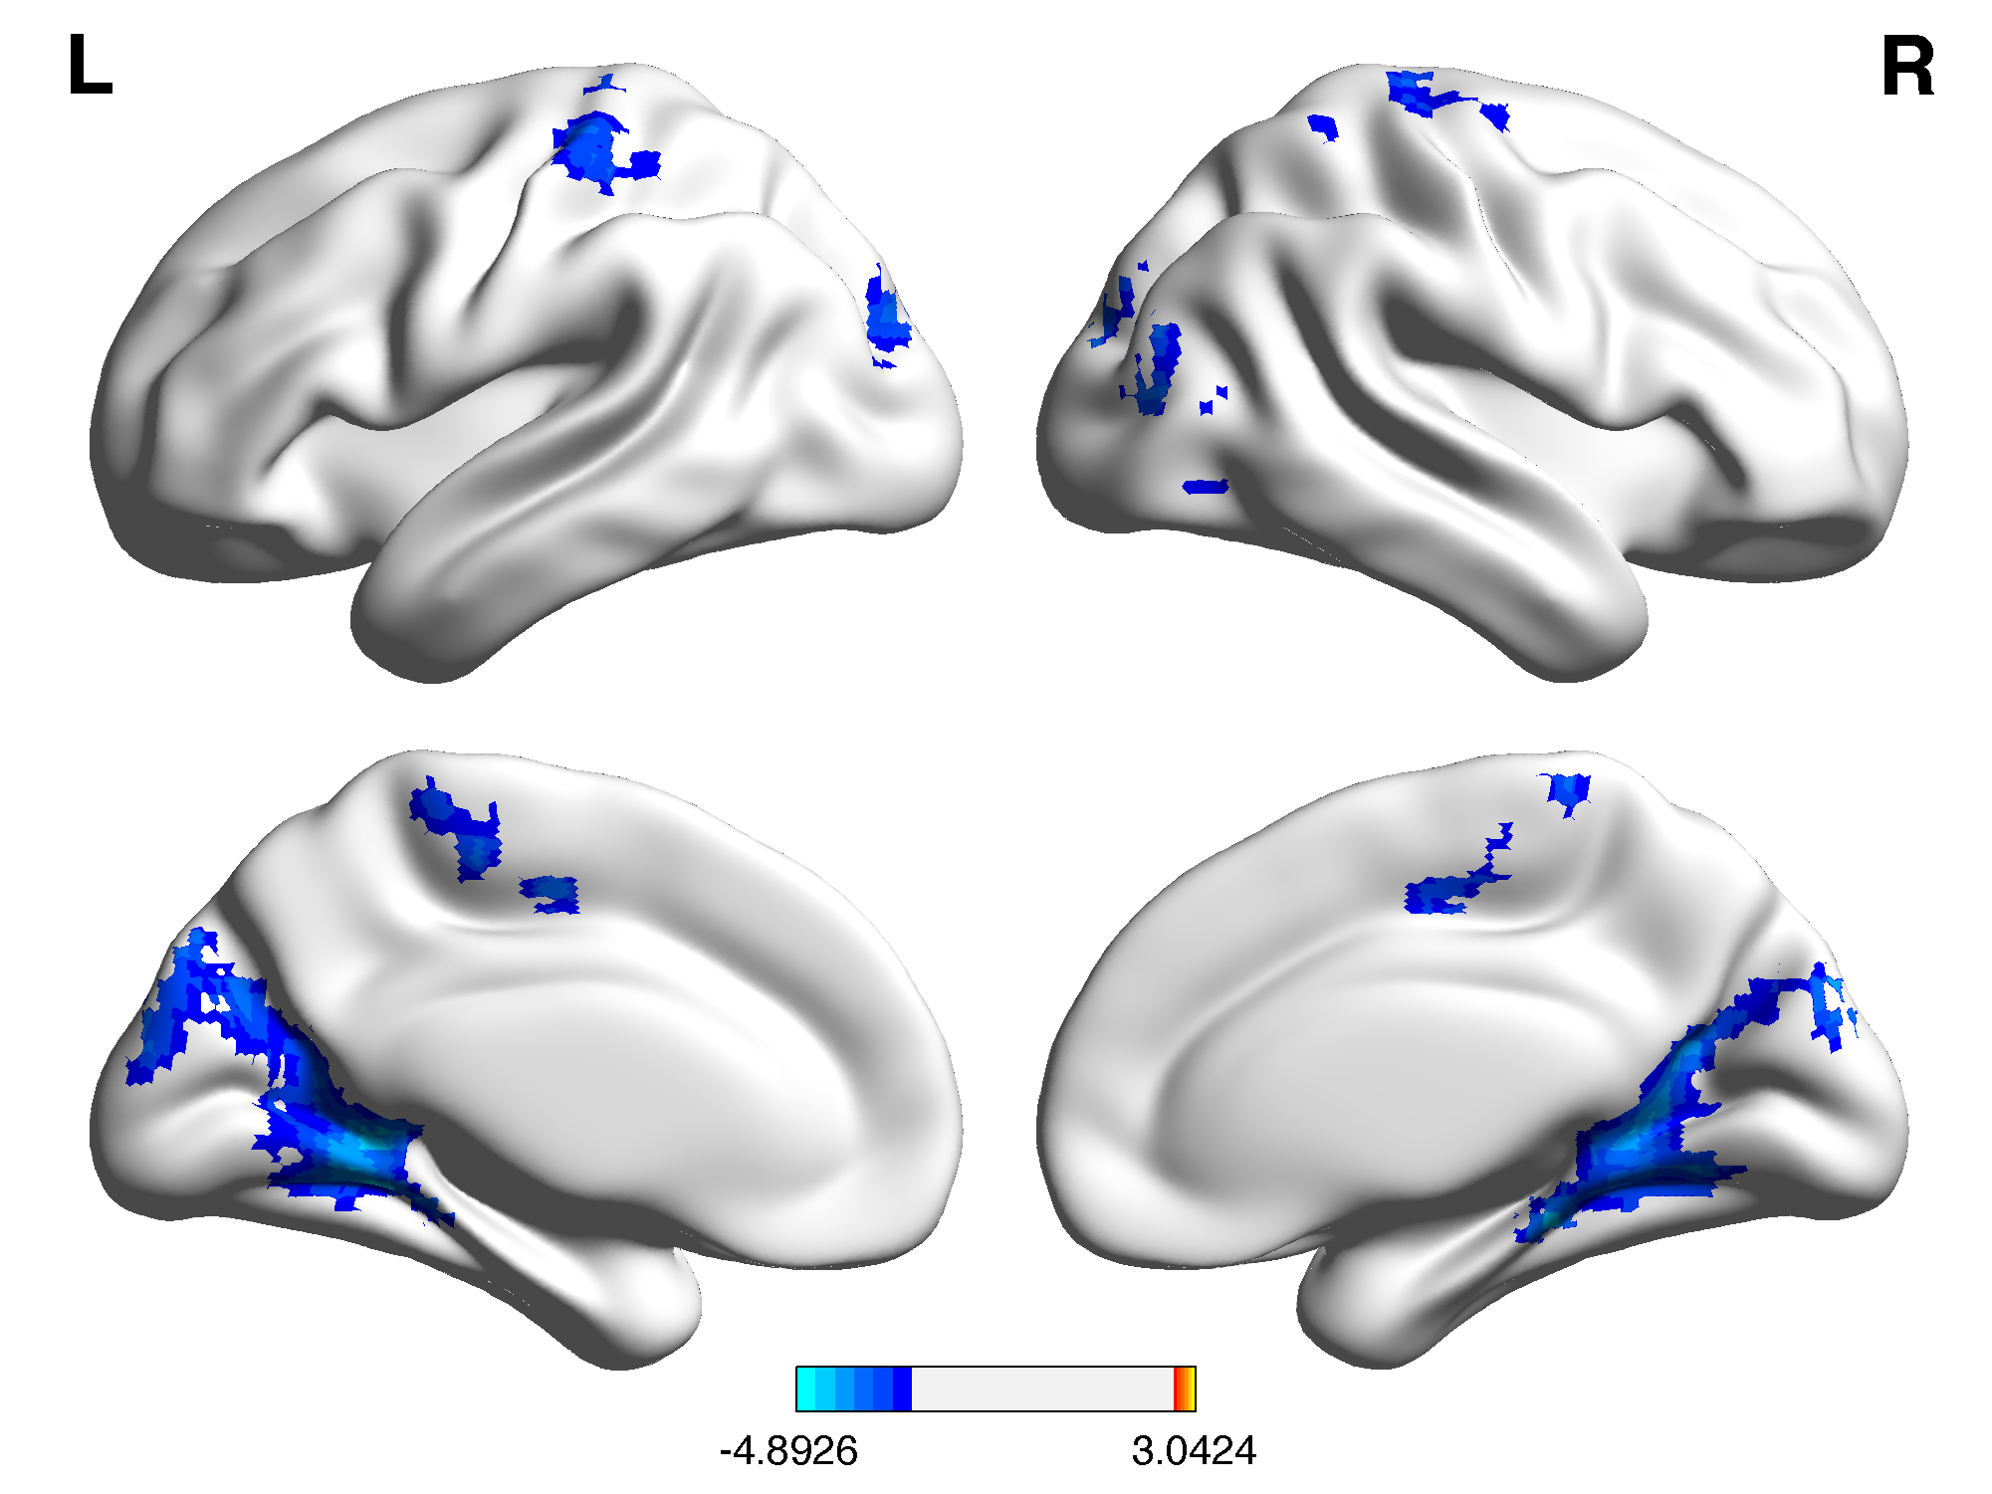
Figure S5. Effects of interaction of diagnosis × CT haplotype on striatal functional connectivity after IQ was removed from and age² was added into the covariates. All clusters survived cluster-level Gaussian Random Field corrected p<0.05, with cluster-height threshold p<0.005.
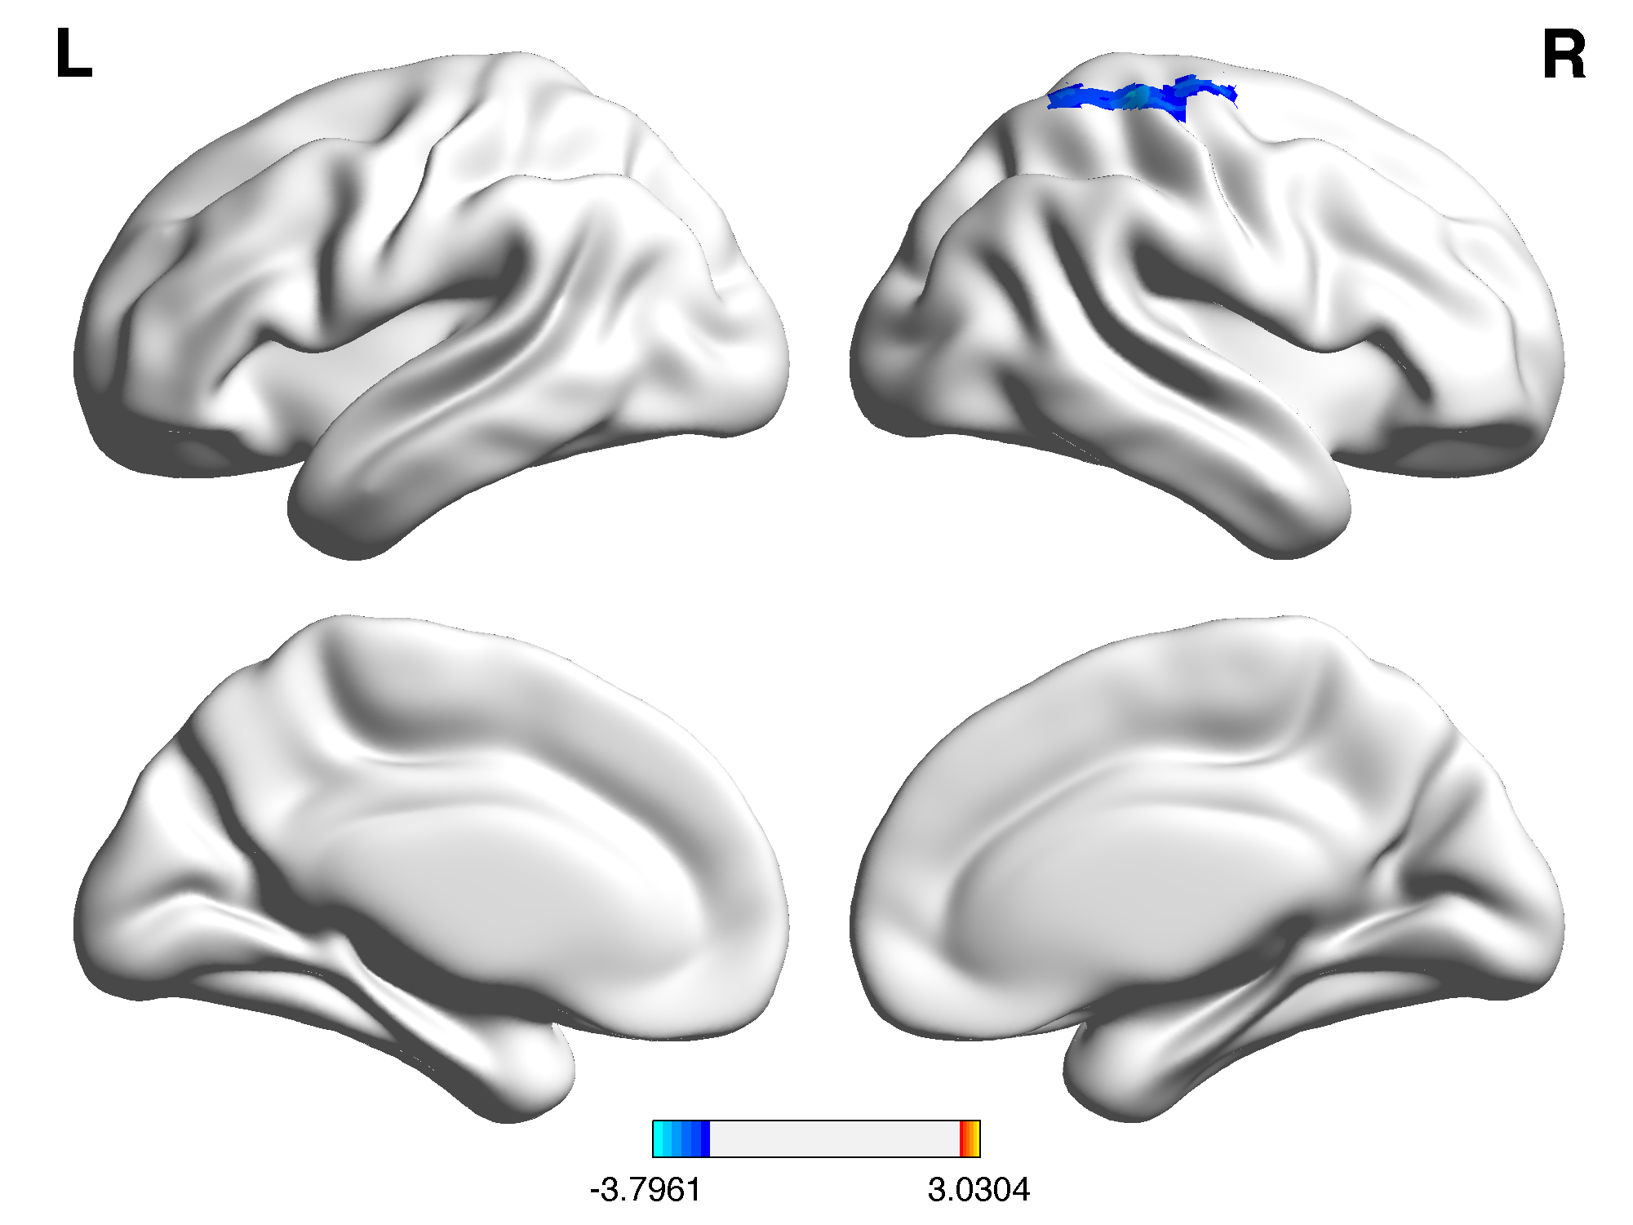

Table S1. Genotype distributions of the DAT1 gene polymorphisms (rs27048 and rs429699) in the ADHD and TD groups

Polymorphism | ADHD  N (%) | TD  N (%) | χ² | p-value
rs27048
CC | 69 (71.9) | 71 (62.3) | 2.18 | 0.34
CT | 23 (24) | 36 (31.6)
TT | 4 (4.1) | 7 (6.1)
rs429699
CC | 58 (60.4) | 64 (56.1) | 1.05 | 0.59
CT | 32 (33.3) | 45 (39.5)
TT | 6 (6.3) | 5 (4.4)
rs27048(C)- rs429699(T) haplotype
0 | 57 (59.4) | 65 (57) | 1.24 | 0.54
1 | 33 (34.3) | 45 (39.5)
2 | 6 (6.3) | 4 (3.5)
ADHD, attention deficit hyperactivity disorder; DAT1, dopamine transporter gene; TD, typically developing youths.

Table S2. Coordinates for striatal seeds
 | x | y | z
Caudate seeds
Dorsal Caudate (DC) | (±) 13 | 15 | 9
Superior Ventral Striatum (VSs) | (±) 10 | 15 | 0
Putamen seeds
Dorsal-Caudal Putamen (dcP) | (±) 28 | 1 | 3
Dorsal-Rostral Putamen (drP) | (±) 25 | 8 | 6
Ventral-Rostral Putamen (vrP) | (±) 20 | 12 | -3

Table S3. Correlations between visual memory and dorsal caudate functional connectivity in the ADHD-NonCT group
 | lDC-rSM | rDC-lDLPF/bAC
 | r | qª | r | qª
Delayed Matching to Sample
correct responses in the total trials | 0.07 | 0.98 | −0.02 | 0.98
probability of an error following a correct response | −0.004 | 0.98 | 0.05 | 0.98
ADHD, attention deficit hyperactivity disorder; l, left; r, right; b, bilateral; DC; dorsal caudate; SM, sensorimotor; DLPF, dorsolateral prefrontal; AC, anterior cingulate.
ª Adjusted by false discovery rate

Table S4. Correlations between visual memory and dorsal caudate functional connectivity in the TD-CT group
 | lDC-rSM | rDC-lDLPF/bAC
 | r | qª | r | qª
Delayed Matching to Sample
correct responses in the total trials | −0.03 | 0.93 | −0.001 | 0.93
probability of an error following a correct response | 0.16 | 0.93 | −0.07 | 0.93
TD, typically developing; l, left; r, right; b, bilateral; DC; dorsal caudate; SM, sensorimotor; DLPF, dorsolateral prefrontal; AC, anterior cingulate.
ª Adjusted by false discovery rate

Table S5. Correlations between visual memory and dorsal caudate functional connectivity in the TD-NonCT group
 | lDC-rSM | rDC-lDLPF/bAC
 | r | qª | r | qª
Delayed Matching to Sample
correct responses in the total trials | −0.07 | 0.64 | 0.06 | 0.64
probability of an error following a correct response | 0.11 | 0.64 | −0.12 | 0.64
TD, typically developing; l, left; r, right; b, bilateral; DC; dorsal caudate; SM, sensorimotor; DLPF, dorsolateral prefrontal; AC, anterior cingulate.
ª Adjusted by false discovery rate

