Supplementary Materials

Abnormal Reward Valuation and Event-Related Connectivity in Unmedicated Major Depressive Disorder

Experiment Details
Written informed consent was obtained then, questionnaires and an interview conducted which lasted an hour, then task training for 10-20 minutes followed by 50 minutes scanning then debriefing lasting 5 minutes. Participants were paid £20 plus a performance dependent bonus of up to £10. Final scores were converted into a percentage.
Subjects passively observed fractals; each was always followed by either a reward symbol (£) indicating ‘value’ or a blank screen indicating ‘no value’. After each fractal was observed on four occasions it appeared, at some later time, in a single decision trial where subjects were asked to choose the higher reward probability; their internally estimated value for the fractal or an explicit numeric value. Either option could have a value 10% 20% or 30% higher than the other or equal value. This means a total of 240 fractals (60x4) were observed with 60 decisions being made. Fractals were presented for 3 to 4 seconds. Outcomes were presented for 2.5 to 3.5 seconds. Decisions had to be made within a 5 second response window. Null events (blank screens) and null decisions (requiring a button press in response to a cross in the centre of the screen) were randomly interspersed throughout the experiment. The sequence of observations and decisions were interleaved in a pseudo-random order and identical for all subjects. The study was divided into 4 sessions of 15 min each between which there were periods where participants could briefly rest. Each session was split into 3 blocks and during each block participants made 5 decisions. Participants did not receive feedback during the task but were told their performance scores would be converted into money they would receive at the end of the experiment. The task is summarised in Figure 1 (main text).

Behavioural modelling
We recently published a detailed computational modelling analysis of participants’ behaviour on the task (Rupprechter et al., 2018). Here we summarise the approach and main findings. We fitted seven different models, representing distinct hypotheses about participants’ decision-making, to the data. All models assume that participants estimate an internal value for each fractal stimulus and compare this internal value to the explicit value at decision time. To model the probability of choosing an action, the value difference was passed into a standard softmax function, which also included an inverse temperature parameter β. Higher values of β lead to more deterministic decision-making. The parameter can be interpreted as an individual’s ability to use their internal value estimations to make decisions.
Four different variations of reinforcement learning (RL) models were defined. These models incorporate trial-by-trial prediction errors and learning rate parameters. After an outcome is observed, the expected value of the fractal that was displayed is updated by adding the prediction error (difference between expected value and reward outcome coded as 1 or 0) scaled by the learning rate. The initial value was either set to a fitted initial value parameter (in two of the RL models) or fixed at 0.5 corresponding to a prior belief that reward was equally likely from either option. Two models included separate learning rates for separate reward outcomes, aiming to test whether learning would be different following rewards versus no-rewards. We also fitted the winning model of the original study by Stankevicius et al. (2014) which tested the Bayesian observer hypothesis. This model assumed that participants would count the number of times each fractal was followed by reward and combine this evidence with a prior belief about the probability of rewards associated with fractals. The model does not explicitly model the observation phase of the experiment and instead assumed at the decision time perfect counting had occurred. To overcome these limitations, we fitted two additional models (‘Leaky’ and ‘Leaky-ρ’) which also assumed participants would count the number of times a fractal was followed by reward, but this was modelled on a trial-by-trial basis. In addition, a memory or discounting parameter was included, which assumed that subjects forgot about some of the previously observed values.
Model fitting was based on maximum a posteriori estimates, which included an empirical Gaussian prior estimated from the data. Parameters were initialised with maximum likelihood estimates and then an expectation-maximization procedure applied to iteratively update these estimates until convergence. The integrated Bayesian Information Criterion (iBIC) was used to identify the model that best fit the data while also penalizing for model complexity.
The best fitting model according to iBIC was the Leaky model, which updated the value for fractal i on trial t as where A is a memory parameter and smaller A reflected increased forgetting or retrospective discounting, and r was unity if a £ reward symbol was observed and zero
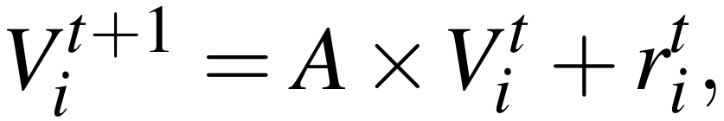
otherwise.

As above, the probability of choosing a fractal i was calculated using a softmax function incorporating estimated value (V) and explicitly presented values (phi)

where f(x) = x/4 is a transformation of the internal value estimate comparable to the explicitly displayed reward probability.
We identified differences between the groups in both memory parameter (z = −2.15, p = 0.031; A patients μ ± σ =0.90 ± 0.04, median = 0.91; A controls μ ± σ = 0.92 ± 0.09, median = 0.96) and softmax β parameter (z = −2.34, p = 0.019; β patients μ ± σ = 4.67 ± 1.45, β controls μ ± σ = 5.89 ± 1.33). This indicates MDD patients discounted more of their estimated values and found it harder to follow their internal value estimations.

Logistic Regression
Logistic regression models were fitted using glmfit in MATLAB to the data of all participants except one, which was then used to predict the group of the left-out participant (using glmval and a threshold of 0.5). This was repeated all participants. Overall, we were able to classify 27 participants (14 patients, 13 controls) correctly, which corresponds to an accuracy of 79% (27 out of 34, precision=76%, recall=81%). The area under the ROC curve, for which the p threshold was varied between 0 and 1 and true and false positive rates were calculated, was approximately 0.86 (Figure S5).

Value difference signal encoding: Group comparison
Beta values were extracted from the first level contrast images of each participant and then compared between two groups. We did not find a group difference with betas extracted from a 5mm sphere within the aMCC region identified as being active during decision making (-2,14,50) for value difference (t(29.09)=-0.30, p=0.764) or absolute value difference (t(29.28)=-0.990, p=0.330) signal encoding. We also did not find a group difference of value difference encoding in slightly different aMCC ROIs ([-14,16,48]: t(23.47)=-1.33, p=0.197; [12,24,28]: t(24.32)=0.42, p=0.682). Neither did we find a group difference of absolute value difference encoding in different aMCC ([-4,24,46]: t(23.92)=-0.69, p=0.498; [10,10,46]: t(28.49)=-1.55, p=0.132) or rACC ([-16,42,8]: t(29.72)=-1.21, p=0.237; [-4,50,-14]: t(29.04)=-1.86, p=0.074) regions of interest.

Connectivity analysis
The conditions included in the gPPI analysis were outcome time, fractal presentation time, decision prompt time, button press time, and null events. Event-related connectivity methods are not as well established as some other areas of neuroimaging, so we also explored beta series correlation analysis (BASCO toolbox; Göttlich et al. 2015), as an additional method to infer event-related functional connectivity between a dACC seed region and other brain regions. Encouragingly, we obtained a similar result as gPPI, with controls showing stronger connectivity between dACC and rACC than patients at the decision-time (Figure S6).

Structural differences
To address the possibility of structural differences influencing our results (see discussion in main text), we performed additional analyses. For every participant, we obtained a grey matter probability image (c1*.nii in SPM) during preprocessing of the T1 structural image and an estimated forward deformation field image (y_*.nii in SPM) used to normalise the functional images. The deformation field was used to normalise the grey matter probability image, including a resampling of voxels in the same way as was done for the functional scans; giving for each resampled voxel, an estimate of the probability that a voxel was grey matter. We then multiplied beta values in the hippocampal and rACC ROIs (5mm) of contrast images for value encoding at fractal presentation time by these grey matter weights. From each ROI the mean values were calculated and between group Welch’s t-tests done. The results still showed significant group differences after these adjustments (L hippocampus (-36,-32,2) t(21.36)=3.313, p=0.003; R hippocampus (48,-26,4) t(31.03)=2.501, p=0.018; rACC (14,50,-10) t(31.19)=2.890, p=0.007)

Interpretation of Results
We were cautious in interpreting our results: i) At a behavioural level we found decreased ‘value memory’ and at an imaging level we found decreased ‘value encoding’ in the brain. Theories of decision making posit that value estimations are used as the basis of decision making. Therefore, altered value encoding could have been the cause of the observed behavioural abnormalities. However, as both behaviour and brain encoding were abnormal we were cautions about a possible circular argument in interpreting our data further than we have in the main text. ii) Regarding abnormalities in decision-making, we made the prediction that we would find both an activation across participants and a group difference in cortical signals at the decision time. We further hypothesized a signal encoding ‘value difference’ because in our behavioural model, this is the variable which enters at the decision event time. Importantly though, these variables are related. While it would be possible to test for a direct correlation between the signal encoding and estimated inverse temperature parameters at the second level, interpretation with our data would be difficult.

Control analyses
We repeated our analysis using a decreased individual voxel threshold (p<0.01) for multiple comparison corrections and reproduced the figures from the main text (Figures S1-S4). Results were broadly similar, with the exception of negative value difference encoding signal across participants which was not significant (Figure S4). Additional Monte Carlo simulations showed that with an assumed individual voxel type 1 error of p=0.01 a smaller cluster size of k=102 would be needed to correct for multiple comparisons at the same cluster correction threshold of p0.01. The script (cluster_threshold_beta.m) can be found on the author’s webpage (https://www2.bc.edu/sd-slotnick/scripts.htm).

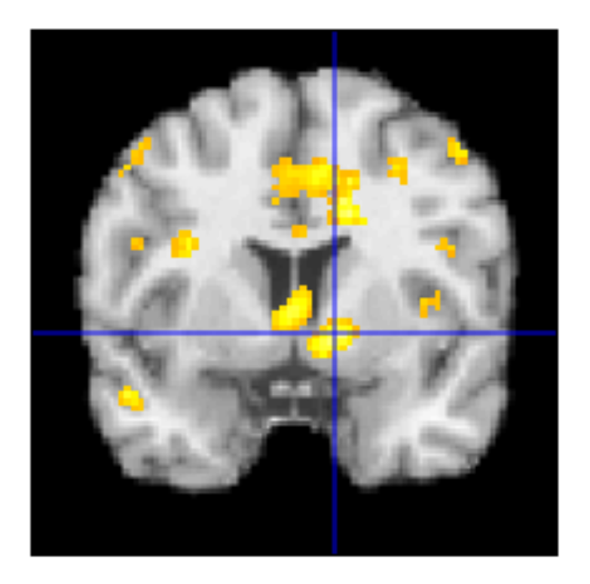
Figure S1. Decreased reward activation in MDD participants compared to healthy controls in the striatum. Display threshold p0.01 and k108; c.f. Figure 2B.

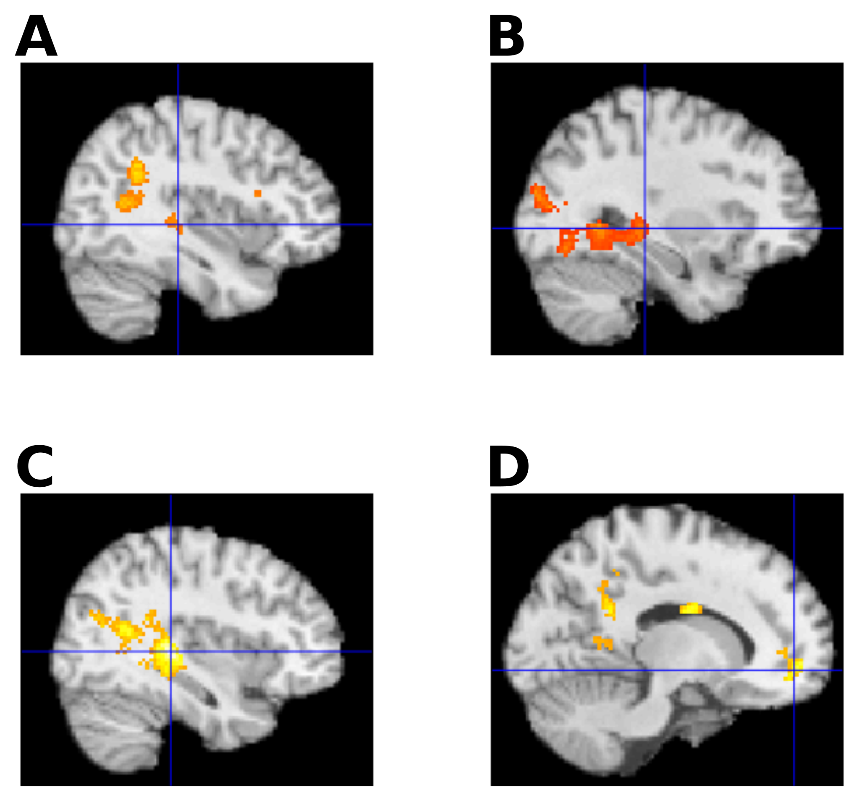

Figure S2. Reward value encoding at fractal presentation time. (A) Positive value encoding within healthy controls. Note that the cluster size here is k=66; c.f. Figure 3A. (B) Negative value encoding in depressed participants. Display threshold p0.01 and k108; c.f. Figure 3B. (C) Larger value encoding in healthy controls compared to MDD participants in hippocampus. Display threshold p0.01 and k108; c.f. Figure 3B – left. (D) Larger value encoding in healthy controls compared to MDD participants in rostral ACC. Note that the cluster size here is k=91; c.f. Figure 3B – right.
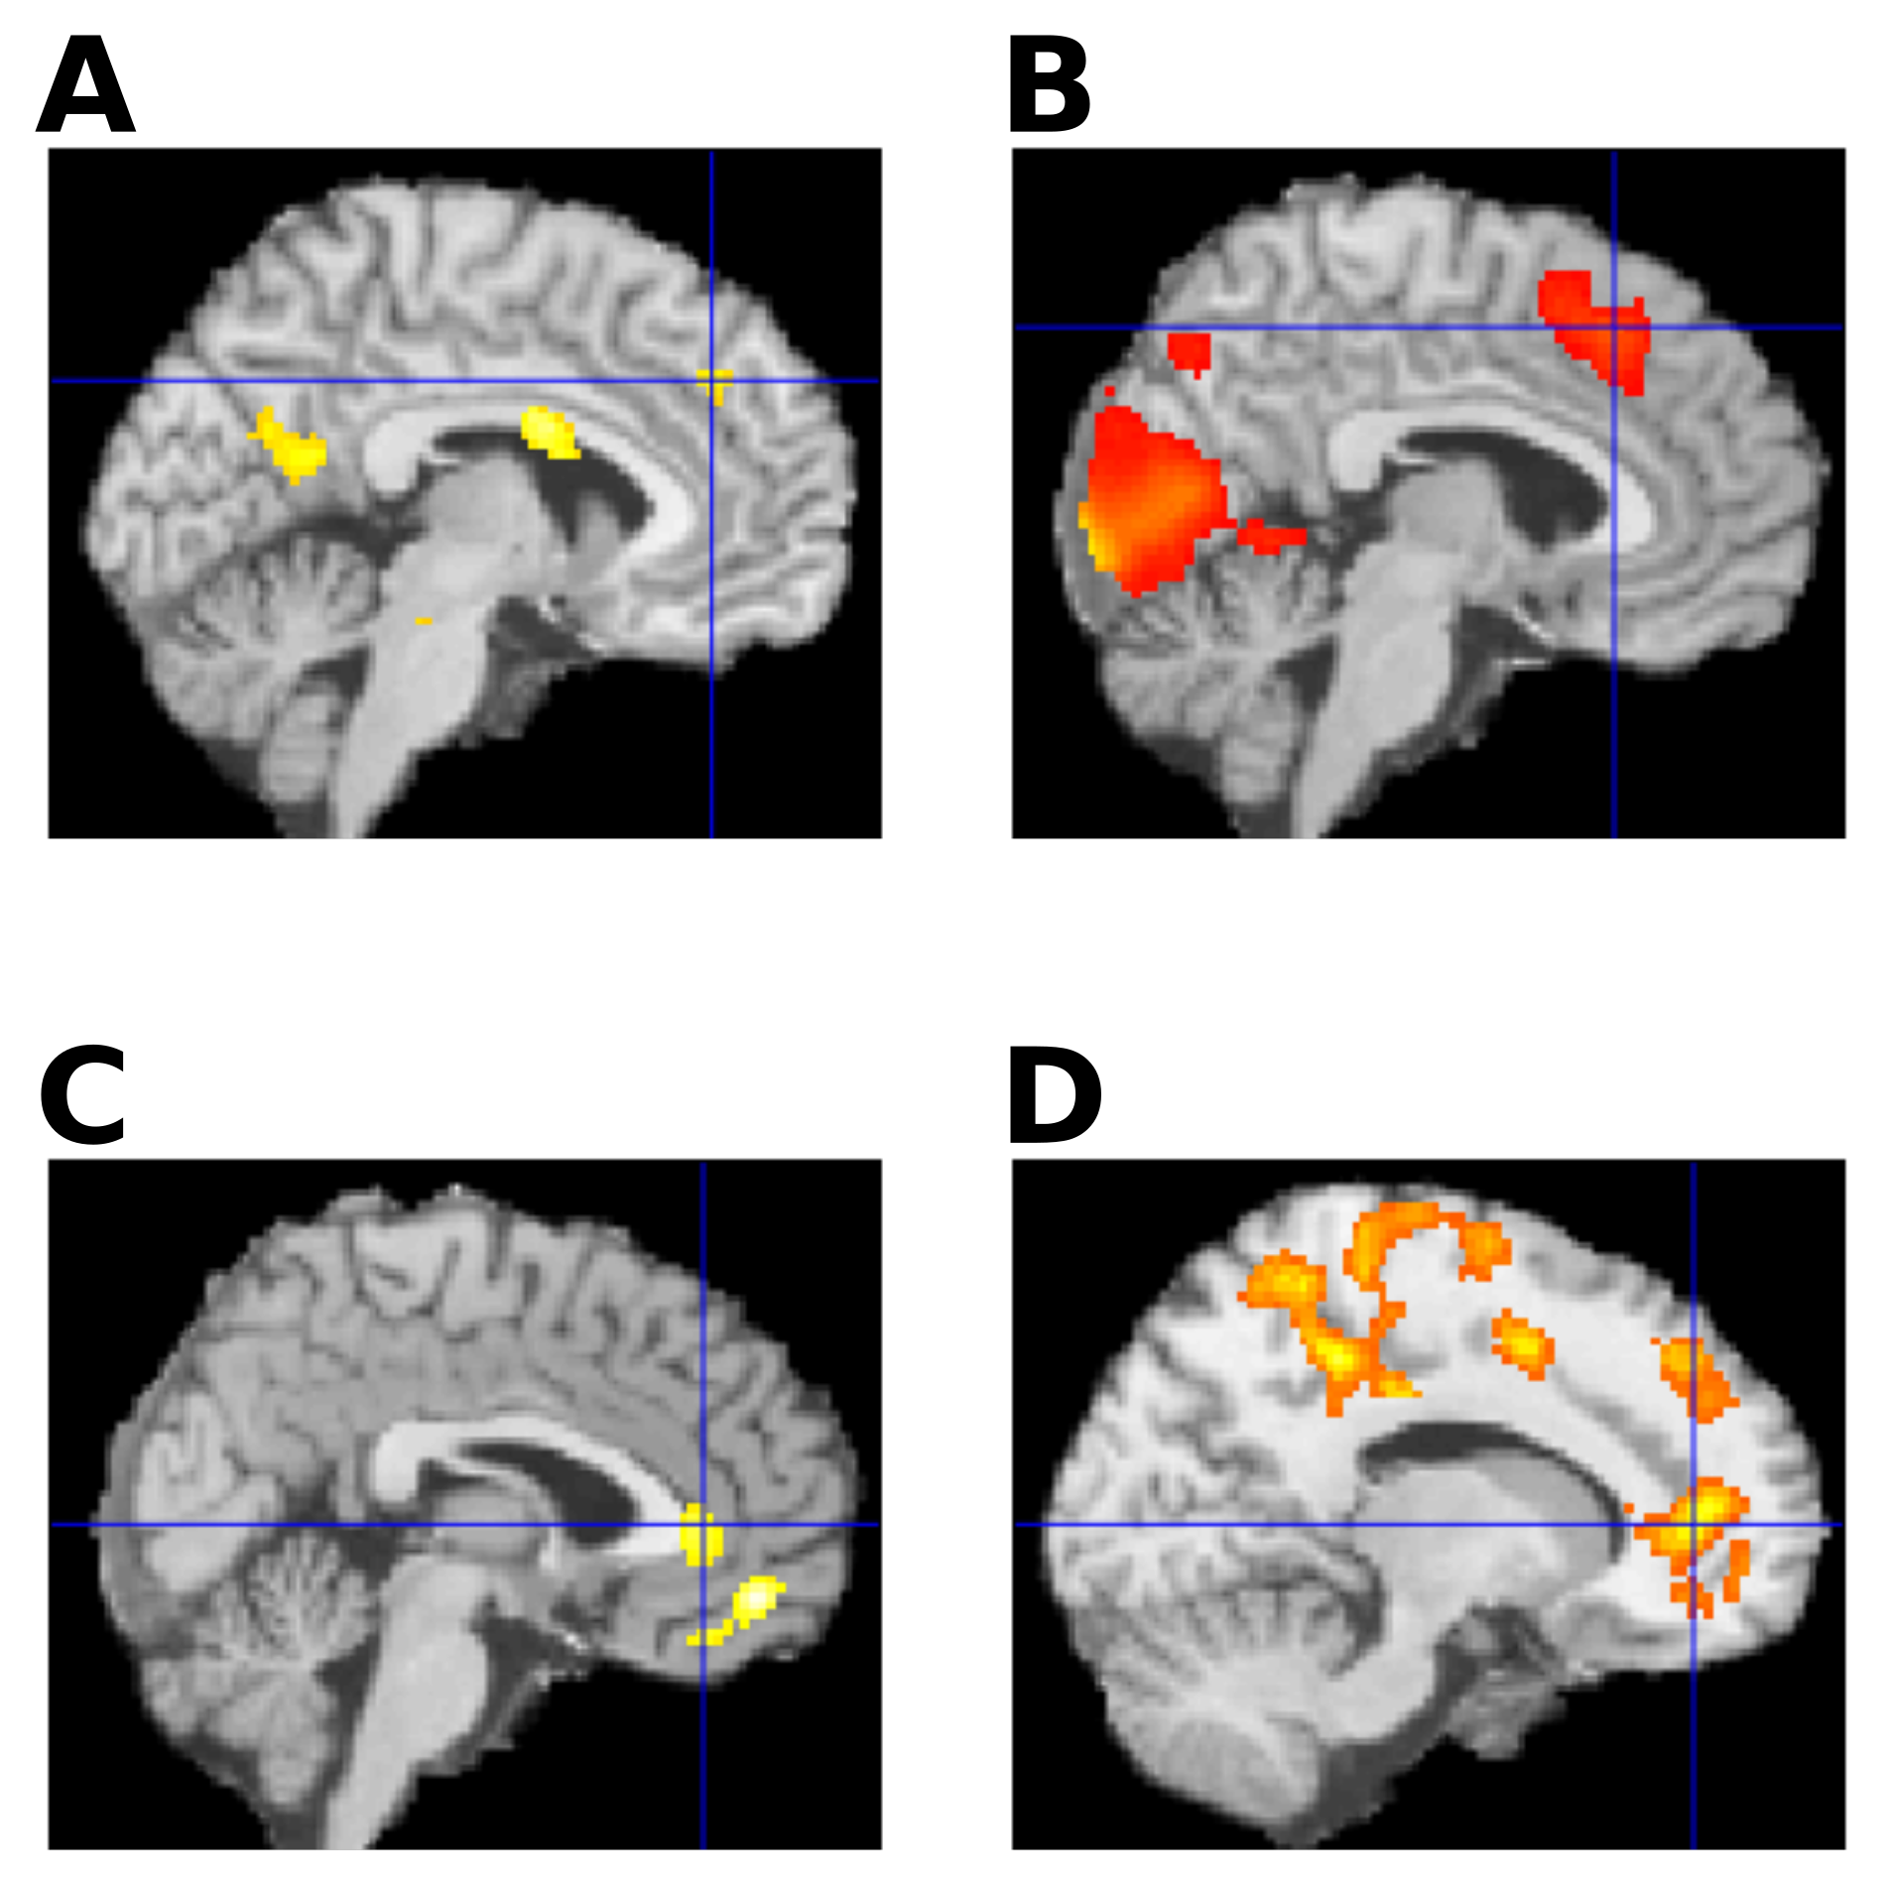
Figure S3. Activation during decision making. (A) Larger activations in MDD compared to controls. Note that the cluster size here is k=103; c.f. Figure 4B. (B) Negative absolute value difference encoding signal across participants. Display threshold p0.01 and k108; c.f. Figure 4D. (C) Positive absolute value difference encoding signal across participants. Note that the cluster size here is k=97 and the cluster size for the second cluster further down (ventral) is k=144; c.f. Figure 4E. (D) Decreased event-related connectivity in depression between dorsal cingulate region and other cingulate regions. Display threshold p0.01 and k108; c.f. Figure 4F.
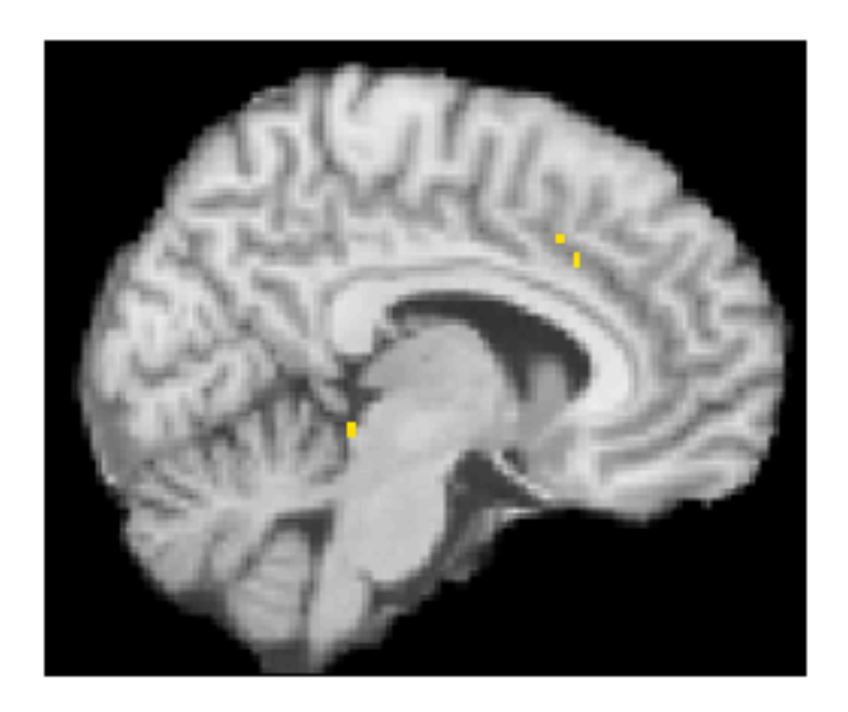

Figure S4. Negative value difference encoding signal across participants was not significant in the anterior mid-cingulate region at an individual voxel threshold of p0.01; c.f. Figure 4C.

Figures

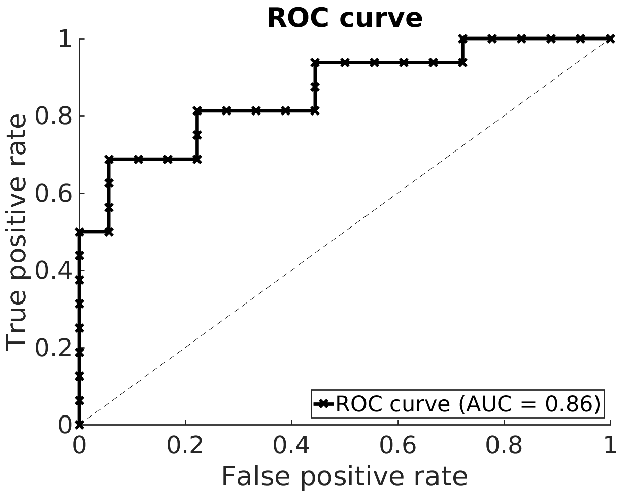
Figure S5. The ROC curve (AUC =0.86) of our logistic regression classifier.

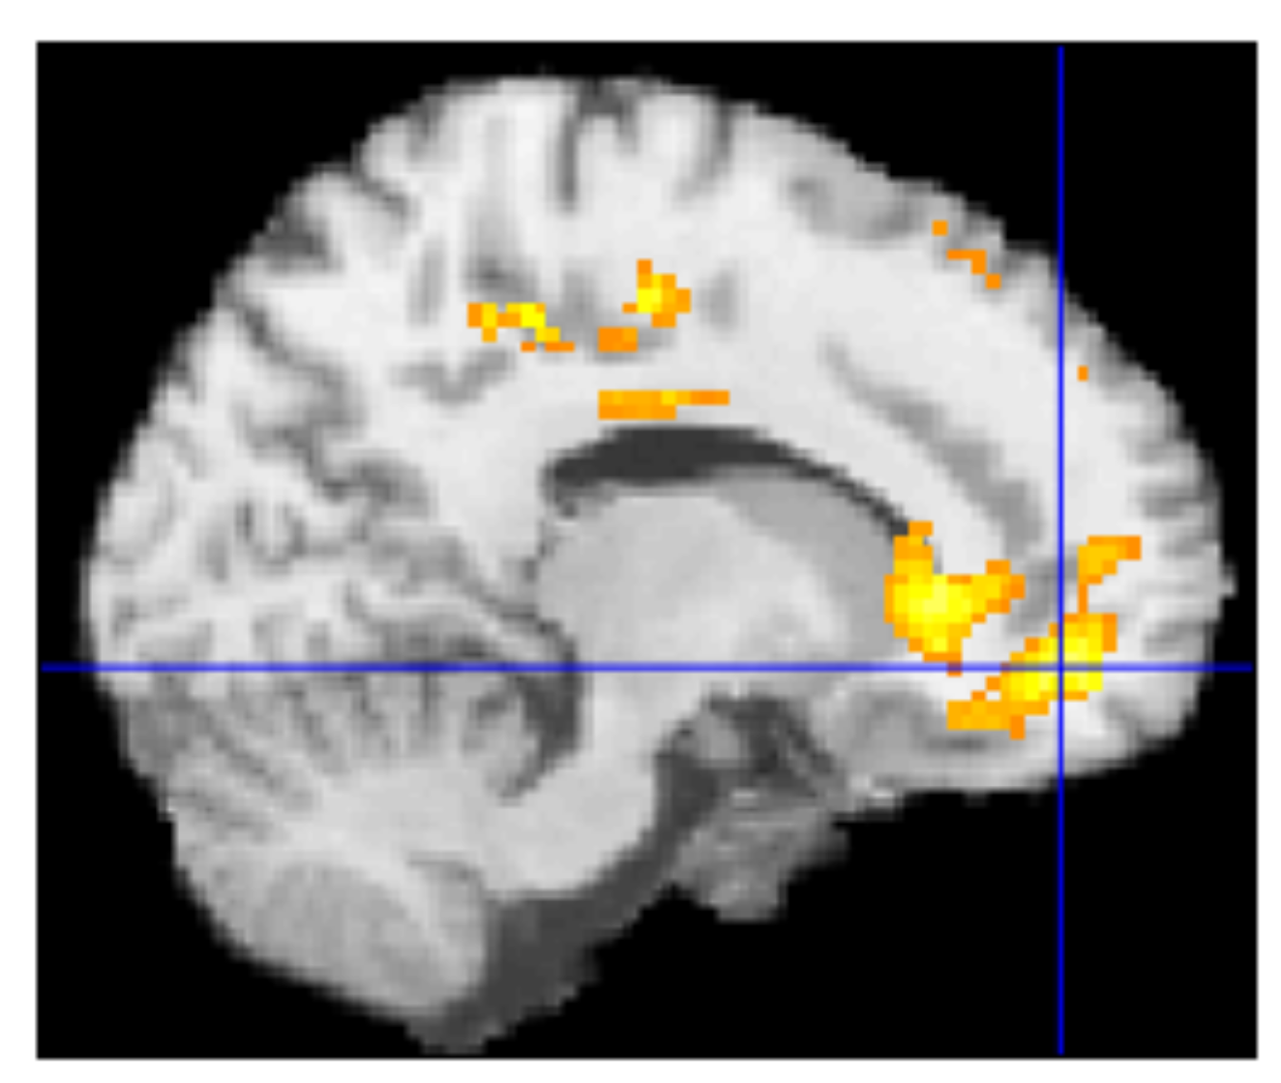
Figure S6. Functional connectivity. Significantly higher functional connectivity in HC compared to MDD subjects between a dACC seed region with rostral ACC and PCC, obtained using beta series correlations (Göttlich et al., 2015).

Tables

Questionnaire | Patients | Controls
BDI | 25.9 ± 12.9 | 5.4 ± 5.6
DSAB | 15.1 ± 4.0 | 16.9 ± 2.4
HAD-A | 12.7 ± 5.1 | 4.3 ± 2.5
HAD-D | 8.6 ± 4.6 | 1.8 ± 2.0
HAMA | 18.8 ± 6.9 | 1.8 ± 2.7
LOT-R | 9.0 ± 5.1 | 18.4 ± 3.1
MADRS | 18.8 ± 6.9 | 1.8 ± 2.7
NART | 45.8 ± 4.5 | 47.3 ± 3.6
RSE | 13.3 ± 6.9 | 23.7 ± 4.6
SHAPS | 38.6 ± 8.7 | 49.2 ± 5.9
Agreeableness | 39.6 ± 6.5 | 45.6 ± 5.7
Conscientiousness | 36.4 ± 10.0 | 44.8 ± 7.2
Extraversion | 31.2 ± 7.6 | 43.3 ± 4.2
Neuroticism | 46.9 ± 7.1 | 31.4 ± 6.9
Openness | 41.5 ± 5.4 | 45.8 ± 5.3

Table S1. Clinical characteristics of participants. BDI = Beck Depression Inventory; DSAB = Digit Score Part B; HAD = Hospital Anxiety and Depression Scale; HAMA = Hamilton Anxiety Rating Scale; LOT-R = Life Orientation Test – Revised; MADRS = Montgomery-Åsberg Depression Rating Scale; NART = National Adult Reading Test; RSE = Rosenberg Self-Esteem Scale; SHAPS = Snaith-Hamilton Pleasure Scale; Scores displayed as mean ± std.

Reward response

Regions | t | z | MNI coordinates [mm] |  |  | Voxels in cluster
 |  |  | x | y | z
Controls + Patients
striatum, midcingulate, dorsolateral cortex, occipital lobe | 12.19 | 7.39 | -14 | -90 | 2 | 94077
 | 4.89 | 4.20 | 10 | 12 | -4
 | 4.44 | 3.89 | -10 | 18 | 0
 | 8.28 | 6.01 | -10 | 10 | 48
 | 8.25 | 6.00 | -46 | 8 | 24
 | 7.14 | 5.48 | 44 | 6 | 32
Controls > Patients
Striatum, nucleus accumbens | 4.58 | 3.99 | 22 | 26 | 10 | 27510
 | 4.48 | 3.92 | -22 | 14 | -16
 | 4.45 | 3.9 | -48 | -36 | 30
Cerebellum | 4.44 | 3.89 | -30 | -52 | -42 | 1691
 | 2.9 | 2.71 | 8 | -70 | -28
 | 2.83 | 2.65 | -28 | -64 | -52
thalamus | 3.4 | 3.12 | 2 | -32 | 2 | 357
 | 2.31 | 2.21 | 10 | -24 | -2
 | 2.31 | 2.21 | 20 | -18 | -2
Cerebellum | 3.05 | 2.84 | 36 | -52 | -44 | 461
 | 2.55 | 2.42 | 4 | -58 | -48
 | 2.51 | 2.38 | 40 | -58 | -48
FFA | 3.03 | 2.82 | 48 | -60 | -18 | 229
 | 2.48 | 2.36 | 46 | -52 | -22
 | 2.28 | 2.18 | 46 | -70 | -16
Auditory cortex / insula | 3.01 | 2.8 | -38 | -18 | 4 | 127

Value encoding

Regions | t | z | MNI coordinates [mm] |  |  | Voxels in cluster
 |  |  | x | y | z
Controls (activations)
Occipital lobe | 6.29 | 4.34 | -16 | -102 | 4 | 748
Precuneus, L hippocampus, caudate, prefrontal cortex | 5.7 | 4.1 | 8 | -58 | 40 | 16096
 | 5.62 | 4.06 | -8 | -54 | 52
 | 5.58 | 4.04 | 0 | -52 | 48
Occipital lobe | 4.19 | 3.36 | 26 | -96 | -4 | 337
 | 2.91 | 2.55 | 34 | -94 | 4
 | 2.74 | 2.43 | 10 | -88 | -6
Supramarginal gyrus | 3.98 | 3.24 | 58 | -44 | 32 | 645
 | 3.27 | 2.8 | 48 | -46 | 36
 | 2.3 | 2.09 | 40 | -52 | 32
R Supp motor area | 3.66 | 3.04 | 16 | -2 | 56 | 183
 | 2.41 | 2.19 | 16 | -6 | 68
R temporal gyrus, R hippocampus | 3.61 | 3.02 | 66 | -20 | -4 | 744
 | 3.51 | 2.95 | 34 | -50 | 10
 | 3.06 | 2.65 | 66 | -10 | 0
brainstem | 2.36 | 2.14 | 10 | -38 | -46 | 160
 | 2.32 | 2.11 | 0 | -32 | -54
 | 2.16 | 1.99 | 0 | -20 | -36
Patients (deactivations)
Occipital lobe, hippocampus | 8.38 | 5.21 | 18 | -88 | 18 | 20400
 | 8.07 | 5.11 | 38 | -68 | -8
 | 5.47 | 4.1 | -2 | -86 | -6
Medial prefrontal cortex, rostral ACC | 4.16 | 3.41 | 14 | 50 | -10 | 1035
 | 3.3 | 2.86 | 2 | 34 | -18
 | 3.01 | 2.66 | 2 | 24 | -22
Motor cortex | 3.68 | 3.11 | -38 | -8 | 36 | 730
 | 3.09 | 2.72 | -4 | -16 | 54
 | 2.7 | 2.43 | -48 | -8 | 34
Motor cortex | 3.6 | 3.06 | 16 | -26 | 68 | 898
 | 3.51 | 3 | 20 | -30 | 54
 | 3 | 2.65 | 4 | -26 | 70
R amygdala | 3.55 | 3.03 | 30 | 8 | -18 | 213
 | 1.95 | 1.83 | 30 | -2 | -16
Brainstem | 3.2 | 2.79 | 6 | -16 | -42 | 108
 | 2.42 | 2.22 | -2 | -18 | -36
Brainstem | 2.64 | 2.38 | 2 | -38 | -48 | 119
Corpus callosum | 2.57 | 2.33 | 8 | -2 | 28 | 115
 | 2.01 | 1.88 | -4 | -6 | 26
Controls > Patients
Hippocampus, precuneus | 4.88 | 4.19 | -36 | -32 | 2 | 18480
 | 4.57 | 3.98 | 50 | -4 | 18
 | 4.4 | 3.86 | -32 | -68 | 16
Medial prefrontal cortex, rostral ACC, R anterior insula | 3.73 | 3.37 | 14 | 50 | -8 | 2169
 | 3.61 | 3.28 | 28 | 12 | 44
 | 3.41 | 3.12 | 28 | 20 | 12
Precuneus | 2.92 | 2.73 | -10 | -58 | 48 | 161
 | 2.06 | 1.98 | 4 | -64 | 54
 | 2.03 | 1.96 | -4 | -66 | 56
Brainstem | 2.84 | 2.66 | 0 | -20 | -38 | 122
L anterior insula | 2.65 | 2.5 | -28 | 12 | 16 | 109
 | 2.33 | 2.23 | -36 | 18 | 16
 | 2.17 | 2.09 | -30 | 26 | 18
Brainstem | 2.63 | 2.49 | 4 | -38 | -48 | 108

Decision making

Regions | t | z | MNI coordinates [mm] |  |  | Voxels in cluster
 |  |  | x | y | z
Controls + Patients
Anterior insula, dorsal ACC (aMCC), striatum | 16.68 | Inf | 32 | 26 | -6 | 111774
 | 14.21 | Inf | 16 | 0 | -6
 | 14.07 | Inf | -28 | 22 | -2
 | 14.74 | Inf | 26 | -66 | -4
 | 14.61 | Inf | -16 | -68 | 12
 | 14.02 | Inf | -26 | -62 | -8
 | 12.91 | 7.59 | -2 | 14 | 50
Patients > Controls
Insula | 4.21 | 3.73 | 8 | 0 | 26 | 1185
 | 3.26 | 3.01 | 34 | -22 | 24
 | 2.89 | 2.7 | -8 | -4 | 22
sgACC | 4.06 | 3.62 | -2 | 28 | -2 | 176
Occipital lobe | 3.44 | 3.15 | -34 | -88 | 24 | 384
 | 2.94 | 2.74 | -48 | -74 | 26
 | 2.44 | 2.32 | -36 | -76 | 44
insula | 3.3 | 3.04 | -38 | -8 | 20 | 675
 | 3.23 | 2.99 | -36 | -26 | 22
 | 3.14 | 2.91 | -44 | -24 | 20
(para)hippocampus, brainstem | 3.25 | 3 | -20 | -28 | -18 | 950
 | 3.19 | 2.95 | 14 | -36 | -20
 | 3.19 | 2.95 | 12 | -22 | -16
dACC | 3.21 | 2.97 | 22 | 28 | 42 | 741
 | 3.11 | 2.88 | -12 | 20 | 32
 | 3.01 | 2.81 | 6 | 38 | 34
PCC | 3.14 | 2.91 | -2 | -56 | 28 | 1651
 | 2.93 | 2.74 | 6 | -52 | 18
 | 2.9 | 2.71 | 2 | -60 | 22
Supp motor area | 3.09 | 2.87 | -8 | -18 | 62 | 157
 | 1.96 | 1.9 | 4 | -12 | 64
Temporal lobe, hippocampus | 3.07 | 2.86 | -22 | -34 | 4 | 154
 | 2.05 | 1.98 | -12 | -32 | 12
Temporal lobe, hippocampus | 3.06 | 2.85 | 42 | -34 | 4 | 534
 | 2.84 | 2.66 | 40 | -52 | -6
 | 2.56 | 2.42 | 28 | -36 | 0
Occipital lobe | 2.92 | 2.73 | 42 | -60 | 28 | 113
Occipital lobe | 2.76 | 2.6 | -40 | -70 | 2 | 266
 | 2.39 | 2.28 | -34 | -76 | -4
 | 1.93 | 1.87 | -40 | -58 | -12
Prefrontal cortex | 2.72 | 2.57 | 54 | 24 | 32 | 245
 | 2.38 | 2.26 | 36 | 6 | 34
 | 2.16 | 2.08 | 52 | 14 | 40
Temporal lobe | 2.68 | 2.52 | -42 | -34 | -4 | 456
 | 2.67 | 2.52 | -36 | -44 | -14
 | 2.24 | 2.15 | -38 | -46 | -6
Occipital lobe | 2.6 | 2.46 | 36 | -70 | -10 | 121

References

Göttlich M., Beyer F., Krämer U. BASCO: a toolbox for task-related functional connectivity. Frontiers in systems neuroscience, Frontiers, 2015;9.
Rupprechter S, Stankevicius A, Huys Q, Steele JD, Series P. Major Depression Impairs the Use of Reward Values for Decision-Making. Scientific Reports. 2018;(in press).
Stankevicius A, Huys Q, Kalra A, Series P. Optimism as a prior belief about the probability of future reward. PLoS Computational Biology. 2014;10.

