Supplementary Material

Methods
Statistical analysis
Affective cognition
For the Social Scenarios Task, ratings of affect (1-100) were firstly arcsine transformed. Emotion reactivity was then calculated as the difference in emotion rating between view neutral and view positive/negative conditions, whereas emotion down-regulation was calculated as the difference in emotion rating between the view positive/negative and dampen positive/negative conditions. The Facial Expression Recognition task reaction times (ms) were log-transformed. Discrimination accuracy (d′) was obtained for each facial expression (happy, surprise, sad, angry, disgust, fear) using the following formula: Pr = ([number of hits + 0.5]/[number of targets + 1]) - ([number of false alarms + 0.5]/[number of distractors + 1]) (Corwin, 1994). For the Faces Dot-Probe Task, vigilance scores were calculated by subtracting reaction times (ms) to the identification of probes after the appearance of neutral faces from the RT to the identification of probes after affective faces.

Results

Whole group descriptives
The initial sample consisted of 334 participants; 172 patients with BD, 48 URs, and 110 HCs. However, 14 patients were excluded from the HCA analysis due to missing data, resulting in a total of 158 BD patients. Patients with BD, their URs, and HCs did not differ in sex. Nevertheless, as expected, URs (i.e., siblings and children) were younger than patients with BD and HCs. Patients with BD exhibited increased subsyndromal depression and mania symptoms relative to URs and HCs. Patients had also undergone fewer years of education compared to controls, and relatives exhibited decreased premorbid IQ compared to HCs.

Exploratory post hoc correlations
Across all patients with BD, more global neurocognitive impairment was weakly associated with patients being more commonly prescribed antipsychotic medication (r = -.22, p = .004) and less lithium (r = .20, p = .007). Further, within the globally impaired subgroup, more global impairment was associated with being more commonly prescribed antidepressants (r = -.39, p = .018) and antipsychotics (r = -.38, p = .019). No significant correlations were found between neurocognition and the use of medication for cognitively intact patients (ps ≥ .096) or selectively impaired patients (ps ≥ .114). Correlation matrix between specific neurocognitive domains and medication status is provided in Table S2.

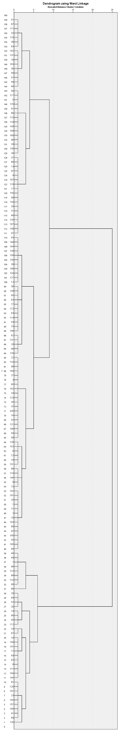
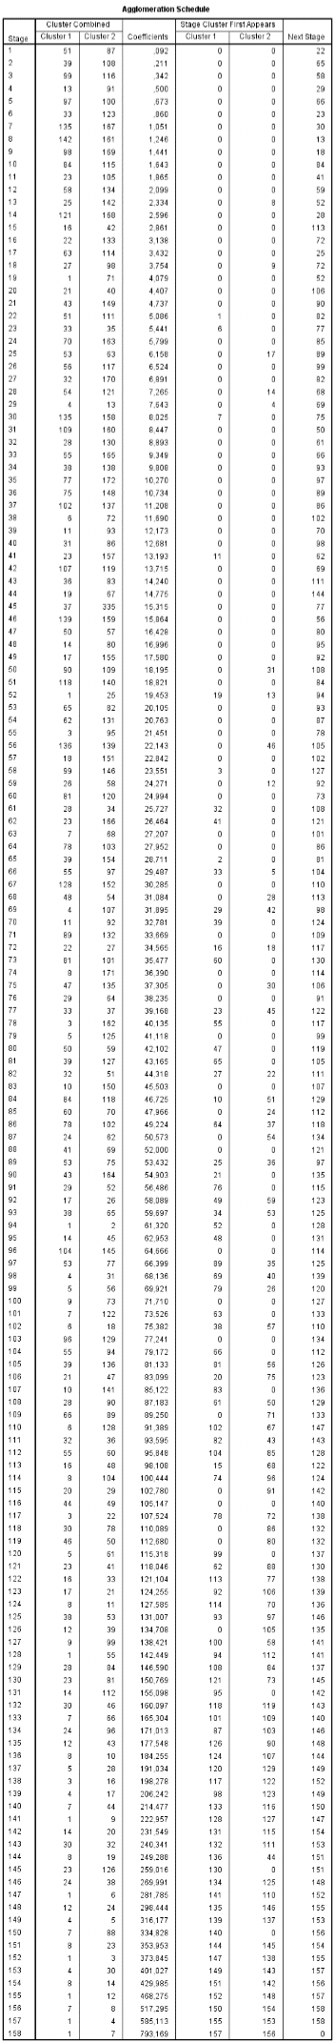

Figure S1. Dendrogram and agglomeration schedule.

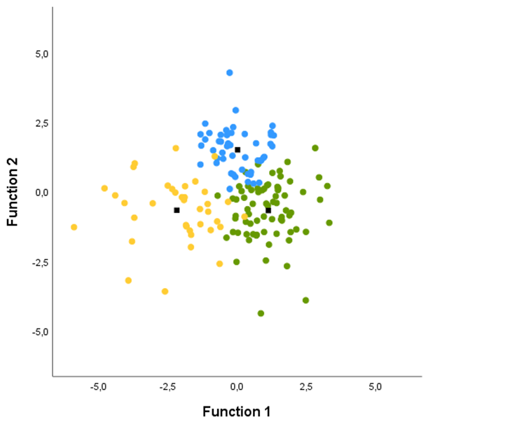

Figure S2. Discriminant functions plot.
The first discriminant function maximally separates the ‘globally impaired’ cluster from the ‘cognitively intact’ and ‘selectively impaired’ clusters, whereas the second discriminant function maximally separates the ‘selectively impaired’ cluster and the ‘cognitively intact’ and ‘globally impaired’ clusters. Cluster 1 (green) = cognitively intact; cluster 2 (blue) = selectively impaired; cluster 3 (yellow) = globally impaired.

Table S1. Demographic and clinical variables comparing the patients with bipolar disorder, their unaffected relatives, and healthy controls.
 | BD | UR | HC |  | Group comparisons
 | M (SD) | M (SD) | M (SD) | p | BD vs. HC | UR vs. HC
N | 158 | 52 | 110
Sex (% Female) | 62.70% | 51.90% | 58.20% | ns
Age | 32.4 (9.6) | 27.1 (6.5) | 31.6 (11.0) | 0.009 | BD = HC | UR < HC
Education, years | 14.7 (3.3) | 14.9 (2.9) | 15.9 (2.3) | 0.003 | BD < HC | UR = HC
IQ | 111.9 (6.2) | 110.6 (5.9) | 113.0 (5.8) | 0.026 | BD = HC | UR < HC
HDRS-17 | 5.3 (4.0) | 2.2 (2.5) | 1.2 (1.6) | < .001 | BD > HC | UR = HC
YMRS | 2.6 (3.2) | 1.0 (1.4) | 0.9 (1.6) | < .001 | BD > HC | UR = HC
BD type 2, n (%) | 103 (65%)
Age at onset | 23.3 (8.9)
Illness duration in years ª | 8.6 (8.1)
Untreated BD in years ^{b} | 7.5 (8.1)
Number of depressive episodes | 11.3 (18.2)
Number of manic episodes | 1.0 (3.5)
Number of hypomanic episodes | 8.1 (12.4)
Number of mixed episodes | 0.2 (1.2)
Number of psychotic episodes | 0.5 (1.6)
Number of hospitalisations | 0.9 (1.6)
Medication, n yes
Antidepressants | 35
Antipsychotics | 53
Anticonvulsants | 82
Lithium | 14
FAST
Autonomy | 1.6 (2.2) | 0.3 (0.6) | 0.1 (0.4) | < .001 | BD > HC | UR = HC
Occupational | 6.0 (7.0) | 0.9 (3.0) | 0.2 (0.5) | < .001 | BD > HC | UR = HC
Cognitive | 4.1 (3.6) | 0.7 (1.0) | 0.4 (0.8) | < .001 | BD > HC | UR = HC
Financial | 1.1 (1.6) | 0.2 (0.6) | 0.1 (0.4) | < .001 | BD > HC | UR = HC
Relationships | 3.2 (3.3) | 0.5 (1.0) | 0.4 (0.9) | < .001 | BD > HC | UR = HC
Leisure | 1.2 (1.6) | 0.5 (0.8) | 0.2 (0.5) | < .001 | BD > HC | UR = HC
Total score | 17.3 (12.6) | 3.0 (4.7) | 1.5 (2.0) | < .001 | BD > HC | UR = HC
Abbreviations: BD: bipolar disorder; UR: unaffected relatives; HC: healthy controls; HDRS: Hamilton depression rating scale; YMRS: Young mania rating scale; FAST: Functional assessment short test.
Note: analyses were conducted using mixed model analyses with familial relationship as random factor to account for overlapping genetic variance between patients and relatives.
ª Illness duration was defined as the time from the first mania, hypomania, or mixed episode to the time of the first testing in BIO.
^{b} Untreated BD was calculated as time from first mania, hypomania, or mixed episode to the time of diagnosis.

Table S2. Associations between global neurocognition and emotional cognitive subtests.
 |  | Social Scenarios Task |  |  | Facial Expression Recognition
 |  | Down-regulation of positive emotions | Positive emotion reactivity |  | Reaction time |  |  |  | Accuracy
 |  |  |  |  | Overall positive emotions | Overall negative emotions | All emotions |  | Overall positive emotions | Overall negative emotions | All emotions
Healthy controls n = 106 |  | .196* | .132 |  | -.408** | -.378** | -.411** |  | .274* | .346** | .357**
Cognitively intact subgroup n = 72 |  | .003 | .186 |  | -.035 | -.051 | -.052 |  | .117 | .05 | .077
Selectively impaired subgroup n = 47 |  | .151 | -.071 |  | -.471** | -.431** | -.457** |  | .107 | .169 | .182
Globally impaired subgroup n = 36 |  | -.148 | -.204 |  | -.628** | -.522** | -.587** |  | .428* | .362* | .429*
Relatives of cognitively intact patients n = 25 |  | .242 | -.122 |  | -.146 | .388 | .247 |  | .306 | .300 | .334
Relatives of cognitively impaired patients n = 23 |  | .116 | .332 |  | -.303 | -.592** | -.452* |  | .524* | .631** | .637**

Note. * = sig at the .05 level. ** = sig at .001 level.

Table S3. Pearson correlations between neurocognitive domains and medication status
 |  | Verbal learning | Processing speed | Executive control | Working memory | Verbal fluency | Sustained attention | Global cognition
Intact  cluster  n = 72 | Antidepressants | .050 | .019 | -.219 | -.012 | -.185 | -.212 | -.198
 | Antipsychotics | .153 | -.177 | -.208 | .068 | -.028 | -.191 | -.146
 | Antiepileptics | -.109 | .216 | .194 | -.049 | .019 | .115 | .137
 | Lithium | .139 | -.100 | -.227 | .083 | .003 | -.043 | -.066
Selectively impaired  n = 49 | Antidepressants | .226 | -.040 | -.085 | -.132 | .176 | .105 | .105
 | Antipsychotics | -.126 | .100 | .142 | .209 | -.028 | .080 | .103
 | Antiepileptics | .095 | .187 | .057 | -.234 | .217 | .353* | .228
 | Lithium | -.240 | .090 | -.084 | -.156 | -.038 | -.036 | -.167
Globally impaired  n = 37 | Antidepressants | -.081 | -.317 | -.220 | -.157 | -.297 | -.227 | -.387*
 | Antipsychotics | -.125 | -.114 | -.391* | -.179 | -.333* | -.138 | -.384*
 | Antiepileptics | .140 | -.021 | -.083 | -.239 | .154 | -.016 | -.011
 | Lithium | -.294 | -.219 | -.177 | -.032 | -.142 | -.188 | -.324
Note. * sig at the .05 level. ** sig at the .001 level.

References

Corwin. J. (1994). On measuring discrimination and response bias: Unequal numbers of targets and distractors and two classes of distractors. Neuropsychology 8. 110.

