Risk Components | Development sample  (n = 196) |  | Validation sample  (n = 93) |  | Z | p value
 | Median  [Range] | Mean  (SD) | Median  [Range] | Mean  (SD)
Negative symptoms | 29.3  [0.2-87.5] | 30.5  (17.6) | 25.9  [0.2-60.8] | 27.6  (15.4) | 1.178 | 0.239
General function | 13.0  [0.1-76.3] | 14.7  (11.9) | 11.3  [0.1-40.3] | 12.8  (8.5) | 0.711 | 0.477
Cognitive performance | 29.8  [0.2-94.3] | 30.6  (18.2) | 31.8  [0.1-82.4] | 31.4  (19.0) | 0.286 | 0.775
Positive symptoms | 23.2  [0.5-67.4] | 24.2  (14.5) | 26.0  [0-70.3] | 28.3  (16.7) | 1.713 | 0.087
eTable 2. Risk Components of the Development and Validation Sample.
Note: Z for Mann-Whitney U Test (nonparametric test).

eFigure 2. Distribution of Individualized Percent Contributions of Specific Risk Factors to the Overall Risk Estimate .
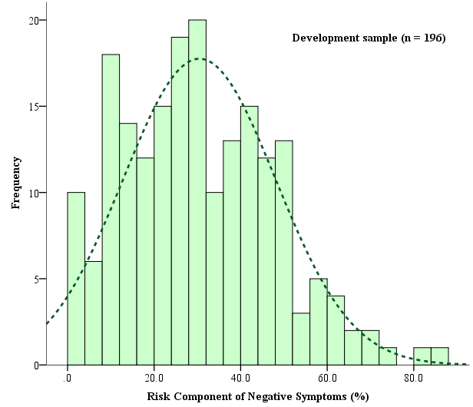
Percent of estimated total risk accounted for by negative symptoms (%)
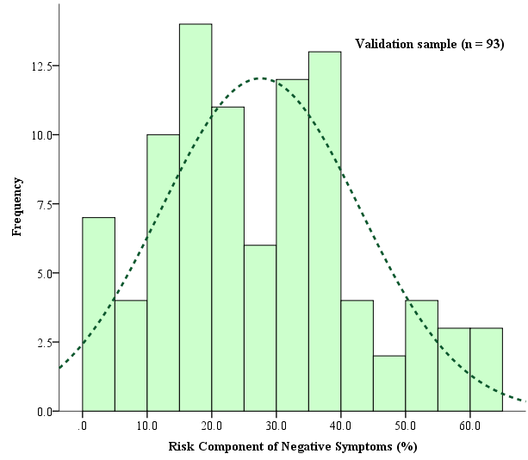
Percent of estimated total risk accounted for by negative symptoms (%)
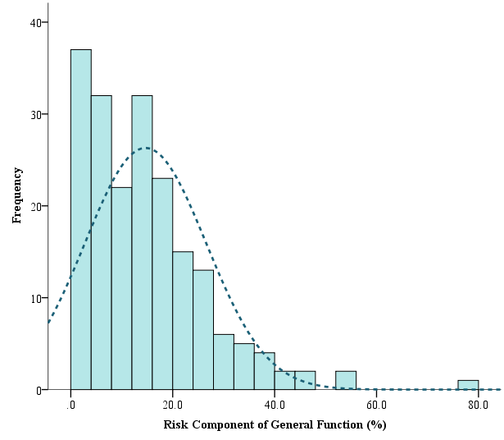
Percent of estimated total risk accounted for by general function (%)
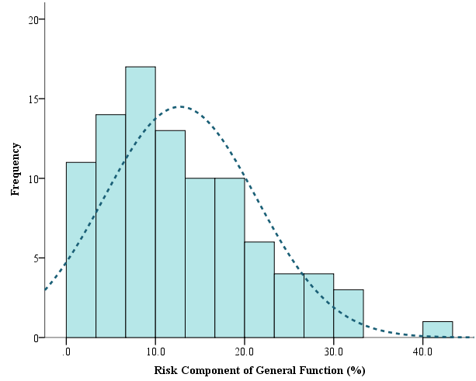
Percent of estimated total risk accounted for by general function (%)
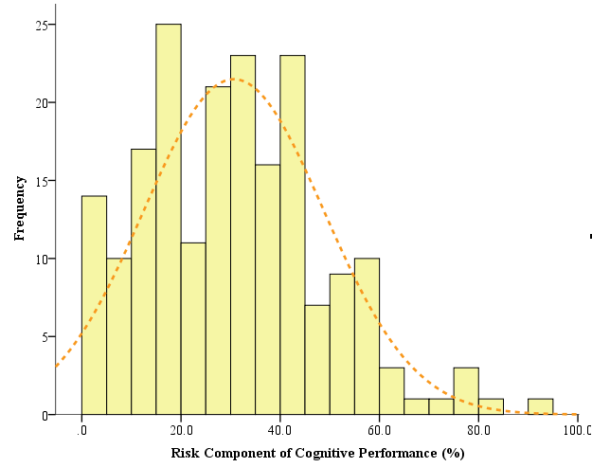
Percent of estimated total risk accounted for by cognitive performance (%)
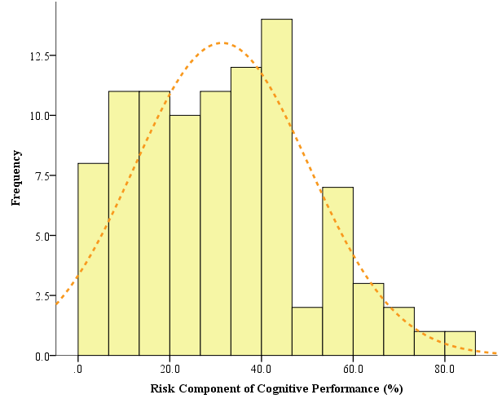
Percent of estimated total risk accounted for by cognitive performance (%)
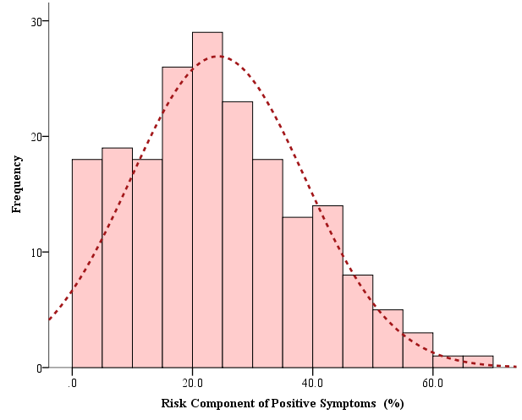
Percent of estimated total risk accounted for by positive symptoms (%)
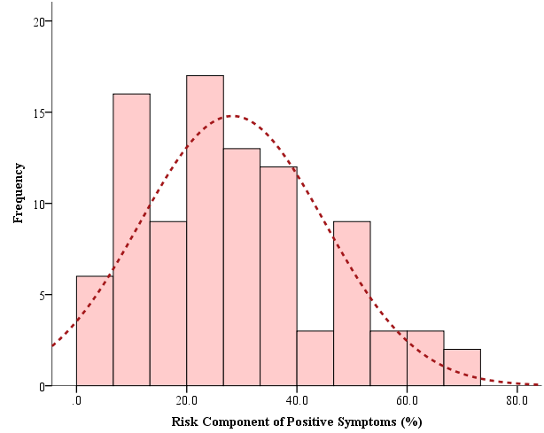
Percent of estimated total risk accounted for by positive symptoms (%)

