Supplement figures for the manuscript Elovainio et al. Is moderate depression associated with sleep stage architecture in adolescence? Testing the stage type associations using network and transition probability approaches

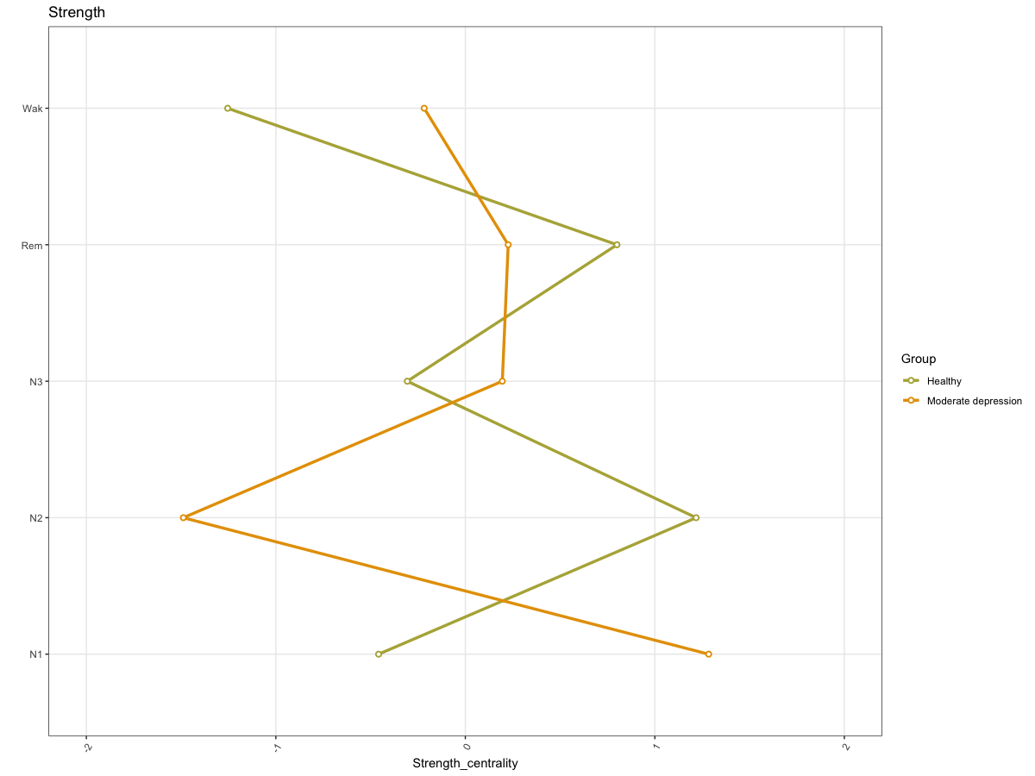

Supplement Figure 1. Network strength centrality of various sleep stages in those with moderate depression and others

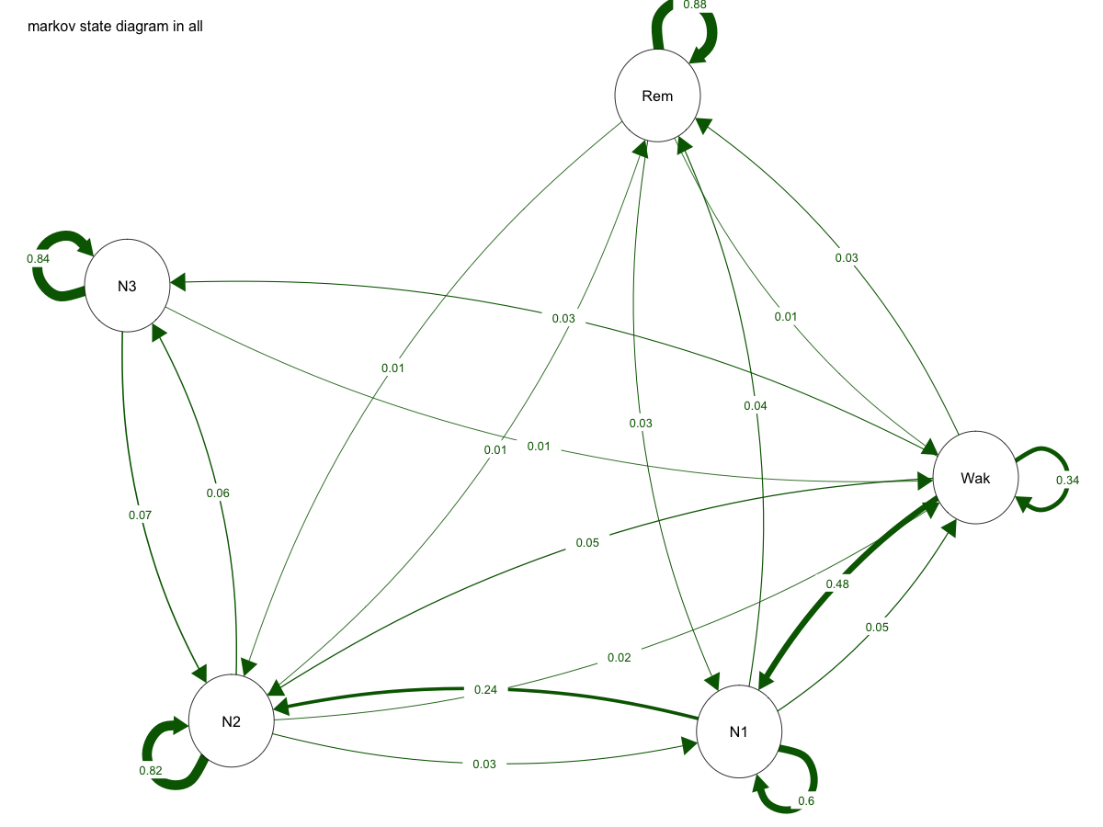

Supplement Figure 2

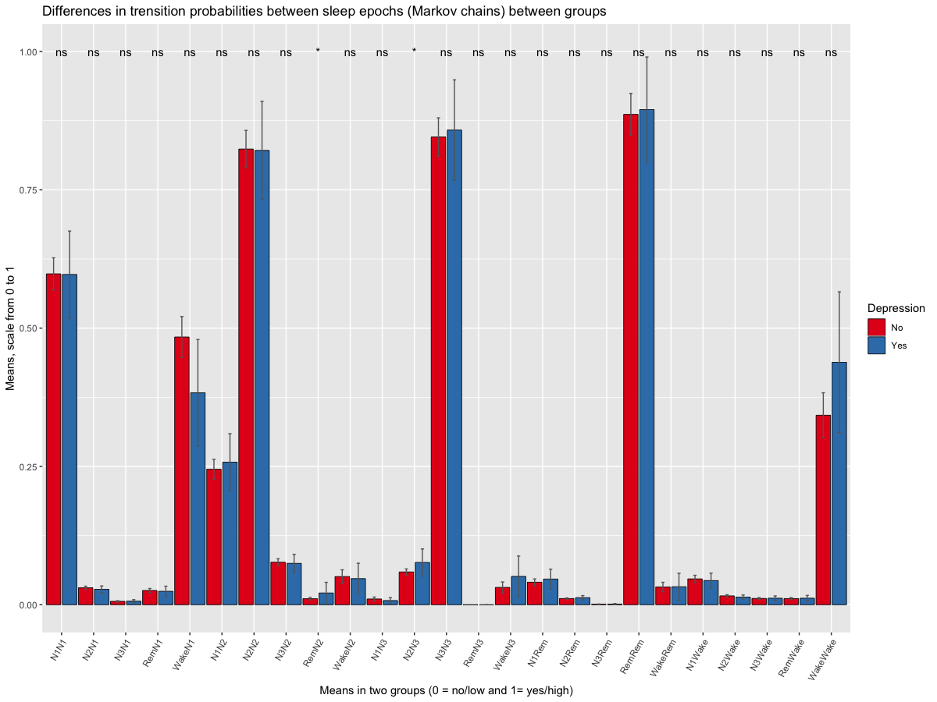
Supplement Figure 3. Sleep stage transition probabilities (Markov chains) in those with moderate depression and others.

