Supplemental information (SI)

Sample
Participants were excluded from actigraphy assessment if: 1) they were in a mood episode; 2) they had known irregular activity patterns (for example, due to an irregular work schedule) based on either self-report in the sleep diary or a background demographic questionnaire; or 3) other factors could have interfered with their activity patterns, such as a physical condition, based on self-report on background information. See Pagani et al. (Pagani et al., 2016) for details regarding the excluded participants. Written informed consent was obtained from each participant. Institutional review boards at participating institutions approved all study procedures.

Assessment
The length of time between the cognitive, brain and actigraphy assessments ranged from 0-49 months with an average of 14.4 (SD=13.5; data available for 408 individuals) months between the actigraphy-brain assessments and 12.4 (SD=13.2; data available for 553 individuals) months between the actigraphy-behavioral assessments. BP-1 probands were determined to be in a euthymic mood state at the time of all assessments (see below).

Genetic analysis
The family members (n=850) were genotyped using the Illumina Omni 2.5 chip in three batches. Each batch included a replicate of a subset of the samples that were used for quality assurance across the batches. Twelve samples were excluded from the final sample because of quality control issues. Genotyping completeness averaged 99.78% in the 838 samples that passed quality assurance parameters. One subject had genotyping completeness <95%; because this was a BP case and was missing only 5.7% of genotypes we retained the case for analysis. For linkage mapping we used 99,446 single nucleotide polymorphisms (SNPs) that met quality control standards had a minor allele frequency (MAF) greater than 0.35 and had been pruned to have a linkage disequilibrium r2<0.5. Pedigree-wide Mendel checks were implemented on the set of 99,446 SNPs and all data showing greater than one Mendel error within a family (0.7% of markers) was set to missing. Allele frequency calculations estimates of linkage disequilibrium and calculations of Hardy-Weinberg equilibrium were performed using only unrelated (founder) individuals. The software package Loki implements a Markov Chain Monte Carlo method (Heath et al., 1997)) and was used to estimate the multipoint identical by descent allele-sharing in the pedigrees from genotype data.

Activity Recording Calibrations and inclusion- and exclusion criteria
Actigraphy was measured using the Actiwatch Spectrum (Philips Respironics). The Actiwatch records activity counts (in 1-minute epochs) and ambient light level.
In order to minimize effects of interdevice variability on the results two independent procedures were applied; i.e. rocker test calibrations and wrist test calibrations to calibrate the Actiwatches before use (see (Pagani et al., 2016) for a detailed description of these procedures).
Actiwatches were placed on the non-dominant wrist of the participant for 14 consecutive days. Participants were asked to not remove the Actiwatch and to press the marker button when they lay down to sleep and again when they got out of bed. In addition, participants were asked to keep a sleep diary.

Description of actigraphy traits

Rest period
The rest period for each 24 hours was defined as the first moment after 6:00 PM when the subject lay down in bed trying to sleep. Actigraphy data was combined with data from sleep logs, when available, to determine the rest period. An activity threshold (median of overall activity not exceeding 50 counts per epoch) was applied to identify consistent epochs of low activity.

Activity level
We derived phenotypes of overall activity levels across the circadian cycle, from the raw mean and median of activity over 24 hours, and mean and SD of activity in four 6-hour time windows, beginning at midnight.
See (Pagani et al., 2016) for a more detailed description of actigraphy procedures, delineation of phenotypes and quality control procedures.

Neuroimaging
We acquired T1-weighted structural neuroimages on 1.5-T scanners from 420 subjects (229 from CVCR and 191 from CO). Freesurfer software was used, with manual inspection of intermediate steps in the processing stream to correct common errors resulting in 96 structural magnetic resonance imaging (MRI) phenotypes including measures of volume, surface area and cortical thickness (as previously reported by (Fears et al., 2015)).
The two scanners that were used in CO and CVCR were calibrated. During the study period images were checked for quality control, resulting in minimal site differences. We found that scanner effect was similar across age, sex and diagnosis (Fears et al., 2015).

Supplemental Table 1. Demographics of sample with data on actigraphy traits
 | Participants with BP-I |  | Non-BP-I relatives
 | CVCR | CO | CVCR | CO
N | 70 | 66 | 219 | 203
Females | 36 | 40 | 118 | 117
Age range (years) | 27-81 | 21-78 | 18-87 | 18-82
Mean age (SD) | 50.3 (13.4) | 46.94 (12.74) | 48.1 (16.3) | 45.13 (17.25)
Mean years of education (SD) | 7.7 (5.0) | 9.17 (4.67) | 7.9 (4.9) | 8.67 (4.51)
Summary statistics for sex, age and education. CO= Antioquia region of Colombia; CVCR=Central Valley of Costa Rica; SD=Standard deviations

Supplemental Table 2. Diagnoses in non-BP-I relatives*
DSM-IV-TR diagnosis | N
No diagnosis | 347
Any mood disorder | 53
Alcohol or drug dependence | 13
Any anxiety disorder | 8
Adjustment disorder | 1
*Assessed using MINI (40)

Supplemental Table 3. Actigraphy-brain trait associations in BP-I probands and their non-BP-I relatives
Actigraphy trait | Brain trait | N | Beta | p-value | R² | q-value
Mean of awake duration | Brain stem | 420 | 0.02 | 0.45 | 0.0006 | 0.57
Mean of awake duration | Cerebellum cortex | 420 | 0.006 | 0.82 | 0 | 0.89
Mean of awake duration | Cerebral cortex | 420 | 0.04 | 0.11 | 0.008 | 0.24
Mean of awake duration | Cerebral white matter volume | 420 | 0.08 | 0.004 | 0.02 | 0.04*
Mean of awake duration | Corpus Callosum | 420 | 0.06 | 0.15 | 0.002 | 0.27
Mean of awake duration | Thickness of the frontal pole | 420 | 0.12 | 0.005 | 0.02 | 0.04*
Mean of awake duration | Thickness of the fusiform | 420 | 0.05 | 0.19 | 0.002 | 0.32
Mean of awake duration | Thickness of the lateral orbitofronal | 420 | 0.06 | 0.15 | 0.004 | 0.28
Mean of awake duration | Thickness of the lingual | 420 | 0.09 | 0.03 | 0.009 | 0.11
Mean of awake duration | Thickness of the pars opercularis | 420 | 0.06 | 0.15 | 0.003 | 0.28
Mean of awake duration | Thickness of the pars orbitalis | 420 | 0.09 | 0.04 | 0.01 | 0.13
Mean of awake duration | Thickness of the pars triangularis | 420 | 0.09 | 0.04 | 0.009 | 0.13
Mean of awake duration | Thickness of the rostral middle frontal | 420 | 0.08 | 0.05 | 0.006 | 0.16
Mean of awake duration | Thickness of the superior frontal | 420 | 0.03 | 0.33 | 0.001 | 0.47
Mean of awake duration | Thickness of the superior temporal | 420 | 0.08 | 0.03 | 0.01 | 0.13
Mean of awake duration | Thalamus volume | 420 | 0.04 | 0.17 | 0.004 | 0.31
Mean of awake duration | Ventral diencephalon | 420 | -0.02 | 0.51 | 0.0006 | 0.62
Mean of awake duration | Third ventricle volume | 420 | -0.13 | 0.0007 | 0.03 | 0.01*
Amplitude of activity | Brain stem | 420 | 0.10 | 0.008 | 0.01 | 0.05*
Amplitude of activity | Cerebellum cortex | 420 | 0.04 | 0.26 | 0.001 | 0.39
Amplitude of activity | Cerebral cortex | 420 | 0.07 | 0.005 | 0.01 | 0.04*
Amplitude of activity | Cerebral white matter | 420 | 0.13 | 6.12E-06** | 0.03 | 0.001**
Amplitude of activity | Corpus callosum | 420 | 0.12 | 0.01 | 0.002 | 0.06
Amplitude of activity | Thickness of the frontal pole | 420 | 0.10 | 0.03 | 0.007 | 0.11
Amplitude of activity | Thickness of the fusiform | 420 | 0.15 | 0.001 | 0.02 | 0.01*
Amplitude of activity | Thickness of the lateral orbitofrontal cortex | 420 | 0.12 | 0.01 | 0.01 | 0.06
Amplitude of activity | Thickness of the lingual | 420 | 0.07 | 0.12 | 0.003 | 0.25
Amplitude of activity | Thickness of the pars opercularis | 420 | 0.12 | 0.006 | 0.02 | 0.04*
Amplitude of activity | Thickness of the pars orbitalis | 420 | 0.09 | 0.05 | 0.006 | 0.16
Amplitude of activity | Thickness of the pars triangularis | 420 | 0.11 | 0.01 | 0.01 | 0.07
Amplitude of activity | Thickness of the rostral middle frontal | 420 | 0.13 | 0.003 | 0.02 | 0.03*
Amplitude of activity | Thickness of the superior frontal | 420 | 0.10 | 0.01 | 0.01 | 0.06
Amplitude of activity | Thickness of the superior temporal | 420 | 0.16 | 9.82E-05** | 0.02 | 0.006**
Amplitude of activity | Thalamus volume | 420 | 0.12 | 5.55E-05** | 0.03 | 0.006**
Amplitude of activity | Ventral diencephalon | 420 | 0.12 | 0.0004 | 0.02 | 0.01*
Amplitude of activity | Third ventricle volume | 420 | -0.13 | 0.002 | 0.006 | 0.03*
Inter-daily stability | Brain stem | 420 | 0.07 | 0.04 | 0.003 | 0.13
Inter-daily stability | Cerebellum cortex | 420 | 0.04 | 0.14 | 0.002 | 0.26
Inter-daily stability | Cerebral cortex | 420 | 0.05 | 0.07 | 0.003 | 0.19
Inter-daily stability | Cerebral white matter | 420 | 0.06 | 0.05 | 0.002 | 0.15
Inter-daily stability | Corpus callosum | 420 | 0.04 | 0.33 | 0 | 0.47
Inter-daily stability | Thickness frontal pole | 420 | 0.02 | 0.62 | 0.0006 | 0.74
Inter-daily stability | Thickness fusiform | 420 | 0.03 | 0.4 | 0.002 | 0.60
Inter-daily stability | Thickness lateral orbitofrontal | 420 | -0.04 | 0.42 | 0.0004 | 0.54
Inter-daily stability | Thickness lingual | 420 | 0.004 | 0.93 | 0 | 0.94
Inter-daily stability | Thickness pars opercularis | 420 | 0.009 | 0.83 | 0.0003 | 0.89
Inter-daily stability | Thickness pars orbitalis | 420 | 0.001 | 0.97 | 0 | 0.97
Inter-daily stability | Thickness pars triangularis | 420 | 0.01 | 0.75 | 0.0003 | 0.83
Inter-daily stability | Thickness rostral middle frontal | 420 | 0.02 | 0.60 | 0.001 | 0.72
Inter-daily stability | Thickness superior frontal | 420 | 0.03 | 0.39 | 0.002 | 0.52
Inter-daily stability | Thickness superior temporal | 420 | 0.02 | 0.55 | 0.0007 | 0.65
Inter-daily stability | Thalamus volume | 420 | 0.04 | 0.21 | 0 | 0.34
Inter-daily stability | Ventral diencephalon | 420 | 0.08 | 0.02 | 0.002 | 0.08
Inter-daily stability | Third ventricle volume | 420 | -0.004 | 0.92 | 0 | 0.94
Intra-daily variability | Brain stem | 420 | -0.08 | 0.03 | 0.008 | 0.11
Intra-daily variability | Cerebellum cortex | 420 | -0.06 | 0.05 | 0.008 | 0.16
Intra-daily variability | Cerebral cortex | 420 | -0.04 | 0.12 | 0.002 | 0.25
Intra-daily variability | Cerebral white matter | 420 | -0.10 | 0.0004 | 0.01 | 0.01*
Intra-daily variability | Corpus callosum | 420 | -0.06 | 0.19 | 0 | 0.32
Intra-daily variability | Thickness of the frontal pole | 420 | 0.009 | 0.85 | 0.0003 | 0.90
Intra-daily variability | Thickness of the fusiform | 420 | -0.0002 | 0.997 | 0 | 0.997
Intra-daily variability | Thickness of the lateral orbitofrontal | 420 | 0.04 | 0.35 | 0.002 | 0.48
Intra-daily variability | Thickness of the lingual gyrus | 420 | -0.009 | 0.85 | 0 | 0.90
Intra-daily variability | Thickness of the pars opercularis | 420 | 0.04 | 0.36 | 0.002 | 0.49
Intra-daily variability | Thickness of the pars orbitalis | 420 | 0.03 | 0.51 | 0.002 | 0.62
Intra-daily variability | Thickness of the pars triangularis | 420 | 0.02 | 0.67 | 0.0009 | 0.79
Intra-daily variability | Thickness of the rostral middle frontal gyrus | 420 | 0.02 | 0.71 | 0.0003 | 0.81
Intra-daily variability | Thickness of the superior frontal gyrus | 420 | 0.03 | 0.48 | 0.002 | 0.60
Intra-daily variability | Thickness of the superior temporal gyrus | 420 | 0.01 | 0.74 | 0.0008 | 0.83
Intra-daily variability | Thalamus volume | 420 | -0.06 | 0.05 | 0.003 | 0.16
Intra-daily variability | Ventral diencephalon | 420 | -0.09 | 0.005 | 0.01 | 0.04*
Intra-daily variability | Third ventricle volume | 420 | 0.02 | 0.63 | 0 | 0.74
Median of activity | Brain stem | 420 | 0.05 | 0.13 | 0.004 | 0.25
Median of activity | Cerebellar cortex | 420 | 0.03 | 0.36 | 0.0009 | 0.49
Median of activity | Cerebral cortex | 420 | 0.06 | 0.02 | 0.01 | 0.09
Median of activity | Cerebral white matter | 420 | 0.10 | 0.0005 | 0.02 | 0.01*
Median of activity | Corpus callosum | 420 | 0.05 | 0.29 | 0 | 0.43
Median of activity | Thickness of the frontal pole | 420 | 0.12 | 0.009 | 0.01 | 0.05
Median of activity | Thickness of the fusiform gyrus | 420 | 0.07 | 0.13 | 0.005 | 0.25
Median of activity | Thickness of the lateral orbitofrontal cortex | 420 | 0.05 | 0.23 | 0.003 | 0.36
Median of activity | Thickness of the lingual gyrus | 420 | 0.06 | 0.16 | 0.003 | 0.29
Median of activity | Thickness of the pars opercularis | 420 | 0.08 | 0.08 | 0.006 | 0.19
Median of activity | Thickness of the pars orbitalis | 420 | 0.05 | 0.28 | 0.003 | 0.42
Median of activity | Thickness of the pars triangularis | 420 | 0.07 | 0.10 | 0.005 | 0.23
Median of activity | Thickness of the rostral middle frontal gyrus | 420 | 0.08 | 0.08 | 0.006 | 0.19
Median of activity | Thickness of superior frontal gyrus | 420 | 0.04 | 0.30 | 0.001 | 0.43
Median of activity | Thickness of the superior temporal gyrus | 420 | 0.10 | 0.01 | 0.01 | 0.07
Median of activity | Thalamus volume | 420 | 0.06 | 0.03 | 0.008 | 0.13
Median of activity | Ventral diencephalon | 420 | 0.06 | 0.06 | 0.006 | 0.18
Median of activity | Third ventricle volume | 420 | -0.07 | 0.06 | 0.007 | 0.16
Relative amplitude | Brain stem | 420 | 0.11 | 0.001 | 0.01 | 0.01*
Relative amplitude | Cerebellum cortex | 420 | 0.01 | 0.73 | 0 | 0.81
Relative amplitude | Cerebral cortex | 420 | 0.002 | 0.93 | 0 | 0.94
Relative amplitude | Cerebral white matter | 420 | 0.08 | 0.003 | 0.008 | 0.03*
Relative amplitude | Corpus callosum | 420 | 0.10 | 0.02 | 0.008 | 0.07
Relative amplitude | Thickness of the frontal pole | 420 | 0.05 | 0.23 | 0.002 | 0.36
Relative amplitude | Thickness of the fusiform | 420 | 0.08 | 0.05 | 0.01 | 0.16
Relative amplitude | Thickness of the lateral orbito frontal | 420 | 0.07 | 0.11 | 0.006 | 0.24
Relative amplitude | Thickness of the lingual | 420 | 0.02 | 0.69 | 0.0002 | 0.79
Relative amplitude | Thickness of the pars opercularis | 420 | 0.05 | 0.24 | 0.005 | 0.37
Relative amplitude | Thickness of the pars orbitalis | 420 | 0.06 | 0.22 | 0.002 | 0.35
Relative amplitude | Thickness of the pars triangularis | 420 | 0.07 | 0.12 | 0.006 | 0.24
Relative amplitude | Thickness of the rostral middle frontal | 420 | 0.10 | 0.02 | 0.01 | 0.07
Relative amplitude | Thickness of the superior frontal | 420 | 0.08 | 0.03 | 0.01 | 0.11
Relative amplitude | Thickness of the superior temporal | 420 | 0.06 | 0.13 | 0.005 | 0.26
Relative amplitude | Thalamus volume | 420 | 0.10 | 0.0006 | 0.02 | 0.01*
Relative amplitude | Ventral diencephalon | 420 | 0.09 | 0.005 | 0.01 | 0.04*
Relative amplitude | Third ventricle | 420 | -0.03 | 0.41 | 0 | 0.54
Sleep bout length mean | Brain stem | 420 | -0.009 | 0.80 | 0.0001 | 0.87
Sleep bout length mean | Cerebellum cortex | 420 | -0.03 | 0.36 | 0.001 | 0.49
Sleep bout length mean | Cerebral cortex | 420 | -0.09 | 0.0002 | 0.04 | 0.008*
Sleep bout length mean | Cerebral white matter | 420 | -0.02 | 0.40 | 0.004 | 0.53
Sleep bout length mean | Corpus callosum | 420 | -0.09 | 0.05 | 0.01 | 0.16
Sleep bout length mean | Thickness of the frontal pole | 420 | -0.03 | 0.44 | 0.001 | 0.57
Sleep bout length mean | Thickness of the fusiform | 420 | -0.10 | 0.02 | 0.006 | 0.09
Sleep bout length mean | Thickness of the lateral orbito frontal | 420 | -0.06 | 0.20 | 0.004 | 0.34
Sleep bout length mean | Thickness of the lingual | 420 | -0.07 | 0.11 | 0.006 | 0.23
Sleep bout length mean | Thicknes of the pars opercularis | 420 | -0.03 | 0.44 | 0.0007 | 0.56
Sleep bout length mean | Thickness of the pars orbitalis | 420 | -0.01 | 0.80 | 0 | 0.87
Sleep bout length mean | Thickness of the pars triangularis | 420 | -0.02 | 0.69 | 0 | 0.79
Sleep bout length mean | Thickness of the rostral middle frontal | 420 | -0.01 | 0.76 | 0.0002 | 0.84
Sleep bout length mean | Thickness of the superior frontal | 420 | -0.01 | 0.73 | 0.0003 | 0.82
Sleep bout length mean | Thickness of the superior temporal | 420 | -0.06 | 0.15 | 0.003 | 0.27
Sleep bout length mean | Thalamus volume | 420 | -0.04 | 0.19 | 0.005 | 0.32
Sleep bout length mean | Ventral diencephalon | 420 | -0.06 | 0.07 | 0.009 | 0.18
Sleep bout length mean | Third ventricle volume | 420 | 0.11 | 0.005 | 0.03 | 0.04*
Sleep duration mean | Brain stem | 420 | -0.04 | 0.21 | 0.002 | 0.34
Sleep duration mean | Cerebellum cortex | 420 | -0.003 | 0.90 | 0 | 0.92
Sleep duration mean | Cerebral cortex | 420 | -0.05 | 0.05 | 0.01 | 0.16
Sleep duration mean | Cerebral white matter | 420 | -0.09 | 0.001 | 0.02 | 0.01*
Sleep duration mean | Corpus callosum | 420 | -0.07 | 0.10 | 0.004 | 0.23
Sleep duration mean | Thickness of the frontal pole | 420 | -0.14 | 0.001 | 0.02 | 0.01*
Sleep duration mean | Thickness of the fusiform | 420 | -0.07 | 0.11 | 0.001 | 0.23
Sleep duration mean | Thickness of the lateral orbitor frontal | 420 | -0.08 | 0.06 | 0.007 | 0.17
Sleep duration mean | Thickness of the lingual | 420 | -0.10 | 0.01 | 0.01 | 0.07
Sleep duration mean | Thickness of the pars opercularis | 420 | -0.06 | 0.10 | 0.002 | 0.23
Sleep duration mean | Thickness of the pars orbitalis | 420 | -0.10 | 0.01 | 0.02 | 0.07
Sleep duration mean | Thickness of the pars triangularis | 420 | -0.11 | 0.009 | 0.01 | 0.05
Sleep duration mean | Thickness of the rostral middle frontal | 420 | -0.11 | 0.006 | 0.01 | 0.04*
Sleep duration mean | Thickness of the superior frontal | 420 | -0.06 | 0.08 | 0.005 | 0.20
Sleep duration mean | Thickness of the superior temporal | 420 | -0.08 | 0.03 | 0.009 | 0.11
Sleep duration mean | Thalamus volume | 420 | -0.05 | 0.08 | 0.006 | 0.20
Sleep duration mean | Ventral diencephalon | 420 | 0.005 | 0.88 | 0 | 0.92
Sleep duration mean | Third ventricle volume | 420 | 0.13 | 0.0003 | 0.03 | 0.008*
Sleep offset mean | Brain stem | 420 | -0.07 | 0.08 | 0.01 | 0.20
Sleep offset mean | Cerebellum cortex | 420 | -0.04 | 0.30 | 0.004 | 0.44
Sleep offset mean | Cerebral cortex | 420 | -0.03 | 0.37 | 0.002 | 0.50
Sleep offset mean | Cerebral white matter | 420 | -0.07 | 0.04 | 0.003 | 0.14
Sleep offset mean | Corpus callosum | 420 | -0.09 | 0.09 | 0.001 | 0.21
Sleep offset mean | Thickness of the frontal pole | 420 | -0.12 | 0.02 | 0.01 | 0.08
Sleep offset mean | Thickness of the fusiform | 420 | -0.10 | 0.04 | 0.01 | 0.13
Sleep offset mean | Thickness of the lateral orbito frontal | 420 | -0.10 | 0.04 | 0.01 | 0.14
Sleep offset mean | Thickness of the lingual | 420 | -0.06 | 0.18 | 0.004 | 0.32
Sleep offset mean | Thickness of the pars opercularis | 420 | -0.14 | 0.005 | 0.02 | 0.04*
Sleep offset mean | Thickness of the pars orbitalis | 420 | -0.07 | 0.15 | 0.004 | 0.28
Sleep offset mean | Thickness of the pars triangularis | 420 | -0.18 | 0.0001** | 0.03 | 0.006**
Sleep offset mean | Thickness of the rostral middle frontal | 420 | -0.18 | 0.0002** | 0.03 | 0.008**
Sleep offset mean | Thickness of the superior frontal | 420 | -0.11 | 0.008 | 0.02 | 0.05*
Sleep offset mean | Thickness of the superior temporal | 420 | -0.12 | 0.01 | 0.01 | 0.06
Sleep offset mean | Thalamus volume | 420 | -0.08 | 0.01 | 0.01 | 0.07
Sleep offset mean | Ventral diencephalon | 420 | -0.04 | 0.25 | 0.006 | 0.39
Sleep offset mean | Third ventricle volume | 420 | 0.12 | 0.007 | 0.01 | 0.049*
Sleep onset mean | Brain stem | 420 | -0.03 | 0.45 | 0.004 | 0.57
Sleep onset mean | Cerebellum cortex | 420 | -0.04 | 0.24 | 0.008 | 0.37
Sleep onset mean | Cerebral cortex | 420 | 0.04 | 0.19 | 0.004 | 0.32
Sleep onset mean | Cerebral white matter | 420 | 0.06 | 0.10 | 0.009 | 0.23
Sleep onset mean | Corpus callosum | 420 | 0.008 | 0.89 | 0.0002 | 0.93
Sleep onset mean | Thickness of the frontal pole | 420 | 0.06 | 0.25 | 0.003 | 0.39
Sleep onset mean | Thickness of the fusiform | 420 | -0.02 | 0.74 | 0.002 | 0.83
Sleep onset mean | Thickness of the lateral orbito frontal | 420 | -0.01 | 0.84 | 0.0003 | 0.89
Sleep onset mean | Thickness of the lingual | 420 | 0.07 | 0.19 | 0.002 | 0.32
Sleep onset mean | Thickness of the pars opercularis | 420 | -0.05 | 0.31 | 0.004 | 0.45
Sleep onset mean | Thickness of the pars orbitalis | 420 | 0.05 | 0.34 | 0.003 | 0.47
Sleep onset mean | Thickness of the pars triangularis | 420 | -0.07 | 0.20 | 0.006 | 0.33
Sleep onset mean | Thichness of the rostral middle frontal | 420 | -0.05 | 0.33 | 0.005 | 0.47
Sleep onset mean | Thickness of the superior frontal | 420 | -0.03 | 0.43 | 0.003 | 0.56
Sleep onset mean | Thickness of the superior temporal | 420 | 0.004 | 0.94 | 0.0001 | 0.94
Sleep onset mean | Thalamus volume | 420 | -0.02 | 0.52 | 0.0007 | 0.63
Sleep onset mean | Ventral diencephalon | 420 | -0.06 | 0.12 | 0.009 | 0.25
Sleep onset mean | Third ventricle volume | 420 | -0.06 | 0.26 | 0.003 | 0.39
Total minutes awake mean | Brain stem | 420 | 0.03 | 0.34 | 0.002 | 0.47
Total minutes awake mean | Cerebellum cortex | 420 | 0.01 | 0.69 | 0 | 0.79
Total minutes awake mean | Cerebral cortex | 420 | 0.04 | 0.07 | 0.009 | 0.19
Total minutes awake mean | Cerebral white matter | 420 | 0.10 | 0.0006 | 0.02 | 0.01*
Total minutes awake mean | Corpus callosum | 420 | 0.06 | 0.18 | 0.0006 | 0.31
Total minutes awake mean | Thickness of the frontal pole | 420 | 0.13 | 0.002 | 0.02 | 0.03*
Total minutes awake mean | Thickness of the fusiform | 420 | 0.05 | 0.22 | 0.002 | 0.34
Total minutes awake mean | Thickness of the lateral orbito frontal | 420 | 0.04 | 0.35 | 0.002 | 0.48
Total minutes awake mean | Thickness of the lingual | 420 | 0.06 | 0.14 | 0.003 | 0.26
Total minutes awake mean | Thickness of the pars opercularis | 420 | 0.05 | 0.21 | 0.001 | 0.34
Total minutes awake mean | Thickness of the pars orbitalis | 420 | 0.07 | 0.14 | 0.006 | 0.26
Total minutes awake mean | Thickness of the pars triangularis | 420 | 0.07 | 0.12 | 0.004 | 0.24
Total minutes awake mean | Thickness of the rostral middle frontal | 420 | 0.07 | 0.11 | 0.004 | 0.23
Total minutes awake mean | Thickness of the superior frontal | 420 | 0.03 | 0.48 | 0.0005 | 0.59
Total minutes awake mean | Thickness of the superior temporal | 420 | 0.07 | 0.07 | 0.006 | 0.18
Total minutes awake mean | Thalamus volume | 420 | 0.05 | 0.08 | 0.006 | 0.20
Total minutes awake mean | Ventral diencephalon | 420 | 0.008 | 0.79 | 0.0002 | 0.87
Total minutes awake mean | Third ventricle volume | 420 | -0.11 | 0.005 | 0.020 | 0.04*
WASO mean | Brain stem | 420 | -0.05 | 0.13 | 0.003 | 0.25
WASO mean | Cerebellum cortex | 420 | 0.02 | 0.40 | 0.003 | 0.53
WASO mean | Cerebral cortex | 420 | 0.04 | 0.08 | 0.007 | 0.19
WASO mean | Cerebral white matter | 420 | -0.06 | 0.02 | 0.006 | 0.10
WASO mean | Corpus callosum | 420 | -0.04 | 0.33 | 0.002 | 0.47
WASO mean | Thickness of the frontal pole | 420 | -0.09 | 0.04 | 0.009 | 0.14
WASO mean | Thickness of the fusiform | 420 | 0.006 | 0.89 | 0 | 0.93
WASO mean | Thickness of the lateral orbito frontal | 420 | -0.03 | 0.49 | 0.001 | 0.60
WASO mean | Thickness of the lingual | 420 | -0.03 | 0.49 | 0.001 | 0.60
WASO mean | Thickness of the pars opercularis | 420 | -0.03 | 0.46 | 0.002 | 0.58
WASO mean | Thickness of the pars orbitalis | 420 | -0.08 | 0.08 | 0.009 | 0.19
WASO mean | Thickness of the pars triangularis | 420 | -0.07 | 0.09 | 0.008 | 0.21
WASO mean | Thickness of the rostral middle frontal | 420 | -0.08 | 0.04 | 0.009 | 0.14
WASO mean | Thickness of the superior frontal | 420 | -0.05 | 0.14 | 0.005 | 0.26
WASO mean | Thickness of the superior temporal | 420 | -0.005 | 0.90 | 0.0002 | 0.93
WASO mean | Thalamus volume | 420 | -0.05 | 0.09 | 0.005 | 0.22
WASO mean | Ventral diencephalon | 420 | 0.007 | 0.83 | 0.0003 | 0.89
WASO mean | Third ventricle volume | 420 | 0.02 | 0.68 | 0 | 0.79
**Bonferroni significant; *FDR significant; WASO = total minutes in awake bouts after sleep onset; CVLT=California Verbal Learning Test; SCAP= Spatial Capacity Delayed Response Task; WMS=Wechsler Memory Scale; IP-CPT = Identical Pairs Continuous Performance Task; SST=Stop Signal Task; n=number; R²=Explained variance; q-value is FDR-corrected p-value

Supplemental Table 4. Actigraphy-behavior trait associations in BP-I probands and their non-BP-I relatives
Actigraphy trait | Behavior trait | n | Beta | p-value | R² | q-value
Mean of awake duration | Impulsivity (Aggression Questionnaire) | 557 | -0.07 | 0.09 | 0.005 | 0.24
Mean of awake duration | Impulsivity (Barratt Impulsivity Scale) | 557 | -0.15 | 0.0004 | 0.02 | 0.007*
Mean of awake duration | Perceptual creativity | 558 | 0.02 | 0.59 | 0 | 0.74
Mean of awake duration | Delusion proneness | 557 | -0.07 | 0.10 | 0.005 | 0.25
Mean of awake duration | Cyclothymia | 557 | -0.12 | 0.003 | 0.02 | 0.03*
Mean of awake duration | Depressive factor | 557 | -0.06 | 0.12 | 0.005 | 0.29
Mean of awake duration | Irritable factor | 557 | -0.05 | 0.25 | 0.003 | 0.46
Mean of awake duration | WMS Logical Memory immediate | 558 | 0.1 | 0.004 | 0.02 | 0.03*
Mean of awake duration | WMS logical memory delay | 558 | 0.12 | 0.0003 | 0.02 | 0.007*
Mean of awake duration | WMS Logical Memory recognition | 553 | 0.10 | 0.005 | 0.02 | 0.04*
Mean of awake duration | Digit Symbol copy | 545 | 0.02 | 0.51 | 0.002 | 0.68
Mean of awake duration | CVLT trials 1-5 | 552 | 0.07 | 0.04 | 0.009 | 0.15
Mean of awake duration | CVLT Delayed Recall | 548 | 0.07 | 0.05 | 0.008 | 0.17
Mean of awake duration | Verbal Working memory Letter-Number sequencing | 530 | 0.09 | 0.005 | 0.02 | 0.04*
Mean of awake duration | SCAP | 546 | 0.07 | 0.07 | 0.006 | 0.20
Mean of awake duration | Face memory | 550 | 0.06 | 0.07 | 0.009 | 0.21
Mean of awake duration | Trail Making Test number sequencing | 453 | -0.08 | 0.03 | 0.01 | 0.13
Mean of awake duration | Trail Making Test number-letter sequencing | 430 | -0.08 | 0.02 | 0.01 | 0.09
Mean of awake duration | SST Correct go | 533 | 0.16 | 8.99E-05** | 0.03 | 0.003**
Mean of awake duration | Verbal fluency category | 533 | 0.07 | 0.07 | 0.007 | 0.20
Mean of awake duration | IP-CPT Hits | 502 | 0.10 | 0.01 | 0.02 | 0.07
Amplitude of acitivity | Impulsivity (Aggression Questionnaire) | 557 | -0.03 | 0.48 | 0.002 | 0.66
Amplitude of activity | Impulsivity (Barratt Impulsivity Scale) | 557 | -0.08 | 0.05 | 0.007 | 0.18
Amplitude of activity | Perceptual creativity | 558 | -0.04 | 0.30 | 0.003 | 0.49
Amplitude of activity | Delusion proneness | 557 | -0.07 | 0.14 | 0.005 | 0.31
Amplitude of activity | Cyclothymia | 557 | -0.06 | 0.14 | 0.004 | 0.31
Amplitude of activity | Depressive factor | 557 | -0.04 | 0.36 | 0.002 | 0.55
Amplitude of activity | Irritable factor | 557 | -0.04 | 0.35 | 0.003 | 0.55
Amplitude of activity | WMS Logical Memory immediate | 558 | 0.07 | 0.06 | 0.003 | 0.19
Amplitude of activity | WMS logical memory delay | 558 | 0.05 | 0.19 | 0.002 | 0.37
Amplitude of activity | WMS Logical Memory recognition | 553 | 0.03 | 0.39 | 0 | 0.57
Amplitude of activity | Digit Symbol copy | 545 | -0.01 | 0.74 | 0.001 | 0.84
Amplitude of activity | CVLT trials 1-5 | 552 | 0.03 | 0.46 | 0.0003 | 0.63
Amplitude of activity | CVLT Delayed Recall | 548 | 0.07 | 0.05 | 0.005 | 0.17
Amplitude of activity | Verbal Working memory Letter-Number sequencing | 530 | 0.07 | 0.06 | 0.0003 | 0.20
Amplitude of activity | SCAP | 546 | -0.03 | 0.39 | 0.002 | 0.57
Amplitude of activity | Face memory | 550 | 0.05 | 0.19 | 0 | 0.37
Amplitude of activity | Trail Making Test number sequencing | 453 | -0.04 | 0.26 | 0 | 0.46
Amplitude of activity | Trail Making Test number-letter sequencing | 430 | -0.04 | 0.29 | 0.0008 | 0.49
Amplitude of activity | SST Correct go | 533 | 0.06 | 0.13 | 0.003 | 0.29
Amplitude of activity | Verbal fluency category | 533 | 0.06 | 0.15 | 0 | 0.32
Amplitude of activity | IP-CPT Hits | 502 | 0.09 | 0.04 | 0.004 | 0.14
Inter-daily stability | Impulsivity (Aggression Questionnaire) | 557 | -0.06 | 0.14 | 0.005 | 0.31
Inter-daily stability | Impulsivity (Barratt Impulsivity Scale) | 557 | -0.06 | 0.15 | 0.004 | 0.32
Inter-daily stability | Perceptual creativity | 558 | -0.04 | 0.26 | 0.003 | 0.46
Inter-daily stability | PDI_Sum | 557 | -0.009 | 0.85 | 0.0002 | 0.91
Inter-daily stability | Cyclothymia | 557 | -0.08 | 0.04 | 0.007 | 0.16
Inter-daily stability | Depressive factor | 557 | -0.04 | 0.36 | 0.002 | 0.55
Inter-daily stability | Irritable factor | 557 | -0.07 | 0.08 | 0.007 | 0.22
Inter-daily stability | WMS Logical Memory immediate | 558 | 0.003 | 0.93 | 0 | 0.95
Inter-daily stability | WMS logical memory delay | 558 | -0.01 | 0.79 | 0.0006 | 0.88
Inter-daily stability | WMS Logical Memory recognition | 553 | -0.06 | 0.14 | 0.005 | 0.31
Inter-daily stability | Digit Symbol copy | 545 | -0.04 | 0.15 | 0.007 | 0.32
Inter-daily stability | CVLT trials 1-5 | 552 | -0.04 | 0.24 | 0.003 | 0.44
Inter-daily stability | CVLT Delayed Recall | 548 | -0.05 | 0.15 | 0.004 | 0.32
Inter-daily stability | Verbal Working memory Letter-Number sequencing | 530 | -0.05 | 0.14 | 0.006 | 0.31
Inter-daily stability | SCAP | 546 | -0.03 | 0.37 | 0.002 | 0.55
Inter-daily stability | Face memory | 550 | -0.08 | 0.04 | 0.01 | 0.14
Inter-daily stability | Trail Making Test number sequencing | 453 | 0.02 | 0.50 | 0.001 | 0.68
Inter-daily stability | Trail Making Test number-letter sequencing | 430 | 0.07 | 0.05 | 0.01 | 0.17
Inter-daily stability | SST Correct go | 533 | -0.008 | 0.84 | 0.0002 | 0.91
Inter-daily stability | Verbal fluency category | 533 | -0.004 | 0.92 | 0.0001 | 0.95
Inter-daily stability | IP-CPT Hits | 502 | -0.05 | 0.22 | 0.004 | 0.42
Intra-daily variability | Impulsivity (Aggression Questionnaire) | 557 | -0.004 | 0.92 | 0 | 0.95
Intra-daily variability | Impulsivity (Barratt Impulsivity Scale) | 557 | -0.01 | 0.78 | 0.0001 | 0.87
Intra-daily variability | Perceptual creativity | 558 | 0.03 | 0.40 | 0.002 | 0.57
Intra-daily variability | Delusion proneness | 557 | 0.06 | 0.15 | 0.004 | 0.32
Intra-daily variability | Cyclothymia | 557 | 0.03 | 0.38 | 0.001 | 0.56
Intra-daily variability | Depressive factor | 557 | -0.01 | 0.70 | 0.0002 | 0.82
Intra-daily variability | Irritable factor | 557 | 0.02 | 0.68 | 0.0006 | 0.80
Intra-daily variability | WMS Logical Memory immediate | 558 | -0.04 | 0.20 | 0 | 0.39
Intra-daily variability | WMS logical memory delay | 558 | -0.03 | 0.40 | 0 | 0.57
Intra-daily variability | WMS Logical Memory recognition | 553 | -0.03 | 0.39 | 0 | 0.57
Intra-daily variability | Digit Symbol copy | 545 | 0.06 | 0.05 | 0.01 | 0.17
Intra-daily variability | CVLT trials 1-5 | 552 | -0.03 | 0.33 | 0 | 0.54
Intra-daily variability | CVLT Delayed Recall | 548 | -0.006 | 0.87 | 0 | 0.92
Intra-daily variability | Verbal Working memory Letter-Number sequencing | 530 | 0.002 | 0.95 | 0.0002 | 0.95
Intra-daily variability | SCAP | 546 | 0.009 | 0.81 | 0.0002 | 0.89
Intra-daily variability | Face memory | 550 | -0.01 | 0.70 | 0 | 0.82
Intra-daily variability | Trail Making Test number sequencing | 453 | 0.002 | 0.95 | 0 | 0.95
Intra-daily variability | Trail Making Test number-letter sequencing | 430 | -0.04 | 0.27 | 0.004 | 0.47
Intra-daily variability | SST Correct go | 533 | -0.04 | 0.29 | 0.001 | 0.49
Intra-daily variability | Verbal fluency category | 533 | -0.03 | 0.37 | 0.0001 | 0.56
Intra-daily variability | IP-CPT Hits | 502 | 0.03 | 0.44 | 0.002 | 0.61
Median activity | Impulsivity (Aggression Questionnaire) | 557 | -0.08 | 0.07 | 0.007 | 0.20
Median activity | Impulsivity (Barratt Impulsivity Scale) | 557 | -0.14 | 0.0008 | 0.02 | 0.01*
Median activity | Perceptual creativity | 558 | 0.003 | 0.94 | 0 | 0.95
Median activity | Delusion proneness | 557 | -0.12 | 0.006 | 0.01 | 0.04*
Median activity | Cyclothymia | 557 | -0.15 | 0.0004 | 0.02 | 0.007*
Median activity | Depressive factor | 557 | -0.07 | 0.07 | 0.007 | 0.20
Median activity | Irritable factor | 557 | -0.04 | 0.32 | 0.003 | 0.53
Median activity | WMS Logical Memory immediate | 558 | 0.13 | 0.0004 | 0.02 | 0.007*
Median activity | WMS logical memory delay | 558 | 0.12 | 0.0008 | 0.02 | 0.01*
Median activity | WMS Logical Memory recognition | 553 | 0.07 | 0.08 | 0.005 | 0.22
Median activity | Digit Symbol copy | 545 | -0.003 | 0.93 | 0.0001 | 0.95
Median activity | CVLT trials 1-5 | 552 | 0.04 | 0.25 | 0.003 | 0.45
Median activity | CVLT Delayed Recall | 548 | 0.06 | 0.09 | 0.005 | 0.23
Median activity | Verbal Working memory Letter-Number sequencing | 530 | 0.08 | 0.02 | 0.010 | 0.09
Median activity | SCAP | 546 | 0.02 | 0.53 | 0.0007 | 0.70
Median activity | Face memory | 550 | 0.04 | 0.33 | 0.0001 | 0.54
Median activity | Trail Making Test number sequencing | 453 | -0.09 | 0.01 | 0.01 | 0.07
Median activity | Trail Making Test number-letter sequencing | 430 | -0.06 | 0.09 | 0.005 | 0.24
Median activity | SST Correct go | 533 | 0.11 | 0.007 | 0.01 | 0.04*
Median activity | Verbal fluency category | 533 | 0.08 | 0.02 | 0.007 | 0.10
Median activity | IP-CPT Hits | 502 | 0.09 | 0.02 | 0.01 | 0.09
Relative amplitude | Impulsivity (Aggression Questionnaire) | 557 | -0.01 | 0.80 | 0.0005 | 0.89
Relative amplitude | Impulsivity (Barratt Impulsivity Scale) | 557 | -0.04 | 0.34 | 0.002 | 0.54
Relative amplitude | Perceptual creativity | 558 | -0.05 | 0.18 | 0.004 | 0.36
Relative amplitude | Delusion proneness | 557 | 0.04 | 0.36 | 0.0009 | 0.55
Relative amplitude | Cyclothymia | 557 | 0.01 | 0.72 | 0.0002 | 0.84
Relative amplitude | Depressive factor | 557 | 0.008 | 0.84 | 0 | 0.91
Relative amplitude | Irritable factor | 557 | -0.02 | 0.62 | 0.001 | 0.76
Relative amplitude | WMS Logical Memory immediate | 558 | -0.02 | 0.64 | 0.0009 | 0.77
Relative amplitude | WMS logical memory delay | 558 | 0.01 | 0.69 | 0 | 0.81
Relative amplitude | WMS Logical Memory recognition | 553 | -0.04 | 0.34 | 0.002 | 0.55
Relative amplitude | Digit Symbol copy | 545 | -0.01 | 0.64 | 0.0006 | 0.77
Relative amplitude | CVLT trials 1-5 | 552 | 0.03 | 0.40 | 0.001 | 0.57
Relative amplitude | CVLT Delayed Recall | 548 | 0.05 | 0.12 | 0.004 | 0.29
Relative amplitude | Verbal Working memory Letter-Number sequencing | 530 | -0.01 | 0.71 | 0.001 | 0.82
Relative amplitude | SCAP | 546 | -0.05 | 0.18 | 0.004 | 0.36
Relative amplitude | Face memory | 550 | 0.02 | 0.56 | 0 | 0.72
Relative amplitude | Trail Making Test number sequencing | 453 | 0.01 | 0.76 | 0 | 0.86
Relative amplitude | Trail Making Test number-letter sequencing | 430 | -0.01 | 0.72 | 0.0004 | 0.84
Relative amplitude | SST Correct go | 533 | -0.004 | 0.92 | 0.0001 | 0.95
Relative amplitude | Verbal fluency category | 533 | 0.02 | 0.53 | 0.0001 | 0.70
Relative amplitude | IP-CPT Hits | 502 | 0.04 | 0.27 | 0.0004 | 0.46
Sleep bout length mean | Impulsivity (Aggression Questionnaire) | 557 | -0.009 | 0.83 | 0.0002 | 0.91
Sleep bout length mean | Impulsivity (Barratt Impulsivity Scale) | 557 | -0.02 | 0.61 | 0.0007 | 0.75
Sleep bout length mean | Perceptual creativity | 558 | 0.04 | 0.29 | 0.002 | 0.49
Sleep bout length mean | Delusion proneness | 557 | 0.03 | 0.46 | 0.001 | 0.64
Sleep bout length mean | Cyclothymia | 557 | 0.02 | 0.57 | 0.0006 | 0.73
Sleep bout length mean | Depressive factor | 557 | -0.02 | 0.58 | 0.0002 | 0.73
Sleep bout length mean | Irritable factor | 557 | -0.06 | 0.14 | 0.004 | 0.31
Sleep bout length mean | WMS Logical Memory immediate | 558 | -0.06 | 0.12 | 0.006 | 0.29
Sleep bout length mean | WMS logical memory delay | 558 | -0.06 | 0.11 | 0.006 | 0.28
Sleep bout length mean | WMS Logical Memory recognition | 553 | -0.10 | 0.009 | 0.01 | 0.05
Sleep bout length mean | Digit Symbol copy | 545 | -0.09 | 0.002 | 0.01 | 0.02*
Sleep bout length mean | CVLT trials 1-5 | 552 | -0.06 | 0.09 | 0.005 | 0.23
Sleep bout length mean | CVLT Delayed Recall | 548 | -0.05 | 0.13 | 0.003 | 0.31
Sleep bout length mean | Verbal Working memory Letter-Number sequencing | 530 | -0.10 | 0.004 | 0.02 | 0.03*
Sleep bout length mean | SCAP | 546 | -0.07 | 0.08 | 0.006 | 0.22
Sleep bout length mean | Face memory | 550 | -0.03 | 0.35 | 0.0001 | 0.55
Sleep bout length mean | Trail Making Test number sequencing | 453 | 0.10 | 0.01 | 0.01 | 0.06
Sleep bout length mean | Trail Making Test number-letter sequencing | 430 | 0.04 | 0.25 | 0.0005 | 0.45
Sleep bout length mean | SST Correct go | 533 | -0.03 | 0.41 | 0.002 | 0.58
Sleep bout length mean | Verbal fluency category | 533 | -0.05 | 0.17 | 0.006 | 0.35
Sleep bout length mean | IP-CPT Hits | 502 | -0.02 | 0.54 | 0.0003 | 0.70
Sleep duration mean | Impulsivity (Aggression Questionnaire) | 557 | 0.05 | 0.22 | 0.003 | 0.42
Sleep duration mean | Impulsivity (Barratt Impulsivity Scale) | 557 | 0.15 | 0.0004 | 0.02 | 0.007*
Sleep duration mean | Perceptual creativity | 558 | -0.02 | 0.55 | 0 | 0.71
Sleep duration mean | Delusion proneness | 557 | 0.05 | 0.23 | 0.003 | 0.42
Sleep duration mean | Cyclothymia | 557 | 0.11 | 0.004 | 0.01 | 0.03*
Sleep duration mean | Depressive factor | 557 | 0.07 | 0.08 | 0.006 | 0.22
Sleep duration mean | Irritable factor | 557 | 0.02 | 0.56 | 0.0009 | 0.71
Sleep duration mean | WMS Logical Memory immediate | 558 | -0.10 | 0.003 | 0.02 | 0.03*
Sleep duration mean | WMS logical memory delay | 558 | -0.13 | 8.76E-05** | 0.03 | 0.003**
Sleep duration mean | WMS Logical Memory recognition | 553 | -0.11 | 0.004 | 0.02 | 0.03*
Sleep duration mean | Digit Symbol copy | 545 | -0.05 | 0.07 | 0.007 | 0.21
Sleep duration mean | CVLT trials 1-5 | 552 | -0.09 | 0.007 | 0.014 | 0.04*
Sleep duration mean | CVLT Delayed Recall | 548 | -0.08 | 0.02 | 0.01 | 0.08
Sleep duration mean | Verbal Working memory Letter-Number sequencing | 530 | -0.11 | 0.0009 | 0.03 | 0.01*
Sleep duration mean | SCAP | 546 | -0.09 | 0.02 | 0.01 | 0.09
Sleep duration mean | Face memory | 550 | -0.07 | 0.04 | 0.01 | 0.15
Sleep duration mean | Trail Making Test number sequencing | 453 | 0.10 | 0.003 | 0.02 | 0.03*
Sleep duration mean | Trail Making Test number-letter sequencing | 430 | 0.10 | 0.002 | 0.02 | 0.02*
Sleep duration mean | SST Correct go | 533 | -0.18 | 6.29E-06** | 0.04 | 0.0005**
Sleep duration mean | Verbal fluency category | 533 | -0.06 | 0.09 | 0.006 | 0.24
Sleep duration mean | IP-CPT Hits | 502 | -0.13 | 0.001 | 0.03 | 0.01*
Sleep offset mean | Impulsivity (Aggression Questionnaire) | 557 | 0.10 | 0.03 | 0.01 | 0.13
Sleep offset mean | Impulsivity (Barratt Impulsivity Scale) | 557 | 0.20 | 1.81E-05** | 0.03 | 0.0009**
Sleep offset mean | Perceptual creativity | 558 | -0.01 | 0.82 | 0 | 0.90
Sleep offset mean | Delusion proneness | 557 | 0.04 | 0.35 | 0.002 | 0.55
Sleep offset mean | Cyclothymia | 557 | 0.11 | 0.01 | 0.01 | 0.06
Sleep offset mean | Depressive factor | 557 | 0.07 | 0.13 | 0.005 | 0.29
Sleep offset mean | Irritable factor | 557 | 0.09 | 0.05 | 0.009 | 0.17
Sleep offset mean | WMS Logical Memory immediate | 558 | 0.05 | 0.24 | 0.005 | 0.44
Sleep offset mean | WMS logical memory delay | 558 | 0.03 | 0.45 | 0.002 | 0.63
Sleep offset mean | WMS Logical Memory recognition | 553 | 0.09 | 0.05 | 0.009 | 0.17
Sleep offset mean | Digit Symbol copy | 545 | -0.002 | 0.94 | 0 | 0.95
Sleep offset mean | CVLT trials 1-5 | 552 | 0.004 | 0.90 | 0.0002 | 0.94
Sleep offset mean | CVLT Delayed Recall | 548 | 0.009 | 0.81 | 0.0003 | 0.90
Sleep offset mean | Verbal Working memory Letter-Number sequencing | 530 | -0.02 | 0.51 | 0 | 0.68
Sleep offset mean | SCAP | 546 | 0.04 | 0.33 | 0.002 | 0.54
Sleep offset mean | Face memory | 550 | -0.02 | 0.53 | 0 | 0.70
Sleep offset mean | Trail Making Test number sequencing | 453 | 0.02 | 0.69 | 0 | 0.81
Sleep offset mean | Trail Making Test number-letter sequencing | 430 | 0.07 | 0.07 | 0.004 | 0.21
Sleep offset mean | SST Correct go | 533 | -0.04 | 0.38 | 0.002 | 0.56
Sleep offset mean | Verbal fluency category | 533 | -0.04 | 0.36 | 0 | 0.55
Sleep offset mean | IP-CPT Hits | 502 | -0.03 | 0.55 | 0.0008 | 0.71
Sleep onset mean | Impulsivity (Aggression Questionnaire) | 557 | 0.04 | 0.39 | 0.003 | 0.57
Sleep onset mean | Impulsivity (Barratt Impulsivity Scale) | 557 | 0.05 | 0.27 | 0.003 | 0.46
Sleep onset mean | Perceptual creativity | 558 | 0.006 | 0.90 | 0 | 0.94
Sleep onset mean | Delusion proneness | 557 | -0.03 | 0.61 | 0.0006 | 0.76
Sleep onset mean | Cyclothymia | 557 | -0.006 | 0.89 | 0 | 0.94
Sleep onset mean | Depressive factor | 557 | -0.008 | 0.87 | 0 | 0.92
Sleep onset mean | Irritable factor | 557 | 0.07 | 0.17 | 0.005 | 0.35
Sleep onset mean | WMS Logical Memory immediate | 558 | 0.18 | 1.24E-05** | 0.04 | 0.0008**
Sleep onset mean | WMS logical memory delay | 558 | 0.20 | 1.66E-06** | 0.04 | 0.0002**
Sleep onset mean | WMS Logical Memory recognition | 553 | 0.22 | 1.03E-06** | 0.05 | 0.0002**
Sleep onset mean | Digit Symbol copy | 545 | 0.06 | 0.08 | 0.010 | 0.22
Sleep onset mean | CVLT trials 1-5 | 552 | 0.12 | 0.003 | 0.02 | 0.03*
Sleep onset mean | CVLT Delayed Recall | 548 | 0.11 | 0.006 | 0.02 | 0.04*
Sleep onset mean | Verbal Working memory Letter-Number sequencing | 530 | 0.10 | 0.009 | 0.02 | 0.05
Sleep onset mean | SCAP | 546 | 0.13 | 0.003 | 0.02 | 0.03*
Sleep onset mean | Face memory | 550 | 0.06 | 0.18 | 0.006 | 0.36
Sleep onset mean | Trail Making Test number sequencing | 453 | -0.10 | 0.02 | 0.01 | 0.08
Sleep onset mean | Trail Making Test number-letter sequencing | 430 | -0.05 | 0.26 | 0.004 | 0.46
Sleep onset mean | SST Correct go | 533 | 0.14 | 0.002 | 0.02 | 0.02*
Sleep onset mean | Verbal fluency category | 533 | 0.03 | 0.50 | 0.002 | 0.68
Sleep onset mean | IP-CPT Hits | 502 | 0.11 | 0.02 | 0.01 | 0.08
Total minutes awake mean | Impulsivity (Aggression Questionnaire) | 557 | -0.09 | 0.03 | 0.01 | 0.13
Total minutes awake mean | Impulsivity (Barratt Impulsivity Scale) | 557 | -0.16 | 0.0002 | 0.02 | 0.006*
Total minutes awake mean | Perceptual creativity | 558 | -0.01 | 0.74 | 0.0004 | 0.84
Total minutes awake mean | Delusion proneness | 557 | -0.09 | 0.04 | 0.008 | 0.15
Total minutes awake mean | Cyclothymia | 557 | -0.16 | 6.03E-05** | 0.03 | 0.003**
Total minutes awake mean | Depressive factor | 557 | -0.07 | 0.06 | 0.008 | 0.20
Total minutes awake mean | Irritable factor | 557 | -0.07 | 0.12 | 0.006 | 0.29
Total minutes awake mean | WMS Logical Memory immediate | 558 | 0.11 | 0.002 | 0.02 | 0.02*
Total minutes awake mean | WMS logical memory delay | 558 | 0.12 | 0.0004 | 0.02 | 0.007*
Total minutes awake mean | WMS Logical Memory recognition | 553 | 0.10 | 0.01 | 0.01 | 0.06
Total minutes awake mean | Digit Symbol copy | 545 | -0.005 | 0.87 | 0 | 0.92
Total minutes awake mean | CVLT trials 1-5 | 552 | 0.06 | 0.05 | 0.008 | 0.17
Total minutes awake mean | CVLT Delayed Recall | 548 | 0.07 | 0.04 | 0.009 | 0.14
Total minutes awake mean | Verbal Working memory Letter-Number sequencing | 530 | 0.09 | 0.006 | 0.02 | 0.04*
Total minutes awake mean | SCAP | 546 | 0.05 | 0.18 | 0.004 | 0.36
Total minutes awake mean | Face memory | 550 | 0.03 | 0.37 | 0.002 | 0.56
Total minutes awake mean | Trail Making Test number sequencing | 453 | -0.07 | 0.03 | 0.009 | 0.14
Total minutes awake mean | Trail Making Test number-letter sequencing | 430 | -0.06 | 0.07 | 0.008 | 0.20
Total minutes awake mean | SST Correct go | 533 | 0.14 | 0.0006 | 0.02 | 0.009*
Total minutes awake mean | Verbal fluency category | 533 | 0.09 | 0.02 | 0.010 | 0.09
Total minutes awake mean | IP-CPT Hits | 502 | 0.10 | 0.007 | 0.02 | 0.04*
WASO mean | Impulsivity (Aggression Questionnaire) | 557 | 0.02 | 0.59 | 0.0009 | 0.74
WASO mean | Impulsivity (Barratt Impulsivity Scale) | 557 | 0.09 | 0.04 | 0.009 | 0.14
WASO mean | Perceptual creativity | 558 | -0.02 | 0.67 | 0 | 0.80
WASO mean | Delusion proneness | 557 | -0.05 | 0.24 | 0.002 | 0.44
WASO mean | Cyclothymia | 557 | 0.003 | 0.95 | 0 | 0.95
WASO mean | Depressive factor | 557 | 0.03 | 0.38 | 0.002 | 0.56
WASO mean | Irritable factor | 557 | 0.04 | 0.33 | 0.002 | 0.54
WASO mean | WMS Logical Memory immediate | 558 | -0.006 | 0.87 | 0.0001 | 0.92
WASO mean | WMS logical memory delay | 558 | -0.04 | 0.21 | 0.003 | 0.40
WASO mean | WMS Logical Memory recognition | 553 | 0.02 | 0.61 | 0 | 0.75
WASO mean | Digit Symbol copy | 545 | 0.04 | 0.14 | 0 | 0.31
WASO mean | CVLT trials 1-5 | 552 | -0.005 | 0.87 | 0.0002 | 0.92
WASO mean | CVLT Delayed Recall | 548 | -0.009 | 0.78 | 0.0004 | 0.87
WASO mean | Verbal Working memory Letter-Number sequencing | 530 | 0.01 | 0.64 | 0 | 0.77
WASO mean | SCAP | 546 | 0.02 | 0.64 | 0.0004 | 0.77
WASO mean | Face memory | 550 | -0.03 | 0.43 | 0.002 | 0.60
WASO mean | Trail Making Test number sequencing | 453 | -0.01 | 0.75 | 0 | 0.85
WASO mean | Trail Making Test number-letter sequencing | 430 | 0.04 | 0.29 | 0.005 | 0.49
WASO mean | SST Correct go | 533 | -0.06 | 0.10 | 0.005 | 0.25
WASO mean | Verbal fluency category | 533 | -0.02 | 0.63 | 0.0004 | 0.77
WASO mean | IP-CPT Hits | 502 | -0.06 | 0.10 | 0.007 | 0.25
**Bonferroni significant; *FDR significant; WASO = total minutes in awake bouts after sleep onset; CVLT=California Verbal Learning Test; SCAP= Spatial Capacity Delayed Response Task; WMS=Wechsler Memory Scale; IP-CPT = Identical Pairs Continuous Performance Task; SST=Stop Signal Task; n=number; R²=Explained variance; q-value is FDR-corrected p-value

Supplemental Table 5. Bonferroni-significant actigraphy-brain and actigraphy-behavior associations, adjusted for mood symptoms*
Actigraphy trait | Brain or behavior trait | Beta | p-value
Mean of Awake Duration | SST Correct go | 0.15 | 0.0005
Sleep Duration Mean | WMS logical memory delay | -0.12 | 0.0004
Sleep Duration Mean | SST Correct go | -0.18 | 0.00004
Sleep Offset Mean | Impulsivity (Barratt Impulsivity Scale) | 0.21 | 0.00007
Sleep Onset Mean | WMS logical memory delay | 0.19 | 0.00003
Sleep Onset Mean | WMS logical memory recognition | 0.20 | 0.00007
Sleep Onset Mean | WMS logical memory immediate | 0.18 | 0.00006
Total Minutes Awake Mean | Cyclothymia | -0.14 | 0.001
Amplitude of Activity | Cerebral white matter volume | 0.14 | 0.00004
Amplitude of Activity | Thickness of superior temporal | 0.17 | 0.0003
Amplitude of Activity | Thalamus volume | 0.11 | 0.0012
Sleep Offset Mean | Thickness of the pars triangularis | -0.18 | 0.0006
Sleep Offset Mean | Thickness of the rostral middle frontal | -0.18 | 0.0003
*Analyses corrected for mood symptoms by including total scores of the Young Mania Rating Scale and Hamilton Depression Rating Scale as covariates

Supplemental Table 6. Genetically correlated activity-brain and activity-behavior pairs+
Activity measure | Brain or behavior | N | Rhop | Rhog | Rhog SE | Rhoe
Amplitude of activity | Thickness of superior temporal gyrus** | 420 | 0.14 | -0.39 | 0.18 | 0.45
Mean of sleep bout length | Cerebral Cortex* | 420 | -0.21 | -0.53 | 0.18 | -0.06
Sleep Duration, mean | WMS Logical Memory delay** | 558 | -0.18 | -0.35 | 0.17 | -0.09
Sleep Duration, mean | VWM Letter-number sequencing* | 530 | -0.16 | -0.61 | 0.22 | -0.01
Average of bed time | WMS Logical Memory immediate** | 558 | 0.20 | 0.35 | 0.11 | 0.07
Average of bed time | WMS Logical Memory delay** | 558 | 0.21 | 0.28 | 0.11 | 0.13
Average of bed time | WMS Logical Memory recognition** | 553 | 0.21 | 0.29 | 0.12 | 0.15
Mean of awake duration | WMS Logical Memory recognition* | 553 | 0.13 | 0.35 | 0.17 | 0.03
Mean of awake duration | VWM Letter-Number Sequencing* | 530 | 0.14 | 0.58 | 0.22 | -0.01
Rhop=phenotypic correlation; Rhog=genetic correlation; SE=standard error; Rhoe=environmental correlation; WMS=Wechsler Memory Scale; VWM=Verbal Working Memory; *FDR-significant actigraphy-brain or actigraphy-behavior associations; **Bonferroni-significant actigraphy-brain or actigraphy-behavior traits; + Genetic correlation >2 SE from 0
Supplemental Figure 1. Relationships between significantly associated brain and actigraphy traits in BP-I probands and non-BP-I relatives 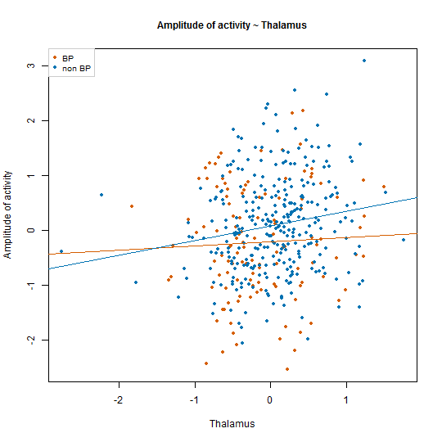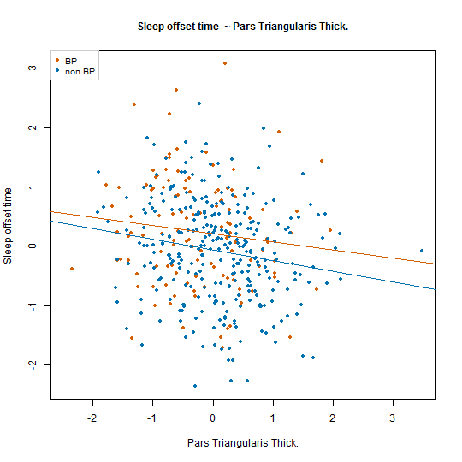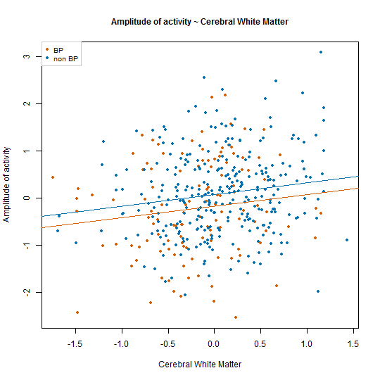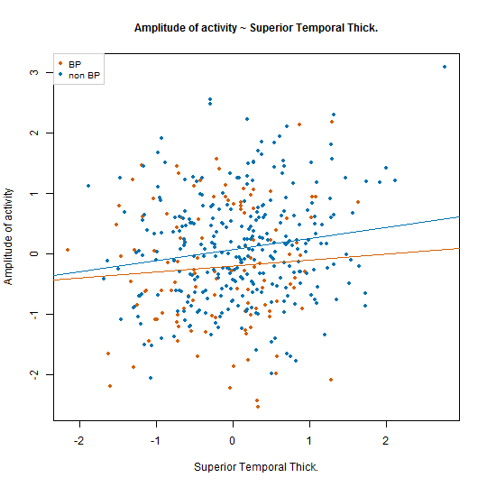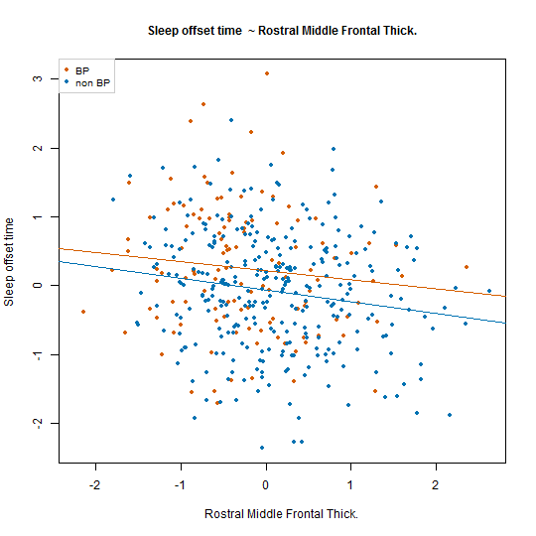
Supplemental Figure 2. Relationships between significantly associated behavioral and actigraphy traits in BP-I probands and non-BP-I relatives
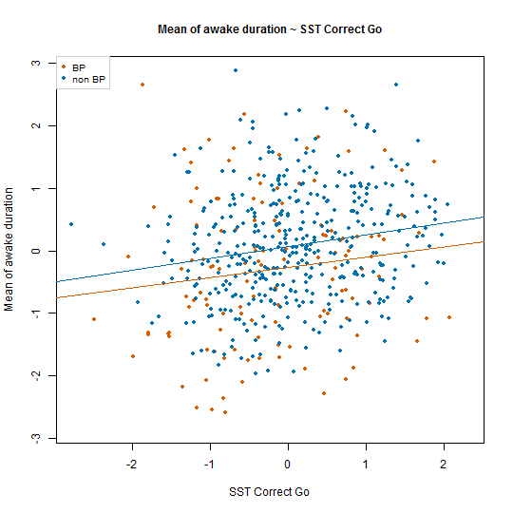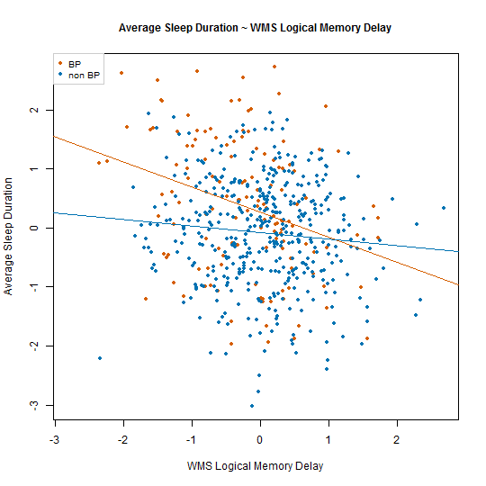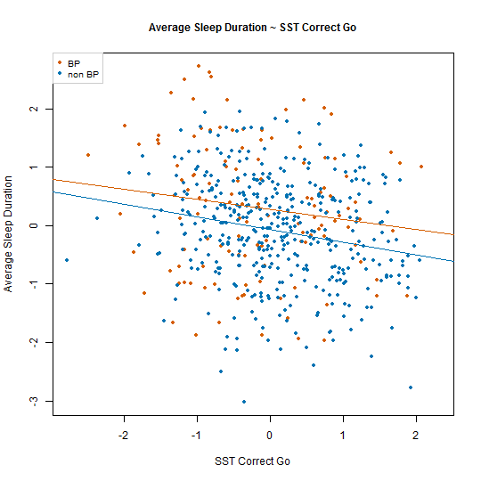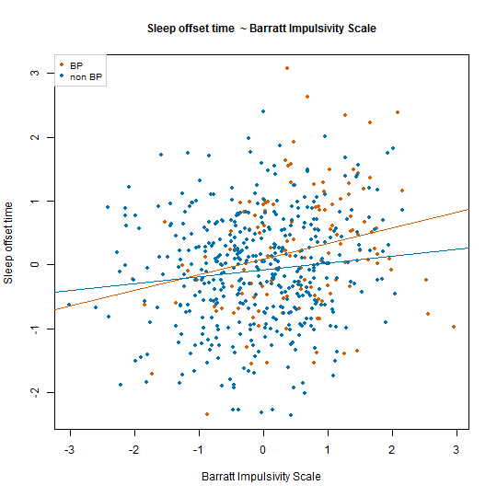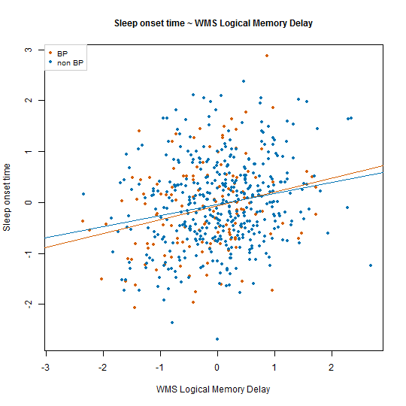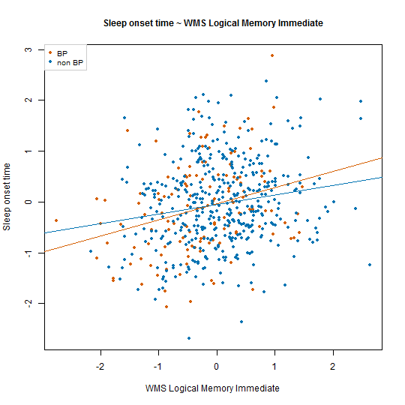

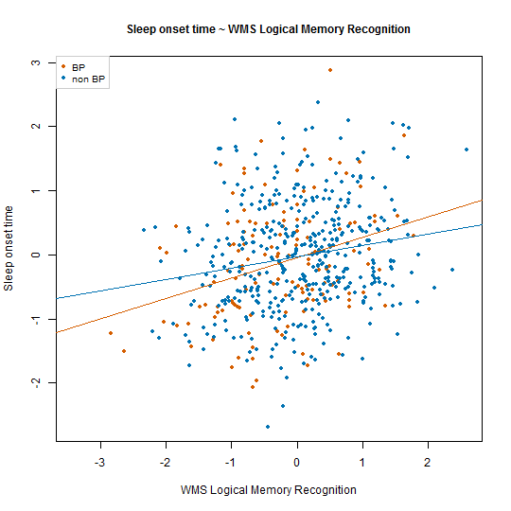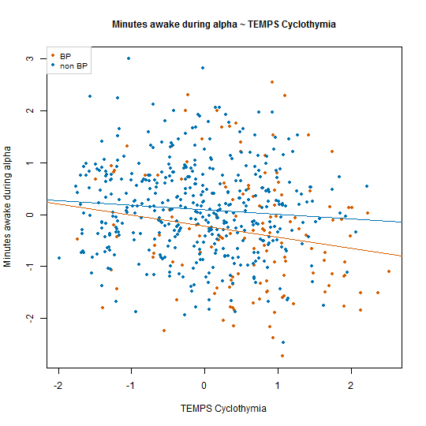

References
Fears, S. C., Schür, R., Sjouwerman, R., Service, S. K., Araya, C., Araya, X., Bejarano, J., Knowles, E., Gomez-Makhinson, J., Lopez, M. C., Aldana, I., Teshiba, T. M., Abaryan, Z., Al-Sharif, N. B., Navarro, L., Tishler, T. A., Altshuler, L., Bartzokis, G., Escobar, J. I., Glahn, D. C., Thompson, P. M., Lopez-Jaramillo, C., Macaya, G., Molina, J., Reus, V. I., Sabatti, C., Cantor, R. M., Freimer, N. B. & Bearden, C. E. (2015). Brain structure–function associations in multi-generational families genetically enriched for bipolar disorder. Brain 138, 2087-2102.
Fears, S. C., Service, S. K., Kremeyer, B. & et al. (2014). Multisystem component phenotypes of bipolar disorder for genetic investigations of extended pedigrees. JAMA Psychiatry 71, 375-387.
Freimer, N. B., Reus, V. I., Escamilla, M., Spesny, M., Smith, L., Service, S., Gallegos, A., Meza, L., Batki, S., Vinogradov, S., Leon, P. & Sandkuijl, L. A. (1996). An approach to investigating linkage for bipolar disorder using large Costa Rican pedigrees. Am J Med Genet 67, 254-63.
Hamilton, M. (1960). A rating scale for depression. J Neurol Neurosurg Psychiatry 23, 56-62.
Heath, S. C., Snow, G. L., Thompson, E. A., Tseng, C. & Wijsman, E. M. (1997). MCMC segregation and linkage analysis. Genet Epidemiol 14, 1011-6.
Herzberg, I., Jasinska, A., Garcia, J., Jawaheer, D., Service, S., Kremeyer, B., Duque, C., Parra, M. V., Vega, J., Ortiz, D., Carvajal, L., Polanco, G., Restrepo, G. J., Lopez, C., Palacio, C., Levinson, M., Aldana, I., Mathews, C., Davanzo, P., Molina, J., Fournier, E., Bejarano, J., Ramirez, M., Ortiz, C. A., Araya, X., Sabatti, C., Reus, V., Macaya, G., Bedoya, G., Ospina, J., Freimer, N. & Ruiz-Linares, A. (2006). Convergent linkage evidence from two Latin-American population isolates supports the presence of a susceptibility locus for bipolar disorder in 5q31-34. Hum Mol Genet 15, 3146-53.
Hong, K. S., McInnes, L. A., Service, S. K., Song, T., Lucas, J., Silva, S., Fournier, E., Leon, P., Molina, J., Reus, V. I., Sandkuijl, L. A. & Freimer, N. B. (2004). Genetic mapping using haplotype and model-free linkage analysis supports previous evidence for a locus predisposing to severe bipolar disorder at 5q31-33. Am J Med Genet B Neuropsychiatr Genet 125b, 83-6.
Nurnberger, J. I., Jr., Blehar, M. C., Kaufmann, C. A., York-Cooler, C., Simpson, S. G., Harkavy-Friedman, J., Severe, J. B., Malaspina, D. & Reich, T. (1994). Diagnostic interview for genetic studies. Rationale, unique features, and training. NIMH Genetics Initiative. Arch Gen Psychiatry 51, 849-59; discussion 863-4.
Pagani, L., St. Clair, P. A., Teshiba, T. M., Service, S. K., Fears, S. C., Araya, C., Araya, X., Bejarano, J., Ramirez, M., Castrillón, G., Gomez-Makhinson, J., Lopez, M. C., Montoya, G., Montoya, C. P., Aldana, I., Navarro, L., Freimer, D. G., Safaie, B., Keung, L.-W., Greenspan, K., Chou, K., Escobar, J. I., Ospina-Duque, J., Kremeyer, B., Ruiz-Linares, A., Cantor, R. M., Lopez-Jaramillo, C., Macaya, G., Molina, J., Reus, V. I., Sabatti, C., Bearden, C. E., Takahashi, J. S. & Freimer, N. B. (2016). Genetic contributions to circadian activity rhythm and sleep pattern phenotypes in pedigrees segregating for severe bipolar disorder. Proceedings of the National Academy of Sciences 113, E754-E761.
Palacio, C. A., Garcia, J., Arbelaez, M. P., Sanchez, R., Aguirre, B., Garces, I. C., Montoya, G. J., Gomez, J., Agudelo, A., Lopez, C. A., Calle, J. J., Cardeno, C. A., Cano, J. F., Lopez, M. C., Montoya, P., Herrera, C. P., Gonzalez, N., Gonzalez, A., Bedoya, G., Ruiz, A. & Ospina, J. (2004). [Validation of the Diagnostic Interview for Genetic Studies (DIGS) in Colombia]. Biomedica 24, 56-62.
Sheehan, D. V., Lecrubier, Y., Sheehan, K. H., Amorim, P., Janavs, J., Weiller, E., Hergueta, T., Baker, R. & Dunbar, G. C. (1998). The Mini-International Neuropsychiatric Interview (M.I.N.I.): the development and validation of a structured diagnostic psychiatric interview for DSM-IV and ICD-10. J Clin Psychiatry 59 Suppl 20, 22-33;quiz 34-57.
Young, R. C., Biggs, J. T., Ziegler, V. E. & Meyer, D. A. (1978). A rating scale for mania: reliability, validity and sensitivity. Br J Psychiatry 133, 429-35.

