Supplementary Material
Table S1. Regions of activation and de-activation in the autobiographical recall vs non-memory-evoking conditionn.

 | MNI coordinates
Region/Contrast | x | y | z | Z-value | k | p
Controls
recall > non-recall
Thalamus | -2 | -4 | 4 | 7.09 | 17834 | p < 0.001
Precuneus | 8 | -56 | 22 | 6.96
Cerebellum | 36 | -62 | -28 | 6.69
Calcarine cortex | 4 | -56 | -16 | 6.59
Medial prefrontal cortex | -2 | 62 | 6 | 6.32 | 10515 | p < 0.001
Supplementary motor area | -2 | 18 | 48 | 5.67
Anterior cingulate cortex | -4 | 46 | 16 | 5.55
Middle occipital cortex | -46 | -74 | 34 | 6.25 | 1671 | p < 0.001
Middle temporal cortex | -50 | -70 | 20 | 5.54
Middle temporal cortex | -62 | -8 | -18 | 4.47 | 444 | p < 0.001
Angular gyrus | 50 | -74 | 32 | 4.51 | 201 | p = 0.020
Controls
Non-recall > recall
Middle occipital cortex | -42 | -82 | 8 | 6.27 | 19270 | p < 0.001
Superior occipital cortex | 28 | -74 | 38 | 6.24
Superior parietal cortex | 20 | -56 | 60 | 6.03
Superior temporal cortex | -50 | -10 | 0 | 6.06 | 1929 | p < 0.001
Middle temporal cortex | -60 | -20 | 2 | 5.19
Frontal pole | 30 | 68 | 10 | 5.66 | 692 | p < 0.001
Patients
recall > non-recall
Medial prefrontal cortex | -4 | 56 | 2 | 5.39 | 3372 | p < 0.001
Anterior cingulate cortex | -4 | 28 | 32 | 4.16
Posterior cingulate cortex | -4 | -48 | 34 | 5.72 | 3248 | p < 0.001
Precuneus | -6 | -54 | 24 | 5.66
Parahippocampal gyrus | -12 | -2 | -20 | 4.40 | 1032 | p < 0.001
 | 24 | -20 | -20 | 5.18 | 878 | p < 0.001
Superior frontal cortex | -16 | 36 | 54 | 4.87 | 803 | p < 0.001
Angular gyrus | -42 | -62 | 28 | 3.97 | 489 | p < 0.001
Middle temporal cortex | -62 | -22 | -16 | 4.46 | 435 | p < 0.001
 | 62 | -6 | -22 | 4.88 | 226 | p = 0.012
Temporal pole | -58 | 10 | -12 | 3.90 | 251 | p = 0.007

Table S2. Regions of activation and de-activation in the autobiographical recall condition compared to fixation.

 | MNI coordinates
Region/Contrast | x | y | z | Z-value | k | p
Controls: activation
Calcarine cortex | 16 | -86 | 2 | 8.14 | 58713 | p < 0.001
Cerebellum | 36 | -62 | -28 | 8.09
Inferior frontal cortex | -38 | 30 | -10 | 7.87
Middle temporal cortex | -64 | -34 | -10 | 7.14
Middle temporal cortex | 58 | -58 | 16 | 5.03 | 598 | p < 0.001
Precuneus | -6 | -74 | 56 | 3.97 | 144 | p = 0.047
Controls: de-activation
Postcentral gyrus | 22 | -42 | 76 | 6.17 | 7728 | p < 0.001
Superior temporal gyrus | 52 | -30 | 14 | 5.96
Mid-cingulate cortex | 12 | -30 | 42 | 5.95
Superior parietal cortex | 20 | -50 | 64 | 5.78
Heschl gyrus | -38 | -20 | 12 | 6.95 | 3285 | p < 0.001
Superior temporal gyrus | -54 | -8 | 0 | 6.05
Supramarginal gyrus | -64 | -26 | 30 | 5.49
Rolandic operculum | -50 | -26 | 16 | 5.33
Superior parietal cortex | -22 | -44 | 66 | 5.30 | 1079 | p < 0.001
Inferior temporal cortex | 50 | -68 | -4 | 5.48 | 859 | p < 0.001
Middle occipital cortex | -46 | -72 | 4 | 4.66 | 242 | p = 0.004
Patients: activation
Calcarine cortex | 14 | -90 | 2 | 8.16 | 69677 | p < 0.001
Cerebellum | 10 | -82 | -16 | 7.46
Lingual gyrus | -18 | -94 | -12 | 7.05
Inferior frontal cortex | -54 | 16 | 0 | 7.01
Angular gyrus | 36 | -58 | 50 | 4.22 | 240 | p = 0.005
Middle temporal cortex | 52 | -34 | -4 | 4.39 | 142 | p = 0.049

Figure S1. Boxplots showing activation levels in patients and controls for the four clusters of differences between groups in the autobiographical memory evoking vs non-evoking cues contrast. Y-axis depicts parameter estimates (beta values).

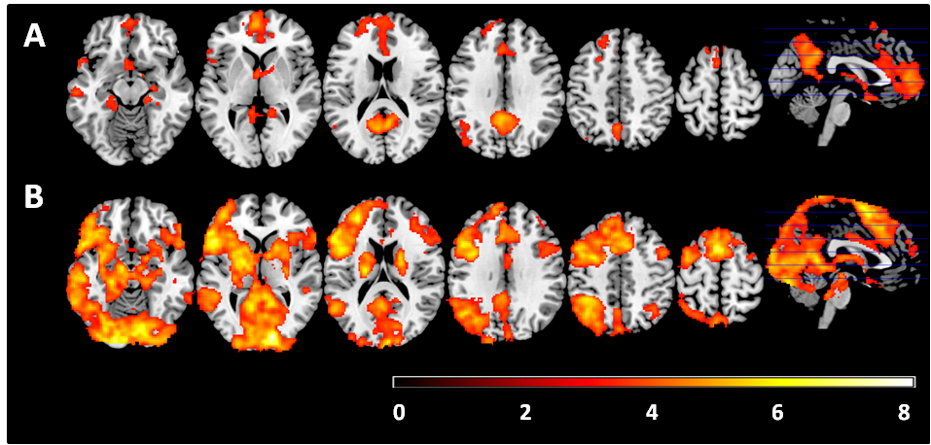
Figure S2. Mean activation maps for the patient group, controlling for antipsychotic dose (in chlorpromazine equivalents): (A) Areas of significant differences between the autobiographical memory-evoking and non-evoking cue conditions. (B) Areas of significant differences between the autobiographical memory-evoking cues and fixation conditions. Colour bars depict Z values. Images are displayed in neurological convention (right is right).

Figure S3. Boxplots showing activation levels in patients and controls for the seven clusters of differences between groups in the autobiographical memory evoking vs fixation contrast. Y-axis depicts parameter estimates (beta values).

