Amygdala Functional Connectivity in Major Depression – Disentangling Markers of Pathology, Risk and Resilience

Supplemental information

Carolin Wackerhagen¹, Ilya M. Veer¹, Susanne Erk¹, Sebastian Mohnke¹, Tristram Lett, Torsten Wüstenberg¹, Nina Romanczuk-Seiferth¹, Kristina Otto², Janina I. Schweiger², Heike Tost², Andreas Meyer-Lindenberg², Andreas Heinz¹, Henrik Walter¹

¹Dept. of Psychiatry and Psychotherapy, Charité - Universitätsmedizin Berlin, Campus Mitte, Berlin, Germany; ²Dept. of Psychiatry and Psychotherapy, Central Institute of Mental Health, Mannheim; Germany
Background 2
S1. Assumptions for group comparisons 2
Methods 3
S2. Sample selection 3
S3. Task description 3
S4. Generalized pychophysiological interactions (gPPI) 4
S5. Regions of interest 5
S6. Automated labeling of resulting group effect clusters 7
S7. Factor analysis of negative affectivity measures 8
Results 9
S8. Supplemental clinical characterization 9
S9. Task effects on brain response and amygdala FC 11
S10. Hypothesis-driven group comparisons of amygdala activation 14
S11. Correlation between negative affect score and brain activation (faces>shapes) 15
S12. Group effects on amygdala FC in the combined analysis 16
S13. Spatial involvement of result maps with BrainMap 20 components 18
S14. Result maps of single group comparisons of amygdala FC 20
S15. Effects of medication 26
S16. Results of study 2 group comparison 28
S17. Results of exploratory analyses of SFG (BA32) functional connectivity 31
References 32

Background

Assumptions for group comparisons
To disentangle neural mechanisms of pathology, we compared MDD patients, first-degree relatives of MDD patients, and controls. The theoretical assumptions underlying these group comparisons are illustrated in the Venn-diagram in Figure S1.

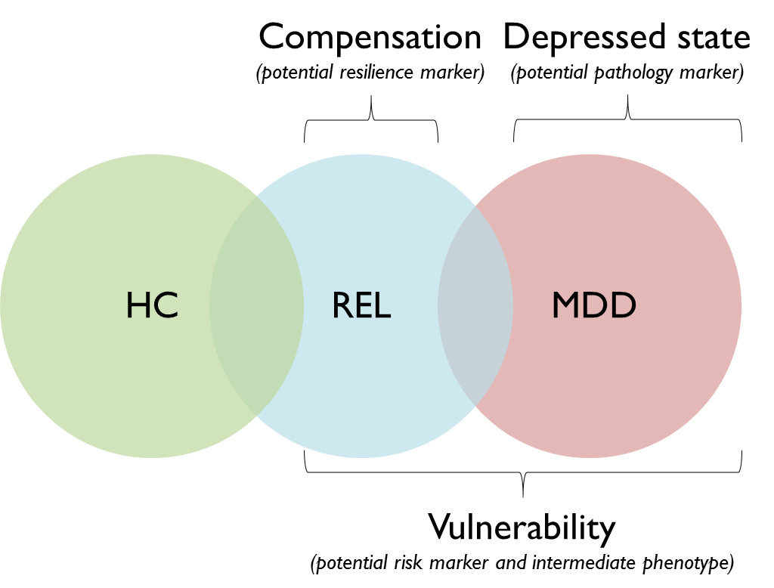
Figure S1. Theoretical assumptions for the interpretation of group differences. Abbreviations: HC, Healthy controls; MDD, Patients with major depressive disorder; REL, first-degree relatives of MDD patients.
We assumed that features unique in relatives (REL) compared to healthy controls (HC) and MDD patients (MDD) might serve a compensatory function and present putative mechanisms of resilience capacity. Features unique in MDD patients compared to HC and REL were assumed to correspond to the depressed state and present mechanisms of pathology. Features shared by MDD and REL that differed from HC were interpreted to be associated with vulnerability for depression and to present putative risk biomarkers and intermediate phenotype candidates.

Methods

Sample selection
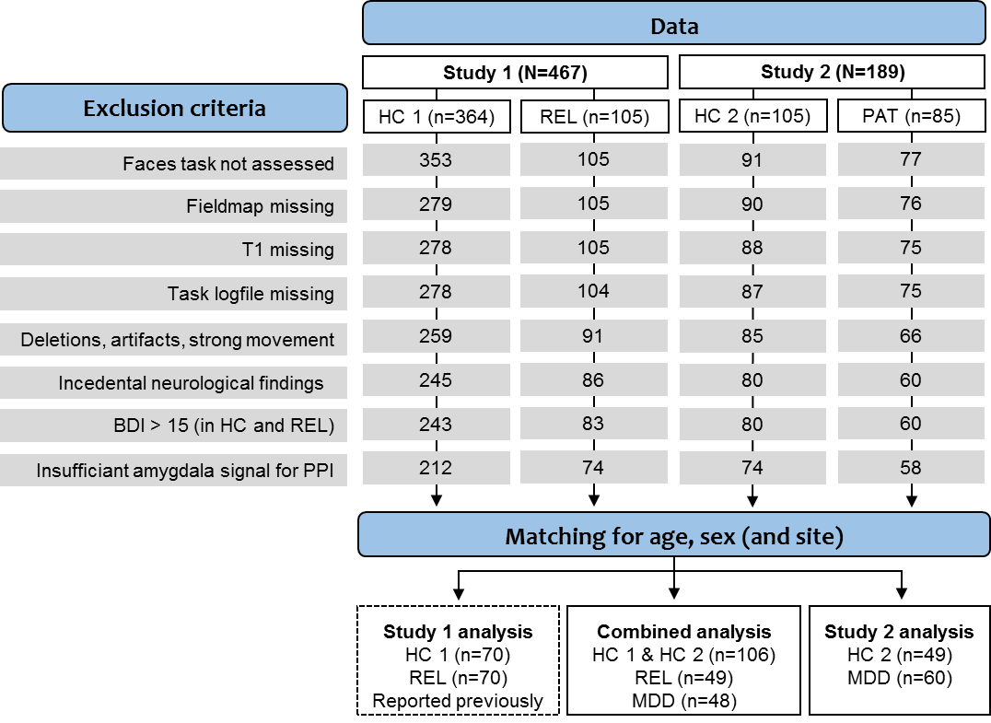
Figure S2. Detailed sample selection summary. Group sizes after quality checks are shown for each exclusion criterion and group separately. Relatives and patients differed in their age distribution (many relatives were aged between 18 and 25, while many patients were aged between 45 and 55), so that a relatively high number of participants had to be excluded in favor of matching for age.

Task description
The implicit emotional processing fMRI task was an adaptation of the faces and shapes matching task initially introduced by Hariri and colleagues (2002a). In each trial, subjects had to identify the matching pair in a trio of stimuli by pressing the right or left button. The task included two conditions (shapes matching, faces matching), which were presented in alternating blocks (4 blocks per condition), each of which consisted of six trials à 5 seconds. In the shapes condition, stimuli included circles as well as vertical and horizontal ellipses. In the faces condition, grayscale photographs (Ekman & Friesen 1976) of angry and fearful faces, counterbalanced for sex, were presented. An instruction screen was presented for 2 seconds before each block. The instruction (dark blue), the control (blue) and emotion (red) condition as well as button presses (stimulus onset, duration until button was pressed) were modelled in a blocked design in SPM. Both conditions (regressors A and B), the instruction (C), and individual button presses (D; onset: onset of trial; duration: duration until button was pressed) were modeled in separate regressors. While regressors A and B were regressors of interest to estimate the effects of implicit emotional processing, regressors C and D were included to reduce error variance induced by task-associated process of no interest.
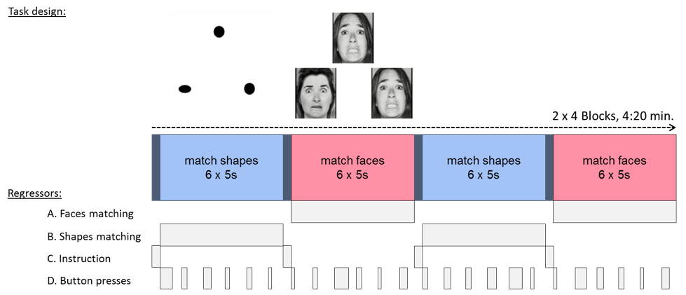
Figure S3. Schematic illustration of the faces matching task design. Participants were presented with a trio of stimuli and instructed to indicate which one of the objects in the bottom is identical to the object in the top. Four blocks per condition appeared in an alternating order, each containing six trials. For each subject, contrast images of the brain activity and amygdala FC during both conditions were computed and further analyzed in group-level analyses.

Generalized pychophysiological interactions (gPPI)
PPI is a measure of the degree to which the temporal correlation (=functional connectivity) of BOLD signal between brain regions (physiological factor) is modulated by the experimental context (psychological factor) (Friston et al. 1997). For that purpose, the standard GLM design for statistical interactions is applied to fMRI data: the dependent variable y (whole-brain voxel-wise BOLD time course) is modeled by a) a physiological variable x (BOLD time course in the seed region), b) a psychological variable m (contrast vector representing task conditions) and c) the interaction of x and m (PPI term). All voxels with significant portions of variance explained by the PPI term significantly differ between task conditions in their correlation strength with the seed region. The original PPI implementation by Friston et al. (1997) is configured to only detect between-conditions effects of no more than two conditions, which limits the flexibility of analyses and has been criticized to lack power due to collinearity of the task term and the PPI term (O’Reilly et al. 2012). Generalized PPI resolves these limitations by allowing to include each task regressor in the model, which enables the assessment of both across and between conditions effects of any number of conditions and thereby increases specificity and sensitivity of results (McLaren et al. 2012). We chose gPPI for these reasons and because it has proven the most powerful FC measure especially for block-designed tasks, not only compared to standard PPI but also compared to beta series correlations (Cisler et al. 2014).

Regions of interest
Literature-based probabilistic maps of right and left amygdala: First, we created anatomical ROIs, which comprised the cytoarchitectonic maps of superficial, laterobasal and centromedial subregions of the amygdalae (Zilles et al. 2002; Amunts et al. 2005). Second, spatial coordinates for functional ROIs were taken from studies reporting effects of negative emotional faces matching (faces > control) in healthy subjects (see Table S1 for coordinates and references). Third, based on this data set, we created the ROIs in a three-step process (Beck et al. 2012): First, the probability that a voxel at a given position within an anatomical ROI showed neural activity regarding the corresponding literature was estimated by calculating a 3D normal (Gaussian) distribution G(x, y, z) as follows (Turkeltaub et al. 2002):
where C is the covariance matrix for all coordinate triples x, y, z from the underlying literature and x, y, z are the mean values of the x, y, and z coordinates, respectively (Nielsen & Hansen 2002). Second, the outer limits of the finally used ROI were defined by (a) the outer limits of the anatomical ROI and (b) a threshold of 2 standard deviations of the resulting 3D distribution. Finally, a binary mask including all voxels spatially within these boundaries was formed. Specifically for spatially extended anatomical ROIs containing probably different functional subregions, this procedure leads to a spatial reduction to design relevant coordinates within these ROIs.

Left Amygdala |  |  |  |  | Right Amygdala
Coordinates |  |  | Space | Reference | Coordinates |  |  | Space | Reference
x | y | z |  |  | x | y | z
-14 | -9 | -15 | MNI | Brown et al. 2005 | 14 | -1 | -10 | MNI | Brown et al. 2005
-28 | -6 | -18 | MNI | Carballedo et al. 2011 | 28 | -2 | -20 | MNI | Carballedo et al. 2011
-22 | -7 | -22 | MNI | Charlet et al. 2013 | 20 | -7 | -19 | MNI | Charlet et al. 2013
-21 | -3 | -18 | MNI | El Khoury-Malhame et al. 2011 | 24 | -6 | -21 | MNI | El Khoury-Malhame et al. 2011
-22 | -5 | -20 | TAL | Fakra E et al. 2009 | 20 | -3 | -20 | TAL | Fakra E et al. 2009
-22 | -5 | -11 | TAL | Fonzo et al. 2013 | 30 | -4.5 | -14.5 | TAL | Fonzo et al. 2010
-18.8 | -11.3 | -12.1 | TAL | Hariri et al. 2005 | 20 | -6 | -13 | TAL | Fonzo et al., 2013
-28 | -6 | -16 | TAL | Hariri et al. 2002 | 24 | -8 | -16 | TAL | Hariri et al., 2002, 1st cohort
-28 | -4 | -16 | MNI | Hulvershorn et al. 2012 | 28 | -4 | -16 | TAL | Hariri et al., 2002, 2nd cohort
-18 | -8 | -14 | MNI | Kleinhans et al. 2010 | 18.8 | -8.4 | -12.2 | TAL | Hariri et al., 2005
-20 | -11 | -16 | MNI | Manuck et al. 2007 | 20 | -4 | -16 | TAL | Hariri et al. 2002
-24 | -4 | -18 | MNI | Manuck et al., 2010 | 18 | -10 | -12 | MNI | Kleinhans et al., 2010
-22 | -2 | -20 | TAL | Matthews et al., 2008 | 21 | -6 | -17 | MNI | Manuck et al., 2010
-23 | -4 | -15 | MNI | Mingtian et al., 2012 | 22 | -3 | -12 | MNI | Manuck et al. 2007
-22 | -4 | -18 | MNI | Payer et al., 2008 | 27 | -5 | -21.5 | TAL | Matthews et al. 2008
-28 | -6 | -16 | TAL | Peluso et al., 2009 | 25 | -1 | -16 | MNI | Mingtian et al., 2012
-23 | -2 | -16 | MNI | Sauder et al., 2013 | 22 | -4 | -16 | MNI | Payer et al., 2008
-24 | -2 | -12 | MNI | Williams et al. 2006 | 30 | -4 | -16 | TAL | Peluso et al., 2009
-18 | -4.4 | -16 | MNI | Zhong et al., 2011 | 26 | -1 | -17 | MNI | Sauder et al. 2013
 |  |  |  |  | 23.6 | -1.6 | -21.4 | MNI | Zhong et al., 2011
Table S1. Coordinates and References of literature-based amygdala ROI masks. Abbreviations: MNI, Montreal Neurological Institute; TAL, Talairach.

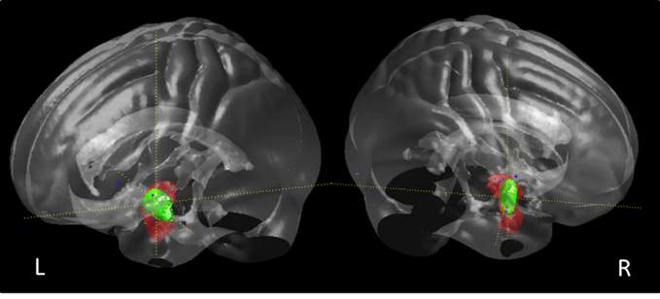
Figure S4. Literature-based probabilistic ROI masks of bilateral amygdalae. Anatomical boundaries (shown in red) are based on the Jülich cytoarchitectonic atlas of superficial, laterobasal and centromedial subregions. Probabilistic maps (green) of literature coordinates (blue) within these boundaries were computed as a 3D Gaussian distribution within 1.96 SD.
The location of functional connectivity seeds within the amygdalae is shown in Figure S5. Peak effects of the faces vs. shapes contrast were mainly in the basolateral nucleus. The location of peak effects within the amygdalae did not significantly differ between groups (see Table S2).
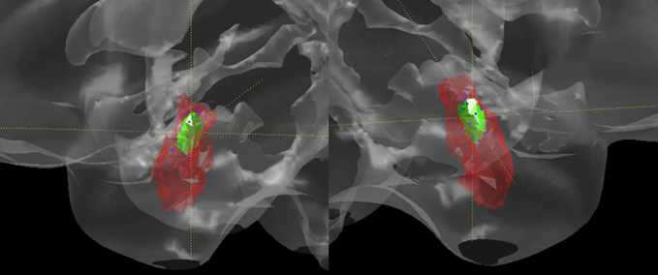
Figure S5. Average location of seed voxels for FC analyses. Annotations: Anatomical boundaries (red) are based on the Jülich cytoarchitectonic atlas of superficial, laterobasal and centromedial amygdalae. Probabilistic maps (green) of seed voxels (blue) within these boundaries were computed as a 3D Gaussian distribution within 1.96 SD.

Seed region |  | Controls | Relatives | Patients | χ² | p
Left Amygdala n (%)
 | Laterobasal | 96 (9.6) | 38 (77.6) | 43 (89.6) | 7.934 | .094
 | Centromedial | 9 (8.5) | 11 (22.4) | 4 (8.3)
 | Superficial | 1 (.9) | - | 1 (2.1)
Right Amygdala n (%)
 | Laterobasal | 101 (95.3) | 40 (81.6) | 40 (83.3) | 11.418 | .076
 | Centromedial | 3 (2.8) | 6 (12.2) | 5 (1.4)
 | Superficial | 2 (1.9) | 2 (4.1) | 3 (6.3)
 | Amygdalostriatal Transition Area | - | 1 (2.0) | -
Table S2. Frequencies of anatomical subdivisions of amygdala seed locations.
ROI mask of the prefrontal cortex: For the PFC ROI (Figure S6), a mask of the combined anatomical boundaries of the lateral, medial and orbital surfaces of the frontal lobe as provided by the automated anatomical labeling (AAL) atlas (Tzourio-Mazoyer et al., 2002) was computed using the Wake Forest University (WFU) pickatlas for SPM version 2.5 (http://fmri.wfubmc.edu/software/pickatlas) (Maldjian, Laurienti, Kraft, & Burdette, 2003) and then smoothed with an 8mm kernel.
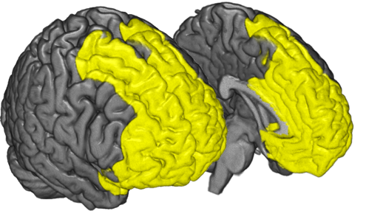
Figure S6. ROI mask of the prefrontal cortex.

Automated labeling of resulting group effect clusters
Additionally to the anatomy toolbox, which we used to identify the anatomical location of peak voxels, we used the intrinsic connectivity network (ICN) atlas (https://www.nitrc.org/projects/icn_atlas/) (Kozák et al. 2017) as a method to not only label single coordinates of significant voxels, but to quantify the degree to which distributed clusters of group effects in amygdala FC belonged to certain functional networks. We assessed spatial involvement of our effects with regions of the BrainMap20 atlas. The BrainMap20 atlas consists of 18 BrainMap co-activation networks and 2 artefact components based on ICA decomposition (d = 20) of the BrainMap Project, a large-scale neuroimaging experiment meta-analysis (Laird 2005). The spatial involvement is the ratio of significant voxels in a BrainMap component to the total volume of this component.

Factor analysis of negative affectivity measures
To investigate whether amygdala FC with regions identified in the pathology, vulnerability, and resilience contrast correlated with negative affectivity (NA), we performed post hoc multiple regression analyses of amygdala FC (right and left amygdala separately) with a comprehensive measure of NA, conducted by factor analysis of the measures BDI, SCL-90 Depression Scale, Neuroticism and STAI-T (STAI-S was excluded because not assessed at study site Mannheim in study 1) using SPSS. Due to missing psychometric data, the total sample size in the NA analysis decreased to N=193. Statistical assumptions for factor analyses are presented in Table S3.
Criterion | Statistic
Correlations of NA-measures range | .49-81
KMO-measure h² | .73
Bartlett’s Sphericity p | <.0001
Number of factors with Eigenvalues > 1 | 1
Explained variance % | 7.0
Communalities range | .64-.78
Component loadings range | .28-.31
Correlations with NA measures range | .80-.85
Table S3. Assumptions for factor analyses of NA measures.

Results

Supplemental clinical characterization
In this section, clinical characteristics of the patient group, medication status, and results of post-hoc contrasts of the comparison of clinical measures are provided.
Clinical Characteristic |  |  | n / mean±SD (range)
 | ICD-10 Diagnosis
 |  | F32.- Depressive episode | 9
 |  | F33.- Recurrent depressive disorder | 39
 | Severity at time of scan
 |  | Mild | 7
 |  | Moderate | 22
 |  | Severe | 19
 | Average duration of MDE in F32.- in months |  | 6.7 ± (1-20)
 | Number of previous MDEs in F33.-
 |  | 1 | 8
 |  | 2 | 9
 |  | 3 | 7
 |  | More than 5 | 16
 |  | Average | 7.8±1.32 (1-49)
 | Average age of first hospitalization (n=34) |  | 27.7±9.8 (11-51)
 | Lifetime Suicidality
 |  | Suicide Attempt | 9
 |  | Specific plans / preparations | 7
 |  | Suicidal ideation | 14
 |  | Weary of life | 13
 |  | No suicidal thoughts | 3
 | Average Duration of medication (years, n=19*) |  | 4.9±4.6 (1-14)
 | Average Duration of psychotherapy (months, n=38) |  | 2.1±17.3 (1-81)
 | Life-time axis-I comorbidity
 |  | ICD-10 F10 Alcohol abuse | 2
 |  | ICD-10 F4 Anxiety disorders | 11
 |  | ICD-10 F50 Eating disorders | 3
 |  | None | 32
 | First-degree relatives with depression |  | 23
 |  | No first-degree relative with depression | 24
 |  | One first-degree relative with depression | 14
 |  | Two first-degree relatives with depression | 7
 |  | Three first-degree relatives with depression | 2
 | First-degree relatives with other psychiatric disorder |  | 15
 |  | Alcohol dependence | 4
 |  | Psychotic disorder | 1
 |  | Bipolar disorder | 3
 |  | Anxiety disorder | 3
 |  | Eating disorder | 1
 |  | Asperger Syndrome | 2
Table S4. Clinical characteristics of the patient group. Abbreviations: ICD-10, International Statistical Classification of Diseases and Related Health Problems, 10th version; MDE, major depressive episode.

Medication at time of scanning |  | n
No psychotropic medication |  | 14
Psychotropic Medication |  | 33
 | SSRI | 6
 | SSRI + Antipsychotic | 2
 | SSRI + Antipsychotic + Anticonvulsant | 1
 | SSRI + Mirtazapine | 2
 | SSRI + Tricyclic antidepressant | 2
 | SSRI + SNRI + Tricyclic antidepressant | 1
 | SNRI | 5
 | SNRI + Antipsychotic | 1
 | SNRI + Lithium | 1
 | SNDRI + Mirtazapine, Lithium | 1
 | SNDRI + Antipsychotic | 1
 | Tricyclic antidepressant | 4
 | Tricyclic antidepressant + Anticonvulsant | 1
 | Tricyclic antidepressant + Mirtazapine | 1
 | Antipsychotic + Agomelatin | 1
 | Moclobemide | 1
 | Mirtazapine + Antipsychotic + Benzodiazepine | 1
 | Undocumented class of medication | 1
Undocumented class of medicaton |  | 1
Table S5. Status and type of medication in the patient group. Abbreviations: SNDRI, selective noradrenaline dopamine reuptake inhibitor; SNRI, selective norepinephrine reuptake inhibitor; SNRI, selective norepinephrine reuptake inhibitor; SSNRI, Selective serotonin noradrenaline reuptake inhibitor.

Characteristic |  | PAT vs HC |  | PAT vs REL |  | REL vs HC
 |  | Mean diff | p | Mean diff | p | Mean diff | p
 | SCL-Depression | 1.39 | <.0001 | 1.28 | <.0001 | -1.11 | .433
 | BDI | 19.64 | <.0001 | 17.74 | <.0001 | 1.89 | .264
 | STAI-S | 17.94 | <.0001 | 17.87 | <.0001 | .07 | .999
 | STAI-T | 22.67 | <.0001 | 2.77 | <.0001 | 1.90 | .565
 | NEO Neuroticism | 18.00 | <.0001 | 15.03 | <.0001 | 2.97 | .053
Table S6. Post-hoc contrast of group comparisons of clinical measures. Hochberg GT2 was used for post-hoc tests. Patients had significantly higher values in measures of negative affect compared to controls as well as relatives, while these measures did not significantly differ between relatives and controls.

Task effects on brain response and amygdala FC
Figure S7. Task effects on brain response. Overlay of study 1 (Wackerhagen et al. 2017) (n=140) and study 2 (n=109) of BOLD signal across groups in the faces > shapes (top panel, study 1 = red, study 2 = green) and shapes > faces (bottom panel, study 1 = dark blue, study 2 = cyan), (whole-brain FWE-corrected p <.05).

Figure S8. Task effects on amygdala FC. Overlay of study 1 (Wackerhagen et al. 2017) (n=140) and study 2 (n=109) of amygdala FC estimates across groups in the faces > shapes (top panel, study 1 = red, study 2 = green) and shapes > faces (bottom panel, study 1 = dark blue, study 2 = cyan), (whole-brain FWE-corrected p <.05).

Brain region | k | H | T | P_{(FWE)} | MNI coord.
 |  |  |  |  | x | y | z
Faces > Shapes
Inferior Occipital Gyrus | 7625 | L | 26.41 | <.0001 | -24 | -94 | -4
Cuneus |  | R | 25.52 | <.0001 | 21 | -94 | 8
Calcarine Gyrus |  | R | 25.24 | <.0001 | 18 | -94 | -4
Inferior Occipital Gyrus |  | R | 24.20 | <.0001 | 30 | -88 | -4
Fusiform Gyrus |  | L | 22.24 | <.0001 | -36 | -76 | -13
Fusiform Gyrus |  | R | 19.46 | <.0001 | 39 | -52 | -16
Hippocampus |  | R | 14.87 | <.0001 | 21 | -4 | -13
Amygdala |  | R | 14.63 | <.0001 | 21 | -4 | -16
Thalamus: Visual |  | L | 13.99 | <.0001 | -21 | -31 | -1
Thalamus |  | R | 13.21 | <.0001 | 21 | -28 | -1
Amygdala |  | L | 12.74 | <.0001 | -21 | -7 | -13
Superior Frontal Gyrus |  | L | 11.55 | <.0001 | -9 | 62 | 35
Middle Frontal Gyrus |  | R | 11.46 | <.0001 | 54 | 29 | 32
Middle Frontal Gyrus |  | L | 11.05 | <.0001 | -51 | 23 | 41
Inferior Frontal Gyrus (Pars Triangularis) |  | L | 1.36 | <.0001 | -54 | 32 | 26
Hippocampus |  | L | 1.32 | <.0001 | -33 | -16 | -13
Superior Medial Gyrus |  | L | 9.73 | <.0001 | -6 | 44 | 56
Superior Medial Gyrus |  | R | 9.61 | <.0001 | 9 | 56 | 44
Precentral Gyrus |  | R | 9.52 | <.0001 | 45 | -7 | 62
Inferior Frontal Gyrus (Pars Opercularis) |  | R | 9.00 | <.0001 | 42 | 14 | 26
Superior Frontal Gyrus |  | R | 8.82 | <.0001 | 15 | 53 | 44
Postcentral Gyrus |  | R | 8.44 | <.0001 | 63 | -7 | 41
Rectal Gyrus | 63 | L | 7.63 | <.0001 | 0 | 47 | -19
Superior Temporal Gyrus | 36 | R | 7.48 | <.0001 | 48 | -37 | 8
Shapes > Faces
Inferior Parietal Lobule (Area PGa) | 351 | L | 5.62 | .0021 | -57 | -61 | 35
SupraMarginal Gyrus | 600 | R | 8.73 | <.0001 | 45 | -31 | 41
Angular Gyrus |  | R | 8.61 | <.0001 | 45 | -76 | 38
Postcentral Gyrus |  | R | 6.89 | <.0001 | 45 | -40 | 59
Inferior Parietal Lobule |  | R | 6.25 | .0002 | 30 | -40 | 50
Mid Cingulate Cortex | 107 | R | 6.99 | <.0001 | 6 | -22 | 38
Superior Temporal Gyrus | 21 | R | 6.76 | <.0001 | 54 | -34 | 23
Posterior Cingulate Cortex | 1 | L | 6.69 | <.0001 | -12 | -40 | 14
Middle Occipital Gyrus | 34 | L | 6.64 | <.0001 | -42 | -67 | 5
Middle Temporal Gyrus |  | L | 6.27 | .0001 | -57 | -67 | 5
Precentral Gyrus | 20 | L | 6.55 | <.0001 | -48 | 2 | 20
Superior Parietal Lobule | 22 | R | 5.81 | .0010 | 15 | -58 | 65
Anterior Cingulate Cortex | 40 | R | 5.75 | .0013 | 9 | 35 | 14
Middle Frontal Gyrus |  | R | 5.60 | .0023 | 33 | 32 | 38
Superior Frontal Gyrus | 21 | R | 5.43 | .0045 | 21 | 14 | 56
Middle Frontal Gyrus | 24 | L | 5.38 | .0053 | -27 | 23 | 35
Superior Parietal Lobule | 9 | L | 5.32 | .0066 | -27 | -58 | 65
Table S7. Coordinates, statistics, and anatomical labels of task effects on brain response (study 2 sample).

Brain region | k | H | T | P_{(FWE)} | MNI coord.
 |  |  |  |  | x | y | z
Faces > Shapes
Inferior Frontal Gyrus (Pars Opercularis) | 268 | R | 4.67 | <.0001 | 45 | 11 | 32
Inferior Frontal Gyrus (Pars Triangularis) |  | R | 3.65 | .0015 | 54 | 26 | 29
Inferior Temporal Gyrus | 314 | R | 4.51 | <.0001 | 51 | -70 | -7
Middle Temporal Gyrus |  | R | 4.07 | .0001 | 45 | -61 | -4
Inferior Occipital Gyrus |  | R | 3.77 | .0007 | 36 | -85 | -1
Precentral Gyrus | 86 | L | 3.94 | .0002 | -57 | 5 | 41
Inferior Frontal Gyrus (Pars Triangularis) |  | L | 3.93 | .0002 | -57 | 23 | 29
Shapes > Faces
Mid Cingulate Cortex | 2443 |  | 10.74 | <.0001 | 0 | -19 | 41
Mid Cingulate Cortex |  | R | 8.62 | <.0001 | 6 | -37 | 50
Cuneus |  | L | 8.39 | <.0001 | -6 | -73 | 29
Precuneus |  | R | 8.32 | <.0001 | 9 | -64 | 32
Precuneus |  | L | 7.30 | <.0001 | -9 | -64 | 38
Cuneus |  | R | 7.02 | <.0001 | 6 | -85 | 29
Anterior Cingulate Cortex |  | R | 6.79 | <.0001 | 3 | 14 | 29
Calcarine Gyrus |  | L | 5.81 | .0005 | -9 | -61 | 11
Posterior-Medial Frontal |  | R | 5.71 | .0007 | 9 | -10 | 56
Anterior Cingulate Cortex | 853 | R | 9.38 | <.0001 | 0 | 50 | -1
Mid Orbital Gyrus |  | L | 7.49 | <.0001 | -12 | 47 | -7
Inferior Frontal Gyrus (Pars Orbitalis) |  | L | 7.08 | <.0001 | -27 | 32 | -16
Middle Orbital Gyrus |  | L | 6.61 | <.0001 | -18 | 29 | -16
Caudate Nucleus |  | L | 6.41 | <.0001 | -12 | 23 | -7
Rectal Gyrus |  | L | 6.15 | .0001 | -15 | 26 | -13
Caudate Nucleus |  | R | 6.10 | .0001 | 15 | 11 | -10
Olfactory cortex |  | R | 5.46 | .0022 | 6 | 23 | -4
Middle Temporal Gyrus | 805 | L | 9.00 | <.0001 | -54 | -34 | 5
Superior Temporal Gyrus |  | L | 8.77 | <.0001 | -57 | -4 | -10
SupraMarginal Gyrus |  | L | 7.45 | <.0001 | -48 | -43 | 32
Angular Gyrus |  | L | 7.21 | <.0001 | -45 | -58 | 26
Inferior Parietal Lobule (Area PFm) |  | L | 6.44 | <.0001 | -63 | -55 | 17
Middle Frontal Gyrus | 258 | L | 7.32 | <.0001 | -27 | 29 | 41
Superior Frontal Gyrus |  | L | 6.62 | <.0001 | -15 | 44 | 38
Superior Temporal Gyrus | 184 | R | 7.30 | <.0001 | 60 | -10 | -7
Middle Frontal Gyrus | 79 | R | 6.15 | .0001 | 30 | 35 | 44
Precentral Gyrus | 12 | L | 5.98 | .0002 | -39 | -10 | 44
Medial Temporal Pole | 9 | R | 5.70 | .0007 | 48 | 14 | -34
Rolandic Operculum |  | R | 5.20 | .0065 | 48 | -28 | 20
Postcentral Gyrus | 46 | R | 5.46 | .0021 | 30 | -37 | 62
ParaHippocampal Gyrus | 7 | R | 5.35 | .0035 | 33 | -28 | -13
Superior Frontal Gyrus | 10 | R | 5.35 | .0035 | 21 | -13 | 71
Angular Gyrus | 10 | R | 5.35 | .0035 | 51 | -61 | 32
Table S8 Coordinates, statistics, and anatomical labels of task effects on bilateral amygdala FC (study 2 sample).

Hypothesis-driven group comparisons of amygdala activation
Brain response within the right and left amygdala ROI masks were extracted and compared between groups. Group differences were tested overall (assuming all groups to differ) as well as for the risk contrast, (controls vs. relatives and patients).
Region | Controls | Relatives | Patients | F | p
Left amygdala | 4.74 | 5.74 | 6.31 | .868 | .421
Right amygdala | 4.08 | 5.60 | 5.59 | 1.543 | .216
Mean bilateral amygdala | 4.41 | 5.67 | 5.95 | 1.294 | .277
 | Controls | Relatives and Patients |  | T | p
Left amygdala | 4.74 | 6.02 |  | 1.261 | .209
Right amygdala | 4.08 | 5.60 |  | 1.761 | .080
Mean bilateral amygdala | 4.41 | 5.81 |  | 1.597 | .112
Table S9. Group comparison of brain response (faces > shapes) in amygdala ROIs.

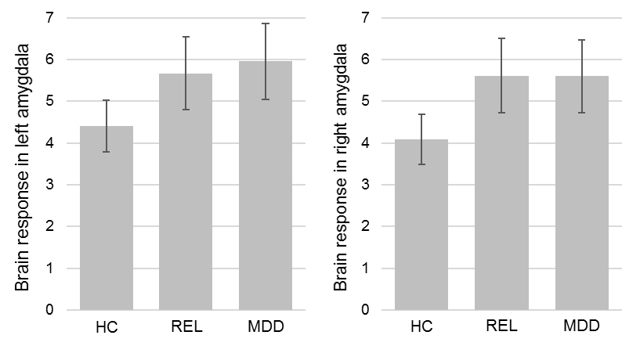
Figure S9. Group means of amygdala response (faces>shapes). Error bars indicate ±1 standard error.

Correlation between negative affect score and brain activation (faces>shapes)

Brain region | k | H | T | P_{(ROI)} | d | MNI coord.
 |  |  |  |  |  | x | y | z
Superior Frontal Gyrus (BA32) | 49 | L | 4.37 | .0297 |  | -15 | 23 | 41
Table S10. Coordinates, statistics, and anatomical labels of the effect of the NA score on brain response. Results show a negative effect of NA on activation in the left superior frontal gyrus, BA32, significant at p<.05, FWE-corrected for the PFC ROI.

 | NA Factor score |  | SCL-90 Depression |  | BDI |  | STAI Trait Anxiety |  | NEO Neuroticism |  | Hamilton Depression |  | Clinical Global Impression
 | r | p | r | p | r | p | r | p | r | p | r | p | r | p
MDD | -.53 | <.01 | -.54 | <.01 | -.54 | <.01 | -.49 | .01 | -.34 | .02 | -.33 | .02 | -.51 | <.01
REL | -.02 | .88 | .13 | .40 | -.08 | .61 | -.06 | .70 | -.09 | .56 | - | - | - | -
HC | -.26 | <.01 | -.22 | .03 | -.10 | .33 | -.29 | <.01 | -.27 | <.01 | - | - | - | -
Total | -.22 | <.01 | -.21 | <.01 | -.21 | <.01 | -.22 | <.01 | -.20 | <.01 | - | - | - | -
Table S11. Correlation of SFG activation (faces > shapes) with NA measures.

Group effects on amygdala FC in the combined analysis
Results of the pathology, risk, and resilience contrast conjunctions as well as the spatial involvement of the conjunction maps with BrainMap20 components are provided in this section.

Brain region | k | H | T | P_{(FWE)} | MNI coord.
 |  |  |  |  | x | y | z
Across conditions
Superior Occipital Gyrus | 1388 | R | 8.64 | <.0001 | 18 | -91 | 35
Superior Occipital Gyrus |  | L | 6.45 | <.0001 | -24 | -91 | 32
Angular Gyrus |  | R | 8.53 | <.0001 | 51 | -64 | 26
Cuneus |  | L | 8.49 | <.0001 | -6 | -91 | 32
Cuneus |  | R | 7.61 | <.0001 | 24 | -82 | 47
Precuneus |  | L | 7.55 | <.0001 | -3 | -49 | 65
Precuneus |  | R | 7.00 | <.0001 | 3 | -40 | 53
Mid Cingulate Cortex |  | R | 7.10 | <.0001 | 0 | -43 | 50
Mid Cingulate Cortex |  | L | 6.19 | .0001 | -6 | -16 | 38
Superior Parietal Lobule |  | L | 6.69 | <.0001 | -21 | -82 | 47
Paracentral Lobule |  | R | 6.66 | <.0001 | 0 | -40 | 68
Middle Temporal Gyrus |  | R | 6.49 | <.0001 | 42 | -55 | 17
Middle Occipital Gyrus |  | R | 6.47 | <.0001 | 39 | -79 | 38
Middle Occipital Gyrus |  | L | 5.58 | .0012 | -33 | -88 | 32
Area 5Ci (SPL) |  | L | 6.39 | <.0001 | -15 | -43 | 44
Inferior Parietal Lobule |  | L | 6.13 | .0001 | -27 | -82 | 44
Posterior-Medial Frontal |  | R | 5.38 | .0029 | 3 | -4 | 50
Postcentral Gyrus | 44 | R | 6.97 | <.0001 | 57 | -13 | 20
Postcentral Gyrus | 15 | L | 5.71 | .0006 | -51 | -10 | 20
Area 3a | 45 | R | 6.87 | <.0001 | 39 | -19 | 35
Superior Medial Gyrus | 90 | L | 6.85 | <.0001 | -3 | 56 | 14
Temporal Pole | 14 | R | 6.58 | <.0001 | 60 | 8 | -7
Temporal Pole | 37 | L | 5.84 | .0004 | -60 | 5 | -1
Angular Gyrus | 46 | L | 6.18 | .0001 | -54 | -64 | 26
SupraMarginal Gyrus | 64 | L | 6.09 | .0001 | -60 | -34 | 26
Area TE 3 | 64 | L | 5.91 | .0003 | -66 | -28 | 17
Heschls Gyrus | 33 | R | 5.84 | .0004 | 36 | -31 | 14
Precentral Gyrus | 45 | R | 5.77 | .0005 | 48 | -16 | 44
Area 4p | 16 | R | 5.43 | .0022 | 18 | -34 | 59
Anterior Cingulate Cortex | 10 | L | 5.41 | .0024 | -3 | 35 | 8
Between Conditions
Middle Frontal Gyrus | 34 | R | 7.07 | <.0001 | 39 | 5 | 56
Inferior Parietal Lobule | 18 | R | 5.54 | .0015 | 51 | -40 | 50
Temporal Pole | 9 | R | 5.52 | .0017 | 42 | 20 | -22
Table S12. Coordinates, statistics, and anatomical labels of the pathology contrast (conjunction of the contrasts controls > patients and relatives > patients) in bilateral amygdala FC. A statistical threshold of p<0.0055 (Bonferroni-corrected for nine tests) was applied.

Brain region | k | H | T | P_{(FWE)} | MNI coord.
 |  |  |  |  | x | y | z
Across Conditions
Inferior Frontal Gyrus (Pars Opercularis) | 51 | L | 8.17 | <.0001 | -60 | 11 | 14
Precentral Gyrus | 40 | L | 7.79 | <.0001 | -24 | -22 | 74
Precentral Gyrus | 209 | R | 7.34 | <.0001 | 33 | -22 | 65
Superior Frontal Gyrus |  | R | 6.66 | <.0001 | 21 | -7 | 71
Posterior-Medial Frontal |  | R | 5.54 | .0014 | 12 | 8 | 71
Superior Parietal Lobule | 247 | R | 6.88 | <.0001 | 21 | -73 | 47
Superior Occipital Gyrus |  | R | 6.82 | <.0001 | 21 | -82 | 32
Cuneus |  | R | 6.24 | .0001 | 15 | -85 | 29
Middle Occipital Gyrus |  | R | 6.12 | .0001 | 30 | -82 | 29
Angular Gyrus |  | R | 5.86 | .0003 | 33 | -52 | 41
Superior Parietal Lobule | 102 | L | 6.83 | <.0001 | -18 | -64 | 47
Precuneus |  | L | 6.54 | <.0001 | -15 | -55 | 56
Postcentral Gyrus | 33 | L | 5.94 | .0002 | -27 | -40 | 65
Superior Occipital Gyrus | 11 | L | 5.24 | .0052 | -24 | -85 | 29
Fusiform Gyrus (Area FG2) | 10 | R | 5.34 | <.0001 | 45 | -61 | -4
Between Conditions (Faces > Shapes)
Fusiform Gyrus (Area FG2) | 10 | R | 5.34 | <.0001 | 45 | -61 | -4
Table S13. Coordinates, statistics, and anatomical labels of the risk contrast (conjunction of the contrasts controls > patients and controls > relatives) in bilateral amygdala FC. A statistical threshold of p<0.0055 (Bonferroni-corrected for nine tests) was applied.

Brain region | k | H | T | P_{(FWE)} | MNI coord.
 |  |  |  |  | x | y | z
Across Conditions
Anterior Cingulate Cortex | 138 | L | 8.05 | <.0001 | -6 | 44 | 2
Mid Orbital Gyrus |  | R | 6.73 | <.0001 | 6 | 26 | -13
Rectal Gyrus |  | L | 5.85 | .0003 | -3 | 32 | -16
Cuneus | 6 | L | 6.90 | <.0001 | -6 | -88 | 41
Area hOc4d [V3A] |  | L | 5.67 | .0008 | -9 | -91 | 38
Angular Gyrus | 17 | R | 6.42 | <.0001 | 51 | -70 | 32
Between Conditions (Faces > Shapes)
Middle Temporal Gyrus | 5 | L | 6.91 | <.0001 | -42 | -13 | -25
Superior Temporal Gyrus | 17 | L | 5.95 | .0002 | -66 | -37 | 5
Rolandic Operculum | 18 | R | 5.94 | .0002 | 60 | 8 | 2
Middle Frontal Gyrus | 14 | R | 5.70 | .0007 | 30 | 32 | 29
Table S14 Coordinates, statistics, and anatomical labels of the resilience contrast (cunction of the contrasts relatives > patients and relatives > controls) in bilateral amygdala FC. A statistical threshold of p<0.0055 (Bonferroni-corrected for nine tests) was applied.

Spatial involvement of result maps with BrainMap 20 components
The spatial involvement of group effects in amygdala FC (conjunction maps of single group contrasts as reported in the main text) with components of the BrainMap20 atlas are shown in Figure S10, Figure S11, and Figure S12. Labels of the BrainMap (BM) components are provided in Table S15.
Figure S10. Spatial involvement of the pathology contrast (conjunction of controls > patients and relatives > patients) and BrainMap20 components.
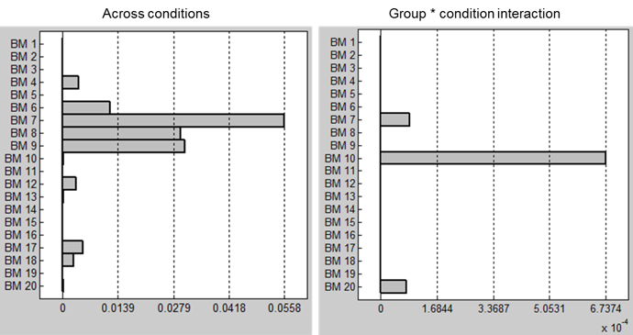
Figure S11. Spatial involvement of the risk contrast (conjunction of controls > patients and controls > relatives) and BrainMap20 components.

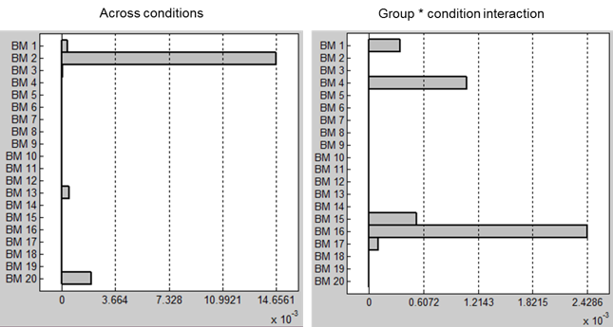
Figure S12. Spatial involvement of the resilience contrast (conjunction of relatives > patients and relatives > controls) and BrainMap20 components.

BM | Label
1 | Limbic and medial-temporal areas
2 | Subgenual ACC and OFC
3 | Bilateral BG and thalamus
4 | Bilateral anterior insula/frontal opercula and the anterior aspect of the body of the cingulate gyrus
5 | Midbrain
6 | Superior and middle frontal gyri
7 | Middle frontal gyri and superior parietal lobules
8 | Ventral precentral gyri, central sulci, postcentral gyri, superior and inferior cerebellum
9 | Superior parietal lobule
10 | Middle and inferior temporal gyri
11 | Lateral posterior occipital cortex
12 | Medial posterior occipital cortex
13 | Medial prefrontal and posterior cingulate/precuneus areas, default mode network
14 | Cerebellum
15 | Right-lateralized fronto-parietal regions
16 | Transverse temporal gyri
17 | Dorsal precentral gyri, central sulci, postcentral gyri, superior and inferior cerebellum
18 | Left-lateralized fronto-parietal regions
19 | Artefactual component
20 | Artefactual component
Table S15. Labels of BrainMap20 (BM) components.

Result maps of single group comparisons of amygdala FC
Figure S13. Group differences in amygdala FC - controls & relatives > patients (pathology contrast). Top panel shows effects across conditions, bottom panel shows effects between conditions (faces>shapes); dark blue: controls > patients; cyan: relatives > patients; p <.05, whole-brain FWE-corrected.
Figure S14. Group differences in amygdala FC – controls > relatives & patients (risk contrast). Top panel shows effects across conditions, bottom panel shows effects between conditions (faces>shapes); dark blue: controls > patients; cyan: controls > relatives; p <.05, whole-brain FWE-corrected.

Figure S15. Group differences in amygdala FC, relatives vs. patients & controls (resilience contrast). Top panel shows effects across conditions, bottom panel shows effects between conditions (faces>shapes). Yellow: relatives > controls; red: relatives > patients; p <.05, whole-brain FWE-corrected.

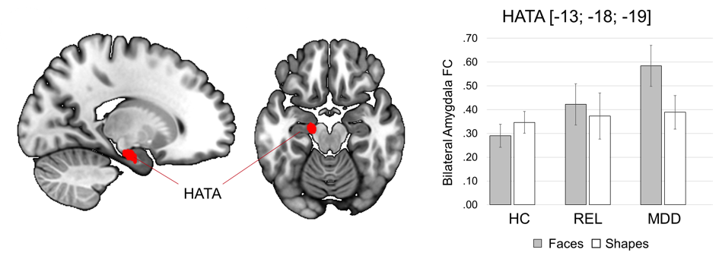
Figure S16. Difference between patients and controls (MDD>HC1&2) in amygdala FC between conditions (faces > shapes). Red: patients > controls; p <.05, whole-brain FWE-corrected. Abbreviations: HATA, Hippocampal amygdala transition area.

Brain region | k | H | T | P_{(FWE)} | MNI coord.
 |  |  |  |  | x | y | z
Across Conditions
Precuneus | 5712 | R | 1.22 | <.0001 | 6 | -46 | 53
Precuneus |  | L | 1.13 | <.0001 | -6 | -49 | 62
Superior Occipital Gyrus |  | R | 9.97 | <.0001 | 21 | -88 | 32
Superior Occipital Gyrus |  | L | 7.20 | <.0001 | -24 | -91 | 29
Precentral Gyrus |  | R | 9.69 | <.0001 | 24 | -31 | 71
Precentral Gyrus |  | L | 9.01 | <.0001 | -21 | -22 | 74
Posterior Cingulate Cortex |  | R | 9.17 | <.0001 | 3 | -43 | 11
Posterior Cingulate Cortex |  | L | 7.74 | <.0001 | -6 | -43 | 11
Angular Gyrus |  | R | 8.85 | <.0001 | 51 | -61 | 26
Postcentral Gyrus |  | R | 8.63 | <.0001 | 33 | -37 | 65
Cuneus |  | L | 8.49 | <.0001 | -6 | -91 | 32
Mid Cingulate Cortex |  | R | 8.42 | <.0001 | 15 | -40 | 38
Mid Cingulate Cortex |  | L | 8.30 | <.0001 | -9 | -1 | 35
Paracentral Lobule |  | R | 8.31 | <.0001 | 6 | -22 | 77
Posterior-Medial Frontal |  | R | 8.20 | <.0001 | 6 | -7 | 50
Posterior-Medial Frontal |  | L | 7.36 | <.0001 | 3 | 5 | 50
Postcentral Gyrus |  | L | 8.12 | <.0001 | -21 | -46 | 56
Inferior Parietal Lobule |  | R | 7.99 | <.0001 | 30 | -55 | 50
Area 3a |  | R | 7.70 | <.0001 | 39 | -19 | 35
Rolandic Operculum |  | R | 7.70 | <.0001 | 57 | -16 | 17
Middle Temporal Gyrus |  | R | 7.65 | <.0001 | 42 | -52 | 14
Middle Occipital Gyrus |  | R | 7.60 | <.0001 | 36 | -82 | 35
Superior Frontal Gyrus |  | R | 7.53 | <.0001 | 15 | -10 | 74
Superior Parietal Lobule |  | L | 7.49 | <.0001 | -18 | -82 | 47
Superior Parietal Lobule |  | R | 7.17 | <.0001 | 21 | -58 | 62
Area 2 |  | R | 6.85 | <.0001 | 18 | -43 | 59
Rolandic Operculum | 744 | L | 9.86 | <.0001 | -60 | 8 | 2
SupraMarginal Gyrus |  | L | 8.50 | <.0001 | -54 | -34 | 26
Superior Temporal Gyrus |  | L | 8.15 | <.0001 | -63 | -1 | 2
Middle Temporal Gyrus |  | L | 6.43 | <.0001 | -63 | -4 | -13
Temporal Pole | 47 | R | 7.55 | <.0001 | 60 | 8 | -4
Superior Medial Gyrus | 199 | L | 7.36 | <.0001 | 0 | 59 | 14
Mid Orbital Gyrus |  | L | 5.97 | .0002 | -6 | 53 | -10
Thalamus Temporal | 50 | R | 7.04 | <.0001 | 3 | -19 | 11
Thalamus |  | L | 6.47 | <.0001 | -3 | -19 | 11
Superior Frontal Gyrus |  | L | 6.44 | <.0001 | -15 | 32 | 53
Middle Frontal Gyrus | 135 | R | 6.35 | <.0001 | 27 | 38 | 29
Superior Medial Gyrus |  | R | 5.50 | .0017 | 9 | 53 | 38
Calcarine Gyrus | 34 | L | 6.35 | <.0001 | -21 | -52 | 11
Fusiform Gyrus | 12 | R | 6.20 | .0001 | 36 | -52 | -22
Angular Gyrus | 53 | L | 6.18 | .0001 | -54 | -64 | 26
Inferior Frontal Gyrus (Pars Triangularis) | 14 | R | 6.17 | .0001 | 60 | 20 | 23
Calcarine Gyrus | 11 | R | 6.09 | .0001 | 30 | -58 | 11
Middle Frontal Gyrus | 44 | L | 6.00 | .0002 | -27 | 38 | 32
Area Id1 | 9 | R | 5.73 | .0006 | 45 | 2 | -19
Lingual Gyrus | 10 | R | 5.57 | .0012 | 12 | -70 | -10
Middle Occipital Gyrus | 13 | L | 5.47 | .0019 | -27 | -58 | 32
Anterior Cingulate Cortex | 10 | L | 5.41 | .0024 | -3 | 35 | 8
Bewteen Conditions (Faces > Shapes)
Lingual Gyrus | 73 | R | 8.13 | <.0001 | 39 | 5 | 56
Superior Occipital Gyrus |  | R | 6.11 | .0001 | 27 | 14 | 53
Lingual Gyrus | 67 | L | 7.00 | <.0001 | -18 | -79 | -13
Superior Frontal Gyrus |  | L | 5.52 | .0016 | -15 | -88 | -13
Superior Frontal Gyrus | 70 | R | 5.78 | .0005 | 33 | -70 | 44
Middle Temporal Gyrus | 53 | R | 6.67 | <.0001 | 48 | -64 | -4
Middle Frontal Gyrus | 6 | R | 5.93 | .0003 | 48 | -52 | -4
Inferior Frontal Gyrus (Pars Triangularis) | 14 | L | 6.19 | .0001 | -48 | -49 | -7
Inferior Frontal Gyrus (Pars Triangularis) | 18 | R | 6.15 | .0001 | 39 | 20 | -22
Middle Occipital Gyrus | 42 | L | 6.13 | .0001 | -36 | -76 | 8
Middle Occipital Gyrus |  | R | 5.15 | .0079 | 33 | -76 | 26
Temporal Pole | 20 | L | 5.80 | .0005 | -39 | 23 | -22
Fusiform Gyrus |  | R | 5.53 | .0016 | 27 | -64 | 32
Inferior Temporal Gyrus | 30 | R | 5.60 | .0012 | 48 | -40 | 47
Mid Cingulate Cortex | 9 | L | 5.42 | .0025 | -12 | -34 | 80
Superior Parietal Lobule | 8 | L | 5.25 | .0054 | -27 | -79 | 44
Table S16. Amygdala FC, controls > patients.

Brain region | k | H | T | P_{(FWE)} | MNI coord.
 |  |  |  |  | x | y | z
Across Conditions
Superior Frontal Gyrus | 959 | R | 9.88 | <.0001 | 27 | -4 | 68
Precentral Gyrus |  | R | 8.76 | <.0001 | 33 | -13 | 68
Middle Frontal Gyrus |  | R | 7.69 | <.0001 | 36 | 2 | 62
Middle Occipital Gyrus |  | R | 7.50 | <.0001 | 42 | -76 | 11
Superior Occipital Gyrus |  | R | 7.43 | <.0001 | 18 | -82 | 29
Superior Parietal Lobule |  | R | 6.72 | <.0001 | 21 | -67 | 50
Posterior-Medial Frontal |  | R | 6.23 | .0001 | 12 | 8 | 74
Area hIP3 (IPS) |  | R | 6.06 | .0001 | 30 | -52 | 41
Inferior Parietal Lobule |  | R | 5.64 | .0009 | 42 | -37 | 50
Inferior Frontal Gyrus (Pars Opercularis) | 66 | L | 8.66 | <.0001 | -63 | 11 | 14
Precentral Gyrus | 155 | L | 8.33 | <.0001 | -21 | -19 | 74
Superior Frontal Gyrus |  | L | 5.96 | .0002 | -27 | -1 | 71
Posterior-Medial Frontal |  | L | 5.28 | .0043 | -6 | -4 | 77
Superior Parietal Lobule | 248 | L | 7.30 | <.0001 | -21 | -70 | 44
Middle Occipital Gyrus |  | L | 6.99 | <.0001 | -27 | -73 | 29
Precuneus |  | L | 6.54 | <.0001 | -15 | -55 | 56
Inferior Frontal Gyrus Pars (Triangularis) | 34 | R | 7.00 | <.0001 | 63 | 20 | 8
Inferior Occipital Gyrus | 48 | L | 6.48 | <.0001 | -54 | -70 | -10
Middle Occipital Gyrus |  | L | 6.21 | .0001 | -48 | -82 | 2
Mid Cingulate Cortex | 28 | R | 6.46 | <.0001 | 9 | 11 | 44
Fusiform Gyrus | 20 | R | 6.37 | <.0001 | 33 | -43 | -10
Postcentral Gyrus | 33 | L | 5.94 | .0002 | -27 | -40 | 65
Superior Medial Gyrus | 7 | R | 5.61 | .0010 | 6 | 53 | 44
Inferior Temporal Gyrus | 15 | R | 5.52 | .0015 | 48 | -61 | -7
Temporal Pole | 5 | L | 5.43 | .0022 | -45 | 17 | -25
Inferior Frontal Gyrus (Pars Opercularis) | 6 | R | 5.24 | .0052 | 45 | 8 | 26
Between Conditions (Faces > Shapes)
Inferior Temporal Gyrus | 10 | R | 6.87 | <.0001 | 54 | -22 | -19
Middle Temporal Gyrus | 15 | R | 6.54 | <.0001 | 42 | -64 | -4
Middle Occipital Gyrus | 26 | L | 5.75 | .0006 | -27 | -76 | 35
Postcentral Gyrus | 6 | R | 5.56 | .0014 | 12 | -40 | 77
Precuneus | 12 | L | 5.25 | .0052 | -3 | -52 | 41
Table S17. Amygdala FC, controls > relatives.

Brain region | k | H | T | P_{(FWE)} | MNI coord.
 |  |  |  |  | x | y | z
Across Conditions
Angular Gyrus | 1732 | R | 11.02 | <.0001 | 51 | -70 | 38
Area hOc4d [V3A] |  | L | 1.81 | <.0001 | -9 | -91 | 38
Cuneus |  | L | 1.11 | <.0001 | -6 | -88 | 41
Cuneus |  | R | 8.98 | <.0001 | 18 | -85 | 47
Superior Occipital Gyrus |  | R | 8.64 | <.0001 | 18 | -91 | 35
Superior Occipital Gyrus |  | L | 7.52 | <.0001 | -15 | -94 | 29
Middle Occipital Gyrus |  | L | 8.33 | <.0001 | -33 | -82 | 41
Middle Occipital Gyrus |  | R | 6.26 | <.0001 | 36 | -82 | 35
Inferior Parietal Lobule (Area PGp) |  | L | 8.03 | <.0001 | -39 | -82 | 35
Precuneus |  | L | 7.71 | <.0001 | -9 | -79 | 56
Precuneus |  | R | 7.00 | <.0001 | 3 | -40 | 53
Paracentral Lobule |  | R | 7.40 | <.0001 | 3 | -40 | 71
Superior Parietal Lobule |  | L | 7.39 | <.0001 | -18 | -82 | 50
Superior Parietal Lobule |  | R | 7.00 | <.0001 | 12 | -82 | 50
Mid Cingulate Cortex |  | L | 7.10 | <.0001 | 0 | -43 | 50
Mid Cingulate Cortex |  | R | 6.64 | <.0001 | 3 | -55 | 32
Area 5Ci (SPL) |  | L | 6.59 | <.0001 | -15 | -43 | 44
Middle Temporal Gyrus |  | L | 6.54 | <.0001 | -42 | -58 | 23
Middle Temporal Gyrus |  | R | 6.49 | <.0001 | 42 | -55 | 17
Area 33 |  | R | 6.36 | <.0001 | 6 | -1 | 29
Posterior-Medial Frontal |  | R | 5.38 | .0029 | 3 | -4 | 50
Posterior Cingulate Cortex |  | L | 5.15 | .0075 | -9 | -46 | 23
Anterior Cingulate Cortex | 456 | L | 8.76 | <.0001 | -6 | 44 | 2
Superior Frontal Gyrus |  | L | 8.27 | <.0001 | -15 | 53 | 14
Superior Medial Gyrus |  | L | 7.45 | <.0001 | -3 | 53 | 11
Mid Orbital Gyrus |  | L | 7.15 | <.0001 | -6 | 32 | -13
Mid Orbital Gyrus |  | R | 6.73 | <.0001 | 6 | 26 | -13
Middle Frontal Gyrus | 21 | L | 7.26 | <.0001 | -27 | 20 | 35
Temporal Pole | 70 | R | 6.58 | <.0001 | 60 | 8 | -7
Temporal Pole | 37 | L | 5.84 | .0004 | -60 | 5 | -1
Calcarine Gyrus | 13 | L | 7.05 | <.0001 | -24 | -67 | 11
Postcentral Gyrus | 45 | R | 6.97 | <.0001 | 57 | -13 | 20
Postcentral Gyrus | 19 | L | 5.71 | .0006 | -51 | -10 | 20
Area 3a | 46 | R | 6.87 | <.0001 | 39 | -19 | 35
Precentral Gyrus |  | R | 5.77 | .0005 | 48 | -16 | 44
Precentral Gyrus | 11 | L | 6.26 | <.0001 | -48 | -4 | 44
Superior Temporal Gyrus | 48 | R | 6.18 | .0001 | 63 | -31 | 23
Rolandic Operculum | 77 | L | 6.14 | .0001 | -45 | -28 | 23
SupraMarginal Gyrus |  | L | 6.09 | .0001 | -60 | -34 | 26
Area TE 3 |  | L | 5.91 | .0003 | -66 | -28 | 17
Area 4p | 16 | R | 5.43 | .0022 | 18 | -34 | 59
Paracentral Lobule | 8 | L | 5.49 | .0018 | -6 | -22 | 77
Superior Frontal Gyrus | 9 | R | 5.33 | .0035 | 15 | 32 | 53
Between Conditions (Faces > Shapes)
Inferior Temporal Gyrus | 9 | L | 8.19 | <.0001 | -42 | -13 | -25
Middle Frontal Gyrus | 88 | R | 6.37 | <.0001 | 36 | 59 | 14
Inferior Occipital Gyrus | 30 | R | 7.09 | <.0001 | 39 | -79 | -16
Paracentral Lobule | 22 | L | 6.45 | <.0001 | -15 | -19 | 80
Inferior Frontal Gyrus (Pars Orbitalis) | 17 | L | 6.41 | <.0001 | -51 | 26 | -4
Inferior Frontal Gyrus (Pars Opercularis) | 13 | R | 6.29 | <.0001 | 45 | 11 | 14
Middle Temporal Gyrus | 21 | L | 6.19 | .0001 | -63 | -37 | 8
Temporal Pole | 19 | R | 6.11 | .0001 | 42 | 20 | -25
Rolandic Operculum | 18 | R | 5.94 | .0002 | 60 | 8 | 2
Inferior Parietal Lobule | 23 | R | 5.93 | .0003 | 51 | -40 | 50
Middle Temporal Gyrus | 6 | R | 5.59 | .0012 | 57 | -4 | -22
Temporal Pole | 5 | L | 5.36 | .0034 | -42 | 20 | -22
Precuneus | 6 | R | 5.29 | .0045 | 3 | -61 | 65
Area hOc4v [V4(v)] | 5 | L | 5.22 | .0060 | -33 | -85 | -19
Table S18. Amygdala FC, relatives > patients.

Brain region | k | H | T | P_{(FWE)} | MNI coord.
 |  |  |  |  | x | y | z
Across Conditions
Anterior Cingulate Cortex | 151 | L | 8.05 | <.0001 | -6 | 44 | 2
Olfactory cortex |  | R | 7.57 | <.0001 | 6 | 23 | -13
Rectal Gyrus |  | L | 6.00 | .0002 | 0 | 32 | -16
Cuneus | 6 | L | 6.90 | <.0001 | -6 | -88 | 41
Area hOc4d [V3A] |  | L | 5.67 | .0008 | -9 | -91 | 38
Angular Gyrus | 17 | R | 6.42 | <.0001 | 51 | -70 | 32
Inferior Parietal Lobule (Area PGp) | 9 | L | 5.21 | .0057 | -42 | -79 | 38
Between Conditions (Faces > Shapes)
Mid Orbital Gyrus | 11 | L | 8.38 | <.0001 | -9 | 50 | -13
Mid Orbital Gyrus | 5 | R | 6.15 | .0001 | 9 | 53 | -10
Superior Temporal Gyrus | 26 | L | 6.40 | <.0001 | -66 | -37 | 14
Middle Temporal Gyrus |  | L | 6.40 | <.0001 | -66 | -37 | 8
Middle Temporal Gyrus |  | R | 5.21 | .0062 | 51 | 5 | -22
SupraMarginal Gyrus | 67 | R | 6.32 | <.0001 | 63 | -43 | 38
Superior Temporal Gyrus |  | R | 6.17 | .0001 | 57 | -46 | 23
Middle Frontal Gyrus | 23 | R | 6.28 | <.000 | 33 | 32 | 26
Temporal Pole | 21 | R | 6.20 | .0001 | 39 | 8 | -25
Hippocampus |  | R | 5.34 | .0037 | 36 | -10 | -16
Posterior-Medial Frontal | 7 | R | 5.43 | .0025 | 12 | -1 | 74
Superior Frontal Gyrus | 6 | L | 5.18 | .0071 | -18 | 26 | 62
Table S19. Amygdala FC, relatives > controls.

Brain region | k | H | T | P_{(FWE)} | MNI coord.
 |  |  |  |  | x | y | z
Across Conditions
-
Between Conditions (Faces > Shapes)
Hippocampal Amygdala Transition Area | 21 | L | 6.46 | <.0001 | -18 | -13 | -19
Table S20. Amygdala FC, patients > controls

Effects of medication

Figure S17. Effects of medication on amygdala FC. Overlay of group contrasts in amygdala FC. In dark blue, the pathology contrast (controls & relatives > all patients, n=203) from the main analysis is shown. In cyan, the pathology contrast with only unmedicated patients (controls & relatives > unmedicated patients, n =169) is shown. The top panel shows effects across conditions, the bottom panel shows effects between conditions (faces > shapes). Effects are presented at a whole-brain FWE-corrected threshold of p <.05.

Brain region | k | H | T | P_{FWE} | P uncorrected | MNI coord.
 |  |  |  |  |  | x | y | z
Across conditions
Precuneus | 4201 | L | 6.91 | <.0001 | <.0001 | -3 | -40 | 71
Precuneus |  | R | 5.22 | .0061 | <.0001 | 3 | -37 | 56
Posterior Cingulate Cortex |  | L | 6.54 | <.0001 | <.0001 | -9 | -43 | 23
Posterior Cingulate Cortex |  | R | 5.69 | .0008 | <.0001 | 9 | -43 | 17
Area 3a |  | R | 6.52 | <.0001 | <.0001 | 39 | -19 | 32
Superior Temporal Gyrus |  | L | 6.22 | .0001 | <.0001 | -57 | -34 | 14
Mid Cingulate Cortex |  | R | 5.82 | .0005 | <.0001 | 6 | -13 | 32
Mid Cingulate Cortex |  | L | 5.50 | .0018 | <.0001 | -6 | -25 | 32
Paracentral Lobule |  | R | 5.71 | .0007 | <.0001 | 15 | -40 | 56
Paracentral Lobule |  | L | 5.48 | .0020 | <.0001 | 0 | -28 | 53
Postcentral Gyrus |  | L | 5.55 | .0015 | <.0001 | -54 | -10 | 20
Postcentral Gyrus |  | R | 4.41 | .1204 | <.0001 | 57 | -10 | 41
Thalamus: Temporal |  | R | 5.50 | .0018 | <.0001 | 3 | -19 | 11
Thalamus: Prefrontal |  | L | 4.89 | .0215 | <.0001 | -18 | -13 | 14
Posterior-Medial Frontal |  | L | 5.30 | .0043 | <.0001 | -3 | -16 | 50
Posterior-Medial Frontal |  | R | 4.93 | .0187 | <.0001 | 6 | -19 | 56
Rolandic Operculum |  | R | 5.01 | .0140 | <.0001 | 57 | -13 | 17
Superior Parietal Lobule |  | R | 4.97 | .0163 | <.0001 | 18 | -46 | 68
Calcarine Gyrus |  | L | 4.91 | .0202 | <.0001 | -9 | -55 | 8
Heschls Gyrus |  | R | 4.59 | .0666 | <.0001 | 39 | -22 | 14
Thalamus |  | R | 4.57 | .0698 | <.0001 | 18 | -13 | 17
Thalamus |  | L | 4.22 | .2172 | <.0001 | -9 | -31 | 5
SupraMarginal Gyrus |  | L | 4.47 | .1009 | <.0001 | -45 | -31 | 23
Cuneus | 22 | L | 6.68 | <.0001 | <.0001 | 0 | -94 | 26
Superior Parietal Lobule | 313 | L | 5.96 | .0002 | <.0001 | -15 | -82 | 50
Angular Gyrus |  | L | 5.20 | .0066 | <.0001 | -57 | -61 | 29
Superior Medial Gyrus | 245 | L | 5.63 | .0010 | <.0001 | -9 | 56 | 26
Superior Medial Gyrus |  | R | 3.79 | .6143 | .0001 | 6 | 56 | 26
Mid Orbital Gyrus |  | L | 4.82 | .0289 | <.0001 | -3 | 50 | -10
Superior Frontal Gyrus |  | L | 4.30 | .1734 | <.0001 | -12 | 50 | 35
Angular Gyrus | 121 | R | 5.56 | .0014 | <.0001 | 39 | -70 | 50
Middle Temporal Gyrus | 64 | R | 4.84 | .0262 | <.0001 | 54 | 2 | -25
Middle Temporal Gyrus | 9 | L | 3.90 | .4981 | .0001 | -60 | 5 | -16
Precentral Gyrus | 6 | L | 3.79 | .6205 | .0001 | -45 | -7 | 44
Superior Orbital Gyrus | 22 | L | 3.63 | .7821 | .0002 | -27 | 50 | -1
Faces > Shapes
Amygdala (LB) | 84 | R | 6.24 | .0001 | <.0001 | 36 | -1 | -25
ParaHippocampal Gyrus |  | R | 4.69 | .0469 | <.0001 | 27 | -16 | -25
Middle Temporal Gyrus |  | R | 4.37 | .1405 | <.0001 | 48 | 2 | -28
Hippocampus |  | R | 4.28 | .1889 | <.0001 | 27 | -13 | -19
Superior Frontal Gyrus | 99 | R | 5.28 | .0048 | <.0001 | 21 | 35 | 32
Middle Frontal Gyrus | 19 | L | 4.78 | .0342 | <.0001 | -27 | 44 | 11
Middle Frontal Gyrus | 13 | R | 4.30 | .1789 | <.0001 | 42 | 5 | 59
Superior Frontal Gyrus | 11 | L | 4.05 | .3626 | <.0001 | -18 | 44 | 29
Caudate Nucleus | 12 | R | 3.91 | .4971 | .0001 | 12 | 5 | 20
Rolandic Operculum | 17 | L | 3.85 | .5636 | .0001 | -54 | -1 | 8
Superior Temporal Gyrus |  | L | 3.52 | .8827 | .0003 | -60 | -7 | 2
Thalamus: Motor | 17 | L | 3.84 | .5786 | .0001 | -24 | -16 | 8
Table S21. Amygdala FC, controls & relatives > unmedicated patients, coordinates, statistics, and anatomical labels

Results of study 2 group comparison
Demographic and clinical characteristics of the sample from study 2 (n=109) are provided in Table S22. Demographic characteristics of the study 1 sample were reported previously (Wackerhagen et al. 2017).
Characteristic |  | HC 2 (n = 49) | Patients (n = 60) | df | F χ² | p | η² Φ
Age mean ±SD, F, η² |  | 32.94 ±1.77 | 36.63 ±12.67 | 107 | 2.62 | .108 | .024
Sex N (%), χ², Φ
 | Male | 22 (45) | 18 (30) | 1 | 2.58 | .108 | .154
 | Female | 27 (55) | 42 (70)
Study Site N (%), χ², Φ
 | Charité Berlin | 36 (73) | 31 (52) | 1 | 5.41 | .020 | .223
 | ZI Mannheim | 13 (27) | 29 (48)
Clinical measures mean ±SD, F, η²
 | BDI | 2.12 ±2.77 | 22.45 ±11.45 | 107 | 147.19 | <.001 | .579
 | SCL_DEPR | .15 ±.17 | 1.57 ±.83 | 106 | 137.94 | <.001 | .565
 | STAI-S | 31.55 ±6.52 | 5.67 ±11.64 | 105 | 106.83 | <.001 | .504
 | STAI-T | 32.45 ±7.86 | 57.10 ±1.50 | 104 | 179.00 | <.001 | .633
 | NEO Neuroticism | 13.80 ±6.07 | 32.44 ±7.72 | 106 | 188.65 | <.001 | .640
Table S22. Demographic and clinical characteristics of HC2 and MDD patients (N=109). Abbreviations: BDI, Beck’s Depression Inventory; NEO, NEO Five Factory Inventory; STAI-S, State Trait Anxiety Inventory - State Anxiety; STAI-T, State Trait Anxiety Inventory - Trait Anxiety; ZI, Central Institute of Mental Health.

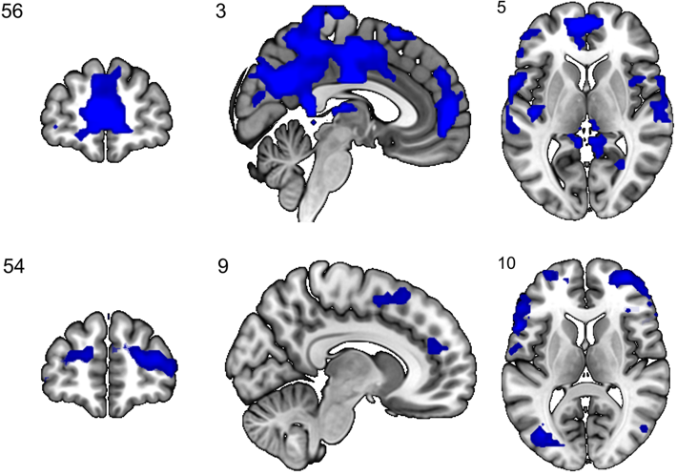
Figure S18. Group differences in amygdala FC, controls > patients (study 2 sample). Top panel shows effects across conditions, bottom panel shows effects between conditions (faces>shapes). Blue: controls > patients; p <.05, whole-brain FWE-corrected.

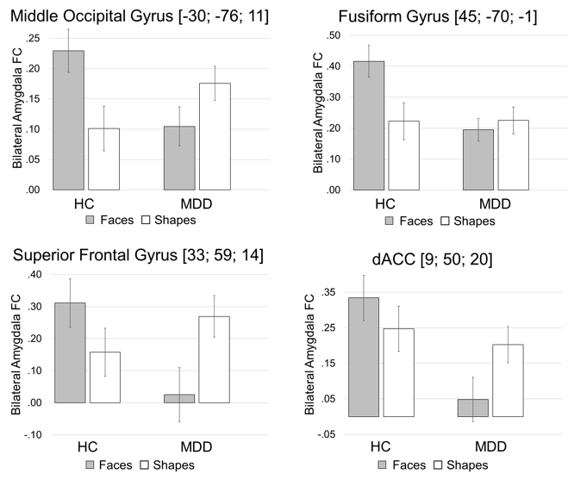
Figure S19. Group by condition interactions of amygdala FC (controls > patients, study 2; faces > shapes).

Brain region | k | H | T | P_{FWE} | MNI coord.
 |  |  |  |  | x | y | z
Across conditions | 8395 | R | 12.20 | <.0001 | 48 | -58 | 26
Angular Gyrus |  | R | 1.73 | <.0001 | 3 | -43 | 11
Posterior Cingulate Cortex |  | L | 1.42 | <.0001 | -6 | 56 | 8
Superior Medial Gyrus |  | R | 1.14 | <.0001 | 12 | -58 | 29
Precuneus |  | L | 9.97 | <.0001 | -54 | 20 | 17
Inferior Frontal Gyrus (pars Triangularis) |  | L | 9.68 | <.0001 | -9 | 50 | -4
Mid Orbital Gyrus |  | L | 9.64 | <.0001 | -3 | 53 | -1
Anterior Cingulate Cortex |  | R | 9.44 | <.0001 | 15 | -91 | 32
Cuneus |  | L | 9.31 | <.0001 | -57 | -37 | 11
Superior Temporal Gyrus |  | R | 9.25 | <.0001 | 6 | -19 | 80
Paracentral Lobule |  | R | 9.24 | <.0001 | 6 | -7 | 50
Posterior-Medial Frontal |  | R | 9.10 | <.0001 | 45 | -19 | 59
Precentral Gyrus |  | L | 9.03 | <.0001 | -9 | -46 | 62
Precuneus |  | L | 8.94 | <.0001 | -6 | -43 | 11
Posterior Cingulate Cortex |  | R | 8.93 | <.0001 | 51 | -16 | 17
Rolandic Operculum |  | R | 8.86 | <.0001 | 42 | -52 | 11
Middle Temporal Gyrus |  | L | 8.64 | <.0001 | -21 | 20 | 41
Middle Frontal Gyrus |  | L | 8.63 | <.0001 | -12 | 32 | 56
Superior Frontal Gyrus |  | L | 8.51 | <.0001 | -57 | -64 | 23
Angular Gyrus |  | L | 8.48 | <.0001 | -12 | -49 | 35
MCC |  | R | 8.46 | <.0001 | 15 | 41 | 38
Superior Frontal Gyrus |  | L | 8.40 | <.0001 | -3 | -37 | 68
Paracentral Lobule |  | L | 8.34 | <.0001 | -60 | 8 | 2
Rolandic Operculum |  | R | 8.19 | <.0001 | 36 | -13 | 17
Insula Lobe |  | R | 8.15 | <.0001 | 30 | -61 | 8
Calcarine Gyrus |  | R | 8.07 | <.0001 | 3 | -19 | 11
Thalamus: Temporal |  | R | 8.02 | <.0001 | 9 | 53 | 38
Superior Medial Gyrus |  | R | 7.95 | <.0001 | 36 | -82 | 35
Middle Occipital Gyrus |  | L | 7.75 | <.0001 | -15 | -46 | 74
Superior Parietal Lobule |  | R | 7.70 | <.0001 | 57 | 11 | -13
Temporal Pole |  | R | 7.70 | <.0001 | 63 | 2 | -4
Superior Temporal Gyrus |  | R | 7.66 | <.0001 | 36 | -37 | 65
Postcentral Gyrus | 121 | R | 7.50 | <.0001 | 42 | -70 | -16
Inferior Occipital Gyrus |  | R | 7.45 | <.0001 | 36 | -55 | -22
Inferior Temporal Gyrus | 59 | L | 7.45 | <.0001 | -21 | -22 | 74
Precentral Gyrus |  | L | 5.96 | .0006 | -33 | -28 | 68
Postcentral Gyrus | 21 | L | 7.07 | <.0001 | -27 | 8 | -16
Insula Lobe |  | L | 5.25 | .0097 | -21 | -1 | -13
Temporal Pole | 43 | R | 6.15 | <.0001 | 12 | -91 | -4
Calcarine Gyrus |  | R | 5.42 | .0003 | 24 | -79 | -16
Fusiform Gyrus |  | R | 5.41 | .0050 | 24 | -88 | -7
Lingual Gyrus | 10 | L | 6.00 | .0054 | -30 | 44 | 8
Middle Frontal Gyrus | 13 | L | 5.92 | .0005 | -36 | 32 | -10
Inferior Frontal Gyrus (pars Orbitalis) | 10 | L | 5.20 | .0007 | -39 | -82 | 14
Middle Occipital Gyrus |  | R | 12.20 | .0116 | 48 | -58 | 26
Table S23. Amygdala FC across conditions, controls > patients (study 2 sample).

Brain region | k | H | T | P_{FWE} | MNI coord.
 |  |  |  |  | x | y | z
Middle Occipital Gyrus | 170 | L | 8.73 | <.0001 | -30 | -76 | 11
Superior Frontal Gyrus | 443 | R | 8.59 | <.0001 | 33 | 59 | 14
Inferior Frontal Gyrus (pars Triangularis) |  | R | 7.06 | <.0001 | 39 | 32 | 2
Inferior Frontal Gyrus (pars Orbitalis) |  | R | 6.02 | .0005 | 48 | 44 | -7
Anterior Cingulate Cortex |  | R | 5.90 | .0009 | 6 | 41 | 26
Superior Medial Gyrus |  | L | 5.81 | .0013 | 3 | 35 | 41
Insula Lobe |  | R | 5.36 | .0074 | 33 | 23 | -19
Middle Frontal Gyrus | 390 | R | 8.58 | <.0001 | 39 | 8 | 56
Precentral Gyrus |  | R | 8.57 | <.0001 | 30 | -1 | 50
Inferior Frontal Gyrus (pars Opercularis) |  | R | 6.97 | <.0001 | 45 | 17 | 32
Inferior Frontal Gyrus (pars Triangularis) | 294 | L | 8.52 | <.0001 | -57 | 17 | 8
Inferior Frontal Gyrus (pars Opercularis) |  | L | 8.17 | <.0001 | -60 | 14 | 14
Area 45 |  | L | 7.54 | <.0001 | -57 | 32 | 8
Rolandic Operculum |  | L | 5.93 | .0008 | -63 | -4 | 11
Angular Gyrus | 123 | R | 8.27 | <.0001 | 36 | -49 | 38
Middle Occipital Gyrus |  | R | 5.61 | .0029 | 30 | -67 | 26
Superior Parietal Lobule | 84 | L | 8.02 | <.0001 | -27 | -67 | 59
Precuneus |  | L | 7.56 | <.0001 | -15 | -67 | 62
Inferior Temporal Gyrus | 31 | R | 7.76 | <.0001 | 54 | -22 | -19
Lingual Gyrus | 87 | L | 6.72 | <.0001 | -15 | -79 | -13
Fusiform Gyrus | 99 | R | 7.31 | <.0001 | 45 | -70 | -1
Temporal Pole |  | L | 5.75 | .0016 | -36 | 20 | -22
Posterior-Medial Frontal | 126 | L | 6.94 | <.0001 | 0 | 14 | 47
Posterior-Medial Frontal |  | R | 6.86 | <.0001 | 12 | 23 | 56
Superior Frontal Gyrus | 28 | L | 6.92 | <.0001 | -18 | 8 | 65
Postcentral Gyrus | 34 | L | 6.89 | <.0001 | -15 | -34 | 77
Paracentral Lobule |  | L | 5.03 | .0260 | -9 | -25 | 77
Middle Frontal Gyrus | 123 | L | 6.87 | <.0001 | -36 | 5 | 56
Precentral Gyrus |  | L | 6.15 | .0003 | -36 | 5 | 44
Postcentral Gyrus | 56 | R | 6.73 | <.0001 | 57 | -7 | 38
Inferior Parietal Lobule |  | L | 5.89 | .0009 | -42 | -40 | 44
Superior Occipital Gyrus | 22 | R | 5.69 | .0021 | 27 | -91 | 20
Superior Parietal Lobule | 22 | R | 5.48 | .0049 | 33 | -61 | 65
Table S24. Amygdala FC between conditions (faces>shapes), controls > patients (study 2 sample).

Results of exploratory analyses of SFG (BA32) functional connectivity

Brain region | k | H | T | P_{(ROI)} | MNI coord.
 |  |  |  |  | x | y | z
ACC | 132 | R | 4.55 | .0179 | 9 | 32 | -4
 |  | L | 4.28 | .0475 | -12 | 38 | -1
Table S25. Coordinates and statistics of significant effects of group by condition interactions in functional connectivity of the left SFG (relatives > controls & patients; faces > shapes). Results are FWE-corrected for the PFC ROI.

References
Amunts K, Kedo O, Kindler M, Pieperhoff P, Mohlberg H, Shah NJ, Habel U, Schneider F, Zilles K (2005). Cytoarchitectonic mapping of the human amygdala, hippocampal region and entorhinal cortex: intersubject variability and probability maps. Anatomy and embryology 210, 343–352.
Beck A, Wüstenberg T, Genauck A, Wrase J, Schlagenhauf F, Smolka MN, Mann K, Heinz A (2012). Effect of brain structure, brain function, and brain connectivity on relapse in alcohol-dependent patients. Archives of General Psychiatry 69, 842–852.
Brown SM, Peet E, Manuck SB, Williamson DE, Dahl RE, Ferrell RE, Hariri AR (2005). A regulatory variant of the human tryptophan hydroxylase-2 gene biases amygdala reactivity. Molecular Psychiatry 10, 884–888.
Carballedo A, Scheuerecker J, Meisenzahl E, Schoepf V, Bokde A, Möller H-J, Doyle M, Wiesmann M, Frodl T (2011). Functional connectivity of emotional processing in depression. Journal of Affective Disorders 134, 272–279.
Charlet K, Schlagenhauf F, Richter A, Naundorf K, Dornhof L, Weinfurtner CEJ, König F, Walaszek B, Schubert F, Müller CA, Gutwinski S, Seissinger A, Schmitz L, Walter H, Beck A, Gallinat J, Kiefer F, Heinz A (2013). Neural activation during processing of aversive faces predicts treatment outcome in alcoholism. Addiction Biology
Cisler JM, Bush K, Steele JS (2014). A comparison of statistical methods for detecting context-modulated functional connectivity in fMRI. NeuroImage 84, 1042–1052.
Ekman P, Friesen WV (1976). Pictures of Facial Affect. Consulting Psychologists Press: Palo Alto.
El Khoury-Malhame M, Reynaud E, Soriano A, Michael K, Salgado-Pineda P, Zendjidjian X, Gellato C, Eric F, Lefebvre M-N, Rouby F, Samuelian J-C, Anton J-L, Blin O, Khalfa S (2011). Amygdala activity correlates with attentional bias in PTSD. Neuropsychologia 49, 1969–1973.
Fakra E, Hyde LW, Gorka A, et al (2009). Effects of htr1a c(−1019)g on amygdala reactivity and trait anxiety. Archives of General Psychiatry 66, 33–40.
Fonzo GA, Flagan TM, Sullivan S, Allard CB, Grimes EM, Simmons AN, Paulus MP, Stein MB (2013). Neural functional and structural correlates of childhood maltreatment in women with intimate-partner violence-related posttraumatic stress disorder. Psychiatry Research: Neuroimaging 211, 93–103.
Fonzo GA, Simmons AN, Thorp SR, Norman SB, Paulus MP, Stein MB (2010). Exaggerated and disconnected insular-amygdalar BOLD Response to threat-related emotional faces in women with intimate-partner violence PTSD. Biological psychiatry 68, 433–441.
Friston KJ, Buechel C, Fink GR, Morris J, Rolls E, Dolan RJ (1997). Psychophysiological and modulatory interactions in neuroimaging. NeuroImage 6, 218–229.
Hariri AR, Drabant EM, Munoz KE, Kolachana BS, Mattay VS, Egan MF (2005). A susceptibility gene for affective disorders and the response of the human amygdala. Archives of General Psychiatry 62, 146–152.
Hariri AR, Mattay VS, Tessitore A, Kolachana B, Fera F, Goldman D, Egan MF, Weinberger DR (2002a). Serotonin transporter genetic variation and the response of the human amygdala. Science 297, 400–403.
Hariri AR, Tessitore A, Mattay VS, Fera F, Weinberger DR (2002b). The amygdala response to emotional stimuli: a comparison of faces and scenes. NeuroImage 17, 317–323.
Hulvershorn LA, Karne H, Gunn AD, Hartwick SL, Wang Y, Hummer TA, Anand A (2012). Neural activation during facial emotion processing in unmedicated bipolar depression, euthymia, and mania. Biological Psychiatry 71, 603–610.
Kleinhans NM, Richards T, Weaver K, Johnson LC, Greenson J, Dawson G, Aylward E (2010). Association between amygdala response to emotional faces and social anxiety in autism spectrum disorders. Neuropsychologia 48, 3665–3670.
Kozák LR, van Graan LA, Chaudhary UJ, Szabó ÁG, Lemieux L (2017). ICN_Atlas: Automated description and quantification of functional MRI activation patterns in the framework of intrinsic connectivity networks. NeuroImage 163, 319–341.
Laird AR (2005). BrainMap: the social evolution of a human brain mapping database. Neuroinformatics 3, 65–78.
Manuck SB, Brown S, Forbes E, Hariri A (2007). Temporal stability of individual differences in amygdala reactivity. American Journal of Psychiatry 164, 1613–1614.
Manuck SB, Marsland AL, Flory JD, Gorka A, Ferrell RE, Hariri AR (2010). Salivary testosterone and a trinucleotide (CAG) length polymorphism in the androgen receptor gene predict amygdala reactivity in men. Psychoneuroendocrinology 35, 94–104.
Matthews SC, Strigo IA, Simmons AN, Yang TT, Paulus MP (2008). Decreased functional coupling of the amygdala and supragenual cingulate is related to increased depression in unmedicated individuals with current major depressive disorder. Journal of Affective Disorders 111, 13–20.
McLaren DG, Ries ML, Xu G, Johnson SC (2012). A generalized form of context-dependent psychophysiological interactions (gPPI): A comparison to standard approaches. NeuroImage 61, 1277–1286.
Mingtian Z, Shuqiao Y, Xiongzhao Z, Jinyao Y, Xueling Z, Xiang W, Yingzi L, Jian L, Wei W (2012). Elevated amygdala activity to negative faces in young adults with early onset major depressive disorder. Psychiatry Research: Neuroimaging 201, 107–112.
Nielsen FA, Hansen LK (2002). Modeling of activation data in the BrainMap database: detection of outliers. Human Brain Mapping 15, 146–156.
O’Reilly JX, Woolrich MW, Behrens TEJ, Smith SM, Johansen-Berg H (2012). Tools of the trade: psychophysiological interactions and functional connectivity. Social Cognitive and Affective Neuroscience 7, 604–609.
Payer DE, Lieberman MD, Monterosso JR, Xu J, Fong TW, London ED (2008). Differences in cortical activity between methamphetamine-dependent and healthy individuals performing a facial affect matching task. Drug and Alcohol Dependence 93, 93–102.
Peluso MAM, Glahn DC, Matsuo K, Monkul ES, Najt P, Zamarripa F, Li J, Lancaster JL, Fox PT, Gao J-H, Soares JC (2009). Amygdala hyperactivation in untreated depressed individuals. Psychiatry Research: Neuroimaging 173, 158–161.
Sauder CL, Hajcak G, Angstadt M, Phan KL (2013). Test-retest reliability of amygdala response to emotional faces. Psychophysiology 50, 1147–1156.
Turkeltaub PE, Eden GF, Jones KM, Zeffiro TA (2002). Meta-analysis of the functional neuroanatomy of single-word reading: method and validation. NeuroImage 16, 765–780.
Wackerhagen C, Wüstenberg T, Mohnke S, Erk S, Veer IM, Kruschwitz JD, Garbusow M, Romund L, Otto K, Schweiger JI, Tost H, Heinz A, Meyer-Lindenberg A, Walter H, Romanczuk-Seiferth N (2017). Influence of Familial Risk for Depression on Cortico-Limbic Connectivity during Implicit Emotional Processing. Neuropsychopharmacology 42, 1729–1738.
Williams LM, Kemp AH, Felmingham K, Barton M, Olivieri G, Peduto A, Gordon E, Bryant RA (2006). Trauma modulates amygdala and medial prefrontal responses to consciously attended fear. NeuroImage 29, 347–357.
Zhong M, Wang X, Xiao J, Yi J, Zhu X, Liao J, Wang W, Yao S (2011). Amygdala hyperactivation and prefrontal hypoactivation in subjects with cognitive vulnerability to depression. Biological Psychology 88, 233–242.
Zilles K, Schleicher A, Palomero-Gallagher N, Amunts K (2002). 21 - Quantitative Analysis of Cyto- and Receptor Architecture of the Human Brain A2 - Toga, Arthur W. In Brain Mapping: The Methods (Second Edition) (ed. J. C. Mazziotta), pp 573–602. Academic Press: San Diego.

