Supplemental materials

Abnormal cognitive effort allocation and
its association with amotivation in first-episode psychosis

Chang WC,^{1,2,7}* Westbrook A,^{3,4,7} Strauss GP,⁵ Chu AOK,¹ Chong CSY,⁶ Siu CMW,⁶
Chan SKW,^{1,2} Lee EMH,¹ Hui CLM,¹ Suen YM,¹ Lo TL,⁶ Chen EYH^{1,2}

Supplementary materials

- Figure S1. Schematic illustration of the Cognitive Effort-Discounting (COGED) paradigm
- Table S1. Parameter estimates of tested models for group differences in effort discounting adjusting for N-back performance and base amount
- Table S2. Reward-benefit and effort-cost sensitivity measures of patients and controls
- Table S3. Correlations of reward-benefit and effort-cost sensitivity measures with clinical and cognitive variables in patients
- Figure S2 Scatter plots illustrating relationships between effort task measures and negative symptoms
- Table S4. Correlations of reward-benefit and effort-cost sensitivity measures with clinical and cognitive variables in controls

Fig. S1. Schematic illustration of the Cognitive Effort-Discounting (COGED) paradigm (Westbrook et al., 2013). COGED task comprises N-back practice, effort discounting and N-back redo. In the current study, COGED task was modified so that N-back practice included 2 rounds x 5 N-back levels (i.e., levels N=1-5) instead of 3 rounds x 6 N-back levels (i.e., levels N=1-6). A participant makes a series of two-alternative choices between repeating a harder option (a trial of higher N-back level with N>1) for a larger monetary reward or an easier option (a trial of 1-back level) for a smaller monetary reward in effort discounting procedure. If a participant selects the harder option, the reward offer for the easier option is increased, and if a participant selects the easier option, its reward offer is decreased until a participant’s point of indifference between reward offers is reached (titrated over 5 decision-making trials).

Table S1. Parameter estimates of tested models for group differences in effort discounting adjusting
for N-back performance and base amount
Parameter | Estimate | SE | t | p
Model A: FEP vs HC adjusting for N-back performance and base amount
Intercept | 0.69 | 0.06 | 11.39 | <0.001***
Taskª | -0.15 | 0.02 | -9.85 | <0.001***
Group^{b} | -0.13 | 0.07 | -1.66 | 0.10
Task Performance | 0.03 | 0.01 | 1.96 | 0.05
Base amount | 0.02 | 0.01 | 1.84 | 0.07
Task x Group | 0.03 | 0.02 | 1.56 | 0.12
Model B: HIGH-AMO vs LOW-AMO vs HC adjusting for N-back performance and base amount
Intercept | 0.69 | 1.16 | 11.66 | <0.001***
Taskª | -0.15 | 0.02 | -9.72 | <0.001***
LOW-AMO Group | -0.00 | 0.08 | -0.01 | 0.99
HIGH-AMO Group | -0.27 | 0.09 | -2.99 | <0.01**
Task Performance | 0.03 | 0.01 | 2.08 | 0.04*
Base amount | 0.02 | 0.01 | 1.84 | 0.07
Task x LOW-AMO Group | 0.01 | 0.03 | 0.39 | 0.70
Task x HIGH-AMO Group | 0.06 | 0.03 | 2.28 | 0.03*
FEP, First-episode psychosis patients; HC, Healthy controls; HIGH-AMO, Patients with high
amotivation; LOW-AMO, Patients with low amotivation.
ª Task refers to the main effect of N-back task level in predicting subjective value.
^{b} Group refers to the main effect of diagnostic group (patients vs. controls) in predicting subjective
value.
*p<0.05; **p<0.01; ***p<0.001

Table S2. Reward-benefit and effort-cost sensitivity measures of patients and controls
 | Patients | Controls | Statistic
Variables^{c} | (N = 40) | (N = 44) | (t)ª | p
Reward-benefit sensitivity^{d} | -0.01 (0.17) | 0.09 (0.18) | -2.5 | 0.02
Effort-cost sensitivity^{e} | -0.72 (0.24) | -0.82 (0.11) | 2.4 | 0.02
 | HIGH-AMO | LOW-AMO | Statistics
 | (n = 18) | (n = 22) | (F)^{b} | p^{b}
Reward-benefit sensitivity^{d} | -0.07 (0.15) | 0.04 (0.18) | 5.2 | 0.01
Effort-cost sensitivity^{e} | -0.73 (0.20) | -0.71 (0.27) | 3.2 | 0.05
AMO, Amotivation
ª Potential group differences were examined using independent-samples t-tests.
^{b} Test statistics and P values reflect three-group analyses between HIGH-AMO (patients with high
amotivation), LOW-AMO (patients with low amotivation) and control groups.
^{c} Data are presented in mean and standard deviations.
^{d} Theoretically, reward-benefit sensitivity is positively correlated with subjective value (SV). Thus, the higher
the reward-benefit sensitivity index, the higher the reward value perceived by a participant.
^{e} Theoretically, effort-cost sensitivity is negatively correlated with subjective value (SV). Thus, the higher
the absolute value of effort-cost sensitivity, the more subjectively costly the cognitive effort perceived by a
participant.

Table S3. Correlations of reward-benefit and effort-cost sensitivity measures with clinical and cognitive
variables in patients.ª
 | Reward-benefit sensitivity |  |  | Effort-cost sensitivity
Variables | r | p |  | r | p
Clinical characteristics
BNSS total score | -0.44^{b} | 0.01 |  | 0.09^{b} | 0.57
BNSS amotivation score | -0.41^{b} | 0.01 |  | 0.04^{b} | 0.79
BNSS diminished expression score | -0.18 | 0.26 |  | 0.08 | 0.63
PANSS positive symptom score | -0.16 | 0.32 |  | -0.20 | 0.22
PANSS disorganization score | -0.23 | 0.16 |  | -0.05 | 0.77
CDS total score | -0.22 | 0.17 |  | -0.04 | 0.79
SAS average score | -0.11 | 0.50 |  | 0.11 | 0.51
Chlorpromazine equivalents | -0.18 | 0.26 |  | -0.09 | 0.61
Cognitive function
Digit symbol coding | 0.33 | 0.04 |  | -0.11 | 0.51
Logical memory | 0.04 | 0.79 |  | -0.18 | 0.30
Letter cancellation | 0.18 | 0.28 |  | 0.09 | 0.60
Trail making A | 0.17 | 0.32 |  | -0.15 | 0.40
Trail making B | 0.30 | 0.08 |  | -0.32 | 0.06
Cognitive composite score | 0.24 | 0.13 |  | -0.18 | 0.25

BNSS, Brief Negative Symptom Scale; CDS, Calgary Depression Scale; PANSS, Positive and Negative
Syndrome Scale; SAS, Simpson-Angus Scale.
ª Pearson product-mean correlation analyses were performed.
^{b} We also performed partial correlation analyses of reward-benefit sensitivity and effort-cost sensitivity with
BNSS total and amotivation scores, controlling the effect of chlorpromazine equivalents, as antipsychotic
treatment may cause secondary negative symptoms and modulates value-based and effort-based decision-making.
Results showed that the associations of reward-benefit sensitivity with BNSS total (r = -0.52, p < 0.01) and
amotivation scores (r = -0.49, p < 0.01) remained significant. Effort-cost sensitivity was not correlated with
BNSS total (r = -0.06, p = 0.72) and amotivation (r = -0.10, p = 0.53) scores.

- (B)

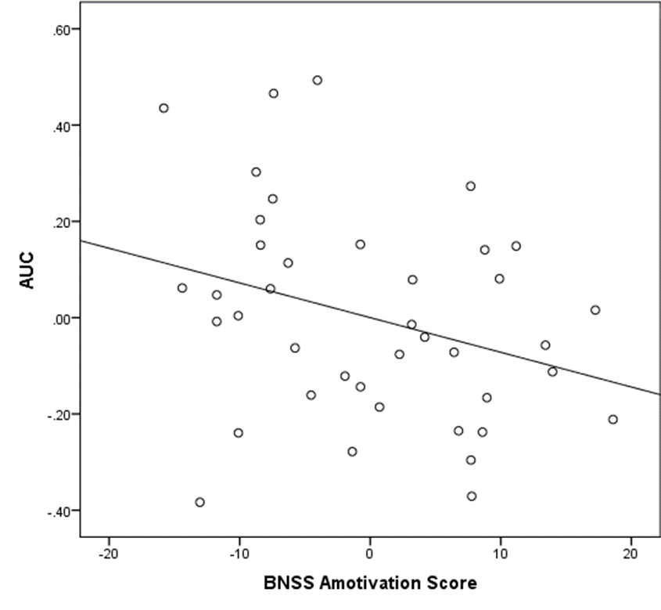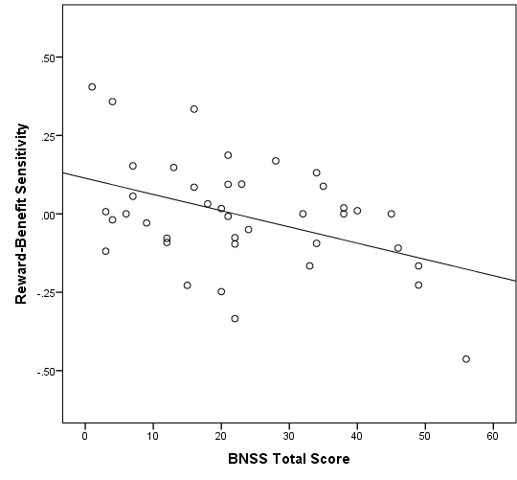

(C)

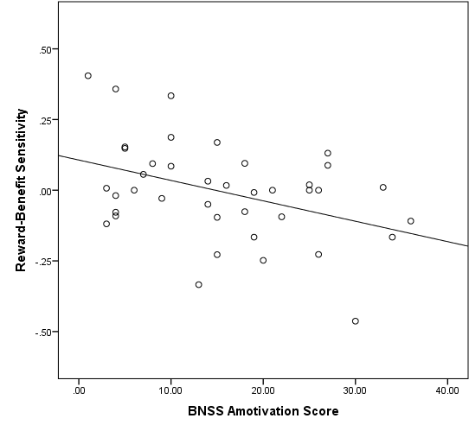

Fig. S2. Scatter plots illustrating relationships between effort task measures and negative symptoms.
(A) Correlation between AUC and BNSS amotivation score (residualized score), controlling for chlorpromazine equivalents (r = -0.31, p = 0.06). (B) Correlation between reward-benefit sensitivity and BNSS total score (r = -0.44, p = 0.01). (C) Correlation between reward-benefit sensitivity and BNSS amotivation score (r = -0.41, p = 0.01).
AUC, Area under the discounting curve; BNSS, Brief Negative Symptom Scale.

Table S4. Correlations of reward-benefit and effort-cost sensitivity measures with clinical and cognitive
variables in controlsª
 | Reward-benefit sensitivity |  |  | Effort-cost sensitivity
Cognitive functions | r | p |  | r | p
Digit symbol coding | -0.16 | 0.29 |  | -0.02 | 0.89
Logical memory | 0.11 | 0.49 |  | -0.01 | 0.99
Letter cancellation | 0.13 | 0.43 |  | -0.24 | 0.13
Trail making A | -0.01 | 0.94 |  | 0.04 | 0.80
Trail making B | 0.05 | 0.75 |  | -0.10 | 0.55
Cognitive composite score | 0.04 | 0.81 |  | 0.06 | 0.72
ª Pearson product-mean correlation analyses were performed.

