Supplemental Information

Whole blood transcriptome analysis in bipolar disorder reveals strong lithium effect

Authors
Catharine E. Krebs, Anil P.S. Ori, Annabel Vreeker, Timothy Wu, Rita M. Cantor, Marco P. Boks, Rene S. Kahn, Loes M. Olde Loohuis, Roel A. Ophoff

Supplemental Methods.............................................................................................................. 2

Sample preparation, RNA sequencing, and read alignment………………….............................. 2
Sequencing metrics...................................................................................................................... 3
Gene expression principal component analysis........................................................................... 3
Differential expression analysis.................................................................................................... 3
Body mass index sensitivity analysis............................................................................................ 5
Co-expression network analysis.................................................................................................. 6

Estimation of cell-type proportions............................................................................................... 6
Genotyping and polygenic risk scores.......................................................................................... 7

Functional annotation................................................................................................................... 8
Curation of DEG lists from previous studies and enrichment analyses........................................ 8
Weighted gene co-expression network module preservation analysis....................................... 10

Enrichment of cell types in co-expression modules.................................................................... 11
Estimation of heritability and genetic correlations...................................................................... 12
MAGMA settings......................................................................................................................... 12
Secondary gene-set analyses with sleep phenotype GWAS .................................................... 12
Supplemental Tables S1-S9..................................................................................................... 14
Supplemental Figures S1-S9................................................................................................... 21
References................................................................................................................................ 28

Supplemental Methods

Sample preparation, RNA sequencing, and read alignment
Peripheral whole blood was drawn and processed for genotyping and RNA sequencing from 240 controls and 240 cases, all of whom where euthymic, and of whom 227 (94.6%) had a diagnosis of bipolar I disorder and 13 (5.4%) had a diagnosis of bipolar II disorder. Whole blood was collected in PaxGene Blood RNA tubes and total RNA extracted using the PAXgene isolation kit (Qiagen) according to manufacturer’s protocols. RNA integrity number (RIN) values were obtained using Agilent’s NRA 6000 Nano kit and 2100 Bioanalyzer. RNA concentrations were determined using the Quant-iT RiboGreen RNA Assay kit. The UCLA Neuroscience Genomics Core subsequently performed RNA sequencing and prepared sample libraries using the TruSeq Stranded RNA plus Ribo-Zero Gold library prep kit to remove ribosomal and globin RNA to enrich for messenger and noncoding RNAs. Concentration of the sequencing library was determined on a TapeStation and a pool of barcoded libraries were layered on eight lanes of the Illumina flow cell bridge amplified to raw clusters. An average of 24.9 million paired-end reads of 50 bases in length per sample were obtained on an Illumina HiSeq 2500. The raw sequence data were processed for quality control (QC) using FastQC, after which all samples were deemed suitable for downstream analysis. Reads were mapped to human reference genome hg19 using allowing for two mismatches yielding an average mapping rate of 96.0% per sample and an average concordant pair mapping rate of 89.8% per sample. Samples had an average of 33.9% duplicate reads. Picard Tools were used to obtain 18 different sequencing metrics such as number of reads, percent mapped reads, and number of coding bases, that were examined for QC and then processed for dimension reduction using principal component analysis (PCA; see Gene expression principal component analysis below). The first three principal components, which explain 75.9%, 16.9%, and 6.4% of variance, respectively, were used as covariates in subsequent analyses.

Sequencing metrics
Transcriptome alignments were analyzed for quality control using CollectRnaSeqMetrics in Picard Tools. Eighteen sequencing metrics were obtained: number of paired reads, percent duplication, percent GC content, number of bases passing Illumina’s filter, number of bases passing Illumina’s filter that were aligned, number of coding bases, number of UTR bases, number of intronic bases, number of intergenic bases, number of correct strand reads, number of incorrect strand reads, percent mRNA bases, percent usable bases, median coverage, median 5’ bias, median 3’ bias, and median 5’ to 3’ bias. Upon examination of these metrics, no samples were removed for low quality. They were then processed for PCA dimension reduction using the prcomp function in R. Principal components one through three, which explain 75.9%, 16.9%, and 6.4% of the variance in sequencing metrics respectively, were used as covariates in subsequent analyses.

Gene expression principal component analysis
Principal component analysis (PCA) of gene expression quantification was performed for visualization and quality control purposes. To do this, first the read count matrix obtained from HTseq was transformed using the variance stabilizing transformation function in DESeq2 (Love et al., 2014) and then filtered for the 500 most variable genes. PCA was then performed using the prcomp function in R. Principal components were examined for their relationship to technical and biological variables. PC1 distinctly separates samples by sex except for four samples, which we removed from further analyses due to apparent mix-up or contamination.

Differential expression analysis
Filtered counts were converted to log2-counts-per-million (log-cpm) to account for differences between samples in sequencing depth and to stabilize variances at high counts. Then, the mean-variance relationship was modelled with precision weights at the individual observation level using limma voom (Law et al., 2014). Briefly, voom non-parametrically estimates the mean-variance trend of the logged read counts and uses this to predict the variance of each log-cpm value. The predicted variance is then used as a weight, which is incorporated into the linear model procedure during differential expression analysis. These gene-wise weighted least-squares linear models are fitted to the normalized log-cpm values, taking into account the voom precision weights and the final covariate model, generating a coefficient for the effect of each variable on each gene’s expression:

gene expression ~ covariates + trait of interest
Then, for each gene, the coefficient for the trait of interest is statistically tested for being significantly different from zero.
The final covariate model for differentially expressed genes (DEGs) between BD cases and controls included the following variables: age, sex, lithium use, tobacco use, ascertainment group, RIN, sequencing plate, and sequencing metric PCs 1 through 3. The final covariate model for DEGs between subjects being treated with lithium (i.e. lithium users) and non-lithium users included the following variables: BD diagnosis, age, sex, tobacco use, ascertainment group, RIN, sequencing plate, and sequencing metric PCs 1 through 3. Although there were no controls being treated with lithium, diagnosis was included in the lithium-use comparison to account for BD-effects within the non-lithium using group. Tobacco use was included in both analyses because of its well-characterized effect on whole blood gene expression (Huan et al., 2016). Information regarding subjects’ body mass index (BMI) was incomplete. Because a sensitivity analysis of the effects of BMI on lithium use, cell type proportions, and gene expression demonstrated minimal effects (see below), BMI was not included in the main analysis.

Body mass index sensitivity analysis
Mood stabilizers and antipsychotics are known to cause weight gain (Gracious and Meyer, 2005). Although information regarding body mass index (BMI) was incomplete and not included in the main analysis (missing in 100 out of 480 subjects), we explored the relationship between BMI and lithium use to determine if it could be a possible source of confounding in our dataset. BMI was first regressed on age, sex, and tobacco use and the residuals subsequently compared across controls, non-lithium users, and lithium users in an ANOVA and Tukey pairwise comparisons (Figure S2).

Because it has also been demonstrated that higher BMI is associated with higher absolute numbers of neutrophils, absolute lymphocytes, and total white blood cells (Rhee et al., 2018, Dixon and O'Brien, 2006), we explored the relationships between BMI and cell type proportions in our dataset. To do so, leukocyte proportions (see “Estimation of cell-type proportions” section in the main text methods section) were regressed on sex, age, tobacco use, sequencing plate, RIN, and sequencing metric PCs 1 through 3, and the residuals were used to predict BMI in a stepwise linear regression using the stepAIC function in the MASS package in R (Table S2). Four cell types significantly predicted BMI: T cells CD4 memory resting, T cells gamma delta, monocytes, and mast cells resting. Our results indicate that BMI covaries with lithium use and cell type proportions in our dataset and may explain a small portion of the gene expression differences found in lithium users.

To determine the effect of BMI on gene expression, the dataset was limited to controls only (N = 172) and a differential expression analysis for BMI was conducted with limma as described in the main text using the covariates sex, age, tobacco use, assessment group, RIN, and sequencing metric PCs 1 through 3. Zero BMI-associated differentially expressed genes (DEGs) survived at false discovery rate (FDR)-corrected P < 0.05, indicating that BMI has no detectable effect on gene expression independent of BD status and lithium use. To assess the potential contribution of BMI to lithium-associated gene expression effects, we compared the BMI effects from this analysis to lithium use effects from the main differential expression analysis (main text “Widespread subtle gene expression changes in lithium users”) within the 976 lithium-use DEGs. To do this, we calculated the –log10 P-value of each gene then multiplied it by the sign of its log2 fold change. We then calculated the Spearman rank correlation of these BMI and lithium use signed –log10 P-values (Figure S3; rho = 0.178, P = 2.49E-08). While highly significant, the BMI and lithium effects are only nominally correlated, indicating that BMI accounts for a small proportion of the lithium-use gene expression effects we observe.

Co-expression network analysis
The covariate model for WGCNA analyses included age, sex, tobacco use, assessment group, RIN, sequencing plate, and sequencing metric PCs 1 through 3. The $β$ parameter was set to 7 according to the approximate scale-free topology criterion (Figure S5) described by Langfelder and Horvath (Langfelder and Horvath, 2008), the minimum module size was set to 30, deep split was set to 2, and module merge cut height was set to 0.25. Intramodular connectivity k_{IM} was calculated to determine the level of connectivity for the genes in modules significantly associated with traits of interest.

Estimation of cell-type proportions
To estimate cell-type composition in our sample we employed the CIBERSORT online software (cibersort.stanford.edu) (Newman et al., 2015). Briefly, CIBERSORT uses reference gene expression signatures to estimate the relative proportions of cell types in tissues with complex, heterogeneous cell composition via linear support vector regression. The reference dataset we used to deconvolve our mixture of whole blood cell types was the validated leukocyte gene signature matrix that is provided with the CIBERSORT software, termed LM22 (Newman et al., 2015). It contains 547 genes whose expression discriminate between 22 different human hematopoietic cell phenotypes (Table S3), including seven T-cell types, naive and memory B cells, plasma cells, natural killer cells, and myeloid subsets.
To prepare our gene expression data for input to CIBERSORT, raw expression counts from HTSeq were converted to transcripts per million (TPM). Using the resulting matrix of TPM values for our 480 samples and the LM22 gene signature matrix as input, CIBERSORT was run online with 100 permutations and with quantile normalization disabled as recommended for RNA-seq data. The output matrix consisted of deconvolution results with relative fractions of cell types normalized to 1 across all cell subsets for each sample. The resulting estimated cell-type proportions were regressed on sex, age, tobacco use, sequencing plate, RIN, and sequencing metric PCs 1 through 3, and the residuals were used to predict lithium use in a stepwise linear regression using the stepAIC function in the MASS package in R.

Genotyping and polygenic risk scores
Genotyping was performed on a subset of samples (N_{cases} = 234, N_{controls} = 187) using the Illumina Infinium Human OmniExpressExome. Standard genotyping quality control was performed with PLINK (Purcell et al., 2007) to remove outliers and low quality SNPs and samples [36]. Imputation was performed on the Michigan Imputation Server (imputationserver.sph.umich.edu) (Das et al., 2016) with the 1000 Genomes Phase 3 version 5 reference panel (Genomes Project et al., 2015), Eagle phasing (Loh et al., 2016), and European ancestry. Following imputation, variants were excluded if they had mismatching alleles, if they were duplicates or indels, or if they had a SNP call rate < 90%. After imputation each sample had 46,625,935 SNPs. The imputed data were further filtered for r² > 0.3 and MAF > 0.05, yielding a final set of 6,828,668 SNPs per sample.
A polygenic risk score (PRS) for a given individual represents the cumulative genetic load of disease risk alleles and is defined as the sum of trait-associated alleles across many genetic loci, weighted by effect sizes estimated from a genome-wide association study. To calculate PRS for BD, we used associated alleles from the largest BD (Stahl et al., 2019) GWAS with our samples removed at a P-value cut-off of P < 0.05. We corrected for the top ten genotyping PCs then compared PRS scores between BD cases and controls and between lithium using cases and non-lithium using cases by computing the Student’s t-test.

Functional annotation
The Database for Annotation, Visualization, and Integrated Discovery (DAVID, v6.8) (Huang da et al., 2009) was used for functional annotation of each gene list. We used three gene lists from the differential expression analysis: the 976 lithium DEGs at FDR < 0.05, the 754 up-regulated lithium DEGs at FDR < 0.05, and the 222 down-regulated lithium DEGs at FDR < 0.05. We also used gene lists from the five co-expression network analysis modules that were significantly associated with BD: M1 (N_{genes} = 2,092), M7 (N_{genes} = 700), M9 (N_{genes} = 55), M11 (N_{genes} = 622), and M26 (N_{genes} = 484). The full set of 12,344 filtered and normalized genes used as input for differential expression and co-expression network analyses was used as background to determine overrepresentation in each of the gene lists. The functional annotation clustering tool was applied using unique Ensembl IDs and the following databases: SP_PIR_KEYWORDS, UP_SEQ_FEATURE, GOTERM_BP_FAT, GOTERM_CC_FAT, GOTERM_MF_FAT, BIOCARTA, KEGG_PATHWAY, INTERPRO, UCSC_TFBS. Cluster annotations were called significant if the enrichment was greater than 1.0 and at least 1 gene list in the annotation cluster survived Bonferroni correction (P < 0.05).

Curation of DEG lists from previous studies and enrichment analyses
To compare our results with the results of previous studies, PubMed was searched for transcriptome-wide gene expression studies with BD case-control or lithium treatment designs. Four schizophrenia case control studies and one major depressive disorder study were also included because of their large sample sizes and therefore increased power to detect differentially expressed genes. Both microarray and RNA sequencing technologies were considered. A variety of tissues were considered including peripheral whole blood and post-mortem brain from different regions, as well as several in vitro cell culture designs. Criteria for studies included in the comparison analysis were having > 10 samples, > 50 DEGs at FDR < 0.1, and differential expression analysis statistics available for download. The set of genes from Breen, et al. (Breen et al., 2016) was limited to genes with FDR < 0.005 because those were the only genes available for download.
Hypergeometric overlap tests were performed between the lithium-use DEGs and each of the gene lists from these previous using the GeneOverlap library in R. The full set of 12,344 genes expressed with > 10 counts in 90% of samples was considered as background gene expression. To account for multiple tests, Bonferroni correction was applied. For gene sets with significant hypergeometric P-values, the concordance rate and correlation statistics were calculated.
We inspected whether DEGs were differentially expressed in two recent BD case-control studies in cerebral cortex (Gandal et al., 2018a, Gandal et al., 2018b) and studies in The Stanley Medical Research Institute Online Genomics Database (www.stanleygenomics.org) (Higgs et al., 2006). We also inspected whether DEGs were expressed in brain tissues and cell types. A gene was considered to be expressed in frontal cortex tissue if it had a median gene TPM > 1 in GTEx (www.gtexportal.org). A gene was considered to be expressed in one of the six brain cell types (Zhang et al., 2016) (neurons, fetal astrocytes, mature astrocytes, oligodendrocytes, microglia/ macrophages, and endothelia) if it had a mean FPKM > 1.

Weighted gene co-expression network module preservation analysis
Using the same pipeline as described in Methods, we constructed WGCNA (Langfelder and Horvath, 2008) networks in four groups separately: BD cases (β = 4.2), controls (β = 5.5), lithium users (β = 7), and non-lithium users (β = 7). These networks were then assessed for module preservation using the WGCNA package in R. This module preservation analysis considers the structure of co-expression modules constructed in one group, the reference network, then tests the density and connectivity of these same module structures in another group, the test network. Four analyses were run: with the BD case network as the reference and the control network as the test, vice versa, with the lithium use network as the reference and the non-lithium use as the test, and vice versa.
Evaluating module preservation requires the module assignment of each gene in the reference network, as well as adjacency matrices for both the reference network and the test network. Using these inputs for each of the four analyses, various module preservation statistics were calculated using modulePreservation in the WGCNA package with 200 permutations. Two main types of preservation statistics were calculated: density based preservation statistics, which determine whether module nodes (genes) remain highly connected in the test network, and connectivity based preservation statistics, which determine whether the connectivity pattern between nodes in the reference network is similar to that in the test network. Significance levels (permutation test P-values) were calculated by using a permutation test procedure that randomly permutes the module assignment in the test data. To evaluate module preservation between networks, the composite Z_{summary} statistic was considered, which is the average of the density and connectivity based preservation statistics. Lower Z scores correspond to reference modules that are lesser preserved in the test network. Modules with Z scores less than 2 were considered not to be preserved. Modules with Z scores greater than 2 but less than 10 were considered to be moderately preserved. Modules with Z scores greater than 10 were considered to be well-preserved. Because Z statistics and permutation test P-values depend on the module size, the composite module preservation statistic medianRank, which is less dependent on module size, was also used to compare relative preservation among the modules. The medianRank statistic summarizes the ranks of the observed density and connectivity preservation statistics. Results of the module preservation analyses can be seen in Figure S6.

Enrichment of cell types in co-expression modules
The enrichment of LM22 cell types in gene co-expression modules determined from WGCNA was calculated in two ways. First, the hypergeometric overlap between modules and cell type signature genes was calculated. The binary matrix of LM22 signature genes provided by Newman et al. (Newman et al., 2015), where 1 denotes that a gene was significantly differentially expressed in that particular cell type and 0 denotes that it was not, was used to extract lists of signature genes for each cell type, or genes with a value of 1. These lists are partially overlapping, with 262 genes being unique to a given list and 285 genes being shared between $≥$ 2 lists (maximum 10 lists). Then, using the GeneOverlap library in R, the hypergeometric overlap was calculated between each of these 22 cell type signature gene lists and each of the 27 module gene lists using the full set of 12,344 filtered and normalized genes as background.
Second, binary cell type signatures were used to predict module membership values in a linear model. We reasoned that this method might be more powerful than a strict overlap due to the fact that every gene has a module membership value for every module, regardless if it was assigned to that module. The gene co-expression network output, which consists of module membership values for each gene for each module, was limited to the set of LM22 signature genes that were expressed in our sample (N_{genes} = 331). These values were then used as an outcome in a linear model, with the binary matrix of LM22 signature genes as predictors. To avoid multiple testing penalties, only five regressions were run on the five modules that were associated with lithium: M1, M7, M9, M11, and M26.

Estimation of heritability and genetic correlations
Linkage Disequilibrium (LD) Score Regression (LDSR) (Bulik-Sullivan et al., 2015b) was used to estimate SNP-based heritability (SNP-h²). Pre-computed LD scores from 1000 Genomes European data (Genomes Project et al., 2015) provided through the LDSR github and GWAS summary statistics file processed and reformatted to .sumstats format were used as input to the software. Genetic correlations between traits were estimated using cross-trait LDSR and the --rg flag (Bulik-Sullivan et al., 2015a).

MAGMA settings
MAGMA was used to run gene property analyses, which uses a multiple regression framework to associate a continuous gene variable to GWAS gene level p-values. High quality SNPs (INFO > 0.9) were mapped to genes using Ensembl gene IDs and NCBI build 37.3 gene boundaries +/- 10kb extensions using the -- annotate flag. For each phenotype, we generated gene-level p-values by computing the mean SNP association using the default gene model (‘snp-wise=mean’). We only included SNP with MAF > 5% and dropped synonymous or duplicate SNPs after the first entry (‘synonym-dup=drop-dup’). For each annotation, we then regressed gene-level GWAS test statistics on the corresponding gene annotation variable using the ‘--gene-covar’ function while adjusting for gene size, SNP density, and LD-induced correlations (‘--model correct=all’), which is estimated from an ancestry-matched 1KG reference panel. In all analyses, we included only genes for which we had both the gene variable and GWAS gene level test statistic available. Two-sided p-values are reported.

Secondary gene-set analyses with sleep phenotype GWAS
Secondary gene-set analyses were performed across four sleep traits from publicly available GWAS datasets (Jones et al., 2016) (chronotype, sleep duration, undersleeper, and oversleeper) and 2 sets of DEGs (BD at FDR < 0.2 and lithium-use at FDR < 0.05). MAGMA v1.06 (de Leeuw et al., 2015) was run using the same settings as described in the main text.
Supplemental Tables S1-S9
First author | Year | Tissue | Diagnosis | Condition tested | N samples | Platform | DEG cutoff | N DEGs | Pathways/ terms enriched in DEGs
Elashoff (Elashoff et al., 2007) | 2007 | *Multiple brain regions | BD & HC | BD vs. HC | †284, 331 | Microarray | meta P < 0.001 | 375 | Energy metabolism, protein turnover, MHC antigen response, RNA processing, intracellular transport activity, stress response, and metallothionein
Matigian (Matigian et al., 2007) | 2007 | LCLs | BD & MZ | BD vs MZ | 3, 3 | Microarray | FC > 1.3 | 82 | Programmed cell death, protein metabolism, regulation of transcription, and Wnt signaling
Choi (Choi et al., 2011) | 2011 | PFC | BD & HC | BD vs. HC | 40, 43 | Microarray | FC > 1.3 & FDR < 0.05 | 367 | -
Akula (Akula et al., 2014) | 2014 | Dorsolateral PFC | BD & HC | BD vs. HC | 11, 11 | Sequencing | FDR < 0.05 | 5 | ‡Transmembrane receptor protein phosphatase activity, regulation of transmission of nerve impule, GTPase binding, regulation of cyclic nucleotide metabolic processes, and cell part morphogenesis
Beech (Beech et al., 2014) | 2014 | Whole blood | BD | LR vs. LNR | 9, 19 | Microarray | FDR < 0.1 | 62 | -
Witt (Witt et al., 2014) | 2014 | Whole blood | BD & HC | EU vs. HC | 11, 10 | Microarray | FDR < 0.05 | 262 | -
 |  |  |  | MA vs. HC | 11, 10 | Microarray | FDR < 0.05 | 216 | Human diseases, metabolism, ribosome
 |  |  |  | EU vs. MA | 11, 11 | Microarray | FDR < 0.05 | 22 | -
Xiao (Xiao et al., 2014) | 2014 | BA9 | BD & HC | BD vs. HC | 7, 6 | Sequencing | FC > 1.5 | 2,085 | Morphogenesis, nervous system development, synaptic transmission, axon guidance, regulation of action potential, ion homeostasis, etc.
 |  | BA24 | BD & HC | BD vs. HC | 7, 6 | Sequencing | FC > 1.5 | 1,643 | Synaptic transmission, signaling, cellular homeostasis, morphogenesis, nervous system development, ion transport, etc.
Cruceanu (Cruceanu et al., 2015) | 2015 | Anterior cingulate cortex | BD & HC | BD vs. HC | 13, 13 | Sequencing | FDR ≤ 0.05 | 10 | G-protein coupled receptor pathways
Madison (Madison et al., 2015) | 2015 | Fibroblasts | BD ped | AF vs. UAF | #6, 6 | Sequencing | FC > 1.5 & P < 0.05 | 1 | -
 |  | iPSCs | BD ped | AF vs. UAF | #6, 6 | Sequencing | FC > 1.5 & P < 0.05 | 0 | -
 |  | NPCs | BD ped | AF vs. UAF | #6, 6 | Sequencing | FC > 1.5 & P < 0.05 | 18 | ‡Key neuronal processes
Mertens (Mertens et al., 2015) | 2015 | Neurons | BD & HC | BD vs. HC | 6, 4 | Sequencing | FDR ≤ 0.1 | 45 | Calcium ion signaling, neuroactive ligand-receptor interaction, PKA/PKC signaling, and action potential firing
Zhao (Zhao et al., 2015) | 2015 | Cingulate cortex | BD & HC | BD vs. HC | 25, 26 | Sequencing | FDR ≤ 0.1 | 153 | GnRH signaling, taste transduction, vascular smooth muscle contraction, gap junction, Huntington's disease, chemokine signaling pathway, RNA polymerase, Phosphatidylinositol signaling system, apoptosis, etc.
Anand (Anand et al., 2016) | 2016 | Peripheral lymphocytes | BD | T vs. UT | 22, 22 | Microarray | FDR < 0.05 | 35 | Interferon signaling, glucocorticoid, VDR/RXR, EGF and aldosterone receptor signaling, and PI3 kinase signaling
Breen(Breen et al., 2016) | 2016 | LCLs | BD | LR-T vs. LNR-T | 8, 8 | Sequencing | P < 0.05 | 244 | DNA repair, protein deacetylation, cellular response to stress, nucleoplasm
 |  |  | BD & HC | T vs. UT | 23, 23 | Sequencing | FDR < 0.05 | 2,803 | -
Pacifico (Pacifico and Davis, 2017) | 2016 | Dorsal striatum | BD & HC | BD vs. HC | 18, 17 | Sequencing | FDR < 0.05 | 14 | Immune response, inflammation, and oxidative phosphorylation
Peterson (Peterson et al., 2016) | 2016 | LCLs | BD ped | AF vs. UAF | 193, 593 | Microarray | FDR < 0.05 | 0 | -
Fries (Fries et al., 2017) | 2017 | LCLs | BD | T vs. UT | 62, 62 | Microarray | FDR < 0.05 | 236 | Cell death
Kittel-Schneider (Kittel-Schneider et al., 2017) | 2017 | LCLs | BD & HC | T vs. UT | 21, 21 | Microarray | P < 0.05E-5 | 459 | Apoptosis, protein transport, cell cycle, RNA processing, etc.
 |  | Fibroblasts | BD & HC | BD vs. HC | 10, 11 | Microarray | P < 0.05E-4 | 296 | Cell signaling, wound healing, cell adhesion, etc.
 |  | LCLs | BD & HC | BD vs. HC | 10, 11 | Microarray | P < 0.05E-5 | 58 | Leukocyte activation, apoptosis, immune response, etc.
Vizlin-Hodzic (Vizlin-Hodzic et al., 2017) | 2017 | iPSCs | BD | BD vs. HC | 6, 4 | Sequencing | FDR < 0.05 | 3 | TREM1
 |  | NSCs | BD | BD vs. HC | 6, 4 | Sequencing | FDR < 0.05 | 42 | Inflammation, GABA receptor signaling, dopamine receptor signaling, and TREM1
Mostafavi (Mostafavi et al., 2014) | 2014 | Whole blood | MDD & HC | MDD vs. HC | 463, 459 | Sequencing | P < 3.6E-6 | 0 | §Interferon alpha/beta signaling
van Eijk (van Eijk et al., 2015) | 2014 | Whole blood | SCZ & HC | SCZ vs. HC | 106, 96 | Microarray | FDR < 0.05 | 525 | -
Zhao (Zhao et al., 2015) | 2015 | Cingulate cortex | SCZ & HC | SCZ vs. HC | 31, 26 | Sequencing | FDR ≤ 0.1 | 105 | Circadian rhythm, prostate cancer, Natural killer cell mediated cytotoxicity, signaling pathways, etc.
Fromer (Fromer et al., 2016) | 2016 | Dorsolateral PFC | SCZ & HC | SCZ vs. HC | 258, 279 | Sequencing | FDR ≤ 0.05 | 693 | -
Hess (Hess et al., 2016) | 2016 | Whole blood | SCZ & HC | SCZ vs. HC | 300, 278 | Microarray | mega FDR < 0.1 | 2,238 | Innate immune and inflammatory signaling, cellular stress response, response to androgens, glycotic metabolism, cell survival and growth, DNA repair, mitochondrial function, etc.
Jansen (Jansen et al., 2016) | 2016 | Whole blood | MDD & HC | C-MDD vs. HC | 882, 331 | Microarray | FDR < 0.1 | 129 | Interleukin 6 signaling pathway, natural killer cell mediated cytotoxicity, apoptosis, immune response
Table S1. Review of previous BD and lithium studies with differential expression analyses. Select schizophrenia and major depressive disorder studies were included (at the bottom of the table) as examples of what larger BD and lithium studies might look like. *Multiple brain regions including frontal BA46, BA10, BA6, BA8, BA9, and cerebellum. †165 BD individuals (samples partially overlapping). ‡Enrichment analysis was performed on genes with nominal p-values (P < 0.05). §Enrichment analysis was performed on genes with small p-values (sets of top N genes, N = [30, 60, 100, 150, 300, 500]). #N = 2 samples with 3 replicates each. Abbreviations: AF, affected; BD, bipolar disorder; BD ped, BD pedigree; C-MDD, current major depressive disorder; DEGs, differentially expressed genes; EU, euthymic; FC, fold change; FDR, false discovery rate; HC, healthy control; iPSCs, induced pluripotent stem cells; LCLs, lymphoblastoid cell lines; LNR, lithium non-responder; LNR-T, lithium non-responder treated with lithium; LR, lithium-responder; LR-T, lithium responder treated with lithium; MA, manic; MDD, major depressive disorder; MZ, unaffected monozygotic twin; NPCs, neural progenitor cells; NSCs, neural stem cells; PFC, prefrontal cortex; SCZ, schizophrenia; T, treated with lithium; UAF, unaffected; UT, untreated with lithium.

Cell type | t value | Pr(>|t|)
T cells CD4 memory resting | 2.13 | 3.39E-02
T cells gamma delta | 2.96 | 3.27E-03
Monocytes | 2.27 | 2.41E-02
Mast cells resting | -2.60 | 9.67E-03

Table S2. Results of the stepwise linear regression using residualized leukocyte cell type proportions to predict BMI (Adjusted R² = 0.053, F = 4.32, P = 3.22E-04).

Leukocyte reference cell types
B cells naive
B cells memory
Plasma cells
T cells CD8
T cells CD4 naive
T cells CD4 memory resting
T cells CD4 memory activated
T cells follicular helper*
T cells regulatory*
T cells gamma delta
NK cells resting
NK cells activated
Monocytes
Macrophages M0
Macrophages M1*
Macrophages M2
Dendritic cells resting
Dendritic cells activated
Mast cells resting
Mast cells activated*
Eosinophils
Neutrophils

Table S3. Leukocyte reference cell types ordered and clustered by function. *Estimated as zero in all samples.

A.
 |  |  |  |  | Mean expression in Zhang in FPKM
 |  |  |  |  | (FC relative to the other five cell types)
Ensembl ID | Gene symbol |  | Median expression in GTEx frontal cortex (TPM) |  | Fetal astrocytes | Mature astrocytes | Neurons | Oligoden-drocytes | Microglia/ macro-phage | Endo-thelial
ENSG00000203872 | C6orf163 |  | 0.30 |  | - | - | - | - | - | -
ENSG00000103051 | COG4 |  | 27.4 |  | 1.62 (1.16) | 2.95 (2.61) | 1.10 (0.73) | 1.41 (0.98) | 0.93 (0.60) | 0.61 (0.38)
ENSG00000249859 | PVT1 |  | 0.56 |  | - | - | - | - | - | -
ENSG00000088538 | DOCK3 |  | 37.6 |  | 1.95 (0.74) | 1.73 (0.65) | 8.72 (6.82) | 1.89 (0.72) | 0.52 (0.18) | 0.31 (0.10)
ENSG00000267702 | - |  | 0.046 |  | - | - | - | - | - | -
ENSG00000122507 | BBS9 |  | 4.31 |  | 10.11 (1.39) | 7.62 (0.98) | 5.72 (0.70) | 9.39 (1.26) | 4.03 (0.47) | 9.74 (1.32)

B.
Ensembl ID | Gene symbol |  | Stanley Genomics DE results for BD |  | Microarray DE results for BD (Gandal et al., 2018a) | RNA-seq DE results for BD (Gandal et al., 2018a) | RNA-seq DE results for BD (Gandal et al., 2018b)
ENSG00000203872 | C6orf163 |  | NS |  | - | - | 0.44
ENSG00000103051 | COG4 |  | NS in combined analysis, down-regulated in three studies |  | 0.38 | 0.71 | 0.34
ENSG00000249859 | PVT1 |  | NS |  | - | 0.96 | 0.031
ENSG00000088538 | DOCK3 |  | NS in combined analysis, down-regulated in one study |  | 0.74 | 1.00 | 0.54
ENSG00000267702 | - |  | - |  | - | 0.90 | 0.89
ENSG00000122507 | BBS9 |  | - |  | 0.95 | 0.78 | 0.96

Table S4. BD DEG (A) expression in brain tissue and cell types and (B) results from Stanley Genomics and Gandal et al. analyses (Gandal et al., 2018a, Gandal et al., 2018b). Gandal DE results are FDR-corrected p-values. Abbreviations: FC, log 2 fold change; TPM, transcripts per million; FPKM, fragments per kilobase million; NS, not significant; -, not present.

First author | Year | Tissue | Diagnosis | Conditions tested | N samples | Platform | FDR | N DEGs |  | Hyper-geometric P-value | N over-lapping DEGs | % con-cordant | rho | Spearman P-value
Anand (Anand et al., 2016) | 2016 | Peripheral lymphocytes | BD | T vs. UT | 22, 22 | Microarray | 0.05 | 35 |  | 4.66E-12 | 18 | 100 | 0.35 | 0.15
Beech (Beech et al., 2014) | 2014 | Whole blood | BD | LR vs. LNR | 9, 19 | Microarray | 0.1 | 62 |  | 0.99 | 1 | - | - | -
Breen (Breen et al., 2016) | 2016 | LCLs | BD & HC | T vs. UT | 23, 23 | Sequencing | 0.005 | 1,504 |  | 9.23E-03 | 134 | 84.6 | 0.55 | 2.20E-16
Choi (Choi et al., 2011) | 2011 | PFC | BD & HC | BD vs. HC | 40, 43 | Microarray | 0.05 | 379 |  | 1.00 | 13 | - | - | -
Fries (Fries et al., 2017) | 2017 | LCLs | BD | T vs. UT | 62, 62 | Microarray | 0.05 | 236 |  | 6.62E-02 | 24 | - | - | -
Fromer (Fromer et al., 2016) | 2016 | PFC | SCZ & HC | SCZ vs. HC | 258, 279 | Sequencing | 0.05 | 693 |  | 0.87 | 41 | - | - | -
Hess (Hess et al., 2016) | 2016 | Whole blood | SCZ & HC | SCZ vs. HC | 300, 278 | Microarray | 0.05 | 1,613 |  | 0.85 | 109 | - | - | -
Jansen (Jansen et al., 2016) | 2016 | Whole blood | MDD & HC | C-MDD vs. HC | 882, 331 | Microarray | 0.1 | 142 |  | 0.48 | 10 | - | - | -
Kittel-Schneider (Kittel-Schneider et al., 2017) | 2017 | LCLs | BD & HC | T vs. UT | 21, 21 | Microarray | *0.05 | 459 |  | 0.97 | 18 | - | - | -
 |  | Fibroblasts | BD & HC | BD vs. HC | 10, 11 | Microarray | *0.05 | 296 |  | 1.00 | 4 | - | - | -
 |  | LCLs | BD & HC | BD vs. HC | 10, 11 | Microarray | *0.05 | 57 |  | 0.86 | 2 | - | - | -
van Eijk (van Eijk et al., 2015) | 2014 | Whole blood | SCZ & HC | SCZ vs. HC | 106, 96 | Microarray | 0.05 | 525 |  | 0.12 | 34 | - | - | -
Zhao (Zhao et al., 2015) | 2015 | Cingulate cortex | BD & HC | BD vs. HC | 25, 26 | Sequencing | 0.1 | 153 |  | 0.97 | 6 | - | - | -
 |  |  | SCZ & HC | SCZ vs. HC | 31, 26 | Sequencing | 0.1 | 105 |  | 0.37 | 9 | - | - | -

Table S5. Overlap between lithium-use DEGs and previous studies. DEG lists from previous studies were included upon the following criteria: >10 samples, > 50 DEGs at FDR < 0.1, and data available for download. *Bonferroni-Holm P < 0.05. Abbreviations: BD, bipolar disorder; C-MDD, current major depressive disorder; DEGs, differentially expressed genes; FDR, false discovery rate; HC, healthy control; LCLs, lymphoblastoid cell lines; LNR, lithium non-responder; LR, lithium-responder; MDD, major depressive disorder; PFC, prefrontal cortex; SCZ, schizophrenia; T, treated with lithium; UT, untreated with lithium.

 |  | Correlation P-value
Module |  | Lithium use | BD diagnosis |  | Hypergeometric P-value
M1 |  | 9.40E-04* | 0.21 |  | 2.03E-97*
M2 |  | 0.36 | 0.99 |  | 0.90
M3 |  | 0.36 | 0.17 |  | 1.00
M4 |  | 0.63 | 0.51 |  | 0.98
M5 |  | 0.62 | 5.31E-02 |  | 0.97
M6 |  | 5.49E-02 | 0.11 |  | 1.00
M7 |  | 4.50E-04* | 3.10E-03 |  | 1.00
M8 |  | 0.51 | 0.73 |  | 1.00
M9 |  | 1.15E-03* | 0.17 |  | 6.15E-07*
M10 |  | 3.01E-03 | 1.92E-02 |  | 0.39
M11 |  | 3.12E-04* | 1.76E-02 |  | 4.93E-13*
M12 |  | 3.05E-02 | 1.93E-02 |  | 1.00
M13 |  | 0.38 | 0.41 |  | 1.00
M14 |  | 0.59 | 0.13 |  | 0.56
M15 |  | 0.18 | 0.18 |  | 1.00
M16 |  | 0.82 | 0.23 |  | 1.00
M17 |  | 0.34 | 4.37E-02 |  | 1.00
M18 |  | 1.87E-02 | 0.16 |  | 0.83
M19 |  | 0.13 | 0.87 |  | 0.98
M20 |  | 5.50E-03 | 1.02E-02 |  | 1.00
M21 |  | 0.69 | 0.50 |  | 1.00
M22 |  | 0.35 | 0.24 |  | 1.00
M23 |  | 0.64 | 0.98 |  | 1.00
M24 |  | 0.58 | 0.45 |  | 1.00
M25 |  | 1.16E-02 | 0.38 |  | 3.83E-02
M26 |  | 2.00E-04* | 2.68E-03 |  | 1.00
M27 |  | 0.31 | 8.46E-02 |  | 1.00

Table S6. Co-expression module association with BD diagnosis and lithium use. Because all variables other than BD diagnosis and lithium use were regressed out from the gene expression data prior to the co-expression analysis, any possible effect of these variables was removed from the data and module associations are not shown non-significant (not shown). Correlation P-values were calculated by correlating gene module membership values with gene significance values for the traits shown. Hypergeometric P-values were calculated by testing for overlap between the list of lithium-use DEGs and the list of genes within each module. *Significant at Bonferroni corrected P < $α$ = 0.05/27.

 | Bipolar disorder | Schizophrenia | Depression
GWAS | r_{G} (SE)
Bipolar disorder | 0.35 (-0.017) | 0.69 (-0.021) | 0.32 (-0.034)
Schizophrenia | 0.69 (-0.021) | 0.24 (-0.0094) | 0.29 (-0.029)
Depression | 0.32 (-0.034) | 0.29 (-0.029) | 0.050 (-0.0029)

Table S7. Genetic correlations (r_{G}) between the three psychiatric GWAS traits (PGC BD GWAS (Stahl et al., 2019), PGC schizophrenia GWAS (Schizophrenia Working Group of the Psychiatric Genomics, 2014), and 23andMe self-reported depression GWAS (Hyde et al., 2016)) used for gene set analysis. The SNP-based heritability for each trait is on the diagonal.

 |  | Bipolar disorder |  | Schizophrenia |  | Depression
Gene set |  | β | P | β | P | β | P
BD DEGs | All | -0.036 | 0.39 | 0.026 | 0.58 | -0.048 | 0.22
 | Up-regulated | -0.066 | 0.21 | 0.040 | 0.49 | -0.033 | 0.50
 | Down-regulated | 0.020 | 0.78 | -0.001 | 0.99 | -0.071 | 0.26
Li DEGs | All | 0.027 | 0.45 | -0.010 | 0.81 | -0.015 | 0.65
 | Up-regulated | 0.043 | 0.29 | 0.012 | 0.80 | 0.003 | 0.94
 | Down-regulated | -0.022 | 0.74 | -0.071 | 0.36 | -0.063 | 0.32
Positive control |  | 1.040 | 1.28E-27 | 0.27 | 1.79E-02 | 0.044 | 0.64
Negative control |  | -0.002 | 0.95 | -0.021 | 0.58 | 0.002 | 0.94

Table S8. Results of the gene-set analysis using MAGMA (de Leeuw et al., 2015). DEG sets were stratified by up- and down-regulated genes. The BD DEG set was extended to include genes with FDR-corrected P < 0.2. The positive control gene-set consisted of the top 100 most significant genes from a random draw of N = 1,000 using the BD GWAS gene-level test statistics. The negative control gene-set consisted of a random draw of N = 1,000 genes using the BD GWAS gene-level test-statistics. Two-sided p-values are reported.

 |  |  |  |  |  |  | Gene set
 |  |  |  |  |  |  | BD DEGs |  | Li DEGs
 | N cases | N controls | h² (SE) | BD r_{G} (SE) | r_{G} P |  | β | P | β | P
Chronotype | 128,266 | * | 0.10 (0.006) | -0.01 (0.04) | 0.73 |  | -0.026 | 0.50 | 0.03 | 0.36
Sleep duration | 128,266 | * | 0.057 (0.006) | 0.19 (0.04) | 1.70E-05 |  | -0.028 | 0.45 | 0.035 | 0.25
Undersleeper | 28,980 | 81,204 | 0.049 (0.005) | -0.15 (0.05) | 1.80E-03 |  | 0.0029 | 0.94 | -0.017 | -0.057
Oversleeper | 10,102 | 81,204 | 0.027 (0.006) | 0.20 (0.07) | 2.60E-03 |  | 0.016 | 0.66 | -0.040 | 5.47E-02

Table S9. Sleep phenotype SNP-based heritabilities (SNP-h²) and genetic correlations (r_{G}) with BD and results of the gene-set analysis using MAGMA. *Continuous phenotype. SE, standard error.

Supplemental Figures S1-S7
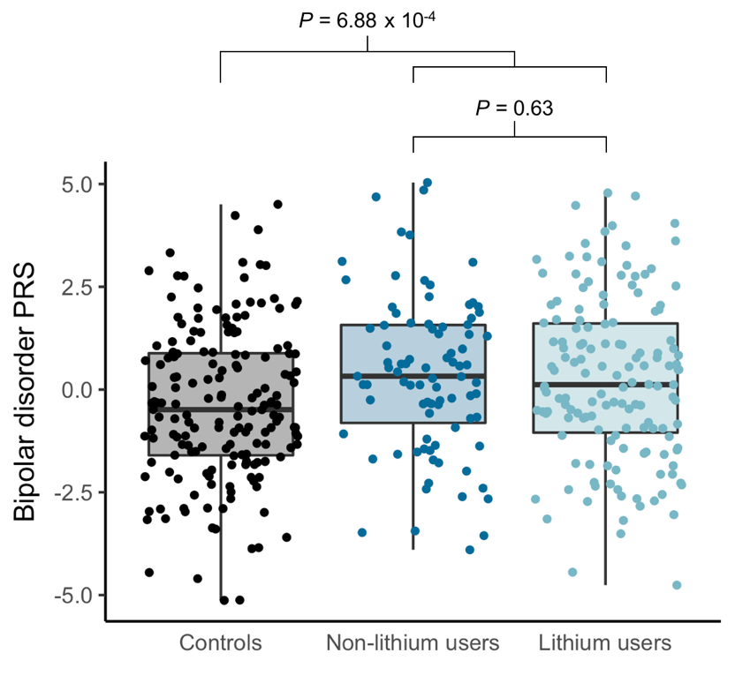
Figure S1. BD polygenic risk scores across groups. PRS calculated from the largest BD GWAS (Stahl et al., 2019) was significantly different between cases and controls (t = -3.42, P = 6.88 x 10⁻⁴) but not between cases using lithium and cases not using lithium (t = 0.48, P = 0.63).

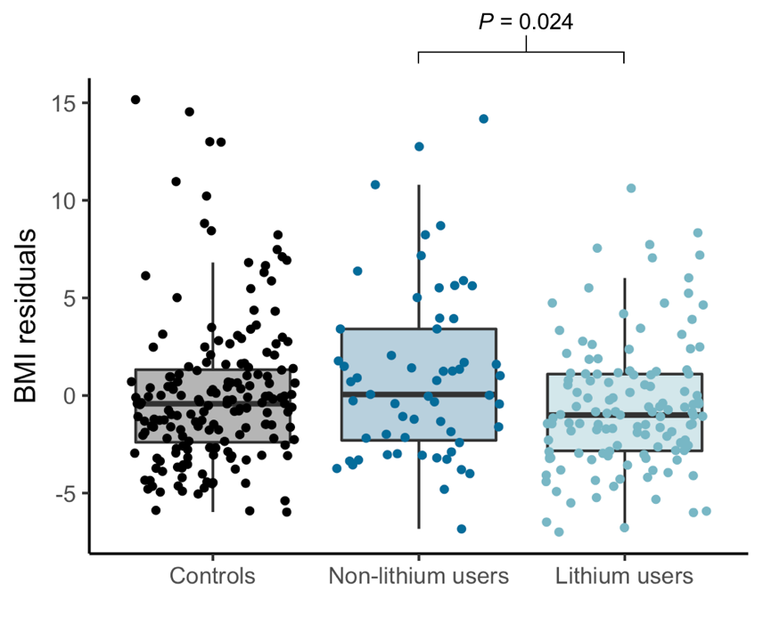
Figure S2. BMI residuals across groups. BMI corrected for age, sex, and tobacco use was significantly different across groups (ANOVA F = 3.52, P = 0.031), driven by the difference between lithium users and non-lithium users (Tukey pairwise comparisons: controls vs. non-lithium users P_{adj} = 0.24; controls vs. lithium users P_{adj} = 0.31; lithium vs. non-lithium users P_{adj} = 0.024).
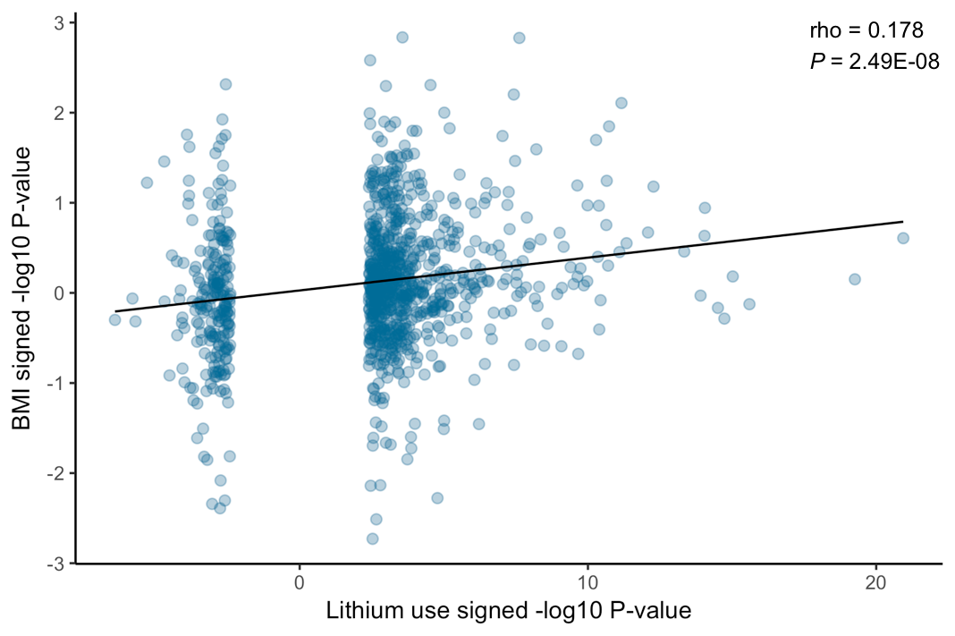
Figure S3.

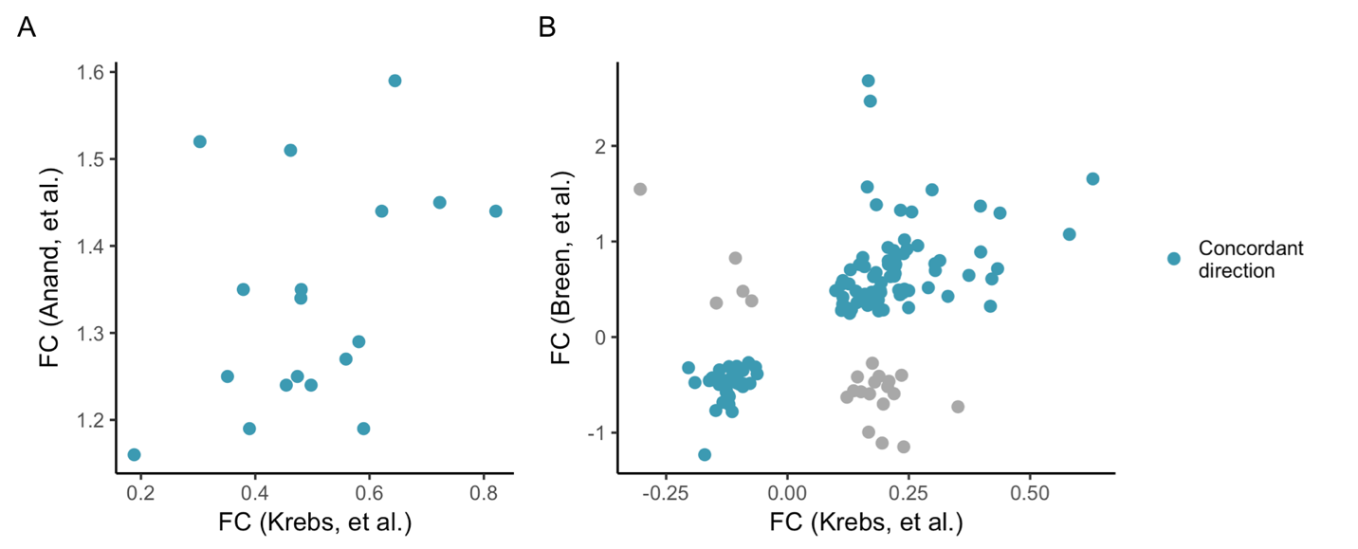
Figure S4. Comparison of fold changes of overlapping DEGs in the current study (Krebs, et al.) overlapping (A) with Anand, et al. (Anand et al., 2016) (N_{genes} = 18) and (B) with Breen, et al. (Breen et al., 2016) (N_{genes} = 134). Genes whose effects are concordant in direction are colored in blue.

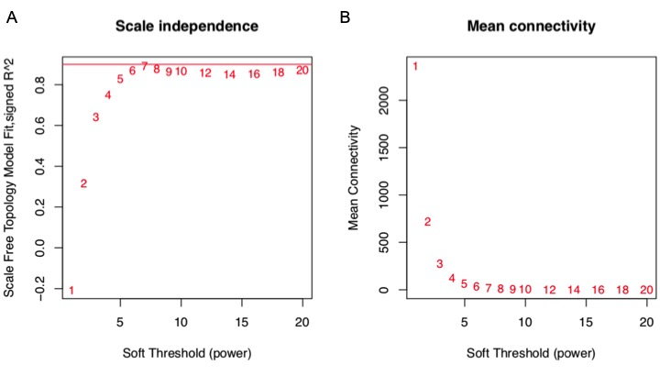
Figure S5. WGCNA (A) scale independence and (B) mean connectivity graphs.

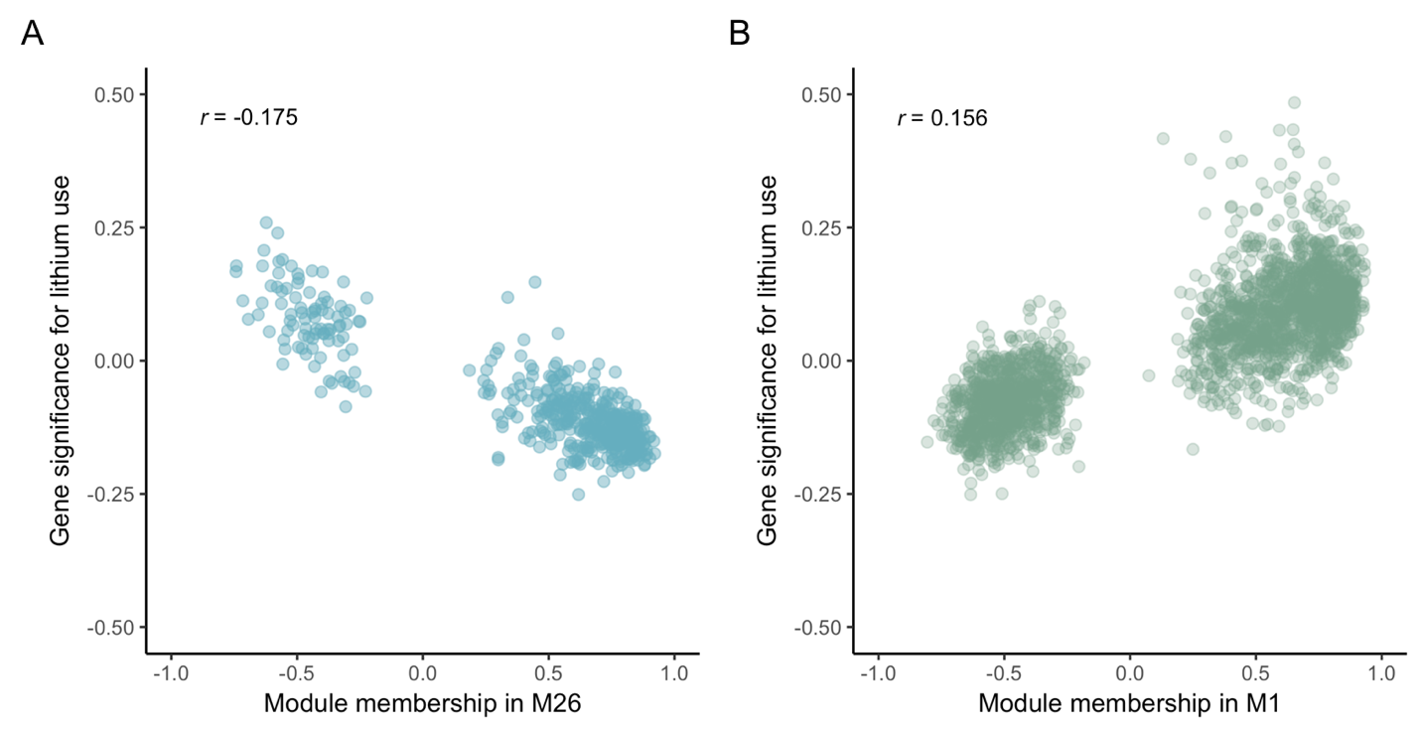

Figure S6. Module correlation with lithium use for (A) M26 and (B) M1. Module membership is the correlation of each gene’s expression with the module eigengene, which is the first principal component of the module. Gene significance for lithium use is the correlation of each gene’s expression with lithium use.

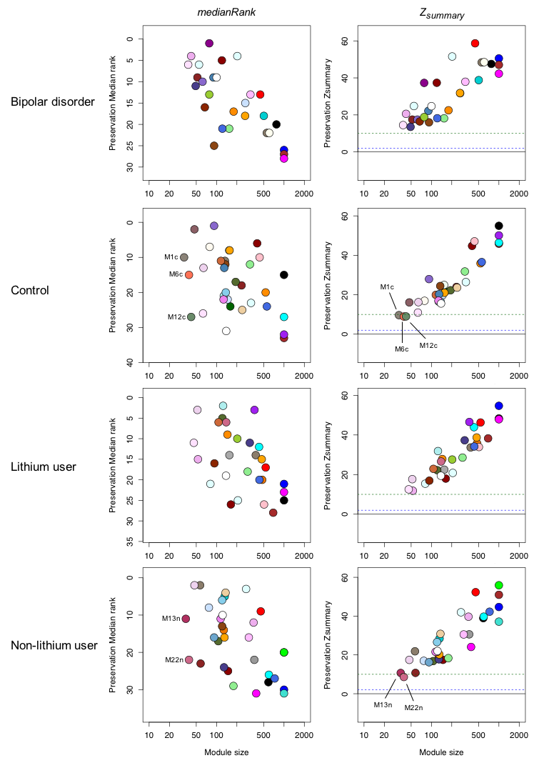
Figure S7. Module preservation analysis. The blue dashed line represents a Z_{summary} = 2, below which a module is considered not to be preserved. The green dashed line represents a Z_{summary} = 10. If a module falls between the green and blue dashed lines it is considered to be weakly to moderately preserved. If a module falls above the green dashed line, it is considered to be strongly preserved. The 28 modules in the BD case network were significantly preserved in controls. The 33 modules in the control network were significantly preserved in BD cases. Three modules in the control network displayed moderate preservation in cases, M6c, M12c, and M1c (Z_{summary} = 8.9, 9, and 9.7, respectively), but their median ranks were not among the top indicating that their low summary preservation statistics were due to small module size. The 29 modules in the lithium-use network were all significantly preserved in non-lithium users. The 32 modules in the non-lithium use network were all significantly preserved in lithium users. Two modules in the non-lithium-treated network displayed moderate preservation, M22n and M13n (Z_{summary} = 8.6 and 9.5, respectively), but their median ranks were not among the top indicating that their low summary preservation statistics were due to small module size.
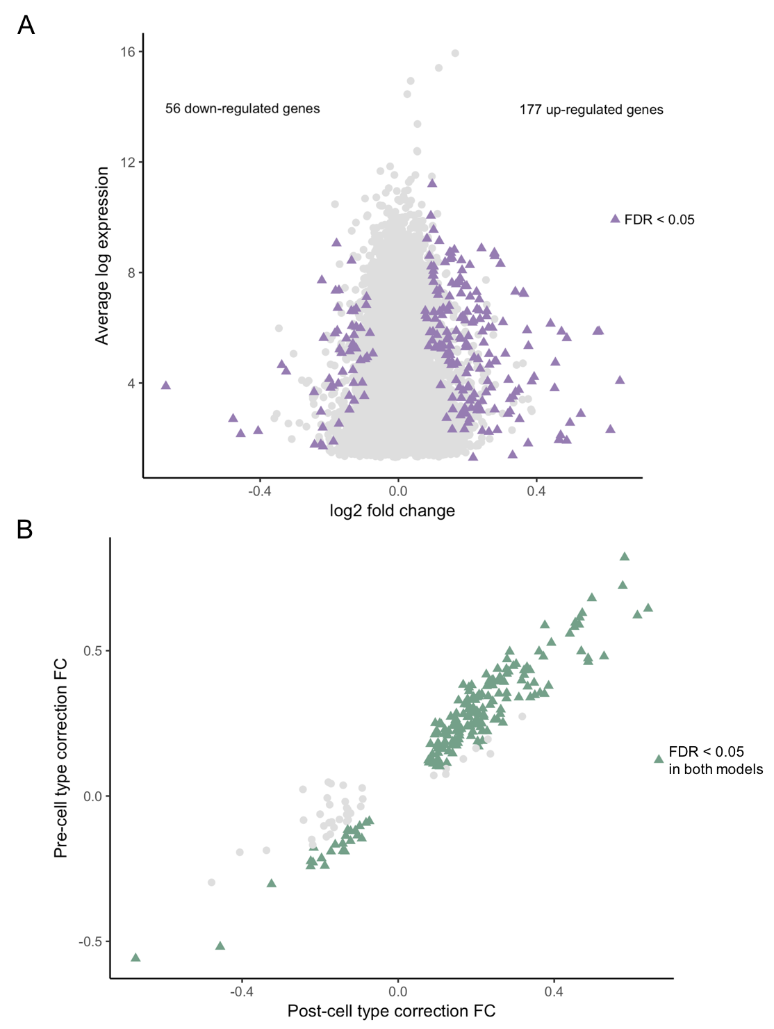
Figure S8. Estimated cell-type proportions partially explain lithium-associated changes in gene expression. (A) After correcting for estimated cell-type proportions, 233 DEGs remain significant (shown as purple triangles, FDR < 0.05; all other genes tested shown as light gray circles). (B) Comparison of log₂ fold changes (FC) before (y-axis) and after (x-axis) correcting for cell type proportion estimates. Of the 233 genes significant after correcting for cell type estimates, 194 (83.2%) were significant in the original model without correcting for cell type estimates and concordant in the direction of effect (shown as green triangles, FDR < 0.05).

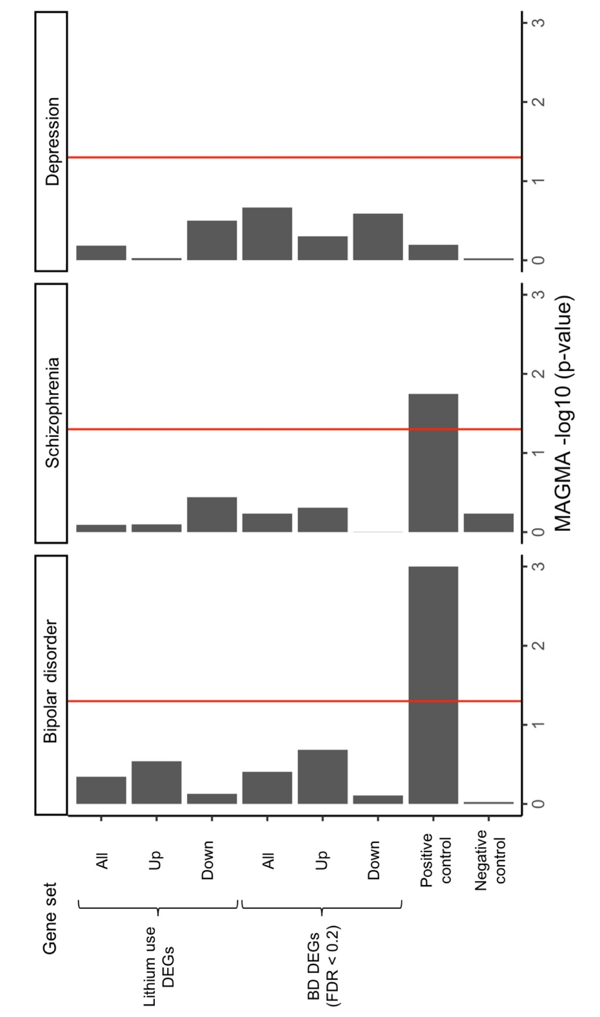
Figure S9. Gene-set enrichment of DEG sets with genes in psychiatric trait-associated loci (PGC BD GWAS (Stahl et al., 2019), PGC schizophrenia GWAS (Schizophrenia Working Group of the Psychiatric Genomics, 2014), and 23andMe self-reported depression GWAS (Hyde et al., 2016)) using MAGMA (de Leeuw et al., 2015). DEG sets stratified by up- and down-regulated genes. The BD DEG set was extended to include genes with FDR-corrected P < 0.2. The positive control gene-set consisted of the top 100 most significant genes from a random draw of N = 1,000 using the BD GWAS gene-level test statistics. The positive control gene-set association with BD was highly significant (P = 1.28 x 10⁻²⁷) but the -log₁₀ P-value was limited to 3 in the plot. The negative control gene-set consisted of a random draw of N = 1,000 genes using the BD GWAS gene-level test-statistics. The red line represents the significance threshold of -log₁₀(0.05). All P-values and effect sizes are reported in Table S8.

References

ABRAMOVIC, L., BOKS, M. P., VREEKER, A., BOUTER, D. C., KRUIPER, C., VERKOOIJEN, S., VAN BERGEN, A. H., OPHOFF, R. A., KAHN, R. S. & VAN HAREN, N. E. 2016. The association of antipsychotic medication and lithium with brain measures in patients with bipolar disorder. European Neuropsychopharmacology, 26, 1741-1751.
ABRAMOVIC, L., BOKS, M. P. M., VREEKER, A., VERKOOIJEN, S., VAN BERGEN, A. H., OPHOFF, R. A., KAHN, R. S. & VAN HAREN, N. E. M. 2018. White matter disruptions in patients with bipolar disorder. European Neuropsychopharmacology, 28, 743-751.
AKULA, N., BARB, J., JIANG, X., WENDLAND, J. R., CHOI, K. H., SEN, S. K., HOU, L., CHEN, D. T., LAJE, G., JOHNSON, K., LIPSKA, B. K., KLEINMAN, J. E., CORRADA-BRAVO, H., DETERA-WADLEIGH, S., MUNSON, P. J. & MCMAHON, F. J. 2014. RNA-sequencing of the brain transcriptome implicates dysregulation of neuroplasticity, circadian rhythms and GTPase binding in bipolar disorder. Molecular Psychiatry, 19, 1179-85.
ANAND, A., MCCLINTICK, J. N., MURRELL, J., KARNE, H., NURNBERGER, J. I. & EDENBERG, H. J. 2016. Effects of Lithium Monotherapy for Bipolar Disorder on Gene Expression in Peripheral Lymphocytes. Molecular Neuropsychiatry, 2, 115-123.
BEECH, R. D., LEFFERT, J. J., LIN, A., SYLVIA, L. G., UMLAUF, S., MANE, S., ZHAO, H., BOWDEN, C., CALABRESE, J. R., FRIEDMAN, E. S., KETTER, T. A., IOSIFESCU, D. V., REILLY-HARRINGTON, N. A., OSTACHER, M., THASE, M. E. & NIERENBERG, A. 2014. Gene-expression differences in peripheral blood between lithium responders and non-responders in the Lithium Treatment-Moderate dose Use Study (LiTMUS). Pharmacogenomics J, 14, 182-91.
BREEN, M. S., WHITE, C. H., SHEKHTMAN, T., LIN, K., LOONEY, D., WOELK, C. H. & KELSOE, J. R. 2016. Lithium-responsive genes and gene networks in bipolar disorder patient-derived lymphoblastoid cell lines. Pharmacogenomics J, 16, 446-53.
BULIK-SULLIVAN, B., FINUCANE, H. K., ANTTILA, V., GUSEV, A., DAY, F. R., LOH, P. R., REPROGEN, C., PSYCHIATRIC GENOMICS, C., GENETIC CONSORTIUM FOR ANOREXIA NERVOSA OF THE WELLCOME TRUST CASE CONTROL, C., DUNCAN, L., PERRY, J. R., PATTERSON, N., ROBINSON, E. B., DALY, M. J., PRICE, A. L. & NEALE, B. M. 2015a. An atlas of genetic correlations across human diseases and traits. Nature Genetics, 47, 1236-41.
BULIK-SULLIVAN, B. K., LOH, P. R., FINUCANE, H. K., RIPKE, S., YANG, J., SCHIZOPHRENIA WORKING GROUP OF THE PSYCHIATRIC GENOMICS, C., PATTERSON, N., DALY, M. J., PRICE, A. L. & NEALE, B. M. 2015b. LD Score regression distinguishes confounding from polygenicity in genome-wide association studies. Nature Genetics, 47, 291-5.
CHOI, K. H., HIGGS, B. W., WENDLAND, J. R., SONG, J., MCMAHON, F. J. & WEBSTER, M. J. 2011. Gene expression and genetic variation data implicate PCLO in bipolar disorder. Biological Psychiatry, 69, 353-9.
CRUCEANU, C., TAN, P. P., ROGIC, S., LOPEZ, J. P., TORRES-PLATAS, S. G., GIGEK, C. O., ALDA, M., ROULEAU, G. A., PAVLIDIS, P. & TURECKI, G. 2015. Transcriptome sequencing of the anterior cingulate in bipolar disorder: dysregulation of G protein-coupled receptors. American Journal of Psychiatry, 172, 1131-40.
DAS, S., FORER, L., SCHONHERR, S., SIDORE, C., LOCKE, A. E., KWONG, A., VRIEZE, S. I., CHEW, E. Y., LEVY, S., MCGUE, M., SCHLESSINGER, D., STAMBOLIAN, D., LOH, P. R., IACONO, W. G., SWAROOP, A., SCOTT, L. J., CUCCA, F., KRONENBERG, F., BOEHNKE, M., ABECASIS, G. R. & FUCHSBERGER, C. 2016. Next-generation genotype imputation service and methods. Nature Genetics, 48, 1284-1287.
DE LEEUW, C. A., MOOIJ, J. M., HESKES, T. & POSTHUMA, D. 2015. MAGMA: generalized gene-set analysis of GWAS data. PLoS Computational Biology, 11, e1004219.
DIXON, J. B. & O'BRIEN, P. E. 2006. Obesity and the white blood cell count: changes with sustained weight loss. Obesity Surgery, 16, 251-7.
ELASHOFF, M., HIGGS, B. W., YOLKEN, R. H., KNABLE, M. B., WEIS, S., WEBSTER, M. J., BARCI, B. M. & TORREY, E. F. 2007. Meta-analysis of 12 genomic studies in bipolar disorder. Journal of Molecular Neuroscience, 31, 221-43.
FRIES, G. R., COLPO, G. D., MONROY-JARAMILLO, N., ZHAO, J., ZHAO, Z., ARNOLD, J. G., BOWDEN, C. L. & WALSS-BASS, C. 2017. Distinct lithium-induced gene expression effects in lymphoblastoid cell lines from patients with bipolar disorder. European Neuropsychopharmacology, 27, 1110-1119.
FROMER, M., ROUSSOS, P., SIEBERTS, S. K., JOHNSON, J. S., KAVANAGH, D. H., PERUMAL, T. M., RUDERFER, D. M., OH, E. C., TOPOL, A., SHAH, H. R., KLEI, L. L., KRAMER, R., PINTO, D., GUMUS, Z. H., CICEK, A. E., DANG, K. K., BROWNE, A., LU, C., XIE, L., READHEAD, B., STAHL, E. A., XIAO, J., PARVIZI, M., HAMAMSY, T., FULLARD, J. F., WANG, Y. C., MAHAJAN, M. C., DERRY, J. M., DUDLEY, J. T., HEMBY, S. E., LOGSDON, B. A., TALBOT, K., RAJ, T., BENNETT, D. A., DE JAGER, P. L., ZHU, J., ZHANG, B., SULLIVAN, P. F., CHESS, A., PURCELL, S. M., SHINOBU, L. A., MANGRAVITE, L. M., TOYOSHIBA, H., GUR, R. E., HAHN, C. G., LEWIS, D. A., HAROUTUNIAN, V., PETERS, M. A., LIPSKA, B. K., BUXBAUM, J. D., SCHADT, E. E., HIRAI, K., ROEDER, K., BRENNAND, K. J., KATSANIS, N., DOMENICI, E., DEVLIN, B. & SKLAR, P. 2016. Gene expression elucidates functional impact of polygenic risk for schizophrenia. Nature Neuroscience, 19, 1442-1453.
GANDAL, M. J., HANEY, J. R., PARIKSHAK, N. N., LEPPA, V., RAMASWAMI, G., HARTL, C., SCHORK, A. J., APPADURAI, V., BUIL, A., WERGE, T. M., LIU, C., WHITE, K. P., COMMONMIND, C., PSYCH, E. C., I, P.-B. W. G., HORVATH, S. & GESCHWIND, D. H. 2018a. Shared molecular neuropathology across major psychiatric disorders parallels polygenic overlap. Science, 359, 693-697.
GANDAL, M. J., ZHANG, P., HADJIMICHAEL, E., WALKER, R. L., CHEN, C., LIU, S., WON, H., VAN BAKEL, H., VARGHESE, M., WANG, Y., SHIEH, A. W., HANEY, J., PARHAMI, S., BELMONT, J., KIM, M., MORAN LOSADA, P., KHAN, Z., MLECZKO, J., XIA, Y., DAI, R., WANG, D., YANG, Y. T., XU, M., FISH, K., HOF, P. R., WARRELL, J., FITZGERALD, D., WHITE, K., JAFFE, A. E., PSYCH, E. C., PETERS, M. A., GERSTEIN, M., LIU, C., IAKOUCHEVA, L. M., PINTO, D. & GESCHWIND, D. H. 2018b. Transcriptome-wide isoform-level dysregulation in ASD, schizophrenia, and bipolar disorder. Science, 362.
GENOMES PROJECT, C., AUTON, A., BROOKS, L. D., DURBIN, R. M., GARRISON, E. P., KANG, H. M., KORBEL, J. O., MARCHINI, J. L., MCCARTHY, S., MCVEAN, G. A. & ABECASIS, G. R. 2015. A global reference for human genetic variation. Nature, 526, 68-74.
GRACIOUS, B. L. & MEYER, A. E. 2005. Psychotropic-induced weight gain and potential pharmacologic treatment strategies. Psychiatry (Edgmont), 2, 36-42.
HESS, J. L., TYLEE, D. S., BARVE, R., DE JONG, S., OPHOFF, R. A., KUMARASINGHE, N., TOONEY, P., SCHALL, U., GARDINER, E., BEVERIDGE, N. J., SCOTT, R. J., YASAWARDENE, S., PERERA, A., MENDIS, J., CARR, V., KELLY, B., CAIRNS, M., NEUROBEHAVIOURAL GENETICS, U., TSUANG, M. T. & GLATT, S. J. 2016. Transcriptome-wide mega-analyses reveal joint dysregulation of immunologic genes and transcription regulators in brain and blood in schizophrenia. Schizophrenia Research, 176, 114-124.
HIGGS, B. W., ELASHOFF, M., RICHMAN, S. & BARCI, B. 2006. An online database for brain disease research. BMC Genomics, 7, 70.
HUAN, T., JOEHANES, R., SCHURMANN, C., SCHRAMM, K., PILLING, L. C., PETERS, M. J., MAGI, R., DEMEO, D., O'CONNOR, G. T., FERRUCCI, L., TEUMER, A., HOMUTH, G., BIFFAR, R., VOLKER, U., HERDER, C., WALDENBERGER, M., PETERS, A., ZEILINGER, S., METSPALU, A., HOFMAN, A., UITTERLINDEN, A. G., HERNANDEZ, D. G., SINGLETON, A. B., BANDINELLI, S., MUNSON, P. J., LIN, H., BENJAMIN, E. J., ESKO, T., GRABE, H. J., PROKISCH, H., VAN MEURS, J. B., MELZER, D. & LEVY, D. 2016. A whole-blood transcriptome meta-analysis identifies gene expression signatures of cigarette smoking. Human Molecular Genetics, 25, 4611-4623.
HUANG DA, W., SHERMAN, B. T. & LEMPICKI, R. A. 2009. Systematic and integrative analysis of large gene lists using DAVID bioinformatics resources. Nature Protocols, 4, 44-57.
HYDE, C. L., NAGLE, M. W., TIAN, C., CHEN, X., PACIGA, S. A., WENDLAND, J. R., TUNG, J. Y., HINDS, D. A., PERLIS, R. H. & WINSLOW, A. R. 2016. Identification of 15 genetic loci associated with risk of major depression in individuals of European descent. Nature Genetics, 48, 1031-6.
JANSEN, R., PENNINX, B. W., MADAR, V., XIA, K., MILANESCHI, Y., HOTTENGA, J. J., HAMMERSCHLAG, A. R., BEEKMAN, A., VAN DER WEE, N., SMIT, J. H., BROOKS, A. I., TISCHFIELD, J., POSTHUMA, D., SCHOEVERS, R., VAN GROOTHEEST, G., WILLEMSEN, G., DE GEUS, E. J., BOOMSMA, D. I., WRIGHT, F. A., ZOU, F., SUN, W. & SULLIVAN, P. F. 2016. Gene expression in major depressive disorder. Molecular Psychiatry, 21, 444.
JONES, S. E., TYRRELL, J., WOOD, A. R., BEAUMONT, R. N., RUTH, K. S., TUKE, M. A., YAGHOOTKAR, H., HU, Y., TEDER-LAVING, M., HAYWARD, C., ROENNEBERG, T., WILSON, J. F., DEL GRECO, F., HICKS, A. A., SHIN, C., YUN, C. H., LEE, S. K., METSPALU, A., BYRNE, E. M., GEHRMAN, P. R., TIEMEIER, H., ALLEBRANDT, K. V., FREATHY, R. M., MURRAY, A., HINDS, D. A., FRAYLING, T. M. & WEEDON, M. N. 2016. Genome-Wide Association Analyses in 128,266 Individuals Identifies New Morningness and Sleep Duration Loci. PLoS Genetics, 12, e1006125.
KITTEL-SCHNEIDER, S., HILSCHER, M., SCHOLZ, C. J., WEBER, H., GRUNEWALD, L., SCHWARZ, R., CHIOCCHETTI, A. G. & REIF, A. 2017. Lithium-induced gene expression alterations in two peripheral cell models of bipolar disorder. World Journal of Biological Psychiatry, 1-14.
LANGFELDER, P. & HORVATH, S. 2008. WGCNA: an R package for weighted correlation network analysis. BMC Bioinformatics, 9, 559.
LAW, C. W., CHEN, Y., SHI, W. & SMYTH, G. K. 2014. voom: Precision weights unlock linear model analysis tools for RNA-seq read counts. Genome Biology, 15, R29.
LOH, P. R., DANECEK, P., PALAMARA, P. F., FUCHSBERGER, C., Y, A. R., H, K. F., SCHOENHERR, S., FORER, L., MCCARTHY, S., ABECASIS, G. R., DURBIN, R. & A, L. P. 2016. Reference-based phasing using the Haplotype Reference Consortium panel. Nature Genetics, 48, 1443-1448.
LOVE, M. I., HUBER, W. & ANDERS, S. 2014. Moderated estimation of fold change and dispersion for RNA-seq data with DESeq2. Genome Biology, 15, 550.
LUYKX, J. J., BAKKER, S. C., LENTJES, E., NEELEMAN, M., STRENGMAN, E., MENTINK, L., DEYOUNG, J., DE JONG, S., SUL, J. H., ESKIN, E., VAN EIJK, K., VAN SETTEN, J., BUIZER-VOSKAMP, J. E., CANTOR, R. M., LU, A., VAN AMERONGEN, M., VAN DONGEN, E. P., KEIJZERS, P., KAPPEN, T., BORGDORFF, P., BRUINS, P., DERKS, E. M., KAHN, R. S. & OPHOFF, R. A. 2014. Genome-wide association study of monoamine metabolite levels in human cerebrospinal fluid. Molecular Psychiatry, 19, 228-34.
MADISON, J. M., ZHOU, F., NIGAM, A., HUSSAIN, A., BARKER, D. D., NEHME, R., VAN DER VEN, K., HSU, J., WOLF, P., FLEISHMAN, M., O'DUSHLAINE, C., ROSE, S., CHAMBERT, K., LAU, F. H., AHFELDT, T., RUECKERT, E. H., SHERIDAN, S. D., FASS, D. M., NEMESH, J., MULLEN, T. E., DAHERON, L., MCCARROLL, S., SKLAR, P., PERLIS, R. H. & HAGGARTY, S. J. 2015. Characterization of bipolar disorder patient-specific induced pluripotent stem cells from a family reveals neurodevelopmental and mRNA expression abnormalities. Molecular Psychiatry, 20, 703-17.
MATIGIAN, N., WINDUS, L., SMITH, H., FILIPPICH, C., PANTELIS, C., MCGRATH, J., MOWRY, B. & HAYWARD, N. 2007. Expression profiling in monozygotic twins discordant for bipolar disorder reveals dysregulation of the WNT signalling pathway. Molecular Psychiatry, 12, 815-25.
MERTENS, J., WANG, Q. W., KIM, Y., YU, D. X., PHAM, S., YANG, B., ZHENG, Y., DIFFENDERFER, K. E., ZHANG, J., SOLTANI, S., EAMES, T., SCHAFER, S. T., BOYER, L., MARCHETTO, M. C., NURNBERGER, J. I., CALABRESE, J. R., ODEGAARD, K. J., MCCARTHY, M. J., ZANDI, P. P., ALDA, M., NIEVERGELT, C. M., PHARMACOGENOMICS OF BIPOLAR DISORDER, S., MI, S., BRENNAND, K. J., KELSOE, J. R., GAGE, F. H. & YAO, J. 2015. Differential responses to lithium in hyperexcitable neurons from patients with bipolar disorder. Nature, 527, 95-9.
MOSTAFAVI, S., BATTLE, A., ZHU, X., POTASH, J. B., WEISSMAN, M. M., SHI, J., BECKMAN, K., HAUDENSCHILD, C., MCCORMICK, C., MEI, R., GAMEROFF, M. J., GINDES, H., ADAMS, P., GOES, F. S., MONDIMORE, F. M., MACKINNON, D. F., NOTES, L., SCHWEIZER, B., FURMAN, D., MONTGOMERY, S. B., URBAN, A. E., KOLLER, D. & LEVINSON, D. F. 2014. Type I interferon signaling genes in recurrent major depression: increased expression detected by whole-blood RNA sequencing. Molecular Psychiatry, 19, 1267-74.
NEWMAN, A. M., LIU, C. L., GREEN, M. R., GENTLES, A. J., FENG, W., XU, Y., HOANG, C. D., DIEHN, M. & ALIZADEH, A. A. 2015. Robust enumeration of cell subsets from tissue expression profiles. Nature Methods, 12, 453-7.
PACIFICO, R. & DAVIS, R. L. 2017. Transcriptome sequencing implicates dorsal striatum-specific gene network, immune response and energy metabolism pathways in bipolar disorder. Molecular Psychiatry, 22, 441-449.
PETERSON, C. B., SERVICE, S. K., JASINSKA, A. J., GAO, F., ZELAYA, I., TESHIBA, T. M., BEARDEN, C. E., CANTOR, R. M., REUS, V. I., MACAYA, G., LOPEZ-JARAMILLO, C., BOGOMOLOV, M., BENJAMINI, Y., ESKIN, E., COPPOLA, G., FREIMER, N. B. & SABATTI, C. 2016. Characterization of Expression Quantitative Trait Loci in Pedigrees from Colombia and Costa Rica Ascertained for Bipolar Disorder. PLoS Genetics, 12, e1006046.
PURCELL, S., NEALE, B., TODD-BROWN, K., THOMAS, L., FERREIRA, M. A., BENDER, D., MALLER, J., SKLAR, P., DE BAKKER, P. I., DALY, M. J. & SHAM, P. C. 2007. PLINK: a tool set for whole-genome association and population-based linkage analyses. American Journal of Human Genetics, 81, 559-75.
RHEE, H., LOVE, T. & HARRINGTON, D. 2018. Blood Neutrophil Count is Associated with Body Mass Index in Adolescents with Asthma. JSM Allergy Asthma, 3.
SCHIZOPHRENIA WORKING GROUP OF THE PSYCHIATRIC GENOMICS, C. 2014. Biological insights from 108 schizophrenia-associated genetic loci. Nature, 511, 421-7.
STAHL, E. A., BREEN, G., FORSTNER, A. J., MCQUILLIN, A., RIPKE, S., TRUBETSKOY, V., MATTHEISEN, M., WANG, Y., COLEMAN, J. R. I., GASPAR, H. A., DE LEEUW, C. A., STEINBERG, S., PAVLIDES, J. M. W., TRZASKOWSKI, M., BYRNE, E. M., PERS, T. H., HOLMANS, P. A., RICHARDS, A. L., ABBOTT, L., AGERBO, E., AKIL, H., ALBANI, D., ALLIEY-RODRIGUEZ, N., ALS, T. D., ANJORIN, A., ANTILLA, V., AWASTHI, S., BADNER, J. A., BAEKVAD-HANSEN, M., BARCHAS, J. D., BASS, N., BAUER, M., BELLIVEAU, R., BERGEN, S. E., PEDERSEN, C. B., BOEN, E., BOKS, M. P., BOOCOCK, J., BUDDE, M., BUNNEY, W., BURMEISTER, M., BYBJERG-GRAUHOLM, J., BYERLEY, W., CASAS, M., CERRATO, F., CERVANTES, P., CHAMBERT, K., CHARNEY, A. W., CHEN, D., CHURCHHOUSE, C., CLARKE, T. K., CORYELL, W., CRAIG, D. W., CRUCEANU, C., CURTIS, D., CZERSKI, P. M., DALE, A. M., DE JONG, S., DEGENHARDT, F., DEL-FAVERO, J., DEPAULO, J. R., DJUROVIC, S., DOBBYN, A. L., DUMONT, A., ELVSASHAGEN, T., ESCOTT-PRICE, V., FAN, C. C., FISCHER, S. B., FLICKINGER, M., FOROUD, T. M., FORTY, L., FRANK, J., FRASER, C., FREIMER, N. B., FRISEN, L., GADE, K., GAGE, D., GARNHAM, J., GIAMBARTOLOMEI, C., PEDERSEN, M. G., GOLDSTEIN, J., GORDON, S. D., GORDON-SMITH, K., GREEN, E. K., GREEN, M. J., GREENWOOD, T. A., GROVE, J., GUAN, W., GUZMAN-PARRA, J., HAMSHERE, M. L., HAUTZINGER, M., HEILBRONNER, U., HERMS, S., HIPOLITO, M., HOFFMANN, P., HOLLAND, D., HUCKINS, L., JAMAIN, S., JOHNSON, J. S., JUREUS, A., et al. 2019. Genome-wide association study identifies 30 loci associated with bipolar disorder. Nature Genetics, 51, 793-803.
VAN EIJK, K. R., DE JONG, S., STRENGMAN, E., BUIZER-VOSKAMP, J. E., KAHN, R. S., BOKS, M. P., HORVATH, S. & OPHOFF, R. A. 2015. Identification of schizophrenia-associated loci by combining DNA methylation and gene expression data from whole blood. European Journal of Human Genetics, 23, 1106-10.
VIZLIN-HODZIC, D., ZHAI, Q., ILLES, S., SODERSTEN, K., TRUVE, K., PARRIS, T. Z., SOBHAN, P. K., SALMELA, S., KOSALAI, S. T., KANDURI, C., STRANDBERG, J., SETH, H., BONTELL, T. O., HANSE, E., AGREN, H. & FUNA, K. 2017. Early onset of inflammation during ontogeny of bipolar disorder: the NLRP2 inflammasome gene distinctly differentiates between patients and healthy controls in the transition between iPS cell and neural stem cell stages. Translational Psychiatry, 7, e1010.
WITT, S. H., JURAEVA, D., STICHT, C., STROHMAIER, J., MEIER, S., TREUTLEIN, J., DUKAL, H., FRANK, J., LANG, M., DEUSCHLE, M., SCHULZE, T. G., DEGENHARDT, F., MATTHEISEN, M., BRORS, B., CICHON, S., NOTHEN, M. M., WITT, C. C. & RIETSCHEL, M. 2014. Investigation of manic and euthymic episodes identifies state- and trait-specific gene expression and STAB1 as a new candidate gene for bipolar disorder. Translational Psychiatry, 4, e426.
XIAO, Y., CAMARILLO, C., PING, Y., ARANA, T. B., ZHAO, H., THOMPSON, P. M., XU, C., SU, B. B., FAN, H., ORDONEZ, J., WANG, L., MAO, C., ZHANG, Y., CRUZ, D., ESCAMILLA, M. A., LI, X. & XU, C. 2014. The DNA methylome and transcriptome of different brain regions in schizophrenia and bipolar disorder. PLoS One, 9, e95875.
ZHANG, Y., SLOAN, S. A., CLARKE, L. E., CANEDA, C., PLAZA, C. A., BLUMENTHAL, P. D., VOGEL, H., STEINBERG, G. K., EDWARDS, M. S., LI, G., DUNCAN, J. A., 3RD, CHESHIER, S. H., SHUER, L. M., CHANG, E. F., GRANT, G. A., GEPHART, M. G. & BARRES, B. A. 2016. Purification and Characterization of Progenitor and Mature Human Astrocytes Reveals Transcriptional and Functional Differences with Mouse. Neuron, 89, 37-53.
ZHAO, Z., XU, J., CHEN, J., KIM, S., REIMERS, M., BACANU, S. A., YU, H., LIU, C., SUN, J., WANG, Q., JIA, P., XU, F., ZHANG, Y., KENDLER, K. S., PENG, Z. & CHEN, X. 2015. Transcriptome sequencing and genome-wide association analyses reveal lysosomal function and actin cytoskeleton remodeling in schizophrenia and bipolar disorder. Molecular Psychiatry, 20, 563-572.

