**Supplemental Method**

**fMRI Acquisition**

At UM an eyes-open resting state scan was acquired over 8 minutes on a 3.0 T GE Signa scanner (Milwaukee, WI) using T2*-weighted single shot reverse spiral sequence with the following parameters: 90 degree flip, field-of-view 20, matrix size = 64 x 64, slice thickness = 4 mm, 30 ms echo time, 29 slices. Eyes-open, resting scans at UIC were collected over eight minutes on a 3.0 T GE Discovery scanner (Milwaukee, WI) using parallel imaging with ASSET and T2* gradient-echo axial EPI with the following parameters: 90 degree flip, field-of-view 22, matrix size = 64 x 64, slice thickness = 3 mm, 22.2 ms echo time, 44 slices. Both sites used TRs of 2000 ms and a total of 240 TRs for the resting scans. Also at both sites, high-resolution anatomic T1 scans were obtained for spatial normalization; motion was minimized with foam pads, a visual tracking line (UIC only) and/or cross on the display (UIC and UM), and by conveying the importance of staying still to participants.

**Functional Connectivity MRI Preprocessing**

Several steps were taken to reduce the potential impact of sources of noise and artifact. Slice timing was completed with SPM8 (http://www.fil.ion.ucl.ac.uk/spm/doc/) and motion correction algorithms were applied using FSL (http://fsl.fmrib.ox.ac.uk/fsl/fslwiki/). Co-registration of structural images to functional images was followed with spatial normalization of the coregistered T1-spgr to the Montreal Neurological Institute (MNI) 152 brain template. The resulting normalization matrix then was applied to the slice-time-corrected time series data. These normalized T2* time series data were spatially smoothed with a 5 mm Gaussian kernel resulting in T2* images with isotropic voxels, 2 mm on each side.

Time series data were de-trended and mean-centered. Motion parameters were regressed out (Jo et al. 2013). Based upon the recent literature (Jo et al. 2013; Power et al. 2012, 2014), motion volumes were identified based on any TR to TR movement exceeding .5 mm, and did not differ between groups. Preprocessing did not involve “scrubbing” of motion volumes (e.g., with aCompCor; Behzadi et al. 2007); although this procedure attenuates motion-related artifacts when mean signals are used, it provides no additional benefit in terms of motion artifact reduction or connectivity specificity (Muschelli et al. 2014)and may even introduce distortions between seeds and nodes in a non-linear way (Jo et al. 2013). Movement also was addressed in connectivity analyses by regressing out the top 5 PCA components of the masked white matter and CSF signals, as recommended in the recent literature (Jo et al. 2013; Power et al. 2012, 2014, 2017; Behzadi et al. 2007). Global signal was not regressed due to collinearity violations with gray matter signal, problematic mis-estimates of anticorrelations (Fox et al. 2009), and because it does not diminish distortion in distance-micromovement relationships (Jo et al. 2013). For example, although motion can be the source of artifact in connectivity correlations, global signal regression may exacerbate distance-dependent bias, making residual signal more susceptible to the presence of motion, and by extension, to the levels of censoring (Murphy et al. 2009; Saad et al. 2012). Finally time-series were band-pass filtered over 0.01 – 0.10 Hz. Correlation coefficients were calculated between mean time course for seed regions and all other voxels of the brain, resulting in a 3-dimensional correlation coefficient image (r image). These r images were transformed to z scores using a Fisher transformation.

**Supplemental Results**

**Supplemental Results from Primary Four-Group Model (HC, MD, SI, and SB)**

**Unmasked Analyses.** Clusters that were identified by the main effect of group in unmasked analyses within each of the three network seed models are displayed in Supplemental Table 2.

**Correlations with Illness Characteristics.** Supplemental nonparametric correlational analyses examined the extent to which illness characteristics were associated with each of the seven extracted cluster-to-seed connectivity values that differed between groups (Supplemental Table 3). Connectivity values were not correlated with current symptoms of depression or anxiety, or with age of mood disorder onset or number of lifetime depressive episodes.

**Comparison of Group Differences among Individuals with Suicide Attempt.** To examine whether group differences between groups would extend to individuals with a definitive suicide attempt, we compared individuals with SB to individuals who had definite suicidal intent (*n* = 8; Supplemental Figure 2), in terms of the extracted cluster-to-seed connectivity values that differed between groups, described earlier. Individuals with a suicide attempt did not differ significantly in any of these eight clusters (*p*s > .05).

**Future Suicidal Behavior and Intensive Treatment.** Prospective data were available for a subset of participants (n=7 SB, n=97 MD) who completed a LIFE (Keller et al. 1987) interview at a one-year follow-up visit, at which point information was obtained regarding future self-reported suicide attempts and treatment that required a higher level of care than outpatient treatment (e.g., inpatient, partial hospitalization, or intensive outpatient). A greater proportion of individuals in the SB group (43%) had engaged in future SB or required a higher level of care than outpatient treatment, relative to individuals in the MD group (5%), *Χ2*(1)=4.35, *p*=.04. This provides some evidence that consistent with prior work (Valtonen et al. 2006; Lewinsohn et al. 1994; Brown et al. 2000), individuals with a history of SB had elevated risk for future SB and/or requiring a higher level of care.

**Site Differences.** Site differences were examined in the eight cluster-to-network extracted connectivity values that differed between groups. Linear regressions examined the main effects of group and site, and the group x site interaction on data extracted from these regions. Of the eight comparisons, one effect was significant: for connectivity from the right precuneus to the seeds in the SEN (*t* = 4.24, *p* < .001), connectivity was greater at UM than at UIC. However, there were no significant group x site interactions, suggesting that site did not affect the predictive models.

**Experiment-Wise Error Rate and False Discovery Rate.** The primary study analyses involved the group comparisons in connectivity between the five clusters and the three sets of network seeds (using ANOVA). 15 analyses with an alpha of .05 would yield an experiment-wise error rate of 1 – (1 - .05)15 = 54%. However, several steps were taken to balance risk of type I / II errors in these primary analyses. False discovery rate (Benjamini and Hochberg, 1995) for the 15 ANOVAs would yield a threshold of alpha = .027, a threshold that all ANOVAs that were significant when uncorrected survived. Tukey’s posthoc pairwise comparisons for these tests were only reported when the ANOVA was significant. We also used appropriate cluster-level correction within each given analyses in SPM before extracting data from these identified regions.

**Alternative Results from Three-Group Model (HC, MD, and SB)**

An alternate set of models were conducted under the assumption that individuals with a mood disorder who have a history of suicidal ideation may not differ substantively from those who do not, given that most individuals with a mood disorder experience SI (Nock et al. 2010). These models contained three groups: HC, MD, and SB, with no distinction made about SI. Post-hoc analyses examined extracted data and further subdivided the MD group into those with a history of SI.

**Cognitive Control Network Seeds Model.** In the CCN seeds model, the main effect of group contrast yielded two clusters within the CCN mask that differed by group (Supplemental Table 4; Supplemental Figure 3). One of these regions was in the right middle frontal gyrus (MFG). Individuals with a history of SB had significantly less connectivity between this right MFG region and the CCN seeds than did either the MD group (*p*=.01) or the HC group (*p*<.001), whereas the MD and HC groups did not differ (*p*=.17). The second region that differed between groups in terms of connectivity to the CCN seeds was in the right inferior parietal lobule (IPL). MD individuals had less connectivity than HCs (*p*<.001), but individuals with SB did not differ from either MD individuals (*p*=.69) or HCs (*p*=.36). The main effect of group contrast did not identify any regions within either the SEN or DMN masks in which groups differed in degree of connectivity to the four CCN seeds.

We then evaluated cross-network connectivity by examining how groups differed in connectivity between these above two CCN clusters and each of the other two networks. Connectivity with the right MFG cluster did not differ between groups for the SEN seeds (*F*(2, 209)=0.94, *p*=.39) or the DMN seeds (*F*(2, 209)=1.98, *p*=.14). Connectivity with the right IPL cluster did not differ between groups for the SEN seeds (*F*(2, 209)=0.44, *p*=.65) or for the DMN seeds (*F*(2, 209)=0.32, *p*=.73).

**Salience and Emotional Network Seeds Model.** In the SEN seeds model, the main effect of group contrast identified one cluster in the right ventral inferior frontal gyrus (IFG; which fell within the DMN mask), and no clusters within either the CCN or the SEN masks (Supplemental Table 4). Individuals with SB had significantly less connectivity between this right IFG region and the SEN seeds than did either the MD group (*p*<.001) or the HC group (*p*=.002), whereas the MD and HC groups did not differ (*p*=.96).

We then examined how groups differed in connectivity between the right IFG region and each of the other two networks. Connectivity with the right IFG did not differ between groups for the CCN seed model (*F*(2, 209)=0.43, *p*=.65), but did differ for the DMN seed model (*F*(2, 209)=4.18, *p*=.02), such that individuals with a history of SB had significantly less connectivity with the DMN seeds than did either the MD group (*p*=.04) or the HC group (*p*=.01), whereas the MD and HC groups did not differ (*p*=.69).

**Default Mode Network Seeds Model**. In the DMN seeds model, the main effect of group contrast yielded one cluster within the CCN mask (right MFG) that differed by group (Supplemental Table 4; Supplemental Figure 3), and no clusters within either the SEN or the DMN masks (Supplemental Table 4). Individuals with SB had less connectivity between this right MFG region and the DMN seeds than HCs (*p*=.001) and had marginally less connectivity than the MD group (*p*=.06). The MD group had less connectivity than did the HC group (*p=*.03).

We then examined how groups differed in connectivity between the right MFG region and each of the other two sets of network seeds. Connectivity with the CCN seed model differed significantly between groups (*F*(2, 209)=3.69, *p*=.03); individuals with SB exhibited significantly less connectivity between the right MFG region and the CCN seeds than did HCs (*p*=.02), and had marginally less connectivity than MD individuals (*p*=.09); HCs and MD individuals did not differ from one another (*p*=.49). Connectivity between this right MFG region and the SEN seed model also differed between groups (*F*(2, 209)=3.88, *p*=.02). Individuals with SB exhibited marginally less connectivity between the right MFG region and the SEN seeds than did HCs (*p*=.08), but did not differ from MD individuals (*p*=.66). The MD group had marginally less connectivity than HCs (*p*=.05).

**Comparison of Connectivity Differences in Relation to History of Suicidal Ideation vs. Suicidal Behavior within Three-Group Models.** Supplemental analyses also examined the extent to which regions of group difference were specific to individuals with SB, as opposed to suicidal ideation (SI) more generally. Thus, individuals with a mood disorder were subdivided into those without history of suicidal ideation or behavior (MD; *n* = 52), those with history of suicidal ideation but not behavior (SI; *n* = 60), and were compared to those with SB (*n* = 18) and HCs (*n* = 82). In several of the cluster-to-network connectivity variables, individuals with SB differed from HC, MD, and SI groups, whereas other regions (e.g., right IPL connectivity to CCN) were related to MD more broadly (Supplemental Figure 4).

**Supplemental Table 1.** Summary of Cohen’s *d* Effect Sizes at Time 1 and Time 2 for Pairwise Comparisons with Suicidal Behavior Group for Extracted Cluster-to-Network Seed Variables.



Note. Bolded cluster name indicates cluster-to-seed connectivity values that differed by group at Time 1 in an omnibus test (ANOVA); bolded effect size value represents pairwise comparison (Tukey’s) that was significantly different.

**Supplemental Table 2.** Regions of Significant Connectivity within Three Network Models from Main Effect of Group Contrast Comparing Individuals with History of Suicide-Related Behavior (SB), History of Suicidal Ideation (SI), Mood Disorder with no History of SB or SI (MD), and Healthy Comparison Participants (HC), without Network Masks.



Note. BA, Brodmann area. x, y, z = MNI (Montreal Neurological Institute) coordinates of significant peak effects.

**Supplemental Table 3.** Supplemental Nonparametric Correlations between Illness Characteristics and the Extracted Cluster-to-Seed Connectivity Values that Differed between Groups.



Note. Bold values represent significant at *p* < .05. Correlation values represent Spearman's rho. Correlations with number of previous major depressive episodes and age at mood disorder onset are within groups with no history of suicide-related behavior or ideation (MD), history of suicidal ideation only (SI), and suicide-related behavior (SB) groups only.

**Supplemental Table 4.** Regions of Significant Connectivity within Three Network Models from Main Effect of Group Contrast Comparing Three Groups: Individuals with History of Suicide-Related Behavior (SB), Any Mood Disorder with no History of SB (MD), and Healthy Comparison Participants (HC), and Masks for Each of Three Networks.



Note. BA, Brodmann area. x, y, z = MNI (Montreal Neurological Institute) coordinates of significant peak effects.

**Supplemental Table 5.** Accuracy, Sensitivity, and Specificity of Classification of Group Membership based on Extracted Data from Main Effect Contrasts of Regions of Significant Connectivity within the Three Network Models at Time 1, and from These Same Regions at Time 2, Comparing Three Groups (SB, MD, and HC).



Note. SB = history of suicidal behavior; MD = no suicidal behavior with mood disorder; HC = healthy comparison.

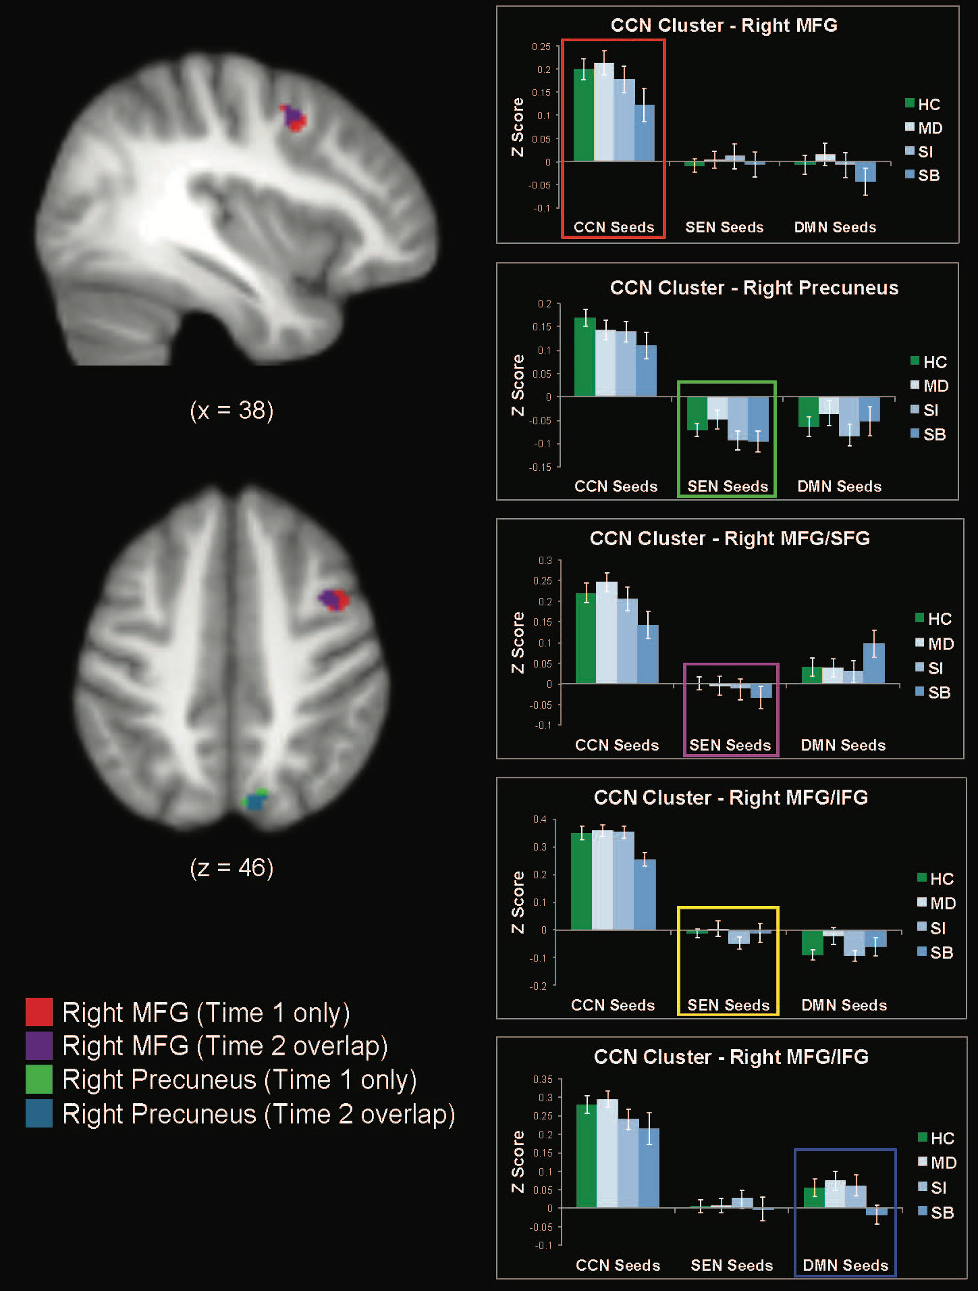

**Supplemental Figure 1.** Time 2 data, extracted from the five clusters that were identified by the three models as differing between groups at Time 1. Plotted by group and by network seed model (error bars represent standard errors from the mean of each group within each contrast; colored boxes are the same color as the relevant cluster and indicate the model that was used to identify the cluster).



**Supplemental Figure 2.** Extracted values within selected clusters plotted separately among individuals with a mood disorder with no self-injurious behavior (MD; *n* = 52), among individuals with a mood disorder with a history of suicidal ideation but no self-injurious behavior (SI; *n* = 60), among individuals with suicidal behavior but not definite intent (SB; *n* = 8), and among individuals with a suicide attempt (SA, indicated by “definite” suicidal intent on DIGS; *n* = 9). Error bars represent standard errors from the mean of each group.

~~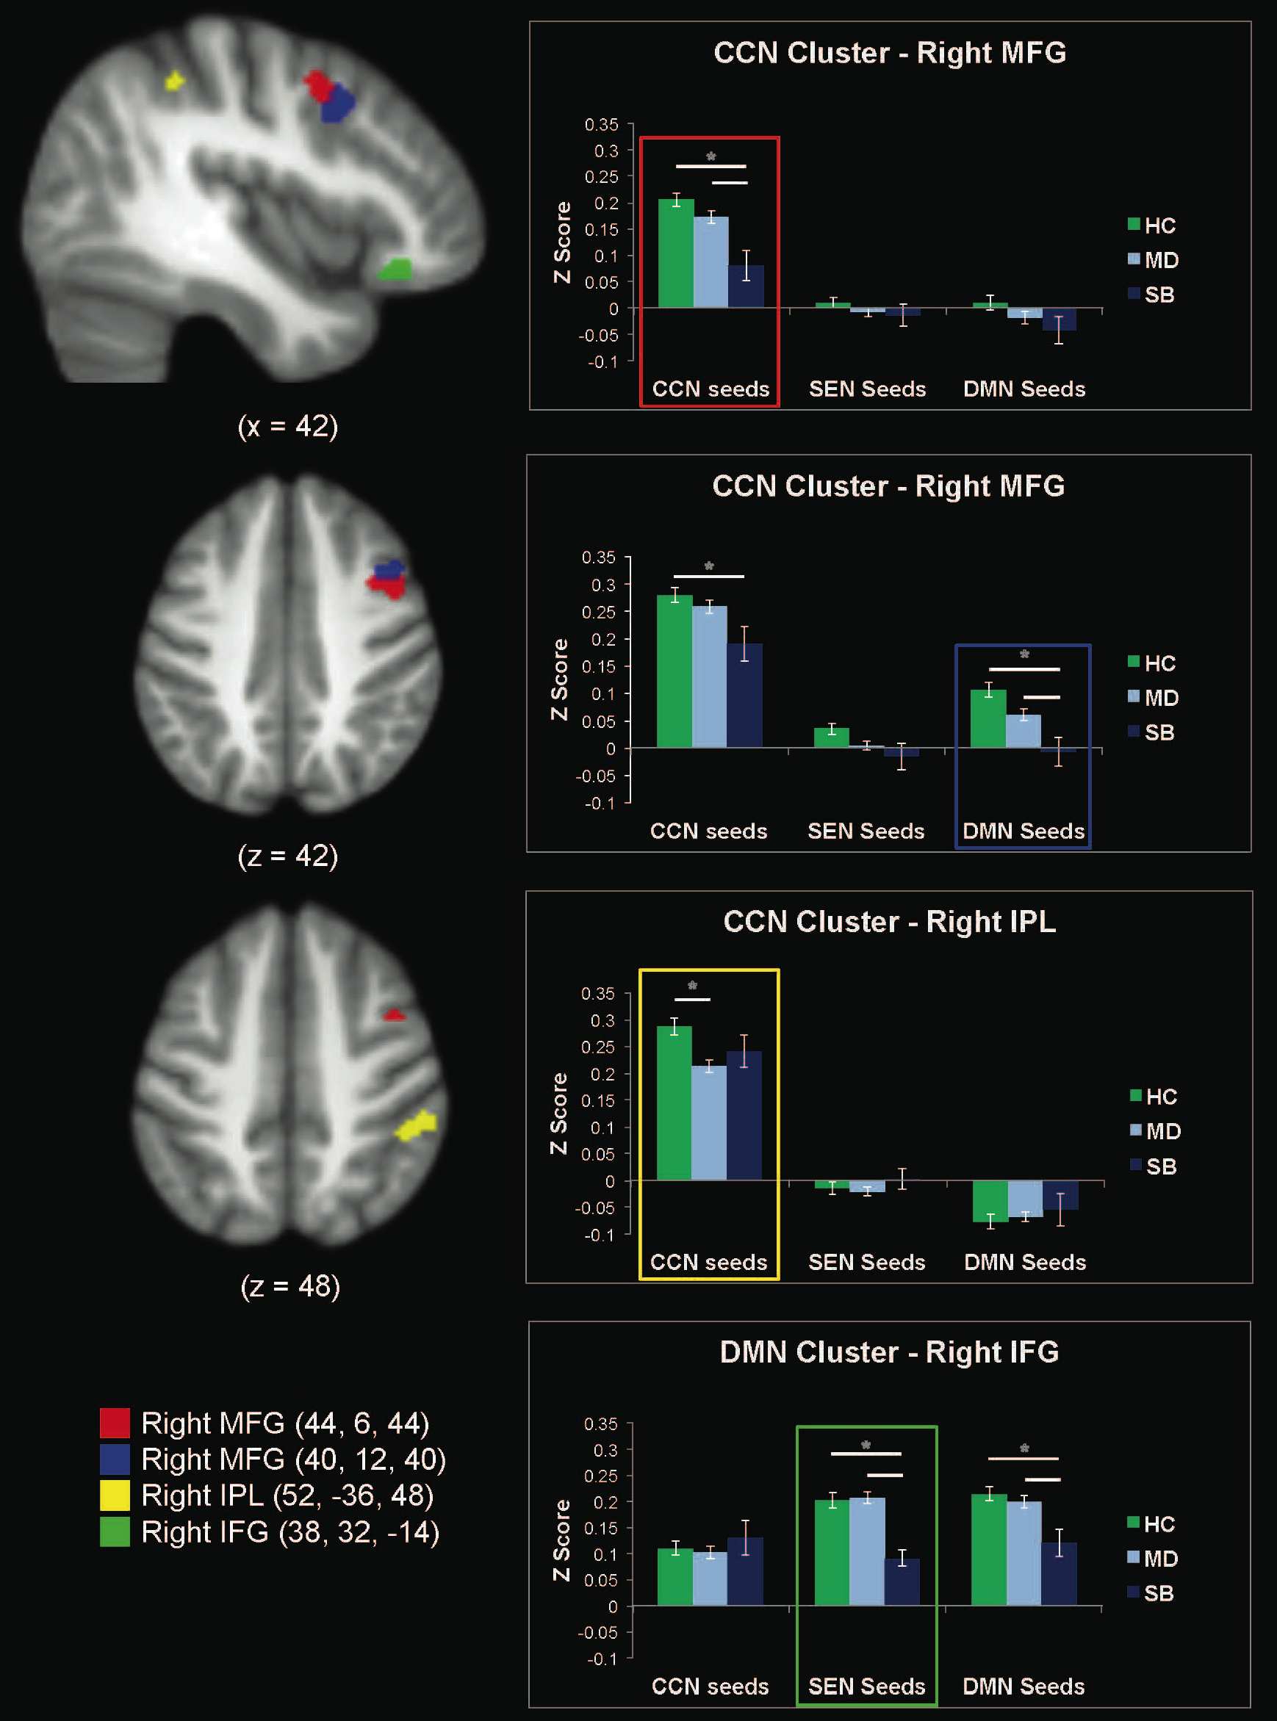~~

**Supplemental Figure 3.** Data extracted from the four clusters that were identified by the three 3-group (SB, MD, HC) models as differing at Time 1. Includes spatial maps of significant main effect contrasts, and extracted values within each contrast cluster plotted by group and by network seed model (error bars represent standard errors from the mean of each group within each contrast; colored boxes represent the model that was used to identify the cluster).

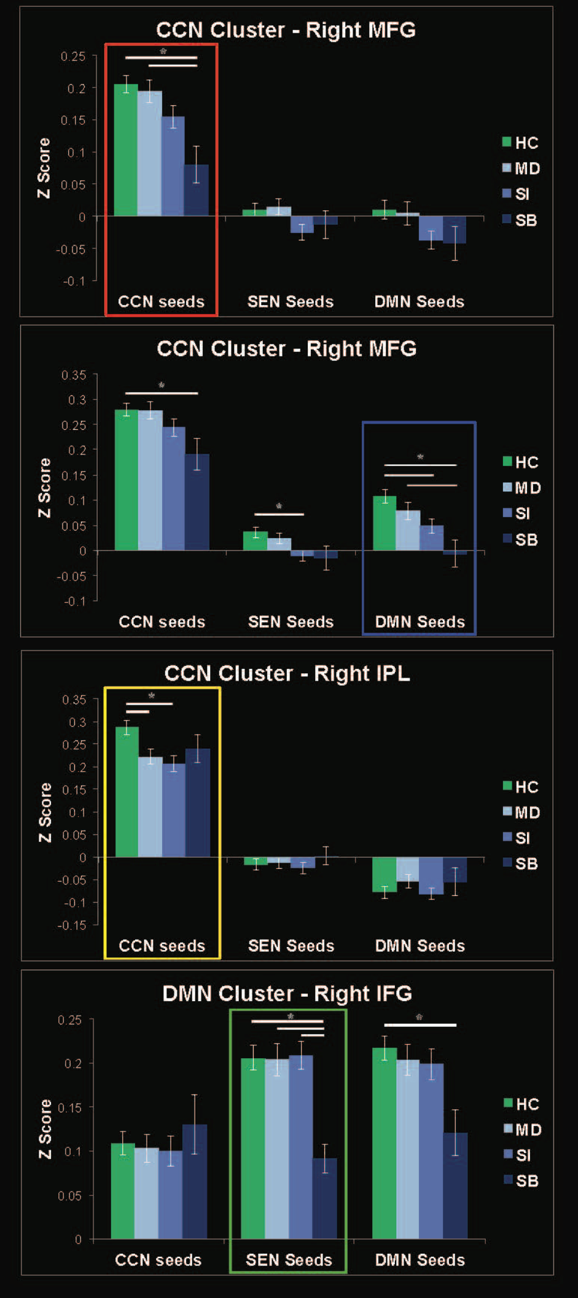

**Supplemental Figure 4.** Comparison of four groups on data extracted from the four clusters that were identified by the three 3-group (SB, MD, HC) models as differing at Time 1. Plotted by four groups (healthy comparison [HC], mood disorder with no history of suicidal ideation or behavior [MD], mood disorder with history of suicidal ideation only [SI], and mood disorder with history of suicidal behavior [SB]) and by network seed model (error bars represent standard errors from the mean of each group within each contrast; colored boxes represent the model that was used to identify the cluster).