Supplemental Materials

Inter-relationships among psychopathology, premorbid adjustment, cognition, and psychosocial functioning in first-episode psychosis: a network analysis approach

Chang WC*^{1,2}, Wong CSM¹, Or PCF¹, Chu AOK¹, Hui CLM¹, Chan SKW^{1,2}, Lee EMH¹,
Suen YN¹, Chen EYH^{1,2}

Supplementary Materials

- Table S1. Zero-order correlation matrix of the variables selected for the network analysis
- Figure S1. Bootstrapped 95% confidence intervals of edge weights
- Figure S2. Case-dropping subset bootstrap procedure to assess stability of centrality indices
- Figure S3. Bootstrapped difference tests for edge-weights
- Figure S4. Bootstrapped difference tests for node strength
- Appendix. Script for R-network

Table S1. Zero-order correlation matrix of the variables selected for the network analysis
 | PAS | DUP | POS | DIS | EXC | AMO | DE | DEP | DSym | DSpn | LM | VR | VF | WCST | RFS | SF12
PAS | 1.00
DUP | 0.09 | 1.00
POS | 0.15 | 0.29 | 1.00
DIS | 0.17 | 0.10 | 0.31 | 1.00
EXC | 0.15 | 0.11 | 0.39 | 0.19 | 1.00
AMO | 0.34 | 0.10 | 0.26 | 0.33 | 0.28 | 1.00
DE | 0.16 | -0.05 | 0.01 | 0.32 | 0.15 | 0.51 | 1.00
DEP | -0.01 | 0.19 | 0.17 | 0.10 | 0.09 | 0.23 | 0.09 | 1.00
DSym | -0.07 | -0.08 | -0.13 | -0.29 | -0.05 | -0.24 | -0.20 | -0.12 | 1.00
DSpn | -0.03 | -0.04 | -0.17 | -0.26 | -0.15 | -0.03 | -0.01 | -0.13 | 0.34 | 1.00
LM | -0.14 | -0.01 | -0.07 | -0.23 | -0.04 | -0.11 | -0.11 | 0.06 | 0.36 | 0.24 | 1.00
VR | 0.01 | -0.06 | -0.12 | -0.22 | -0.01 | -0.11 | -0.05 | -0.06 | 0.30 | 0.22 | 0.29 | 1.00
VF | -0.05 | -0.06 | -0.06 | -0.17 | 0.01 | -0.15 | -0.17 | -0.12 | 0.45 | 0.36 | 0.33 | 0.25 | 1.00
WCST | 0.11 | 0.11 | 0.16 | 0.23 | 0.05 | 0.19 | 0.10 | 0.03 | -0.33 | -0.23 | -0.28 | -0.27 | -0.27 | 1.00
RFS | -0.25 | -0.21 | -0.27 | -0.28 | -0.21 | -0.52 | -0.29 | -0.20 | 0.23 | 0.09 | 0.12 | 0.19 | 0.16 | -0.15 | 1.00
SF12 | -0.03 | -0.17 | -0.23 | -0.16 | -0.06 | -0.18 | -0.06 | -0.42 | 0.16 | 0.11 | 0.04 | 0.15 | 0.08 | -0.08 | 0.27 | 1.00

Fig. S1. Bootstrapped 95% confidence intervals of edge weights
Note: The red line indicates the sample edge-weight (sorted in increasing order in x-axis) and the gray bar is the bootstrapped confidence interval. In y-axis, edge labels are omitted to avoid cluttering.

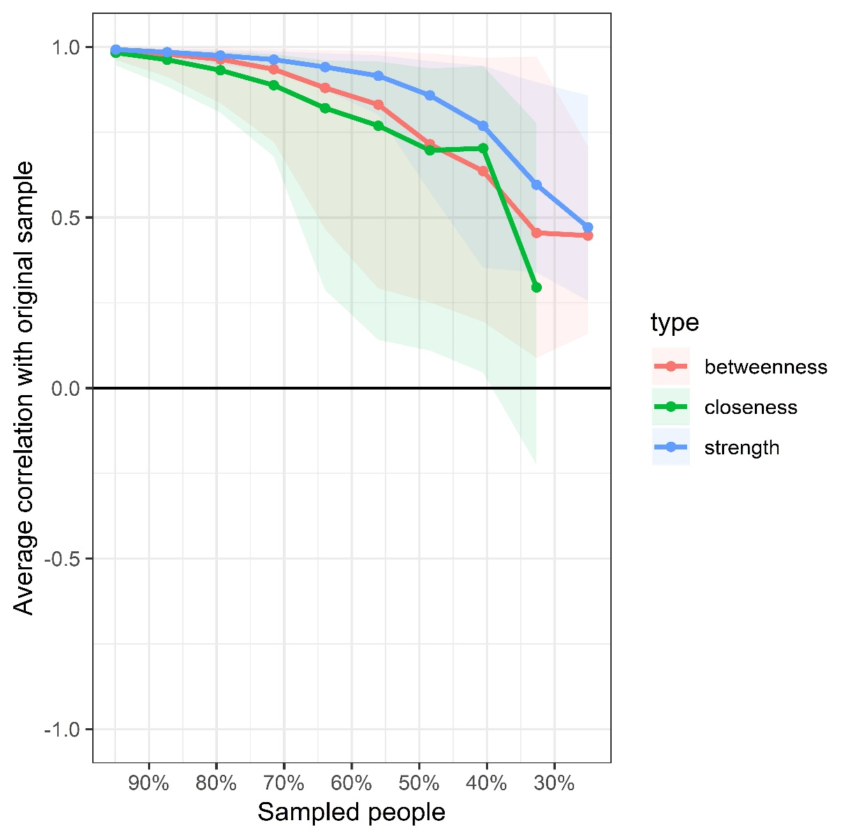

Fig. S2. Case-dropping subset bootstrap procedure to assess stability of centrality indices
Note: Average correlations (y-axis) between centrality indices of the original network for the whole sample and those estimated from networks for subsamples with participants dropped (x-axis, percentages of sampled participants). Lines indicate values of average correlations and areas indicate range from the 2.5th quantile to the 97.5th quantile.

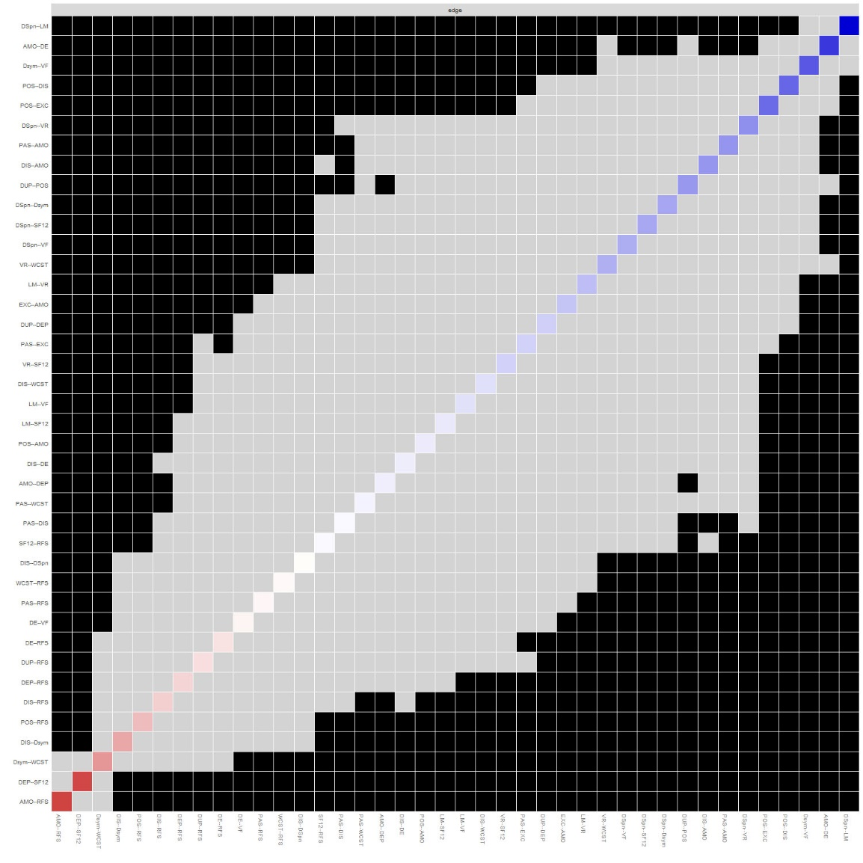

Fig. S3. Bootstrapped difference tests for edge-weights
Note: Gray boxes indicate edge-weights that do not differ significantly from one another, while black boxes indicate edge-weights that do differ significantly. Blue and red boxes on the diagonal correspond to edge-weights with positive and negative correlations, respectively.

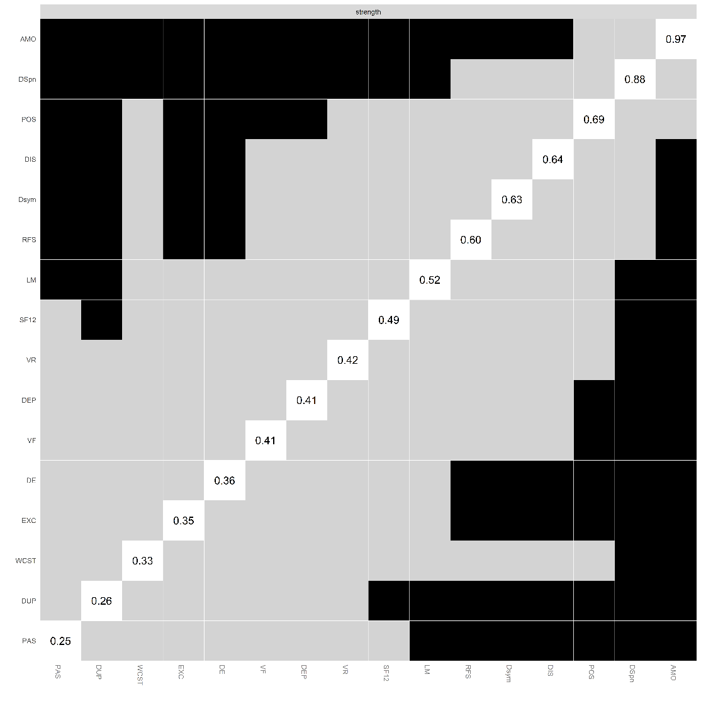

Fig. S4. Bootstrapped difference tests for node strength
Note: Gray boxes indicate node strengths that do not differ significantly from one another, while black boxes indicate node strengths that do differ significantly. The number in the white boxes (i.e., diagonal line) represent the value of node strength.

Appendix. Script for R-network

Script for R-network construction and analyses, and estimation of network accuracy and stability.

###################
#**Import libraries** #
###################
library(boot)
library(ggplot2)
library(foreign)
library(dplyr)
library(bootnet)
library(qgraph)
library(NetworkComparisonTest)
library(huge)
library(matrixcalc)
library(corpcor)
library(graphics)
library(igraph)
library(rgr)

####################################
# Reda data, set up dataframe with labels #
####################################
networkdata=read.spss("source path",to.data.frame = TRUE)
netdf <- subset(networkdata, select=c(DUP, PAS, POS, DIS, EXC, AMO, DE, DEP, DSym, DSpan, LM, VF, VR, WCST, SF12, RFS))

####################################
# Unregularized partial correlation network #
####################################
# paritial correlation
corNet <- cor_auto(netdf, npn.SKEPTIC = FALSE, missing = "pairwise")
# npn
npnNet <- huge.npn(corNet, npn.func = "skeptic")
#Unregularized partial correlation network
Graph_pcor <- qgraph(corNet, graph = "pcor", layout = "spring", threshold = "none", sampleSize = nrow(netdf), alpha = 0.05)

#############################################
# Regularized partial correlation network #
#############################################
#"npn" will apply the nonparanormal transformation (via huge.npn)
# and then compute correlations

#EBIC hyperparameter gamma
network050 <- estimateNetwork (netdf, default = "EBICglasso", corMethod = "npn", tuning = 0.5, verbose = TRUE, weighted = TRUE, signed = TRUE)
NetworkPlot <- plot(network050, layout = "spring", theme = "classic", weighted = TRUE, signed = TRUE, statistics = c("strength", "closeness", "betweenness"))
centrality(network050)

#Generate centrality plot
centralityPlot(network050, include =c("Strength", "Closeness", "Betweenness"))
centralityPlot(network050,include =c("Strength", "Closeness", "Betweenness"), orderBy = "Strength")

###############################
# Edge-weight accuracy: Bootstrap #
###############################
#Generate 95%CI for edge-weights to examine their stability
#by default, non-parametric bootstrap is used
boot1 <- bootnet(network050, nBoots = 3000, default = "EBICglasso", nCores = 6)

plot(boot1, labels = TRUE, order = "sample")

#Plot significant differences (alpha = 0.05) of edges:
plot(boot1, "edge", plot = "difference",onlyNonZero = TRUE, order = "sample", labels.scale= TRUE)

# Plot significant differences (alpha = 0.05) of node strength:
plot(boot1, "strength", plot = "difference", order = "sample")

#Accuracy of centrality indices

#case-drop subset bootstrap
boot2 <- bootnet(network050, nBoots = 3000, type = "case", default = "EBICglasso", nCores = 6)
plot(boot2, labels = TRUE, order = "sample")
corStability(boot2, cor = 0.7)

#Quantify accuracy by generating CS coefficient, by default a correlation of 0.7 btw bootstrap sample and original sample was tested

boot3 <- bootnet(network050, nBoots = 3000, default = "EBICglasso", type = "node", nCores = 6) #node-drop subset bootstrap
plot(boot3, labels = FALSE,order = "sample")
corStability(boot3)

########################################
# Network Comparison Test Gender #
########################################
group1=read.spss("source path male",to.data.frame = TRUE)

group1df <- subset(group1, select=c(DUP, PAS, POS, DIS, EXC, AMO, DE, DEP, DSym, DSpan, LM, VF, VR, WCST, SF12, RFS))

group2=read.spss("source path female",to.data.frame = TRUE)
group2df <- subset(group2, select=c(DUP, PAS, POS, DIS, EXC, AMO, DE, DEP, DSym, DSpan, LM, VF, VR, WCST, SF12, RFS))

#remove missing data (i.e. NA)
#https://www.rdocumentation.org/packages/rgr/versions/1.1.15/topics/remove.na

library("rgr")
group1dfNA <- remove.na(group1df)
group2dfNA <- remove.na(group2df)

group1dfNAMatrix <- data.matrix(group1dfNA[["x"]], rownames.force = NA)
group2dfNAMatrix <- data.matrix(group2dfNA[["x"]], rownames.force = NA)

#execute Network Comparasion Test
#require: parameter data1, data2 without missing data (i.e. NA), by remove.na function
library('NetworkComparisonTest')
nctnum <- NCT(group1dfNAMatrix, group2dfNAMatrix, 0.5, it=1000, binary.data=FALSE, paired=FALSE, weighted=TRUE, AND=TRUE, test.edges=FALSE, edges, progressbar=TRUE)

set.seed(1)
res2 <- NCT(group1dfNAMatrix, group2dfNAMatrix, test.edges=TRUE, edges="all")

#plot result of network structure and global strength invariance test
plot(nctnum, what="network")

plot(nctnum, what="strength")

