Supplementary Table 1: Allele and genotype frequency of three loci in MIR137
SNP ID | Allele freq. (%) |  | OR (%95CI) | p | Genotype freq. (%) |  |  | OR (%95CI) | p
rs1625579 | Tª | G^{b} | T/G  1.142 (0.81 - 1.62) | 0.477 | TT | GT | GG | (GG+GT)/TT  0.864 (0.60 - 1.25) | 0.457
NC | 1088 (94.6) | 62 (5.4) |  |  | 515 (89.6) | 59 (10.2) | 1 (0.2)
SZ | 1106 (93.9) | 72 (6.1) |  |  | 519 (88.1) | 69 (11.7) | 1 (0.2)
rs1702294 | C | T | C/T  1.142 (0.81 - 1.62) | 0.477 | CC | CT | TT | (CT+TT)/CC  0.866 (0.61- 1.25) | 0.460
NC | 1088 (94.6) | 62 (5.4) |  |  | 514 (89.4) | 60 (10.4) | 1 (0.2)
SZ | 1106 (93.9) | 72 (6.1) |  |  | 518 (87.9) | 70 (11.9) | 1 (0.2)
rs1198589 | C | T | C/T  1.087 (0.77 - 1.54) | 0.660 | CC | CT | TT | (CT+TT)/CC  0.898 (0.63- 1.29) | 0.582
NC | 1085 (94.4) | 65 (5.6) |  |  | 512 (89.0) | 61 (10.6) | 2 (0.4)
SZ | 1106 (93.9) | 72 (6.1) |  |  | 518 (87.9) | 70 (11.9) | 1 (0.2)
Note: SZ: schizophrenia patients; NC: normal controls; CI: confidence interval; OR: odds ratio.
ª The effect allele
^{b} The reference allele
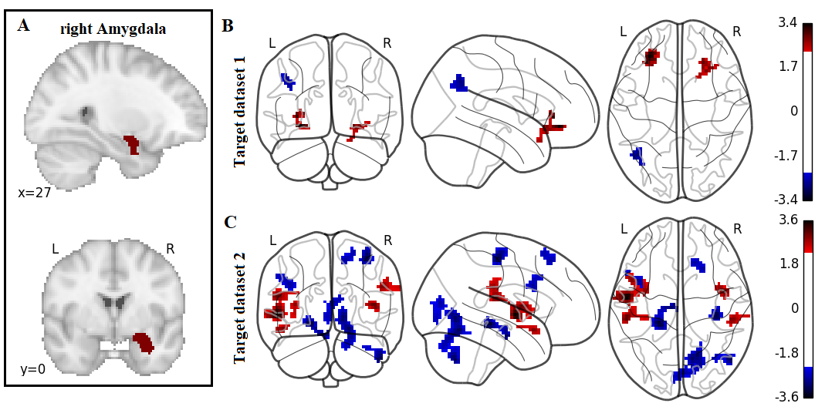
Supplementary Figure 1: The association between the MIR137 PRS and the FCs of the right Amygdala. (A) Right amygdala as ROI; (B) multiple regression testing the association between the MIR137 PRS and the FCs of the right amygdala in target dataset 1 with AlphaSim correction (single voxel P < .01, corrected threshold P < .05 and cluster size threshold CS > 31 voxels); (C) multiple regression testing the association between the MIR137 PRS and the FCs of the right amygdala in target dataset 2 with AlphaSim correction (single voxel P < .01, corrected threshold P < .05 and cluster size threshold CS > 31 voxels).

