Supplemental materials

Impairment in the Goal-Directed Corticostriatal Learning System as a Biomarker for Obsessive-Compulsive Disorder
Chenjie Dong^{1*}, Qiong Yang^{2, 3*}, Jingjing Liang¹, Zhen Wei⁴, Carol A. Seger^{1, 6}, Hongying Han⁵, Yuping Ning^{2, 3}, Qi Chen¹ and ZiWen Peng^{7, 1}

- Results of one sample T test of functional connectivity analysis and Granger Causality analysis
We have employed one-sample T test for functional connectivity (FC) results and Granger Causality analysis (GCA) results of three ROIs, including the bilateral nucleus accumbens, the bilateral caudate and the bilateralputamen. The results showed that three distinguished distributions were existed in each sub-network on striatum, sensorimotor network, associative network and limbic network, which is consistent with previous study that sub regions in striatum showed districted sub-networks (Figure. S1).

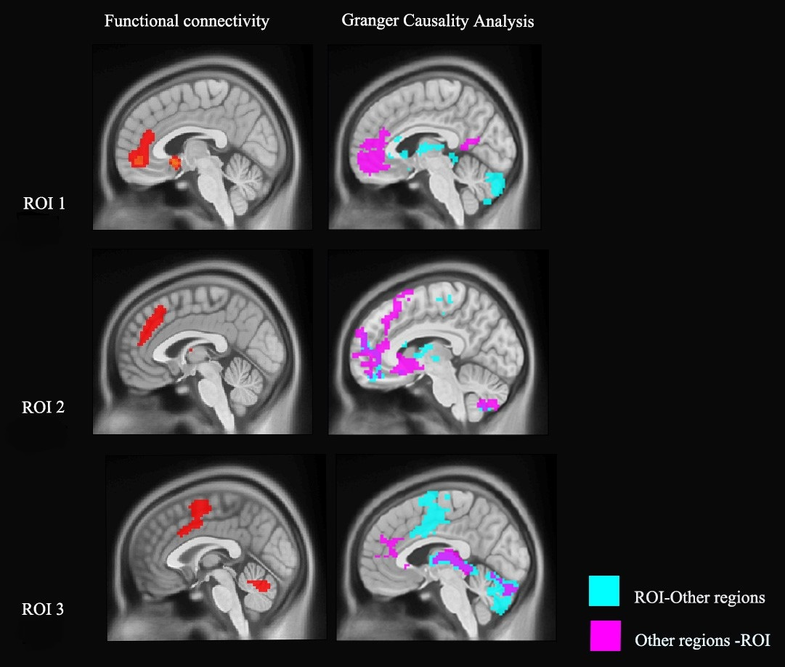
Fig. S1. Results of one sample T test of functional connectivity analysis and GCA analysis on three striatum subregions (all participants n=105).ROI: Regions of Interest; ROI1: nucleus accumbens; ROI2: caudate; ROI3: putamen. Our study clearly distinguished the different distribution of GCA effect of each sub-network on striatum. (FDR correction, p<0.05)

2. GCA results of OCD patients, age matched siblings and healthy controls.
Because the sample of OCD first-degree relatives in present study included both siblings and parents, the average age of the first-degree relatives group was significantly higher than the OCD group and control group. Therefore, we performed an additional analysis comparing EC between the OCD, age matched siblings and healthy control groups. The results showed patterns that were very similar to the main analysis including all first-degree relatives (figure. S2, figure. S3).

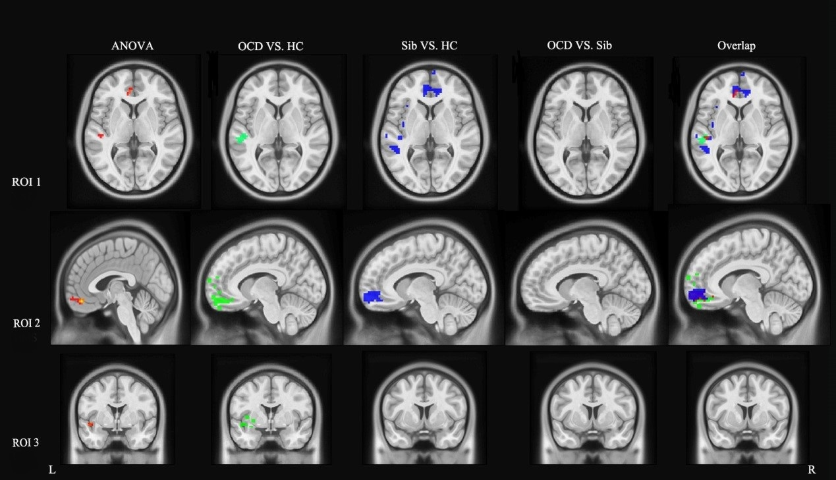
Fig. S2. GCA coefficients difference from three left ROIs to other brain regions among OCD patients, unaffected siblings and healthy controls. ROI: Regions of Interest; ROI1: nucleus accumbens; ROI2: caudate; ROI3: putamen. OCD: Obsessive–compulsive disorder group; Sib: unaffected sibling group; HC: healthy control group; Overlap: Overlap regions between OCD compared with HC and Sib compare with HC; (GRF correction, cluster level p< 0.05, voxel level p<0.01, corrected)

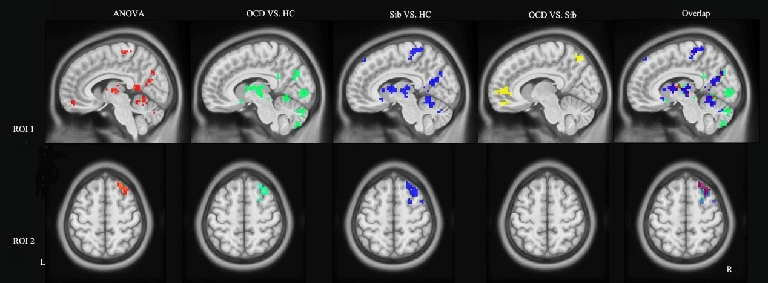
Fig.S3. GCA coefficient differences from other brain regions to two left striatal ROIs for OCD patients, unaffected siblings and healthy controls. ROI: Regions of Interest; ROI1: nucleus accumbens; ROI2: caudate. OCD: Obsessive–compulsive disorder group; Sib: unaffected sibling group; HC: healthy control group; Overlap: Overlap regions between OCD compared with HC and Sib compare with HC; (GRF correction, cluster level p< 0.05, voxel level p<0.01, corrected)

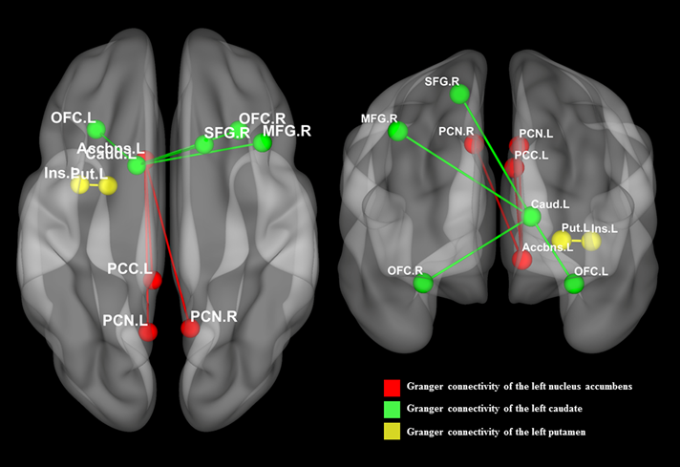
Fig.S4. Between-group differences in Granger connectivity of left striatal ROIs.
Both OCD patients and their first-degree relatives showed changes in effective connectivity in caudate (green) and nucleus accumbens (red), including increased EC from PCC to left nucleus accumbens, and increased EC from left caudate to OFC, and decreased EC from DLPFC to left caudate. Only the OCD patients showed increased EC from putamen to insula (yellow).
Abbreviations: Accumbens, nucleus accumbens; Caud, caudate; Ins, insula; L, left hemisphere; MFG, medial frontal gyrus; OFC, orbital frontal cortex; PCC, posterior cingulate; PCN, precuneus cortex; Put, putamen; R, right hemisphere; SFG, superior frontal gyrus, (GRF correction, cluster level p < 0.05, voxel level p <0.01, corrected).

Table S1 Medication details for OCD patients
Medication | Number of cases | Average dosage (mg)
citalopram | 2 |  | 40
clomipramine | 1 |  | 100
fluoxetine | 2 |  | 46.7
fluvoxamine | 2 |  | 250
mirtazapine | 1 |  | 30
paroxetine | 4 |  | 40
sertraline | 3 |  | 162.5
paroxetine + sodium valproate | 1 |  | 40 + 666.7
paroxetine + quetiapine | 2 |  | 40 + 400

