Cognitive reserve attenuates age-related cognitive decline in the context of putatively accelerated brain ageing in schizophrenia-spectrum disorders

Tamsyn E Van Rheenen, Birgitte Fagerlund, Vanessa Cropley, Cassandra Wannan, Jason Bruggemann, Roshel K Lenroot, Suresh Sundram, Cynthia Shannon Weickert, Thomas W Weickert, Andrew Zalesky, Chad A Bousman and Christos Pantelis

Supplementary material

Participant characterisation.

The ASRB is a register of research data collected by scientific collaborators across five Australian sites¹. ASRB exclusion criteria for participants included: i) a history of organic brain disorder, ii) electroconvulsive therapy in the previous 6 months, iii) current substance dependence, iv) movement disorders, v) brain injury with post-traumatic amnesia or vi) an IQ < 70. Healthy controls with a personal or family history of psychosis or bipolar I disorder were also excluded. Detailed information regarding the consent procedures are available elsewhere ¹. The Diagnostic Interview for Psychosis ² was used to obtain clinical symptom ratings and confirm patient diagnoses according to ICD-10 or DSM-IV criteria. The Scale for the Assessment of Negative Symptoms ³ was used to assess negative symptoms.

Supplementary Table 1. Differences in brain - cognition relationships between cognitive reserve subgroups

DV | Moderator  IV  Interaction | b | se | t | p | 95% Lower bound CI | 95% Upper bound CI | Model summary | Model summary after addition of interaction term
Matrix Reasoning
 | Global Frontal Volume | .00 | .00 | 4.49 | .00 | .00 | .00 | F (8,205) =8.75, p=.00, R²=.33 | F (1,205) =7.91 p=.01, R² change=.03
 | CR subgroup | 4.93 | .76 | 6.44 | .00 | 3.48 | 6.42
 | Interaction | -.00 | .00 | -2.81 | .01 | .00 | .00
 | Conditional effect of IV for Low CR | .00 | .00 | 5.35 | .00 | .00 | .00
 | Conditional effect of IV for Average CR | .00 | .00 | 2.79 | .01 | .00 | .00
 | Pars Orbitalis Volume | .00 | .00 | 3.86 | .00 | .00 | .00 | F (8,205) =7.76 p=.00, R²=.31 | F (1,205) =11.26, p=.00, R² change=.05
 | CR subgroup | 4.99 | .79 | 6.35 | .00 | 3.43 | 6.45
 | Interaction | -.00 | .00 | -3.36 | .00 | -.01 | -.00
 | Conditional effect of IV for Low CR | .01 | .00 | 4.41 | .00 | .00 | .01
 | Conditional effect of IV for Average CR | .00 | .00 | 1.40 | .17 | -.00 | .00
 | Pars Triangularis Volume | .00 | .00 | 4.24 | .00 | .00 | .00 | F (8,205) =8.76, p=.00, R²=34 | F (1,205) =6.44, p=.01, R² change=.03
 | CR subgroup | 4.94 | .78 | 6.31 | .00 | 3.46 | 6.44
 | Interaction | -.00 | .00 | -2.54 | .01 | -.00 | -.00
 | Conditional effect of IV for Low CR | .00 | .00 | 4.21 | .00 | .00 | .00
 | Conditional effect of IV for Average CR | .00 | .00 | 2.29 | .02 | .00 | .00
 | Pars Orbitalis Area | .01 | .00 | 2.30 | .02 | .00 | .01 | F (8,205) =5.94, p=.00, R²=.27 | F (1,205) =6.15, p=.01, R² change=.40
 | CR subgroup | 4.6 | .79 | 5.86 | .00 | 3.19 | 6.19
 | Interaction | -.0 | .01 | -2.47 | .014 | -.02 | -.00
 | Conditional effect of IV for Low CR | .02 | .01 | 2.73 | .01 | .00 | .03
 | Conditional effect of IV for Average CR | .00 | .00 | .75 | .45 | -.00 | .01
 | Pars Triangularis Area | .00 | .00 | 2.89 | .00 | .00 | .01 | F (8,205) =6.89, p=.00, R²=.29 | F (1,205) =6.34, p=.01, R² change=.03
 | CR subgroup | 4.54 | .79 | 5.74 | .00 | 3.09 | 6.13
 | Interaction | -.01 | .00 | -2.51 | .01 | -.01 | -.00
 | Conditional effect of IV for Low CR | .01 | .00 | 3.51 | .00 | .00 | .01
 | Conditional effect of IV for Average CR | .00 | .00 | 1.07 | .28 | -.00 | .00
LNS | Pars Orbitalis Volume | .00 | .00 | 2.38 | .02 | .00 | .00 | F (8,205) =6.01 p=.00, R²=.19 | F (1,205) =6.08, p=.03, R² change=.01
 | CR subgroup | 2.03 | .37 | 5.55 | .00 | 1.34 | 2.72
 | Interaction | -.00 | .00 | -2.47 | .02 | -.00 | -.00
 | Conditional effect of IV for Low CR | .00 | .00 | 2.98 | .00 | .00 | .00
 | Conditional effect of IV for Average CR | .00 | .00 | .41 | .68 | -.00 | .00
 | Pars Triangularis Volume | .00 | .00 | 1.50 | .1341 | -.00 | .00 | F (8,205) =6.49 p=.00, R²=.21 | F (1,205) =11.16, p=.03, R² change=.05
 | CR subgroup | 1.99 | .36 | 5.52 | .00 | 1.31 | 2.67
 | Interaction | -.00 | .00 | -3.34 | .00 | -.00 | -.00
 | Conditional effect of IV for Low CR | .00 | .00 | 3.30 | .00 | .00 | .00
 | Conditional effect of IV for Average CR | -.00 | .00 | -.63 | .53 | -.00 | .00
 | Pars Orbitalis Area | .00 | .00 | 2.43 | .02 | .00 | .01 | F (8,205) =7.10 p=.00, R²=.19 | F (1,205) =7.50, p=.01, R² change=.04
 | CR subgroup | 1.94 | .37 | 5.25 | .00 | 1.26 | 2.63
 | Interaction | -.01 | .00 | -2.74 | .01 | -.01 | -.00
 | Conditional effect of IV for Low CR | .00 | .00 | 2.98 | .00 | .00 | .00
 | Conditional effect of IV for Average CR | .00 | .00 | .41 | .68 | -.00 | .00
 | Pars Triangularis Area | .00 | .00 | 1.47 | .14 | -.00 | .00 | F (8,205) =6.85, p=.00, R²=.21 | F (1,205) =11.15, p=.00, R² change=.05
 | CR subgroup | 1.88 | .36 | 5.18 | .00 | 1.18 | 2.59
 | Interaction | -.00 | .00 | -3.34 | .00 | -.00 | -.00
 | Conditional effect of IV for Low CR | .00 | .00 | 3.30 | .00 | .00 | .00
 | Conditional effect of IV for Average CR | -.00 | .00 | -.63 | .53 | -.00 | .00
CR=cognitive reserve. Site and intracranial volume were controlled in all analyses. Note that only analyses in which the interaction effect survived FDR correction are reported. Values for covariates are not displayed for brevity. Confidence intervals for all but the conditional effects of age for each group are bias corrected.

Supplementary Table 2. Differences in age-related change in working memory performance between cognitive reserve subgroups

DV: | IV  Moderator  Interaction | b | se | t | p | 95% Lower bound CI | 95% Upper bound CI | Model summary | Model summary after addition of highest order unconditional interaction term
LNS |  |  |  |  |  |  |  | F (7,206) =4.69, p=.00, R²=.16 | F (1,206) =3.18 p=.08, R² change=.01
 | Age | -.03 | .02 | -1.88 | .06 | -.07 | .00
 | CR subgroup | 2.12 | .39 | 5.49 | .00 | 1.39 | 2.83
 | Age* CR subgroup | .07 | .04 | 1.79 | .08 | -.00 | .15
 | Conditional effect of age for Low CR subgroup | -.08 | .04 | -2.23 | .03 | -.15 | -.01
 | Conditional effect of age for Average CR subgroup | -.01 | .02 | -.43 | .67 | -.05 | .03
¹ Controlling for site. CR=cognitive reserve, HC = healthy controls. Values for covariates are not displayed for brevity. Note that the interaction is only trending toward significance, but post-hoc probing of effects show an effect of age on LNS scores for only the Low CR group. Confidence intervals for all but the conditional effects of age for each group are bias corrected.

Supplementary Table 3. Differences in age-related change in fluid reasoning between cognitive reserve subgroups versus controls

 | DV: | Variables | b | se | t | p | 95%  Lower bound CI | 95% Upper bound CI | Model summary | Model summary  after addition of  highest order unconditional interaction term
Table 3a | MR |  |  |  |  |  |  |  | F (10,371) =13.41, p=.00, R²=.57 | F (2,371) = 6.94,  p=.00, R² change=.04
 |  | Age effects irrespective of group | -.10 | .03 | -3.54 | .00 | -.16 | -.05
 |  | MR difference for Average CR subgroup vs HC | -1.58 | .51 | -3.13 | .00 | -2.56 | -.60
 |  | MR difference for Low CR subgroup vs HC | -7.48 | .79 | -9.43 | .00 | -9.08 | -5.97
 |  | Age effect difference for Average CR subgroup vs HC | .01 | .04 | .26 | .79 | -.07 | .09
 |  | Age effect difference for Low CR subgroup vs HC | -.27 | .08 | -3.51 | .00 | -.42 | -.12
 |  | Conditional effect of age for HC | -.10 | .03 | -3.54 | .00 | -.16 | -.05
 |  | Conditional effect of age for Average CR | -.09 | .03 | -2.98 | .00 | -.15 | -.03
 |  | Conditional effect of age for Low CR | -.37 | .07 | -5.26 | .00 | -.51 | -.23
¹ Controlling for site, gender. Values for covariates are not displayed for brevity. MR= Matrix Reasoning, LNS=Letter Number Sequencing, CR=cognitive reserve. Confidence intervals for all but the conditional effects of age for each group are bias corrected.

Supplementary Figure 1. Visual guide to sequential analysis steps. MR = Matrix Reasoning; LNS= Letter Number Sequencing; GF=global frontal; SF=superior frontal, RMF = rostral middle frontal; CMF=caudal middle frontal, POP=pars opercularis, PT=pars triangularis, PORB=pars orbitalis, LOF=lateral orbitofrontal; MOF=medial orbitofrontal, PC=precentral and PARA=paracentral, FP= frontal pole volume.¹ = Group was specified as a multicategorical moderator and results were produced in reference to the difference between each CR group and controls

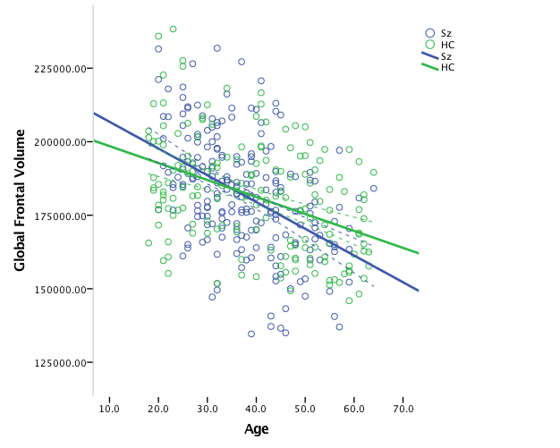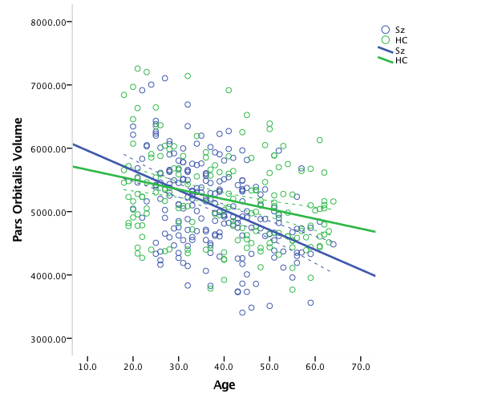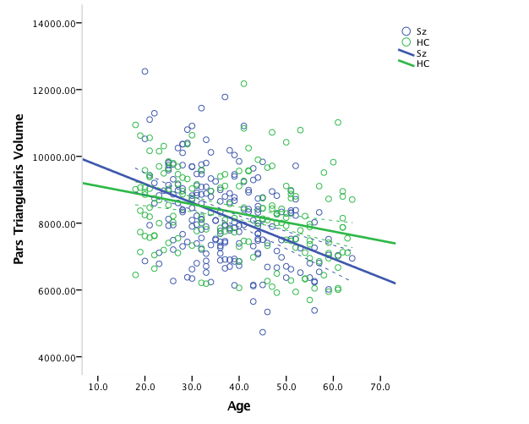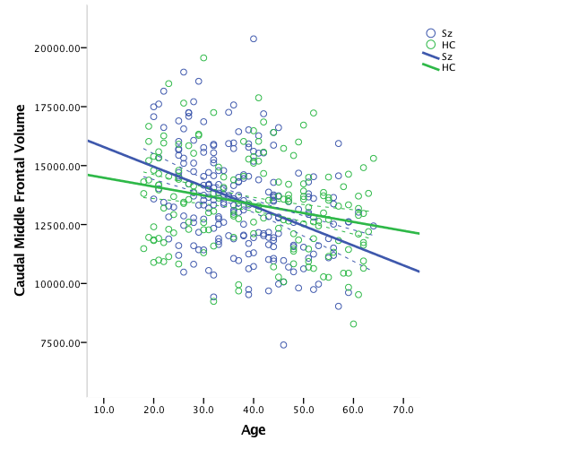
a)

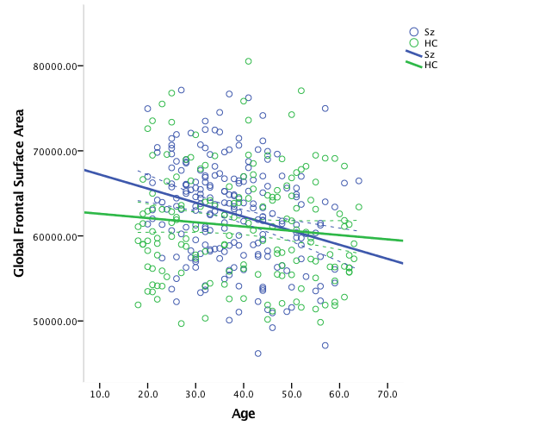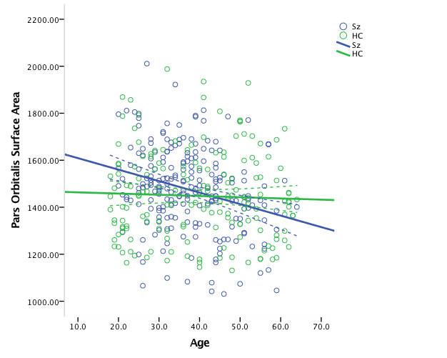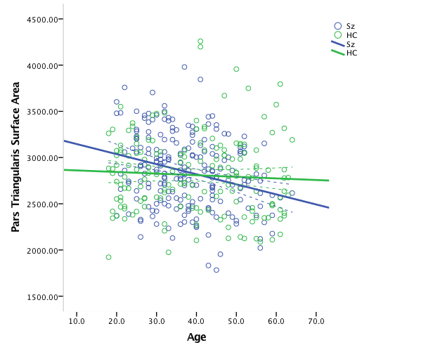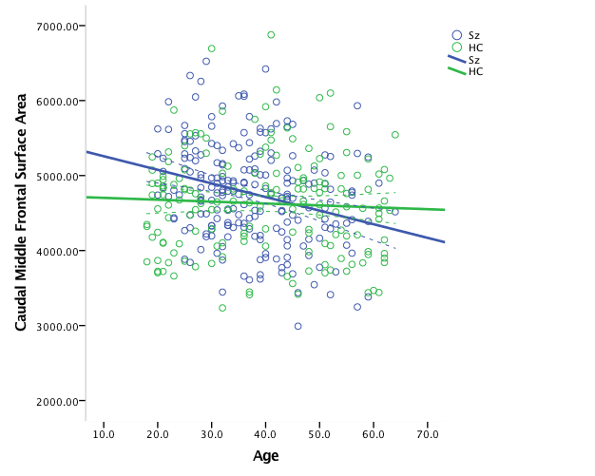
b)

Supplementary Figure 2. Diagnostic differences in age-related brain structural change; Panel A) Volume; Panel B) Surface area. Volume is reported in mm³, surface area reported in mm², age is reported in years. Sz = schizophrenia-spectrum group; HC = healthy controls. Graphs represent brain regions for which age*diagnosis interactions survived FDR correction.

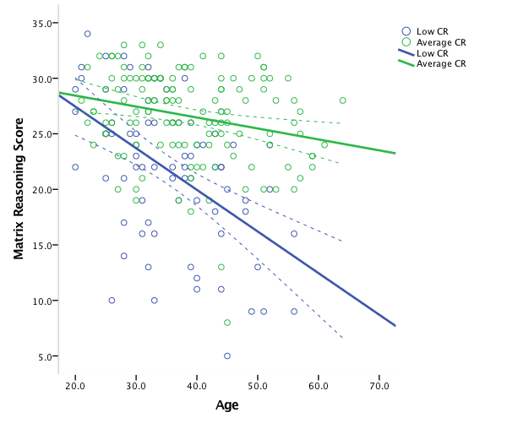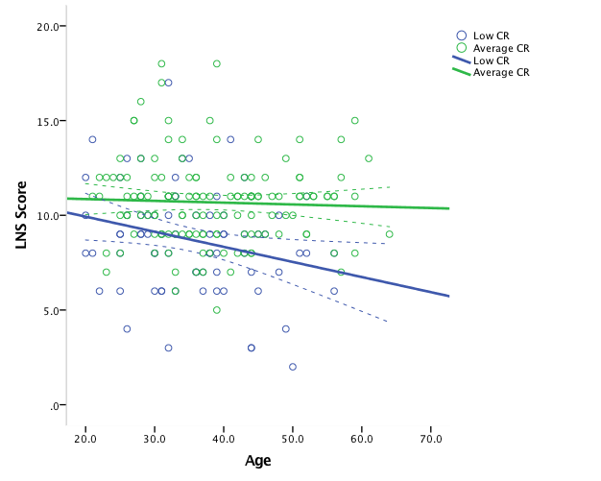
b)
a)

Supplementary Figure 3. Age-related decline in cognition for low and average cognitive reserve (CR) schizophrenia-spectrum subgroups. a) Matrix Reasoning; b) Letter Number Sequencing (LNS). Age is reported in years. Note that the age* CR interaction effect for Matrix Reasoning survived FDR correction, but the age* CR subgroup interaction for the LNS only trended toward significance. The effects of age on LNS scores differed between CR subgroups, such that only the low CR subgroup showed a decline in LNS performance with age. Age-related decline in Matrix Reasoning performance was evident for both low and average CR subgroups, but decline was significantly more exaggerated in the former.

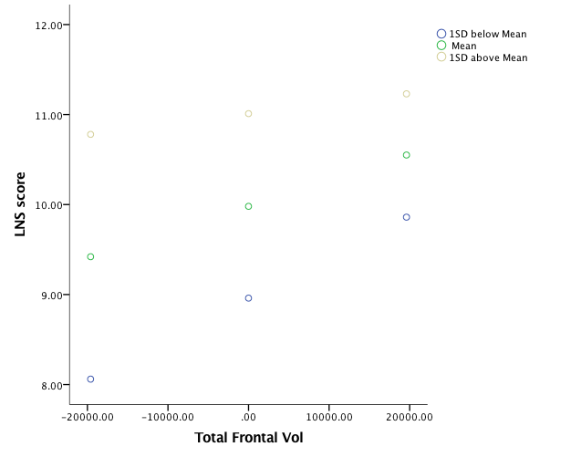
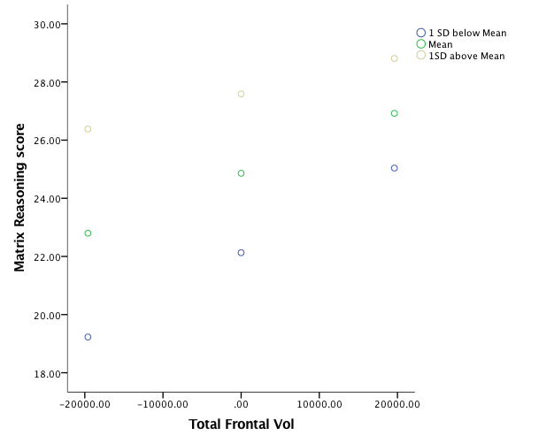

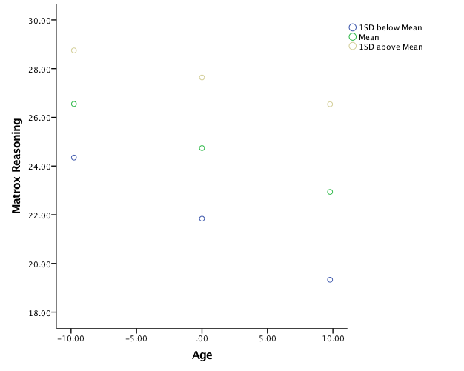
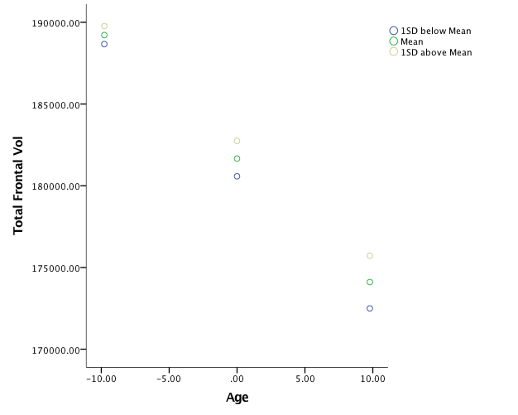

Supplementary Figure 4. Example of analyses outcomes when cognitive reserve (CR) was analyzed as a continuous variable in the schizophrenia-spectrum group. The outcomes of only some analyses are presented for demonstration purposes. Analyses are reported as a function of high (1SD above mean), medium (at mean) or low (1SD below mean) CR. a) cognition-global frontal volume relationships; b) age-global frontal volume relationship; c) age-cognition relationships.

References

1. Loughland C, Draganic D, McCabe K, et al. Australian Schizophrenia Research Bank: a database of comprehensive clinical, endophenotypic and genetic data for aetiological studies of schizophrenia. Aust. N. Z. J. Psychiatry. 2010;44(11):1029-1035.
2. Castle DJ, Jablensky A, McGrath JJ, et al. The diagnostic interview for psychoses (DIP): development, reliability and applications. Psychol. Med. 2006;36:69-80.
3. Andreasen NA. Scale for the Assessment of Negative Symptoms. 1984.
4. Dale AM, Fischl B, Sereno MI. Cortical surface-based analysis: I. Segmentation and surface reconstruction. Neuroimage. 1999;9(2):179-194.
5. Fischl B, Sereno MI, Dale AM. Cortical surface-based analysis: II: inflation, flattening, and a surface-based coordinate system. Neuroimage. 1999;9(2):195-207.
6. Fischl B, Dale AM. Measuring the thickness of the human cerebral cortex from magnetic resonance images. Proceedings of the National Academy of Sciences. 2000;97(20):11050-11055.
7. Fischl B, Salat DH, Busa E, et al. Whole brain segmentation: automated labeling of neuroanatomical structures in the human brain. Neuron. 2002;33(3):341-355.
8. Desikan RS, Ségonne F, Fischl B, et al. An automated labeling system for subdividing the human cerebral cortex on MRI scans into gyral based regions of interest. Neuroimage. 2006;31(3):968-980.

