Other Supplementary Material
Validation of the Process Analyses using the Full Sample
Using data from the full sample, we tested the model in which the two time-invarying covariates, change in mental health knowledge and peer support, predicted the trajectory of the outcome variable, Total DASS slope. Although a poorer fit than with the subsample, the model had adequate fit with the full sample data, χ² (11) = 31.323, p = .001, χ²/df = 2.848, CFI = 0.962, TLI = 0.927, RMSEA = 0.043. The results were similar to that with the subsample; peer support significantly predicted the trajectory of Total DASS from the core program’s start to the 6-month follow-up; change in mental health knowledge did not. The standardized path coefficient from Peer Support to the Total DASS slope was significant (β = -.994, p < .001) suggesting that a higher rating of group helpfulness predicts a more rapid decline in psychological distress over the course of the program and the 6-month follow-up period while controlling for the influence of change in mental health knowledge.
Next, the final model (Figure 2) was run with the full sample and it demonstrated good model fit to the data, χ² (78) = 190.878, p < .001, χ²/df = 2.447, CFI = 0.948, TLI = 0.931, RMSEA = 0.038. The standardized path coefficients are reported in Supplementary Figure 1. Both the level of group helpfulness and the change in knowledge significantly predicted the self-blame and stigmatising attitudes trajectory, and the communication trajectory from the start of the core program to the 6-month follow-up. The more mental health knowledge gained during the program and the higher ratings of perceived group helpfulness predicted a more rapid decline in levels of self-blame and stigma, and a more rapid increase in communication with their relative over the course of the core program, the consolidation period, and the 6-month follow-up, while controlling for the influence of the other key input.

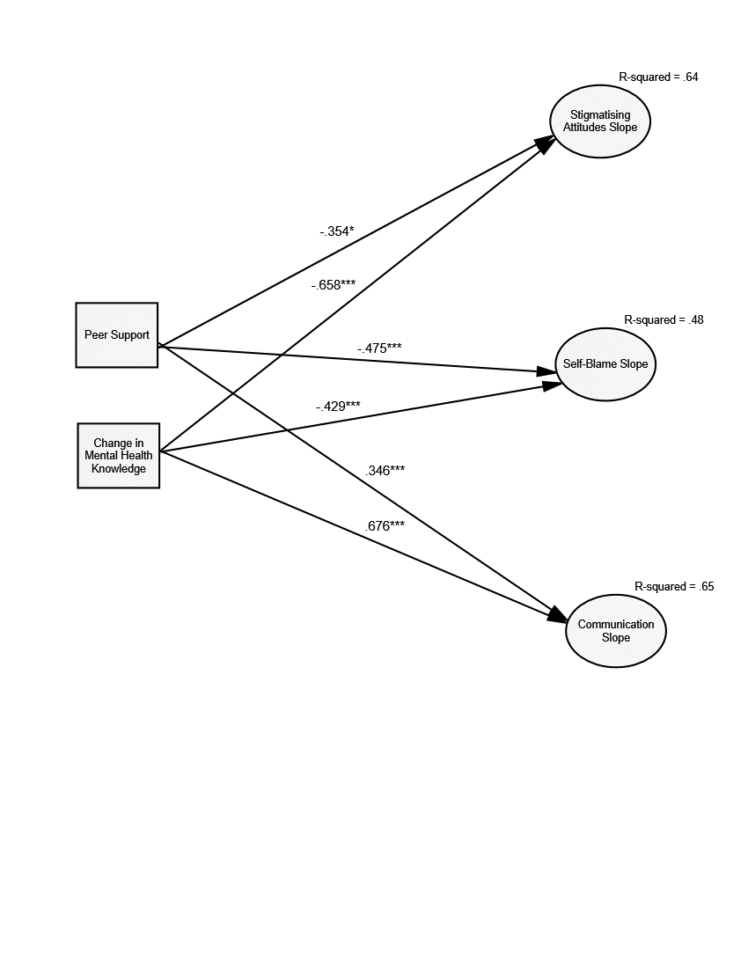
Supplementary Figure 1. Final multivariate latent growth model for growth in process variables from the start of the programme through the follow-up period using the full sample. Path coefficients are standardized. Intercept, observed indicators, and covariances among the residual variances are omitted from the figure. *p < .05. **p < .01. ***p < .001.

Supplementary Table 1.
Inter-correlations for model variables at Time 2 (Full sample).

 | 1 | 2 | 3 | 4 | 5 | 6 | 7 | 8 | 9 | 10 | 11
1. Depression DASS subscale^ | -
2. Anxiety DASS subscale ^ | .54* | -
3. Stress DASS subscale | .66* | .61* | -
4. Communication | -.25* | -.15* | -.20* | -
5. Relationship Feelings | -.33* | -.20* | -.30* | .57* | -
6. Relationship Quality | -.23* | -.07 | -.13* | .69* | .66* | -
7. Stigmatising attitudes ^ | .15* | .17* | .09 | -.31* | -.24* | -.25* | -
8. Self-blame | .37* | .33* | .36* | -.24* | -.28* | -.17* | .51* | -
9. Knowledge | -.13* | -.10 | -.05 | .37* | .19* | .24* | -.33* | -.29* | -
10. Peer Support ^ | -.08 | -.09 | -.15* | .24* | .10* | .12* | -.13* | -.21* | .19* | -
11. Total DASS | .83* | .74* | .90* | -.23* | -.30* | -.14* | .15* | .39* | -.12* | -.13* | -
Note: * p<.05, n = 395, ^ = transformed variable used in analysis. DASS = the Depression, Anxiety and Stress Scale-21.

Supplementary Table 2.
Inter-correlations for model variables at Time 2 (Subsample).

 | 1 | 2 | 3 | 4 | 5 | 6 | 7 | 8 | 9 | 10 | 11
1. Depression DASS subscale^ | -
2. Anxiety DASS subscale ^ | .53* | -
3. Stress DASS subscale | .62* | .59* | -
4. Communication | -.25* | -.16* | -.12 | -
5. Relationship Feelings | -.37 | -.23* | -.26* | .52* | -
6. Relationship Quality | -.28 | -.10 | -.08 | .66* | .69* | -
7. Stigmatising attitudes ^ | .13 | .21* | .02 | -.30* | -.23* | -.22* | -
8. Self-blame | .39* | .35* | .29* | -.20* | -.26* | -.17* | .57* | -
9. Knowledge | -.05 | -.08 | .04 | .42* | .20* | .29* | -.36* | -.32* | -
10. Peer Support ^ | -.02 | -.08 | -.07 | .27* | .15* | .21* | -.12 | -.15 | .32* | -
11. Total DASS | .81* | .73* | .90* | -.20* | -.30* | -.15 | .11 | .39* | -.03 | .81* | -
Note: * p<.05, n = 166, ^ = transformed variable used in analysis. DASS = the Depression, Anxiety and Stress Scale-21.

