Supplementary Material

Differential patterns of brain activation between hoarding disorder and
obsessive-compulsive disorder during executive performance

Supplement 1: Between-group differences in task-related activations at the whole-brain level.

Table S1: Behavioral data during the performance of the stop-signal and the switch-signal tasks.

Table S2. Between-group differences in task-related brain activations inside the frontal lobe mask.

Table S3. Between-group differences in task-related activations at the whole-brain level.

Table S4. Correlations of whole-brain brain activations with behavioral and clinical measures

Figure S1: Schematic representation of the stop-signal task (A) and the switch signal task (B).

Figure S2: Bar graphs illustrating the significant between-group differences in task performance described in Table S1.

Figure S3: Between-group differences in task-related activations during error processing in the stop-signal task at the whole-brain level

Figure S4: Between-group differences in task-related activations during error processing in the switch-signal task at the whole-brain level

Figure S5: Scatter plots of the correlations between brain activation and task performance or clinical characteristics

Supplement 1: Significant between-group differences in task-related brain activations outside the frontal lobe mask.

In additional whole brain analyses, we found the following results: in the stop-signal task, patients with Hoarding Disorder (HD) exhibited decreased activation of the right somatosensory cortex during error processing in comparison to patients with Obsessive-Compulsive Disorder (OCD) and Healthy Controls. Moreover, in the switch-signal task, the HD group showed a right-lateralized deactivation of a cluster comprising the fusiform and the middle and inferior temporal gyrus and the inferior occipital gyrus during error processing. Similarly, we observed deactivations in the HD group compared to both the OCD and HC groups in a left-lateralized cluster comprising the fusiform (extending to the cerebellum) and middle occipital gyri.

Table S1. Behavioral data during the performance of the stop-signal and the switch-signal tasks.
Variables | Patients with HD  (n=17) | Patients with OCD  (n=18) | Healthy Controls | Statistics
 |  |  | (n=19)
Stop-signal task |  |  |  | F | p
Correct go trials | 114.12 ± 21.45 | 109.22 ± 17.39 | 115.31 ± 15.52 | 0.57 | 0.57
RT in correct go trials (ms) | 673.88 ± 74.27 | 778.86 ± 40.02 | 758.64 ± 49.73 | 17.21 | 0.00*
Commission errors in no-go trials | 26.47 ± 4.36 | 21.89 ± 2.85 | 22.58 ± 3.45 | 8.25 | 0.00*
Switch-signal task |  |  |  | F | p
Correct go trials | 112.41 ± 22.79 | 115.94 ± 12.40 | 124.47 ± 7.07 | 3.02 | 0.06
RT in correct go trials (ms) | 680.83 ± 82.75 | 754.68 ± 47.42 | 723.87 ± 54.57 | 6.08 | 0.00*
RT in correct switch trials (ms) | 593.11 ± 127.53 | 575.63 ± 147.45 | 520.92 ± 89.49 | 1.71 | 0.19
Commission errors in switch trials | 13.18 ± 5.70 | 7.28 ± 6.42 | 9.68 ± 6.50 | 3.95 | 0.02*
Omission errors in switch trials | 21.59 ± 9.53 | 25.39 ± 12.96 | 18.63 ± 8.64 | 1.91 | 0.16
Total errors in switch trials | 34.77 ± 5.96 | 32.67 ± 9.02 | 28.31 ± 3.09 | 4,73 | 0.01*
Mean and standard deviation are provided for each variable. * Denotes significant between-group differences (p<0.05) assessed with F-tests. HD: Hoarding Disorder; OCD: Obsessive-Compulsive Disorder; RT: reaction time.

Table S2. Significant between-group differences in task-related brain activations inside the frontal lobe mask.
Group differences | Brain region | x, y, z | TFCE | P  (FWE-corr) | CS
Stop-signal task: error processing
HD<OCD&HC
 | dlPFC R | 32, 54, 20 | 781.59 | 0.035 | 594
 | dmPFC R | 6, 42, 27 | 740.68 | 0.042 | 123
 | dmPFC L | -3, 59, 20 | 737.63 | 0.043 | 121
Switch-signal task: successful switching
HD>OCD&HC
 | Lateral OFC R | 26, 36, -20 | 813.48 | 0.026 | 221
Switch-signal task: error processing
OCD>HD&HC
 | rACC R | 10, 40, -6 | 752.33 | 0.034 | 669
HD<OCD&HC
 | dlPFC R | 42, 51, 23 | 1315.35 | 0.003 | 7798
 | Precentral Gyrus R | 44, -2, 54 | 1196.15 | 0.005 | 8269
 | Lateral OFC R | 21, 47, -21 | 816.15 | 0.034 | 834
Anatomical coordinates (x, y, z) are given in Montreal Neurological Institute (MNI) space. BA: Brodmann Area; TFCE: Threshold-Free Cluster Enhancement; CS: Cluster size; HD: Hoarding Disorder; OCD: Obsessive-Compulsive Disorder; HC: Healthy Controls; dlPFC: dorsolateral Prefrontal Cortex; dmPFC: dorsomedial Prefrontal Cortex; rACC: rostral Anterior Cingulate Cortex; L: Left; R: Right.

Table S3. Significant between-group differences in task-related brain activations outside the frontal lobe mask.
Group differences | Brain region | x, y, z | TFCE | P  (FWE-corr) | CS
 | Stop-signal task: error processing
HD<OCD&HC
 | Somatosensory Cortex R | 11, -30, 47 | 500.79 | 0.034 | 189
 | Switch-signal task: error processing
HD<OCD&HC
 | Fusiform R / Mid-Inf Temporal  Gyrus R / Inf Occipital Gyrus R | 27, -75, -11 | 946.19 | 0.003 | 4355
 | Fusiform L / Cerebellum L | -32, -78, -23 | 839.02 | 0.006 | 3001
 | Mid. Occipital Gyrus L | -35, -87, 20 | 517.10 | 0.040 | 75
Anatomical coordinates (x, y, z) are given in Montreal Neurological Institute (MNI) space. BA: Brodmann Area; TFCE: Threshold-Free Cluster Enhancement; CS: Cluster size; HD: Hoarding Disorder; OCD: Obsessive-Compulsive Disorder; HC: Healthy Controls; Inf: Inferior; Mid: Middle; L: Left; R: Right.

Table S4. Significant correlations of brain activity with behavioral and clinical measures
Brain Activations – Behavioral Measures
Brain region | Variable |  | Group
Switch-signal task
 | Correct Go trials | Omission Errors
Fusiform R / Mid-Inf Temporal  Gyrus R / Inf Occipital Gyrus R  (27, -75, -11) | r = 0.794  p = 0.000 | r = -0.543  p = 0.03 | HD
Fusiform L / Cerebellum L  (-32, -78, -23) | r = 0.703  p = 0.002 |  | HD
Brain Activations – Clinical Measures
Brain region | Variable |  | Group
No Significant results
Correlation coefficients (r) and p-values (p) are provided for each correlation. L: Left; R: Right; Mid: Middle; Inf: Inferior; HD: Hoarding Disorder; OCD: Obsessive-Compulsive Disorder.

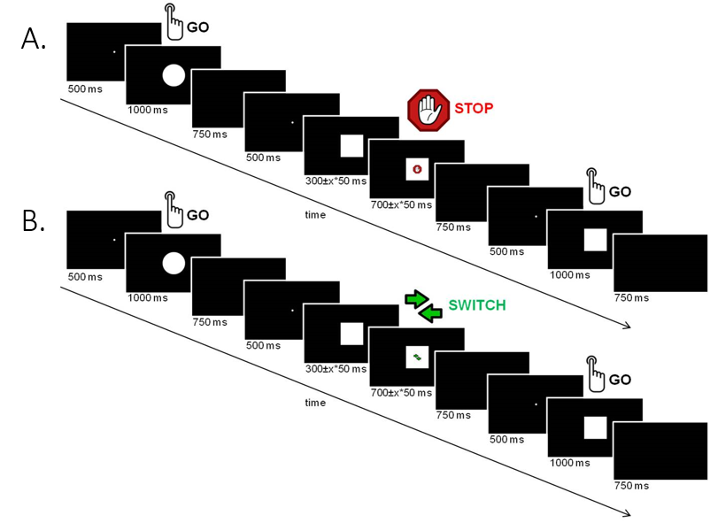
Figure S1: Schematic representation of the stop-signal task (A) and the switch signal task (B).

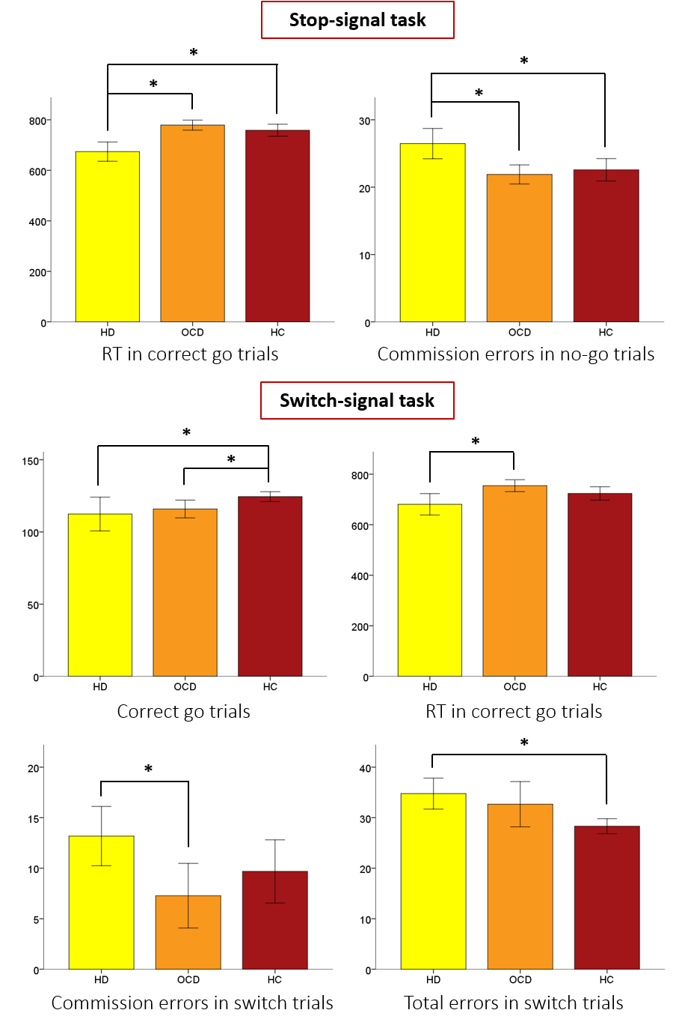
Figure S2. Bar graphs illustrating the significant between-group differences in performance described in table S1.
* Denotes significant between-group differences (p<0.05). HD: Hoarding Disorder; OCD: Obsessive-Compulsive Disorder; HC: Healthy Controls.
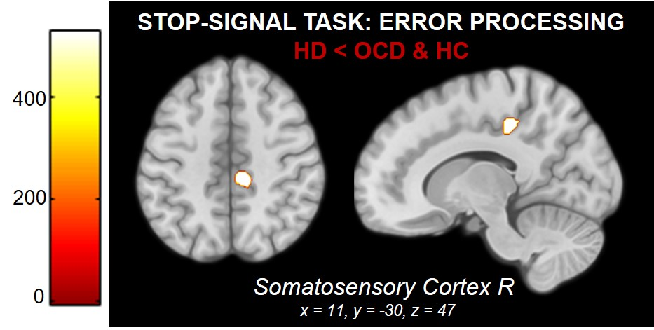
Figure S3: Between-group differences in task-related activations during error processing in the stop-signal task at the whole-brain level. Color bar indicates TFCE values, which result from combining voxel-height and cluster size. HD: Hoarding Disorder; OCD: Obsessive-Compulsive Disorder; HC: Healthy Controls; R: Right.

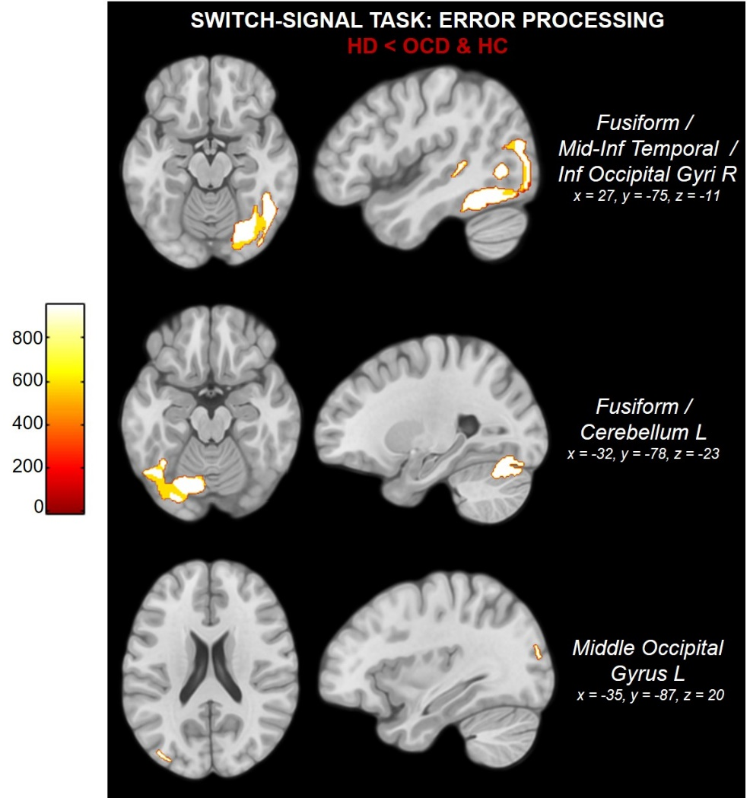

Figure S4: Between-group differences in task-related activations during error processing in the switch-signal task at the whole-brain level. Color bar indicates TFCE values, which result from combining voxel-height and cluster size. HD: Hoarding Disorder; OCD: Obsessive-Compulsive Disorder; HC: Healthy Controls; Mid: Middle; Inf: Inferior; R: Right; L: Left.

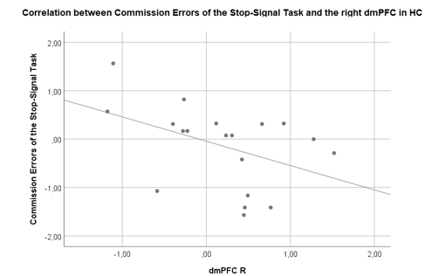

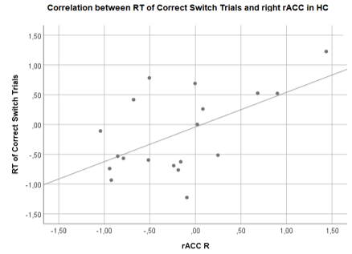

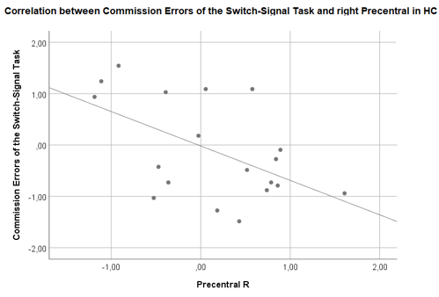
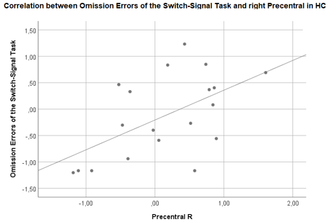

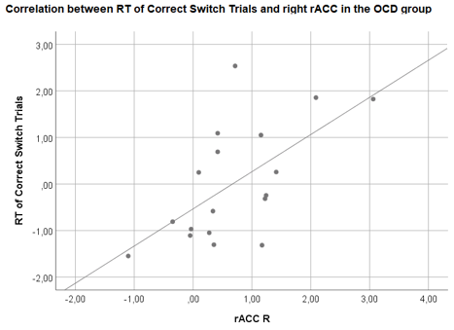

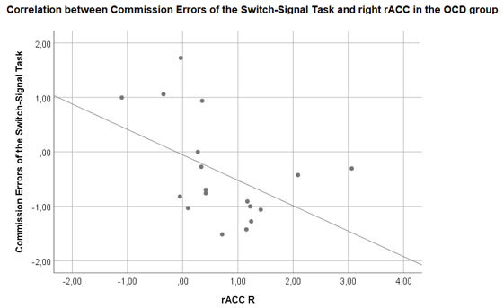
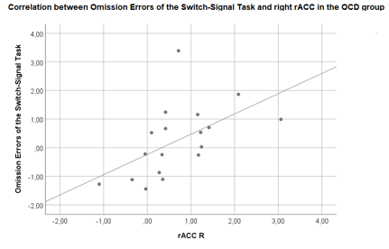

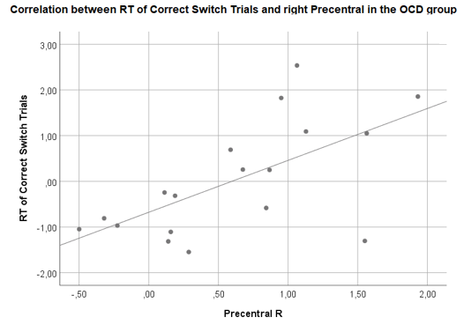

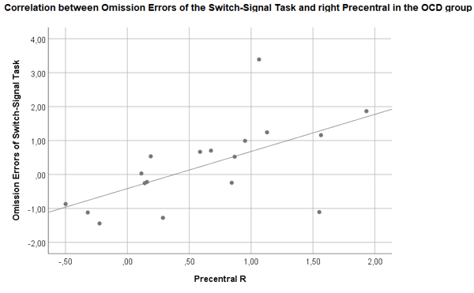

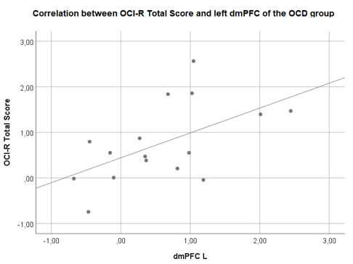

Figure S5: Scatter plots of the correlations between brain activation and task performance or clinical characteristics.
HC: Healthy Controls; OCD: Obsessive-Compulsive Disorder; RT: Reaction Time; dmPFC: dorsomedial Prefrontal Cortex; rACC: rostral Anterior Cingulate Cortex; R: Right; L: Left

