Supplemental materials

Supplemental Methods
Normative modelling
Normative modelling is based on a Gaussian process regression framework (Rasmussen & Williams 2006). The model consists of ‘covariates’ that are the predictors for ‘responses’, which are for instance measures of brain structure or function. This framework is implemented by splitting the data into a training and test-set, using either cross- or out-of-sample validation.
A Gaussian process specifies a distribution over functions, such that any finite number of elements has a joint Gaussian distribution. A Gaussian process can be denoted by $N(m\left(x\right),k\left(x,x^{'}\right))$ and is uniquely specified by a mean $(m\left(x\right))$ and covariance $k\left(x,x^{'}\right))$ function. Gaussian process models can be used for Bayesian nonlinear regression based on a set of training data. We use an unconstrained latent function to model the relationships between data points. The goal is to estimate this function from the training data in such a way that it allows us to accurately predict a new target from the test data. To reach this end a Gaussian process prior distribution is placed over the latent function and its posterior distribution is computed using Bayes rule. A more elaborate description of the methods can be found in Marquand et al. 2016a.
In this study, we used covariates age and sex to predict brain structure at each voxel. We implemented this framework using 10-fold cross-validation for healthy individuals and out-of-sample validation for individuals with ADHD. We could not follow the same procedure for controls and cases, due to the size of our sample, as discussed in the limitations paragraph.

Supplemental Figures
Supplemental Figure 1: The age distributions slit by healthy individuals and individuals with ADHD.

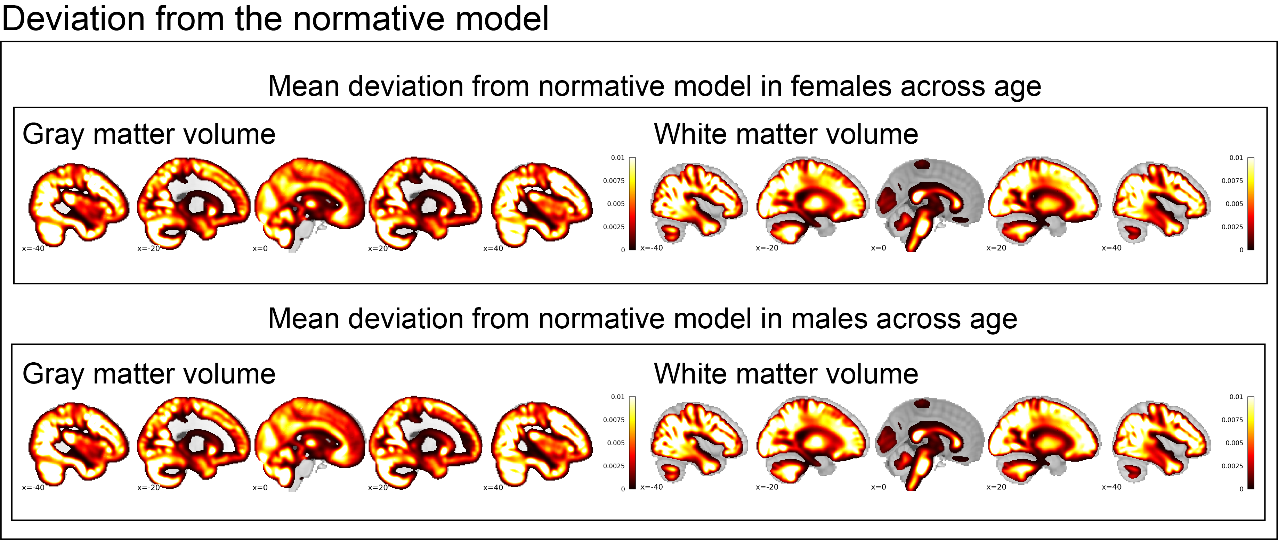
Supplemental Figure 2: Mean deviation from normative model across all ages separately for females and males

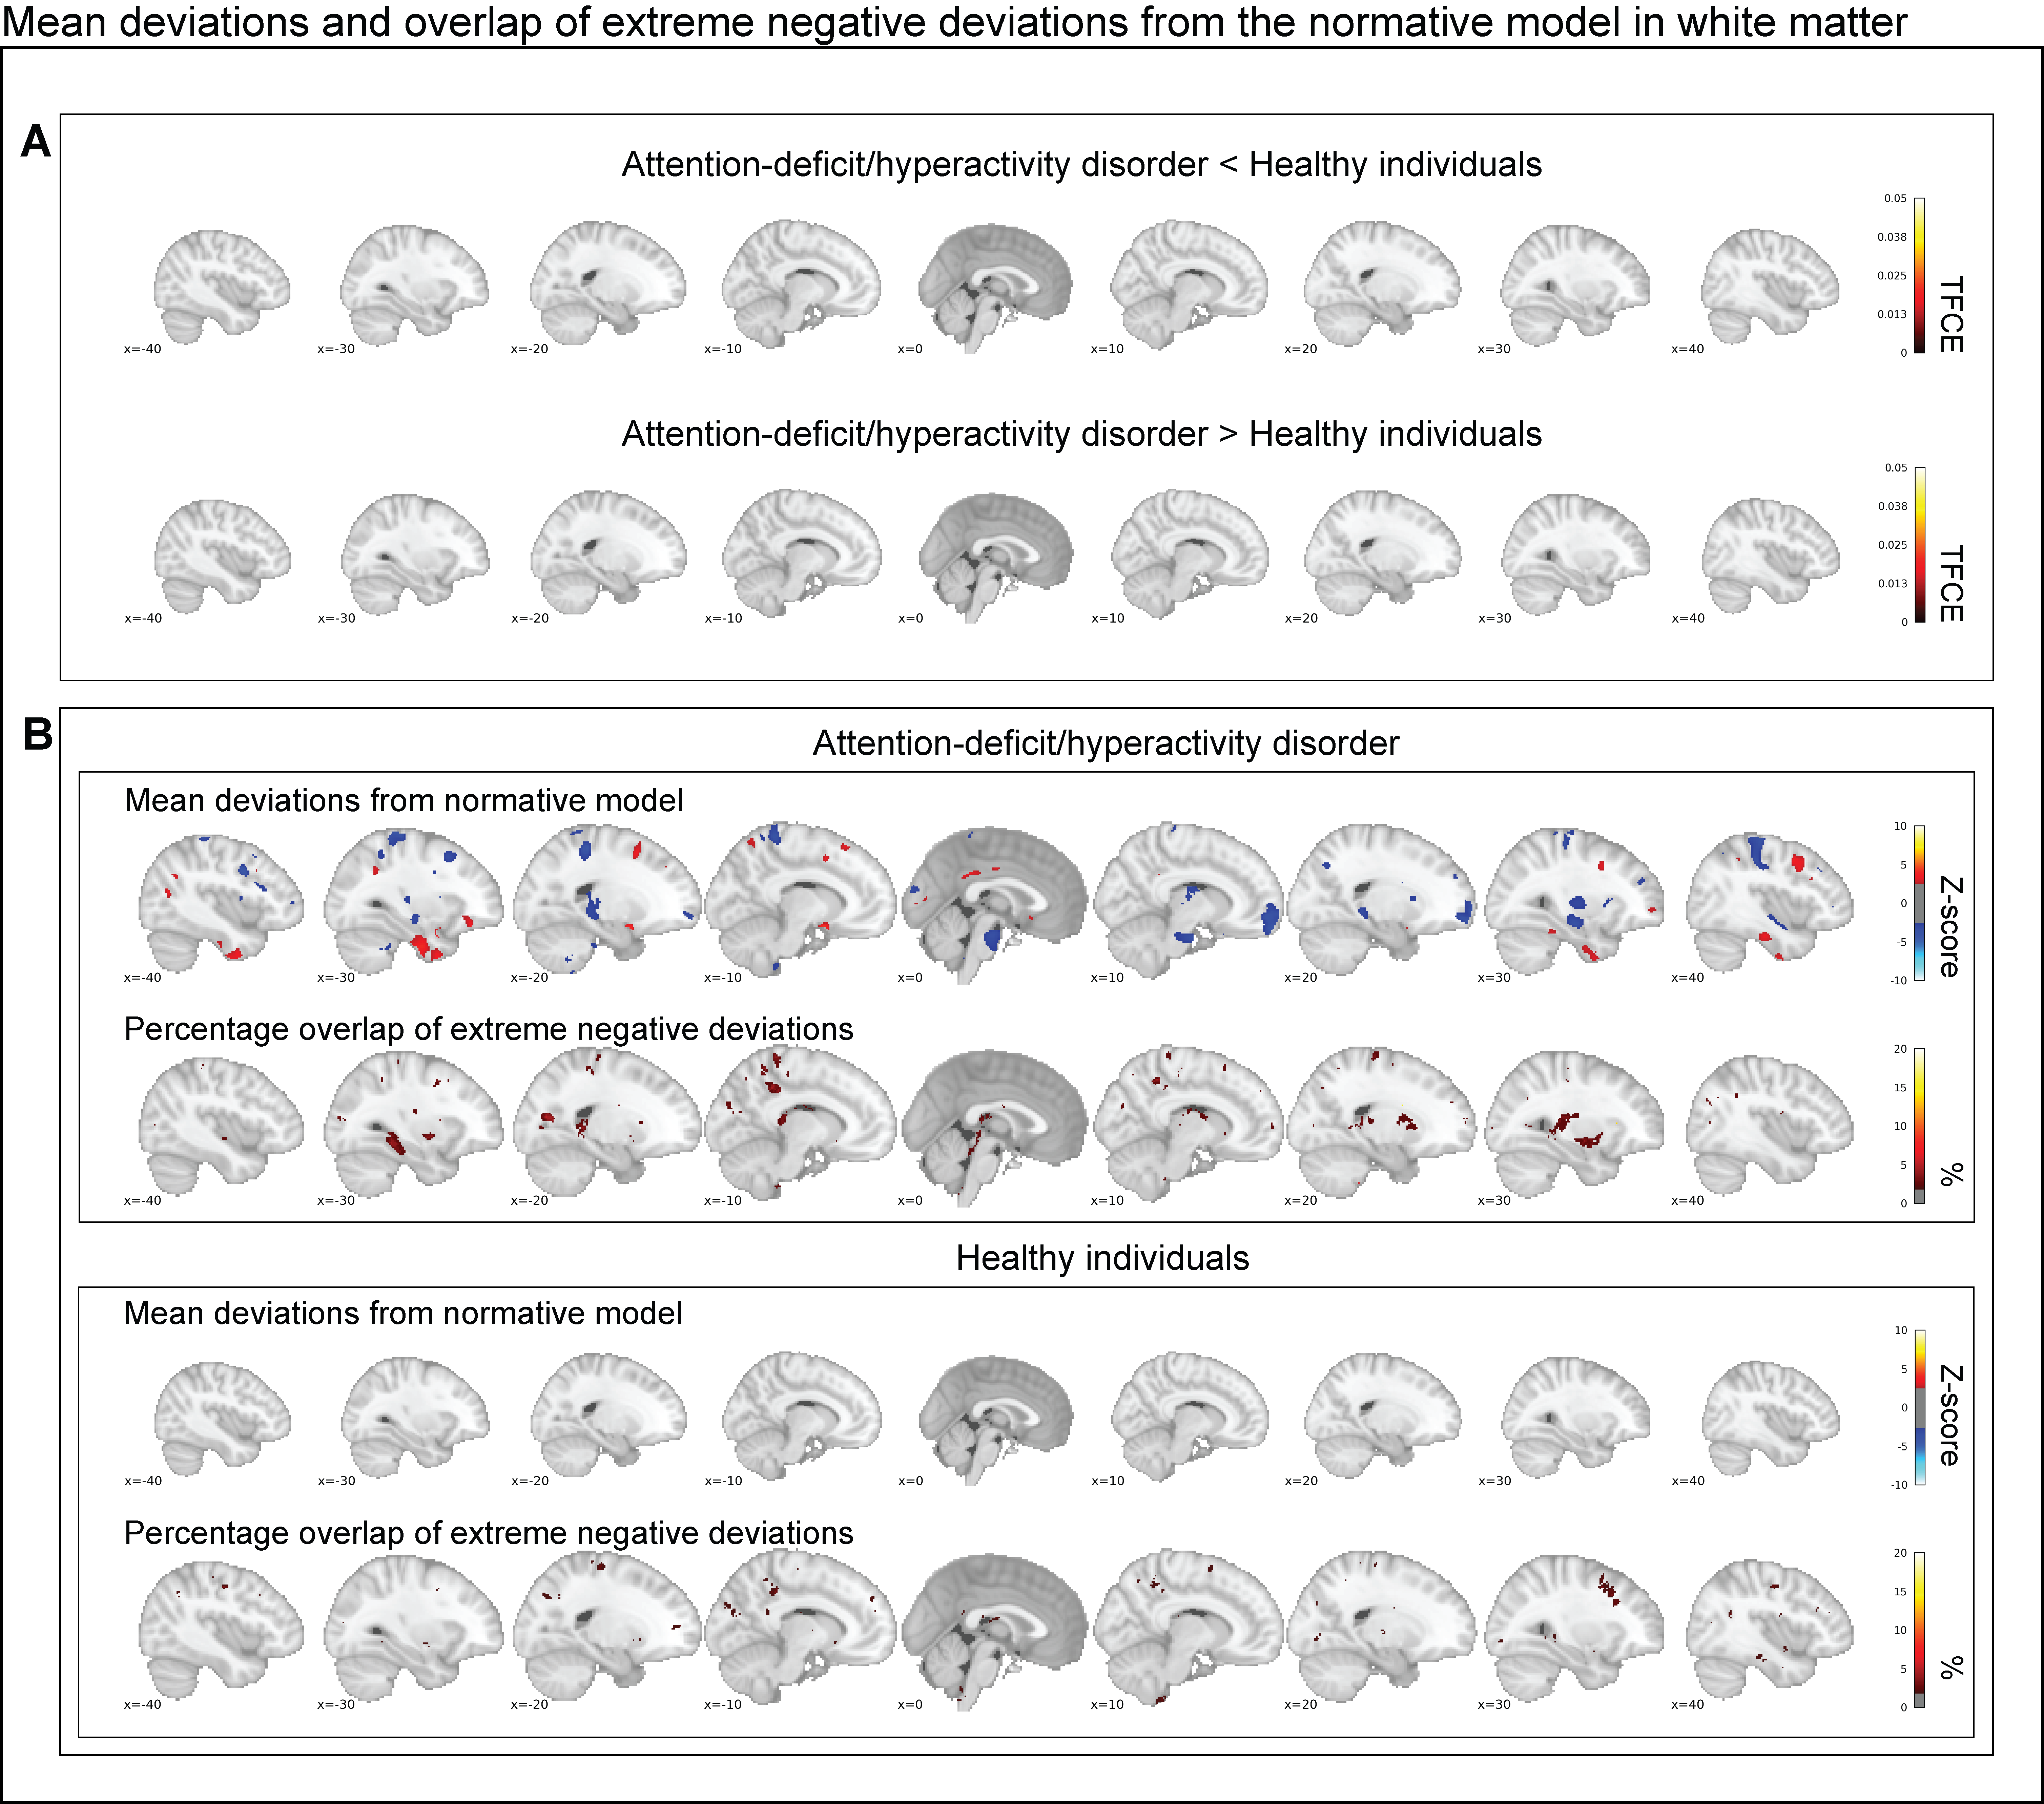
Supplemental Figure 3: In A, the contrast between persistent ADHD and healthy controls is depicted corrected at a false discovery rate of 5%. There is no significant difference between persist ADHD and healthy individuals in white matter. In B, the group-level mean deviations of individuals with persistent ADHD and healthy individuals are depicted (|Z| < 2.6) and compared to the overlap maps of extreme negative deviations (Z < -2.6). In summary, we observe some convergence between the overlap maps and the mean deviations from the normative model in white matter.

Supplemental Figure 4: In A, the group-level mean deviations in gray matter of individuals with persistent ADHD and healthy individuals are depicted (|Z| < 2.6) and compared to the overlap maps of extreme positive deviations (Z > +2.6) in gray matter. In B, the group-level mean deviations in white matter of individuals with persistent ADHD and healthy individuals are depicted (|Z| < 2.6) and compared to the overlap maps of extreme positive deviations (Z > +2.6) in white matter.

Supplemental Figure 5: The overlap of the most extreme positive deviations is depicted, representing the percentage of individuals showing an extreme value. The overlaps are false discovery rate corrected at the 5% chance level. The findings resemble those shown in Figure 3, extreme negative deviations overlap more in patients with ADHD than in healthy controls, but overlap is highly limited and focal in a few regions.

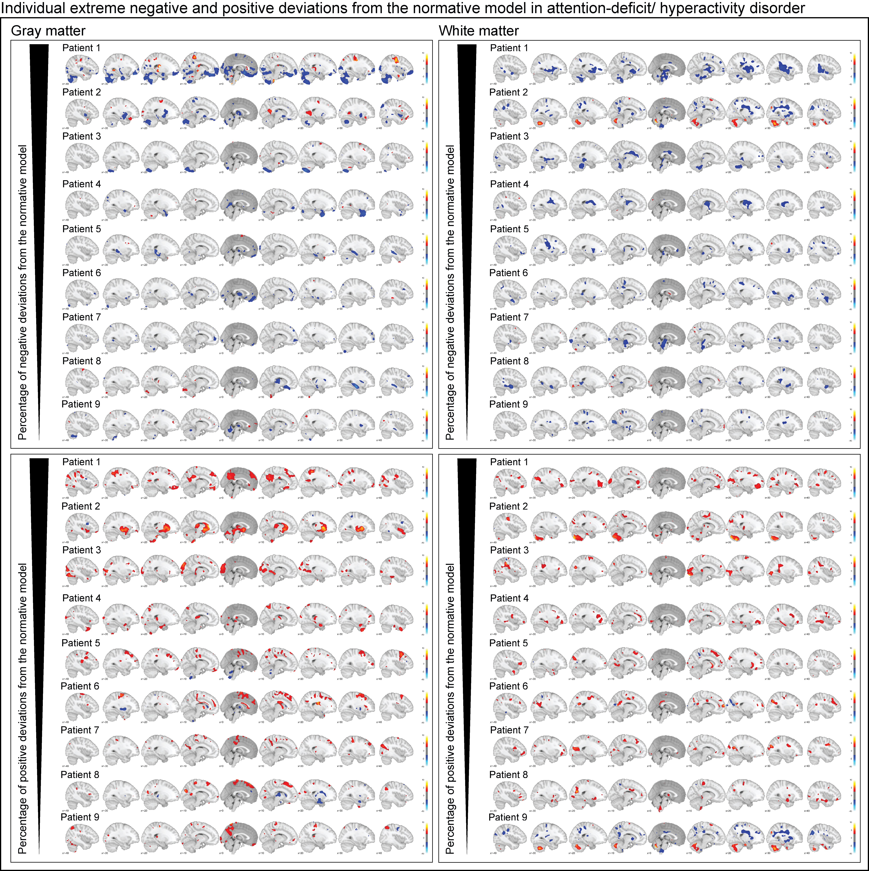
Supplemental Figure 6: The individual deviations from the normative model in gray matter and white matter are depicted for individuals with persistent ADHD. Starting on the left, the extreme negative deviations are followed by extreme positive deviations in gray matter, on the right the same is shown in white matter.

Supplemental Tables

Supplemental Table 1: Association of deviations from the normative model with age, comorbidity, stimulant medication, and symptom scores in ADHD
Age# | β | p
GM percentage positive deviations | -0.082 | 0.311
GM percentage negative deviations | 0.073 | 0.368
WM percentage positive deviations | 0.094 | 0.249
WM percentage negative deviations | 0.198 | 0.014*
Comorbidity ^{a#} | β | p
GM percentage positive deviations | -0.117 | 0.153
GM percentage negative deviations | 0.079 | 0.332
WM percentage positive deviations | -0.027 | 0.742
WM percentage negative deviations | -0.019 | 0.813
Stimulant medication ^{b#} | β | p
GM percentage positive deviations | -0.064 | 0.435
GM percentage negative deviations | 0.145 | 0.073
WM percentage positive deviations | 0.098 | 0.227
WM percentage negative deviations | 0.136 | 0.093
Hyperactivity/impulsivity ^{c#} | β | p
GM percentage positive deviations | 0.075 | 0.397
GM percentage negative deviations | -0.013 | 0.884
WM percentage positive deviations | -0.013 | 0.888
WM percentage negative deviations | 0.083 | 0.348
Inattention ^{d#} | β | p
GM percentage positive deviations | 0.017 | 0.845
GM percentage negative deviations | -0.148 | 0.094
WM percentage positive deviations | -0.152 | 0.086
WM percentage negative deviations | -0.022 | 0.801
ª Number of comorbid disorders such as major depressive disorder based on SCID (Structured Clinical Interview)
^{b} Medication is taken today, was in the past or not at all
^{c} DIVA (diagnostic interview for adult ADHD) hyperactivity/impulsivity symptoms in adults
^{d} DIVA inattention symptoms in adults
# all analyses were performed in the ADHD group

Supplemental references

Marquand AF, Rezek I, Buitelaar J, Beckmann CF (2016). Understanding Heterogeneity in Clinical Cohorts Using Normative Models: Beyond Case-Control Studies. . Elsevier Biological Psychiatry 80, 552–561.
Rasmussen CE, Williams CKI (2006). Gaussian processes for machine learning. In Gaussian Processes for Machine Learning vol 14, pp112–114.

