Supplementary material

**Participants**

Patients were recruited from in- and outpatient mental health centres in the Capital Region of Denmark as part of the Pan European Collaboration on Antipsychotic Naive Schizophrenia (PECANS) project, a large, multimodal longitudinal study on antipsychotic-naïve first-episode schizophrenia patients. There is a partial overlap between the participants in the present study and participants in previous publications from the PECANS study on psychophysiology (Düring *et al.* 2014, 2015), reward processing (Nielsen *et al.* 2012a, 2012b, 2016), dopamine D2/3 binding and treatment outcome (Wulff *et al.* 2015), structural brain changes (Ebdrup *et al.* 2016), resting state (Anhøj *et al.* 2017), oxidative stress (Nordholm *et al.* 2016) and cognition (Bak *et al.* 2017). Other structural and fMRI data, data on cognitive disturbances, genetic data and data on the hypothalamic-pituitary-adrenalaxis related to the PECANS cohort will be published elsewhere. SPECT scan was only performed during the last period of the study, which means that only 32 patients and 28 HCs were included in the SPECT part of the study; see the flowchart in Figure 1.

**The reward paradigm**

A variant of the modified version of the monetary incentive delay task described by Knutson et al. (2000, 2001a, 2001b) and modified by Cooper and Knutson (2008) was used to elicit VS activation during reward anticipation. Presented during the fMRI acquisition, the task consisted of two runs with a total time of 36 min (18 min/run). Prior to the scanning participants had 10 minutes outside the scanner to practice the task to minimise later learning effects in the scanner.



+

Press



**Figure S1.** *The reward task*

Participants were presented initially with a cue indicating the conditions of the trial (one of six conditions); see Figure S1. After a short delay (2-4s), a visual target appeared briefly (200-300ms) on the screen and participants were instructed to press a button while the target was on the screen. After another delay (2-4s), participants received feedback on the outcome, including the total amount of money they had gained. The initial target duration for all participants and trial conditions was 300ms, and the paradigm timing was automatically adjusted to obtain an average hit rate of 66%, depending on individual subject performance.

There were six different trial conditions representing two levels of uncertainty (certain and uncertain), combined with three levels of value expectation (gain, neutral and loss). Certain gain or loss was represented with blue arrows and was independent of the participants’ performance. Uncertain gain or loss, represented with green arrows, indicated that the outcome required the participants to press the button in time. In these uncertain-gain trials, participants earned €7 on a hit and €0 on a miss. In uncertain-loss trials, participants earned €0 on a hit and lost €7 on a miss. In the two neutral trials (arrows pointing both ways), participants knew the outcome would be €0, regardless of whether they hit the button in time. The participants were instructed to respond rapidly in all trial conditions but were not informed about the adaptive timing algorithm. A single trial lasted 15 seconds, and each of the six trial conditions was presented 12 times in a pseudo-randomised order in each of the two runs. After the entire scanning, the participants received the amount of money they had won, typically €45–85 per run.

**Behavioural data**

The total amount of monetary gain was compared between patients and controls using 2*2 repeated measures ANOVA, with group as between-subject factor and time as within-subject factor.

Hit rate and reaction time were analysed with 2*2*4 repeated measures ANOVA with group as between-subject factor and time and trial type as within-subject factors. Only the four conditions used for the fMRI contrasts were included in these analyses (uncertain gain, uncertain loss and the two neutral conditions).

**Results**

For monetary gain, there was no effect of group or time and no group*time interaction.

For hit rate, there was a main effect of trial type, which was highest in the two uncertain trials (F3,39=31.7, p<0.001). There was no effect of group or time and no interactions. This was also the case for reaction time (shortest in uncertain trials, F3,39=13.3, p<0.001), although there was a significant group*trial*time interaction (F1,3,39=3.0, p=0.034). Over time, HCs improved in reaction time in uncertain gain trial, whereas patients improved in reaction time in uncertain neutral trials but were slower in certain neutral trials.

**fMRI analyses**

Second-level analyses of group differences of the salience contrast (Figure S2) at baseline and follow-up was performed. Additionally, to illustrate the salience contrast activity at group level, the main effect of the salience contrast was extracted for each group at each time point. The resulting z statistic images were thresholded using clusters determined by Z>2.3 and a corrected cluster significance threshold of p=0.05.

***Figure S2.*** *The salience contrast: Uncertain gain and loss (salient) cues versus neutral cues*

**>**

Similar to our previous studies (Nielsen *et al.* 2012a, 2012b) we found significant differences at baseline between the antipsychotic-naïve first-episode patients and HCs in the salience contrast activity. At follow-up, the group difference was less pronounced and no longer present in the striatal region; see Figure S3. There was no significant group*time interaction using the whole-brain approach.

***Figure S3****. Whole-brain group comparison of the salience contrast at baseline (A) and at follow-up (B). The clusters are areas where there is increased activity in the healthy controls compared to patients. For illustrative purposes, significant cluster activity of the salience contrast is shown in patients at baseline (C) and follow-up (D), and in healthy controls at baseline (E) and follow-up (F).*

*All the z statistic images illustrate a corrected cluster significance threshold of p=0.05, with clusters determined by z>2.3.*

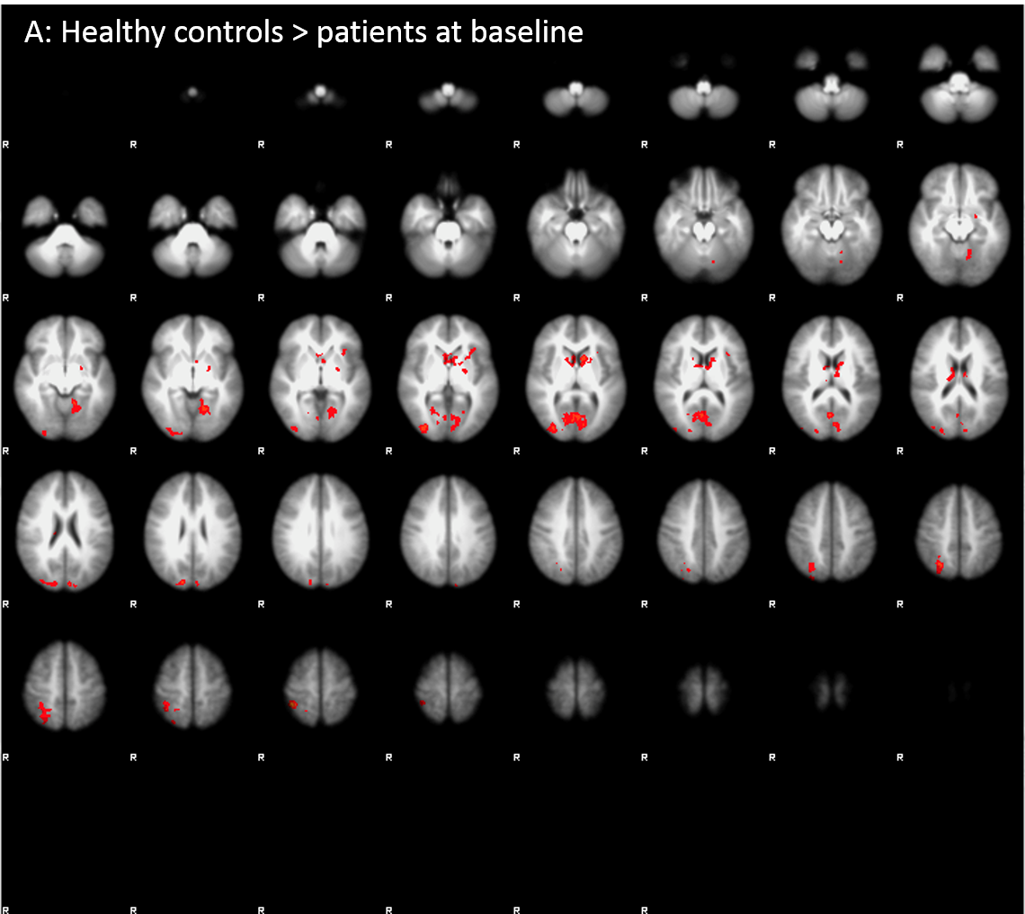

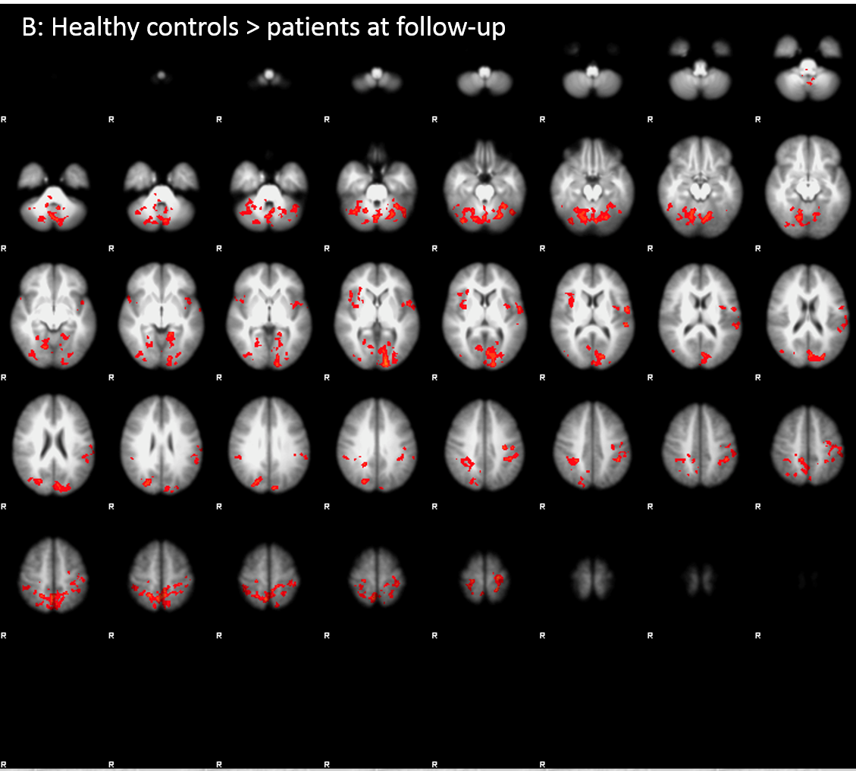

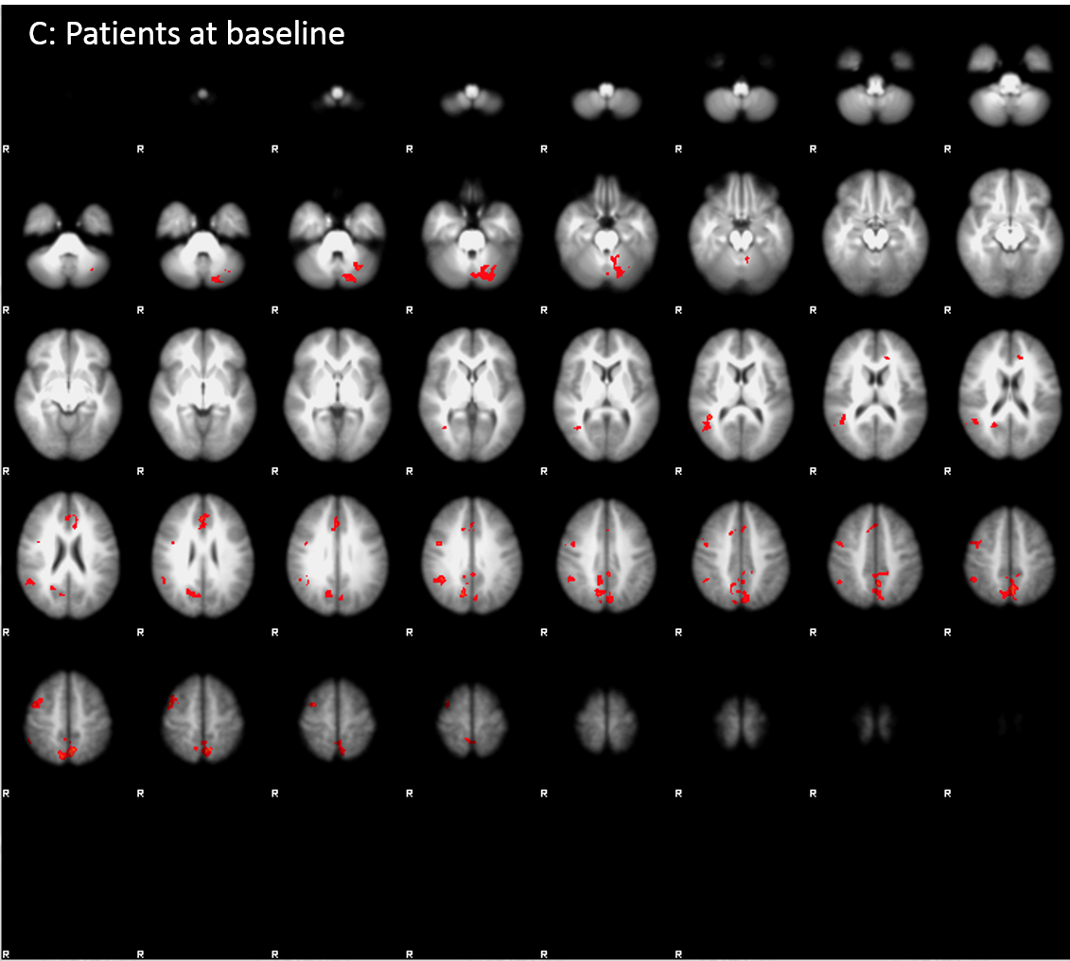

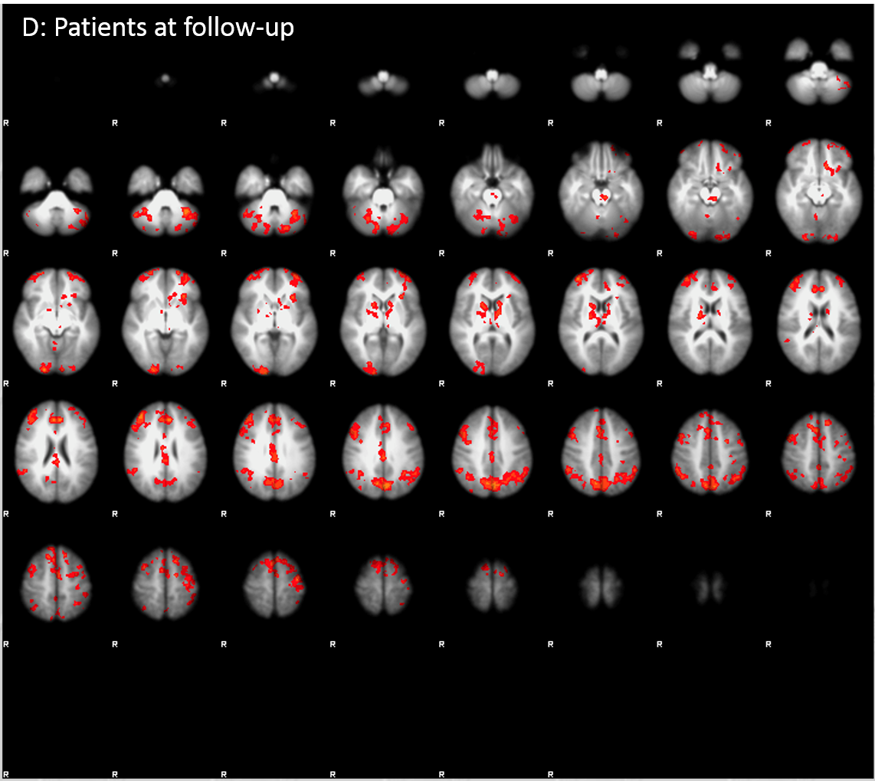

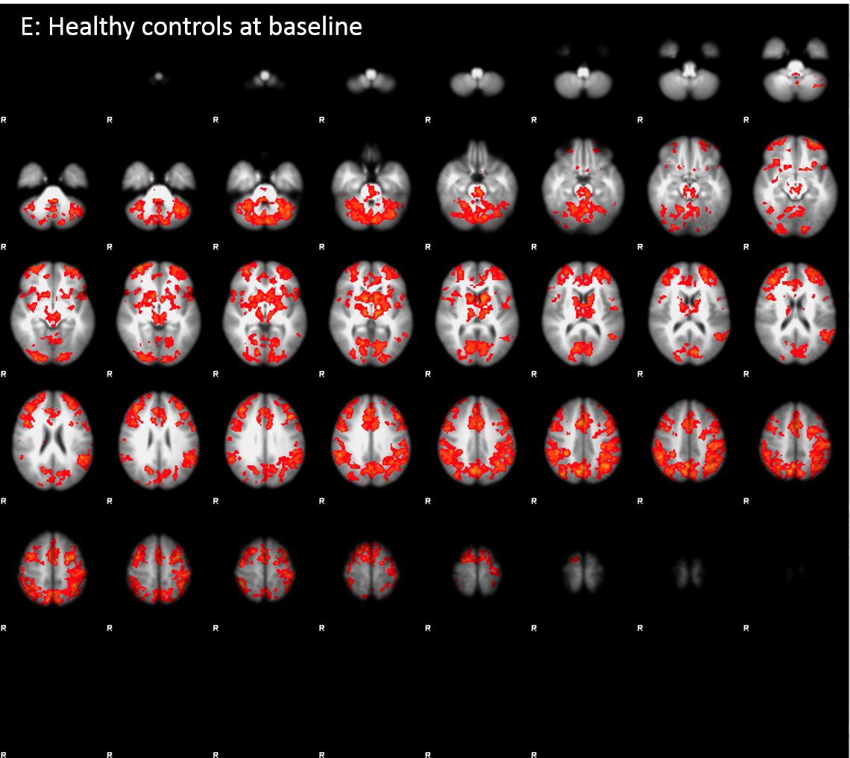

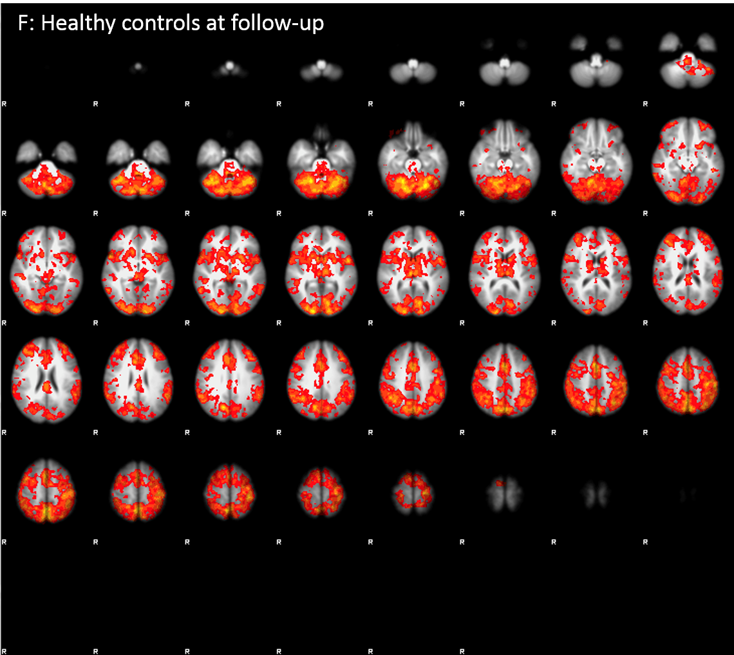

**SPECT acquisition**

The SPECT and computerised tomography (CT) data were obtained with a Siemens Symbia™ T2 series SPECT•CT scanner with low-energy, high-resolution collimators (full width at half maximum 7.5 mm) and two slice CT. The ligand [123I]-IBZM was chosen due to its selectivity for striatal D2/3 receptors (Kung *et al.* 1989; Seibyl *et al.* 1992), and the SPECT scanning was performed using the constant infusion technique (Carson *et al.* 1993; Laruelle *et al.* 1994).

The participants received 185mBq [123I]-IBZM (GE Healthcare, Eindhoven, Holland), one half given as a bolus injection and the other half given as an infusion during the entire 240-minute session. Prior to administration of the [123I]-IBZM bolus, 200 mg perchlorate mixture iv was given to block thyroid uptake of free radioactive iodine. After 180 min, a CT scout and 2 x 30 min SPECT scans were performed. Between the two scans, a low-dose CT scan was acquired for attenuation correction. Tracer steady state was assumed after 180 min of constant infusion following the bolus injection with [123I]-IBZM. It was assumed that the total parent radioligand (free plus protein-bound radioligand) in plasma at steady-state equals the concentration in the brain tissue, which is not directly measurable (Laruelle *et al.* 1995). Figure S4 displays typical examples of the activity measured in the plasma during the time of the scanning (A) from a patient baseline scanning, (B) from a patient follow-up scanning and (C) from a control subject.

Venous blood samples were collected prior to administration of the bolus and every 30 min during the scanning period. The plasma-free fraction of [123I]-IBZM was determined using ultrafiltration (Centrifree, 30,000 MW) (Zea-Ponce & Laruelle 1999). The plasma metabolite analysis of [123I]-IBZM was performed using Oasis WCX solid-phase extraction units, Waters and stepwise elution with water, 40% acetonitrile and acidified 95% methanol. The native compound was eluted in the water phase, and the metabolites in the subsequent elution.

Figure S4. [123I]-IBZM activity shown in blood plasma during the time of scanning. Patient baseline (A), patient follow up (B) and control subject (C).

(A)

(B)

(C)

**References**

**Anhøj S, Nielsen MØ, Jensen MH, Ford K, Fagerlund B, Williamson P** (2017). OUP accepted manuscript. *Schizophrenia Bulletin*, 1–9.

**Bak N, Ebdrup BH, Oranje B, Fagerlund B, Jensen MH, Düring SW, Nielsen M, GlenthØj BY, Hansen LK** (2017). Two subgroups of antipsychotic-naive, first-episode schizophrenia patients identified with a Gaussian mixture model on cognition and electrophysiology. . Nature Publishing Group *Translational Psychiatry* **7**, e1087-8.

**Carson RE, Channing MA, Blasberg RG, Dunn BB, Cohen M, Rice KC, Herscovitch P** (1993). Comparison of Bolus and Infusion Methods for Receptor Quantitation : Application to e8p ] Cyclofoxy and Positron Emission Tomography

**Cooper JC, Knutson B** (2008). Valence and salience contribute to nucleus accumbens activation. *NeuroImage* **39**, 538–547.

**Düring S, Glenthøj BY, Oranje B** (2015). Effects of Blocking D2/D3 Receptors on Mismatch Negativity and P3a Amplitude of Initially Antipsychotic Naïve, First Episode Schizophrenia Patients. *The international journal of neuropsychopharmacology* **19**, pyv109.

**Düring S, Glenthøj BY, Andersen GS, Oranje B** (2014). Effects of Dopamine D2/D3 Blockade on Human Sensory and Sensorimotor gating in Initially Antipsychotic-Naïve, First-Episode Schizophrenia Patients. *Neuropsychopharmacology :* 3000–3008.

**Ebdrup BH, Raghava JM, Nielsen MØ, Rostrup E, Glenthøj B** (2016). Frontal fasciculi and psychotic symptoms in antipsychotic-naive patients with schizophrenia before and after 6 weeks of selective dopamine D2/3 receptor blockade. *Journal of Psychiatry and Neuroscience* **41**

**Knutson B, Fong GW, Adams CM, Varner JL, Hommer D** (2001a). Dissociation of reward anticipation and outcome with event-related fMRI. *Neuroreport* **12**, 3683–7.

**Knutson B, Westdorp A, Kaiser E, Hommer D** (2000). FMRI visualization of brain activity during a monetary incentive delay task. *NeuroImage* **12**, 20–27.

**Knutson B, Adams CM, Fong GW, Hommer D** (2001b). Anticipation of increasing monetary reward selectively recruits nucleus accumbens. *The Journal of neuroscience :* **21**, RC159.

**Kung HF, Alavi A, Chang W, Kung M, Keyes JW, Velchik MG, Billings J, Pan S, Noto R** (1989). In Vivo SPECT Imaging of CNS D . -2 Dopamine Receptors : Initial Studies Iodine-123-IBZM in Humans, 573–579.

**Laruelle M, Abi-dargham A, Ai-tikriti MS, Baldwin RM, Zea-ponce Y, Zoghbi SS, Charney DS, Hoffer PB, Innis RB** (1994). SPECT Quantification of [ 1231 ] lomazenil Binding to Benzodiazepine Receptors in Nonhuman Primates : II . Equilibrium Analysis of Constant Infusion Experiments and Correlation with In Vitro Parameters

**Laruelle M, Abi-Dargham A, van Dyck CH, Rosenblatt W, Zea-Ponce Y, Zoghbi SS, et** al (1995): SPECT imaging of striatal dopamine release after amphetamine challenge. J Nucl Med 36:1182-1190.

**Nielsen MO, Rostrup E, Wulff S, Bak N, Broberg BV, Lublin H, Kapur S, Glenthoj B** (2012a). Improvement of brain reward abnormalities by antipsychotic monotherapy in schizophrenia. *Archives of General Psychiatry* **69**, 1195–1204.

**Nielsen MO, Rostrup E, Wulff S, Glenthøj B, Ebdrup BH** (2016). Striatal reward activity and antipsychotic-associated weight change in patients with schizophrenia undergoing initial treatment. *JAMA Psychiatry* **73**, 121–128.

**Nielsen MØ, Rostrup E, Wulff S, Bak N, Lublin H, Kapur S, Glenthøj B** (2012b). Alterations of the brain reward system in antipsychotic naïve schizophrenia patients. *Biological psychiatry* **71**, 898–905.

**Nordholm D, Poulsen HE, Hjorthøj C, Randers L, Nielsen MØ, Wulff S, Krakauer K, Nørbak-Emig H, Henriksen T, Glenthøj B, Nordentoft M** (2016). Systemic oxidative DNA and RNA damage are not increased during early phases of psychosis: A case control study. *Psychiatry Research* **241**

**Seibyl JP, Woods SW, Zoghbi SS, Baldwin RM, Dey HM, Goddard AW, Zea-ponce Y, Zubal G, Germine M, Smith E, Heninger GR, Charney DS, Kung HF, Alavi A, Hoffer PB, Innis RB** (1992). Dynamic SPECT Imaging of Dopamine D2 Receptors in Human Subjects with iodine-123-IBZM. *J. Nucl: Med* **33**, 1964–1971.

**Wulff S, Pinborg LH, Svarer C, Jensen LT, Nielsen MØ, Allerup P, Bak N, Rasmussen H, Frandsen E, Rostrup E, Glenthøj BY** (2015). Striatal D2/3 binding potential values in drug-naïve first-episode schizophrenia patients correlate with treatment outcome. . Oxford University Press *Schizophrenia Bulletin* **41**, 1143–1152.

**Zea-Ponce Y, Laruelle M** (1999). Protein precipitation: an expedient procedure for the routine analysis of the plasma metabolites of [123I]IBZM. *Nuclear medicine and biology* **26**, 811–4.