Social cognition or social class and culture? On the interpretation of differences in social cognitive performance

Supplementary Materials

David Dodell-Feder, Kerry J. Ressler, and Laura T. Germine

Age Effects

|  |  |  |  |  |  |  |
| --- | --- | --- | --- | --- | --- | --- |
| Measure | Segment 1 *b* [95% CI] | Age Breakpoint [95% CI] | Segment 2 *b* [95% CI] | Age Breakpoint [95% CI] | Segment 3 *b* [95% CI] | Adjusted *R*2 |
| RMET-36 | .190 [.164, .216] | 17.26 [16.83, 17.69] | .006 [.005, .008] | - | - | .0693 |
| RMET-16 | .104 [.076, .132] | 18.41 [17.41, 19.41] | .004 [.002, .007] | - | - | .0324 |
| Multiracial Emotion Identification | .098 [.057, .140] | 16.43 [15.29, 17.57] | .000 [-.002, .002] | - | - | .0090 |
| Emotion Discrimination | .077 [.057, .096] | 21.85 [20.31, 23.38] | -.002 [-.005, .001] | - | - | .0405 |
| Digit Symbol Matching | .148 [.132, .164] | 17.12 [16.77, 17.48] | -.015 [-.019, -.011] | 35.63 [32.85, 38.41] | -.039 [-.042, -.036] | .1465 |

*Note.* The data for RMET-36, RMET-16, Emotion Identification, and Emotion Discrimination tasks were best fit by a two-segment, one-breakpoint model.

Gender Effects

|  |  |  |  |  |  |
| --- | --- | --- | --- | --- | --- |
|  | *z* score *M* [95% CI] | |  |  |  |
| Measure | Female | Male | Welch two-sample *t*-test | Cohen’s *d* [95% CI] | Common Language Effect Size |
| RMET-36 | .09 [.07, .12] | -.15 [-.18, -.11] | *t*(6,787)=10.88* | .24 [.20, .28] | 56.72% |
| RMET-16 | .10 [.07, .13] | -.16 [-.20, -.12] | *t*(4,694)=9.87* | .26 [.21, .31] | 57.36% |
| Multiracial Emotion Identification | .07 [.04, .11] | -.08 [-.13, -.04] | *t*(3,892)=5.43* | .16 [.10, .22] | 54.48% |
| Emotion Discrimination | .08 [.04, .12] | -.16 [-.21, -.10] | *t*(2,296)=6.72* | .24 [.17, .31] | 56.72% |
| Digit Symbol Matching | -.03 [-.05, -.01] | .08 [.06, .10] | *t*(15,540)=-7.08* | -.11 [-.14, -.08] | 46.81% |

*Note*.

* *p*<.001, Bonferonni corrected for multiple tests.

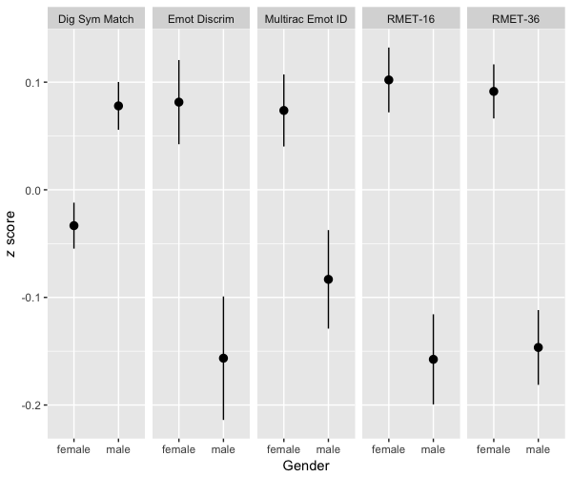

Education Effects

|  |  |  |  |  |  |  |  |
| --- | --- | --- | --- | --- | --- | --- | --- |
|  | *z* score *M* [95% CI] | | | | |  |  |
| Measure | Middle | High | Some College | College | Grad | ANOVA | η2 [95% CI] |
| RMET-36a | -.74 [-.85, -.64] | -.22 [-.26, -.18] | .05 [.02, .09] | .22 [.18, .26] | .25 [.21, .30] | *F*(4, 8,685)=137.80, *p*<.001* | .0597 [.0501, .06914] |
| RMET-16a | -.58 [-.73, -.43] | -.19 [-.24, -.14] | .07 [.03, .12] | .20 [.15, .25] | .19 [.13, .25] | *F*(4, 5,710)=54.86, *p*<.001* | .0370 [.0276, .0465] |
| Multiracial Emotion Identificationb | -.25 [-.38, -.13] | -.03 [-.08, .03] | .06 [.00, .12] | .12 [.06, .18] | .07 [.01, .13] | *F*(4, 4,732)=8.97, *p*<.001* | .0075 [.0029, .0125] |
| Emotion Discriminationc | -.40 [-.58, -.22] | -.23 [-.29, -.17] | .07 [.02, .13] | .21 [.14, .28] | .29 [.20, .37] | *F*(4, 3,538)=40.78, *p*<.001* | .0441 [.0311, .0571] |
| Digit Symbol Matchingd | -.25 [-.31, -.18] | .09 [.06, .11] | .07 [.04, .11] | .14 [.11, .17] | -.03 [-.07, .01] | *F*(4, 13,852)=30.73, *p*<.001* | .0088 [.0058, .0119] |

* Bonferonni corrected *p*-values.

a All post-hoc comparisons (Tukey HSD) significant at *p*<.05 except for Grad vs College.

b The following post-hoc comparisons (Tukey HSD) were significant at *p*<.05: Grad, College, Some College, High > Middle and College > High.

c All post-hoc comparisons (Tukey HSD) significant at *p*<.05 except for High vs Middle and Grad vs College.

d All post-hoc comparisons (Tukey HSD) significant at *p*<.05 except for College, Some College vs High and College vs Some College.

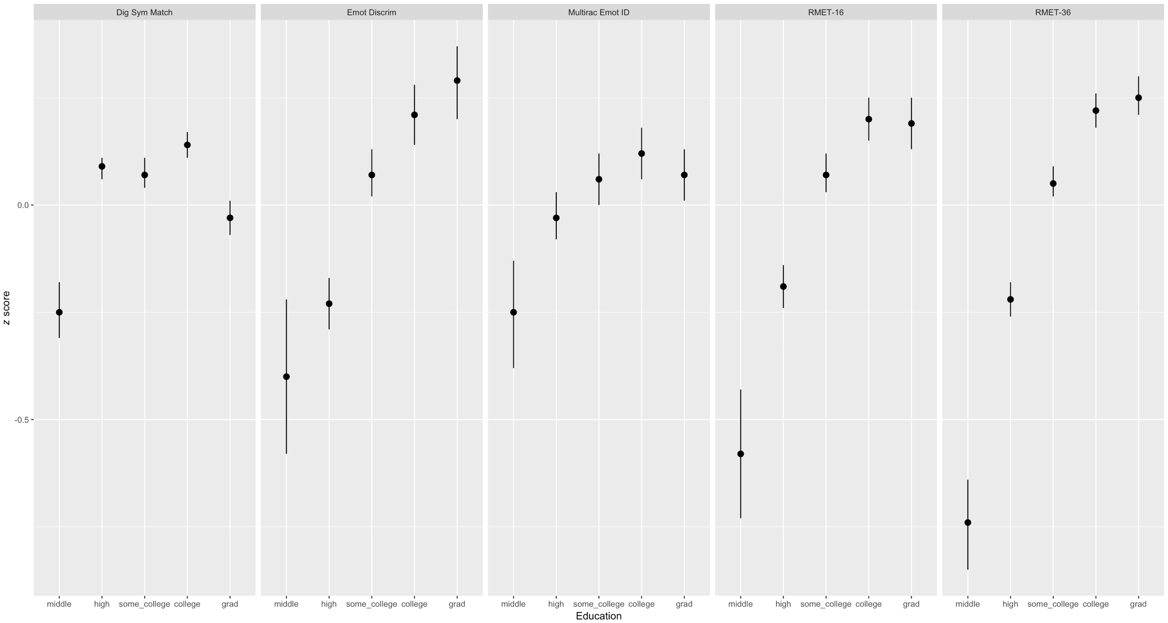

Ethnicity Effects

|  |  |  |  |  |  |  |
| --- | --- | --- | --- | --- | --- | --- |
|  | *z* score *M* [95% CI] | |  |  |  |  |
| Measure | Non-Hispanic | Hispanic | Welch two-sample *t*-test | *p*a | Cohen’s *d* [95% CI] | Common Language Effect Size |
| RMET-36 | .08 [.06, .10] | -.24 [-.32, -.15] | *t*(610)=6.80 | <.001 | .33 [.25, .42] | 59.28% |
| RMET-16 | .11 [.09, .14] | -.19 [-.29, -.10] | *t*(492)=6.01 | <.001 | .31 [.22, .41] | 58.81% |
| Multiracial Emotion Identification | .05 [.02, .08] | -.05 [-.17, .06] | *t*(397)=1.74 | .412 | .11 [.00, .21] | 52.98% |
| Emotion Discrimination | .04 [.01, .08] | -.03 [-.18, .12] | *t*(207)=.88 | 1.000 | .07 [-.08, .22] | 51.99% |
| Digit Symbol Matching | .06 [.04, .08] | .12 [.06, .18] | *t*(1,159)=1.89 | .300 | -.06 [-.13, 0] | 48.22% |

a Bonferonni-corrected *p* value.

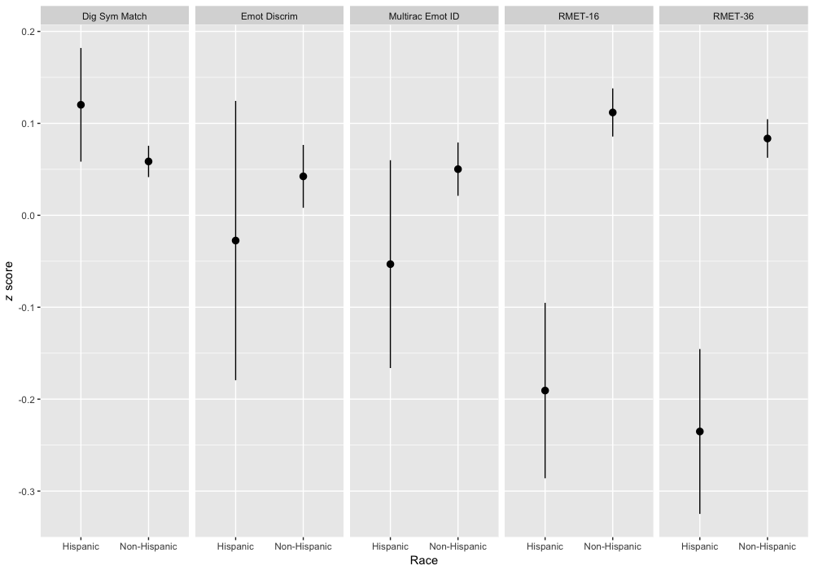

Race Effects

|  |  |  |  |  |  |  |
| --- | --- | --- | --- | --- | --- | --- |
|  | *z* score *M* [95% CI] | | | |  |  |
| Measure | Africa /Black | Americas | Asia | Europe/White | ANOVA | η2 [95% CI] |
| RMET-36a | -.56 [-.66, -.46] | -.37 [-.63, -.12] | -.38 [-.46, -.30] | .14 [.12, .16] | *F*(3, 7,822)=130.40* | .0476 [.0386, .0568] |
| RMET-16b | -.33 [-.45, -.21] | -.74 [-.98, -.50] | -.37 [-.44, -.31] | .18 [.16, .21] | *F*(3, 5,128)=120.30* | .0658 [.0530, .0787] |
| Multiracial Emotion Identificationc | -.06 [-.19, .08] | -.17 [-.44, .11] | -.30 [-.39, -.21] | .09 [.06, .13] | *F*(3, 4,204)=29.57* | .0207 [.0126, .0294] |
| Emotion Discriminationd | -.34 [-.51, -.17] | -.12 [-.55, .31] | -.24 [-.38, -.10] | .06 [.02, .09] | *F*(3, 3,114)=13.70* | .0130 [.0058, .0213] |
| Digit Symbol Matchinge | -.29 [-.36, -.21] | -.17 [-.31, -.03] | .05 [.01, .09] | .06 [.04, .08] | *F*(3, 12,754)=28.46* | .0067 [.0040, .0096] |

* *p*<.001, Bonferonni corrected for multiple tests.

a The following post-hoc comparisons (Tukey HSD) were significant at *p*<.05: Asia>Africa, Europe>Africa/Americas/Asia.

b The following post-hoc comparisons (Tukey HSD) were significant at *p*<.05: Africa>Americas, Asia>Americas, Europe>Africa/Americas/Asia.

c The following post-hoc comparisons (Tukey HSD) were significant at *p*<.05: Africa>Asia, Europe>Asia.

d The following post-hoc comparisons (Tukey HSD) were significant at *p*<.05: Europe>Africa/Asia.

e The following post-hoc comparisons (Tukey HSD) were significant at *p*<.05: Asia>Africa/Americas, Europe>Africa/Americas.

