Supplementary materials.

S1. Data extraction form.
Type of information | Information to be extracted, whenever available | Extracted information
Publication information | Authors
 | Year
 | Title of publication
 | Source (Database)
 | Abstract
 | Date of publication
Eligibility checklist | Title & abstract screening date
 | Full article screening date
 | Eligible for systematic review (PICO)?
 | Eligible for meta-analysis?
Study information | Aim(s) of study
 | Name & country of study
 | Study setting & recruitment strategy
 | Total sample size
 | Study design (case-control, population, intervention, longitudinal)
 | Duration of follow-up
 | Drop out rate
Population (P) | Participant groups & sample sizes
 | Inclusion & exclusion criteria
 | Instrument used to assess UHR/patient status
 | Instrument used to assess healthy control status
 | Instrument used to assess transition to psychosis
Exposure (E) | Childhood adversities measured
 | Instruments used to measure childhood adversities
Outcome (O) | Outcome measure(s)
Demographics | Matching of variables
 | Age
 | Gender (% female)
 | Comorbid psychiatric disorders
 | Rate of transition to psychosis
Findings | Key conclusions from authors
 | Conclusions relevant to our review
Quantitative data (raw data, effect size, error estimates, etc.) | Prevalence (e.g., % or frequency or odds ratio) or severity (e.g., continuous score) of childhood trauma
 | Prevalence (e.g., % or frequency or odds ratio) or severity (e.g., continuous score) of childhood trauma subtypes
 | Prevalence (e.g., % or frequency or odds ratio) or severity (e.g., continuous score) of childhood bullying
 | Prevalence (e.g., % or frequency or odds ratio) or severity (e.g., continuous score) of parental loss/separation
 | Odds ratios/ hazard ratios/ risk ratios/ frequency tables of transition to psychosis given exposure to childhood trauma
 | Odds ratios/ hazard ratios/ risk ratios/ frequency tables of transition to psychosis given exposure to childhood trauma subtypes
 | Odds ratios/ hazard ratios/ risk ratios/ frequency tables of transition to psychosis given exposure to childhood bullying
 | Odds ratios/ hazard ratios/ risk ratios/ frequency tables of transition to psychosis given exposure to parental loss/separation
Other variables | Confounding variables that were controlled for
 | Other variables measured
Contacting of authors | What is needed from authors?
 | Date of contact

S2. Forest plot comparing the severity of childhood trauma between UHR and controls, stratified into the risk of bias of each study. Higher trauma scores reflect higher severity.
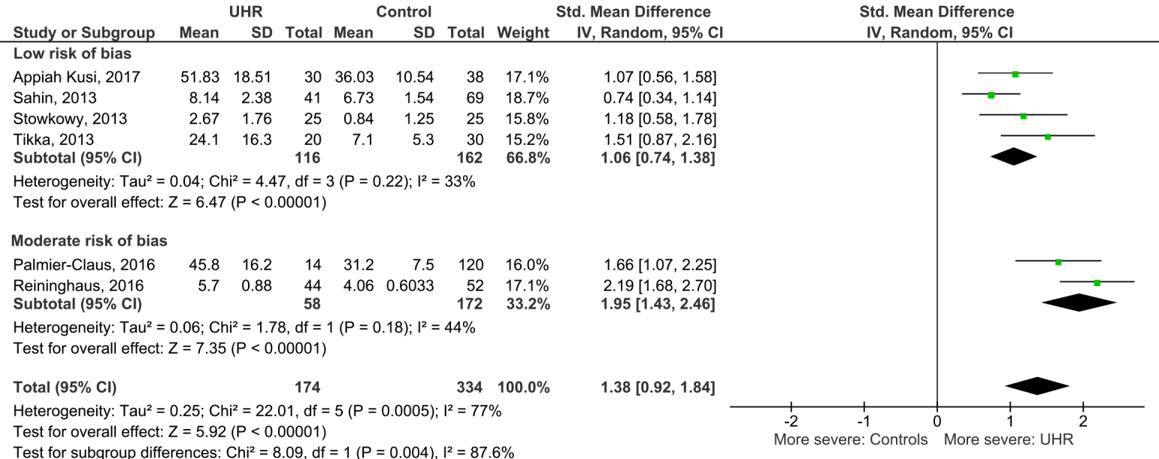

S3. Forest plot comparing the prevalence of trauma subtypes between UHR and controls. Higher odds reflect higher prevalence.
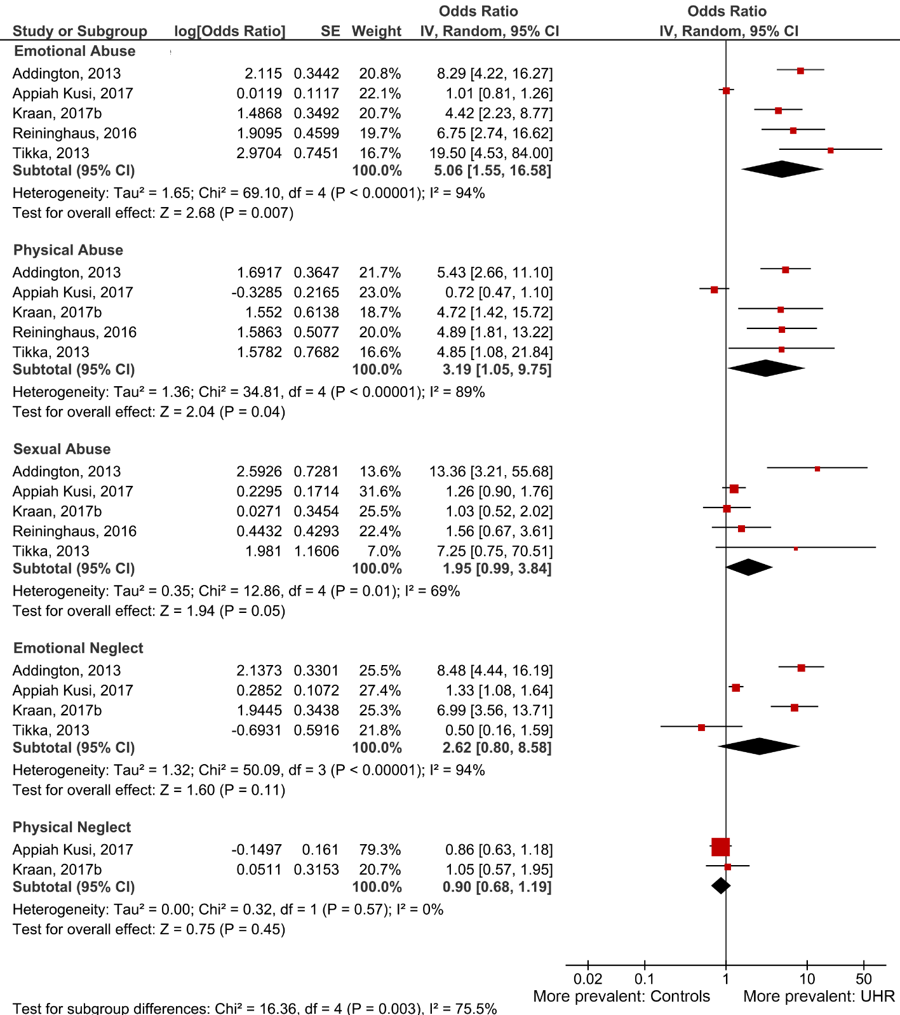
S4. Forest plot comparing the prevalence of bullying victimization between UHR and controls.
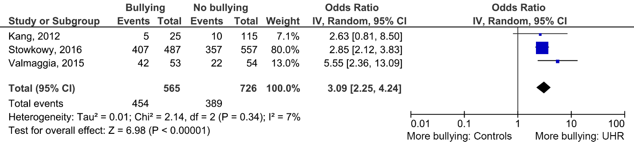

S5. Forest plot of the association between childhood trauma and TTP among UHR.
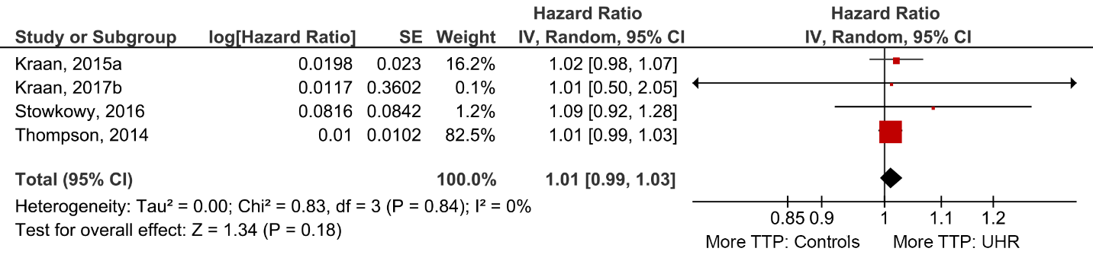

S6. Forest plot of the association between childhood trauma subtypes and TTP among UHR.
