Supplementary material
To better illustrate the relationship between the RLOC activation at baseline and 6 months, we plotted (Figure S1) the RLOC activation during anticipation of monetary loss at baseline and 6 months for healthy controls, individuals with BD who were euthymic at baseline and did not change medications over 6 months, individuals with BD who were euthymic at baseline and change medications over 6 months, individuals with BD who were depressed at baseline, became euthymic or partially depressed at 6 months and did not change medications over 6 months, individuals with BD who were depressed at baseline, became euthymic or partially depressed at 6 months and change medications over 6 months, individuals with BD who were depressed at baseline, remained depressed at 6 month and did not change medications over 6 months, and finally, individuals with BD who were depressed at baseline, remained depressed at 6 month and change medications over 6 months. We also plot the depression and mania scores at baseline and 6 months scans for corresponding groups to illustrate the changes in subjects’ clinical profiles.
While the formal statistical comparisons among these groups were not possible due to the large number of groups and small (sometimes n=1) size of some groups, Figure S1 can provide preliminary information about the relationships among anticipation-related RLOC activation across scans, and various combinations of mood state at baseline, mood improvement and changes in medications over 6 months.
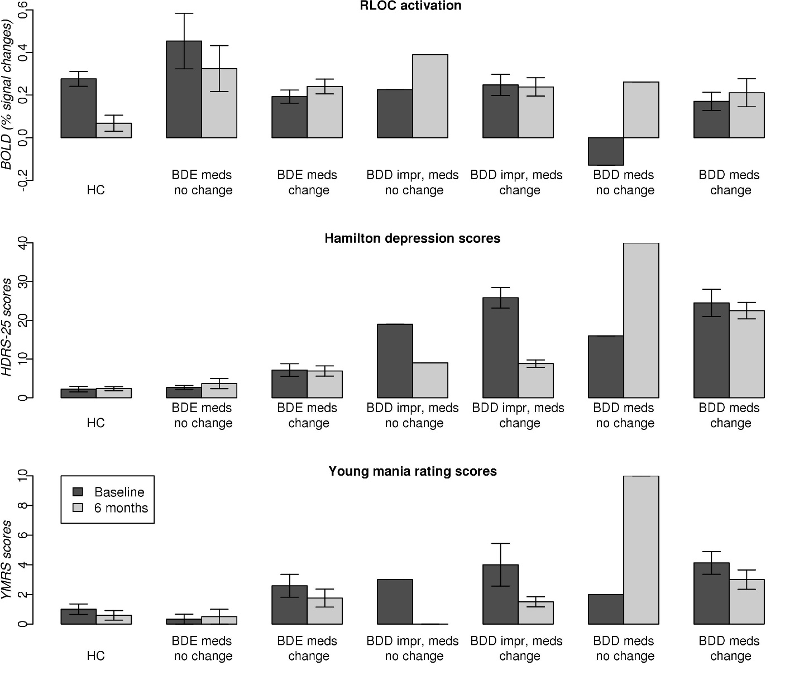
Figure S1. RLOC activation during anticipation of monetary loss, Hamilton depression scores and Young mania rating scale scores at baseline and 6 months. HC – healthy controls (n=17); BDE meds no change – individuals with bipolar disorder who were euthymic at baseline and who remained on the same medications over 6 months (n=6); BDE meds changed - individuals with bipolar disorder who were euthymic at baseline and who changed medications over 6 months (n=12); BDD impr, meds no change - individuals with bipolar disorder who were depressed at baseline, improved over 6 month and remained on the same medications (n=1); BDD impr, meds change - individuals with bipolar disorder who were depressed at baseline, improved over 6 month and changed medications (n=6); BDD meds no change – individuals with bipolar disorder who were depressed at baseline and who remained on the same medications over 6 months (n=1); BDD meds changed - individuals with bipolar disorder who were depressed at baseline and who changed medications over 6 months (n=8).

