A
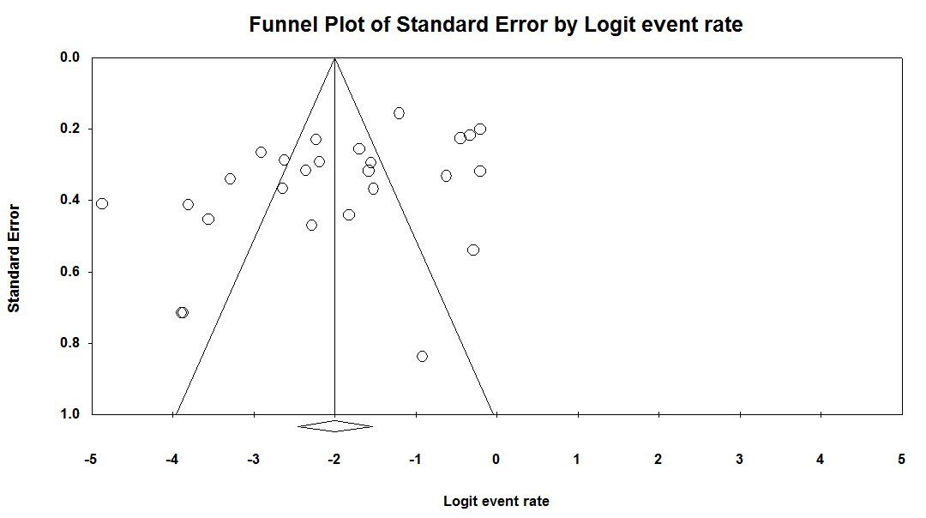
B
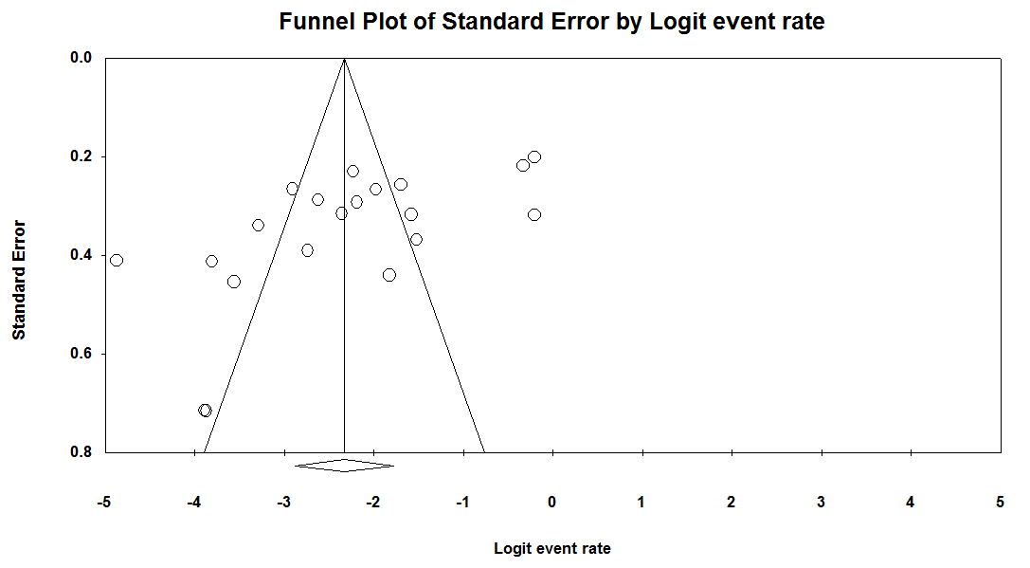
C
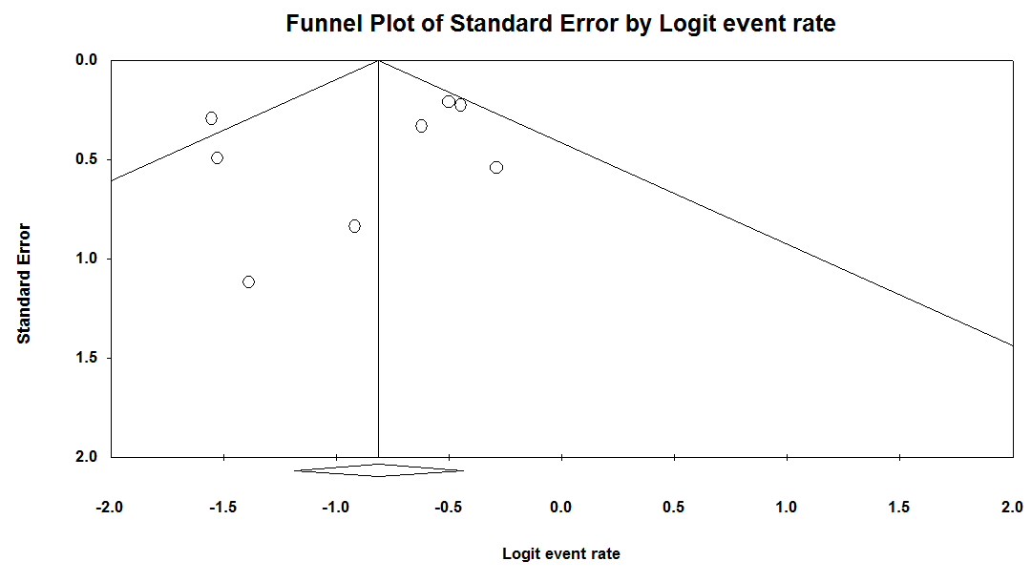

D
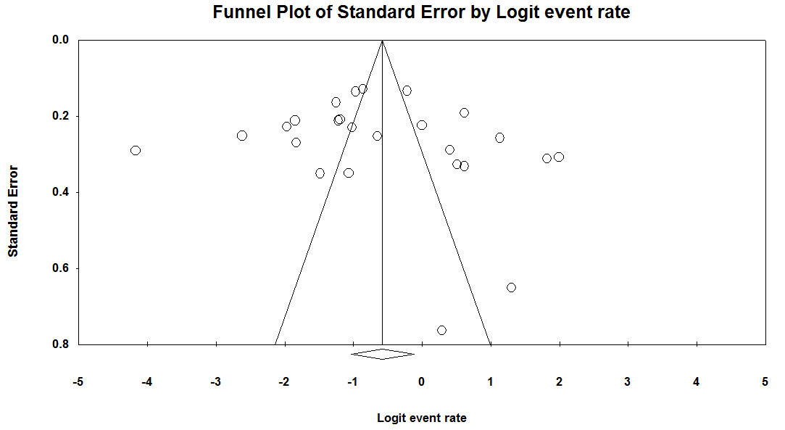
E
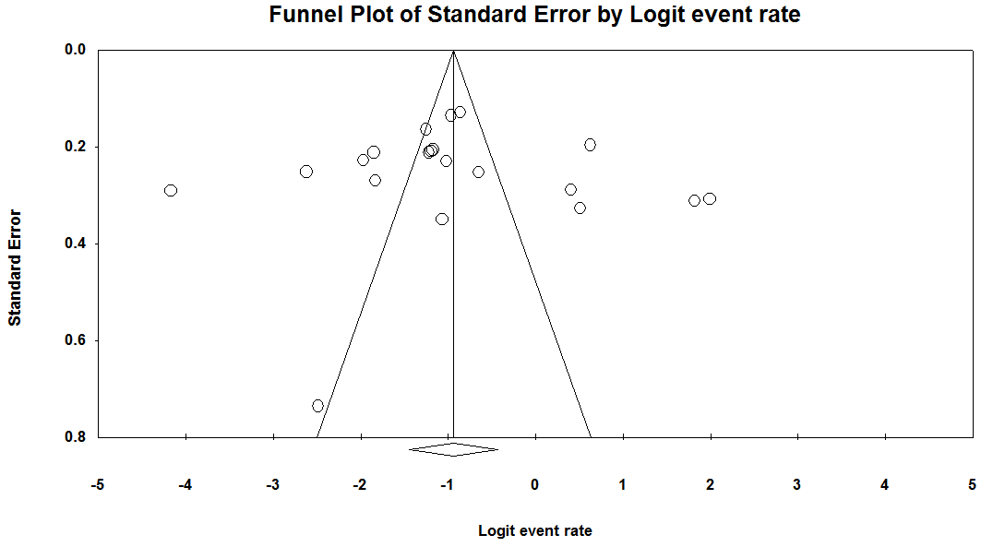
F
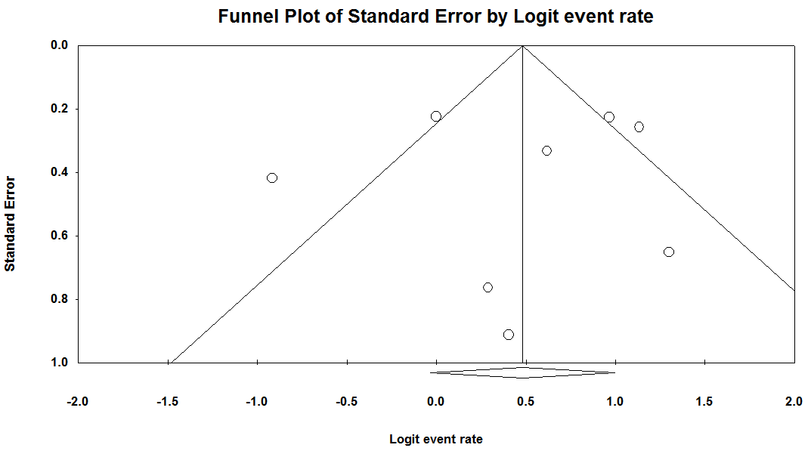
Supplementary figure 6 Publication bias assessment by Begg’s funnel plots showing minor asymmetry with no clear evidence of publication bias in (A) auditory hallucinations in LBD, (B) PD, (C) or DLB. Similar trends were seen in (D) auditory hallucinations in LDB, (E) PD, or (F), DLB.
Study | Study design | # participants | # female | % female | Time of hallucinations presentation | Method of hallucination assessment
Aarsland et al., (2001) | Cross-sectional | 229 | 125 | 54.6 | Past month | NPI
Amar et al., (2014) | Cross-sectional | 40 | 5 | 12.5 | Past month | NPI
Ballard et al., (1999) | Cross-sectional | 270 | 154 | 57 | Past month | MOUSPAD
Ballard et al., (2001) | Longitudinal | 214 | 139 | 65 | Up to one year post-diagnosis | CUSPAD
de Chazeron et al., (2015) | Cross-sectional | 137 | 58 | 42.3 | Past 10 days | PSAS
de Maindreville et al., (2005) | Longitudinal | 141 | NaN | NaN | Up to one year post-diagnosis | Semi-structured interview
Fenelon et al., (2000) | Cross-sectional | 216 | 93 | 43.1 | Past three months | Semi-structured interview
Fenelon et al., (2010) | Cross-sectional | 116 | 41 | 35.3 | Unclear | Questionnaire
Fernandez et al., (1992) | Cross-sectional | 50 | NaN | NaN | At presentation | Not stated
Goetz et al., (1998) | Longitudinal | 787 | 26 | 3.3 | Within 3 months of commencement of L-DOPA | Structured interview
Graham et al., (1997) | Longitudinal | 129 | 60 | 46.5 | Up to 30 years | Structured interview
Gupta et al., (2004) | Cross-sectional | 43 | 10 | 23.3 | Unclear | Semi-structured interview
Holroyd et al., (2001) | Cross-sectional | 98 | 39 | 39.8 | In week prior to presentation at tertiary centre | Semi-structured interview
Klatka et al., (1996) | Retrospective | 112 | 64 | 57.1 | At presentation | Screening hospital records
Lee et al., (2012) | Cross-sectional | 191 | 54 | 28.3 | At evaluation | PPRS
Leu-Semenescu et al., (2011) | Cross-sectional | 100 | 34 | 34 | Any time in the past | Semi-structured interview
Llorca et al., (2016) | Cross-sectional | 100 | 45 | 45 | Any time in the past | PSAS
Mack et al., (2012) | Cross-sectional | 250 | 83 | 33.2 | At presentation | Semi-structured interview
Pacchetti et al., (2005) | Cross-sectional | 289 | 134 | 46.4 | Two months between first and second screening | Semi-structured interview
Paleacu et al., (2005) | Cross-sectional | 276 | 153 | 55.4 | Past month | Questionnaire
Papapetropoulos et al., (2008) | Cross-sectional | 70 | 24 | 34.3 | Active or in the past | UM-PDHQ
Piggott et al., (2007) | Case-control (retrospective) | 25 | 15 | 60 | Until death | Semi-structured interview
Shea et al., (2014) | Case-control (retrospective) | 30 | 16 | 53.3 | Past month | NPI
Suárez-González et al., (2014) | Cross-sectional | 165 | 91 | 55.2 | Past month | NPI & CUSPAD
Svetel et al., (2012) | Cross-sectional | 180 | 85 | 47.2 | Past three months | NPI
Williams et al., (2007) | Cross-sectional | 181 | 78 | 43.1 | Unclear | QSVHI
Supplementary table 1 Overview of study characteristics included in meta-analyses.

Study | Aims stated | Experimental protocol | Baseline criteria | Inclusion and exclusion criteria | Statistical analyses | Outcome assessment | Timeframe for hallucinations | Outcome measures | Description of hallucinations | Total
Aarsland et al., (2001) | 1 | 1 | 1 | 1 | 1 | 1 | 1 | 1 | 0 | 8
Amar et al., (2014) | 1 | 1 | 1 | 1 | 1 | 1 | 1 | 1 | 1 | 9
Ballard et al., (1999) | 1 | 1 | 1 | 1 | 1 | 1 | 1 | 1 | 0 | 8
Ballard et al., (2001) | 1 | 0 | 1 | 1 | 1 | 1 | 1 | 1 | 0 | 7
de Chazeron et al., (2015) | 1 | 1 | 1 | 1 | 1 | 1 | 1 | 1 | 0 | 8
de Maindreville et al., (2005) | 1 | 1 | 0 | 1 | 1 | 1 | 1 | 1 | 0 | 7
Fenelon et al., (2000) | 1 | 1 | 1 | 1 | 1 | 1 | 0 | 1 | 0 | 7
Fenelon et al., (2010) | 1 | 1 | 1 | 1 | 1 | 1 | 1 | 1 | 1 | 9
Fernandez et al., (1992) | 0 | 1 | 0 | 1 | 1 | 1 | 1 | 1 | 0 | 6
Goetz et al., (1998) | 1 | 1 | 0 | 1 | 0 | 1 | 1 | 1 | 0 | 6
Graham et al., (1997) | 1 | 1 | 1 | 1 | 1 | 1 | 0 | 1 | 1 | 8
Gupta et al., (2004) | 1 | 1 | 1 | 1 | 0 | 1 | 0 | 1 | 1 | 7
Holroyd et al., (2001) | 1 | 1 | 0 | 1 | 1 | 1 | 1 | 1 | 0 | 7
Klatka et al., (1996) | 1 | 1 | 1 | 1 | 0 | 1 | 1 | 0 | 0 | 6
Lee et al., (2012) | 1 | 1 | 1 | 1 | 1 | 1 | 1 | 0 | 0 | 7
Leu-Semenescu et al., (2011) | 1 | 1 | 1 | 1 | 1 | 1 | 1 | 0 | 1 | 8
Llorca et al., (2016) | 1 | 1 | 1 | 1 | 1 | 1 | 1 | 1 | 0 | 8
Mack et al., (2012) | 1 | 1 | 1 | 1 | 1 | 1 | 1 | 1 | 0 | 8
Pacchetti et al., (2005) | 1 | 1 | 1 | 1 | 1 | 1 | 1 | 1 | 0 | 8
Paleacu et al., (2005) | 1 | 1 | 1 | 1 | 1 | 1 | 1 | 1 | 0 | 8
Papapetropoulos et al., (2008) | 1 | 1 | 1 | 1 | 1 | 1 | 1 | 1 | 0 | 8
Piggott et al., (2007) | 1 | 1 | 1 | 1 | 1 | 1 | 1 | 1 | 0 | 8
Shea et al., (2014) | 1 | 1 | 0 | 1 | 1 | 1 | 1 | 1 | 0 | 7
Suárez-González et al., (2014) | 1 | 1 | 1 | 1 | 1 | 1 | 1 | 1 | 1 | 9
Svetel et al., (2012) | 1 | 1 | 1 | 1 | 1 | 1 | 1 | 1 | 0 | 8
Williams et al., (2007) | 1 | 1 | 1 | 1 | 0 | 1 | 0 | 1 | 0 | 6
Supplementary table 2 Quality assessment of studies included in quantitative synthesis.
Auditory hallucinations in LBD Meta-regression model, random effects, Z-distribution, Logit event rate (R²=0.38)
Covariate | Coefficient | Standard error | LCL | UCL | Z-value | 2-sided p-value
Intercept | -4.61 | 2.3 | -9.11 | -0.11 | -2.01 | 0.05
Study quality | 0.19 | 0.21 | -0.23 | 0.6 | 0.86 | 0.39
Mean age at disease onset | 0.01 | 0.03 | -0.04 | 0.06 | 0.33 | 0.74
Hallucinations assessed by validated methods yes/no | 1.34 | 0.41 | 0.53 | 2.15 | 3.24 | 0.001
Auditory hallucinations in PD Meta-regression model, random effects, Z-distribution, Logit event rate (R²=0.27)
Covariate | Coefficient | Standard error | LCL | UCL | Z-value | 2-sided p-value
Intercept | -3.51 | 2.51 | -8.42 | 1.4 | -1.4 | 0.161
Study quality | 0.18 | 0.31 | -0.43 | 0.79 | 0.59 | 0.56
Mean age at disease onset | -0.01 | 0.02 | -0.04 | 0.02 | -0.71 | 0.48
Hallucinations assessed by validated methods yes/no | 1.22 | 0.5 | 0.23 | 2.21 | 2.42 | 0.015
Visual hallucinations in LBD Meta-regression model, random effects, Z-distribution, Logit event rate (R²=0.18)
Covariate | Coefficient | Standard error | LCL | UCL | Z-value | 2-sided p-value
Intercept | -2.59 | 2.53 | -7.54 | 2.36 | -1.03 | 0.3
Study quality | 0.02 | 0.24 | -0.45 | 0.49 | 0.08 | 0.94
Mean age at disease onset | 0.02 | 0.03 | -0.04 | 0.07 | 0.59 | 0.55
Hallucinations assessed by validated methods yes/no | 1.54 | 0.46 | 0.64 | 2.45 | 3.36 | 0.0008
Visual hallucinations in PD Meta-regression model, random effects, Z-distribution, Logit event rate (R²=0.09)
Covariate | Coefficient | Standard error | LCL | UCL | Z-value | 2-sided p-value
Intercept | -1.54 | 2.37 | -6.18 | 3.1 | -0.65 | 0.52
Study quality | 0.16 | 0.3 | -0.43 | 0.74 | 0.53 | 0.6
Mean age at disease onset | -0.02 | 0.02 | -0.05 | 0.02 | -1.05 | 0.29
Hallucinations assessed by validated methods yes/no | 1.38 | 0.55 | 0.3 | 2.47 | 2.51 | 0.01
Supplementary table 3 Output from four meta-regression models. All models found that the use of validated methods to detect hallucinations produced higher estimated of prevalence and could account for a significant proportion of the variance. Neither study quality or mean age of disease onset were found to account for a significant proportion of the observed heterogeneity.

Sensitivity analyses auditory hallucinations in LDB
Analyses | # studies | # participants | prevalence (%) | LCL 95% | ULD 95% | I² (%)
2000 and later studies only | 21 | 2714 | 12.7 | 8.1 | 19.2 | 93.1
2005 and later studies only | 16 | 2046 | 12.2 | 6.9 | 20.8 | 93.8
2010 and later studies only | 12 | 1291 | 15.2 | 8 | 27.1 | 93.6
Cross-sectional studies only | 20 | 2628 | 11.7 | 7.5 | 17.8 | 92.8
Quality score >=7/9 | 21 | 2720 | 13.6 | 8.8 | 20.4 | 93.2
Quality score >=8/9 | 15 | 1999 | 14.5 | 8.6 | 23.4 | 93.8
Sensitivity analyses visual hallucinations in LDB
Analyses | # studies | # participants | prevalence (%) | LCL 95% | ULD 95% | I² (%)
2000 and later studies only | 21 | 2614 | 39.3 | 28.8 | 50.8 | 95.8
2005 and later studies only | 16 | 1946 | 39.9 | 26.6 | 54.8 | 96.2
2010 and later studies only | 12 | 1191 | 41 | 21.5 | 63.8 | 96.8
Cross-sectional studies only | 20 | 2528 | 37.1 | 27 | 48.5 | 95.7
Quality score >=7/9 | 21 | 2620 | 38.9 | 28.7 | 50.1 | 95.5
Quality score >=8/9 | 15 | 1899 | 41.7 | 28.8 | 55.7 | 96
Supplementary table 4 Results of sensitivity analyses which demonstrated robustness of our estimates. Including studies only published from 2010 onwards or those of study quality score of 8 or 9/9 produced effect size estimates of around 3% higher for both auditory and visual hallucinations, suggesting our pooled prevalence estimates may be conservative with respect to the true prevalence in the population.

