Supplementary Material

Supplementary figure 1: Funnel plot of studies reporting outcome measures with BP method
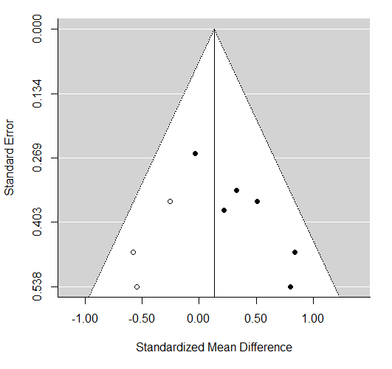

Supplementary figure 2: Forest plot of studies which used [¹¹C]-PK11195 ligand
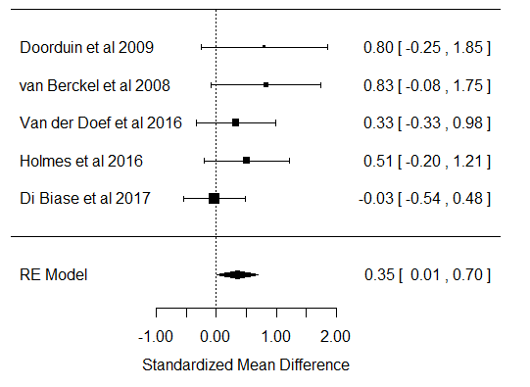

Supplementary figure 3: Funnel plot of studies reporting outcome measures with V_{T} method
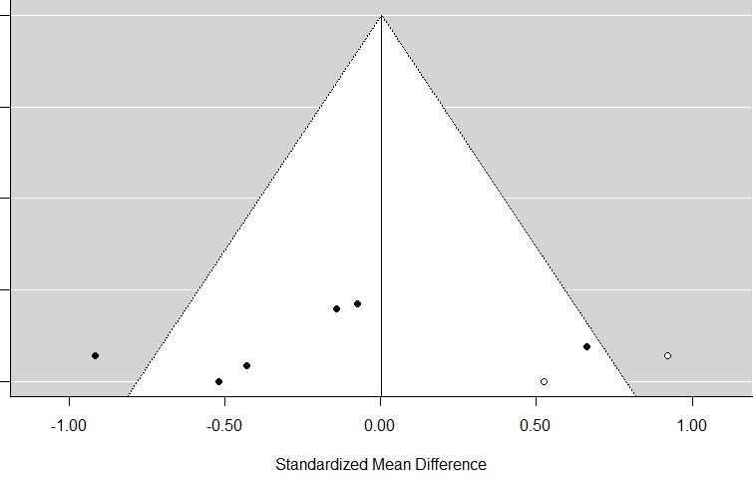

Supplementary figure 4: Forest plot of studies reporting outcome measures with the V_{T} method in mixed affinity binders
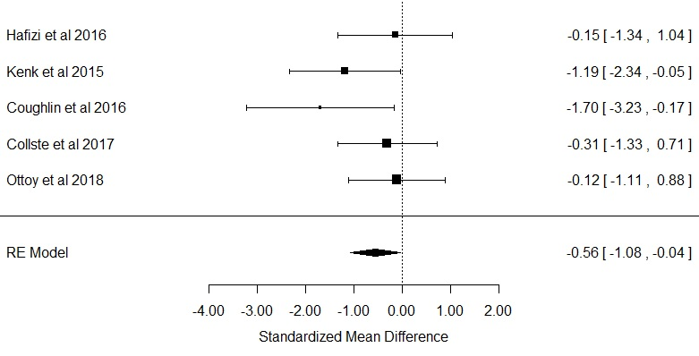

Supplementary figure 5: Forest plot of studies reporting outcome measures with the V_{T} method in high affinity binders
