Supplementary Material
Overview of Cognitive, Psychiatric and Familial Measures
Cognitive assessments were conducted by a clinical psychologist with the version of the Wechsler (Wechsler, 1991; Wechsler, 1997) appropriate to the age of the participant. Structured psychiatric interviews were conducted by a clinical psychologist or a child psychiatrist with the Kiddie-Schedule for Affective Disorders and Schizophrenia (K-SADS-PL) (Kaufman et al., 1997) at T1 – T3 and the Structured Clinical Interview for DSM-IV (SCID) (First et al., 2002) at T4. Inter-rater reliability, based on 10 interviews, was 0.91 based on the Kappa coefficient. The ADI-R was administered at baseline by master’s and Ph.D. – level clinicians who were certified in the reliable administration of the instrument. Adaptive functioning was assessed with the Children’s Global Assessment Scale (CGAS; Shaffer et al., 1983). Prodromal symptoms were assessed at T1 with the K-SADS-PL, and at subsequent timepoints with Structured Interview for Prodromal Syndromes (SIPS; Miller et al., 2003), which had not yet been published at the onset of the study. Parent-rated questionnaires included the Behavior Assessment System for Children, Parent Scale (BASC; Reynolds et al., 1992), Family Environment Scale, Form R (FES; Moos & Moos, 2009), and The Family Interview for Genetic Studies (FIGS; Maxwell, 1992). Additional medical and pharmacotherapy information was collected via parent reports at all timepoints.
Definition and Reliability of Administration of Psychiatric Diagnostic Measures
Attention deficit hyperactivity disorder (ADHD), anxiety disorders (comprised of specific and social phobia, separation anxiety, generalized anxiety disorder, obsessive compulsive disorder, post-traumatic stress disorder) and mood disorders (comprised of bipolar and unipolar depressive disorders) were determined by clinician ratings on the Schedule for Affective Disorders and Schizophrenia for School-Age Children—Present and Lifetime Version (K-SADS-PL) (Kaufman et al. 1997) or the Structured Clinical Interview for DSM-IV-TR axis I Disorders (SCID) (First 2002), depending on the age of the participant. The K-SADS-PL and the SCID were administered by either a board-certified child psychiatrist (WF) or a licensed clinical psychologist (KMA). Reliability for the K-SADS-PL was based on 12 videotaped interviews that were rated by both clinicians, yielding a kappa coefficient of 0.91. Final diagnoses based on the SCID were based on consensus meetings between WF, KMA, and the principal investigator of the study (WRK).
Psychosis-spectrum disorders included prodromal and psychotic disorders (Yi at.al, 2015; Tang et al., 2017; Ramanathan et al., 2017) as determined by scores on the K-SADS-PL at T1 and the Structured Interview For Prodromal Syndromes (SIPS; Miller et al., 2003) at subsequent timepoints. Participants were positive for a prodromal disorder if he or she reported either subthreshold or threshold hallucinations or delusions on the screening module of the K-SADS-PL at T1, or received a score 3 or above on any of the five items on the Positive Symptoms Subscale of the SIPS subsequently. Participants were positive for a psychotic disorder if he/she met diagnostic criteria for schizophrenia, schizoaffective disorder or psychosis NOS on the K-SADS-PL or SCID.

Table S1. Predictors to Persistence
Baseline Predictors | Measure* | Diagnostic Category Modeled
Age | Parent Report | All Disorders
Global Functioning | CGAS | All Disorders
Full Scale IQ | WISC-III | ADHD, Anxiety and Mood Disorders
Family History of ADHD | FIGS | ADHD
ADHD Symptomology (Scores on Hyperactivity, Attention Problems) | BASC | ADHD
Externalizing Scores** | BASC | ADHD, Mood Disorders
Internalizing Scores** | BASC | Anxiety, Mood, and Psychosis-spectrum Disorders
Family Conflict | FES | Anxiety Disorders
Family History of Mania or Depression | FIGS | Mood Disorders
Diagnosis of any Anxiety Disorder | K-SADS-PL | Psychosis-Spectrum Disorder
Diagnosis of Autism Spectrum Disorder | ADI-R | All Disorders
Verbal IQ | WISC-III | Psychosis-Spectrum Disorder
Baseline Prodromal Symptoms | K-SADS-PL | Psychosis-Spectrum Disorder
Longitudinal Predictors
T1 – T3 Change in Verbal IQ  ((T3VIQ – T1VIQ) / (T1VIQ*Time between T1 and T3))*100 | WISC-III / WAIS-III | Psychosis-Spectrum Disorder

*CGAS: Children’s Global Assessment Scale; WISC-III: Weschler Intelligence Scale for Children-3td Edition; FIGS: Family Interview for Genetic Studies; BASC: Behavior Assessment Scale for Children; FES: Family Environment Scale; K-SADS-PL: Kiddie Schedule for Affective Disorders and Schizophrenia-Present and Lifetime Version; ADI-R: Autism Diagnostic Interview-Revised; WAIS-III: Wechsler Adult Intelligence Scale-3rd Edition
** Since youth with 22q11DS exhibit a high rate of psychiatric comorbidity, we did not include the presence of comorbid disorders in our regression analyses for either anxiety or mood disorders because we were concerned that comorbidity would negate the extent to which other variables accounted for variance. Instead, we included parent-rated scores on internalizing and externalizing behaviors (which correlated with the presence of comorbid psychiatric disorders at about 0.50).

Table S2. Number (Percent) of Reported Medication Usage in Controls
Medication | Childhood | Early Adolescence | Late Adolescence | Early Adulthood
Stimulants | 6 (11.76) | 6 (9.68) | 5 (9.43) | 4 (9.76)
Anti-Depressants / Anxiolytics | 2 ( 3.92) | 3 (3.92) | 2 (3.77) | 2 (4.88)

Figure S1. Receiver Operator Characteristic (ROC) Curve for Predictors of Persistence of ADHD, Anxiety Disorders, Mood Disorders and Psychosis-Spectrum Disorders.¹

¹Each receiver operator curve plots the true positive rate (sensitivity) against the false positive rate (1-specificity) of each set of predictors of persistence of a given psychiatric diagnosis. As stated in the text, the curves provide thresholds for scores that would yield optimal sensitivity rates to detect highest risk for persistence of psychiatric disorder (ie., true positives), and optimal “1 – specificity” rates to rule out children who are at lower risk for persistence of psychiatric disorder (i.e., false positives). To identify children with 22q11DS who are at the highest risk for persistence, one might apply a threshold that provides optimal specificity (e.g. > .80) and minimal false positives (e.g. < .20). In the figure above, the ROC curve for predictors of anxiety disorders provides the optimal ratio, where a sensitivity value of .86 yields a false positive rate of only .09.

Figure S2. Proband Trajectories of Diagnoses of Specific Anxiety Disorders across Timepoints. This figure depicts rates (percentages) of specific anxiety diagnoses in probands, across the four timepoints of the study.

Figure S3. Percent of Reported Medication Usage in Probands Diagnosed with a Psychiatric Disorder, by Diagnostic Class and Timepoint¹
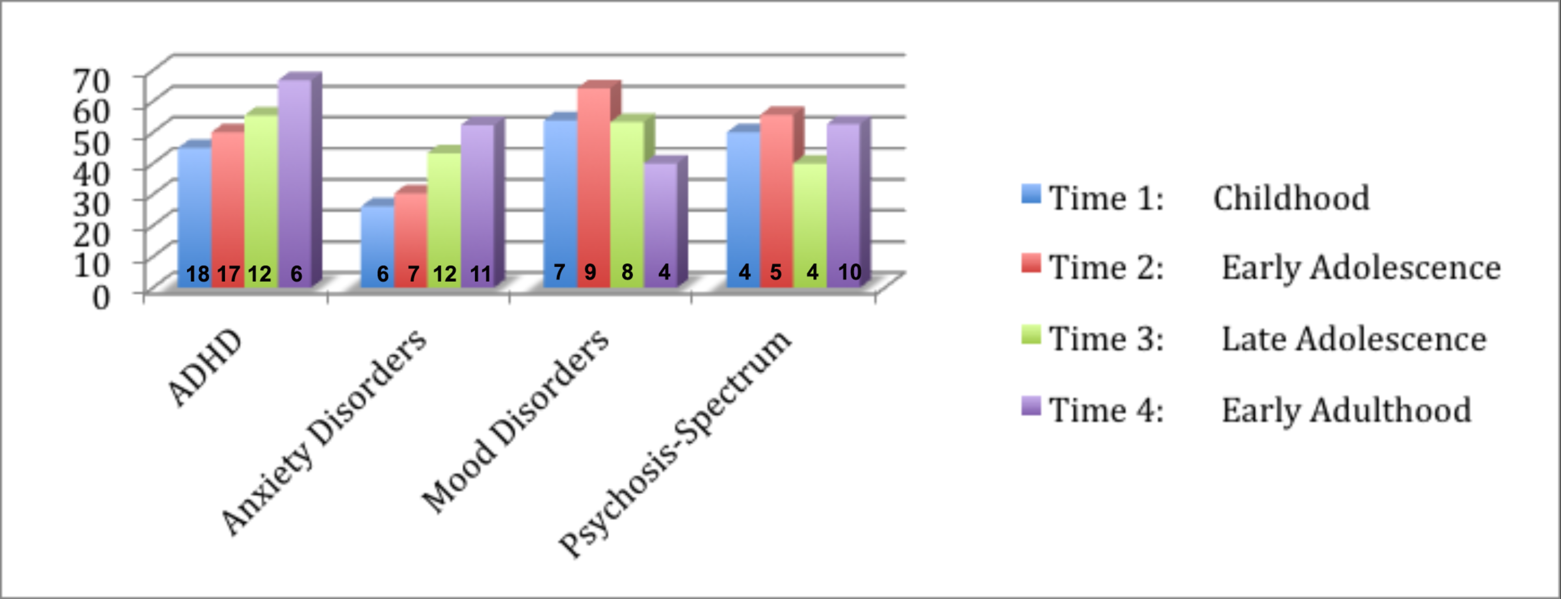
¹ Numerical values within each bar represent the number of probands using psychotropic medication for that diagnostic class, at that timepoint.
Figure S4. Percent of Reported Medication Usage in Controls Diagnosed with a Psychiatric Disorder, by Diagnostic Class and Timepoint.¹
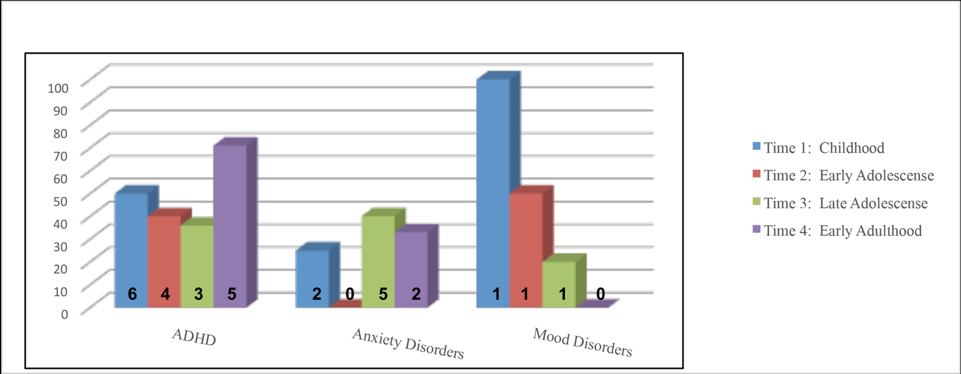
¹ Numerical values within each bar represent the number of controls using psychotropic medication for that diagnostic class, at that timepoint.

References

First MB, Spitzer RL, Gibbon M, Williams JB (2002). Structured clinical interview for DSM-IV-TR axis I disorders, research version, patient edition. (SCID-I/P) New York: Biometrics Research, New York State Psychiatric Institute.
Kaufman J, Birmaher B, Brent D, Rao U, Flynn C, Moreci P, Williamson D, Ryan N (1997). Schedule for Affective Disorders and Schizophrenia for School-Age Children-Present and Lifetime Version (K-SADS-PL): initial reliability and validity data. Journal of the American Academy of Child and Adolescent Psychiatry 36, 980-988.
Maxwell E (1992). Manual for the FIGS. Bethesda, MD: Clinical Neurogenetics Branch, Intramural Research Program NIMH.

Miller, TJ, McGlashan, TH, Rosen, JL, Cadenhead, K, Ventura, J, McFarlane, W, Perkins, DO, Pearlson, GD, Woods, S (2003). Prodromal assessment with the structured interview for prodromal syndromes and the scale of prodromal symptoms: predictive validity, interrater reliability, and training to reliability. Schizophrenia Bulletin 29, 703-715.
Moos R, Moos B (2009). Family Environment Scale Manual and Sampler Test: Development, Applications, and Research. Palo Alto, CA: Mind Garden, Inc.
Ramanathan S, Mattiaccio LM, Coman IL, Botti JC, Fremont W, Faraone SV, Antshel KM, Kates WR (2017). Longitudinal trajectories of cortical thickness as a biomarker for psychosis in individuals with 22q11.2 deletion syndrome. Schizophrenia research 188, 35-41.
Reynolds CR, Kamphaus RW (1992). Behavior Assessment Scales for Children (BASC). Circle Pines, MN: American Guidance Service.
Shaffer D, Gould MS, Brasic J, Ambrosini P, Fisher P, Bird H, Aluwahlia S (1983). A children's global assessment scale (CGAS). Archives of General Psychiatry 40, 1228-1231.
Tang SX, Moore TM, Calkins ME, Yi JJ, Savitt A, Kohler CG, Souders MC, Zackai EH, McDonald-McGinn DM, Emanuel BS, Gur RC, Gur RE (2017). The Psychosis Spectrum in 22q11.2 Deletion Syndrome Is Comparable to That of Nondeleted Youths. Biological psychiatry 82, 17-25.
Wechsler D (1997). Wechsler adult intelligence scale, Third Edition. San Antonio, TX: Psychological Corporation.
Wechsler D (1991). Wechsler intelligence scale for children-Third Edition.. San Antonio, TX: Psychological Corporation.
Yi JJ, Calkins ME, Tang SX, Kohler CG, McDonald-McGinn DM, Zackai EH, Savitt AP, Bilker WB, Whinna DA, Souders MC, Emanuel BS, Gur RC, Gur RE (2015). Impact of psychiatric comorbidity and cognitive deficit on function in 22q11.2 deletion syndrome. The Journal of clinical psychiatry 76, e1262-70.

